The effect of non-specific tight junction modulators on the transepithelial transport of poorly permeable drugs across airway epithelial cells
Maliheh Ghadiriª, Paul M. Youngª, Wolfgang Jarolimek^{b}, Georges E. R. Grau^{c}, Brian Oliver^{d}, and Daniela Trainiª
ª Respiratory Technology, Woolcock Institute of Medical Research and Discipline of Pharmacology, Sydney Medical School.
^{b} Pharmaxis Ltd, 20 Rodborough Rd, Frenchs Forest, NSW 2086, Australia
^{c} Vascular Immunology Unit, Sydney Medical School & Bosch Institute, University of Sydney, Camperdown, Australia,
^{d} School of Life Sciences, University of Technology, Sydney, Australia

Keywords: tight junction, non-tight junction modulator, Calu-3, Na decanoate, EGTA and oleic acid

Introduction
Drug delivery via the lung is an interesting route of delivery due to the large absorptive surface area, thin alveolar barrier and high level of blood circulation of the lung _{[1]}. Thus, with such direct access to the local and systemic circulation, and with such large absorptive area the amount of administered drug can be highly reduced and absorbed faster _{[2]}. However, the efficiency of this route is still low and some pharmacologically active compounds, like peptides and macromolecules, cannot be administered through inhalation due to inadequate absorption for sub-epithelia targeting, limiting their usefulness. The lack of uptake across the epithelia can be due to many reasons; these include; poor aqueous solubility, degradation of active compound by local enzymes and poor membrane permeability _{[3]}.
Poor membrane permeation can occur due to the low lipophilicity or zwitterionic character of a drug at physiological pH (as with many hydrophilic, low-molecular weight compounds). Alternatively, it can be related to the drug being effluxed from the cells via membrane-bound efflux protiens such as p-glycoprotein. Lastly, high molecular weight such as peptides and proteins may have poor permeability due to their molecular size prohibiting them from transepithelial translocation _{[4]} . Subsequently, many attempts have been made to enhance the penetration of drugs delivered by inhalation by overcoming the epithelial barrier of the lung _{[5]}.
The epithelial barrier consist of tight junctions, adherens junctions, gap junctions and desmosomes, each serving a distinct function _{[6]}. Tight junctions (TJ) are the most critical determinant of epithelial barrier function, although evidence suggests that other junctions, particularly adherens junctions, contribute to barrier function by regulating TJ assembly _{[6]}. Essential elements of the TJ are four-transmembrane proteins located at the apical side of cell membrane. The two extracellular loops of these proteins link to the extracellular loops from neighbouring cells, stiffening the paracellular pathway. These proteins are occludins and the family of claudins _{[7]}. Epithelial barrier via TJs acts as a gate to restrict passage of small molecules in a charge specific manner and completely seals diffusion of molecules with molecular size larger than 0.1 nm _{[8]}. Many different strategies have been applied to increase the permeability of drugs via the paracellular route _{[9-11]}, one of which is to modulate the TJ of epithelial cells. Various types of tight junction modulators (TJMs) have been listed in the literature, for example non-specific TJM such as calcium chelators _{[12]} and surfactants _{[13]} and specific TJMs that target TJs-related mechanisms. These later targeting TJMs include protein kinase C activators _{[14]}, bradykinin B2 agonists _{[15]}, cytochalasins B or D _{[16]} and clostridium difficile toxin _{[17]} along with some targeting TJs proteins such as claudin _{[8]} and ocludin _{[18]}.
There is currently limited literature regarding airway epithelium TJMs when compared with the much better characterized TJMs used for intestinal epithelium. Although non-specific epithelial models such as intestinal epithelia cells have shown reasonable correlation with various types of epithelial cells _{[19]}, the use of organ-specific epithelia cell remains desirable for targeted routes of delivery. In this study, non-specific TJMs (sodium decanoate _{[20]}, oleic acid _{[21]} and ethyleneglycol-bis-(β-aminoethyl ether)-N,N'-tetraacetic acid (EGTA) _{[12]}) which have been reported to modulate intestinal TJs and thereby increase para-cellular drug transport have been selected to investigate their potential effect on airway epithelia and drug transport.
Sodium decanoate (Na decanoate), a medium chain fatty acid salt, is a natural compound with wide distribution in food sources, and is a compound already approved as a food additive _{[22]}. Because of its non-toxic property even at high concentrations and its potential to enhance the absorption of poorly permeable drugs, it has been studied as TJM in many in vitro and preclinical studies _{[23-25]}. It was demonstrated that Na decanoate can dilate the TJs in intestinal epithelial cells, resulting in an increase in the transport of a fluorescent marker _{[26]}. Also, it has been shown on Caco-2- cells that Na decanoate may act on the TJs by cytoskeletal contraction triggered by myosin light-chain kinase interaction _{[27]}. Na decanoate demonstrates an increase in the flux of numerous types of poorly permeable moelcules across intestinal epithelia in vitro, including antibiotics _{[28]}, heparin _{[29]}, recombinant epidermal growth factor (EGF) _{[30]} and phenoxymethylpenicillin _{[31]} in vivo.
Oleic acid is a surface active compound with the ability to enhance the absorption of poorly permeable drugs. In intestinal epithelium it has been found to have an effect on the integrity of TJs, increasing paracellular transport in a dose-dependent manner _{[32, 33]}. Oleic acid has also been tested on brain endothelial cells, where it was shown to increase the permeability of hydrophilic drugs _{[34]}.
Another tested compound with tight junction modulatory effect is EGTA (a chelating agent) and its effect on tight junctions have been investigated on intestinal _{[35]}, kidney _{[36]} and mammary gland _{[37]} cells. In all tested epithelial cells it had TJ modulatory effect in favour of paracellular transport.
In this study the effect of selected non-specific TJMs, previously proven effective on intestinal cells, was investigated on lung epithelial cells specifically related to the transport of poorly permeable drugs delivered by inhalation. To evaluate their effect on airway TJs, the barrier function of bronchial epithelial cells (Calu-3) was studied using transepithelial resistance, dynamic cell impedance measurements and para-cellular markers. Furthermore, the effect of each TJM was studied in terms of transport of poorly permeable drug; PXS25. PXS25 is a new class of mannose-6-phosphate-receptor-inhibitor that targeting cystic fibrosis and has been shown to inhibit scar tissue formation _{[38, 39]}. It is highly potent drug but requires targeting of the fibroblast cells that are present sub-epithelia.

Materials and Methods

Cell Culture
Calu-3 cells purchased from American Type Culture Collection (ATCC, USA) were cultured in Dulbecco's Modified Eagle's medium: F-12 (Gibco by ThermoFisher Scientific, Australia) containing 10% (v/v) foetal calf serum (Gibco by ThermoFisher Scientific, Australia), 1% (v/v) non-essential amino acid solution (Sigma-Aldrich, Australia) and 1% (v/v) L-glutamine solution (Sigma-Aldrich, Australia). Cells were maintained in a humidified 95% air, 5% CO₂ atmosphere at 37°C and were subcultured according to American Type Culture Collection recommendations. For transepithelial resistance measurement with chopstick ohmmeter and transport studies, cells were cultured on Transwell® inserts (Corning by Sigma-Aldrich, Australia) using the air-liquid interface (ALI) method and seeded at a density of 1.65 × 10⁵ cells/insert, as described previously _{[40, 41]}. The medium was replaced three times a week and any apical surface liquid removed. TJMs were prepared fresh in complete cell culture medium prior to use; EGTA ≥ 97%, Na decanoate ≥ 98% and oleic acid ≥ 99% (suitable for cell culture) were all purchased from Sigma-Aldrich, Australia.

Cytotoxicity Assay
The in vitro toxicity of TJMs, as a function of concentration, on Calu-3 cell was evaluated using MTS assay (CellTiter 96® Aqueous One Solution Cell Proliferation Assay) from Promega (Sydney, Australia). MTS assay was used to measure cell metabolic activity by spectrophotometric quantitation as an endpoint for cell proliferation. Calu-3 cells were seeded in 96 well-plate at the density of 5 × 10⁴ cells/well and incubated overnight at 37 ºC. Each TJM (100 μl) in a range of concentrations (from 10 nM to 1 M) was added to the seeded cells and incubated for 24 hrs, followed by the addition of 20 µl of MTS reagent and incubated for 2 hrs. Optical absorbance was determined at 490 nm with Spectromax plate reader. Results were performed in triplicate and expressed as the IC₅₀ (50% inhibitory concentration) of each TJM.

Trypan blue exclusion test to measure cell viability
Trypan blue exclusion assay was used as an index of the viability of the Calu-3 cells after exposure to selected concentrations of each TJM. The concentration of each TJM (10 mM Na decanoate, 100 µM oleic acid and 1mM EGTA) was selected according to their respective IC₅₀ and previous studies on Caco-2 cells _{[32, 37, 42]}. After Calu-3 cells were grown to confluence on 60 mm culture dishes, they were exposed to the selected concentration of each TJM. Following 24 hrs of exposure, cells were rinsed in Hanks Balance Salt Solution (HBSS, Gibco by ThermoFisher, Australia), trypsinised, centrifuged and resuspended in 1 ml of medium. Cell suspensions were incubated with 0.4% trypan blue dye for 5 minutes and counted in a hemocytometer chamber under a light microscope. Viable and non-viable cells were counted and viability was calculated by dividing the number of viable cells to the total cell count. HBSS and 1% (v/v) Triton®X-100 were used as negative and positive controls, respectively

Immunofluorescence staining of tight junction proteins
To investigate the effect of TJMs on the structure of airway TJ related proteins, one of the main TJ related proteins from the family of occludins, (ZO-1), was labelled and visualized with confocal microscopy. Zona occludin-1 (ZO-1) which is a tight junction related protein was immunofluorescence stained after incubating cells with the TJMs to evaluate their effect on localisation of this specific protein. ZO-1 belongs to a family of multi domain proteins which interacts with the transmembrane protein occludin, a second tight junction-specific protein and has been implicated as an important scaffold protein _{[43, 44]}. Briefly, Calu-3 cells were plated on sterile 8 chamber slides with a density of 10 × 10⁴ cells/well and incubated overnight. Followed by cell attachment, 200 µl of TJMs in cell culture medium was added to each well and incubated for 24 hrs. Then, cells were rinsed with PBS, fixed in 4% paraformaldehyde, permeabilised and blocked for 15 min (0.1% Triton X-100, 1% BSA (Bovine Serum Albumin)). Cells were incubated in primary antibody (mouse anti-ZO1- Abcam, Australia) for 1 hr at room temperature. Following primary antibody incubation, cells were rinsed three times with 2% BSA/PBS (Bovine Serum Albumin/Phosphate Buffered Saline) solution and then incubated with secondary antibody (Alexa Fluor 488 mouse; Invitrogen by Life Technologies, Australia) for 30 min at room temperature. Following incubation, coverslips were rinsed in PBS and mounted using ProLong Gold (Invitrogen by Life Technologies, Australia) and counterstained with DAPI (Invitrogen by Life Technologies, Australia). Imaging was performed using an Olympus confocal microscope (Olympus IX71).

Epithelial Barrier Function
The epithelial barrier function was studied using two electrically based methods (static resistance and dynamic impedance) and a paracellular marker. Schematic images of measuring transepithelial electrical resistance (TEER) via these two techniques are depicted in Fig. 1-A and B.

Static resistance measurements using an ohmmeter with chopstick electrodes
TEER, a measure of TJ integrity, was calculated from the measured potential resistance difference between the apical and basolateral sides of the cell layer, with passive ion flow being the dominant process reflecting changes in paracellular permeability. Briefly, 250 µl of TJMs in medium was added to the apical compartment of Calu-3 cells cultured in ALI model. Then, TEER was measured at predetermined time points after exposure to TJM up to 4 hrs using a chop stick ohmmeter (EVOM; World Precision Instruments). Resistance was corrected by subtracting the blank inserts and multiplied by the area of the Transwell inserts, according equation below:
Normalised resistance (Ωcm²) = TEER₁-TEER_{blank} × 0.34 cm² (area of Transwell inserts)

Electrical cell-substrate impedance sensing (ECIS)
Epithelial barrier function was also measured using a real-time electrical cell-substrate impedance sensing system (ECIS; Applied BioPhysics, Troy, NY). This technique dynamically records the transepithelial resistance change of the Calu-3 epithelial barrier treated with TJMs. ECIS measurement is an accurate complementary technique to chopstick method. Resistance of the epithelial cells with the chopstick method is measured in ALI cell culture model, while the ECIS technique measures resistance of the cells grown on the ECIS array. For this experiment, 8EW1E arrays (8W1E Applied Biophysics, Troy, NY) were treated with l-cysteine and then coated with collagen (mouse collagen 4%). Post coating each well were inoculated with the cell density of 5×10⁵ cell and grown to get confluent. After reaching confluency, each well was treated with one of the TJMs for 4 hrs. Resistance of each well was measured dynamically every 5 minutes up to 4 hours and data analysed using ECIS software _{[45]}.

Transepithelial cell permeability using a paracellular marker
Permeation of Flu-Na across Calu-3 cell layer in ALI culture was measured in the presence of TJMs and compared with the control’s permeability (non-treated cells). Briefly, TJMs were prepared in a Flu-Na solution with the final concentration of Na decanoate 10 mM, EGTA 1 mM, oleic acid 100 µM and 2.5 mg/ml of Flu-Na and added to the donor chamber of the Transwell, while 600 μl of HBSS was added to the basolateral chamber. At pre-determined time points, 100 μl samples were taken from the basolateral chamber and subsequently replaced with fresh buffer to maintain sink conditions. Samples were placed in a black, 96 well-plate and fluorescence readings were recorded using a Spectromax plate reader with excitation and emission wavelengths settings of 485 and 520 nm, respectively.

Transport of PXS25 enhanced due to the effect of TJMs on Calu-3 cells
The effect of TJMs was evaluated on PXS25 transport through Calu-3 cell layer. In brief, Calu-3 cell cultured in the ALI culture model was incubated in the apical side with a mixture of 100 μM PXS25 with each TJM (Na decanoate 10 mM, EGTA 1 mM and oleic acid 100 µM) while the basal chamber was filled with 600 µl of HBSS. At pre-determined time points, 100 μl aliquots were taken from the basolateral chamber and subsequently replaced with fresh buffer to maintain sink conditions. PXS25 was then extracted from aliquots collected from the basal chamber using an Oasis HLB cartridge (30 mg, 1 ml, Waters, Milford MA, USA) solid phase extraction method _{[46]}. The extracted samples were completely dried out with concentrator (Concentrator Plus- Eppendorf, Australia) and the residue reconstituted in methanol/water 80:20 (600 μl), vortexed for 2 minutes and injected (10 µl) into a High performance liquid chromatography-triple-quadrupole mass spectrometer (Agilent-6460). The analysis was conducted using a C18 (Agilent, Australia) column (Rapid resolution-1.87 micron- 600 bar- 4.6×50 mm) using two mobile phases; A, methanol/water/formic acid (5/94.9/0.1 v/v/v); and B, methanol/water/formic acid (94.9/5/0.1 v/v/v) during an 7.5-min gradient from 20% to 80% mobile phase B at a flow rate of 0.4 ml/min. The mass spectrometer was operated in a negative electrospray ionization mode, with fragmentor voltage of 135v, and collision energy (CID) of 7. The multiple reaction-monitoring (MRM) mode was used for mass spectrometry detection. Parent ion channel of 361.10 m/z and daughter ion channel of 239.0 m/z were used. Retention time was 3.68 min. Samples were analysed in triplicate.

Statistics
Data are presented as mean ± standard deviation. One-way analysis of variance (ANOVA) and Tukey for multiple comparisons were used to determine statistical significance (∗∗P<0.01 and ∗∗∗P<0.001)

Results and discussion

Cytotoxicity and TJ protein localisation
The cytotoxicity of each TJM was investigated on Calu-3 cells over a range of concentrations. The half maximal inhibitory concentration (IC₅₀) for oleic acid, EGTA and Na decanoate were 120 µM, 10 mM and 24 mM, respectively. Previous studies reported Na decanoate and EGTA are safe in a wide range of concentrations, both in vitro and in vivo _{[47-49]}. Consequently, one concentration of each TJM was selected for further studies: Na decanoate 10 mM, EGTA 1 mM and oleic acid 100 µM, respectively. To confirm the viability of cells at the selected concentrations, trypan blue exclusion assay was performed (Fig. 2). Cell damage did not occur in cells grown in medium containing Na decaonate or EGTA. Cell viability was reduced in cells treated with 100 µM oleic acid, however viability was still 75% of the control. The positive control (Triton X-100), which is a toxic compound for the cells, demonstrated viability less than 10%, indicating that the cytotoxicity of TJMs with the selected concentration in Calu-3 cells could be considered safe.
The effect of TJMs on TJ related protein ZO-1was studied after immunofluorescence staining and images presented in Figure 3. Analysis of the images indicated that in the control cells, ZO-1 proteins were localized in the cell boundaries and formed unbroken contours around the cell walls. In cells incubated with TJMs, similarly to the control, ZO-1 accumulated at the cell boundaries and no noticeable morphological or distribution changes in ZO-1 protein localisation were observed. Other studies have shown that changes in tight junction protein’s organization at the cell boundaries can appear after incubation with oleic acid _{[50]} and Na decanoate _{[51]}. For example, Krug et al., studied the effect of Na decanoate on TJ related proteins (occludin, tricellulin, and claudins) _{[47]} and demonstrated that Na decanoate treatment on human intestinal cells induced a disruption in tricellulin and claudin-5 distribution. Similar finding was reported in another study when treating human keratinocite cells with Na decanoate _{[52]}. In this later study, the localization of TJ strands were disintegrated with the dispersion or disappearance of TJ-related proteins (occludin) from the cell surface. Although, Na decanoate has shown alteration in the localization of ZO-1, occluden and claudin-1 in intestinal epithelia, in human airway epithelial monolayers it caused redistribution of F-actin and reorganization of claudin-1, claudin-4, β-catenin, junctional adhesion molecule but not ZO-1_{[23]}.

Effect of TJMs on barrier function of Calu-3 cells
A quantitative measurement of the barrier integrity after treatment for 4 hours with TJMs was determined on Calu-3 cells using two different techniques: 1) with a handheld chopstick ohmmeter using an ALI model of cell culture and, 2) with a real-time ECIS system using a LCC model. TEER results obtained from both techniques are presented in Fig. 4-A and B, respectively. TEER values obtained from the chopstick method decreased in the first 10 minutes after treating Calu-3 cells with Na decanoate, but after 2 hours the TEER returned to control level. Similar findings were reported by Krug et al. _{[47]}, where human colon cell line HT-29/B6 treated with 10 mM Na decanoate showed a decline in TEER in the first 10 minutes of the treatment then return to initial control values. It has also shown in other cell lines that Na decanoate induces fast and reversible reduction of TEER _{[49, 53]}. EGTA treatment did not decrease TEER values compared to the control. Oleic acid reduced TEER values from ~ 400 to 210 Ωcm² after 4 hours treatment with TJM and the values did not return to the control level. These results could be related to the non-reversible effect of oleic acid with the experiment concentration _{[54]}.
ECIS data indicate that exposure to Na decanoate resulted in the dilation of TJs after 2 hrs of incubation, evidenced by the drop in the resistance from 2500 to 2100 Ω. However, this reduction in the cell layers’ resistance was reversible, with values returning to control equivalent at the end of the 4 hours experiment. Incubation with oleic acid increased TEER in the first 10 minutes followed by a decrease to 2200 Ω and this value remained constant during the experiment which indicates the irreversible effect of oleic acid on the TJs’ dilation which correlates well with that shown with the TEER. This finding was consistent with results from another study using alveolar epithelial cells where it was reported that concentrations above 50 µM oleic acid resulted in higher level of permeability in an irreversible manner _{[33]}. The resistance in the cells incubated with EGTA also decreased compared to the control, from 2500 to 2400 Ω, but after 1 hour the resistance was similar to the control values and remained constantly similar for the duration of experiment. In conclusion, both methods of measuring TEER demonstrated a change in the barrier function of Calu-3 cells due to the presence of TJMs. It should be noted that the absolute TEER values obtained from the chopstick method is not equivalent to the values obtained by ECIS due to the absence of basolateral fluid compartment. Therefore, the resistance results obtained from ECIS are calculated in a fundamentally different way which needs to be considered when comparing results obtained with membrane-based experimental setups such as the chopstick technique _{[55]}.

Transepithelial cell permeability using a paracellular marker
Reduction of TEER values upon incubating the cell monolayer to the TJMs resulted in a significant increase in Flu-Na transepithelial permeability. It has been shown that Flu-Na when treated with Na decanoate and oleic acid was significantly transported across Calu-3 compared to the control (Fig. 5A). With Na decanoate treatment, after 4 hours, the transport of Flu-Na across Calu-3 was doubled. With EGTA treated cells, Flu-Na transport was not significantly higher than control for the length of the experiment. This finding suggests that the change in TEER can be an indicator to predict the permeation-enhancing effect of TJMs. The inverse correlation between paracellular transport of Flu-Na across cell layers and TEER was also observed in other studies _{[56, 57]}. These observations are in accordance with the concept of TJ function where the TJ is loosely attaching adjacent cells where consequently the TEER value is lower and the paracellular transport is increased _{[58]}.

Transport of PXS25 enhanced due to the effect of TJMs on Calu-3 cells
Since TJMs enhanced Flu-Na flux across Calu-3 cell layer, TJMs were tested for their effect on the transport of PXS25, a poorly permeable molecule, through Calu-3 epithelial cells. The transport study indicated that TJMs enhanced PXS25 transport across Calu-3 cells treated in the rank order of: Na decanoate > oleic acid > EGTA (Fig. 5B) similar to the Flu-Na transport. Na decanoate increased transport of PXS25 significantly (P< 0.001), in comparison to control cells.. Other studies support this finding where Na decanoate increased the absorption of berberine _{[59]}, cefotaxime _{[60]}, ropivacaine _{[61]} and norfloxacin _{[62]} increased significantly in ex vivo and in vivo studies.

Conclusion
Among the investigated non-specific TJMs, Na decanoate fulfilled the requirements of an effective, non-toxic and reversible tight junction modulator for Calu-3 lung epithelial cell, to be used to enhance the transport of poorly permeable drugs via inhalation. Although further studies are warranted, Na decanoate has the potential of being a promising candidate to be developed as a drug transport enhancer for pulmonary delivery systems.

References
1 . Hohenegger M: Novel and Current Treatment Concepts Using Pulmonary Drug Delivery, Curr Pharm Design, 2010, 16: pp.2484-2492.
2 . Patton J S, Byron P R: Inhaling medicines: delivering drugs to the body through the lungs, Nat Rev Drug Discov, 2007, 6: pp.67-74. 10.1038/nrd2153
3 . Beg S, Swain S, Rizwan M, Irfanuddin M, Malini D S: Bioavailability Enhancement Strategies: Basics, Formulation Approaches and Regulatory Considerations, Curr Drug Deliv, 2011, 8: pp.691-702.
4 . Aungst B J: Absorption Enhancers: Applications and Advances, The AAPS Journal, 2012, 14: pp.10-18. 10.1208/s12248-011-9307-4
5 . Rezaee F, Georas S N: Breaking Barriers New Insights into Airway Epithelial Barrier Function in Health and Disease, Am J Resp Cell Mol, 2014, 50: pp.857-869. 10.1165/rcmb.2013-0541RT
6 . Lapierre L A: The molecular structure of the tight junction, Adv Drug Deliver Rev, 2000, 41: pp.255-264. http://dx.doi.org/10.1016/S0169-409X(00)00045-4
7 . Tsukita S, Furuse M, Itoh M: Multifunctional strands in tight junctions, Nat Rev Mol Cell Biol, 2001, 2: pp.285-293. 10.1038/35067088
8 . Schlingmann B, Molina S A, Koval M: Claudins: Gatekeepers of lung epithelial function, Semin Cell Dev Biol, 2015, 42: pp.47-57. 10.1016/j.semcdb.2015.04.009
9 . Abdayem R, Callejon S, Portes P, Kirilov P, Demarne F, Pirot F, Jannin V, Haftek M: Modulation of transepithelial electric resistance (TEER) in reconstructed human epidermis by excipients known to permeate intestinal tight junctions, Exp Dermatol, 2015, 24: pp.686-691. 10.1111/exd.12750
10 . Brayden D J, Maher S, Bahar B, Walsh E: Sodium caprate-induced increases in intestinal permeability and epithelial damage are prevented by misoprostol, Eur J Pharm Biopharm, 2015, 94: pp.194-206. 10.1016/j.ejpb.2015.05.013
11 . Deli M A: Potential use of tight junction modulators to reversibly open membranous barriers and improve drug delivery, Bba-Biomembranes, 2009, 1788: pp.892-910. DOI 10.1016/j.bbamem.2008.09.016
12 . Ma T Y, Tran D, Hoa N, Nguyen D, Merryfield M, Tarnawski A: Mechanism of extracellular calcium regulation of intestinal epithelial tight junction permeability: Role of cytoskeletal involvement, Microsc Res Techniq, 2000, 51: pp.156-168. Doi 10.1002/1097-0029(20001015)51:2<156::Aid-Jemt7>3.0.Co;2-J
13 . Suzuki T, Hara H: Difructose anhydride III and sodium caprate activate paracellular transport via different intracellular events in Caco-2 cells, Life Sci, 2006, 79: pp.401-410. 10.1016/j.lfs.2006.01.044
14 . Clarke H, Marano C W, Soler A P, Mullin J M: Modification of tight junction function by protein kinase C isoforms, Adv Drug Deliver Rev, 2000, 41: pp.283-301. Doi 10.1016/S0169-409x(00)00047-8
15 . Zhou L, Yang B, Wang Y, Zhang H L, Chen R W, Wang Y B: Bradykinin regulates the expression of claudin-5 in brain microvascular endothelial cells via calcium-induced calcium release, J Neurosci Res, 2014, 92: pp.597-606. 10.1002/jnr.23350
16 . Nybom P, Magnusson K E: Studies with Wortmannin and cytochalasins suggest a pivotal role of phosphatidylinositols in the regulation of tight junction integrity, Bioscience Rep, 1996, 16: pp.265-272. Doi 10.1007/Bf01207340
17 . Nusrat A, von Eichel-Streiber C, Turner J R, Verkade P, Madara J L, Parkos C A: Clostridium difficile toxins disrupt epithelial barrier function by altering membrane microdomain localization of tight junction proteins, Infect Immun, 2001, 69: pp.1329-1336. Doi 10.1128/Iai.69.3.1329-1336.2001
18 . Trujillo J, Molina-Jijon E, Medina-Campos O N, Rodriguez-Munoz R, Reyes J L, Loredo M L, Tapia E, Sanchez-Lozada L G, Barrera-Oviedo D, Pedraza-Chaverri J: Renal tight junction proteins are decreased in cisplatin-induced nephrotoxicity in rats, Toxicol Mech Method, 2014, 24: pp.520-528. 10.3109/15376516.2014.948248
19 . Keely S, Talley N J, Hansbro P M: Pulmonary-intestinal cross-talk in mucosal inflammatory disease, Mucosal immunology, 2012, 5: pp.7-18. 10.1038/mi.2011.55
20 . Brayden D J, Walsh E: Efficacious Intestinal Permeation Enhancement Induced by the Sodium Salt of 10-undecylenic Acid, A Medium Chain Fatty Acid Derivative, Aaps J, 2014, 16: pp.1064-1076. 10.1208/s12248-014-9634-3
21 . Beguin P, Errachid A, Larondelle Y, Schneider Y J: Effect of polyunsaturated fatty acids on tight junctions in a model of the human intestinal epithelium under normal and inflammatory conditions, Food Funct, 2013, 4: pp.923-931. 10.1039/c3fo60036j
22 . Food, Drug Administration H H S: Food Additives Permitted for Direct Addition to Food for Human Consumption; Folic Acid. Final rule, Fed Regist, 2016, 81: pp.22176-22183.
23 . Coyne C B, Ribeiro C M P, Boucher R C, Johnson L G: Acute mechanism of medium chain fatty acid-induced enhancement of airway epithelial permeability, J Pharmacol Exp Ther, 2003, 305: pp.440-450. 10.1124/jpet.102.047654
24 . Soderholm J D, Oman H, Blomquist L, Veen J, Lindmark T, Olaison G: Reversible increase in tight junction permeability to macromolecules in rat ileal mucosa in vitro by sodium caprate, a constituent of milk fat, Digest Dis Sci, 1998, 43: pp.1547-1552. Doi 10.1023/A:1018823100761
25 . Lindmark T, Soderholm J D, Olaison G, Alvan G, Ocklind G, Artursson P: Mechanism of absorption enhancement in humans after rectal administration of ampicillin in suppositories containing sodium caprate, Pharm Res-Dordr, 1997, 14: pp.930-935. Doi 10.1023/A:1012112219578
26 . Hochman J, Artursson P: Mechanisms of absorption enhancement and tight junction regulation, J Control Release, 1994, 29: pp.253-267. http://dx.doi.org/10.1016/0168-3659(94)90072-8
27 . Anderberg E K, Lindmark T, Artursson P: Sodium Caprate Elicits Dilatations in Human Intestinal Tight Junctions and Enhances Drug Absorption by the Paracellular Route, Pharm Res-Dordr, 1993, 10: pp.857-864. Doi 10.1023/A:1018909210879
28 . Shima M, Yohdoh K, Yamaguchi M, Kimura Y, Adachi S, Matsuno R: Effects of medium-chain fatty acids and their acylglycerols on the transport of penicillin V across Caco-2 cell monolayers, Biosci Biotech Bioch, 1997, 61: pp.1150-1155.
29 . Motlekar N A, Srivenugopal K S, Wachtel M S, Youan B B C: Oral delivery of low-molecular-weight heparin using sodium caprate as absorption enhancer reaches therapeutic levels (Retracted Article. See vol 16, pg 723, 2008), J Drug Target, 2005, 13: pp.573-583. Doi 10.1080/10611860500471906
30 . Kim I W, Yoo H, Song I S, Chung Y B, Moon D C, Chung S J, Shim C K: Effect of excipients on the stability and transport of recombinant human epidermal growth factor (rhEGF) across Caco-2 cell monolayers, Arch Pharm Res, 2003, 26: pp.330-337. Doi 10.1007/Bf02976964
31 . Lennernas H, Gjellan K, Hallgren R, Graffner C: The influence of caprate on rectal absorption of phenoxymethylpenicillin: experience from an in-vivo perfusion in humans, J Pharm Pharmacol, 2002, 54: pp.499-508.
32 . Aspenstrom-Fagerlund B, Ring L, Aspenstrom P, Tallkvist J, Ilback N G, Glynn A W: Oleic acid and docosahexaenoic acid cause an increase in the paracellular absorption of hydrophilic compounds in an experimental model of human absorptive enterocytes, Toxicology, 2007, 237: pp.12-23. 10.1016/j.tox.2007.04.014
33 . Wang L Y, Ma J K H, Pan W F, Toledovelasquez D, Malanga C J, Rojanasakul Y: Alveolar Permeability Enhancement by Oleic-Acid and Related Fatty-Acids - Evidence for a Calcium-Dependent Mechanism, Pharm Res-Dordr, 1994, 11: pp.513-517. Doi 10.1023/A:1018906330308
34 . Yamagata K, Tagami M, Takenaga F, Yamori Y, Nara Y, Itoh S: Polyunsaturated fatty acids induce tight junctions to form in brain capillary endothelial cells, Neuroscience, 2003, 116: pp.649-656. 10.1016/S0306-4522(02)00715-7
35 . Chu Q, St George J A, Lukason M, Cheng S H, Scheule R K, Eastman S J: EGTA enhancement of adenovirus-mediated gene transfer to mouse tracheal epithelium in vivo, Hum Gene Ther, 2001, 12: pp.455-467. Doi 10.1089/104303401300042348
36 . Rothen-Rutishauser B, Riesen F K, Braun A, Gunthert M, Wunderli-Allenspach H: Dynamics of tight and adherens junctions under EGTA treatment, The Journal of membrane biology, 2002, 188: pp.151-162. 10.1007/s00232-001-0182-2
37 . Stelwagen K, Farr V C, Davis S R, Prosser C G: EGTA-induced disruption of epithelial cell tight junctions in the lactating caprine mammary gland, The American journal of physiology, 1995, 269: pp.R848-855.
38 . Zhang J, Wong M G, Wong M, Gross S, Chen J, Pollock C, Saad S: A Cationic-Independent Mannose 6-Phosphate Receptor Inhibitor (PXS64) Ameliorates Kidney Fibrosis by Inhibiting Activation of Transforming Growth Factor-β(1), Plos One, 2015, 10: pp.e0116888. 10.1371/journal.pone.0116888
39 . Wong M G, Panchapakesan U, Qi W, Silva D G, Chen X M, Pollock C A: Cation-independent mannose 6-phosphate receptor inhibitor (PXS25) inhibits fibrosis in human proximal tubular cells by inhibiting conversion of latent to active TGF-beta1, American journal of physiology. Renal physiology, 2011, 301: pp.F84-93. 10.1152/ajprenal.00287.2010
40 . Grainger C I, Greenwell L L, Lockley D J, Martin G P, Forbes B: Culture of Calu-3 cells at the air interface provides a representative model of the airway epithelial barrier, Pharm Res-Dordr, 2006, 23: pp.1482-1490. 10.1007/s11095-006-0255-0
41 . Lin H X, Li H, Cho H J, Bian S, Roh H J, Lee M K, Kim J S, Chung S J, Shim C K, Kim D D: Air-liquid interface (ALI) culture of human bronchial epithelial cell monolayers as an in vitro model for airway drug transport studies, J Pharm Sci-Us, 2007, 96: pp.341-350. 10.1002/jps.20803
42 . Sakai M, Imai T, Ohtake H, Azuma H, Otagiri M: Effects of absorption enhancers on the transport of model compounds in Caco-2 cell monolayers: Assessment by confocal laser scanning microscopy, J Pharm Sci-Us, 1997, 86: pp.779-785. DOI 10.1021/js960529n
43 . Fanning A S, Jameson B J, Jesaitis L A, Anderson J M: The tight junction protein ZO-1 establishes a link between the transmembrane protein occludin and the actin cytoskeleton, J Biol Chem, 1998, 273: pp.29745-29753.
44 . McNeil E, Capaldo C T, Macara I G: Zonula Occludens-1 Function in the Assembly of Tight Junctions in Madin-Darby Canine Kidney Epithelial Cells, Mol Biol Cell, 2006, 17: pp.1922-1932. 10.1091/mbc.E05-07-0650
45 . Balasubramanian L, Yip K P, Hsu T H, Lo C M: Impedance analysis of renal vascular smooth muscle cells, Am J Physiol-Cell Ph, 2008, 295: pp.C954-C965. 10.1152/ajpcell.00009.2008
46 . Bourgogne E, Grivet C, Varesio E, Hopfgartner G: Generic on-line solid phase extraction sample preparation strategies for the analysis of drugs in biological matrices by LC-MS/MS, J Pharm Biomed Anal, 2015, 102: pp.290-298. 10.1016/j.jpba.2014.09.030
47 . Krug S M, Amasheh M, Dittmann I, Christoffel I, Fromm M, Amasheh S: Sodium caprate as an enhancer of macromolecule permeation across tricellular tight junctions of intestinal cells, Biomaterials, 2013, 34: pp.275-282. 10.1016/j.biomaterials.2012.09.051
48 . Wang G S, Zabner J, Deering C, Launspach J, Shao J, Bodner M, Jolly D J, Davidson B L, McCray P B: Increasing epithelial junction permeability enhances gene transfer to airway epithelia in vivo, Am J Resp Cell Mol, 2000, 22: pp.129-138.
49 . Maher S, Leonard T W, Jacobsen J, Brayden D J: Safety and efficacy of sodium caprate in promoting oral drug absorption: from in vitro to the clinic, Adv Drug Deliver Rev, 2009, 61: pp.1427-1449. 10.1016/j.addr.2009.09.006
50 . Aspenström-Fagerlund B, Ring L, Aspenström P, Tallkvist J, Ilbäck N-G, Glynn A W: Oleic acid and docosahexaenoic acid cause an increase in the paracellular absorption of hydrophilic compounds in an experimental model of human absorptive enterocytes, Toxicology, 2007, 237: pp.12-23. http://dx.doi.org/10.1016/j.tox.2007.04.014
51 . Del Vecchio G, Tscheik C, Tenz K, Helms H C, Winkler L, Blasig R, Blasig I E: Sodium caprate transiently opens claudin-5-containing barriers at tight junctions of epithelial and endothelial cells, Mol Pharm, 2012, 9: pp.2523-2533. 10.1021/mp3001414
52 . Kurasawa M, Kuroda S, Kida N, Murata M, Oba A, Yamamoto T, Sasaki H: Regulation of tight junction permeability by sodium caprate in human keratinocytes and reconstructed epidermis, Biochem Bioph Res Co, 2009, 381: pp.171-175. http://dx.doi.org/10.1016/j.bbrc.2009.02.005
53 . Brayden D J, Gleeson J, Walsh E G: A head-to-head multi-parametric high content analysis of a series of medium chain fatty acid intestinal permeation enhancers in Caco-2 cells, Eur J Pharm Biopharm, 2014, 88: pp.830-839. 10.1016/j.ejpb.2014.10.008
54 . Hossain Z, Hirata T: Molecular mechanism of intestinal permeability: interaction at tight junctions, Mol Biosyst, 2008, 4: pp.1181-1185. 10.1039/b800402a
55 . Thal S C, Luh C, Schaible E V, Timaru-Kast R, Hedrich J, Luhmann H J, Engelhard K, Zehendner C M: Volatile Anesthetics Influence Blood-Brain Barrier Integrity by Modulation of Tight Junction Protein Expression in Traumatic Brain Injury, Plos One, 2012, 7: pp. ARTN e50752
10.1371/journal.pone.0050752
56 . Song K H, Kim S B, Shim C K, Chung S J, Kim D D, Rhee S K, Choi G J, Kim C H, Kim K: Paracellular permeation-enhancing effect of AT1002 C-terminal amidation in nasal delivery, Drug Des Dev Ther, 2015, 9: pp.1815-1822. Doi 10.2147/Dddt.S79383
57 . Qiu J, Kitamura Y, Miyata Y, Tamaru S, Tanaka K, Tanaka T, Matsui T: Transepithelial Transport of Theasinensins through Caco-2 Cell Monolayers and Their Absorption in Sprague-Dawley Rats after Oral Administration, J Agr Food Chem, 2012, 60: pp.8036-8043. Doi 10.1021/Jf302242n
58 . Anderson J M, Van Itallie C M: Physiology and Function of the Tight Junction, Csh Perspect Biol, 2009, 1: pp. ARTN a002584
DOI 10.1101/cshperspect.a002584
59 . Lv X-Y, Li J, Zhang M, Wang C-M, Fan Z, Wang C-y, Chen L: Enhancement of Sodium Caprate on Intestine Absorption and Antidiabetic Action of Berberine, Aaps Pharmscitech, 2010, 11: pp.372-382. 10.1208/s12249-010-9386-z
60 . Tong H H Y, Du Z, Wang G N, Chan H M, Chang Q, Lai L C M, Chow A H L, Zheng Y: Spray freeze drying with polyvinylpyrrolidone and sodium caprate for improved dissolution and oral bioavailability of oleanolic acid, a BCS Class IV compound, Int J Pharm, 2011, 404: pp.148-158. 10.1016/j.ijpharm.2010.11.027
61 . Brandhonneur N, Dollo G, Ratajczak-Enselme M, Deniau A L, Chevanne F, Estebe J P, Legrand A, Le Corre P: Ex vivo and in vivo diffusion of ropivacaine through spinal meninges: influence of absorption enhancers, Int J Pharm, 2011, 404: pp.36-41. 10.1016/j.ijpharm.2010.10.049
62 . Dos Santos I, Fawaz F, Lagueny A M, Bonini F: Improvement of norfloxacin oral bioavailability by EDTA and sodium caprate, Int J Pharm, 2003, 260: pp.1-4.

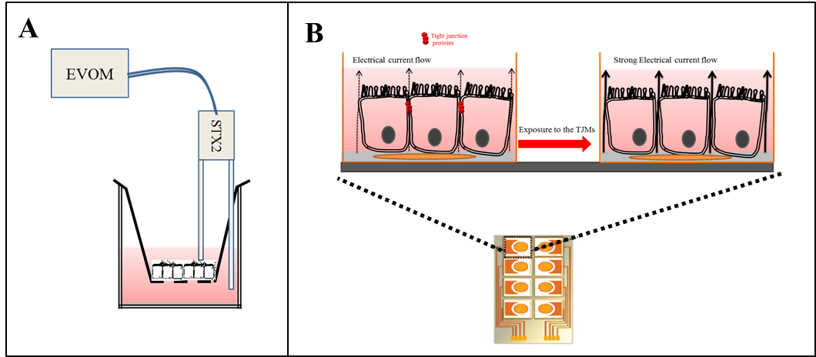
Figure 1- Schematic representation of Calu-3 cell grown in A- air liquid interface culture where TEER was measured using a chopstick ohmmeter. Cells were grown on the filter membrane and each stick of the electrode locates in the apical and basal compartments of the insert and silver coated electrodes measure the passing current and, B- Cell layer are grown to confluence on integrated gold electrodes (orange disk) in ECIS array. The alternative current (AC) will flow in the spaces under and between the cells, as the cell membrane are essentially insulators. Dilation in the tight junctions lets the AC current to flow between cells and the resistance will drop.

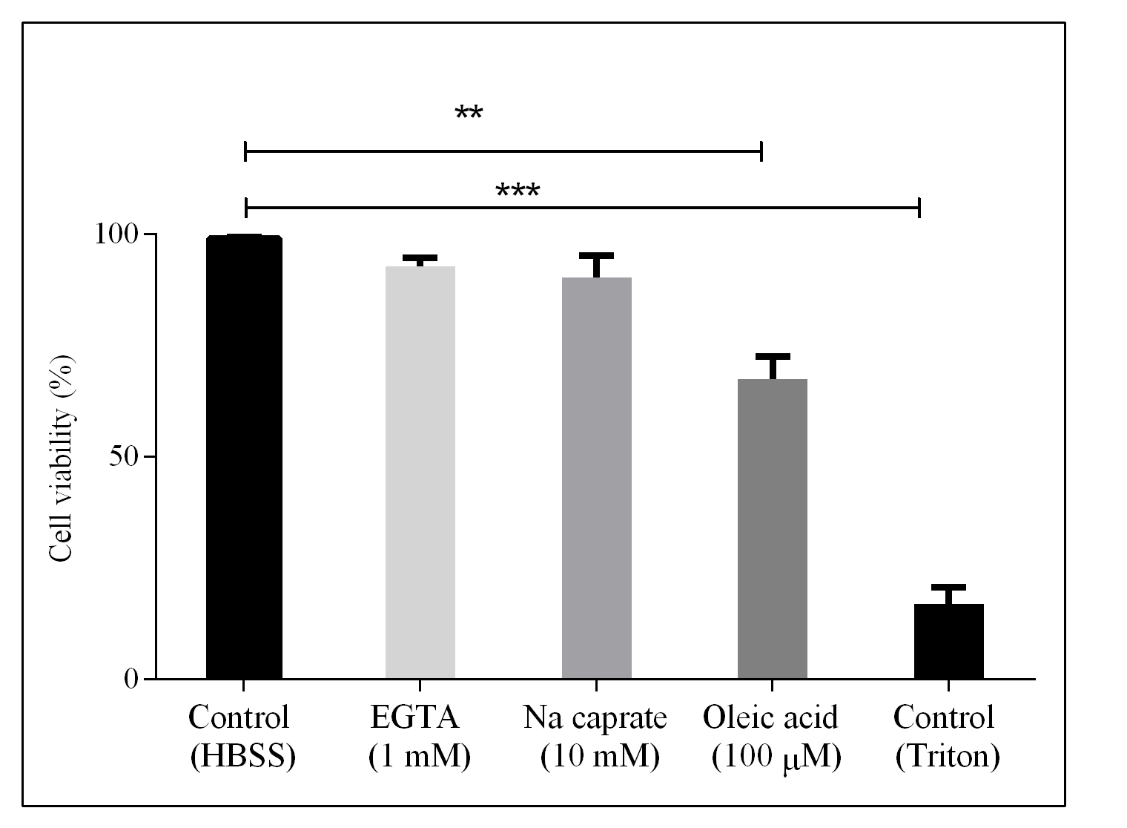
Figure 2- Viability of Calu-3 cells treated with TJMs for 24 hrs (n=3, ± SD), significant difference are defined with *** p<0.0001 and ** p<0.001. HBSS and Triton, negative and positive controls, respectively.
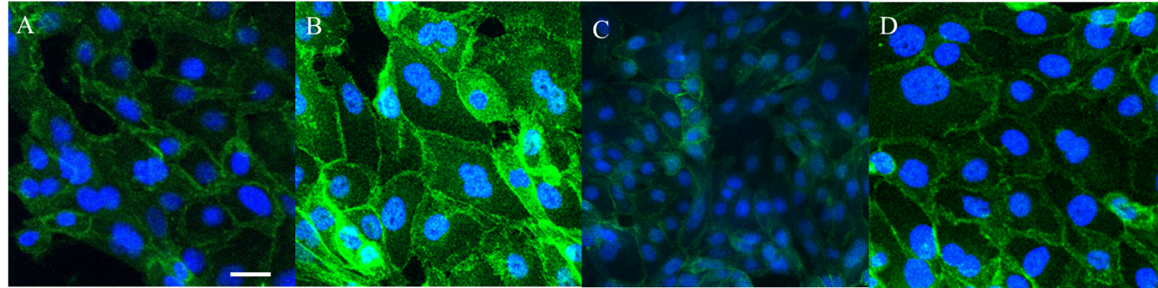
Figure 3- Immunofluorescence staining of Calu-3 cells with mouse anti ZO-1 Monoclonal Antibody - Alexa Fluor® 488 (Green colour), DNA is counter stained with DAPI (Blue colour). The effect of TJMs on ZO-1 localisation on Calu-3 cells were studied after 24 hrs incubation with: A) No treatment, B) EGTA, C) Oleic acid and D) Na decanoate. The bar represents 10µm.

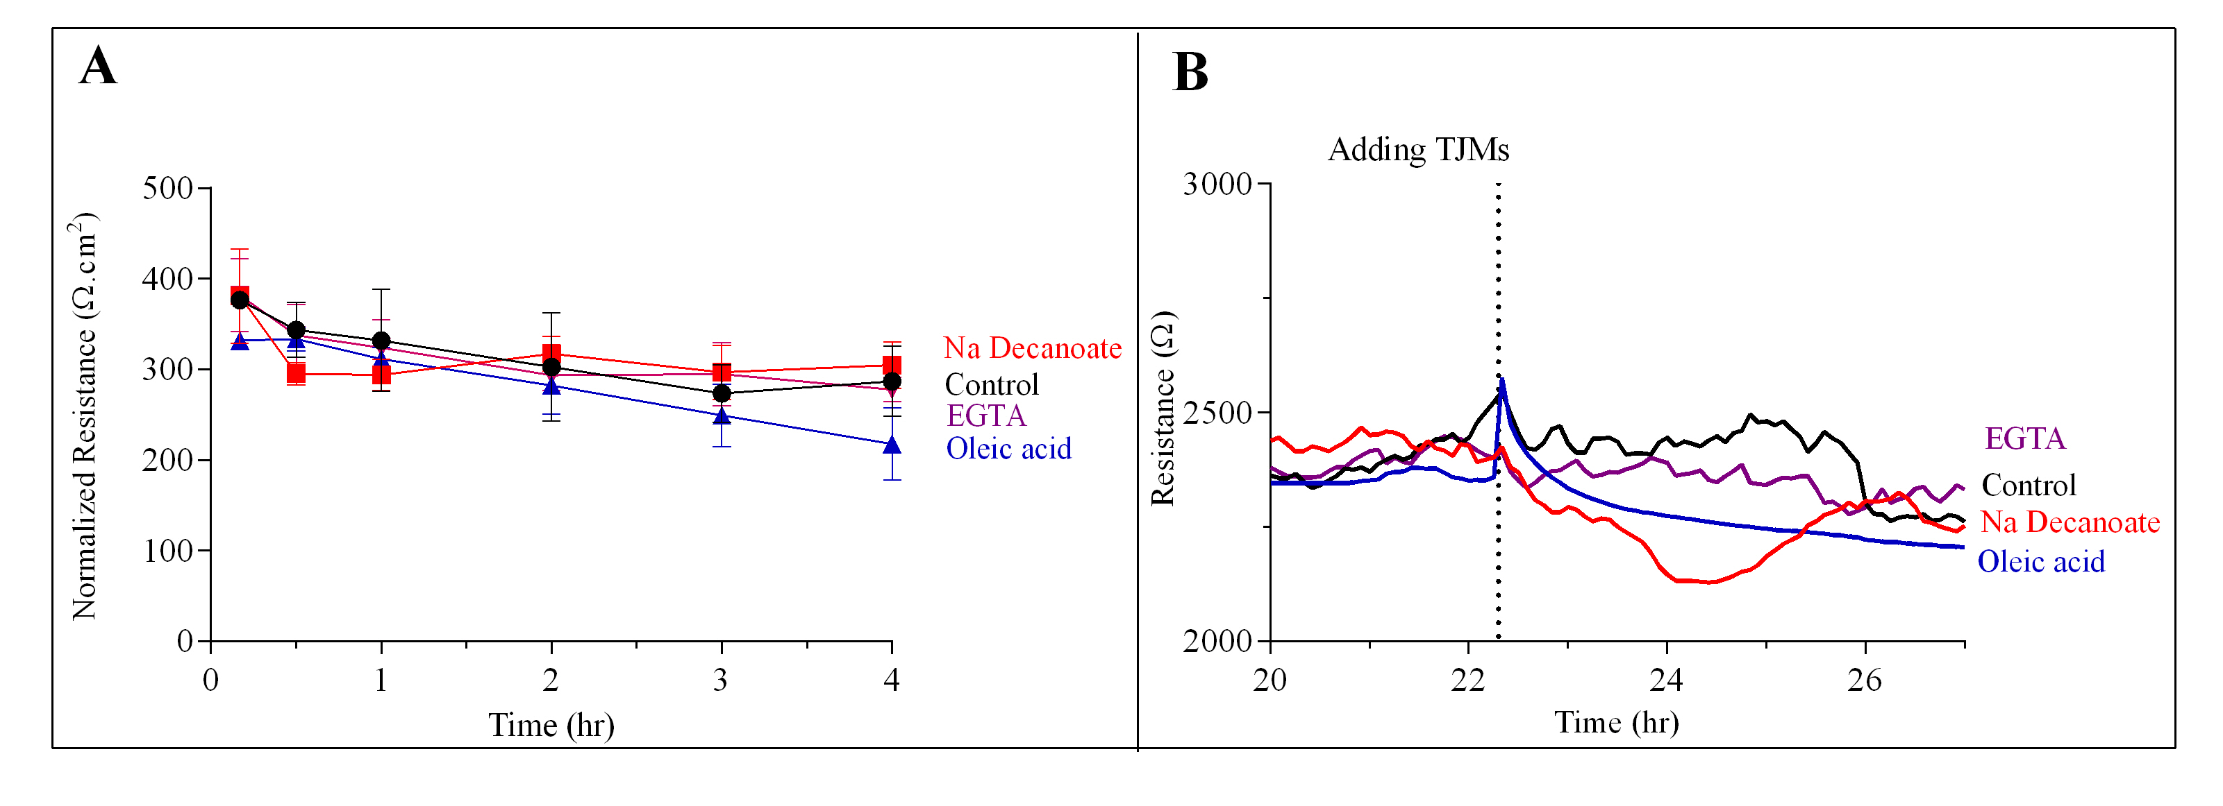
Figure 4- TEER values obtained after incubation for 4hrs with the TJMs using: A- a chopstick ohmmeter (n=3, ± SD); and, B- the ECIS technique.

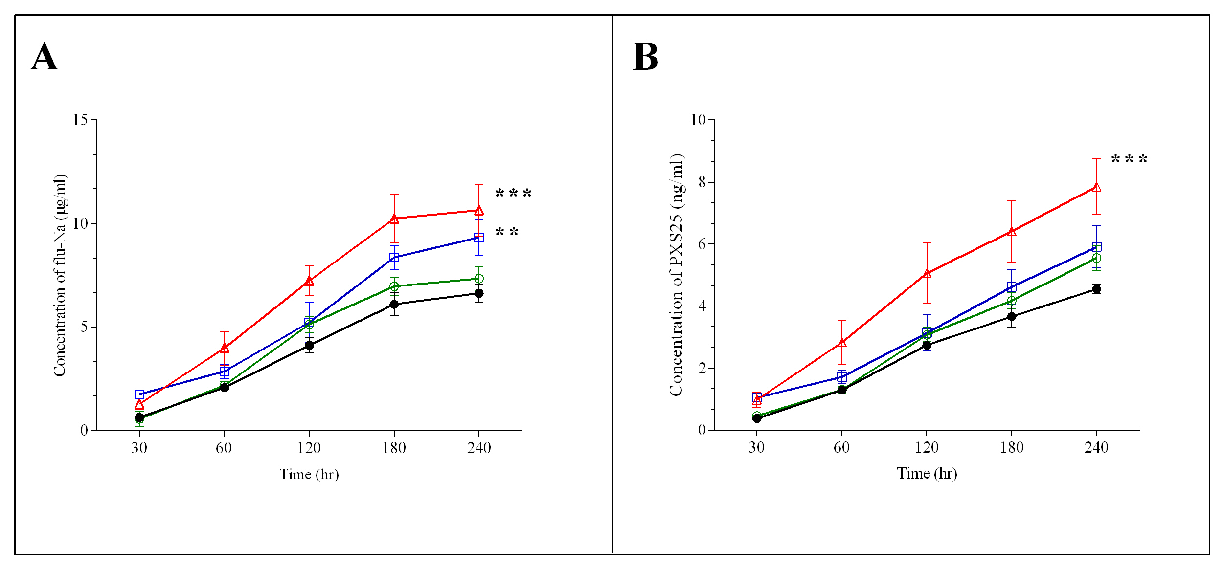
Figure 5- Transport across Calu-3 cells of: A- Flu-Na, B- PXS25 post treatment with TJMs; Black line (•) is Control, red line(▲) is Na decanoate 10 mM, blue line (□) is 100 µM oleic acid and the green line (○) is 1 mM EGTA. Data are expressed as means ± SD of three experiments. The significant difference presented as; *** is p<0.0001 and ** is p<0.001.

