A Study of Plot Ratio and Building Height Restrictions in Densifying Cities Using 3D Spatial Analysis Technology: A Case Study of Parramatta

Pernille Christensenª, Jian Guo^{b}

- School of the Built Environment, University of Technology Sydney
- Department of Building and Real Estate, The Hong Kong Polytechnic University
Abstract:

As urban areas continue to grow globally they face enormous challenges in terms of land supply. The City of Parramatta has been identified as a major growth area for the Sydney Metropolitan area. With a current population forecast for 2016 of 236,272, the City is forecast to grow to 397,339 by 2036, a 68.17% increase over 20 years (Forecast.id, 2016). Over the past 50 years, the City of Parramatta has seen a 72% increase of hot days (over 35 ºC), increasing from 7.4 days in 1967 to 12.7 days in 2015. Temperature impacts are therefore a significant planning factor that must be considered when evaluating future redevelopment proposals for the Parramatta CBD area. This study uses 3D GIS to simulate the impacts of various development densities on temperature and to demonstrate how the use of 3D technology can assist planners and developers in making better informed decisions. Three scenarios with different plot ratios and building heights were digitally simulated in the Parramatta Square mixed-use redevelopment area and compared to understand the urban heat implications of each scenario. Because the insolation factor (a measure of the solar radiation that reaches the earth's surface, measured by the amount of solar energy received per square centimetre per minute) can only be calculated using 3D models, this research offers an innovative approach to understanding how various redevelopment scenarios will impact the urban temperature of the area. Preliminary findings indicate that when the plot ratio and building height are increased, less ground area experiences long-hour sunlight exposure. Simultaneously, the percentage of the total area exposed to long-hour sunlight was decreased sharply. For urban areas experiencing severe heat and increased population growth, perhaps a re-evaluation of development patterns may help address some of the associated impacts.
Key words: 3D model, Parramatta, 3D spatial analysis, Plot ratio and building height
- Introduction

As urban areas continue to grow globally they face enormous challenges in terms of land supply. The City of Parramatta has been identified as a major growth area for the Sydney Metropolitan area, with an expected population growth 68.17% over the next 20 years. Significant steps have been taken to reconsider local planning regulations for the CBD area so that the City can better accommodate this anticipated increase in demand for residential units and office space. Among the key areas of concern for the Parramatta City Council is that the urban renewal strategy for of the CBD consider the impacts of climate change related temperature increases and urban heat island effect, which has increasingly impacted the City as temperatures continue to rise annually in Australia. It is anticipated that an urban resilience-focused approach will needed to address the likely impact of the increased urbanization and densification on the urban heat island effect of the CBD, understanding how new development will impact the temperature factor (insolation, solar radiation, and heat island). For this reason, the impact of new development of the temperature factor should be among the most important issues considered by the Council when assessing the redevelopment plans for the Parramatta area.
Although several studies have been conducted to explore the feasibility of increasing development intensity by assessing environmental impacts, infrastructure capacity and public consultation, these reviews and assessments were conducted using 2D Geographical Information Systems (GIS). Since the spatial distribution of land in the real world is three-dimensional, 3D GIS can help us investigate the world with a more accurate three-dimensional perspective and thereby make better informed decisions. This study aims to investigate the viability and impacts of minor relaxations of plot ratio and building height restrictions (PR/BH) for the Parramatta Square area based on the 3D models and using 3D spatial analyses, such as shadow effects and insolation factors.
Three scenarios with different PR/BH were digitally simulated and compared in this study. Insolation was simulated for each scenario to understand how new developments might impact the ground temperature for city occupants in each development scenario. Findings indicate that when the plot ratio and building height are increased, less ground area experiences long-hour sunlight exposure. Simultaneously, the percentage of the total area exposed to long-hour sunlight was decreased sharply. For urban areas experiencing severe heat and increased population growth, perhaps a re-evaluation of development patterns may help address some of the associated impacts.
- Background
Australia has one of the highest rates of urbanisation in the world, with 89.4% of its population living in urban areas in 2015. This represents an annual population growth of 1.2% in urban areas from 2010 to 2015 (The World Bank, 2016). The City of Parramatta is experiencing higher than average population growth, with a population of 203,183 in 2011, a current population of 236,272 in 2016, and is a projected population of 397,339 in 2036, a 95.56% growth over 25 years and 68.17% increase over 20 years, respectively, representing and annual growth rate of 2.72% (Forecast.id, 2016). Residential development forecasts for the City of Parramatta assumes that the number of dwellings in City of Parramatta will increase by an average of 3,275 dwellings annually, up to 157,294 dwellings in 2036. The distribution of these dwellings will vary by suburb, will an anticipate 328% increase in dwellings in the CBD (See Figure 1, below), and as high as a 1219387% increase in dwellings in the Sydney Olympic Park suburb (ibid, 2016).
The City of Parramatta has taken significant steps to accommodate this growth and anticipate the increased demand for residential units, as well as office space in which this population will work. Urban Growth has developed a Draft Parramatta Road Urban Transformation Strategy, which highlights particular redevelopment areas along the Parramatta Road corridor (which begins in Camperdown and finishes at the intersection with Woodville Road and Church Street in Parramatta) to improve the connection between the Sydney CBD and Parramatta CBD areas. The redevelopment of the Parramatta Road corridor will feed directly into one of Australia’s largest urban renewal projects, Parramatta Square. Parramatta Square is a 3 ha mixed use redevelopment precinct located in Parramatta CBD, bounded by Church, Macquarie, Smith and Darcy Streets. The aim of the Parramatta City Council is to transform the Parramatta CBD into “a vibrant mixed-use hub, accommodating a substantial new public domain with more than 240,000sqm of mixed-use development and new Council facilities.” An animation video of the proposed Parramatta Square development can be found here (City of Parramatta, 2016)
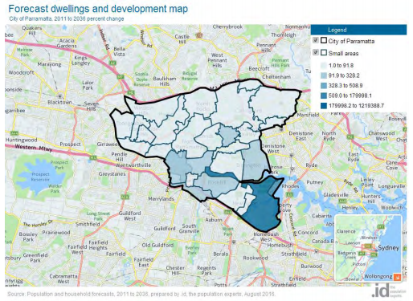
One of the key areas of concern for the Parramatta City Council is that the urban renewal of the CBD also offer possible solutions to the heat island effect, which has increasingly impacted the City as temperatures continue to rise annually in Australia. As noted by Councillor Tony Hadchiti, president of the Western Sydney Regional Organisation of Councils (WSROC), the "[u]rban heat is an issue for all cities, but western Sydney's unique geography and lack of sea breeze means the region is already much hotter than its eastern counterparts" (Cormack, 2016).
Figure 1: City of Parramatta Dwellings - % Change 2011- 2036 (Source: Forecast.id, 2016)
For the western suburbs of Sydney the number of hot days has increased by 60% over the period from 1970 to 2011; this increase is in part caused by the urban heat island effect and in part by the underlying increase in temperatures due to climate change. As of 2012, Parramatta experienced four times as many hot days as Sydney, up from three times as many in the 1970s (Steffen and Hughes, 2012). The Lord Mayor of Parramatta Cr Paul Garrard recently noted that, on average, “Parramatta experiences around thirteen days per year which are 35 degrees and over, compared to Sydney which averages around four,” (26 Nov 2015 press release). Trendline analysis of the temperature data confirms that there were 12.7 days above 35 ºC in 2015. When compared to 1967, when Parramatta experienced 7.4 days above 35 ºC, this represents a 72% increase in hot days from 1967 to 2015 in the Parramatta area. To put the severity of this increase in perspective, the City of Sydney CBD area experienced only 3.5 hot days in 2015, which means the Parramatta CBD has 3.6 times the number of hot days than the Sydney CBD in 2015.
With the scale of growth likely to exacerbate the urban heat island effect of the CBD, understanding how new development will impact the temperature factor (insolation, solar radiation, and heat island) in the CBS should be among the most important issues considered by the Council when assessing the redevelopment plans for the Parramatta area. This research investigates three different Plot Ratios/Building Height (PR/BH) scenarios for the development patterns of Church Street in Parramatta Square to understand how various development pattern decisions will impact the urban temperature factor. Insolation was simulated for each scenario to understand how new developments might impact the ground temperature for city occupants.
- Literature Review
The majority of studies exploring the feasibility of increasing development intensity have assessed environmental impacts, infrastructure capacity and public consultation; however, these studies were conducted using 2D Geographical Information Systems (GIS). With the rapid development of 3D GIS technology, a growing number of researchers are applying this technology to support various decision-making processes for urban development.
In urban planning, decision and policy makers are often faced with the problems of dealing with systems in which natural and human factors are interrelated and lack of realistic representations of reality. Ranzinger and Gleixner (1997) described that urban planners and architects have used 2D drawing plans and building elaborate models from wood and pasteboard to convey their ideas for decades. However, all these methods generally have some drawbacks, such as realistic impression, easy adaption to changes or simple comparison between different variants. Therefore, the old methodology could not meet the demand of more influence in planning processes, the advanced technologies (e.g. GIS and remote sensing) are highly necessary to be introduced in current stage. Over the past decade, efforts have been made to provide improved solutions in the form of 3D spatial analysis for urban settings. For example, Zhang et al. (2004) analyzed urban development issues based on 3D city models. They outlined a series of possible 3D spatial analyses, including visibility, flood, energy, solar panel, and air pollution. Similarly, Mak et al. (2005) used 3D GIS to construct, assess, and analyze the city skyline of Hong Kong. The results showed that 3D GIS is effective in implementing the recommendations of Hong Kong urban design guidelines, such as the measurement of building height and the visibility of ridgeline and skyline Some researchers focused on other issues, such as climate (Li et al., 2004) and urban routes (Thill et al., 2011). In addition, Leszek (2015) recently highlighted the technological trend of 3D spatial analysis for urban development.
Although these studies focused on applying 3D spatial analysis technologies to solve some of the issues in urban development, few studies have emphasized the issue of development control – the effect of relaxation of the maximum PR/BH constraints on the environment. Therefore, in our study, we will focus on the research of investigating the viability of minor relaxation of maximum PR/BH restrictions using 3D models and spatial analyses technology.
- Research Methodology
The framework of this study is presented in Figure 2. There were four main steps in this study. First, a 3D model of Parramatta was established based on the relevant information and available 3D spatial data. Second, 3D spatial analysis was conducted to assess the impacts of various scenarios in terms of Insolation. Third, based on three different Plot Ratios/Building Height (PR/BH) scenarios, a comparative study was conducted to evaluate how the relaxation of PR/BH would affect the surrounding areas and total sunlight changes. Finally, the discussion and conclusion should be addressed.
The 2D Map (Figure 3) & 3D model of the City of Parramatta CBD (Figure 4), as of April 2016, was provided by the Parramatta local government; this included the general footprint of all CBD buildings, overall height of buildings, and other related information. Because the City Council specifically identified the Church Street area as an area in transition, and one which they were particularly interested in understanding the impact of varying PR/BH allowances, this was the chosen for the study area. The current 3D model of the Church Street area is shown in Figure 5.
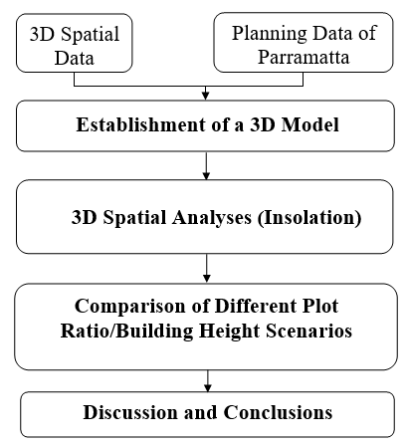
Figure 2: Framework of the study
3D Modeling
The final 3D model of the Church Street area was then overlaid onto a 2D map of the Parramatta CBD to offer context to the model (Figure 6). To compare with the impacts of the PR/BH restrictions, three scenarios with different PR/BH were built for the Church Street area.
- Scenario 1 (S1) (Figure 7) is the original plan according to the current 3D data
- Scenario 2 (S2) (Figure 8) is further increased by 20% for each building based on S1
- Scenario 3 (S3) (Figure 9) is further increased by 50% for each building based on S1
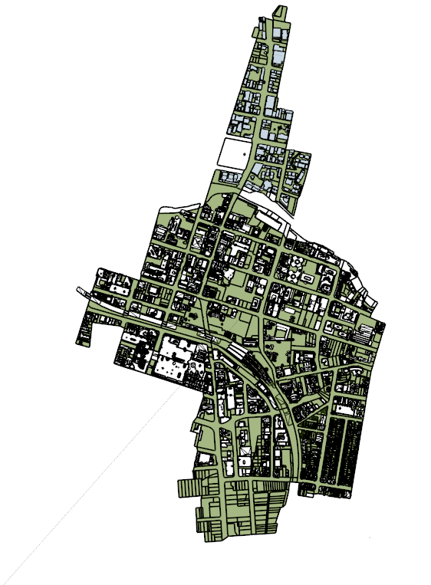
Figure 3: 2D map of Parramatta
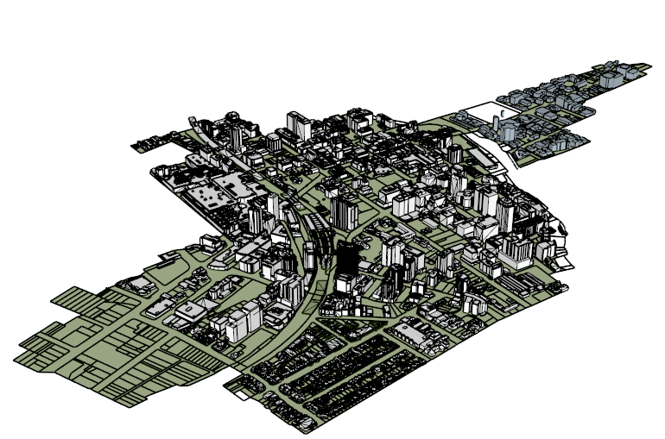
Figure 4: 3D model of Parramatta
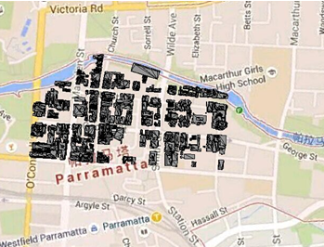
Figure 5: Overlay of 3D of Church Street model onto 2D Parramatta map

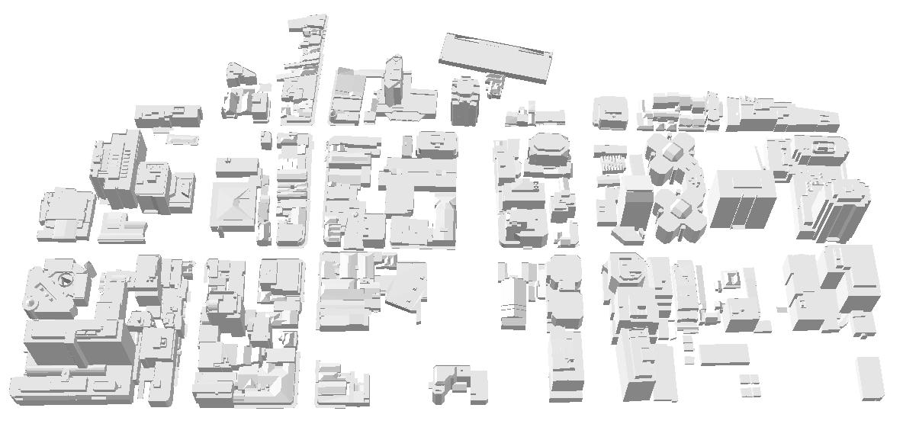
Figure 6: 3D model of Church Street (Part of Parramatta)
Figure 7: Scenario 1 (original plot ratio and building height)
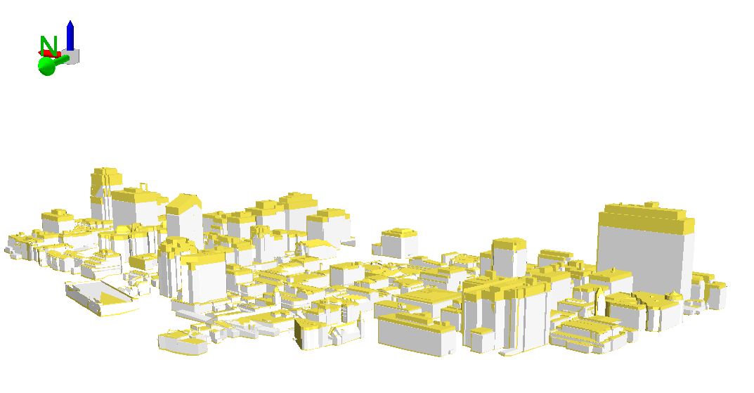
Figure 8: Scenario 2 with increased plot ratio and building height (20% increased yellow parts)

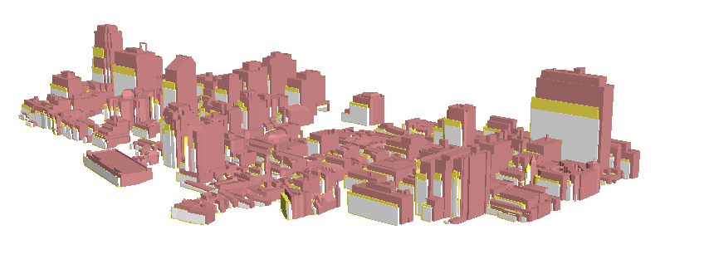
Figure 9: Scenario 3 with further increased plot ratio and building height (50% increased, red parts)

- 3D Spatial Analysis and Experimental Results
As part of electromagnetic radiation emitted by the sun, sunlight is visible during the day when the sun is above the horizon of the Earth. Sunlight altitude and azimuth can by simulated in 3D models (using Australia Bureau of Meteorology data input) to accurately represent how and from where building experience sunlight exposure on any given day of the year. Shadow areas are described as areas where the sunlight is obstructed by an opaque object. In 3D models, shadow areas can be simulated behind any 3D volume when a light is simulated in front of it. Shadow and sunlight hours are two important factors in environmental assessment for urban planning. Insolation is normally used to measure the distribution of sunshine duration in a particular area.
The effects of sunlight hours and the distribution of sunlight in summer, with minor relaxations of PR/BH, were compared using the following pairings of S2 versus S1, and S3 versus S1. With careful consideration, the Church Street area was chosen as the analysis region (Figure 10). The comparative analysis was based on the solar azimuth and altitude (20° was used as the setting in accordance to Parramatta’s location). Finally, the average sunlight hours per day and related locations were determined in summer for S1, S2, and S3 (Figures. 11-13). In addition, the shadow simulation for a chosen day, from the morning to evening, is presented in Figure 14.
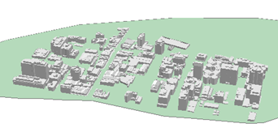
Figure 10: Analysis region with green for insolation analysis in summer
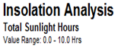
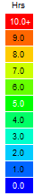
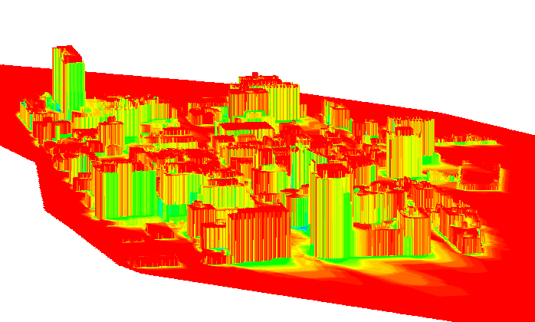
Figure 11: Results of average sunlight hours (enlarged with 1-meter resolution) per day in summer in S1

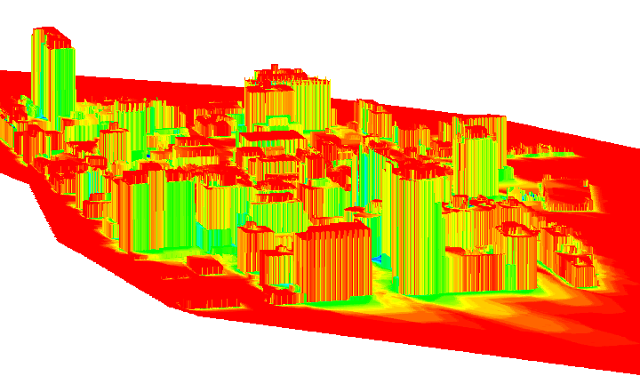
Figure 12: Results of average sunlight hours (enlarged with 1-meter resolution) per day in summer in S2
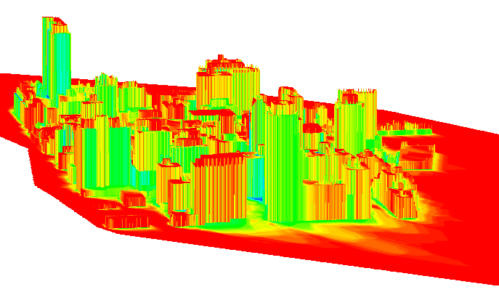
Figure 13: Results of average sunlight hours (enlarged with 1-meter resolution) per day in summer in S3
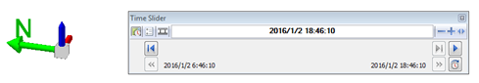
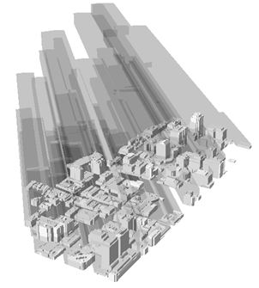
Figure 14: Shadow simulation
Table 1: Comparison of the distribution for the insolation during S1, S2, and S3
Hours | S1 | S2 | S3 | S2 vs S1 | S3 vs S1 | S3 vs S2
 | Percentage (%) | Percentage (%) | Percentage (%) | Percentage (%) | Percentage (%) | Percentage (%)
0-1 | 0.05 | 0.11 | 0.25 | 0.06 | 0.2 | 0.14
1-2 | 0.26 | 0.33 | 0.59 | 0.07 | 0.33 | 0.26
2-3 | 0.32 | 0.41 | 0.92 | 0.09 | 0.6 | 0.51
3-4 | 0.61 | 0.85 | 1.29 | 0.24 | 0.68 | 0.44
4-5 | 1.2 | 1.39 | 2.12 | 0.19 | 0.92 | 0.73
5-6 | 2.43 | 2.70 | 3.73 | 0.27 | 1.3 | 1.03
6-7 | 2.85 | 3.25 | 4.27 | 0.4 | 1.42 | 1.02
7-8 | 4.37 | 4.73 | 5.62 | 0.36 | 1.25 | 0.89
8-9 | 6.25 | 6.49 | 6.58 | 0.24 | 0.33 | 0.09
9-10 | 9.26 | 9.27 | 9.79 | 0.01 | 0.53 | 0.52
10-11 | 44.59 | 45.35 | 44.41 | 0.76 | -0.18 | -0.94
11-12 | 27.82 | 25.12 | 20.43 | -2.7 | -7.39 | -4.69

Table 1 compares Figures 12 and 13 to the base mode (Figure 11). When visually comparing the blue areas (which represent ground and façade areas catching sunlight hours for 0-2 hours) in Figures 11-13, it is clear that more areas are experiencing a shadow effect and receiving less exposure to directly hot summer sunlight. This is reinforced by the quantitative data captured in the model, shown in Table 1 as statistical representations, which indicate that there is an increase of up to 3% of areas experiencing direct sunlight less than 2 hours/day.
Similarly, as shown in Figure 13, the green areas (which represent ground and façade areas catching sunlight over the course of one full day is in the range of 4-6 hours) have also visually increased when compared to the base scenario represented (S1 in Figure 11). The trend is again reinforced by the quantitative capture of data as presented in Table 1, where the highlighted green rows indicate that in S3 the ground and façade areas catching 4-6 hours sunlight over the course of a single day have increased 13% and 10%, respectively, when compared to S1 and S2.
Conversely, the ground and façade areas catching sunlight more than 10 hours over the course of a single day decreases as the building height is increased. When the building height increased, more shadows are generated; therefore, the ground and façade areas experiencing long hours of direct sunlight exposure are decreased. This is particularly evident when looking at the red areas representing 11-12 hours of exposure. As seen in Table 1, S3 has almost a 74% reduction in ground and façade areas experiencing direct sunlight exposure for extended periods of 11-12 hours in a single day when compared to the base model, and also sees a significant decrease of almost 47% when compared to S2.
The ground and façade areas of the buildings (especially the side face) catching sunlight hours gradually decrease as the surrounding building heights are increased. The comparison of these models therefore indicates that the Parramatta CBD area could possibly benefit from the increased building height, as increased building heights may reduce the direct irradiation time of the sunlight resulting in correspondingly decreased temperatures in the CBD and immediately surrounding areas. The City Council should consider whether shadowing effect from buildings could be as one of series of tools to reduce experienced temperatures for residents and visitors of the Parramatta CBD area.
- Discussion and Conclusions
To probe the effects of minor relaxation of the maximum PR/BH restrictions of Church Street area, 3D modeling and simulation technology were applied. Shadow and insolation were considered, and the analysis of this factor was limited to the Church Street area in this study. The authors acknowledge that the limited area of this study may be considered a limitation of the study, and recommend that a broader spatial analyses related to urban heat island and other environmental factors should be investigated and applied in a larger study area, ideally the entire Parramatta CBD area, in the future. Furthermore, additional details of buildings, such as materials and colour, could also be considered in further studies as these also have the ability to impact spatial temperature.
In this study, 3D modeling and spatial analysis technology were used to conduct simulations based on 3D models. 3D models have been demonstrated to improve the public's understanding of the impact of developments in other countries, as they can provide more vivid visualizations than 2D GIS plans, which some community members may struggle to understand.
The effects of increasing the plot ratios and building heights on shadow and insolation for the Church Street area was successfully simulated and analysed for the three scenarios. The findings of insolation spatial analysis indicate that a minor relaxation of the maximum of plot ratios and building heights regulations would lead to the following conclusions.
- Summer conditions were considered for the Church Street area because of the extreme heat experienced in the City over recent years. Through shadow and insolation analysis, the average sunlight hours per day and corresponding percentages for different categories of sunlight hours were calculated, and the results were presented as figures and in a comparative table. A clear trend was identified which indicates that when the PR/BH was increased, the areas catching the shortest sunlight exposure (1-2 hours) were gradually increased, while the areas catching the longest sunlight exposure (10-12 hours) were significantly reduced.
- There was a dramatic drop of about 74% in areas catching 11-12 hours of direct sunlight per day, when compare S2 to S1, when the building heights were increased by 50% above the currently allowed height (S1). The decrease in direct sunlight exposure should also lead to correspondingly decreased temperatures in the CBD and surrounding areas.
- Compared to S1, additional gross floor area of commercial space, residential units or mixed-use space can be offered through the increased BH/PR scenarios in S2 and S3. This could help meet growing demands for office space and residential units as the City experiences growth in the following decades.
This study concludes that significant impacts can be identified related to the shadow and insolation effects under the three scenarios. The findings indicate that the government or the public could assess the environmental impact of land development density from a holistic view, and make effective and future-sighted decisions to improve the overall urban resilience of the City of Parramatta by testing potential development patterns using 3D simulation models and the results of 3D spatial analysis. Furthermore, the methodology proposed in this study can also be applied in other urban renewal cases or for new development areas in other densely populated cities.
- References:
City of Parramatta. (2016). Parramatta Square – A world-class civic heart. Retrieved 17. October, 2016 from: http://www.cityofparramatta.com.au/transformation/parramatta-square/
Cormack, L. (2016). Sydney area an 'urban heat island' vulnerable to extreme temperatures. Sydney Morning Herald. January 14, 2016. Retrieved 17. October, 2016 from: http://www.smh.com.au/environment/sydney-area-an-urban-heat-island-vulnerable-to-extreme-temperatures-20160113-gm4v14.html
Forecast.id. (2016). Population Forecasts: City of Parramatta. Retrieved 17. October, 2016 from: http://forecast.id.com.au/parramatta/home
Leszek, K. (2015). Environmental and urban spatial analysis based on a 3D city model. Computational Science and Its Applications, 9157, 633-645.
Li, W., Putra, S. Y. and Yang, P. P.-J. (2004). GIS analysis for the climatic evaluation of 3D urban geometry - The development of GIS analytical tools for sky view factor. Proceedings of GISDECO.
Mak, A. S.-H., Yip, E. K.-M. and Lai, P.-C. (2005). Developing a city skyline for Hong Kong using GIS and urban design guidelines. URISA Journal, 17(1), 33-42.
Ranzinger, M. and Gleixner, G. (1997). GIS Datasets for 3D urban planning. Computers, Environment and Urban Systems, 21(2), 159-173.
Steffen, W. and Hughes, L. (2012). The Critical Decade: New South Wales climate impacts and opportunities. Climate Commission Secretariat (Department of Climate Change and Energy Efficiency): Canberra. Retrieved 17. October, 2016 from: https://www.climatecouncil.org.au/uploads/111b148abf6c2b7e08e25cc5f6612fdc.pdf
The World Bank. (2016). The World DataBase: World Development Indicators. Retrieved 17. October from: http://databank.worldbank.org/data/home.aspx
Thill, J.-C., Dao, T. H. D. and Zhou, Y. H. (2011). Traveling in the three-dimensional city: applications in route planning, accessibility assessment, location analysis, and beyond. Journal of Transport Geography, 19, 405-421.
Zhang, X., Zhu, Q. and Wang, J. W. (2004). 3D city models based spatial analysis to urban design. Geographic Information Sciences, 10(1), 82-86.

Hot days are defined as days with temperature reaching over 35°C (Steffen and Hughes, 2012).

