**206 Bones of Gray: A Documentalist Perspective on X-Rays**

Bhuva Narayan

University of Technology Sydney, Australia

bhuva.narayan@uts.edu.au

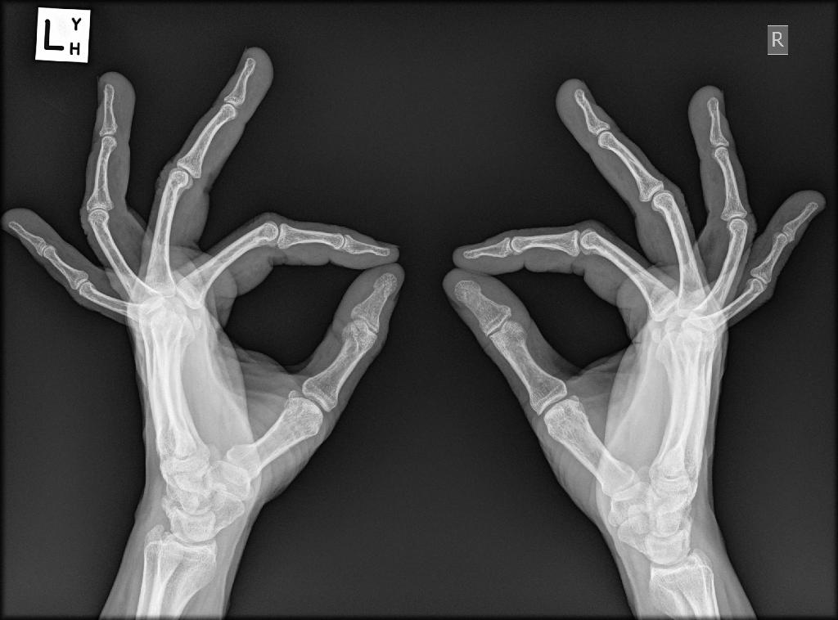

**Keywords:** X-ray as legal document, X-ray as medical evidence, illustrative documents, primary documents, supporting evidence, living documents

**Format:** Paper presentation (verbal with images, animated GIFs, videos, and paper handouts)

**Equipment:** Computer with projector

**Theme:** Historical persepctives on X-ray as medium and as documents through a documentalist framework.

**Paper Proposal**

*“I do not think that the doctrine that an ordinary photograph is the best evidence of what it contains should be applied to X-ray pictures. They constitute an exception to the rule concerning ordinary documents and photographs, for the X-ray pictures are not, in fact the best evidence to laymen of what they contain. ... The opinion of the expert is the best evidence of what they contain - the only evidence.”*

Marion v. Coon Construction Co. (1915)

X-ray images have come a long way from being a curiosity, and even being perceived as a hoax in the nineteenth century, to becoming a key tool in the advance of Science, Medicine, Astronomy, and even airport security, to being used as an artistic medium by several contemporary artists. Interestingly, long before X-ray technology existed, several pre-historic hunting cultures depicted animals by drawing or painting the skeletal frame and internal organs (Chaloupka, 1993), which brings to light the notion of X-ray imaging as just another ‘way of looking’ rather than a new ‘way of seeing’ (Swidersky, 2012).

X-rays, in their early days in the late nineteenth-century, were a matter of some contention as ‘documents of evidence’ in the legal profession, whilst also posing a challenge to the perceived authority of the medical profession; it is the developments in regard to the ‘legal document’ value of X-rays that eventually made them acceptable in the medical profession (Golan, 2004). Much of this legal debate was around the notion of whether X-rays were primary documents, or simply supporting illustrations for expert evidence. This paper is a discussion around the history of X-ray images but examines this history through the lens of the documentalist literature, and the notion of documents as surrogate artefacts, specifically in the context of X-ray images of the human body.

In parallel with the development and evolutions of X-ray imaging technologies, digital technologies have altered the way we create X-ray documents now. From being printed on plate glass, vinyl, and film, X-rays are now simply digitally ‘printed’ on a CD-ROM or DVD and stored as a digital file. Previously, an X-ray ‘print’ was an ‘original’ document that every patient was asked to hold on to for life, as no other copies existed. This was an important reference point to understand any future X-ray images, for the information was always in the difference between one X-ray and the next, rather than in any single image (e.g., tracking the progression of rheumatoid arthritis). The author was recently given one such a CD by the radiologist, and was surprised when the doctor who ordered it didn’t even bother to look at it, for she had already seen it in her e-mail. With a wave of her hand, she said, “You can keep it, it is a document of your body.” Nevertheless, now there are several copies of the X-ray image in various locations, although an original document was never created except fleetingly in the X-ray room. Or was it?

**References**

Golan, T. (2004). The Emergence of the Silent Witness: The Legal and Medical Reception of X-rays, *Social Studies of Science*, 34, 469-499.

Swidersky, R.M. (2012). *X-Ray Vision: A Way of Looking*, Boca Raton, FL: Universal Publishers.

Chaloupka, G. (1993) *Journey in Time: The World's Longest Continuing Art Tradition: The 50,000 Year Story of the Australian Aboriginal Rock Art of Arnhem* Land. Chatswood, N.S.W.: Reed.