Engineering the re-entrant hierarchy and surface energy of PDMS-PVDF membrane for membrane distillation using a facile and benign microsphere coating
Eui-Jong LEE^{1,2}, Bhaskar Jyoti Deka¹, Jiaxin Guo¹, Yun Chul Woo³, Ho Kyong Shon³, and Alicia Kyoungjin AN^{1*}

¹School of Energy and Environment, City University of Hong Kong, Tat Chee Avenue, Kowloon, Hong Kong, China
²Graduate School of Water Resources, Sungkyunkwan University, 2066 Seobu-ro, Jangan-gu, Suwon, Gyeonggi-do, 440-746, Republic of Korea
³ Centre for Technology in Water and Wastewater, School of Civil and Environmental Engineering, University of Technology Sydney (UTS), P.O. Box 123, 15 Broadway, NSW 2007, Australia

*Corresponding author: Dr. Alicia Kyoungjin An
Tel: + (852)-3442-9626, Fax: + (852)-3442-0688, E-mail: alicia.kjan@cityu.edu.hk

Abstract:
To consolidate the position of membrane distillation (MD) as an emerging membrane technology that meets global water challenges, it is crucial to develop membranes with ideal material properties. This paper reports a facile approach for a polyvinylidene fluoride (PVDF)-membrane surface modification that is achieved through the coating of the surface with poly(dimethylsiloxane) (PDMS) polymeric microspheres to lower the membrane-surface energy. The hierarchical surface of the microspheres was built without any assistance of a nano/micro composite, by combining the rapid evaporation of tetrahydrofuran (THF), and the phase separation from condensed water vapor. The fabricated membrane exhibited superhydrophobicity—a high contact angle of 156.9° and a low contact-angle hysteresis of 11.3°—and a high wetting resistance to seawater containing sodium dodecyl sulfate (SDS). Compared with the control PVDF-hexafluoropropylene (HFP) single-layer nanofiber membrane, the proposed fabricated membrane with the polymeric microsphere layer showed smaller pore size and higher liquid entry pressure (LEP). When it was tested for the direct-contact MD (DCMD) in terms of the desalination of seawater (3.5% of NaCl) containing SDS of a progressively increased concentration, the fabricated membrane showed stable desalination and partial wetting for the 0.1 and 0.2 mM SDS, respectively.
Keywords: membrane distillation; polymeric microspheres; electrospraying; electrospun membrane; superhydrophobic

1. Introduction
Membrane distillation (MD) is considered a versatile method that can be substituted for the existing membrane process, or combined with another process (or energy source), due to its unique features, i.e., a vapor-driven process based on low-grade thermal energy, and a lesser susceptibility to high salt concentrations.^{1–3} In addition, regarding the separation mechanism for the volatile matters that penetrate across the hydrophobic membranes, only MD is enabled for the effective removal of the substances, compared with the conventional membrane processes.⁴ With the increase of the steady and economical applicability of MD, membrane wetting is one of the key issues for MD, particularly when treating feed water containing surfactants that make feed liquid readily intrude into membrane pores.⁵ Among various membrane properties, improvement of membrane hydrophobicity is an effective approach to prevent the wetting that commonly decreases productivity through fouling.^{6–8} Several hydrophobicity- enhancement efforts have been conducted over the last two decades.^{9–12}
The commercial hydrophobic membranes for MD are mostly composed of polymers, such as polyvinylidene fluoride (PVDF), polypropylene (PP), and polytetrafluoroethylene (PTFE).^{12, 13} Due to the easy solubility characteristics, PVDF (or the PVDF copolymer) and polystyrene (PS) are ideal materials for the customization of membranes via phase inversion or electrospinning.^{15–18} The high porosity and low tortuosity of the hydrophobic membranes are fabricated using the promising and versatile electrospinning technique; also, the high roughness enhances the hydrophobicity.¹⁹ In spite of the PTFE properties that are the most hydrophobic, few membrane-fabrication studies have been carried out, because of its low electric conductivity, and the difficulty regarding its dissolution.^{19, 20}
However, the simple usage of a hydrophobic polymer in membrane fabrication is insufficient for the formation of a sufficiently hydrophobic membrane for the treatment of different kinds of wastewater, without abnormal wetting during the MD operation. Accordingly, abundant studies for the enhancement of the MD performance have been conducted to modify the surface morphology via the addition of a functionalized nanocomposite to a polymeric solution,^{22–24} or its attachment to prepared membranes.^{25–27} Other researchers attempted to add hydrophobic functional groups on the membrane surface to reduce the surface energy.²⁸ In particular, it is of importance to realize the Cassie-Baxter state,²⁹ considering a composite solid-liquid-air interface. In this condition, the contact angle is determined by the roughness and direct contact area between the liquid and the surface. The specific structure so-called re-entrant confers the solid surface with surprising liquid repellency by trapping air underneath the liquid, which can be possible even if the intrinsic properties of substances are not hydrophobic.³⁰ The re-entrant structure is beneficial to retard membrane wetting, as well as inflow of water vapor into membrane pores, due to the large area of the membrane in contact with air. Recently, an Elimelech research group explained an effect of different fluoroalkyl-chain lengths, with or without any morphologic modification, on the wetting resistance to low surface-tension liquids with dealing with re-entrant structure, and applied it to direct-contact MD (DCMD), using a synthetic wastewater containing different types of contaminant.^{30, 31} The application of the nanomaterial or chemical of a long fluoroalkyl chain is a useful method, but it can give rise to environmental problems.^{32, 33}
Herein, we report a non-fluorine polydimethylsiloxane (PDMS) polymer that is suitable for the fabrication of a tailored membrane for MD due to its low surface energy. While PDMS has been used widely for the formation of hydrophobic surfaces in other research areas,^{35–37} the employment of PDMS for the fabrication of an MD membrane is until now very limited, due to its low molecular weight. Combinations of nanoparticles,³⁸ or another polymer,³⁹ are typically adopted for hydrophobic MD membranes. With regard to membrane-surface modification for which PDMS is used with another polymer, it was recently reported that robust superhydrophobic fabrics were achieved via the squeezing of PVDF/PDMS-solution wetted fabrics with a scraping bar, and the subsequent placement of the fabrics into a non-solvent water.⁴⁰ Moreover, J. Park et al.⁴¹ and J. Gao et al.⁴² attained superhydrophobic surface modifications based on the principle of polymeric phase inversion by using electrospraying with polyimide and polymethylmethacrylate, respectively.
In the context of the previous studies regarding surface modifications for which the mixed polymer of PVDF/PDMS and electrospraying with another polymer are used, a straightforward PVDF/PDMS-based electrospraying technique can be a versatile method for the modification of the membrane-surface properties without additional inorganic materials or functional chemicals. Therefore, in this study, the fabrication of a tailored membrane for MD was attempted by preparing an electrospun membrane, followed by the coating of ragged polymeric microspheres with a mixture of PVDF and PDMS. The mechanism associated with the microspherical formation and its unique structure was elucidated through experimental investigations with different polymeric solutions and operating conditions. The wetting resistance of the fabricated membranes was evaluated according to the membrane characteristics and the DCMD operation, for which synthetic wastewater was used with the raising of the concentration of sodium dodecyl sulfate (SDS).

2. Materials and methods

2.1 Materials
To prepare the polymeric solution for the electrospinning and electrospraying processes, polyvinylidene fluoride-co-hexafluoropropylene (PVDF-HFP, M_{w} = 455,000 g mol⁻¹), polyvinylidene fluoride (PVDF, M_{w} = 530,000 g mol⁻¹), lithium chloride (LiCl), N-dimethylformamide (DMF), tetrahydrofuran (THF), and acetone were purchased from Sigma-Aldrich. Sodium dodecyl sulfate (SDS) with ACS reagent grade was used to control the surface tension of feed water. PDMS (Sylgard® 184) that is composed of a silicon-elastomer base and curing set (10:1 wt/wt), another polymer for electrospraying, was purchased from Dow Corning Corporation. A commercial PVDF (hereafter, C-PVDF) membrane (0.45 μm, HVHP) from Millipore Company was used as a reference membrane in the assessment of the MD performance.

2.2 Membrane fabrication
To fabricate the electrospun membrane that was used as the scaffold membrane for the microsphere-coated membrane, the dope solution was prepared by adding PVDF-HFP into the mixed solvent with N-dimethylformamide (DMF) and acetone with a small LiCl₂, followed by stirring at 70 °C until the polymer was dissolved completely for 12 h. The dope solution (PVDF-HFP:DMF:acetone = 15:59.5:25.5, wt.%) was degassed during the stirring under an ambient temperature, before it was employed in the electrospinning. The electrospun membranes were obtained through the accumulation of charged (16 kV) nanofibers on a collector (15 cm from the nozzle) with a flow rate of 0.7 mL/h. The electrospun membrane without the coating (hereafter, E-PH) was prepared by drying the detached membrane from the collector in an oven at 60 °C for more than one day. Table 1 shows that to prepare the dope solution for the electrospraying, the designated concentration of crosslinked PDMS by mixed precursor and curing agent (10:1 wt%) was dissolved in a mixed solvent with DMF and THF (1:1 wt.%) via a 1 h sonication, followed by a stirring at 80 °C for 4 h. A certain amount of PVDF, 1%, 3% and 5% (hereafter, E1, E3, and E5, respectively). was added to the completely dissolved 3% PDMS solution, and the PVDF/PDMS solution was stirred until the solution became homogenous. The prepared relatively low-concentration polymer solution was employed in the electrospraying process that was carried out directly on the prepared electrospun membrane with PVDF-HFP. Figure 1 shows such a simple fabrication process. The electrospraying operation conditions are a 14-kV voltage, an 8 cm tip-to-collector distance, and a 1.5 mL/h flow rate. The prepared PVDF/PDMS-coated electrospun membrane was dried in an oven to remove the remaining solvents. In this study, two kinds of coated membrane with well-formed polymeric microspheres were obtained through the use of a combination of 2% PVDF and 3% or 5% PDMS (hereafter, E-M3 and E-M5, respectively).
Table 1. Contents of dope solutions used for electrospraying.
Membranes | PVDF  (wt%) | PDMS  (wt%) | DMF  (wt%) | THF  (wt%)
PVDF-1% PDMS-3% (E1) | 1 | 3 | 48 | 48
PVDF-3% PDMS-3% (E3) | 3 | 3 | 47 | 47
PVDF-5% PDMS-3% (E5) | 5 | 3 | 46 | 46
PVDF-2% PDMS-3% (E-M3) | 2 | 3 | 47.5 | 47.5
PVDF-2% PDMS-5% (E-M5) | 2 | 5 | 46.5 | 46.5

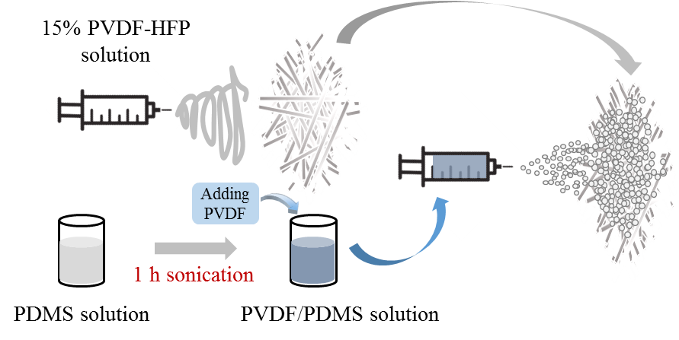
Figure 1. Fabrication process of the polymeric-microsphere-coated membrane.

2.3 Membrane characterizations
Scanning electron microscopy (SEM), Fourier transform infrared spectroscopy (FTIR), and X-ray photoelectron spectroscopy (XPS) techniques were employed to analyze the physicochemical properties of the membrane surface. The surface morphology of the completely dried membranes with the gold coating was visualized by EVO MA 10 (Zeiss, Germany) scanning electron microscopy at an accelerating voltage of 20 kV. The chemical composition of the membrane surface was examined by XPS (PHI-5802, Physical Electronics) and FTIR (IRAffinity-1, Shimadzu). Regarding the FTIR, the attenuated total reflectance (ATR) mode was used, due to the thickness of the membranes. The surface roughness and topography was measured by an optical profiler for 3D surface height measurements of precision surfaces (Wyko NT9300, Vecco, USA).
The pore-size distribution was measured using a calculation with a Young-Laplace formula, for which the data from a capillary flow porometer (POROLUXTM1000, Germany) were used, based on the displacement of a wetting agent (POROFIL, surface tension 16 mN/m). During the application of pressure on the membrane samples covered with water in the same equipment, the highest pressure immediately before the water infiltration was regarded as the liquid entry pressure (LEP) of a water-repellence indicator, like that of the authors’ previous study.⁹ The contact angles and the contact-angle hysteresis were measured using a geometrical method (sessile drop), for which a drop shape analyzer (DSA 100, Kruss, Germany) was used. During the measurement of the advancing (receding) angles, a sharply pointed needle was used to position the needle at the center of the water droplet; regarding the use of the original needle, the water droplet easily moved to the other side, due to the hydrophobic membrane surface, and the surface tension of the droplet. The membrane porosity was calculated by using the weight difference between the completely wetted membrane with 1-butanol and the dry membrane with the material densities of wetting solution and the polymer. The membrane thickness was measured using Digital Calipers (Mitutoya, U.S.A.). All the measurements regarding the membrane properties were in triplicate.

2.4 Direct-contact membrane distillation (DCMD)
The DCMD test was performed using custom-made lab-scale equipment that was composed of a feed (permeate) container, gear pumps, flow meters, and a temperature controller. The feed (60 ± 0.5 °C) was initially filled with 3 L of a 3.5 % NaCl solution containing 0.1 mM SDS, and the SDS concentration was increased by 0.1 mM at 4 h intervals. The reduced feed quantity was supplemented with deionized water (DIW) every 4 h with the additional SDS. The permeate container (20 ± 0.5 °C) with 1.5 L of DIW was placed on an electronic balance that was connected to a computer. The electrical conductivity and the vapor permeability were obtained from a permeate-submerged conductivity probe, and the amount of permeate stored in the container was changed. The effective membrane area was 9.8 cm², and all of the tubes were insulated to minimize the heat loss and the temperature fluctuation.

3. Results and Discussion

3.1 Morphology and formation mechanism of the PVDF-co-PDMS microspheres
3.1.1. Polymer concentration for the formation of microspheres
Under the application of the suitable voltage to the metallic nozzle, a charged polymeric solution emerged from the nozzle, and was placed in an electrical field that is subjected to electrostatic repulsion and coulombic force. Subsequently, the formation of the polymeric fibers or particles is determined by the degree of entanglement, which is influenced by the concentration and the molecular weight of the polymers. In the two kinds of polymer mixture, the PVDF played the roles of an entanglement controller and an electrospraying inducer, due to its large polymeric chains and electric conductivity compared with those of the PDMS. The low polymeric-solution concentration that departed from the nozzle was not converted to nanofibers, but a number of droplets were formed by the repulsive force between the positively charged polymer molecules because of the low entanglement of the solution, which could not enable the fabrication of nanofibers.
Under the application of the PDMS solution in the electrospraying, polymeric microspheres are not evident in the SEM imagery, in spite of the high PDMS concentration (20%), so the hydrophobic surface could not be expected. In consideration of the previous study wherein another polymer was added into the PDMS to create well-formed nanofibers, it is implied here that the PDMS entanglement was deficient, not only for the nanofiber fabrication, but also for the fabrication of the polymeric particles.⁴³ However, in this study, a large amount of the PVDF was not required for the formation of the polymeric particles, and therefore the minimum PVDF quantity for the maintenance of small polymeric droplets in the electrical field is regarded as an optimal dosage. Various surface morphologies can be seen in Figs. 2 (b)–(d), depending on different PVDF concentrations (E1, E3, and E5). Regarding the E1 (PVDF-1% PDMS-3%), the electrospun membrane was covered with a ragged polymeric layer without pores. With a small amount of PVDF addition, the polymeric particles could be formed during its flying over the electrical field, but the preservation of the microspherical shape is not possible, due to the collision against the collector. Unlike the E1, various sizes of the irregular-shaped beads with a smooth spherical surface were observed through the increasing of the PVDF concentration by 3% (E3), and a number of inter-bead thin fibers were also observed. With the increase of the PVDF concentration up to 5% (E5), the size and number of the beads were decreased, and the film formation exhibited a characteristic of the electrospinning process through the use of a low PVDF concentration.⁴⁴ In addition, no structure that was favorable to the enhanced hydrophobicity in the bead surface (i.e., wrinkled patterns or nano-sized bumps) was found. Such a different surface morphology is likely due to the polymer entanglements that are elucidated in the subsequent explanation regarding the formation mechanism of the microspheres, and their surface morphology.
The polymeric mixture is composed of PVDF and PDMS that could be well dissolved in DMF and THF, respectively; that is, both solvents are miscible with each other. During the movement of the polymeric droplets, THF evaporated rapidly compared with DMF, owing to its high volatility; therefore, THF molecules migrated toward the microspherical surface immediately with PDMS molecules, because PDMS could only be dissolved in THF. Due to the miscibility between DMF and THF, it is possible for a small PVDF portion to move to the surface region, which is confirmed via the surface chemical-composition analysis in Section 3.2.
With its influence on the interfacial behavior, the solvent-evaporation rate is one of the crucial factors in the determination of the surface morphology with an influence on the interfacial behavior. During the evaporation of THF, the PDMS molecules could not congregate for the formation of a uniform surface morphology due to an insufficient time frame, and in consideration of the short polymeric chains of the PDMS, and the fast evaporation rate of the THF. With regard to the polymeric entanglements, a relatively smooth bead surface was observed with the increasing of the PVDF concentration of the long polymeric chains (Figs. 2 (c) and (d)); this is because the polymeric entanglements are sufficiently large to recover the uniform distribution. Furthermore, the solvent evaporation induced a cooling effect on the surface region, allowing the water-vapor molecules in the atmosphere to be condensed on the microspherical surface. Phase separation occurred due to the condensed water vapor, and the migration of the non-solvent DMF to the PDMS combined with the interfacial instability caused the ragged morphology on the microspherical surface. Figure 2 (a) shows a schematic of the unique surface morphology of the microspheres that formed near the nozzle that occurred during the traveling process.
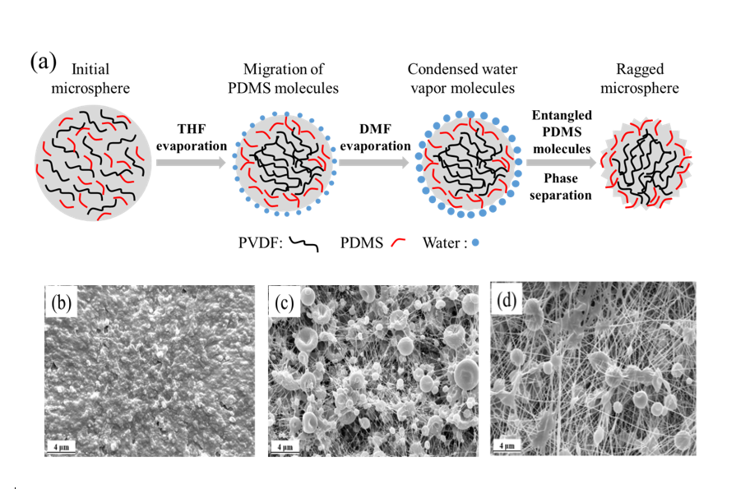
Figure 2. (a) Schematic of the formation of the ragged polymeric microspheres. SEM imagery of the electrospun membranes that were coated by means of the electrospraying with: (b) E1 (PVDF-1% PDMS-3%), (c) E3 (PVDF-3% PDMS-3%), and (d) E5 (PVDF-5% PDMS-3). The humidity during the operations is from 55% to 60%.
To closely examine the roughness of a large sample area (88.8 μm × 66.4 μm) of precision surfaces in 3D, Supplementary Fig. S1 shows the optical profile images that were obtained. The E-M3 (R_{a}: 1,260 nm) and E3 (R_{a}: 1,110 nm) membranes exhibit a rougher surface than that of E1(R_{a}: 933.85 nm) and E5 (R_{a}: 920.46 nm) due to microspheres formation. The colors matching the surface height were visualized in the order of red > green > blue.
3.1.2 Solidification under the low humidity
Interestingly, the well-formed microspheres with many bumps could not be obtained under a relatively low humidity (less than 40%), despite the suitable polymeric entanglements, such as E-M3 (i.e. PVDF-2% PDMS-3%). Primarily, the formation and the mechanical stability of the polymeric microspheres were predominantly affected by the polymeric entanglement. However, despite the fact that low humidity could accelerate the rate of solvent evaporation, due to a relatively small amount of water vapor supposed to be condensed on the microspheres, the well-formed microspheres could not be obtained under a relatively low humidity. Figure S2 shows that the solidification is dominant for the retention of the microspherical shape, after the collision of microspheres against the collector.

3.2 Morphology and chemical composition of the microsphere-coating membrane surface
In the previous section, the formation of the well-formed microspheres with bumps on the surface was elucidated through the contributions of PVDF concentration and the humidity. Figure 3 (a) shows that such hierarchically structured microspheres were obtained in the polymeric condition of PVDF-2% PDMS-3%. Considering the lower surface energy of PDMS compared with the PVDF,⁴⁵ it was expected that an increase of PDMS concentration would be beneficial to water-repellent properties for the anti-wetting of the membrane; however, with the increasing of PDMS concentration to 5% (E-M5), the bumps on the microsphere disappeared, or the wrinkled pattern became vague. As mentioned in the previous Section 3.1, the surface morphology of microspheres was determined by the interfacial behavior and the migration of PDMS molecules to outer layer of microspheres resulting from solvent evaporation. Therefore, during the evaporation of THF, the higher concentration of PDMS allows denser and bigger microspheres leading to smooth surface, rather than winkled pattern with bumps on the microspheres.
In addition, the size of the microsphere of E-M5 was found larger and uniform (1.99 ± 0.21 µm) compared to that of the E-M3 (1.47 ± 0.33 µm) using Image J (NIH, USA), which is attributed to the increased entanglement. At the coating conditions of the PVDF-3% PDMS-3% (Fig. 2 (c)) and the PVDF-2% PDMS-5% (Fig. 3 (b)), 1% of PVDF and 2% of PDMS were increased, respectively, compared with the PVDF-2% PDMS-3%. While a large bead size with a smooth surface morphology and inter-bead linked nanofibers were formed at the former, less-wrinkled patterns and partially linked microspheres were observed at the latter, this is because, compared with PDMS, the longer polymeric chain of PVDF could impact the total entanglement more significantly, albeit with a small addition.
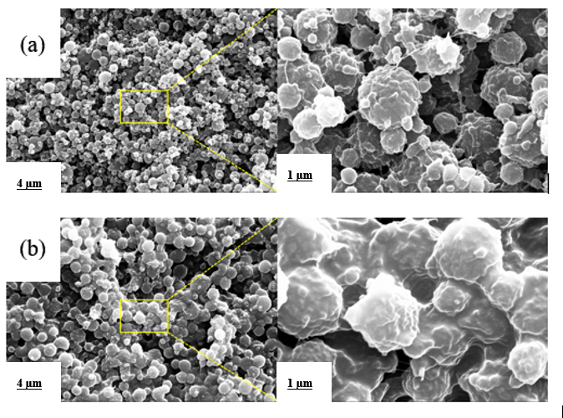
Figure 3. SEM imagery of the electrospun membrane coated with the micropheres using: (a) PVDF-2% PDMS-3% (E-M3), and (b) PVDF-2% PDMS-5% (E-M5). The humidity during the operations is from 55% to 60%.
Figure 4 (a) of the FTIR analysis shows that the surface layers of the three kinds of membrane reveal PVDF characteristics that are composed of the chemical compositions of C-H and C-F due to the electrospinning (or elestrospraying), for which the PVDF copolymer and the mixture of PVDF and PDMS were used. The stretching vibration of the C-H bonds, the symmetrical stretching of the C-F bonds, and the skeletal vibration of the C-C bond were observed at the peaks of 1,400, 1,168, and 877 cm⁻¹, respectively, in all of the membranes.^{46–48} Further evidence of PVDF, the crystallization-induced β phase, was confirmed at the peak of 840 cm⁻¹. Regarding the E-M3 and the E-M5, the PVDF-associated peak intensities were alleviated, which is attributable to the dilution from the addition of PDMS. Instead, both membranes had multi-component peaks in the region from 1,000 to 1,100 cm⁻¹, and the obvious peak at around 800 cm⁻¹ corresponds to the Si-O-Si stretching and the Si(CH₃)₂ rocking.^{48, 49} Another characteristic peak of PDMS was shown between 1,240 and 1,280 cm⁻¹ attributed to Si-CH₃ deformation, which was more obvious in the E-M5 as the peak of 800 cm⁻¹.⁵⁰ Due to a large portion of fluorine in PVDF-HFP, XPS spectra of the E-PH showed a quite-strong F1s peak, and a small C1s peak. In the cases of the E-M3 and the E-M5 that were coated by the mixture of PVDF and PDMS, a relatively intensive O1s peak was evidence of the Si-O-Si bond compared with the E-PH,⁵¹ and a new Si2p peak that could be deconvoluted into the two components of the Si-C and the Si-O was exhibited;⁵² however, in spite of the addition of PVDF, an F1s peak did not appear. Considering the XPS focus on the surface chemical-composition analysis, this result was in line with the depiction of the microsphere-formation mechanism that is associated with the migration of PDMS molecules.
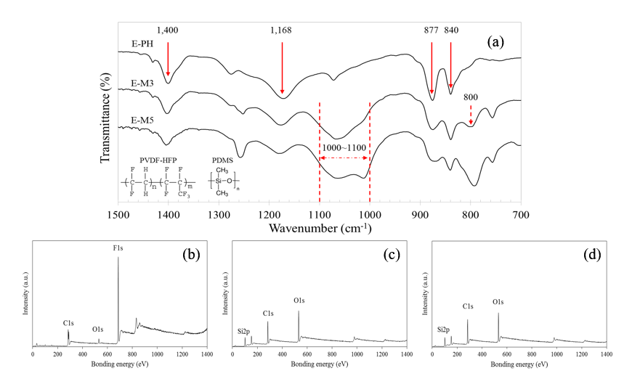
Figure 4. (a) FTIR spectra of the electrospun membrane without (E-PH) and with the micropheres using PVDF-2% PDMS-3% (E-M3) and PVDF-2% PDMS-5% (E-M5). XPS spectra of: (b) E-PH, (c) E-M3, and (d) E-M5.

3.3 Hydrophobic property
Compared with the phase-inversion-fabricated commercial membrane, the electrospun membrane showed a relatively high contact angle (141.1°) due to the unique nanofiber structure, thereby resulting in a high roughness value.⁵³ However, the size of the space formed by the nanofibers and the intrinsic chemical properties of the polymer were not appropriate for the exhibition of a superhydrophobic surface (higher contact angle than 150°). Regarding the membrane-coated microspheres, although the mixture of PVDF and PDMS was used for the formation of the polymeric microspheres, their surface was mainly composed of PDMS, whose surface energy is lower than that of the PVDF. Moreover, the voids of the three phases (i.e., solid, liquid, and vapor) that face each other were formed among the microspheres, or on their ragged surface. Consequently, the coated membrane presented a high contact angle. Compared with the E-M3, the hydrophobicity of the E-M5 diminished despite the high portion of PDMS, due to the fact that the previously mentioned void structure disappeared or decreased.
Figure 5 shows that the advancing angles of each membrane were slightly higher than the corresponding contact angles; this is because, while the contact angle was measured by dropping 0.5 μL of water, the advancing angle with the maximum volume of approximately 15 μL was measured without increase of the three-phase line during the gradual water injection. The receding angle was determined by the interfacial behavior between water and membrane surface. In the case of the E-PH, the empty space on the surface was already filled with water in the contact area, so that the minimum contact angle that was formed during the pulling of the water through the needle was lower than 90°. Alternatively, the unique surface structure of the E-M3 conferred a small gap between the advancing and receding angles that resulted from a non-wetting Cassie state. During the continuation of the water withdrawal, the contact area between the water droplet and the membrane surface was reduced, and finally the remaining water droplet jumped toward the needle (Fig. 5 (d)), which means that the adhesive force among the water molecules was stronger than that between the water molecules and the polymeric membrane surface. Considering the SEM imagery of Fig. 3 (b) and the advancing (receding) angles, the E-M5 membrane surface seems to be in an intermediate state between Wenzel and Cassie states. The disappearance or ambiguity of the bumps on the microspheres allowed the water molecules to partially intrude into the void (air pocket) that formed on the microspherical surface, which resulted in a relatively small receding angle compared with that of the E-M3. Consequently, even with its superhydrophobicity, the E-M5 did not display water-droplet jumping.
Higher CA values in the order of E-M3 > E-M5 > E-PH were consistent even with the contact angle of SDS (Table 2). This implies that the produced membrane has the potential to repel low surface tension liquid, such as SDS.
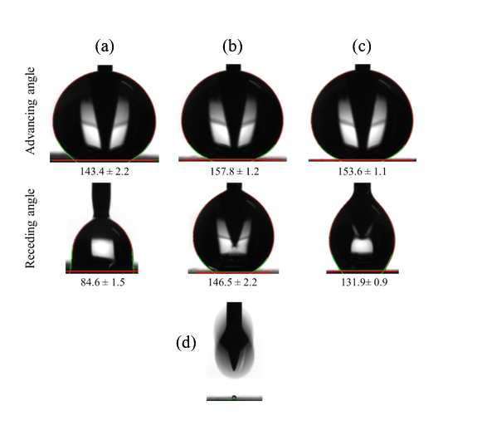
Figure 5. Contact-angle hysteresis of (a) neat electrospun membrane (E-PH) and coated membrane with micropheres, using (b) E-M3, and (c) E-M5. (d) Droplet movement at the end of the process that decreased the volume of the water droplet.

3.4 Other membrane properties
In the measurement based on the capillary-flow porometry, while similar mean-pore-size values were shown in the commercial membrane and both microsphere-coating membranes, the C-PVDF that was made by the phase-inversion method exhibited the smallest maximum pore size, which considerably influences the LEP. In a comparison of the electrospun membrane with and without the microspherical coating, the mean pore size of the electrospun membrane was decreased by more than 20% after the microsphere-coating process. When the electrospraying was employed on the membrane, the membrane still contained a certain amount of solvent, and this means that the pore that resulted from the interconnected fibers could easily be affected by a collision of the polymeric microspheres. Moreover, the upper layer composed of numerous microspheres can confer different spatial properties from the nanofiber-formed void. The various sizes of the E-M3 microspheres are beneficial for the dense structure (small pore size), compared with the relatively large and uniform size of the E-M5. The similar mean pore size of the E-M5 seems to be allowed by the linked structure between the microspheres. Commonly, the pore size of the electrospun membrane is primarily determined by the polymeric concentration. Polymeric-microsphere coating is another method that can be applied to control the membrane pore size with the improvement of the surface hydrophobicity of the membranes. Also, the surface layer of the microspheres is attached firmly on the membrane, due to the incompletely evaporated polymeric microspheres.
Table 2 shows that the electrospun membrane revealed a much larger porosity than the commercial membrane that was fabricated based on the phase inversion; however, after the microspherical coating, the porosity was reduced, but it was still larger than that of the commercial membrane. The polymeric microspheres of the electrospraying contain a large amount of solvent, compared with those of the normal electrospinning. The pressure occurs when the heaviness of the microspheres that bump against the prepared electrospun membrane is sufficient to compress the membrane. The flexible structure of the accumulated nanofibers that needs more time for the solvent evaporation was easily modified by such a microspherical collision.
Table 2. Characteristics of the commercial and prepared electrospun membranes
Code | Mean pore  Size (µm) | Thickness  (µm) | Porosity  (%) | LEP  (kPa) | Water Contact  angle (º) | SDS Contact  angle (º) | Initial flux*  (L/m²/h)
C-PVDF | 0.42±0.02 | 100±1 | 59.2±0.7 | 111.0±1.5 | 117.9±1.6 | 43.7±1.9 | 20.7
E-PH | 0.53±0.02 | 82±4 | 89.5±0.3 | 87.5±2.2 | 141.1±0.9 | 78.2±2.5 | 37.2
E-M3 | 0.40±0.05 | 86±2 | 77.2±0.5 | 104.1±4.2 | 156.9±3.2 | 128.1±2.7 | 31.5
E-M5 | 0.40±0.03 | 84±2 | 72.4±0.5 | 107.0±1.6 | 153.8±2.1 | 119.7±3.6 | 28.8
* Initial flux was calucated as an average value of the first 30 min of experiment
Theoretically, the LEP is determined by the geometric structure of the pores, the liquid surface tension, the liquid/solid contact angle, and the maximum pore size.⁵⁴ Although the contact angle of the C-PVDF was the lowest, the largest LEP value was observed, due to the small maximum pore size. Compared with the E-PH with the lowest LEP that resulted from the largest maximum pore size, the LEPs of both microsphere-coating membranes were significantly enhanced, because the pore size was controlled, in addition to the considerable improvement of the surface hydrophobicity. When the 0.3 mM SDS solution was used for the LEP measurement, the LEP values of the C-PVDF, E-PH, and microsphere-coating membranes (E-M3 and E-M5) were decreased by approximately 19%, 15%, and 10%, respectively. Such different LEP drops are attributed to the different polymers and morphologies of the membrane surface. The cylindrical morphology of the nanofibers in the E-PH is more resistant to the intrusion of the lower-surface-tension liquid, compared with that of water, due to the high contact angle. In particular, in both the E-M3 and the E-M5, the microspheres whose surface mainly consists of the PDMS with small bumps are fairly efficient in preventing the LEP drop.
However, the microsphere-coating membrane did not possess hydrophobicity against low-surface-tension liquids, such as oil and ethanol. As seen in the comparison of the omniphobic and prepared membranes (Fig. 6), both of the membranes showed water-repellent properties due to the intrinsic high contact angles (θ₁ and θ₃) of the fluoroalkyl-silane coating layer and PMDS. When a low-surface-tension liquid like oil or ethanol is employed, the contact angles (θ₂ and θ₄) are lower than the water contact angles (θ₁ and θ₃). Regarding Fig. 6 (a), the spherical type of nanoparticle that is coated with fluoroalkyl silane is favorable to the re-entrant topology, so that the omniphobicity was possible, despite the lower contact angle (θ₂ < θ₁), which means the air pocket can be retained.⁵⁵ In contrast, the bumps on the surface of the microsphere-coating membrane exhibited a hemispherical shape with a larger size compared to the nanoparticle. Morphologically, this structure requires a higher contact angle (θ₄ > θ₂) to hold the low-surface-tension liquid on the bumps; that is, the omniphobicity. According to the previous study,⁵⁶ fluorocarbons are more hydrophobic than hydrocarbons. The intrinsic contact angle of PDMS^{56, 57} (104.7° or 109.3°) was reported as slightly lower or similar to the fluoroalkyl-silane coating layer³² (109°); therefore, the bumpy structure of the current microsphere-coating membrane needs to be improved to attain the omniphobicity. But the coating layer was fabricated using polymers, without any nano/microparticles or chemicals.
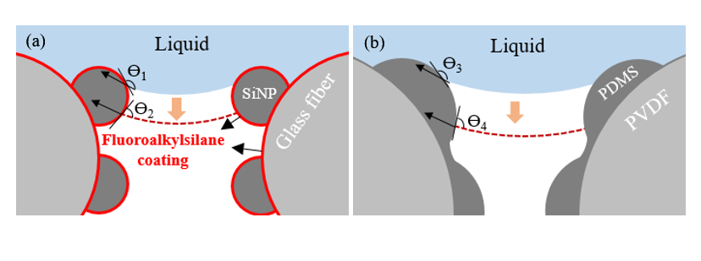
Figure 6. Schematics of (a) omniphobic-surface structure built with nanocomposites and fluoroalkyl-silane coating in a previous study,³² and (b) superhydrophobic-surface structure in the polymeric-microsphere-coating membrane of this study.

3.5 Membrane performance in the direct-contact membrane distillation (DCMD)
Because real seawater contains a certain salinity, as well as diverse kinds of inorganic salt with natural organic matter (NOM), the fouling behavior of MD for desalination is very complicated, and difficult to predict. Humic acid (HA), which due to its affinity with hydrophobic membranes is a major foulant,⁵⁹ can affect the membrane performance of MD, by decreasing the surface tension of raw water.⁶⁰ Therefore, to preserve hydrophobic membranes from the wetting in the MD that is for desalination, the MD membrane needs to be somewhat repellent against liquids with a lower surface tension than common water (72.8 mN/m at 20 °C).
To investigate the wettability and desalination performance of our engineered membrane toward low surface tension seawater, we performed DCMD using feed solution varying in surface tension. When an SDS, representative surfactant, which is an amphiphilic organic compound, is present in saline water, it significantly reduces the surface tension of the medium. Therefore, a feed of synthetic seawater (3.5% NaCl) surface tension was reduced by adding 0.1 mM SDS to 0.3 mM every 4 h during the DCMD operation. The surface tensions of the solutions are appropriately 48, 41.4, and 37 mN/m based on the surface-tension variation, and depending on the SDS and NaCl concentrations at the temperature of 60 °C.⁶¹ Considering the declined values of the surface tension from the addition of various types of HA,⁶² the current feed water was suitable for the simulation of a harsh condition for desalination.
As mentioned in Table 2, all the membranes showed hydrophobic properties at the lowest contact angle of 117.9°, and a considerable resistance against DIW, which was evaluated according to the LEP. However, when the 3.5 % NaCl solution was employed with the 0.1 mM SDS as the feed, the membrane wetting rapidly decreased the water flux and the salt-removal efficiency of the E-PH. Topographically, the nanofiber accumulation of an electrospun membrane confers a re-entrant structure that favors the obstruction of water intrusion inside the membrane. Nevertheless, the prepared electrospun membrane of the E-PH exhibited low permeability and DCMD-operation selectivity, compared with the commercial membrane, due to the large pore size. Although the C-PVDF that was made based on the phase inversion represents the lowest contact-angle value because of a disadvantageous surface morphology, an adequate resistance to the feed water was initially observed. But after 150 min of operation time, the vapor permeability began to decline, and eventually the membrane was wetted completely after the addition of another SDS of 0.1 mM; this is because the surface morphology of the C-PVDF was not close to the re-entrant structure, and the short chain of PVDF composed of the C-H₂ and C-F₂ was not enough to keep the hydrophobicity to low-surface-tension liquids (41.4 mN/m).
In both cases of the membranes that were coated with the microspheres, a flux drop and a significant deterioration of the permeate-water quality were not observed for 4 h under the condition of the 0.1 mM SDS. It is implied here that the re-entrant structure that was built by the low surface energy polymeric microspheres is effective for moderately low surface tension liquids (48 mN/m) in the DCMD for desalination. The membrane pores of the E-M3 and the E-M5 were partially blocked due to the wetting with an increase of the SDS concentration to 0.2 mM (41.4 mN/m), and then a severe wetting occurred abruptly with the consecutive addition of the SDS that reached the concentration of 0.3 mM (37 mN/m).
Recently, studies^{31, 62, 63} related to the membrane modification in the targeting of wastewater with a low surface tension were reported with respect to the MD operation. Compared with these membranes, the proposed microsphere-coated membrane is not proper for MD-process applications for wastewater containing low-surface-tension liquids, such as oil and ethanol; but it is sufficiently hydrophobic to be employed in the treatment of seawater including NOM. Additionally, while the previously mentioned membranes were modified through the use of nanocomposite and hydrophobic chemicals, the proposed membrane was fabricated by a simple electrospraying with polymers.
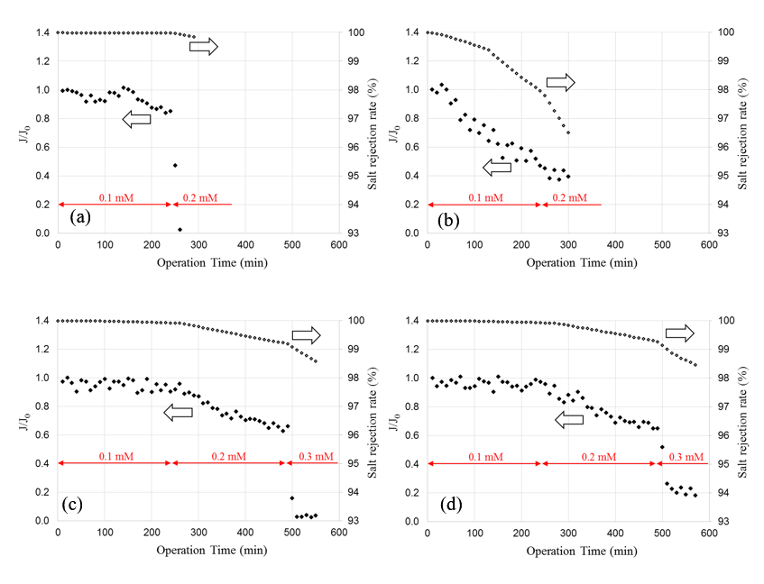
Figure 7. DCMD using 3.5% NaCl including varying amounts of the SDS at the 20 °C permeate and 60 °C feed of (a) commercial membrane (C-PVDF), and (b) neat electrospun membrane (E-PH) and coated membrane with micropheres, using (c) PVDF-2% PDMS-3% (E-M3), and (d) PVDF-2% PDMS-5% (E-M5). J and J₀ are the current and initial fluxes.

- ASSOCIATED CONTENT
Supporting Information
The Supporting Information is available free of charge on the ACS Publications website at
Supplementary Figure S1. Optical profiler images (88.8 μm × 66.4 μm) of (a) PVDF-1% PDMS-3% (E1), (b) PVDF-2%PDMS-3% (E-M3) (c) PVDF-3% PDMS-3% (E3), and (d) PVDF-5% PDMS-3% (E5); Figure S2. PVDF-2% PDMS-3% under the humidity approximately 40 %.

AUTHOR INFORMATION
Corresponding Author
* Tel: + (852)-3442-9626; Fax: + (852)-3442-0688; E-mail: alicia.kjan@cityu.edu.hk
Notes
The authors declare no competing financial interest.
- ACKNOWLEDGMENT
This work was financially supported by the Research Grant Council of Hong Kong through the Early Career Scheme (No. 9048074) and Strategic Research Grant from City University of Hong Kong (No. 7004521).

References

(1) An, A. K.; Lee, E.-J.; Guo, J.; Jeong, S.; Lee, J.-G.; Ghaffour, N. Enhanced vapor transport in membrane distillation via functionalized carbon nanotubes anchored into electrospun nanofibres. Sci. Rep. 2017, 7 (41562).
(2) Ge, Q.; Wang, P.; Wan, C.; Chung, T.-S. Polyelectrolyte-Promoted Forward Osmosis–Membrane Distillation (FO–MD) Hybrid Process for Dye Wastewater Treatment. Environ. Sci. Technol. 2012, 46 (11), 6236–6243.
(3) Lee, J.-G.; Lee, E.-J.; Jeong, S.; Guo, J.; An, A. K.; Guo, H.; Kim, J.; Leiknes, T.; Ghaffour, N. Theoretical modeling and experimental validation of transport and separation properties of carbon nanotube electrospun membrane distillation. J. Memb. Sci. 2017, 526, 395–408.
(4) An, A. K.; Guo, J.; Jeong, S.; Lee, E. J.; Tabatabai, S. A. A.; Leiknes, T. O. High flux and antifouling properties of negatively charged membrane for dyeing wastewater treatment by membrane distillation. Water Res. 2016, 103, 362–371.
(5) Chen, Y.; Tian, M.; Li, X.; Wang, Y.; An, A. K.; Fang, J.; He, T. Anti-wetting behavior of negatively charged superhydrophobic PVDF membranes in direct contact membrane distillation of emulsified wastewaters. J. Memb. Sci. 2017, 535, 230–238.
(6) Gryta, M.; Barancewicz, M. Influence of morphology of PVDF capillary membranes on the performance of direct contact membrane distillation. J. Memb. Sci. 2010, 358 (1–2), 158–167.
(7) Naidu, G.; Jeong, S.; Vigneswaran, S.; Hwang, T.-M.; Choi, Y.-J.; Kim, S.-H. A review on fouling of membrane distillation. Desalin. Water Treat. 2015, 3994 (June), 1–25.
(8) An, A. K.; Guo, J.; Lee, E.-J.; Jeong, S.; Zhao, Y.; Wang, Z.; Leiknes, T. PDMS/PVDF hybrid electrospun membrane with superhydrophobic property and drop impact dynamics for dyeing wastewater treatment using membrane distillation. J. Memb. Sci. 2017, 525, 57–67.
(9) Lee, E.-J.; An, A. K.; He, T.; Woo, Y. C.; Shon, H. K. Electrospun nanofiber membranes incorporating fluorosilane-coated TiO2 nanocomposite for direct contact membrane distillation. J. Memb. Sci. 2016, 520, 145–154.
(10) Lee, E.-J.; An, A. K.; Hadi, P.; Lee, S.; Woo, Y. C.; Shon, H. K. Advanced multi-nozzle electrospun functionalized titanium dioxide/polyvinylidene fluoride-co-hexafluoropropylene (TiO2/PVDF-HFP) composite membranes for direct contact membrane distillation. J. Memb. Sci. 2017, 524, 712–720.
(11) Woo, Y. C.; Tijing, L. D.; Park, M. J.; Yao, M.; Choi, J.-S.; Lee, S.; Kim, S.-H.; An, K.-J.; Shon, H. K. Electrospun dual-layer nonwoven membrane for desalination by air gap membrane distillation. Desalination 2017, 403, 187–198.
(12) Jung, J.; Shin, Y.; Choi, Y.-J. Y.-J.; Sohn, J.; Lee, S.; An, K. Hydrophobic surface modification of membrane distillation (MD) membranes using water-repelling polymer based on urethane rubber. Desalin. Water Treat. 2015, 3994 (June 2015), 1–11.
(13) Drioli, E.; Ali, A.; Macedonio, F. Membrane distillation: Recent developments and perspectives. Desalination 2015, 356, 56–84.
(14) Wang, P.; Chung, T. S. Recent advances in membrane distillation processes: Membrane development, configuration design and application exploring. J. Memb. Sci. 2015, 474, 39–56.
(15) Liao, Y.; Wang, R.; Tian, M.; Qiu, C.; Fane, A. G. Fabrication of polyvinylidene fluoride (PVDF) nanofiber membranes by electro-spinning for direct contact membrane distillation. J. Memb. Sci. 2013, 425–426, 30–39.
(16) Li, X.; Wang, C.; Yang, Y.; Wang, X.; Zhu, M.; Hsiao, B. S. Dual-Biomimetic Superhydrophobic Electrospun Polystyrene Nanofibrous Membranes for Membrane Distillation. ACS Appl. Mater. Interfaces 2014, 6 (4), 2423–2430.
(17) Wu, J.; An, A. K.; Guo, J.; Lee, E.-J.; Farid, M. U.; Jeong, S. CNTs reinforced super-hydrophobic-oleophilic electrospun polystyrene oil sorbent for enhanced sorption capacity and reusability. Chem. Eng. J. 2017, 314, 526–536.
(18) Wang, X.; Ding, B.; Yu, J.; Wang, M. Engineering biomimetic superhydrophobic surfaces of electrospun nanomaterials. Nano Today 2011, 6 (5), 510–530.
(19) Tijing, L. D.; Choi, J. S.; Lee, S.; Kim, S. H.; Shon, H. K. Recent progress of membrane distillation using electrospun nanofibrous membrane. J. Memb. Sci. 2014, 453 (September 2015), 435–462.
(20) Han, D.; Steckl, A. J. Superhydrophobic and Oleophobic Fibers by Coaxial Electrospinning. Langmuir 2009, 25 (16), 9454–9462.
(21) Muthiah, P.; Hsu, S. H.; Sigmund, W. Coaxially electrospun PVDF-teflon AF and teflon AF-PVDF core-sheath nanofiber mats with superhydrophobic properties. Langmuir 2010, 26 (15), 12483–12487.
(22) Van Boeckel, T. P.; Gandra, S.; Ashok, A.; Caudron, Q.; Grenfell, B. T.; Levin, S. A.; Laxminarayan, R. Global antibiotic consumption 2000 to 2010: an analysis of national pharmaceutical sales data. Lancet Infect. Dis. 2014, 14 (8), 742–750.
(23) Li, X.; Yu, X.; Cheng, C.; Deng, L.; Wang, M.; Wang, X. Electrospun Superhydrophobic Organic/Inorganic Composite Nanofibrous Membranes for Membrane Distillation. ACS Appl. Mater. Interfaces 2015, 7 (39), 21919–21930.
(24) Dong, Z.-Q.; Ma, X.-H.; Xu, Z.-L.; Gu, Z.-Y. Superhydrophobic modification of PVDF-SiO2 electrospun nanofiber membranes for vacuum membrane distillation. RSC Adv. 2015, 5 (83), 67962–67970.
(25) Liao, Y.; Wang, R.; Fane, A. G. Engineering superhydrophobic surface on poly(vinylidene fluoride) nanofiber membranes for direct contact membrane distillation. J. Memb. Sci. 2013, 440, 77–87.
(26) Liao, Y.; Wang, R.; Fane, A. G. Fabrication of bioinspired composite nanofiber membranes with robust superhydrophobicity for direct contact membrane distillation. Environ. Sci. Technol. 2014, 48 (11), 6335–6341.
(27) Liao, Y.; Loh, C. H.; Wang, R.; Fane, A. G. Electrospun superhydrophobic membranes with unique structures for membrane distillation. ACS Appl. Mater. Interfaces 2014, 6 (18), 16035–16048.
(28) Yang, C.; Li, X. M.; Gilron, J.; Kong, D. feng; Yin, Y.; Oren, Y.; Linder, C.; He, T. CF4 plasma-modified superhydrophobic PVDF membranes for direct contact membrane distillation. J. Memb. Sci. 2014, 456, 155–161.
(29) A.B.D. Cassie, S. B. Wettability of porous surfaces, Trans. Faraday Soc. 1944, 40, 546–551.
(30) Tuteja, A.; Choi, W.; Mabry, J. M.; McKinley, G. H.; Cohen, R. E. Robust omniphobic surfaces. Proc. Natl. Acad. Sci. U. S. A. 2008, 105 (47), 18200–18205.
(31) Boo, C.; Lee, J.; Elimelech, M. Omniphobic Polyvinylidene Fluoride (PVDF) Membrane for Desalination of Shale Gas Produced Water by Membrane Distillation. Environ. Sci. Technol. 2016, 50 (22), 12275–12282.
(32) Boo, C.; Lee, J.; Elimelech, M. Engineering Surface Energy and Nanostructure of Microporous Films for Expanded Membrane Distillation Applications. Environ. Sci. Technol. 2016, 50 (15), 8112–8119.
(33) Rand, A. A.; Mabury, S. A. Is there a human health risk associated with indirect exposure to perfluoroalkyl carboxylates (PFCAs)? Toxicology 2017, 375, 28–36.
(34) Zhao, P.; Xia, X.; Dong, J.; Xia, N.; Jiang, X.; Li, Y.; Zhu, Y. Short- and long-chain perfluoroalkyl substances in the water, suspended particulate matter, and surface sediment of a turbid river. Sci. Total Environ. 2016, 568, 57–65.
(35) Choi, S.-J.; Kwon, T.-H.; Im, H.; Moon, D.-I.; Baek, D. J.; Seol, M.-L.; Duarte, J. P.; Choi, Y.-K. A Polydimethylsiloxane (PDMS) Sponge for the Selective Absorption of Oil from Water. ACS Appl. Mater. Interfaces 2011, 3 (12), 4552–4556.
(36) Tropmann, A.; Tanguy, L.; Koltay, P.; Zengerle, R.; Riegger, L. Completely superhydrophobic PDMS surfaces for microfluidics. Langmuir 2012, 28 (22), 8292–8295.
(37) Park, E. J.; Cho, Y. K.; Kim, D. H.; Jeong, M. G.; Kim, Y. H.; Kim, Y. D. Hydrophobic polydimethylsiloxane (PDMS) coating of mesoporous silica and its use as a preconcentrating agent of gas analytes. Langmuir 2014, 30 (34), 10256–10262.
(38) Zhang, J.; Song, Z.; Li, B.; Wang, Q.; Wang, S. Fabrication and characterization of superhydrophobic poly (vinylidene fluoride) membrane for direct contact membrane distillation. Desalination 2013, 324, 1–9.
(39) Sun, D.; Liu, M.; Guo, J.; Zhang, J.; Li, B.; Li, D. Preparation and characterization of PDMS-PVDF hydrophobic microporous membrane for membrane distillation. DES 2015, 370, 63–71.
(40) Xue, C.; Li, X.; Jia, S.; Guo, X.; Li, M. RSC Advances Fabrication of robust superhydrophobic fabrics based on coating with PVDF / PDMS. RSC Adv. 2016, 6, 84887–84892.
(41) Park, J. Y.; Oh, K. O.; Won, J. C.; Han, H.; Jung, H. M.; Kim, Y. S. Facile fabrication of superhydrophobic coatings with polyimide particles using a reactive electrospraying process. J. Mater. Chem. 2012, 22 (31), 16005–16010.
(42) Gao, J.; Wong, J. S.-P.; Hu, M.; Li, W.; Li, R. K. Y. Facile preparation of hierarchically porous polymer microspheres for superhydrophobic coating. Nanoscale 2014, 6 (2), 1056–1063.
(43) Yang, D.; Liu, X.; Jin, Y.; Zhu, Y.; Zeng, D.; Jiang, X. Electrospinning of Poly ( dimethylsiloxane )/ Poly ( methyl methacrylate ) Nanofibrous Membrane : Fabrication and Application in Protein Microarrays. 2009, 3335–3340.
(44) Essalhi, M.; Khayet, M. Self-sustained webs of polyvinylidene fluoride electrospun nano-fibers: Effects of polymer concentration and desalination by direct contact membrane distillation. J. Memb. Sci. 2014, 454, 133–143.
(45) Brady, R. F.; Singer, I. L. Mechanical factors favoring release from fouling release coatings. Biofouling 2000, 15 (1–3), 73–81.
(46) Ataollahi, N.; Ahmad, a; Hamzah, H.; Rahman, M. Y. a; Mohamed, N. S. Preparation and Characterization of PVDF-HFP / MG49 Based Polymer Blend Electrolyte. Int. J. Electrochem. Sci. 2012, 7, 6693–6703.
(47) Liu, F.; Abed, M. R. M.; Li, K. Preparation and characterization of poly(vinylidene fluoride) (PVDF) based ultrafiltration membranes using nano γ-Al2O3. J. Memb. Sci. 2011, 366 (1–2), 97–103.
(48) Zhang, F.; Zhang, W.; Yu, Y.; Deng, B.; Li, J.; Jin, J. Sol-gel preparation of PAA-g-PVDF/TiO2 nanocomposite hollow fiber membranes with extremely high water flux and improved antifouling property. J. Memb. Sci. 2013, 432, 25–32.
(49) Berean, K.; Zhen, J.; Nour, M.; Latham, K.; Mcsweeney, C.; Paull, D.; Halim, A.; Kentish, S.; Doherty, C. M.; Hill, A. J.; et al. The effect of crosslinking temperature on the permeability of PDMS membranes : Evidence of extraordinary CO 2 and CH 4 gas permeation. Sep. Purif. Technol. 2014, 122, 96–104.
(50) Nour, M.; Berean, K.; Griffin, M. J.; Matthews, G. I.; Bhaskaran, M.; Sriram, S.; Kalantar-zadeh, K. Sensors and Actuators B : Chemical Nanocomposite carbon-PDMS membranes for gas separation. Sensors Actuators B. Chem. 2012, 161 (1), 982–988.
(51) Kant, M. B.; Shinde, S. D.; Bodas, D.; Patil, K. R.; Sathe, V. G.; Adhi, K. P.; Gosavi, S. W. Surface studies on benzophenone doped PDMS microstructures fabricated using KrF excimer laser direct write lithography. Appl. Surf. Sci. 2014, 314, 292–300.
(52) Ellinas, K.; Pujari, S. P.; Dragatogiannis, D. A.; Charitidis, C. A.; Tserepi, A.; Zuilhof, H.; Gogolides, E. Plasma Micro-Nanotextured, Scratch, Water and Hexadecane Resistant, Superhydrophobic, and Superamphiphobic Polymeric Surfaces with Perfluorinated Monolayers. ACS Appl. Mater. Interfaces 2014, 6 (9), 6510–6524.
(53) Wenzel, R. N. Resistance of solid surfaces to wetting by water. J. Ind. Eng. Chem. (Washington, D. C.) 1936, 28, 988–994.
(54) Yang, X.; Wang, R.; Shi, L.; Fane, A. G.; Debowski, M. Performance improvement of PVDF hollow fiber-based membrane distillation process. J. Memb. Sci. 2011, 369 (1–2), 437–447.
(55) Wu, T.; Suzuki, Y. Design, microfabrication and evaluation of robust high-performance superlyophobic surfaces. Sensors Actuators B Chem. 2011, 156 (1), 401–409.
(56) Meng, H.; Clark, G. A.; Kumar, K. Fluorinated Amino Acids and Biomolecules in Protein Design and Chemical Biology. In Fluorine in Medicinal Chemistry and Chemical Biology; John Wiley & Sons, Ltd, 2009; pp 411–446.
(57) Wu, J.; Lee, N. Y. One-step surface modification for irreversible bonding of various plastics with a poly(dimethylsiloxane) elastomer at room temperature. Lab Chip 2014, 14 (9), 1564–1571.
(58) Zhang, H.; Lee, N. Y. Non-silicon substrate bonding mediated by poly(dimethylsiloxane) interfacial coating. Appl. Surf. Sci. 2015, 327, 233–240.
(59) Jucker, C.; Clark, M. M. Adsorption of aquatic humic substances on hydrophobic ultrafiltration membranes. J. Memb. Sci. 1994, 97, 37–52.
(60) Y., C.; M., S. The surface tension of aqueous solutions of soil humic substances. Soil Science. 1978.
(61) Matijevic, E.; Pethica, B. A. The properties of ionized monolayers. Part 1.-Sodium dodecyl sulphate at the air/water interface. Trans. Faraday Soc. 1958, 54 (0), 1382–1389.
(62) Klaviņš, M.; Purmalis, O. Surface Activity of Humic Acids Depending on Their Origin and Humification Degree. Proc. Latv. Acad. Sci. Sect. B. Nat. Exact, Appl. Sci. 2014, 67 (6), 493–499.
(63) Lee, J.; Boo, C.; Ryu, W. H.; Taylor, A. D.; Elimelech, M. Development of Omniphobic Desalination Membranes Using a Charged Electrospun Nanofiber Scaffold. ACS Appl. Mater. Interfaces 2016, 8 (17), 11154–11161.
(64) Lin, S.; Nejati, S.; Boo, C.; Hu, Y.; Osuji, C. O.; Elimelech, M. Omniphobic Membrane for Robust Membrane Distillation. Environ. Sci. Technol. Lett. 2014, 1 (11), 443–447.

