How child and youth participation links to development effectiveness: findings from a three-year joint agency research project

Keren Winterford, Institute for Sustainable Futures University of Technology Sydney
Anna Gero, Institute for Sustainable Futures University of Technology Sydney
Jackie Robertson, Transform Aid International
Rouena Getigan, ChildFund Australia
Sally Asker, InSIGHT Sustainability
Pratiksha Khanal, United Mission to Nepal

Introduction
Over a three-year period research was carried out in three countries through a research partnership between Australian based NGOs, their in-country partners, a private consultancy and an academic partner to explore the contribution of child and youth participation to development effectiveness. This paper explores the practice and outcomes of the research.

Research focus
Since the United Nations Convention on the Rights of the Child (CRC) was adopted in 1990, the ways in which children and youth participate in development programs has received much attention from both development professionals and academics. A range of different ways to engage children and youth in development has been documented (Asker and Gero 2012). Despite this understanding, the questions of if, and how, their participation contributes to development effectiveness had not been addressed directly and remains unanswered for many development professionals. A research partnership was formed to offer insights to these questions and better understand, if and how child and youth participation contributes to development effectiveness. The field-based research was conducted in Fiji, Laos and Nepal over two phases between 2013 and 2016.

Three Learning Areas and specific research questions framed the research and guided data collection; analysis and write up. Learning Area 1 explored the links between child and youth participation and development effectiveness; Learning Area 2 explored the contributions of child and youth participation to program outcomes and Learning Area 3 used reflection questions to explore child and youth participation in research practice.

The research was carried out in communities in Fiji, Laos and Nepal where projects employed child and youth participation. Three different communities were selected in each of the three countries. For Phase 2 of the research, each research site formed a case study for the research. Prerequisites to choosing the research sites included: good child and youth participation practices (including having children and youth as partners or leaders); long-term community development activities; and a capacity to undertake research.

Exploring the link between child and youth participation and development effectiveness

Contribution of child and youth participation to development effectiveness
In order to explore the link between child and youth participation and development effectiveness a working definition of development effectiveness was prepared for the research. The Development Effectiveness Mapping Tool (ISF: UTS et al. 2017) described five characteristics:
- Participation in setting development priorities;
- Promotion of inclusion and equity, and reduction of marginalisation;
- Knowledge sharing, mutual learning and collaboration;
- Personal and community development; and
- Socio- economic development.
With a direct interest in children and youth, the Development Effectiveness Mapping Tool described examples of changes resulting from child and youth participation specific for children and youth themselves and also changes for others (parents, family, school, community, local government). The Development Effectiveness characteristics were also described in illustrated form to enable effective engagement of children and youth in the research.
The research revealed broad, multi-dimensional and interlinked contributions of child and youth participation across all five dimensions of development effectiveness defined for the research. All participants in the research, young and old, shared that they valued the contributions that children and youth made to create positive change within their families and communities. The research carried out two levels of inquiry which demonstrated how children and youth contributed to development effectiveness.
The first area of inquiry involved children and youth being invited to share individual ‘stories of change’ resulting from their participation in development projects. Through the research activities these changes were then linked to the characteristics of development effectiveness. All five characteristics were demonstrated through the children’s ‘stories of change’ as illustrated in Figure 1 below. In Laos and Nepal, the changes most commonly reported by children and youth linked to personal and community development. In Fiji, the most reported type of change was socio-economic development. For all three countries, the most commonly reported changes matched the focus of the project activities in the country context. For example, the ChildFund Laos ‘Pass it Back’ project in Paka village aimed to build life skills in children and youth through a sport for development program, and research participants described improvements in personal development. In Fiji, the beekeeping project was intentionally a livelihoods project, and participants told stories about socio-economic development.

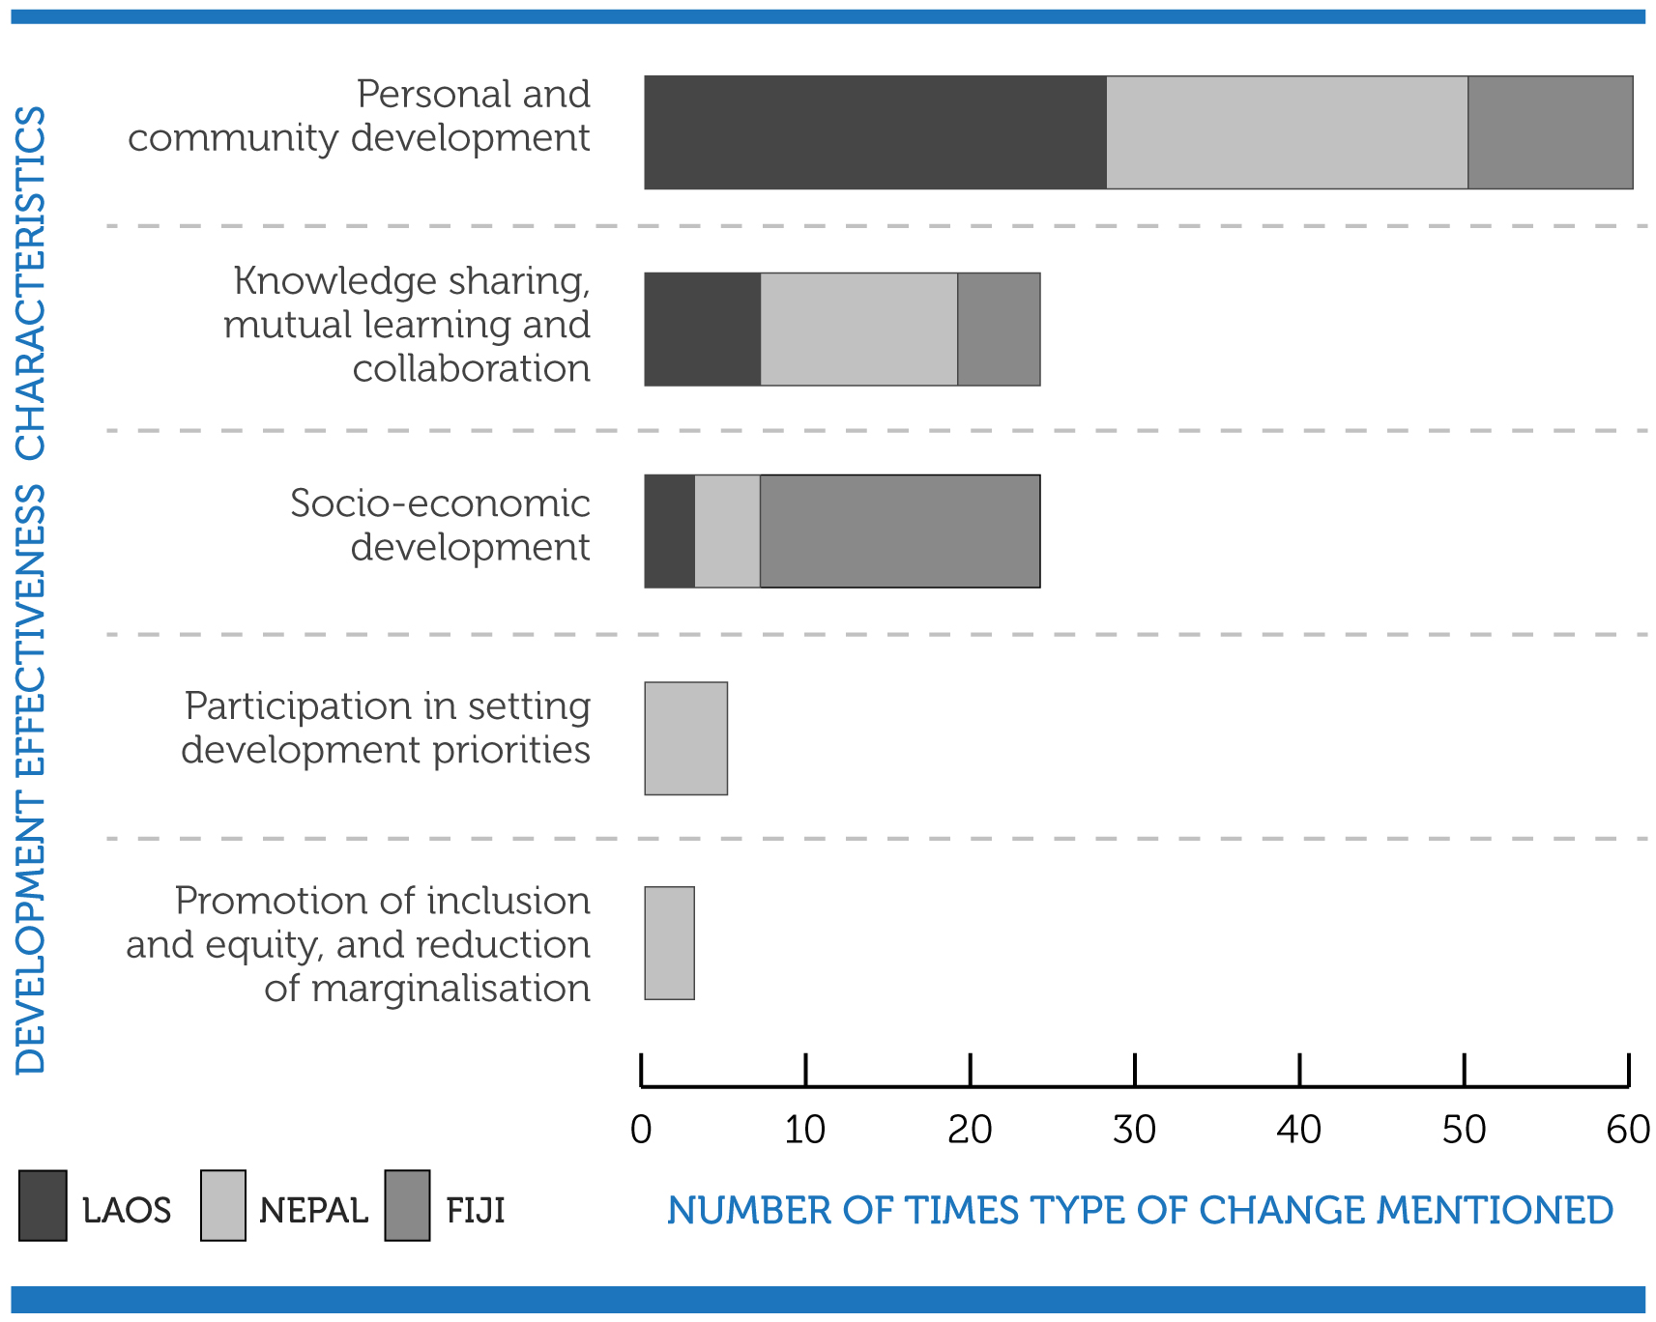
Figure 1: Total number of changes shared by children and youth in each country and how they link to development effectiveness characteristics
The second area of inquiry focused only on one ‘story of change’ chosen in each research location and interviews with adults in the community (parents, teachers and community leaders) and participatory activities with children explored the flow-on effects of the chosen story of change within the community.

Overall, the flow-on changes shared by participants in each country were found to link to all five of the development effectiveness characteristics. The presence of all five characteristics suggests that child and youth participation can contribute to multiple types of change which benefit themselves, their families and their communities. The flow-on changes described by children, youth and adults and how they link to different characteristics of development effectiveness are shown in Figure 2 below. The numbers in the figure show how many times ‘flow-on changes’ were recorded and show slight differences between countries. In Laos, children, youth and adults described personal and community development more often than they did in Nepal and Fiji. This may be reflective of the project focus. In Nepal and Fiji there was a more even spread of flow-on changes, possibly because the projects had been running longer. The research revealed, and as demonstrated in Figure 2, that changes which involved child and youth participation reached far beyond the initial changes first described and experienced by individual children/youth. The participation of children and youth created a broad set of different yet interconnected changes in communities.

The research revealed that child and youth participation led to positive changes within children and youth themselves, and that these changes enabled children and youth to influence broader changes within families and communities. As described by the research participants, child and youth participation can bring about benefits related to personal and community development such as: improved equity, greater social inclusion and improved self-esteem among children and youth. It appears that these benefits form the building blocks for good development outcomes. In the research they were found to contribute to broader sets of changes, such as socio-economic development, improved health and access to education. Child and youth participation resulted in some immediate positive changes for children, youth and adults. These changes as described by the research participants show that there are immediate benefits of supporting children and youth which go beyond preparing them to be leaders in the future.
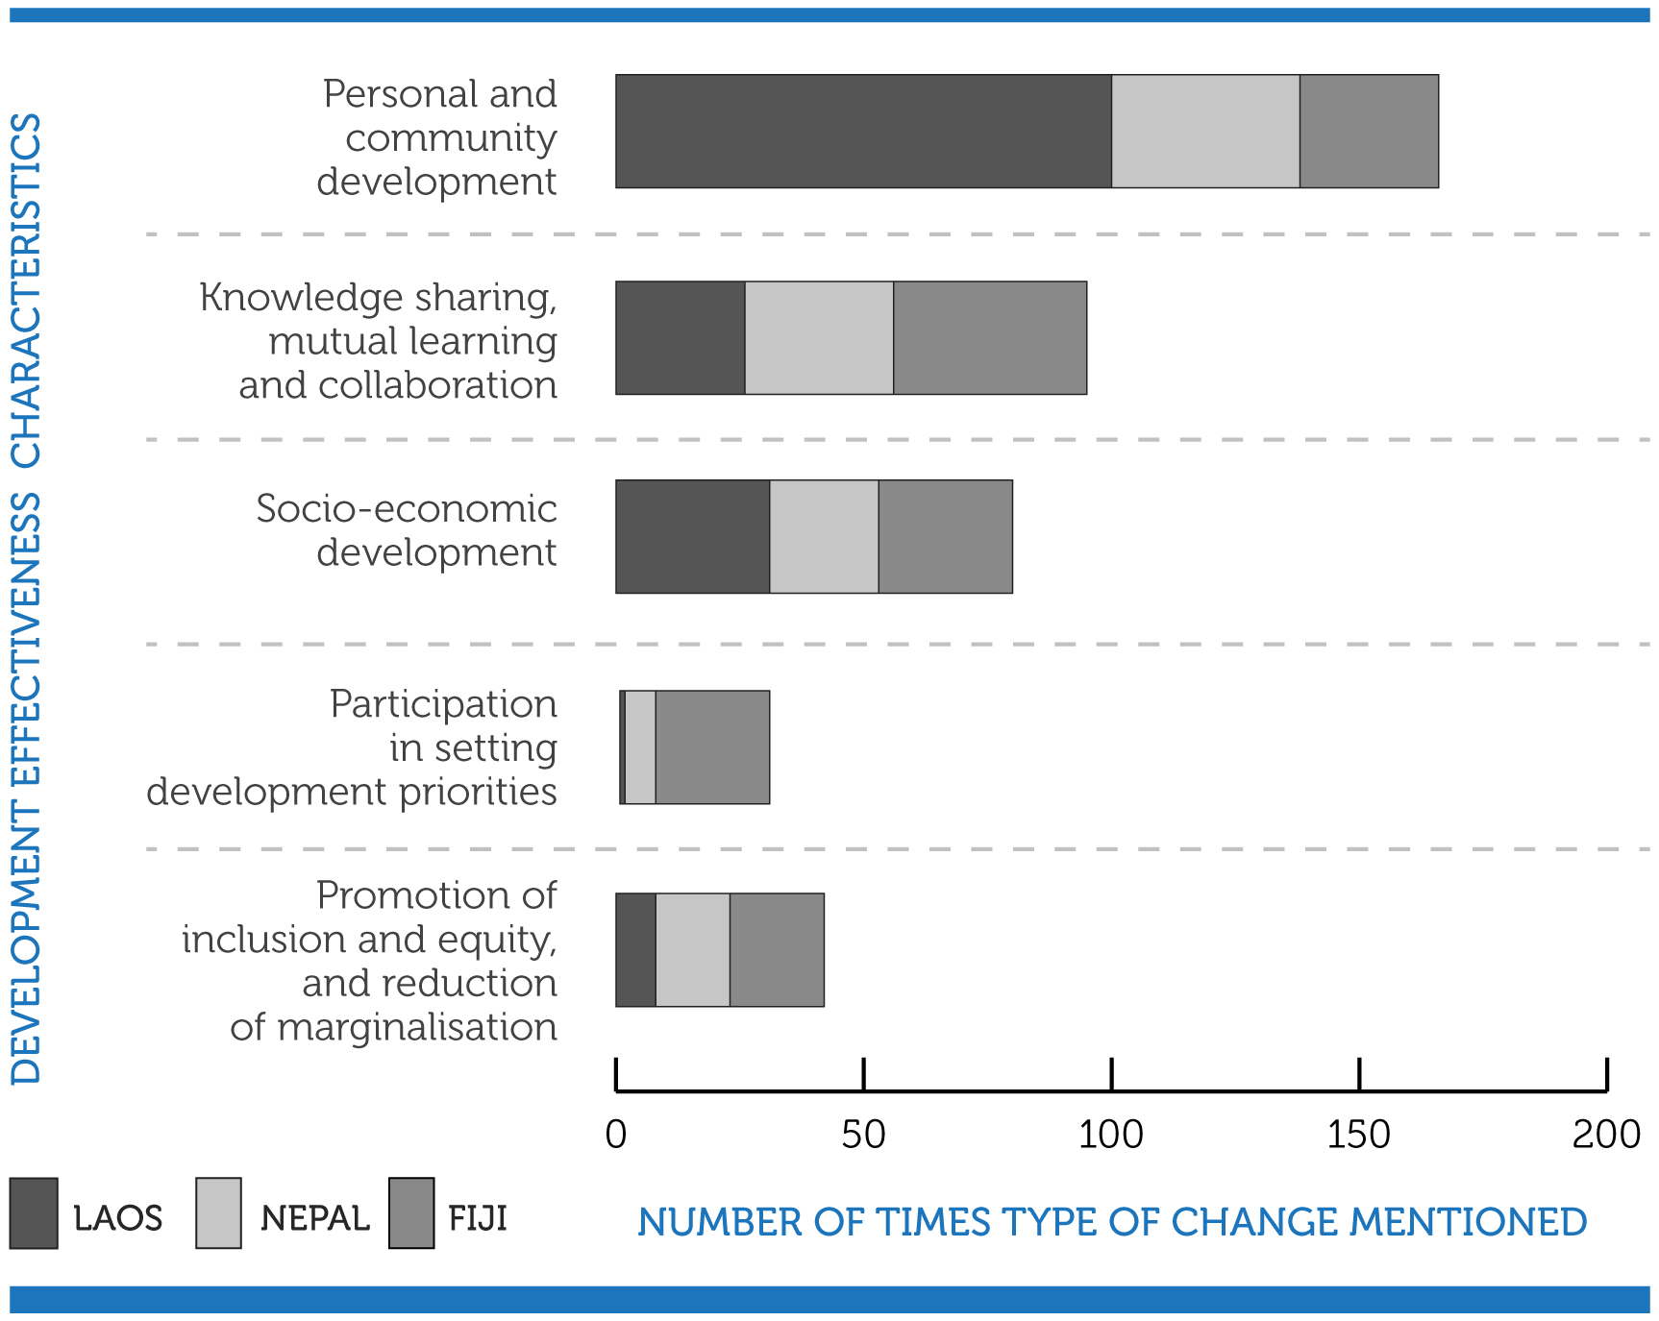
Figure 2: Number of flow-on changes described by children, youth and adults across the three countries (Fiji, Laos, Nepal) and links to development effectiveness characteristics

Contribution of child and youth participation changes in relationships
A key contribution of child and youth participation to development effectiveness was changes to multiple sets of relationships: within peer groups, between children and adults and amongst adults themselves. Both children themselves and also adults interviewed for the research described how child and youth participation led to changes in relationships and shifts in power between children, youth and other family members, and to changes in relationships and shifts in power within the broader community. Contribution of child and youth participation was evident in all nine case studies and described by children and youth and adults alike.

Examples of changes in relationships between children and youth included: child-to-child and youth-to-youth learning (Fiji, Laos, and Nepal); greater trust between siblings and friend (Laos and Nepal), as noted by a male child in Nepal: “My sisters talk about their problems with friends. They are more confident and have raised awareness within the family”; greater respect and generosity between friends (Laos and Nepal); and children becoming role models for other children in their villages (Laos).

Examples of changes in relationships between children and youth and adults included: village and community leaders including children and youth in community events and decision-making (Fiji, Laos and Nepal); parents listening and respecting their children more (Fiji, Laos and Nepal), as described by a female child in Laos: “Parents listen more to the children’s opinions”; and children and youth feeling more confident to speak with adults (Fiji, Laos and Nepal).

Examples of changes in relationships between adults included: allowing women and girls to stay in the home and be included in community life during menstruation (Nepal) and the inclusion of ‘married-in’ people from outside the village in community life (Fiji), as described by a mother in Lutukina Village: “in the past two years the relationships in the village
with us women who are married into the village is very good … now people are listening to each other, and there is no division.”

This research finding highlights the significant contribution of children and youth to broad societal changes underpinned by values, beliefs, attitudes and behaviours (Armitage, C.J. and Mark, C. (2001), though it was beyond the scope of the research to assess the sustained practice of these changes. It is recommended that development practitioners continue to assess the contribution over a longer term period and assess the reach of changes within regular monitoring and evaluation.

Contribution of child and youth participation to project outcomes
The changes described by the research participants (children, youth and adults) in each location aligned with the changes that the development projects aimed to achieve. This is an assurance to NGOs who participated in the research, demonstrating that from the perspectives of local stakeholders project objectives are being met and in some cases exceeded. The research findings also highlight the link between achievement of project objectives and how this contributes to broader development effectiveness outcomes as described in the Development Effectiveness Mapping Tool.
An example of alignment between changes resulting from child and youth participation as described by research participants and project objectives can be shown in Laos. The Child Clubs project in Dindam village in Laos focused on increasing children’s understanding of child protection issues and duty bearers’ obligations, and focused on children sharing their knowledge with their peers, families and community, for example, a female child noted: “Since they joined the child clubs, the children advise people to use the toilets instead of open defecation”. The success of the project was demonstrated through the adults having increased respect for children’s opinions and treating children better within the community, as described by a female child: “Parents learned about child rights, and after that they don’t use child labour too much.”

Child and youth participation in partnership
A key finding of the research was that children, youth and adults alike, valued the role of children and youth as partners in development.

In the research, children, youth and adults were invited to explore the role of child and youth participation in development activities. They were separately asked which role they most preferred for children and youth: as beneficiaries; as partners or as leaders in change. Within Phase 2 of the research, six out of the nine research locations, all participants (children, youth and adults), described preference for working in partnership, for example, a male child in Laos noted: “Because there are children and adults working together to make change. Children and youth learn together”. In the other three research sites children and youth and adults valued different forms of participation – either leadership or partnership. For example, a teacher in Nepal recognised the leadership for children: “The child club members organised the quiz competition in their own initiative. They asked Prayas (the local partner) and teachers for their support in conducting the program.”

The research defined child and youth participation using DFIDs’ ‘three-lens approach’ (DFID 2010), which identifies youth as beneficiaries, partners or leaders. Definitions adapted from the DFID three-lens approach can be found in Table 1.

Table 1: Typology of child and youth participation
Children and youth as beneficiaries | - Target group is adequately informed.  - Participation explicitly focuses on children and youth issues through documentation.  - Participation can prepare the ground for working as partners.
Children and youth as partners | - Participation involves collaborative interventions, in which children and youth are fully consulted and informed.  - Participation implies mutual cooperation and responsibility.  - Participation recognises that children and youth generally need experience working at this level before progressing to becoming leaders and initiators of development (if appropriate) – a progression which not all will want to, or be able to, make.
Children and youth leaders | - Participation enables child/youth-initiated and directed interventions.  - Participation opening up a space for child-/youth-led decision- making (delegation) within existing structures, systems and processes.

The research revealed reasons why partnership was preferred and described value in terms of working together, learning and creating unity. As noted by a child in Laos: “because there are children and adults working together to make change, children and youth learn together to make the change” (Male child, Laos). In Fiji, youth and adults also pointed to the importance of working together as partners to create change. For example in Batiri village, the village headman noted: “I prefer that we work together. If we don’t work together there won’t be unity.” In Lutukina village, Fiji, a youth commented: “we (people in the community) need togetherness and commitment from both youths and adults to do the work well, especially in the village” (Male youth, Fiji). In Fiji, participation of youth through partnership is an important change given that traditionally, youth do not have a strong role or voice in village decision-making.

The research highlighted the value of designing approaches for child and youth participation that enable opportunities for children, youth and adults to work as partners. The research demonstrated that adults, children and youth all viewed working as partners as the most important and effective way to create positive change.

The research partnership
This section of the paper provides an overview of the practice of research partnership and the complementarity of partners, who provided a rich research experience coupled with rigour and quality design and practice, localisation and relevance to produce quality and applicable findings.

Three ANGOs and in-country partner organisations conducted the research: ChildFund Australia with ChildFund Laos in Laos, and Transform Aid International with United Mission to Nepal (UMN) and Prayas Nepal in Nepal and Live & Learn Australia with Live & Learn Fiji in Fiji. The research was supported by an independent consultancy, InSIGHT Sustainability; a university partner, the Institute for Sustainable Futures University of Technology Sydney (ISF: UTS); and a volunteer Peer Review Group (PRG) of child and development and research specialists. The research provided an opportunity for partners to complement each other’s experience and expertise.

Research design and practice
Collaborative research design was led by ISF:UTS and was informed by consideration of quality in qualitative research. Lincoln and Guba’s (1981, 1985) criteria for qualitative research includes two dimensions: trustworthiness and authenticity which informed the research practice. Demonstration of these quality characteristics was evident in the research.

The research design required a tiered approach with shared responsibility between the partners for data collection, analysis and write up. The research was primarily designed by ISF:UTS, the ANGOs and InSIGHT Sustainability in Australia, with review and input by in-country partners. A workshop for the research partners was held in Sydney first to prepare and refine data collection tools and prepare in-country researcher training. Tools were further refined in each country to ensure relevance to local context and research participants. ANGO’s, the independent consultant and their in-country partners conducted training for local researchers to facilitate participatory processes and ensure ethical research practice with children and youth. ‘Learning Circles’ were designed to enable active participation and voice of children and youth, detailed facilitator guides and ‘note taking guides’ were prepared to ensure rigor in the research practice and consistency across all research sites and three locations.

Analysis of research data also involved a tiered practice with shared responsibility across all partners. First stage was the preparation of collation reports, ‘Change Story Reports’, for each research site. In-country partners were responsible for preparing the Change Story Reports drawing on multiple ‘Note Taker booklets’ from ‘Learning Circles’ with children and youth and Conversations (interviews) with adults. The reports captured quotes as well as early analysis in response to the research questions. The second stage involved a review of the collation reports by ANGO staff to ensure the quality of the audit trail, linking raw data, as evidence of research findings. The third stage involved ISF:UTS drawing on the collation reports to prepare a synthesis in response to the research questions. The ‘Change Story Reports’ from each research site were also employed to prepare detailed case studies for each community, which have been included in the Final Learning Paper. Guided by all partners’ interests, the research sought to provide synthesized findings from all research sites, and also provide rich learnings that could also be understood and used in local contexts.

Ethical research
Ethical research was an important consideration for the research partnership. The Peer Review Group (PRG) made up of academics and experts in the field of child participation and child rights provided an important contribution to the development of guidance on ethical research practice. Together the PRG, ISF:UTS and ANGO practitioners developed an approach that would work effectively in practice and ensure guidance was in line the standards of Principles and Guidelines for ethical research and evaluation in development (ACFID 2016). Ethical guidance documents that were developed as a result, were in depth and detailed and included within in-country researcher training. Planned practice was modified in the field and these changes were documented to enable ethical practice in the research to be continually refined from Phase 1 to 2.

Managing working relationships
There were a range of working relationships that needed to be managed within the research partnership. First, the PRG was coordinated by ANGOs and met on average quarterly through the three-year partnership. This group provided valuable comment and insight on key milestones throughout the research including research design and questions and review of draft reporting. Second, the Sydney based ANGOs, academic partner and independent consultant met regularly. Face-to-face meetings provided an opportunity to build relationship, shared working practices and co-create the research practice and outcomes. For this group, two partnership review meetings were held, after Phase 1 and after Phase 2, to reflect on the partnership practice. The research project was evaluated following Phase 2 and a report produced. These meetings provided an opportunity to consider what worked well and areas for improvement. They offered an opportunity for each partner to share their experience and consider how to strengthen practice for the partnership.

Broader consultations with in-country partners were also carried out, after Phase 1 and after Phase 2 to gather their insights on the practice of research and to be informed for future efforts. In-country partners were invited to complete an on-line survey and all partners participated in a teleconference following each phase of the research. Similarly, these processes provided an opportunity to hear different perspectives about the partnership and how the research was carried out in communities.

Experience of research partnership
Informed by this three-year experience, a lot has been learnt about carrying out research in partnership, and insights are offered that may be of value to others considering taking up the baton and contributing to knowledge and learning about development practice. The research project was founded by high-level support from all organisations and was endorsed by CEO commitment to the research. This ensured the continuation of the research across multiple years, staffing and changing context of development. The key individuals of the research also established a shared purpose and commitment. Over time trust and relationship was built, but this required continuous effort and investment. This is especially important where the process is emergent and there is need for flexibility and adaptation along the way. Within any partnership there is a need to establish rules of engagement and ensure there is clear understanding of partnership ways of working, roles, responsibilities and protocols for decision making. In order to create a shared and co-created research design, time and money is needed to allow for all partner input, this is especially important when considering the topic of partnership. This needs to be planned and managed. There is value in conducting research in partnership, as highlighted through the experience of this research partnership. There is value in harnessing individual and organisational strengths to ensure the research becomes greater than the sum of the parts and is enriched by diverse range of expertise and perspectives. Recognising the challenges of achieving the Sustainable Development Goals (SDGs) this perspective is necessary and there is opportunity for the sector to value research partnership not just in terms of research findings but also to value and improve the practice of research and partnership and to value its contribution across multiple dimensions.

Conclusion
The practice and outcomes of the research focused on exploring the contribution of child and youth participation to development effectiveness highlight the value of partnership across many dimensions. First, the research found that preferred practice of child and youth participation, as described by child and youth themselves and also adults is in partnership. Second, the research found multi-dimensional and interlinked contribution of child and youth participation to a range of development effectiveness characteristics, also highlighting the value of partnership to achieving positive change. Third, the practice of partnership to carry out the research enabled contribution across multiple partners drawing on diverse range of experience, expertise and complementary knowledge. As demonstrated through the research findings and also the research practice, enabling best contribution of partnership requires an inclusive approach, planning and ongoing reflection by all partners and refinement of practice to achieve best development outcomes.

References
ACFID. 2016. Principles and Guidelines for ethical research and evaluation in development, Australian Council for International Development. Accessed 3 July 2017: https://acfid.asn.au/sites/site.acfid/files/resource_document/Principles-for-Ethical-Research-and-Evaluation-in-Development2016.pdf

Asker, S. and Gero, A. (2012). The role of child and youth participation in development Effectiveness, ChildFund Australia.

ChildFund Australia et al. (2015). Exploring the link between child and youth participation and development effectiveness: Mid-term Learning Paper, ChildFund Australia.

DFID (2010). Youth participation in development: A guide for development agencies and policy makers, DFID-CSO Youth Working Group.

Guba, E.G. & Lincoln, Y.S. 1981, Effective evaluation, Jossey-Bass, San Francisco.

ISF: UTS, ChildFund Australia, Transform Aid International and InSIGHT Sustainability (2017). Exploring the link between child and youth participation and development effectiveness, A Learning Paper, ChildFund Australia.

Lincoln, Y.S. & Guba, E.G. 1985, Naturalistic inquiry, Sage Publications, Beverly Hills, California.

Armitage, C.J. and Mark, C. (2001). "Efficacy of the theory of planned behaviour: A meta‐analytic review." British journal of social psychology 40.4 p. 471-499.

