Constructing Decision Support System Mechanism in Disaster Management: An Indonesia volcano eruption case study
Abstract
In Disaster Management (DM), a Decision Support System (DSS) success first requires a sufficient amount of representative knowledge to avail it to authorities who need it. A challenge in providing DM knowledge is that relevant authorities are often varied and dispersed and often have different requirements. The knowledge may be needed differently and indeed may need to be presented differently according to the decision making process whether it be for planning/policy making or responding operationally to a real time situation. This reality is indeed reflected in the fact that DSS in DM is often focussed on very specific set of tasks e.g. evacuation, logistic or coordination. The focus can also be DM phase specific e.g. Preparedness or Response phase only. However, the trigger for accessing such knowledge is often an external change be it environmental or organisational. Hence, a variety of views or stakeholders are often involved. In other words, the separation of concerns is often not practical and indeed not feasible due to the complexity of the DM knowledge itself. DM is a complex domain and various concerns and phases are often intertwined. This work advocates a unified access based on a unified representation of the various phases and concerns. The paper contributes to development of the required hybrid mechanisms, some are top down and others are bottom up. The proposed DSS architecture and its development lifecycle accommodate interests of varying DM decision makers. A knowledge conversion process centred on the Meta Object Facility (MOF) is used to structure and disentangle the knowledge for those different interests and roles. A real case study of the recent Mt. Agung volcano eruption in Bali Indonesia is used to evaluate the DSS development process. The evaluation successfully demonstrates the efficacy of the development process and the resultant DSS.
Keywords: Disaster Management, Decision Support System, Knowledge Management, DSS Development process

Introduction
Disasters, both man-made/technological and natural, are on the increase so are the concomitant economic losses (Tatham et al., 2017). Disaster Management (DM) is the systematic attempt to reduce their impact (Coppola, 2011). A key DM objective is to achieve resiliency (Blackman et al., 2017), that is: (1) a capability of bouncing back from unforeseen stress; and/or (2) capability to adapt to the situation. Resiliency is essentially determined by the level to which the affected communities have the necessary resources and ability to manage them during the disaster situations (UNISDR, 2012). Decision Support Systems have a key role, but mechanisms supporting their construction in a way to account for the holistic structure of the decisions involved remain challenging (Leskens et al., 2014; Rosenzweig & Solecki, 2014).
DM decision making processes are commonly initiated by the governmental authorities (DM agencies that are responsible to combat the disasters, e.g.: National Disaster Management Agency (BNPB) in Indonesia, State Emergency Services (SES) in Australia). Decision making processes can be both reactive (bottom up) or proactive (top down). Reactive processes aim to pursue particular objectives in response to the dynamic environment (Ashinaka et al., 2016). They are bottom-up decision-making mechanisms in which the objective is to bounce back as soon as possible from the impact caused by a disaster event. For instance, whenever it is perceived that “volcano is going to erupt” or “eruption will happen in 24 hours” or “first eruption will be started with gases and ashes”, this will then become the trigger knowledge for authorities to undertake all the necessary activities to ensure that all the available resources have been put in place to ensure those who live in the disaster prone areas are evacuated at the first instance to the safer place. All these evacuation activities are guided by the best practice DM knowledge that is normally composed in a Disaster Management Plan (DISPLAN). A DISPLAN typically contains best practice from empirical knowledge that will be used as the guidance for stakeholders (communities/individuals/organisations) in a timely fashion (Santiago et al., 2016). As such DISPLANS equip stakeholders with the empirical knowledge elements that can be crucial in a disaster event. Moreover, the empirical knowledge elements should also be in a context-aware format that can be executed directly by them based on the local wisdom of the area. The typical empirical knowledge elements include, for instance: where to evacuate? the knowledge of who will assist the evacuation properties and animals? which routes should be taken in the evacuation? who will assist those with disabilities? what is the pre- and post-condition just before and right after the evacuation? etc.
On the other hand, proactive decision making processes can also be initiated by the DM stakeholders (Fogli et al., 2017). As a typical top down approach in decision making process, they aim to develop DM resilience endeavours that can be adaptable to environmental changes. For instance, as described in (Opper et al., 2010), to be able to be effective and efficient in achieving the evacuation tasks in a flood disaster event, all related activities should also be known and thoroughly understood by those who are actually living within the prone communities. The stakeholders need not only to recognise the evacuation concept but also recognising other related concepts is crucial. For instance they may well need to be aware of the following: public education and/or risk assessment, assistance for stranded travellers and animals, managing aircraft, maintaining logistics, etc. Therefore, ensuring that the DISPLAN covers as many DM knowledge as possible, e.g. not only the evacuation, but also those all other concepts is crucial. Once all relevant concepts are acquired, instantiating activities and tasks out of them can be done relatively easier. Subsequently, this facilitates a more comprehensive and holistic of the decision making process can be performed.
This paper presents an approach to create a DM DSS that accounts for both types of decision making processes, bottom up or top down. The paper also demonstrates how these decision making processes can be supported in DM. A number of challenges are addressed: first is disentangling the intertwining of DM knowledge across phases (Leskens et al., 2014; Rosenzweig & Solecki, 2014). Second is removing implicit and fuzzy conditions, dealing with the constraints associated with actions described but often left implicit such as organisation constraints, time and uncertainty. Our approach relies on harnessing existing DM documented planned and policies which are systematically decomposed and analysed into a format that can be easily consumed by stakeholders.
The paper is organised as follows: Section 2 provides related works from the extant literature focussing on DSS in DM. Section 3 describes the representation of the decision making mechanisms as deployed in this research. Section 4 describes the evaluation with a real case study of a recent volcanic eruption event. Section 5 discusses and concludes this research. Finally in Section 6, the limitations and future research directions are presented.

Related works
This section describes prior work related to development of DSS for DM. The work presented is organised according to the emphasis and the problems tackled in the process, as follows:

The urgency for addressing the diffusion of DM knowledge across phases
Investigating DSS has been a continuing concern within DM domain (Briceño, 2015; Fogli et al., 2017; Weichselgartner & Pigeon, 2015). The development of DSS for DM is driven with the fact that disasters cannot be prevented, but they can be better managed to reduce loss of properties and lives. The scholarly concerns include finding ways for providing sufficient and representative knowledge for the authorities to assist in timely and improved decisions. This is a challenging and a difficult task due to the fact that there is no identical disaster in which impossible to develop a generic formulation that can be applied to all DM cases (Coppola, 2011). Therefore, understanding (Thapa et al., 2017) and equipping (Mejri & Pesaro, 2015; Rivera et al., 2015) the DM activities with as complete and relevant best practice knowledge as possible is urgent to support the DM resilience endeavours. In addition, it is imperative to note that for the effective and efficient DM activities, the knowledge needs to be decomposed and available at the first place to be able to mechanize the decisions making processes out of it (Weichselgartner & Pigeon, 2015).
One of the emerging issues of providing the sufficient and representative knowledge in a timely manner is because there are numerous stakeholders involved where they come from different backgrounds and have interests. They might adopt different terms of resources, activities, responsibilities, roles, etc., which fundamentally could refer to the same things as others. Thus, for the effective DM activities, ontology (Haghighi et al., 2013; Mescherin et al., 2013; Xing-Ling & Xue-Lian, 2012) is then used to mediate those knowledge discrepancies which later can be used for the effective DM decision making mechanisms. The idea of harnessing ontology aims to address the lack of common ground knowledge that challenge the effectivity of the DM activities (Reddy et al., 2009). However, although these researches (Haghighi et al., 2013; Mescherin et al., 2013; Xing-Ling & Xue-Lian, 2012) present the ontologies for a particular DM activity and/or phase, they do not present how decision making mechanism can be constructed rather ontology is used in the knowledge elicitation issue in the DM domain omitting the decomposing it into an understandable format particularly for those who are on the ground.
On the other side, the concern of these other scholars (Grolinger et al., 2015; Horita et al., 2017; Poslad et al., 2015) are with the fact that there are many potential knowledge sources from the processes of monitoring and reconnaissance of likely disasters. Their view is to leverage these various knowledge sources to enhance the DM decision making processes. They formulate frameworks to demonstrate how the knowledge from the real world layer is able to be transferred holistically into the decision making layer. However, as the heterogeneous of the data, the interoperability and compatibility are the issues that should be addressed at the first place to be able to be used in the effective decision making process. In the cloud environment, by Grolinger et al. (2015), a knowledge as a service (KaaS) framework is then developed to formulate the knowledge acquisition and its delivery processes of those various knowledge sources to the end users. Similarly, Poslad et al. (2015) and Horita et al. (2017) develop the typical frameworks in Internet of Things (IoTs) as well as in the big data environments respectively that aim to enhance DSS in DM activities. Nevertheless, in their researches, the issues on how the knowledge deposited is able to be retrieved by stakeholders for the decision making processes remains unclear. While in other approach, for instance in here (Dorasamy et al., 2017), they also develop an integrated knowledge management system for DSS in DM nonetheless, the issue of how the knowledge is sourced as well as decomposing the fuzzy and intertwined of it into an understandable format based on the urgency of the DM timeline remains unspecified.

The urgency of formal structures for DSS development in DM
Demonstrating the decision making mechanisms perhaps is best described in here (Benaben et al., 2016; Chen et al., 2015; Lauras et al., 2015; Othman & Beydoun, 2016). These scholars employ a metamodel structure as a knowledge repository underpinning the DSS. Metamodel is envisaged as the most representative repository as it populates and synthesizes the most essential and relevant concepts and their relations. As such, for a particular disaster event, the stakeholders can have a broader understanding how to achieve a DM resiliency by identifying the concepts required for that. For facilitating the decision making processes, MOF is employed (OMG, 2013). MOF is a framework defining how the knowledge can be exchanged from the conceptual to the real world layers and the reverse (as illustrated in Figure 1). Among these scholars, the most notable one perhaps is defined by Othman and Beydoun (2016). This is because in Othman and Beydoun (2016), the developed metamodel is sourced from 89 DM models and is validated rigorously through the real case studies. They also go beyond only developing a conceptual-type research by describing a proof-of-concept through building a sophisticated architecture to allow the DM knowledge to be deposited in a metamodel-based repository, DMM (the term coined in here (Othman et al., 2014)).
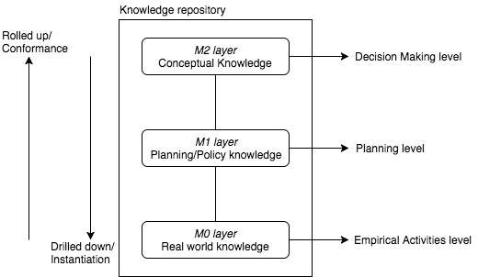
Figure 1. Knowledge transfer guided by MOF framework.
Likewise, this approach can also be observed in other scholars (Benaben et al., 2016; Chen et al., 2015; Lauras et al., 2015). Nonetheless, unlike in Othman & Beydoun (2016), these scholars shortfall in two ways: (1) they do not inform how their metamodels are developed and validated. This is important to guarantee that the decisions constructed based on the metamodel is able to inform the comprehensiveness of the knowledge required to each of particular contexts; (2) their metamodels do not cover all PPRR phases but only response phase (Lauras et al., 2015) and preparedness and response phases only (Benaben et al., 2016) and only a specific flood disaster (Chen et al., 2015). Notwithstanding these, taken into account of the complexities of the knowledge in the DM activities as the basis of DSS in DM, demystifying it in a more understandable format representing the urgency in the DM timeline still become the issue for all of them (Benaben et al., 2016; Chen et al., 2015; Lauras et al., 2015; Othman & Beydoun, 2016)
As mentioned earlier, we draw this paper based our initial works (Inan et al., 2015). This is because, firstly, the work presented in this paper has been part of a larger work that aims to contribute in the DM resilience endeavours. In fact, one of the authors of this paper is highly involved in developing DMM (Othman & Beydoun, 2013). The DMM is resulted from the synthesising various DM models ranging from natural disaster: bushfire, flood, earthquake, etc., to manmade: nuclear disaster, etc. Thus, in such structure, those synthesised DM concepts will guide of what are the typical knowledge needed in the decision making processes for each particular case (for the detail please see (Inan et al., 2017)). Secondly, in the previous works, we have addressed one of the key challenges on how to disentangle the complex knowledge elements described earlier. In particular, we developed a Knowledge Analysis Framework (KAF) to analyse and model DM knowledge subsequently depositing it into DMM. The analysis and model activities conducted employing Agent-Based Models (ABMs) from Agent-Oriented Software Engineering (AOSE). The use of ABMs for disentangling the knowledge out of the DM domain because of their capabilities to represent the complex characteristics out of the domain (Lopez-Lorca et al., 2016). In this task, ABMs are used descriptively to decompose the intertwined knowledge in the DISPLAN guided by the elements in each representative model (the KAF is therefore will be briefly discussed each of the stages in the next section as it underpins this research ).
In addition, as the adopted repository is a metamodel structure which in fact is a model per se (Beydoun et al., 2009), the conversion process of the knowledge managed in ABMs to its metamodel then becomes model to model transformation (Syriani et al., 2013). This has been maturely defined by OMG (OMG, 2013) through the Meta Object facilities (MOF) framework. Thus, adopting MOF is twofold: (2) to guide the transforming process of ABMs to the representative repository; and (2) to provide the clear-cut of the knowledge structured in ABMs as it is aimed for planning/policy or for real world layer. Therefore, MOF also underpins this work given its features. This is as illustrated in Figure 1. Once the knowledge is placed in the repository, it can then be retrieved by the stakeholders. The way the knowledge is structured in the repository allows the construction of the decision making as briefly described earlier as it is structured by distinguishing the knowledge in the conceptual, planning and in the real world activities. The knowledge in these three layers are linked by their semantic relationships as they essentially refer to the same activities but for different context.

The knowledge analysis framework underlying the decision support development
As earlier described, the construction of the decision making mechanism this paper aimed to contribute is underpinned by our validated Disaster Management KAF (Inan & Beydoun, 2017a). As such, to give way of complete understanding of the decision making processes, an overview of how the framework works is provided. Our validated KAF is as drawn in Figure 2 as follows:
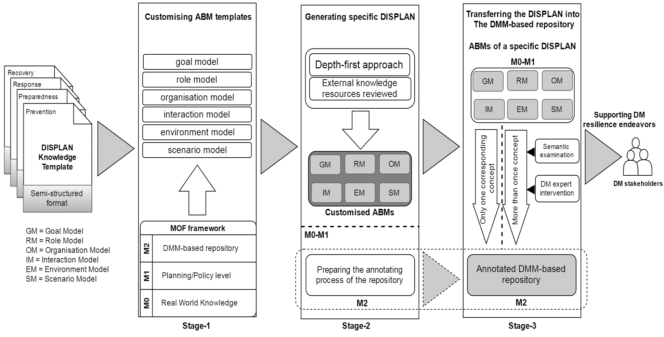
Figure 2. The validated Disaster Management Knowledge Analysis Framework (DM KAF).
This is resulted from the three times validations with the different case studies from Wagga-Wagga SES and Wollongong SES of the New South Wales State (Inan & Beydoun, 2017b; Inan et al., 2016) and Moira Shire SES of the Victoria State, in Australia (Inan & Beydoun, 2017a). The evaluation process follows the strategy prescribed in here (Venable et al., 2016) for the adopted Design Science Research (ADR) (Sein et al., 2011). Since the development, our KAF is considered to not only have thoroughly satisfied the research objectives but also, during the validations, we have demonstrated, the KAF improves its efficiency and effectivity since the development (Inan & Beydoun, 2017a). Moreover, validations through various case studies are aimed to ensure generalisability (Sein et al., 2011) of our validated KAF that is able to be utilised in other DM cases.
As in Figure 2, essentially our validated KAF consists of three main stages, they are: (1) customising ABM templates; (2) generating the specific DISPLAN; and (3) transferring the DISPLAN into the repository. For the purpose of the paper, each of these three stages will only be discussed descriptively to present a general picture how this framework works. This is because the development and evaluations of the framework have been previously presented (Inan et al., 2017). To what follows, the descriptions of the three stages:

Customising ABM templates
Customising ABMs take place in this stage. The input of the framework is the template of the DISPLAN knowledge, for instance the DISPLAN knowledge template of the SES NSW or SES Victoria States. The use of template is to guarantee that the knowledge is sufficient representing its abstraction to be used for others. The DISPLAN template itself is a typical document of knowledge model that is prone to be structured in a business specification format but constituting the primary foundation for the authoritative to be used in the real DM activities. It is also a collection of essential and relevant knowledge elements structured based on the strictly delineated yet widely adopted DM framework, the PPRR phases.
A knowledge engineer with intimate DM background (or DM expert with agent-based paradigm understanding) in involved in the analyses and models the DISPLAN template and structures it into the each of six (6) representative ABMs: goal model, role model, organisation model, interaction model environment model and scenario model. The aim of the tasks is to parse the intertwined and fuzzy knowledge elements to be used in the later phase. The MOF in this stage is used to distinguish the knowledge that is used in the real world DM activities (or based on MOF it is also known as M0) and the one that represents it in the modelling process (M1) to be used in the planning level. The knowledge in these two layers essentially refer to the same knowledge concept but represented differently for the purpose of the decision making processes. The analysis and modelling processes themselves is guided by the knowledge elements of the ABMs and conducted iteratively. In other words, which knowledge element that needs to place to what representative ABM is guided by the knowledge elements of the ABM. The result is six ABMs contained the DISPLAN template. For instance, if the input is the DISPLAN template of the Preparedness phase from the SES Victoria then the result produced from the Stage 1 is the ABM of DISPLAN templates of the SES Victoria of Preparedness phase.

Generating the specific DISPLAN
Once the ABMs of the DISPLAN template is in place, the next process is to generate the ABM DISPLAN templates for a particular place. For instance, the ABM DISPLAN templates of the SES Victoria State generate the ones of Wollongong SES Municipality. The generating process itself employs depth-first approach. The use of template and depth-first approach is to guarantee not only the efficiency but also the effectivity of the generating process (Inan et al., 2017). By embracing the template, developing a particular DISPLAN can be easily generated from the template following the essential and relevant knowledge elements in it. In other words, the DISPLAN development does not have to be from scratch.
Preparing the repository to which the knowledge will be deposited to also occurs in this stage. Based on MOF, the repository essentially is in the M2 layer. The process is by annotating the concepts in the DMM with the representative constructs of the AB metamodel FAML (Beydoun et al., 2009). This is undertaken due to the ABM and the DMM are developed based on the different school of thoughts. Thus, to allow them to communicate each other based on MOF (OMG, 2013), they need to be prepared and synchronised.

Transferring the DISPLAN into the repository
Once ABMs representing the DISPLAN of a particular place is generated as described in this stage, it is then transferred into the repository. Nonetheless, most knowledge elements in this stage are sufficient to be executed immediately as the result of analysis and modelling activities. For some elements, however they need to be further specified with local characteristics to become sufficiently prescriptive towards enacting real world activities. Thus, to best use of the DISPLAN generated for a particular are, completing the existing knowledge by incorporating the external knowledge elements is required. The aim is to guarantee that the knowledge elements particularly to be embraced by those who are on the ground can be as prescriptive as possible representing the context aware and real world activities. Thus, once the incorporating the external knowledge elements into the specified ABM are completed, the transferring process can be proceed. The transfer process is carried out semi automatically by engaging a DM expert with the intimate DM knowledge for a particular disaster.
The knowledge structured in the repository underlies the decision making processes. In the repository, the knowledge is organised based on the 3D structure representing PPRR phases, DM concepts and the urgency level of it. For responding a particular disaster event, the knowledge will inform what DM phase the concern should be taken into account, the representative concept of the event, and the urgency level that represents whether the knowledge is in the conceptual or planning or real world activities layer.

The framework prototyping
As part of the deliverable IS artefacts produced from the research following the DSR methodology, a prototype of the framework is built. The architecture of it is as described in here (Inan & Beydoun, 2017b). It essentially comprises of two transformable tools. The first one is the Agent-Oriented Analysis tool. This tool is used to analyse and model the knowledge elements from DISPLAN template and structure them based on the representing ABMs. The output of the tool is the ABMs of the DISPLAN template that is compiled in an XML file. Subsequently, the knowledge in the XML format is then transferred to the second tool representing the repository. The repository is built using MySQL, an open source Data Base Management System (DBMS) as for its total cost of ownership. The knowledge stored in the DBMS is with the aim to easily manipulate it for the decision making processes.

Decision making support based on the framework
As earlier elucidated, DSS mechanism in this context can be mechanised in two ways: either bottom up and/or top down. This is as illustrated in Figure 3.
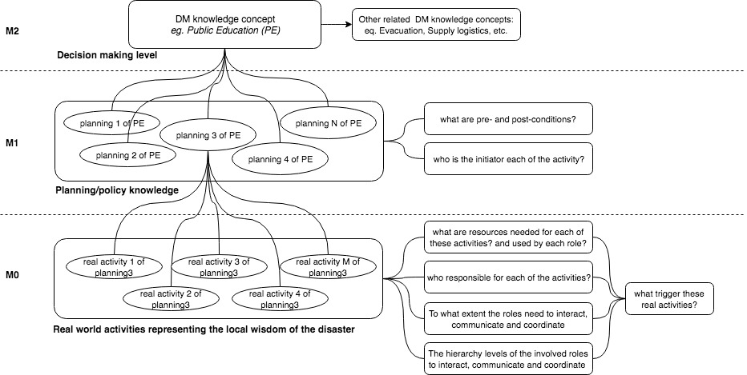
Figure 3. Conceptual construction of decision making mechanism based on the framework.
As can be seen from the Figure 3, while the top down means some concepts in the repository are identified at the first place prior to drill down instantiating the real DM activities, the bottom up means that the decision can be formulated based on particular activities rolled up conforming their constructs in the repository. These constructions are in accordance with MOF that was previously elaborated (Please see Figure 1). Based on MOF these typical relations are instantiation and conformance respectively. Therefore, the relation between the knowledge modelled in ABMs and the DMM-based repository also follows these two relation types. As part of the knowledge analysis framework, all these decision making processes are materialised as in the prototype to be used in this research. In this section, these two types relations underlying the DSS construction of the DM are illustrated as follows:

Bottom up approach
In the bottom up approach (conformance), the decision making begins by recognising the empirical knowledge guiding the activities carried out by authorities as a response to the environment changes. The empirical knowledge is aimed to guide the authorities who are on the real world activities, i.e. they are the ones who directly evacuate those who are exposed and threaten by disaster, interact, collaborate and negotiate with each other, educate people living in the prone areas of the potential risk and how to deal with, distribute aids, etc. In this sense, the knowledge that is specified for them should be sufficiently empirical to guide them in these particular activities. The aim is at achieving the resiliency, that is an ability to bouncing back from unforeseen stress as soon as possible. The authorities who use these typical knowledge elements need not to interpret the knowledge rather making use of it as it is directly. Based on the conceptual construction of the DSS as drawn in Figure 3, this typical knowledge is structured as M0. This then rolls up to identify the representative knowledge elements of the empirical knowledge. Both empirical knowledge and its representative element are in the different layers. This is because they both define different purposes and are used by different roles.
The representation of the knowledge of M0, on the other hand, is described in M1 layer. This is the layer in which the knowledge from M0 is defined in a more abstract form to be used by those who are aimed for. They are essentially the authorities who develop plan or policy of the DM activities. Based on MOF, this layer is then called plan/policy layer. As can be seen from Figure 3, each of the DM knowledge plans in M1 contains various and empirical activities of M0. This is because while the M0 layer contains know-how, -what, -with , -who, -why and -when, these empirical knowledge elements might be represented as one plan/policy only as they fundamentally are in one concept. Moreover, there might be various plans/policies that aim to pursue that particular concept. This concept can be recognised relatively easily as the DM knowledge repository (Othman & Beydoun, 2016) adopted in this research allows this to happen. Recognising the plans/policies and their concept representation can processed by mapping their semantic meanings. All these knowledge structuring processes are allow to happen as the KAF (Inan et al., 2017) underpinning this research.
For instance, in a case of a volcano eruption, the knowledge from the authoritative inform that “volcano is going to erupt”. This knowledge element will be the trigger for the authorities to perform the necessary activities to respond to. The related activities for instance “Search and Rescue (SAR) Team standby in each designated post”, “SAR and authorised DM agency keep monitoring visually and technologically the volcano activities”, etc. As this is the typical empirical knowledge elements then the “technologically” element needs also to be specified, i.e.: whether it could be a telescope or drone with certain specification designed for this activity. This is due to the knowledge in this layer that has to be empirical. Thus, from this instance, the knowledge should inform not only: “what are the activities”, but also “who activate them”, “to what extent the involved roles negotiate, coordinate and interact with each other”, “what are the resources needed by the roles to perform the activities”, and other empirical knowledge elements. Since these knowledge elements have been previously converted in the repository, they can then be retrieved and used based on the need of the authorities in the DM timeline.
Based on the MOF, all these empirical knowledge elements might represent a plan only, for instance “initiating response phase activities”. In other words, this particular plan contains various empirical knowledge activities previously describe and in fact, for a particular trigger, there might be various plans that are related to the one previously. These plans essentially represent the concept, for instance, “command” in the repository (M2). In other words, under the “command” concept of this particular case, there are plans that have been provided under which each of them has the corresponding activities.

Top down approach
On the other hand, the construction of the DSS in DM can be also approached through a top down mechanism. In the top down approach (instantiation), decision making process is constructed by instantiating the recognised knowledge concepts into the corresponding activities. Initially, a concept is acknowledged by authorities. In this research, this process can be done relatively easier as initially all the relevant and essential DM concepts have been populated, synthesized deposited in a representative knowledge repository. In the repository, these concepts are structured and related utilising the metamodel technique which is called Disaster Management Metamodel (DMM) (Othman et al., 2014).
Acknowledging this particular concept is with the aim to develop resiliency. In this context is the ability to adapt to the unforeseen stress. For instance, in order to develop a resilience endeavour to a volcano eruption disaster event in the Response phase activities, there is a need of “A system to manage incident prioritization, critical resource allocation, communications systems integration, and information coordination which includes facilities, equipment, personnel, procedures and communications during a disaster”. Among the populated and synthesized concepts in the repository, this semantic meaning essentially is represented by a concept: Coordination (Othman et al., 2014, p. 258).
However, to be able to achieve this type of resiliency, the more DM concepts recognised for various goals to be achieved, roles to be played, resourced to be identified and activities to be performed, the better. This is because the repository used facilitates this to happen. The repository constitutes essential and relevant concepts of DM: 21, 25, 25, 21 concepts in Prevention, Preparedness, Response and Recovery respectively. Subsequently, all these concepts have to be able to be identified their instantiations, they are the knowledge elements describing the activities, roles, resources and goals of these acknowledged concepts. This is particular urgent for those who are on the lower layers: M1 and M0, as drawn in Figure 3.
As in the figure, while DM concepts are positioned in M2 layer (the example in the previous paragraph is Deployment), that is the layer aimed for those who issue decisions, the M1 layer is intended for those who are in the planning/policy level, and M0 layer contains the empirical knowledge elements described in M1 layer. The example of these mechanisms can be observed from the instance described in the previous paragraph but with the reverse process. That is, the instance of the Coordination is “Search and Rescue (SAR) Team standby in each designated post” and “SAR and authorised DM agency keep monitoring visually and technologically the volcano activities”. These are essentially the examples of plans/policies instantiated from Coordination concept. Subsequently, the empirical activities have to be drilled down from them for those who are on the real world layer. All these knowledge elements are analysed and structured in the repository using the KAF defined previously in Section 2.3. Once the Coordination concept is holistically processes, followed by the other related concepts with the same mechanism.

Evaluations with a case study of Mt. Agung volcano eruption in Bali Indonesia
A case study of Mt. Agung volcano eruption is used to evaluate the developed approaches. The case study presented in this essay is based on the disaster event recently occurred in Bali Indonesia. This is a volcano eruption disaster type that fluctuated since November 2017 up to now at the time the paper is written. The case study is selected to evaluate the DSS in DM as this is the recent disaster event that can be relatively easier tracking its fluctuations status and the activities taken by authorities. Its fluctuations can be monitored through the website of The Centre of Vulcanology, Hazard Mitigation and Geology(PVMBG), the authorised agency in Indonesia that is responsible for enacting the level status of volcano eruption activities that represents urgency.
The level status of volcano eruption itself comprises of 4 levels: (1) normal: there is no volcano activity; (2) vigilante: there is indications that the volcano activities appear; (3) alert: the volcano activities increase and; (4) warning; the volcano activities in the highest status that might lead to erupt or is erupting. Enacting a status by PVMBG will then be followed up by the authoritative agency for managing the disaster, that is BNPB with a set of corresponding activities. In Figure 4, the fluctuations of the Mt. Agung level statuses are drawn in a timeline.
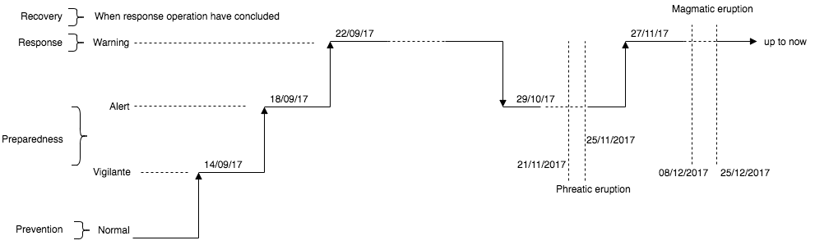
Figure 4. The timeline of Mt. Agung volcano eruption fluctuations.
As previously mentioned, the objective of the research is to construct the decision making process of this disaster case based on the developed KAF as explained in Section 2.3. Our communication with the Deputy Head of Prevention and Preparedness BNPB who is also the National Chief of Mt. Agung DM provided us, although limited, reports containing day to day activities of the agencies involved and the roles they play. In these typical daily reports contain the knowledge to guide the activities of the involved agencies, for instances: the coordinating and communicating the evacuation activities by Indonesia Search and Rescue agency (BASARNAS) and BNPB, distributing tents and coordinating their constructions by Social Ministry, providing temporary education in the evacuation areas by Education Ministry, and etc. Although limited, these reports are sufficient to be used to illustrate the construction of the decision-making mechanisms the paper aims to contribute.
The illustration of this case study is along with the discussion on how these developed approaches: bottom up and top down can be sufficient to be used to represent the case study. In this context, the evaluation strategy follows the Design Science Research (DSR) (Hevner et al., 2004) in Information System (IS) approach, that is ex-ante – naturalistic of Venable et al. (2016). While ex-ante evaluation in this context is that the used artefact of KAF underpinning this research have been rigorously developed and validated previously (Inan & Beydoun, 2017b; Inan et al., 2017), naturalistic evaluation is because the cases study employed for the evaluation of this DM DSS approach based on the real-world case study.

Bottom up approach of the case study
For the purpose of the demonstrating the DSS construction in this bottom up approach, we populated and analysed the reports until a day before the magmatic eruption took place, that was ones before 8 December 2017. We then modelled and deposited the knowledge in those reports utilising the developed KAF (As described in Section 2.3) subsequently visualising the deposited knowledge using the developed tool to ease the evaluation.
As can be seen in Figure 4, in the Mt. Agung case, PVMBG issued a vigilante status on September 14th, then in only subsequent four days, it issued alert status, that was on September 18th, then the warning status, the highest one, was enacted since September 27th 2017 (BNPB, 2017). This warning level status enacted would be the trigger knowledge for the DM authorities to undertake the necessary Response phase type activities that they are responsible for (This paper only discusses DSS construction in Response phase as the space limit). As in Figure 5, the warning status means (a) volcano is going to erupt; (b) eruption will happen in 24 hours; and (c) first eruption will be started with gases and ashes. In Figure 5, these elements are structured in trigger section (1).
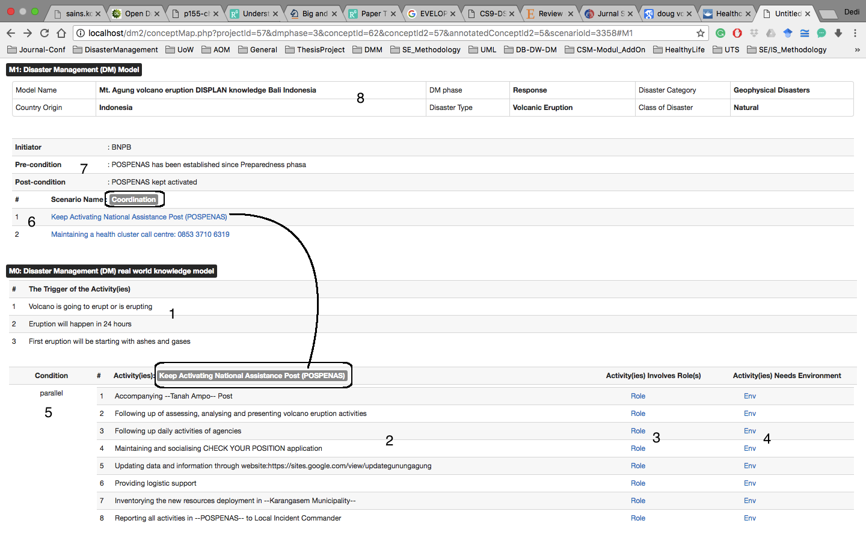
Figure 5. Knowledge structure for decision making system based on MOF framework.
Based on these trigger knowledge elements, all the corresponding knowledge activities (2) that have been previously analysed and stored in the repository will guide the roles (3) responsible for. As for the resources needed in each of the activities or used by each of the roles can be traced in (4) and whether the activities are performed parallel or interleave or sequential is government in (5). For instance, for the activity: maintaining and socialising CHECK YOUR POSISTION application, the roles that are responsible for are: BASARNAS and BNPB, and the resources needed to conduct this particular activity is: Radio FM and the website address to download the application. All these knowledge elements are constructed based on the daily activities on the report provided in the reports. As in the system, these knowledge elements are organised in M0 layer which mean these typical knowledge elements are essentially the ones specified for the roles who are in the real world activities. In other words, they are the typical roles that do not interpret the knowledge any further but utilise it directly. This is also because time limits them.
In the upper layer, M1, all the knowledge elements detailed in M0 are abstracted as the planning/policy level. For instance, all the knowledge elements describing activities represents only one planning/policy, that is “keep activating national assistance post (POSPENAS)” (Please See Figure 5). To be able to perform as complete activities as possible, all related plans/policies are also needed to be conducted. Utilising the KAF, they can be easily identified as in (6). For instance, the other one is “maintaining a health cluster call centre: 085 337 106 319”. By clicking this knowledge element, the knowledge for M0 layer be seen. The pre- and post-condition as well as the initiator of these planning/policy activities (7) are “POSPENAS has been established since Preparedness phase”, “POSPENAS is kept activated” and “BNPB” respectively. The information regarding the origin of the knowledge, the type of the disaster the knowledge is for as well as the country where the knowledge is from is also presented in this layer. This allows other stakeholders to get insight and reuse for the similar DM types. For instance, from (8), the information is that this is the best practice knowledge from Mt. Agung volcano eruption disaster type taken place in Bali Indonesia. The knowledge described is in the Response phase that is categorised as a geophysical disaster of the natural disaster.
As can be seen from Figure 5, the planning/policy knowledge that is defined in M1 fundamentally is represented as only a coordination concept in the DM knowledge repository (M2). There are other various concepts (9) that are directly related to the coordination concept. These other concepts can enrich the insight for those who are highly involved in the Response phase activities in any level real world activities – planning/policy – decision making.

Top down approach of the case study
The construction of the decision-making process can also be approached by a top down mechanism. This approach is the opposite of the bottom up approach previously described. This approach is begun by recognising the essential and relevant concepts. This aims to broaden an understanding as to how the DM activities would be performed. Initially, these essential and relevant DM concepts have been acknowledged in the DM knowledge repository. Acknowledging these various DM concept is allowed as the repository we adopt facilitates this to happen. As can be seen in Figure 5, in the repository all the essential and relevant knowledge concepts in the Response phase are listed in (11) and related in (12). In this case, once one of the them is recognised then the others that are directly related can also be identified easily. The way these concepts are related allows them being identified easily. This allows performing the DM activities in a more comprehensive way as all the essential and relevant concepts have been recognised.
Taking the instance of knowledge elements from bottom up approach, once there is a need to “manage incident prioritization, critical resource allocation, communications systems integration, and information coordination which includes facilities, equipment, personnel, procedures and communications during a disaster” (Othman et al., 2014, p. 258) then these activities are need to represent in a corresponding concept in the repository, that is a Coordination. However, instead of getting insight of only the activities within the Coordination concept alone, recognizing other concepts directly related to is crucial to understand the DM activities in Response phase thoroughly. This is because being able to understand the more related concepts leads to a better understanding in developing DM resilience endeavors. Using this approach, identification of all essential concepts can be conducted easily. As can be seen from Figure 5 the other concepts that are directly related to concept Coordination are: Command, Communication, ResponseGoal, ResponseTask, Rescue, EmergencyOperationCentre. The recognised concepts inform that not only be the Coordination should performed alone in the decision-making mechanism but also these other concepts have to be activated as well. The concept Command informs other activities to be carried on, Communication defines the resources needed by each of activities and/or used by each of the involved roles, ResponseGoal describes the goals to be achieved in each activity scenario and etc. (see Figure 5 (10) and (11)).
In our DSS construction, this knowledge structure is placed in M2 layer. This means that these knowledge concepts are specified for those who are on the decision-making processes. Once a decision is made then those who are on the planning/policy layer (M1) need to describe the knowledge fit for those who are on this particular layer. This process continues to the lower layer, M0, that is aimed to define knowledge as a guidance for those who will be on the ground. This typical knowledge structure allows the decision-making process being mechanised holistically and more complete from the decision making to the policy/planning and to real world levels.

Conclusion and Discussion
This paper presents a construction mechanism of the decision making system in the DM domain. It consists of two approaches: bottom up and top down approaches. The DM case study, that is a volcano eruption of Mt. Agung in Bali Indonesia occurred recently is used in the evaluations for both approaches. The case study is chosen as it can be tracked its fluctuations since normal level, the lowest one, to the highest one, the warning level. This leads to identify the corresponding knowledge required for each of the status levels. The evaluation scenario is based on the DSR methodology, that is ex ante – naturalistic. Evaluation using the DSR paradigm as the KAF as the artefact produced, used and underpinning this research is developed and evaluated using the same methodology. In addition, in this research, an artefact that is a model for the construction of the DSS for DM is also resulted.
Our evaluations of the two approaches using the case study successfully show that the decision making mechanism in DM can be constructed using either bottom up and/or top down. The evaluation demonstrates that, on the one hand, the decision can be mechanised using the external knowledge, that is the trigger one, as the result of the dynamic situations perceived by the authorities. The trigger knowledge is the typical one for the authorities who deal with real operational activities. The DM knowledge elements deposited previously in the repository facilitates the authorities to easily identify them that correspond activities caused by that particular trigger. Nonetheless, for as complete of other operational activities as possible that are crucial in a DM activity, the knowledge elements in the upper layer (planning/policy layers) need also to be laid out. These typical knowledge elements in the upper level aim to give way for as many as related operational activities caused by those particular triggers to be identified. These knowledge elements are then utilised as a guidance by the corresponding authorities to perform those activities. The objective is to develop this typical resiliency: bouncing back from unforeseen stress as soon as possible.
On the other hand, the decision making process in DM can also be mechanised by acknowledging the most essential and relevant knowledge concepts at the first place subsequently embodying them into the more implementable knowledge of activities. This approach is called a top down approach. This is begun by recognising one corresponding concept that is discerned appropriate for developing this typical resiliency, that is a capability to adapt to unforeseen stress. However, to be able to be effective in developing the resilient, recognising as many DM concepts as possible is urgent. These acknowledged concepts are envisaged being able to broaden the scope of understanding of the authorities who are on the decision making level. Therefore, an already identified concept is then followed by recognising other relevant ones that are directly related to. The DM knowledge repository type, the Disaster Management Metamodel (DMM), adopted in this research allows this to happen (See Figure 5 (11) and (12)). Subsequently, to be able to allow these recognised concepts to be executable, they need to be instantiated into scenarios representing the planned activities that can later be effectively and efficiently executed by those who are on the ground.
These both approaches are enabled by the use of Knowledge Analysis Framework (KAF) previously elucidated in Section 2.3. KAF is successfully developed and evaluated (Inan et al., 2017) for allowing the semi-structured knowledge in DM, the one the is used in this research, to be analysed and modelled subsequently transferred it into the representative knowledge repository. This then facilitates the sharing and reusing the knowledge for the similar disaster cases. The KAF facilitates the knowledge elements deposited in the repository to be structured in a way that they can be used at any point of the timeline in a DM case. This structure confirms that it benefits the mechanising of decision support system in DM as the key contribution of this paper.
In time-sensitivity events, these approaches are relevant as they address the knowledge in each DM phases (Prevention, Preparedness, Response and Recovery) holistically instead sequentially. This is conducted by allowing the knowledge to be rolled up and/or drilled down into decision making or planning/policy or real world activities levels. The knowledge in each layer aims to be fit for the each of them who use the knowledge. In other words, these both approaches are fit for each of the DM phases.
Our communication with the Deputy of Prevention and Preparedness of BNPB revealed that in the Mt. Agung volcano eruption, the typical knowledge of decision making is issued by the DM agency in the national level, that is BNPB. In our decision model, it is the M2 type knowledge. For M1, it is the knowledge that is prepared by the DM agency in the provincial level and in the municipality/regency level, they provide the M0 type knowledge elements (In Indonesia, BNPB is in the national level and its form in the provincial/municipality/regency is called BPBD: Local Disaster Management Agency). Although this information shows that the knowledge layering has been commonly practiced in Indonesia DM activities, however, to confirm whether the knowledge of M0 (in regency/municipality level) conforms its M1 in the (provincial level) and M1 conforms its M2 (national level) need a further scrutinise. This is because there is no DISPLAN for provincial/municipality/regency that can be accessed as the evidence. In addition, our approach is able to give way on how the DISPLAN can be better developed, structured and deposited for a better DSS in DM. This confirmation is crucial as the knowledge, apart from they are structured for different roles and purposes, they should be conforming and instantiating one and another.

Limitation and future research direction
The recent eruption of Mt. Agung volcano in Bali Indonesia is successfully used as a case study to demonstrate usage of SS for DM. This successfully evaluates the proposed system architecture. Notwithstanding the promising results, the following few limitations are worth noting: Firstly, the evaluation relied on a re-enactment of the disaster situation, rather than the actual disaster as it unfolded. A stronger evaluation would require a real time deployment of the system. In other words, engaging with a real disaster event is required to ascertain the performance of the system in an operational environment. This will provide feedback and evaluation of the world activities that would ensue as a result of the system. That would certainly shed more light of the efficacy and effectivity of the DSS approach in interacting with the stakeholders under a stressful situation. This real time embedding of the system is clearly not yet feasible at this stage. A deeper understanding the impact of the developed approach on end users is first needed. An intermediate study is required to prepare for an evaluation in a real disaster event. Such study will use IS theories such as activity theory (Engeström, 1999). Indeed, activity theory has extensively been used in the DM domain, e.g. (Allen et al., 2014; Bharosa et al., 2012; Chen et al., 2013; Hasan et al., 2017). The use of this IS theory will be part of our future research direction.
A secondly limitation is that the approach relies on pre-existing level of planning as encoded by the disaster management plans transferred into the DSS. This is not always feasible. For instance, BNPB does not yet have well documented DM plans that can be accessed publicly. The approach relies on the presence of a DISPLAN that is rigorously developed based on the existing best practices. Such plans typically inform the DM activities in Provincial and/or Regency/Municipalities as they can utilise it to develop their own incorporating their local wisdoms. This has been previously demonstrated in the development of DISPLAN Municipalities of Wagga-Wagga and Wollongong in NSW State Emergency Services context as well as the Moira Shire Municipality in Victoria (Inan & Beydoun, 2017a,2017b; Inan et al., 2016). It is our hope that our presented approach will be a further impetus for such plans to be developed where they currently do not exist. Indeed, in our view it is urgent for BNPB (and perhaps other DM agencies in other countries) to develop a customisable DISPLAN containing all the best practice knowledge elements under which it can be used as a foundation to instantiate others in the lower hierarchy levels.

References
Allen, David K., Karanasios, Stan, & Norman, Alistair. (2014). Information sharing and interoperability: the case of major incident management. European Journal of Information Systems (EJIS), 23(4), 418–432.
Ashinaka, Takushi, Kubo, Masao, & Namatame, Akira. (2016). A Decision-Support Tool for Humanitarian Logistics. In Lavangnananda, Kittichai, Phon-Amnuaisuk, Somnuk, Engchuan, Worrawat, & Chan, Jonathan H. (Eds.), Intelligent and Evolutionary Systems: The 19th Asia Paciﬁc Symposium, IES 2015, Bangkok, Thailand, November 2015, Proceedings (pp. 293-304). Cham: Springer International Publishing.
Benaben, F., Lauras, M., Truptil, S., & Salatge, N. (2016). A Metamodel for Knowledge Management in Crisis Management. Paper presented at the 49th Hawaii International Conference on System Sciences (HICSS2016).
Beydoun, G., Low, G., Henderson-Sellers, B., Mouratidis, H., J. Gomez-Sanz, J., Pavon, J., et al. (2009). FAML: A Generic Metamodel for MAS Development. IEEE TRANSACTIONS ON SOFTWARE ENGINEERING, 35(6), 841-863.
Bharosa, Nitesh, Lee, JinKyu, Janssen, Marijn, & Rao, HRaghav. (2012). An activity theory analysis of boundary objects in cross-border information systems development for disaster management. Security Informatics, 1(1), 1-17.
Blackman, Deborah, Nakanishi, Hitomi, & Benson, Angela M. (2017). Disaster resilience as a complex problem: Why linearity is not applicable for long-term recovery. Technological Forecasting and Social Change, 121, 89-98.
BNPB. (2017). Awas Gunung Agung, Status Dinaikkan Dari SIAGA Ke AWAS. Retrieved from https://www.bnpb.go.id/home/detail/3540/Awas-Gunung-Agung,-Status-Dinaikkan-Dari--SIAGA-Ke-AWAS (Access Date:25 November 2017)
Briceño, Sálvano. (2015). Looking Back and Beyond Sendai: 25 Years of International Policy Experience on Disaster Risk Reduction. International Journal of Disaster Risk Science, 6(1), 1-7.
Chen, Nengcheng, Du, Wenying, Song, Fan, & Chen, Zeqiang. (2015). FLCNDEMF: An Event Metamodel for Flood Process Information Management under the Sensor Web Environment. Remote Sensing, 7(6), 7231-7256.
Chen, Rui, Sharman, Raj, Rao, H. Raghav, & Upadhyaya, Shambhu J. (2013). Data model development for fire related extreme events: An activity theory approach. MIS Quarterly, 37(1), 125-147.
Coppola, Damon P. (2011). Introduction to International Disaster Management - Second Edition: Elsevier Inc.
Dorasamy, Magiswary, Raman, Murali, & Kaliannan, Maniam. (2017). Integrated community emergency management and awareness system: A knowledge management system for disaster support. Technological Forecasting and Social Change, 121, 139-167.
Engeström, Y. (1999). Activity Theory and Individual and Social Transformation. In ström, Y. Enge-, Miettinen, R., & Punamäki, R-L. (Eds.), Perspectives on Activity Theory (pp. 19-38). Cambridge UK: Cambridge University Press.
Fogli, Daniela, Greppi, Claudio, & Guida, Giovanni. (2017). Design patterns for emergency management: An exercise in reflective practice. Information & Management, 54(7), 971-986.
Grolinger, Katarina, Mezghani, Emna, Capretz, Miriam AM, & Exposito, Ernesto. (2015). Collaborative knowledge as a service applied to the disaster management domain. International Journal of Cloud Computing, 4(1), 5-27.
Haghighi, Pari Delir, Burstein, Frada, Zaslavsky, Arkady, & Arbon, Paul. (2013). Development and evaluation of ontology for intelligent decision support in medical emergency management for mass gatherings. Decision Support Systems, 54(2), 1192-1204.
Hasan, Helen, Smith, Stephen, & Finnegan, Patrick. (2017). An activity theoretic analysis of the mediating role of information systems in tackling climate change adaptation. Information Systems Journal, 27(3), 271-308.
Hevner, Alan R., March, Salvatore T., Park, Jinsoo, & Ram, Sudha. (2004). Design Science in Information System Research. MIS Quarterly, 28(1), 75-105.
Horita, Flávio E. A., de Albuquerque, João Porto, Marchezini, Victor, & Mendiondo, Eduardo M. (2017). Bridging the gap between decision-making and emerging big data sources: An application of a model-based framework to disaster management in Brazil. Decision Support Systems, 97, 12-22.
Inan, Dedi Iskandar, & Beydoun, Ghassan. (2017a). Disaster Knowledge Management Analysis Framework Utilizing Agent-Based Models: Design Science Research Approach. Paper presented at the The 4th Information Systems International Conference (ISICO 2017) Bali Indonesia.
Inan, Dedi Iskandar, & Beydoun, Ghassan. (2017b). Facilitating Disaster Knowledge Management with Agent-Based Modelling. Paper presented at the Proceedings of the Twenty First Pacific Asia Conference on Information Systems (PACIS2017), Langkawi Malaysia.
Inan, Dedi Iskandar, Beydoun, Ghassan, & Opper, Simon. (2015). Towards knowledge sharing in disaster management: An agent oriented knowledge analysis framework. Paper presented at the Proceedings of the 26th Australasian Conference on Information Systems (ACIS2015), Adelaide, South Australia.
Inan, Dedi Iskandar, Beydoun, Ghassan, & Opper, Simon. (2016). Customising Agent Based Analysis Towards Analysis of Disaster Management Knowledge. Paper presented at the Proceedings of the 27th Australasian Conference on Information Systems (ACIS2016), Wollongong NSW Australia
Inan, Dedi Iskandar, Beydoun, Ghassan, & Opper, Simon. (2017). Agent-based knowledge analysis framework in Disaster Management Information Systems Frontiers, (Forthcoming), 1-20. doi:https://doi.org/10.1007/s10796-017-9792-9
Lauras, Matthieu, Truptil, Sébastien, & Bénaben, Frédérick. (2015). Towards a better management of complex emergencies through crisis management meta-modelling. Disasters, 39(4), 687-714.
Leskens, J. G., Brugnach, M., Hoekstra, A. Y., & Schuurmans, W. (2014). Why are decisions in flood disaster management so poorly supported by information from flood models? Environmental Modelling & Software, 53(0), 53-61.
Lopez-Lorca, Antonio A., Beydoun, Ghassan, Valencia-Garcia, Rafael, & Martinez-Bejar, Rodrigo. (2016). Supporting agent oriented requirement analysis with ontologies. International Journal of Human-Computer Studies, 87(2016), 20-37.
Mejri, O., & Pesaro, G. (2015). Knowledge based strategies for Disaster Risk Reduction: A knowledge management framework to increase understanding and awareness of value of prevention and preparedness. Paper presented at the Safety and Reliability of Complex Engineered Systems - Proceedings of the 25th European Safety and Reliability Conference, ESREL 2015.
Mescherin, S. A., Kirillov, I., & Klimenko, S. (2013). Ontology of Emergency Shared Situation Awareness and Crisis Interoperability. Paper presented at the International Conference on Cyberworlds (CW) 2013.
OMG. (2013). OMG Meta Object Facility (MOF) Core Specification Version 2.4.1: Object Management Group (OMG).
Opper, Stephen, Cinque, Peter, & Davies, Belinda. (2010). Timeline modelling of flood evacuation operations. Paper presented at the 1st International Conference on Evacuation Modelling and Management.
Othman, S. H., & Beydoun, G. (2013). Model-driven disaster management. Information and Management, 50(5), 218-228.
Othman, S. H., & Beydoun, G. (2016). A metamodel-based knowledge sharing system for disaster management. Expert Systems with Applications, 63, 49-65.
Othman, S. H., Beydoun, G., & Sugumaran, V. (2014). Development and validation of a Disaster Management Metamodel (DMM). Information Processing and Management, 50(2), 235-271.
Poslad, S., Middleton, S. E., Chaves, F., Tao, R., Necmioglu, O., & U, Bügel. (2015). A Semantic IoT Early Warning System for Natural Environment Crisis Management. IEEE Transactions on Emerging Topics in Computing, 3(2), 246-257.
Reddy, Madhu C., Paul, Sharoda A., Abraham, Joanna, McNeese, Michael, DeFlitch, Christopher, & Yena, John. (2009). Challenges to effective crisis management: Using information and communication technologies to coordinate emergency medical services and emergency department teams. International Journal of Medical Informatics, 78(2009), 259–269.
Rivera, Claudia, Tehler, Henrik, & Wamsler, Christine. (2015). Fragmentation in disaster risk management systems: A barrier for integrated planning. International Journal of Disaster Risk Reduction.
Rosenzweig, Cynthia, & Solecki, William. (2014). Hurricane Sandy and adaptation pathways in New York: Lessons from a first-responder city. Global Environmental Change, 28(0), 395-408.
Santiago, J. Sedfrey S., Manuela, Wilfred S., Tan, Marion Lara L., Sañez, Siegfried Kiel, & Tong, Aldo Zelig U. (2016). Of timelines and timeliness: lessons from Typhoon Haiyan in early disaster response. Disasters, 40(4), 644-667.
Sein, Maung K., Henfridsson, Ola, Purao, Sandeep, Rossi, Matti, & Lindgren, Rikard. (2011). Action design research. MIS Quarterly, 35(1), 37-56.
Syriani, Eugene, Gray, Jeff, & Vangheluwe, Hans. (2013). Modeling a Model Transformation Language. In Reinhartz-Berger, Iris, Sturm, Arnon, Clark, Tony, Cohen, Sholom, & Bettin, Jorn (Eds.), Domain Engineering (pp. 211-237): Springer Berlin Heidelberg.
Tatham, Peter, Spens, Karen, & Kovács, Gyöngyi. (2017). The humanitarian common logistic operating picture: a solution to the inter-agency coordination challenge. Disasters, 41(1), 77-100.
Thapa, Devinder, Budhathoki, Nama Raj, & Munkvold, Bjørn Erik. (2017). Analyzing Crisis Response through Actor-network: The Case of Kathmandu Living Labs. Communications of the Association for Information Systems (CAIS), 41(2017), 414 – 428.
UNISDR. (2012) How To Make Cities More Resilient - A Handbook For Local Government Leaders. United Nations Office for Disaster Risk Reduction (UNISDR).
Venable, John, Pries-Heje, Jan, & Baskerville, Richard. (2016). FEDS: a Framework for Evaluation in Design Science Research. European Journal of Information Systems (EJIS), 25(1), 77-89.
Weichselgartner, Juergen, & Pigeon, Patrick. (2015). The Role of Knowledge in Disaster Risk Reduction. International Journal of Disaster Risk Science, 6(2), 107-116.
Xing-Ling, Wang, & Xue-Lian, Wu. (2012). A novel knowledge representation method based on ontology for natural disaster decision-making. Paper presented at the Computer Science and Automation Engineering (CSAE), 2012 IEEE International Conference on.

https://bnpb.go.id/berita
http://www.vsi.esdm.go.id/
https://sites.google.com/view/updategunungagung/laporan-harian

