Identification of Complexity Issues in the Jakarta Energy Planning Process using Agent-Oriented Analysis

Yohanes Anggoro, Suwin Sandu, Ghassan Beydoun

*School of Information, Systems and Modelling*

*University of Technology Sydney, AustraliaY*

@uts.edu.au

Abstract

The Jakarta Energy Planning Process (JEPP) is expected to be a successful template for other provinces in Indonesia. However, JEPP consists of a complex set of interrelated activities. These activities are fraught with difficulties and errors, including incorrectness, inconsistency, incompleteness, and redundancy in the process under which the Jakarta energy planning is undertaken. This paper aims to identify complexity issues in JEPP with the aim to alleviate these complexities using Agent-Oriented Analysis (AOA). This research uses the Design Science Research (DSR) method and towards the analysis employs seven Agent-Based Modellings (ABMs), including goal model, role model, organisation model, interaction model, environment model, agent model, and scenario model. The research consists of five stages: the synthesis of a preliminary knowledge analysis framework, the identification of complexity issues, recommendation synthesis, and finally the development of the complete knowledge analysis framework. While the analysis undertaken in this paper focuses on Jakarta, the developed knowledge analysis framework should be useful for energy planners in other regions, and research communities in general who are involved in such endeavours in developing complex planning processes.

**Keywords:**  Agent Oriented Analysis, Energy Planning Process, Knowledge Framework, Complexity Issues.

# Introduction

Jakarta, as the capital city of Indonesia, is expected to act as a role model for the achievement of the National Energy Policy targets set by the National Energy Council. All team members and energy stakeholders involved in the Jakarta Energy Planning Team are also expected to plan future energy needs effectively and to contribute significantly to meet the national energy mix in a sustainable and an environmentally friendly manner. However, energy planning activities and processes are inherently complex. Many problems and constraints invariably arise in the system development and implementation process (Sarmiento et al. 2015). According to Balint et al (2011), some of the common problems that may arise in the energy planning system such as a lack of a single problem statement, administrative and scientific complexity, conflicting data values, conflicting objectives, political complexity, a dynamic and a changing context, and multiplicity of actors involved. Furthermore, another common problem for a process system is the duplication of efforts in the process (Fadilpasic, 2015; Candito, 2016). Repetitive steps often reduce the quality of the process (Beydoun and Hoffmann 1998) and confuse the actors involved. Collecting data and maintaining its quality are also major challenges in the energy planning process both nationally and regionally (Cajot et al. 2017). It is paramount to clearly identify the core issues in the Jakarta energy planning process to formulate the complex energy planning process and this is yet to be adequately undertaken (Cajot et al. 2017).

The objectives of this paper is to improve JEPP. The paper provides a preliminary knowledge analysis framework aiming to provide a recommendation to reduce complexity issues in the energy planning process. The main research question in this paper is “How can Agent-Oriented Analysis (AOA) alleviate several challenges of energy planning process?”. Towards a problem solving through effective and efficient analysis of information system, this research deploys seven ABMs from the Agent-Oriented Software Engineering (AOSE) practice. The models have proved sufficient to cover more than 20 AOSE existing methodologies (Beydoun et al. 2009; Lopez-Lorca et al. 2016). This approach has proved effective in identifying and developing several issues in a complex system (Liang et al. 2013; Miller et al. 2014; Shvartsman and Taveter 2014; Inan 2015). The chosen ABMs are goal model, role model, organisation model, interaction model, environment model, agent model, and scenario model. The use of this methodology addresses a broader research complexity management question by constructing and evaluating knowledge artefact design to understand and solve human and organization complex problems.

This paper provides the developed knowledge analysis framework of the energy planning process based on the AOA using seven ABMs. It provides a practical impact for energy planning process development, especially those that involves the following four complexity challenges: including Correctness, Consistency, Completeness, and Redundancy (3C1R). Tackling these challenges at the outset alleviates more costly effort in further system development activities. The significance of this research will be very influential for many energy stakeholders in national and regional level, which composed of some ministries or local government as policy maker, energy utilities, energy planners, energy analysts, and energy researchers in academic or institute level to facilitate them performing an effective energy planning process. The rest of this paper is organized as follows: The next section reviews the development of agent technology and ABMs in the area of complex systems. The third section describes the methodology used in this research. The fourth section presents the overview of JEPP. The fifth section provides the research results and discussions on knowledge analysis framework. Finally, the sixth section concludes with a discussion of future work.

# Related Work

## Agent Technology

The use of the term agent has been widely used, including in the field of informatics and computer science, industrial, manufacturing, business, and electronic commerce. It resulted in the increasingly unclear definition of agent, as any researcher trying to define the agent with the background knowledge they have (Guralnik 1983; Caglayan et al. 1997; Brenner et al. 1998). Furthermore, Wooldridge and Jennings (1995a) define agent in more detail, the agent is defined to represent a hardware or software that has several properties. Besides having some properties, the agent is conceptualized and implemented as having human characteristics, for example, the agent has both of *mentalistic* and *emotional* characteristics such as knowledge, belief, intention, and obligation. According to Nwana (1996), the concept of agent has been long known in the field of Artificial Intelligence, and was first introduced by Carl Hewitt (Hewitt 1977) with “concurrent actor model”. From various studies related to that model, then the Distributed Artificial Intelligence (DAI) field was born which is derived from the Artificial Intelligence (AI) field. In the development DAI, it possesses several branches of research fields, such as Distributed Problem Solving (DPS), Parallel Artificial Intelligence (PAI), and Multi-Agent System (MAS) (Bond and Gasser 1988; Gasser and Huhns 1989; Chaib-draa et al. 1992; Wooldridge and Jennings 1994; 1995a; 1995b; 1996; Wooldridge et al. 1996; Wooldridge 2002; Lopez-Lorca et al. 2016).

In the development of agent technology, there are more numerous and complicated tasks that have to be done by an agent in a system, and it requires more agents in a system to complete those tasks. The paradigm of system development where there are multiple agents in a system, which interacts, negotiates and coordinate each other to carry out and complete the tasks is called as the Multi-Agent System (MAS). The MAS as sub-field of the AI aims to provide construction principles of a complex system involving several agents and coordination mechanisms for behaviours of the independent agents. Therefore, the MAS approach also can fulfil the user needs and meet the user’s requirements, which can be very complex (Al-azawi and Ayesh 2013), for instance peer-to-peer community based searching systems (Beydoun et al. 2011), and supply chain management (Xu et al. 2011)

## Agent-Based Knowledge Model

The system development is often interpreted as a process to improve existing system by developing a new system to replace the old system. There are some reasons the old system needs to be repaired or replaced, such as the existence of various problems, irregularities in the system, the growth of the organization, to achieve a greater chance, the system changes requested by the user. According to Akbari (2010), AOSE methodology is a business process of system development by using different concept and modeling tools of an agent, and put agents as central modelling to evolve system development paradigm (Wooldridge 1999; Ashamalla et al. 2017). It has been widely used in many domains, including robotics, networking, security, traffic control, gaming and commerce (Akbari 2010), disaster management (Inan et al. 2015).

With the increasing complexity of projects, some methodologies AOSE has been widely proposed by several researchers for instance: MaSE (DeLoach 2005), O-MaSE (DeLoach and Valenzuela 2007), MESSAGE (Dam 2003), Gaia (Wooldridge et al 1999), Promotheus (Padgham 2003), CommonKADS (Schreiber et al. 1994), CoMoMAS (Glaser 1996), MAS-CommonKADS (Iglesias et al. 1998), and Tropos (Mouratidis 2009). Those AOSE methodologies produce MAS by defining various steps, techniques, models, languages. Furthermore, Lopez-Lorca (2016) argue that the Agent-Oriented Analysis (AOA) as an analysis phase in a development life cycle based on AOSE methodology, which aims to capture some knowledge characteristics of existing system that need to be developed. Some literatures have demonstrated the effectiveness of AOA to capture complex knowledge characteristics of a particular domain, which contain various activities and constraints. For example, the use of AOA for the system development of health decision support framework (Liang et al. 2013), military training scenarios (Shvartsman and Taveter 2014), and aircraft turnaround simulation (Miller et al. 2014).

The ABMs or Agent-Oriented Models in the context of AOSE methodology often use to represent a complex organisation systems and capture system knowledge by parsing and extracting the complex system characteristics (Jennings and Wooldridge 2001; Wooldridge and Ciancarini 2001). Because there are many ABMs proposed by several AOSE methodologies (Argente et al 2011), this research only engage seven ABMs to synthesise further detail of JEPP. Those models refer to the generic metamodel for MAS development, which has proved sufficiently cover more than 20 AOSE existing methodologies (Beydoun et al. 2009; Lopez-Lorca et al. 2016).

# Research Methodology

The selection of methodology in this research is vital as it will directly affect the achievement of the study objectives and results (Silver et al. 1995, Zmud 1997, ISR 2002). According to Hevner et al. (2004), there are two research methods in the field of Information System. First is the Behavioural Science method, which has usually been used in natural science research to explain human or organizational behaviour by developing and verifying some existing theories. Another method is based on the Design Science Research (DSR), which is typically used in engineering science research aiming to enhance the capabilities of human or organization by constructing and designing new artefacts. This research use DSR method to assist a problem solving through effective and efficient analysis of information system. The purpose of employing the DSR method in this research is to develop a knowledge analysis framework for identifying real complex problem in energy planning processes and providing recommendation to improve these processes.

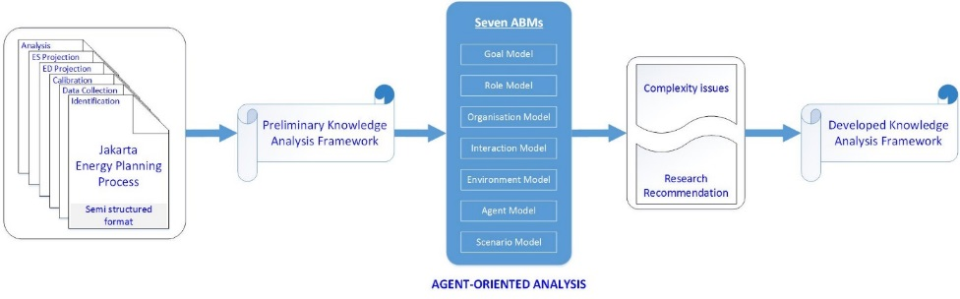

Figure 1. The Agent-Oriented Analysis (AOA) Stages.

Figure 1 describes several stages in this research. Firstly, the input of this research comes from JEPP workflow, which contains detail information of the energy planning process. Secondly, the preliminary knowledge analysis framework is developed based on information contained in JEPP workflow. Thirdly, the AOA of the preliminary knowledge analysis framework is undertaken using seven ABMs in the AOSE methodology to synthesise and to capture complex knowledge of JEPP. The seven ABMs employed in this research are goal model, role model, organisation model, interaction model, environment model, agent model, and scenario model. These models refer to the generic metamodel for MAS development, which has proved sufficiently cover more than 20 AOSE existing methodologies (Beydoun et al. 2009; Lopez-Lorca et al. 2016). Fourthly, based on AOA results, the real complexity issues of JEPP is identified., together with several recommendations provided to reduce complexity issues. Finally, the output of this research will provide developed knowledge analysis framework by considering the research recommendation results.

# Jakarta’s Energy Planning Process

Generally, the energy planning process at either regional or national level requires a diversity of inputs and coordination of various fields, stakeholders and information to achieve a goal of developing sustainable energy systems. According to the Jakarta Governor Decree No. 989 Year 2017, the study team of the Regional Energy General Plan (REGP) of the Jakarta province consists of six main organizational elements, including University (U), Districts (D), Regional Planning Agency (RPA), Regional Secretariat (RS), Regional Department (RD), and Regional Technical Institution (RTI). Each of these organisations has several actors who involve directly on the study implementation and responsible to the study coordinator. In total, there are more than 20 actors as team members. In addition, it also involves some energy stakeholders in 10 organisations at national level to support the study team in collecting socio-technical data to complete the regional energy planning study.

Figure 2 describes the detail of JEPP, which consists of six main steps. The first step aims to identify current energy issues and to define study goals. The second step involves the collection of existing techno-economic data and generation of existing energy chain. The third step aims to define study scenarios and study scope by harmonizing all existing data collected in the previous step, and calibrating the existing energy chain using the International Atomic Energy Agency (IAEA) approach to obtain a reference energy system. The fourth step engages a MAED software (Model for the Analysis of Energy Demand), which is one of the IAEA energy tools, to provide a detailed projection of sectoral energy needs based on several assumptions on future scenarios. The fifth step engages a MESSAGE software (Model for Energy Supply System Alternatives and Their General Environmental impacts) to formulate and evaluate alternative energy supply strategies. The sixth step aims to analyse the projection results of energy supply and demand, and draft the Regional Energy General Plan.

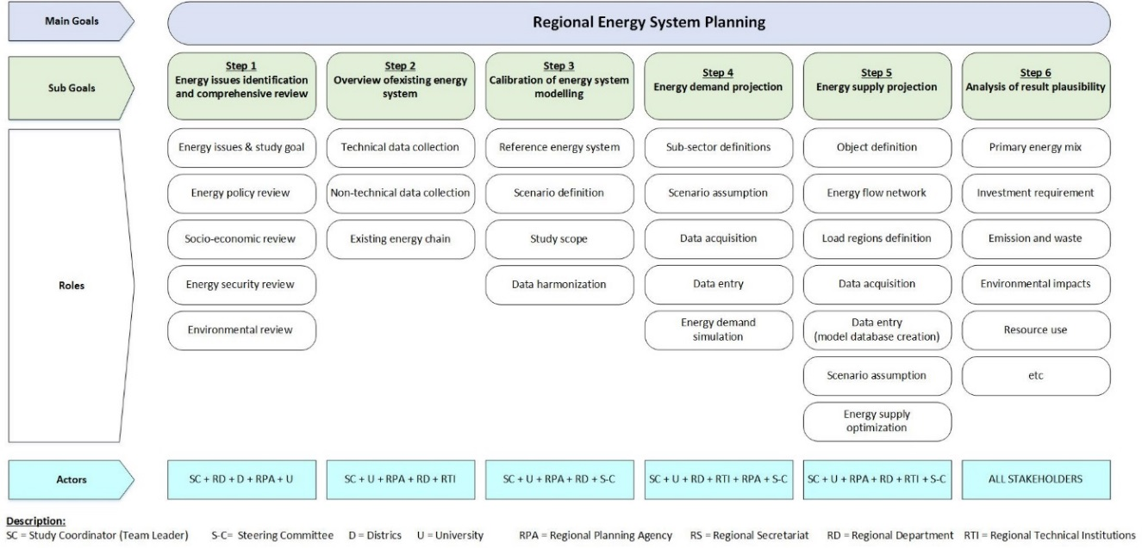

Figure 2. Jakarta energy planning process.

# Results and Discussion

## Preliminary Knowledge Analysis Framework



*Figure 3. Preliminary knowledge analysis framework*

Figure 3 presents the preliminary knowledge analysis framework of JEPP, which shows all activities and actors involved in each process. This preliminary framework aims to capture all existing knowledge of JEPP in a comprehensive and systematic manner based on information described in Figure 2, so that the complex energy planning process can be relatively easily understood. As a result, the preliminary knowledge analysis framework of JEPP as shown in Figure 3 able to describe all detail energy planning activities performed by the Jakarta energy planning team sequentially and systematically. It shows that there are six main goals or activities , i.e., energy issues and study goal identification, overview of existing energy supply system, calibration of energy system modelling, energy demand projection, energy supply projection, and results analysis. Each main goal can be further extended in more detail in several sub-goals within the same process. For example, the overview of existing energy supply system (step 2) can be split into two sub-goals, i.e., techno-economic data collection, and energy chain generation. Each of these goals/activities are then analysed using AOA in the following section.

## Agent-Oriented Analysis

This section discusses the agent-oriented analysis of the preliminary knowledge analysis framework, and generate several ABMs including goal model, role model, organisation model, interaction model, environment model, agent model, and scenario model.

### The goal model

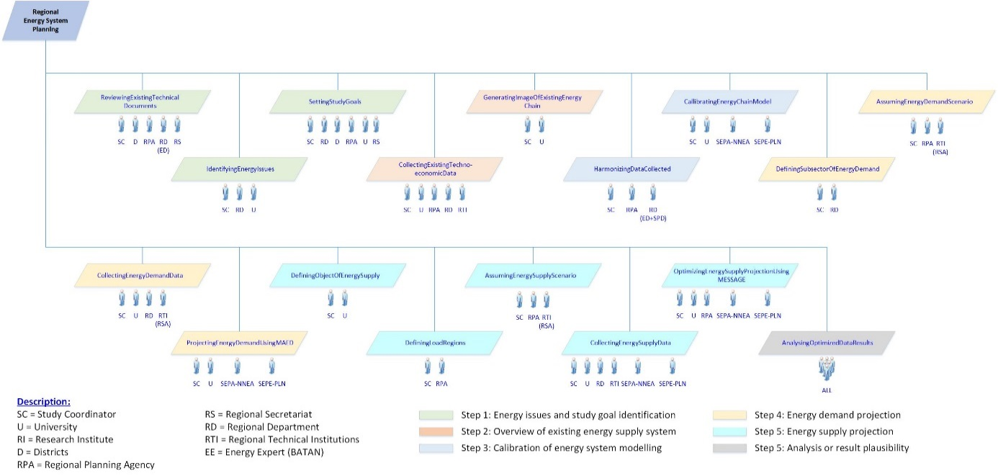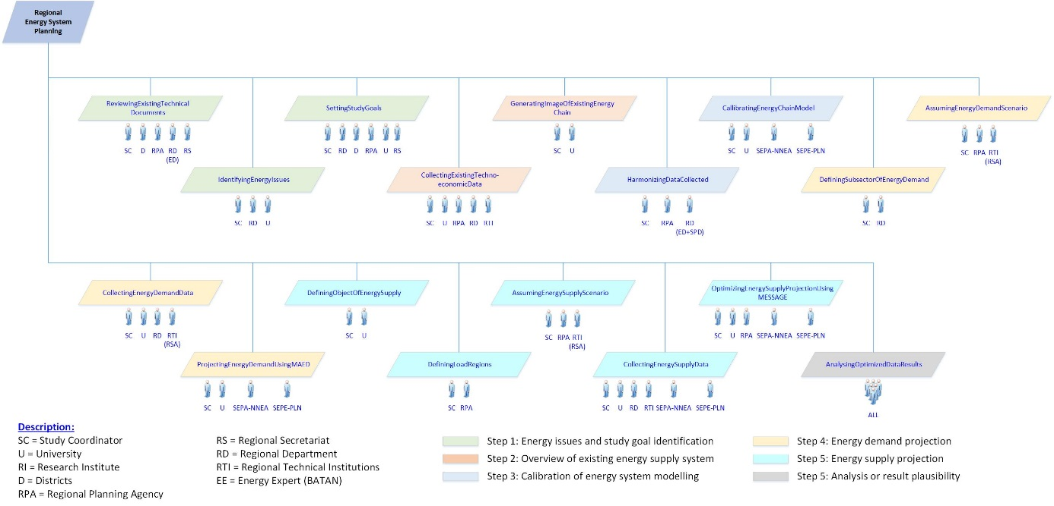

*Figure 4. A goal model of the Jakarta energy planning process, as an example.*

This research starts with the goal model at the beginning of the AOA, and put it as central modelling because it will become the basis for other ABMs to be processed. This research identified all six main goal models and 17 sub-goal models, which cover more than 90 activities or steps of the Jakarta energy planning process. Furthermore, it also identified each role involved in each goal and sub-goal. These goal models are identified to describe and explain the purpose and goal hierarchy in JEPP. As an example, this paper provides one particular main goal model as shown in Figure 4. In Figure 4, it shows only one main goal, i.e., regional energy system planning. This goal model has 17 sub-goals and the roles involved for each sub-goal are also shown. It also presents some knowledge elements, including: First, there are two knowledge elements, i.e. the goal (a main goal and 17 sub-goals) and the role. Second, the objective of energy planning activities is to achieve the main goal. Third, the main goal may consists of several sub-goals that must be responsible to achieve the main goal by having element “how-to” achieve the main goal. Fourth, the role(s) refer to the agent role to chase the sub-goal(s).

### The role model

The role model can be processed after the goal model as the role model represents more detail on responsibilities and constraints that has been identified in the goal model to achieve the system’s goal. This research identified 36 role models, which explain responsibilities of 36 actors/agents involved in the energy planning process based on the Governor Decree No. 989/2017 and real events.

|  |  |
| --- | --- |
| Role ID | R5 |
| Name | EED-IED |
| Description | The Head of Energy and Electricity Division |
| Responsibilities | 1. Preparing meeting agenda, and team’s schedules |
| 2. Reporting discussion report to the team leader |
| 3. Archiving all activities’ report documents |
| Constraints | - |

*Table 1. The role model of the Jakarta energy planning process, as an example.*

An example of the role model is shown in Table 1. It describes only one particular role i.e. EED-IED (Energy and Electricity Division of the Industry and Energy Department) with seven roles and without any constraints. Furthermore, it presents some knowledge elements, including: First, the unique role ID that obtained from the goal model. Second, the role name element that describes the agent’s role. Third, the description element that provides an explanation about the agent’s role. Fourth, the responsibilities element that describes all EED-ID roles in order to achieve the goal or sub-goals models, which EED-ID is responsible for. Fifth, the constraints element that defines the condition of the role’s entities (organisations/agencies/individuals).

### The organisation model

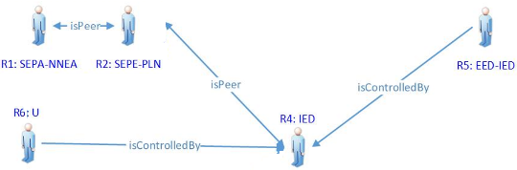 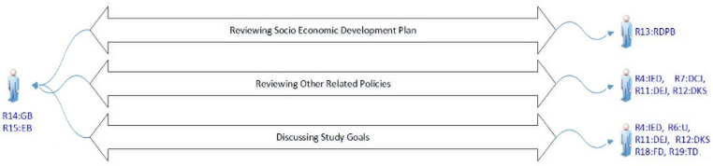

*Figure 6. An interaction model of JEPP, as an example*

*Figure 5. An example of organisation model.*

The organisation model is performed based on hierarchy level of the agent involved in the goal model and the role model. This research identified several organization models for 36 agents involved in JEPP. It aims to inform the work relationship, coordination, communication and negotiation between those agents. An example of the organisation model is shown in Figure 9, which present two knowledge element namely: the roles that obtained from the goal models and the relationship that describe how the roles are related, coordinated, communicated and negotiated each other.

As shown in Figure 5, there are two relationship types i.e. isControlledBy relationship, which define that one of the interrelated roles is in higher administration level and have an authority to control others; and isPeer relationship, which define that both of the interrelated roles has same level position and does not have an authority to control each other.

### The interaction model

In general, the interaction model is performed in this research to connect several activities with their agent’s roles, in which each connection represent an activity that has to be done to achieve main goal or sub-goal defined in the goal model. An example of the interaction model is shown in Figure 6. The knowledge elements captured in the interaction models are as follows: First, the role element is identified based on the goal model and the role model. Second, the activity element, which represent some activities in the sub-goals to achieve the main goal identified in the goal model. Third, the interaction element, which describe the relationship between activities and the agent’s roles.

### The environment model

The aim of the environment model is to identify environment entity that used by MAS when they pursue main goal or sub-goals defined in the goal model. This research identified twelve environment models where each environment entity also has some environment attributes. Furthermore, the environment model presents some knowledge elements, including: First, the unique environment entity ID for each environment element. Second, the environment name element that describes the environment type. Third, the description element that provides an explanation about the environment entity. Fourth, the attribute element that provide environment attribute list. Fifth, the role element that inform several agent’s roles who use this environment model.

|  |  |  |
| --- | --- | --- |
| E7 | Energy system classification | |
| Name | Energy system classification | |
| Environment Entity ID | E7 | |
| Description | Energy system classification used in MESSAGE software | |
| Attributes | # | Unique number distinguishing inputed data |
| Energy system name | Name of energy |
| Energy system type | Energy resources/energy forms/technologies |
| Roles Involved | R1:SEPA-NNEA, R2:SEPE-PLN, R4:IED, R26:EPA-NNEA | |

*Table 2. The environment model of the Jakarta energy planning process, as an example.*

An example of the environment model is shown in Table 2. It illustrates the environment entity of the energy system classification with entity ID “E7” as one of twelve environment entities identified in this research. It informs two environment attributes i.e. “*energy system name”* and *“energy system type”*; and 4 agent roles involved in the activity of energy system classification including R1, R2, R4, R6, R26.

### The agent model

The agent model is required to inform a set of equipment owned by one particular agent or actor to achieve each main goal or sub-goal defined in the goal model. This research identified 27 agent models, which explain more detail about all activities trigger and action, and environment entities of each actor. There are many knowledge element captured in the agent model, including agent name element, description element, reference element that obtained from the role model, environment element that obtained from the environment model, and activity element that provide activities list performed by agent to achieve its main goal or sub goal. Then, in each activity element has sub-element such as activity name element, functionality element that describes which main goal or sub-goals need to be achieved in the activity, trigger element that indicates what event will cause the activity start, and action element that describe a set of activities need to be performed when the activity started.

|  |  |  |  |
| --- | --- | --- | --- |
| Agent Type | DRS Type | | |
| Name | DRS | | |
| Description | Play role as the Deputy of Regional Secretariat | | |
| Reference | R3 | | |
| Environment considerations | E1, E4, E5, E6 | | |
| Activities | Activity Name | : | Discussing Energy Demand Projection Of MAED |
|  | Functionality | : | Discussing Energy Demand Projection Of MAED |
|  | Trigger | : | Final results of energy demand projection |
|  | Action | : | Analysing and evaluating the results of the MAED |
|  | Activity Name | : | Discussing Energy Supply Optimization Of MESSAGE |
|  | Functionality | : | Discussing Energy Supply Optimization Of MESSAGE |
|  | Trigger | : | Final results of energy supply projection |
|  | Action | : | Analysing and evaluating the energy demand projection |

*Table 3. The agent model of the Jakarta energy planning process, as an example.*

An example of the agent model is shown in Table 3. It illustrates the agent model of “*DRS*” has a role as the Deputy of Regional Secretariat. It means that the agent’s role refers to R3 in the role model, and will involve four environment entities i.e. E1, E4, E5, and E6 in the environment model. Then the agent will actively participated in two main activities, namely discussing energy demand projection of MAED, and discussing energy supply optimization of MESSAGE.

### The scenario model

The scenario model as the last of AOA is performed to provide detail descriptions of event sequences to achieve main goal or sub-goals defined in the goal model. This research created 17 scenario models, which describe how each scenario starts and ends. It also has many knowledge elements that similar with the knowledge elements in the agent model. However, the activity element in the scenario model provide all activities list, in which set up together with the role element, and the environment element required to achieve particular objective. Then, the condition element aims to inform whether those activities performed in parallel, sequentially or interleaved way. So that, this scenario model can be understood comprehensively and more easily.

|  |  |  |  |  |
| --- | --- | --- | --- | --- |
| Scenario | S12 | | | |
| Name | Energy Supply Object Definition | | | |
| Goal | Energy Supply Object Definition | | | |
| Initiator | SC | | | |
| Trigger | Final results of energy demand projection have obtained using MAED software | | | |
| Pre-condition | - | | | |
| Post-condition | - | | | |
| Description | - | | | |
| Condition | Step | Activity | Role | Environment Entity |
| Parallel | 1 | Defining Energy Resources | R1:SEPA-NNEA, R6:U | E7, E8, E9 |
| 2 | Defining Energy Forms | R1:SEPA-NNEA, R6:U | E7, E8, E9 |

*Table 4. The scenario model of the Jakarta energy planning process, as an example.*

An example of the scenario model is shown in Table 4. It illustrates that the Scenario “*S12*” aims to provide several object definition of energy supply, which initiate by the Study Coordinator (SC) and will be started when the MAED software result final energy demand projection. Soon, once the scenario has been started, there are two activities that can be performed parallel. Each activity will be conducted by several agent’s roles and will involve several environment entities.

## Complexity Issues of the Jakarta Energy Planning Process

According to Cajot et al (2017), the formulation of complex problems related to energy planning (due to interactions between energy, social and environmental factors) has not been discussed clearly in literature. Since the 1970s, some researchers have referred to the term "*wicked problems*" to explain social and environmental problems that are difficult to formulate. For example, Rittel and Webber (1973) argue that trying to formulate wicked problems is the problem itself. Cajot et al (2017) recently suggests that a knowledge framework is required to describe the complex problems in a complex system. Based on the results of AOA using seven ABMs in previous section, this research has identified several complex problems in the Jakarta energy planning process, as shown in Figure 7.

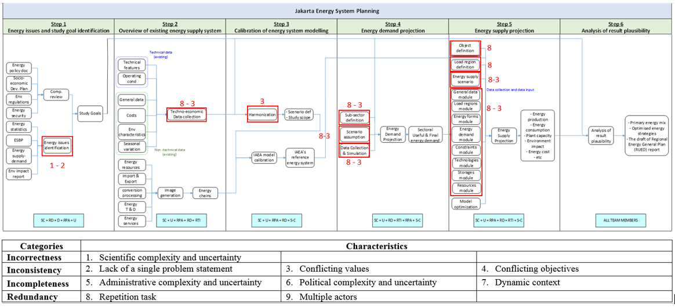

*Figure 7. Several complex problem of the Jakarta energy planning process.*

Figure 7 shows that there are four categories of complex problems i.e. *incorrectness, inconsistency, incompleteness,* and *redundancy.* These problem categories also known as “3C1R” of the complexity aspects, i.e. *correctness, consistency, completeness, and redundancy*. In general, an understanding of 3C1R can be described as follows: First, *correctness* occurs when the requirements components are recorded accurately, without redundancy and reflect the actual client’s needs. Second, *consistency* occurs when the requirements are confirmed to meet the client's needs. Third, *completeness* occurs when there are no missing key definitions on the system. Fourth, *redundancy* usually occurs because of the lack of collaboration between departments, so a process has been adapted in a less systematic way. These definitions imply that the *incorrectness* may occur when the requirements obtained do not accurately reflect the client's future needs, the *inconsistency* may occur when two or more users have conflicting requirements, and the *incompleteness* may occur when the clients are not fully understand the overall impact of the current decision.

Figure 7 also classifies several complex problem into nine problem characteristics including: *Scientific complexity and uncertainty* caused by a decision-making that is inhibited by uncertain or incomplete knowledge. *Lack of a single problem statement*, in which there will be difficulties to agree on the exact nature of the problem, because the definition of the problem lies in the viewpoint of the beholder. *Conflicting values*, in which the number of actors involved, will complicate the objective assessment of each solution. *Conflicting objectives*, in which goals and targets set by many actors and stakeholders on multiple scales, may not be converged if they have no good communication or consensus on those values. *Administrative complexity and uncertainty* caused by fragmentation of government institutions, at various levels and sectors that hinder the implementation of appropriate solutions. *Political complexity and uncertainty*, caused by uncertainty among political groups and public opinion that causes confusion in dominant values. *Dynamic context*, in which the energy planning study is dependent on very time-bound and volatile parameters such as fuel prices and operational costs, investment costs of energy conversion technologies, improvements and new technologies, population growth and high levels of urbanization, changes in political actors and a national agenda, an unstable international and national policy. *Repetition task with multiple tactics to address the problems*, in which the lack of consensus on the best approach to achieving the same results increases with no clarity about goals and values. *Multiple actors with the power to assert their values*, in which some team members and stakeholders can influence the problem and defend their interests, while the interests of third parties also must be considered.

In case of JEPP, as shown in Figure 7, this research identified complexity issues occurred in JEPP, including: the *redundancy* issues (repetition task) and the *inconsistency* issues (conflicting values) occurred in data collection process in step 2, 4, and 5 of JEPP; and data harmonization process between step 3, and step 2, 4, 5 of JEPP. The *incorrectness* issues (scientific complexity and uncertainty) and the *inconsistency* issues (lack of a single problem statement) occurred in energy issues identification process in step 1 of JEPP. Further details, this research identified the *redundancy issues* of data collection process when there are several data collected in step 2, 4, and 5 are similar. For example, step 2 collects several data of technical features data, operating condition data, general data (study timeframe, discount rate), energy cost data, environmental characteristics (emission, waste, land use), and seasonal variation data (load region, load curve). In the same way, the data collection process in step 4, and 5 collect these data obtained in step 2.

## Research Recommendation

By considering some complex problem identified in the Jakarta energy planning process, specifically in some problem spots as shown in Figure 7, this research provides some recommendations for all problem spots to minimize the complexity and to obtain a more efficient process. These recommendations are provided in Table 5 below.

|  |  |
| --- | --- |
| Complex problem | Recommendation |
| Problem spot: Identification of energy issues in step 1.  Real problems:   * Incorrectness: Scientific complexity and uncertainty. * Inconsistency: Lack of a single problem statement. | The review process of energy statistic and environment impact report is still required in the energy planning process. |
| Problem spot: The harmonization of techno-economic data and study scenario characteristics in step 3.  Real problem: Inconsistency: conflicting values. | Maintaining previous process by considering all data collected in step 2. |
| Problem spot: The sub-sectors definition of energy demand in step 4.  Real problems:   * Redundancy: repetition task. * Inconsistency: conflicting value. | Merging the process of sub-sectors definition of energy demand into the data harmonization activity. |
| Problem spot: The creation of future energy demand scenario assumptions in step 4.  Real problems:   * Redundancy: repetition task. * Inconsistency: conflicting value. | Merging the process of scenario assumptions of energy demand into the data harmonization activity. |
| Problem spot: The object definition of the existing regional energy system in step 5.  Real problems: Redundancy: repetition task. | Merging the process of object definition of energy supply in step 5 into the image generation of existing energy chain activity. |
| Problem spot: The load region definition in step 5.  Real problems: Redundancy: repetition task. | Merging the process of load region definition in step 5 into the data collection of load region step 2. |
| Problem spot: The creation of energy supply scenarios in step 5.  Real problems:   * Redundancy: repetition task. * Inconsistency: conflicting value. | Merging the process of energy supply scenario into the data harmonization activity. |
| Problem spot:   * The techno-economic data collection in step 2. * The data collection of energy demand projection in step 4. * The data collection of energy supply projection in step 5.   Real problems:   * Redundancy: repetition tasks. | * Separating the data collection activity and the data entering activity in step 4 and step 5. * Merging the process data collection in step 4 and 5 into the techno-economic data collection activity in step 2. * Keeping the process of data entering of energy demand in step 4 and data entering of energy supply in step 5. |

*Table 5. The research recommendations.*

## Developed Knowledge Analysis Framework

Based on the research recommendation in Section 5.4, this research provides the developed knowledge analysis framework of JEPP as shown in Figure 8. By comparing the developed knowledge analysis framework in Figure 8 with the preliminary knowledge analysis framework in Figure 3, this research has provided significance improvement in the energy planning process. As shown in Figure 8, there are three significance improvements produced in this research. The most significance improvement is in the data collection process, which was conducted repeatedly in step 2, 4, and 5. This research simplifies the data collection process by consolidating this process in step 2 (techno-economic data collection activity) and removing the process in steps 4 and 5. Secondly, the process of sub-sector definition and scenario assumption for energy demand and energy supply system in steps 4 and 5 are simplified by merging it with the process of data harmonisation in step 3. Thirdly, this research simplifies the process of energy chain generation in step 2 by redefining the required aspects in the energy chain system to become more efficient. By reducing some complexities and providing significance improvements in the energy planning process, it is expected that the developed knowledge analysis framework in this research can be used and adopted as a guidance for energy practitioner, energy researcher, academics and energy stakeholders to perform energy planning process in a more efficient way.

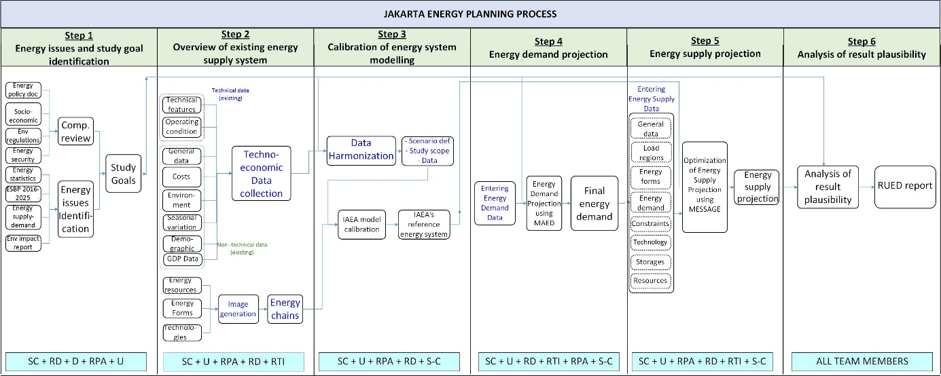

*Figure 8. The developed knowledge analysis framework.*

# Summary and Future Research

The purpose of this research is to improve the energy planning process by reducing complexity factors the process. This research uses DSR method by employing seven ABMs of AOSE to capture knowledge involved in the energy planning process. The results of the research are as follow: Firstly, this research has identified the preliminary knowledge analysis framework based on several information obtained from JEPP. Secondly, this research has captured, and analysed all knowledge artefact of the JEPP by using seven ABMs including goal model, role model, organisation model, interaction model, environment model, agent model, and scenario model. The use of ABMs has helped in understanding the complexity of JEPP in a comprehensive and systematic manner. Thirdly, this research has identified some complex problems in the JEPP that related to the “*3C1R*” complexity aspects, i.e., *correctness, consistency, completeness,* and *redundancy*. Fourthly, this research has provided several recommendations to reduce complex problems in the Jakarta energy planning process. Finally, this research has developed the knowledge analysis framework based on the result of AOA.

For further development, following the DSR method, the next stage of this research will develop more in-depth understanding into the developed knowledge analysis framework obtained in this research. This will enhance the generalisability of the proposed framework to apply it in other countries or regions that similarly have complex planning processes. Therefore, there is a need to perform further evaluation of the 1st version of developed knowledge analysis framework by using internal and external evaluations. Towards further internal evaluation, the framework will be re-evaluated using the same seven ABMs for another case study namely the Indonesia energy planning process. This will produce a refinement of the framework. Later, this will undergo further refinement using yet another case study, the Baltic energy planning process. The additional case studies will enable the formulation of additional assessment criteria considering various backgrounds and characteristics of the process. Ultimately, this will provide assurance that the final developed knowledge framework can be implemented and applied for any energy planning process.

# References

Akbari, Z. 2010. “A Survey of Agent-oriented Software Engineering Paradigm: Towards Its Industrial Acceptance,” *Journal of Computer Engineering Research* (1), pp 14-28.

Argente, E., Beydoun, G., Fuentes-Fernández, R., Henderson-Sellers, B., and Low, G. 2011. “Modelling with Agents,” *Paper presented at the 10th International Workshop Agent-Oriented Software Engineering*, Hungary.

Ashamalla, A., Beydoun, G., and Low, G. 2017. “Model driven approach for realtime requirement analysis of multi-agent systems,” *Computer Languages, Systems & Structures* (50), pp 127-139.

Al-Azawi, R., and Ayesh, A. 2013. “Comparing Agent -Oriented Programming Versus Object-Oriented Programming,” *ICIT 2013 The 6th International Conference on Information Technology*, pp 24-29, Jordan, 8-10 May 2013, IEEE Jordan Chapter.

Balint, P.J., Stewart, R.E., Desai, A. and Walters, L.C. 2011. *Wicked Environmental Problems: Managing uncertainty and conflict*. Island Press.

Beydoun, G., Low, G., Henderson-Sellers, B., Mouratidis,H., Gomez-Sanz, J.J., Pavón, J., and Gonzalez-Perez, C. 2009. “FAML: a generic metamodel for MAS development”, *IEEE Trans.Softw.En* (99: 1), pp 841–863.

Beydoun, G., Hoffmann, A. 1998. *“Simultaneous modelling and knowledge acquisition using NRDR”,* 5th Pacific rim conference on artificial intelligence (PRICAI98), Singapore, Springer-Verlag .

Beydoun, G., Low, G., Tran, N., and Bogg, P. 2011. “Development of a peer-to-peer information sharing system using ontologies,” *Expert Systems with Applications* (38:8), pp 9352-9364.

Bond, A.H., and Gasser, L. 1988. *Readings in Distributed Artificial Intelligence*. Morgan Kaufmann Publishers.

Brenner, W., Zarnekow, R., and Wittig, H. 1998. *Intelligent Software Agents: Foundation and Applications*. Springer-Verlag.

Caglayan, A., Harrison, C., Caglayan, A., and Harrison, C.G. 1997. *Agent Sourcebook: A Complete Guide to Desktop, Internet, and Intranet Agents.* John Wiley & Sons Inc.

Cajot, S., Peter, M., Bahu, J.M., Guignet, F., Koch, A., and Maréchal, F. 2017. “Obstacles in Energy Planning at the Urban Scale,” *Sustainable Cities and Society (30)*, pp 223-236.

Candito, N. 2016. “How Inefficient Processes Are Hurting Your Company.” <https://www.entrepreneur.com/article/286084> retrieved 10 July 2018.

Chaib-draa, B., Moulin, B., Mandiau, R., and Millot, P. 1992. “Trends in Distributed Artificial Intelligence,” *Artificial Intelligence Review* (6), pp 35-66.

Dam, K. 2003. *Evaluating And Comparing Agent-oriented Software Engineering Methodologies, PhD thesis*. School of Computer Science and Information Technology, RMIT University, Australia.

DeLoach, S. 2005. “Multiagent Systems Engineering of Organization-based Multiagent Systems,” *ACM SIGSOFT Software Engineering Notes* (30:4).

DeLoach, S., and Valenzuela, J. 2007. “An agent-environment interaction model,” *Agent-Oriented Software Engineering VII, Springer Berlin Heidelberg* (4405), pp 1-18.

Fadilpasic, S. 2015. “Inefficient processes are to blame for wasted work hour.” <https://www.itproportal.com/2015/09/02/inefficient-processes-are-to-blame-for-wasted-work-hours/> retrieved 10 July 2018.

Gasser, L., and Huhns, M. 1989. *Readings in Distributed Artificial Intelligence, Vol. 2*. Morgan Kaufmann Publishers.

Glaser, N. 1996. *Contribution to Knowledge Modeling in a Multi-Agent Framework (the CoMoMAS Approach)*. PhD Thesis at the L'Universtite Henri Poincare, Nancy I, France, November 1996.

Guralnik, D.B. 1983. *Webster's New World Dictionary*, Prentice Hall School Group.

Hevner, A.R., March, S.T., Park, J., and Ram, S. 2004. “Design science in information system research,” *MIS Quarterly* (28:1), pp 75-105.

Iglesias, C., Garijo, M., Gonzales, J.C., and Velasco, J.R. 1998. “Analysis and design of multiagent systems using mas-commonkads,” *Intelligent Agents IV (ATAL97)*, LNAI 1365 pp. 313-326, Springer-Verlag.

Inan, D. I., Beydoun, G., and Opper, S. 2015. “Towards Knowledge Sharing in Disaster Management: an Agent-Oriented Knowledge Analysis Framework,” *in Proceedings of the 26th Australasian Conference on Information Systems (ACIS2015)*, Adelaide, South Australia, pp 1-13.

ISR. 2002. “Editorial Statement and Policy,” *Information Systems Research* (13:4).

Jennings, N.R., and Wooldridge, M.J. 2001. *Agent-Oriented Software Engineering: Handbook of Agent Technology*. AAAI/MIT Press.

Lopez-Lorca, A. A., Beydoun, G., Valencia-Garcia, R., and Martinez-Bejar, R. 2016. “Supporting Agent-Oriented Requirement Analysis with Ontologies,” *International Journal of Human-Computer Studies* (87), pp 20-37.

Liang, Xiao, Fox, J., and Hong, Zhu. 2013. “An Agent-Oriented Approach to Support Multidisciplinary Care Decisions,” *Paper presented at the 3rd Eastern European Regional Conference on the Engineering of Computer Based Systems (ECBS-EERC)*.

Miller, T., Lu, B., Sterling, L., Beydoun, G., and Taveter, K. 2014. “Requirements Elicitation and Specification Using the Agent Paradigm: The Case Study of an Aircraft Turnaround Simulator,” *IEEE Transactions on Software Engineering* 40(10), pp 1007-1014.

Mouratidis, H. 2009. “Secure Tropos: An Agent Oriented Software Engineering Methodology for the Development of Health and Social Care Information Systems,” *International Journal of Computer Science and Security* (3:3), pp 241-271.

Nwana, H. 1996. “Software Agents: An Overview,” *Knowledge Engineering Review* (11:3). pp 205-244.

Padgham, P. 2003 *Prometheus: A Methodology for Developing Intelligent Agents, Agent-oriented software engineering III.*

Rittel, H. W. J., and Webber, M. M. 1973. “Dilemmas in a general theory of planning,” *Policy Sciences* (4), pp 155–169

Sarmiento, E., Leite, J.C.S.d.P., and Almentero, E. 2015. “Using correctness, consistency, and completeness patterns for automated scenarios verification,” *2015 IEEE Fifth International Workshop on Requirements Patterns (RePa)*.

Schreiber, A.T., Wielinga, B.J., Akkermans, J.M., and Van de Velde, W. 1994. “CommonKADS: A Comprehensive Methodology for KBS Development”.

Shvartsman, I., and Taveter, K. 2014. “From Agent-Oriented Models to Profile Driven Military Training Scenarios” in Zavoral, Filip, Jung, Jason, J., and Badica, Costin (Eds.), *Intelligent Distributed Computing VII* (511), pp 317-322, Springer International Publishing.

Silver, M.S., Markus, M.L., and Beath, C.M. 1995. “The Information Technology Interaction Model: A Foundation for the MBA Core Course,” *MIS Quarterly* (19:3), pp 361-390.

Wooldridge, M., and Jennings, N,R. 1994 “Agent Theories, Architectures, and Languages: A Survey”, *Proceedings of the Workshop on Agent Theories, Architectures, and Languages (ECAI-94).*

Wooldridge, M., and Jennings, N,R. 1995a. *Intelligent Agents*. Lecture Notes in Artificial Intelligence 890, Springer-Verlag.

Wooldridge, M., and Jennings, N,R. 1995b. “Intelligent agents: Theory and Practice,” *Knowledge Engineering Review* (10:2).

Wooldridge, M., Mueller, J.P., and Tambe, M. 1996. *Intelligent Agents II*. Lecture Notes in Artificial Intelligence 1037, Springer-Verlag.

Wooldridge, M., Jennings, N.R., and Kinny, D. 1999. “A Methodology For Agent-oriented Analysis & Design,” *Proceedings of the 3rd annual conference on Autonomous Agents AGENTS '99*, pp 69-76.

Wooldridge, M., and Ciancarini, P. 2001. *Agent-Oriented Software Engineering: The State of the Art*. in Ciancarini, P., and Wooldridge, M. (Eds.). *Agent-Oriented Software Engineering* (1957), pp 1-28. Springer Berlin Heidelberg.

Wooldridge, M. 2002. *An Introduction to MultiAgent Systems*. John Wiley & Sons, LTD.

Xu, D., Wijesooriya, C., Wang, Y.-G., and Beydoun, G. 2011. “Outbound logistics exception monitoring: A multi-perspective ontologies’ approach with intelligent agents,” *Expert Systems with Applications* (38:11), pp 13604-13611.

Zmud, R. 1997. “Editors Comments,” *MIS Quarterly* (21: 2), pp xxi-xxii.

Copyright

**Copyright:** © 2018 authors. This is an open-access article distributed under the terms of the [Creative Commons Attribution-NonCommercial 3.0 Australia License](http://creativecommons.org/licenses/by-nc/3.0/au/), which permits non-commercial use, distribution, and reproduction in any medium, provided the original author and ACIS are credited.