The effect of Schiff base network on the separation performance of thin film nanocomposite forward osmosis membranes

Nawshad Aktherª, Sungil Lim^{a*}, Van Huy Tranª, Sherub Phuntshoª, Yanqin Yang^{b}, Tae-Hyun Bae^{b}, Noreddine Ghaffour^{c}, and Ho Kyong Shonª

Journal Name: Separation and Purification Technology
Date: 14 February 2019

ªCentre for Technology in Water and Wastewater (CTWW), School of Civil and Environmental Engineering, University of Technology Sydney (UTS), NSW 2007, Australia
^{b}School of Chemical and Biomedical Engineering, Nanyang Technological University (NTU), Singapore 637459, Singapore
^{c} King Abdullah University of Science and Technology (KAUST), Water Desalination and Reuse Center (WDRC), Biological & Environmental Science & Engineering Division (BESE), Thuwal, 23955-6900, Saudi Arabia

Abstract
In this study, Schiff base network-1 (SNW-1) nanoparticles, which are covalent organic frameworks (COFs), were used as fillers in the polyamide (PA) active layer to elevate the performance of thin-film nanocomposite (TFN) forward osmosis (FO) membranes. The TFN membranes were prepared by interfacial polymerization (IP) of m-phenylenediamine (MPD) and trimesoyl chloride (TMC), and the SNW-1 nanoparticles were dispersed in the MPD aqueous solution at various concentrations. The secondary amine groups of SNW-1 nanoparticles reacted with the acyl chloride groups of TMC during the IP reaction to form strong covalent/amide bonds, which facilitated better interface integration of SNW-1 nanoparticles in the PA layer. Additionally, the incorporation of amine-rich SNW-1 nanoparticles into the TFN membranes improved their surface hydrophilicity, and the porous structure of SNW-1 nanoparticles offered additional channels for transport of water molecules. The TFN0.005 membrane with a SNW-1 nanoparticle loading of 0.005 wt.% demonstrated a higher water flux than that of pristine TFC membrane in both AL-FS (12.0 vs. 9.3 Lm⁻²h⁻¹) and AL-DS (25.2 vs. 19.4 Lm⁻²h⁻¹) orientations when they were tested with deionized water and 0.5 M NaCl as feed and draw solution, respectively.

Keywords: forward osmosis (FO); interfacial polymerization (IP), covalent organic frameworks (COFs); Schiff base network-1 (SNW-1); thin-film nanocomposite (TFN) membrane.

Introduction
Forward osmosis (FO) has achieved substantial consideration as a sustainable and energy-efficient membrane separation technology. FO processes do not require high hydraulic transmembrane pressure to operate like RO. They are instead operated by the osmotic gradient existing across the semi-permeable membrane due to the concentration difference between the low-concentrated feed solution (FS) and high-concentrated draw solution (DS) [1]. Since FO requires low or no hydraulic pressure to operate, it has several advantages like low fouling tendency, higher water recovery and possibly a lower operating cost compared to pressure-driven processes like ultrafiltration, microfiltration, nanofiltration and RO [2]. Due to these favorable characteristics, FO has been explored for several applications like wastewater and industrial effluent treatment [3-5], fertilizer drawn forward osmosis (FDFO) process [6], heavy metals removal and pharmaceutical product concentration [7, 8], food and brine concentration [9, 10], membrane bioreactors [11, 12], energy production [13] and desalination [14, 15].
Nonetheless, numerous factors make the large-scale application of FO difficult. These challenges include, but are not restricted to, trade-off relationship between membrane flux and selectivity, membrane fouling, and internal concentration polarization (ICP) that can decline water flux by more than 80% by reducing the actual osmotic pressure [16]. Several researchers have tried to address these issues by considering various types of draw solutions, and most importantly by developing membranes [17, 18]. Hence, the synthesis of high-performance membranes has been an active topic of research in the FO field. Both polyamide (PA) thin-film composite (TFC) and cellulose acetate/triacetate (CA/CTA) membranes, which are asymmetric in nature, have been extensively used for FO applications. However, TFC membranes with polyamide (PA) active layer established better water permeability and solute selectivity over extensive operational pH and temperature ranges, which led to their further development via chemical or surface modification and nanomaterial incorporation [18, 19]. Polymeric TFC membranes comprise of a thin dense active layer on top of a porous substrate, which is sometimes supported by a woven or nonwoven polyester mesh to improve the membrane’s mechanical strength [20]. The substrate structure influences the degree of ICP within the porous layer [21]; whereas, the active layer determines the membrane selectivity .
Since the TFC membrane performance is reliant on both its substrate and active layer properties, recent studies on TFC membranes mainly involved incorporation of nanomaterial into the active layer and/or substrate to enhance the membrane’s transport properties, structural characteristics, mechanical stability and chemical resistance [22]. Additionally, nanomaterials were coated on the membrane surface to augment the hydrophilicity, surface charge density and antifouling property of the membrane [23-25]. Several studies also demonstrated that nanocomposite membranes were capable of surpassing the trade-off relationship between membrane flux and selectivity [26, 27]. The performance of nanocomposite FO membranes is substantially affected by the concentration of nanomaterials and their physical and chemical properties. As such, the features of nanocomposite membranes can be tailored depending on the characteristics of nanomaterial chosen. Some of the inorganic nanomaterials that have been extensively used for FO membrane modification include zeolite [28], silica [29, 30] and titanium oxide [31, 32]. Despite nanocomposite membranes possessing several favorable properties, there are several problems associated with them, such as poor nanomaterial dispersion in the solvent, particle aggregation in polymer matrices, and particle instability in water causing nanoparticle loss. The above problems can be addressed by adding organic porous coordination polymers (PCPs), such as covalent organic frameworks (COFs), to membranes because they are porous, hydrophilic and compatible in the polymer phase.
COFs are two or three-dimensional crystalline organic nanoporous solids with extended structures of functional groups that are linked by strong covalent bonds [33]. COFs have been studied as membrane fillers for several applications like gas separation, adsorption and storage [34], photoconduction [35], nanofiltration [36] and catalysis [37] due to their favorable characteristics like thermal stability, porosity, polymer-phase compatibility and low density [33]. Additionally, the structure of COFs can be customized to achieve the desired pore structure and pore size to provide passageways for solvent molecules. Moreover, the presence of organic linkers in COFs make them compatible with organic polymers when compared to inorganic nanomaterials; thereby, minimizing the formation of non-selective voids between COFs and polymer matrix in composite membranes [38]. Furthermore, the high water stability and chemical stability of COFs facilitate the synthesis of highly stable membranes. Therefore, COF-incorporated nanocomposite membranes have the potential for application in FO separation processes.
In this work, amine-rich melamine-based COF nanoparticles called SNW-1 were incorporated as fillers in the PA layer of thin-film nanocomposite (TFN) membranes through the interfacial polymerization (IP) of m-phenylenediamine (MPD) and trimesoyl chloride (TMC) monomers on polysulfone (PSf) substrates to enhance the FO membrane performance. The SNW-1 nanoparticle structure is shown in Figure 1. The SNW-1 nanoparticles were chosen as membrane fillers as they possess several favorable properties: porous structure can provide more channels for transport of water molecules, small spherical size reduces defects in PA layer, secondary amine-groups improve membrane hydrophilicity, good dispersion and stability in both organic and aqueous phase. The secondary amine groups (-NH) of SNW-1 nanoparticles react with the acyl chloride groups (-COCl) of TMC during the IP reaction and form strong covalent bonds to provide structurally stable TFN membranes. The effect of varying the concentrations of SNW-1 nanoparticles on the membrane morphology, roughness, hydrophilicity, intrinsic transport traits, and FO performance was investigated. This work is the first to consider the influence of melamine-based SNW-1 nanoparticles fillers on the performance of TFN FO membranes to the best of our knowledge.
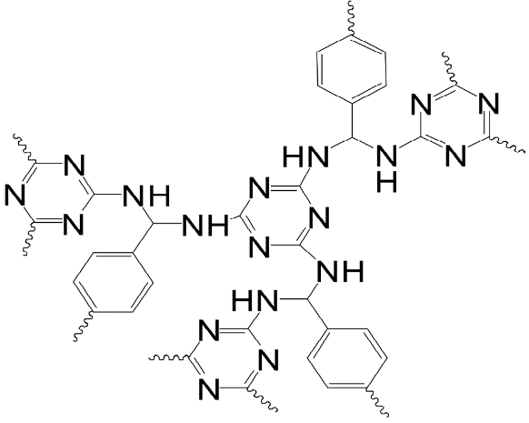
Figure 1: The structure of the amine-rich SNW-1 covalent organic framework.

Materials and methods

Materials
Melamine, terephthalaldehyde (99%, Sigma-Aldrich), acetone (99.8%, Merck), dimethyl sulfoxide (DMSO, 99.9%, Sigma-Aldrich), dichloromethane (DCM, 99.99%, VWR) and tetrahydrofuran (THF, 99%, VWR) were purchased and used without further purifications for the synthesis of SNW-1 nanoparticles. Polysulfone pellets (PSf, Udel® P-3500, Solvay) were used for fabricating microporous polymer membrane substrates and were dried at 50°C for 24 hours before preparing polymer dope solutions using 1-methyl-2pyrrolidone (NMP, ≥99.5%, Merck) as the polymer solvent. The precursors used for the formation of the PA layer included trimesoyl chloride (98%, Sigma-Aldrich), m-phenylenediamine flakes (99%, Sigma-Aldrich) and n-hexane (98.5%, Merck). Deionized water (DI, Milli-Q®, Merck) and sodium chloride (NaCl, Chem Supply) were utilized as FS and DS for the FO tests, respectively.

Synthesis of SNW-1
A solvothermal method, which has been described elsewhere, was used to synthesize the SNW-1 nanoparticles [39]. Briefly, 1.00 g terephthalaldehyde and 0.63 g melamine were dispersed in DMSO (31 mL) and transferred to a condenser tube fitted Schlenk flask. The mixer was continuously mixed and heated to 180°C in an inert environment of nitrogen for 3 days. The suspension was cooled to ambient temperature. SNW-1 nanoparticles were then isolated from the suspension by filtering using a Buchner funnel. The SNW-1 residue was finally rinsed using surplus THF, acetone and DCM. Lastly, the extracted SNW-1 nanoparticles were left to dry in a vacuum oven at 120 °C for 1 day.

Preparation of polysulfone membrane substrates
Polymer dope was made by dissolving 15 wt.% PSf pellets in 85 wt.% NMP under continuous stirring at 500 rpm at 60°C for 1 day to achieve a well-mixed solution. The polymer dope was pre-filtered using PET mesh and left to degas at 34°C for 1 day. The dope solution was then applied on the glass plate by means of a motorized film applicator (Elcometer 4340) and setting the casting knife height at 120 µm under ambient laboratory conditions. The cast PSf polymer film was then instantaneously submerged into a water bath at ambient temperature for 30 min to complete the phase inversion process. Coagulated PSf substrates were then rinsed and placed in DI water for 1 day to eradicate the remaining solvents.

Fabrication of TFC and TFN membranes
The PA layers were assembled on the PSf substrates by IP. Firstly, an air knife was employed to eliminate any remaining water from the substrates. Then the substrates were saturated with 4.0 wt.% aqueous MPD solution for 2.5 min. Surplus amine solution was eliminated from the substrate surfaces using a nitrogen knife. Next, the amine-impregnated substrates were dipped into the organic phase (0.1 wt.% TMC in n-hexane) for 1 min for the PA layer formation. The reacted membranes were then cured for 20 min in the air at ambient temperature. The fabricated membranes were finally washed with DI water to eliminate any surplus monomers. The membranes were then stored in DI water at 4°C for at least one day before conducting the FO tests.
The TFN membranes with SNW-1 nanoparticle fillers were made in a similar fashion to TFC membranes, but different loadings of SNW-1 nanoparticles (0.005, 0.01, 0.02 and 0.04 wt.%) were incorporated into the MPD solution. SNW-1 nanoparticles were uniformly dispersed in DI water by sonicating for 4 h followed by the addition of MPD into the SNW-1 particle dispersion, which was stirred at room temperature for 20 min. The subsequent MPD/SNW-1 saturated substrates were reacted with the TMC solution to initiate the IP process. The resultant PA layers had the SNW-1 nanoparticles embedded inside them. The prepared TFN membranes were represented as TFN0.005, TFN0.01, TFN0.02 and TFN0.04 based on the loading of SNW-1 nanoparticles.

Characterization of SNW-1 nanoparticles, TFC and TFN membranes
The top surface (PA layer) and cross-sectional morphologies of the membranes were analyzed with a scanning electron microscope (SEM, Zeiss Supra 55VP), which was operated at 5-10 kV. Pre-wetted membrane segments were ruptured in liquid nitrogen for the membrane cross-section study. The membrane samples were sputter coated with 12 nm thick Au/Pd prior to SEM analysis.
The surface roughness and morphology of the FO membranes were studied using atomic force microscopy (AFM, Dimension 3100, Bruker) equipped with a scanning probe microscope in tapping mode.
The static water contact angles of the membrane surfaces were measured with an optical tensiometer (Attension Theta Lite 100, Biolin Scientific) at room temperature to determine membrane surface hydrophilicity. Contact angle measurements for each sample were made at five random locations to obtain the mean value.
Fourier transform infrared spectroscopy (FTIR, Shimadzu MIRacle 10) was used to detect the chemical compositions of the SNW-1 nanoparticles and the fabricated membranes, in addition to assessing the chemical changes that occurred due to the reaction between TMC and SNW-1 nanoparticles. FTIR spectra were recorded at room temperature (20 scans at 2 cm⁻¹ resolution).
The nitrogen sorption isotherms of SNW-1 nanoparticles were obtained on a Quantachrome Autosorbe-1 analyzer at 77 K. The samples were degassed for 24 h at 393 K before recording the measurement. Brunauer-Emmet-Teller (BET), NL-DFT and t-plot methods were used to calculate the SNW-1 nanoparticles surface area and micropore volume from the nitrogen gas sorption isotherms. The BET surface area was calculated using the data points in the range of P/P⁰ = 0.05-0.2. The pore size distribution of SNW-1 nanoparticles was measured by applying the Horvath-Kawazoe (HK) method to the nitrogen sorption data obtained at 77 K.

Evaluation of membranes transport properties
The pure water permeability (A) and solute permeability (B) coefficients of the TFC (control) and TFN membranes were determined using the protocol developed for FO membranes by Tiraferri, et al. [40].

Assessment of membrane performance
A laboratory scale FO experimental system was utilized to investigate the performance of the developed membranes. The FO cell comprised of two flow channels with an effective membrane area of 15.4 cm² (2.2 cm wide, 7.0 cm long and 0.3 cm deep). A gear pump (Cole Parmer) was employed to circulate the FS and DS on each channel co-currently at a crossflow velocity of 12.6 cm/s (0.5 L/min). Both DS and FS were maintained at the ambient temperature throughout the performance tests. DI water was used as the FS, while 0.5 M NaCl was used as the DS. The membranes were tested in both AL-DS (active layer oriented towards DS) and AL-FS (active layer oriented towards FS) orientations. The membrane water flux (J_{w}, Lm⁻²h⁻¹) was determined by recording the change in FS mass using a digital mass balance (CAS, South Korea). Whereas, the reverse solute flux (J_{s}, gm⁻²h⁻¹) was obtained by monitoring the change in FS conductivity using a portable conductivity meter (LAQUAact, Horiba Scientific).
The membrane water flux was determined using Eq. 1, where ΔV_{feed,t} is the volume change in FS during the performance test, ∆t is the duration of the performance test and A_{m} is the effective membrane surface area (m²).
$$J_{w}=\frac{{ΔV}_{feed,t}}{A_{m}∆t}$$ | (1)
The reverse solute flux was determined using Eq. 2, where ∆C_{feed,t} and V_{feed,t} are the changes in the FS concentration and volume, respectively after a predetermined time, ∆t.
$$J_{s}=\frac{{ΔC}_{feed,t}V_{feed, t}}{A_{m}∆t}$$ | (2)
A better representation of membrane selectivity, compared to the reverse solute flux (Eq. 2), is the specific reverse solute flux (SRSF, g/L) as it indicates the quantity of draw solute moving into FS for every unit volume of water passing into DS [41]. The SRSF of the membranes was determined using Eq. 3. A smaller SRSF implies greater membrane selectivity in the FO process.
$$SRSF=\frac{J_{s}}{J_{w}}$$ | (3)

Results and discussion

Characterization of SNW-1
The size and morphology of SNW-1 nanoparticles were identified by SEM as shown in Figure 2a. The SNW-1 nanoparticles were observed to be spherical in shape with the diameter of each particle ranging between 20-40 nm. The small size of SNW-1 particles was beneficial for obtaining a homogenous and stable dispersion is the MPD aqueous phase; which further contributed towards the uniform distribution of SNW-1 nanoparticles in the PA layer.
The synthesized SNW-1 nanoparticles were found to have a BET surface area and NL-DFT micropore volume of 500 m²g⁻¹ and 0.14 cm³g⁻¹, respectively, showing a high crosslinking degree in SNW-1 monomers. The calculation by the Horvath-Kawazoe (HK) method revealed that the pore size of SNW-1 nanoparticles was approximately 5.5 Å (Figure 2b), which may provide extra channels for the transport of water molecules.
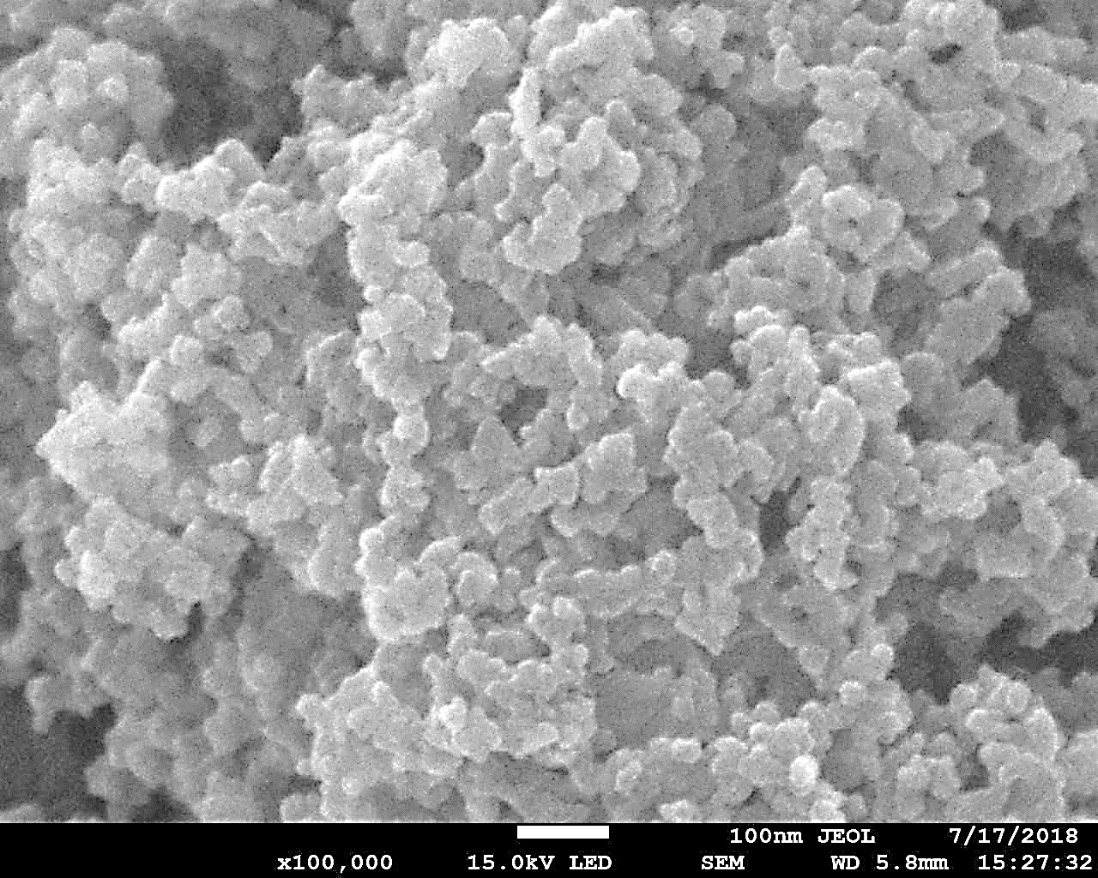
(a)
(b)
100 nm
Figure 2: (a) SEM image of the SNW-1 nanoparticles. (b) Pore size distribution of SNW-1 nanoparticles obtained from the HK method.

Formation of covalent bonds between SNW-1 nanoparticles and polyamide layer
The secondary amine groups (-NH) of SNW-1 nanoparticles can react with the acyl chloride groups (-COCl) of TMC, which will result in the formation of strong and stable covalent bonds between the SNW-1 nanoparticles and the PA layer (Figure S1) [42]. In order to investigate the reaction between the SNW-1 nanoparticles and TMC, a certain amount of SNW-1 nanoparticles were added to 0.1 wt.% TMC organic solution to form the reacted compound called TMC/SNW-1. The FTIR spectra in Figure 3 shows the chemical compositions of the pristine SNW-1 nanoparticles and the reacted TMC/SNW-1 nanoparticles. The FTIR spectrum of SNW-1 nanoparticles demonstrated the distinctive peaks of triazine ring’s semicircle and quadrant stretching at 1465 and 1535 cm⁻¹, respectively; thus, indicating the successful synthesis of SNW-1 nanoparticles and presence of triazine frameworks in their structure [39]. The peak representing triazine ring’s semicircle stretching in TMC/SNW-1 shifted slightly to 1480 cm⁻¹, but the peak for quadrant stretching remained unchanged. Two additional peaks were observed on the TMC/SNW-1 FTIR spectrum at 1610 cm⁻¹ and 1690 cm⁻¹, which are attributed to the aromatic amide band and C=O stretching vibration of the formed tertiary amide group, respectively [43]. The FTIR spectra confirm the occurrence of a chemical reaction between TMC and SNW-1 nanoparticles, where the SNW-1 nanoparticles will be able to covalently bond to the PA via tertiary amide bonds to enhance membrane stability. A conceptual diagram depicting the formation of a tertiary amide bond due to the reaction between TMC and SNW-1 nanoparticles is shown using a red circle in Figure 4.

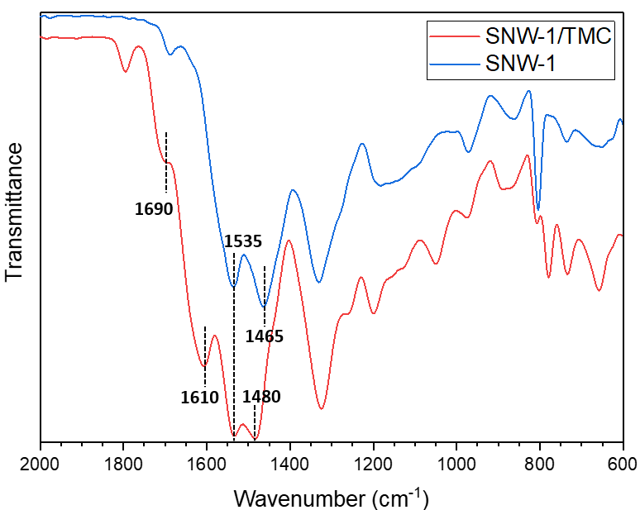
Figure 3: FTIR spectra representing the distinctive peaks of the SNW-1 and TMC/SNW-1 nanoparticles.

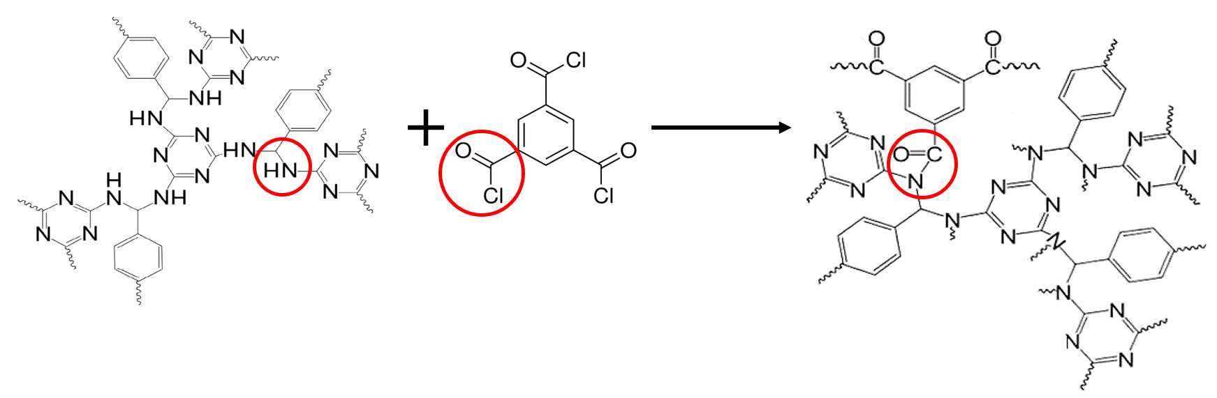
Figure 4: Schematic representation of a tertiary amide bond formation between the SNW-1 nanoparticle and TMC. The secondary amine group of SNW-1 nanoparticle, the acyl chloride group (-COCl) of TMC, and the formed tertiary amide group are shown in red circles.

Characteristics of the TFC and TFN FO membranes
The cross-section morphology of the substrate used for preparing TFC and TFN membranes is shown in Figure S2 . The SEM image revealed that the substrate has both long finger-like pores and macrovoids with a total thickness of nearly 58 µm.
The membrane top surface and cross-sectional SEM images were used to investigate the effect of the SNW-1 nanoparticles addition into the PA layer (Figure 5). All the membrane surfaces demonstrated the characteristic ridge and valley structure of the PA layer resulting from the reaction between MPD and TMC during the IP process (Figure 5a-e). The SEM images of the TFN membranes revealed that the SNW-1 nanoparticles were uniformly dispersed within the PA layer without any noticeable particle agglomeration (Figure 5b-e). The coordination and formation of hydrogen bonds between the amine groups of SNW-1 nanoparticles and MPD allowed self-assembly and good distribution of SNW-1 nanoparticles in the PA rejection layer [44]. In addition, the development of covalent bonds between the PA layer and SNW-1 nanoparticles, as presented in Figure S1, facilitated good compatibility between the SNW-1 nanoparticles and the PA layer.
Nonetheless, the surface of TFN membranes (Figure 5b-e) looked rougher than that of TFC membrane (Figure 5a) due to the development of round lumps that increased with an increment in the SNW-1 nanoparticle loading. Minimal spherical lumps were found on the TFC membrane surface, and it was the smoothest in comparison to the other membranes. The TFN0.04 membrane, on the other hand, demonstrated the highest density of these spherical lumps (Figure 5d), suggesting that the SNW-1 nanoparticles hindered the diffusion of MPD from the substrate into the TMC organic phase; therefore, slowing down the rate of reaction between MPD and TMC. Unhindered IP reaction results in the formation of more leaf-like structures as observed for the PA layer of the TFC membrane [45].
The formation of the PA layer on top of the substrates is clearly noticeable from the cross-sectional SEM images of the TFC and TFN membranes (Figure 5f-j). The overall thickness of the PA layer was found to decrease with an increment in the SNW-1 nanoparticle loading (Figure 6). The reduced PA layer thickness and restricted growth of the ridge and valley structures in the presence of SNW-1 nanoparticles further proved that the SNW-1 nanoparticles inhibited the diffusion of MPD [46, 47].

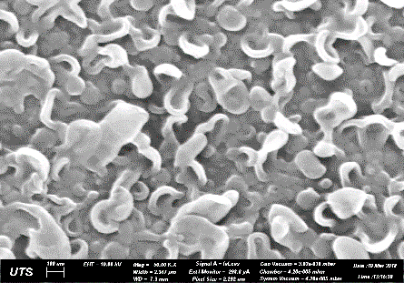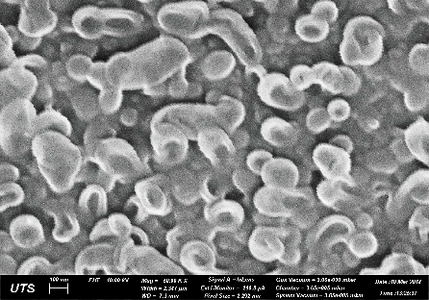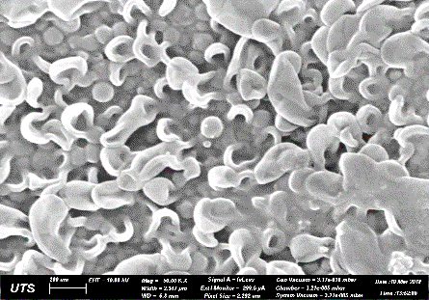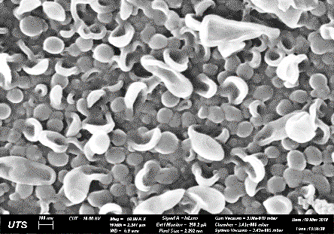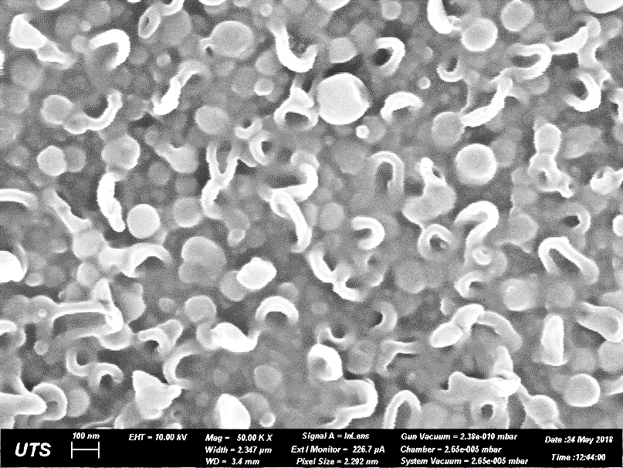
(j)
(i)
(h)
(g)
(f)
(e)
(d)
(c)
(b)
(a)
200 nm
200 nm
200 nm
200 nm
200 nm
600 nm
600 nm
600 nm
600 nm
600 nm
Figure 5: Top surface and cross-sectional SEM images of (a, f) TFC, (b, g) TFN0.005, (c, h) TFN0.01, (d, i) TFN0.02 and (e, j) TFN0.04 membranes.

Figure 6: Average PA layer thickness of the TFC and SNW-1 nanoparticles-incorporated TFN membranes.

The chemical changes on the synthesized TFC and TFN membrane surfaces were examined using FTIR. The spectra of the PSf substrate, TFC and TFN membranes are presented in Figure 7. The bands at 1240 cm⁻¹ (C–O–C stretch), 1149 cm⁻¹ (C–SO₂–C symmetric stretching), 1293 cm⁻¹ (S=O stretch), 1488 cm⁻¹ (CH₃–C–CH₃ stretch) and 1410 cm⁻¹ (C=C aromatic ring stretch) characterize the distinct PSf substrate functional groups [48].
The FTIR spectrum of the TFC membrane demonstrated three additional peaks compared to the PSf substrate. The peak at 1543 cm⁻¹ shows the presence of amide II (C–N stretch), while those at 1665 cm⁻¹ and 1610 cm⁻¹ denote amide I (C=O stretch) and aromatic ring breathing of the formed amide bond, respectively; thus, validating the PA layer formation on the substrate using the IP reaction [48].
The peak at 1543 cm⁻¹ (C–N stretch) was also present for the TFN membranes, and its intensity increased with an increment in the SNW-1 nanoparticle loading as more amide bonds formed when SNW-1 nanoparticles reacted with TMC. The TMC/SNW-1 reaction was further validated from the occurrence of the peak at 1650 cm⁻¹ (C=O stretching in tertiary amides) for all TFN membranes. The increasing peak intensities at higher SNW-1 nanoparticles concentrations signified the formation of more tertiary amide bonds. The formation of tertiary amide bonds take place only when SNW-1 nanoparticles react with TMC as depicted in Figure 4; which explains the absence of the peak at 1650 cm⁻¹ from the FTIR spectrum of the TFC membrane. Additionally, all the TFN membranes demonstrated peaks at 1460 and 1535 cm⁻¹, which represent the triazine ring from the SNW-1 nanoparticles [39]. The TFN membranes also exhibited a peak at 1480 cm⁻¹, which became more prominent at higher SNW-1 nanoparticle loadings as shown by the red box and black arrows in Figure 7. The peak at 1480 cm⁻¹ represents the triazine ring’s semicircle stretching in SNW-1 nanoparticles that reacted with TMC as discussed earlier. The presence of these peaks confirmed the successful integration of SNW-1 nanoparticles into the selective layer during the IP process.

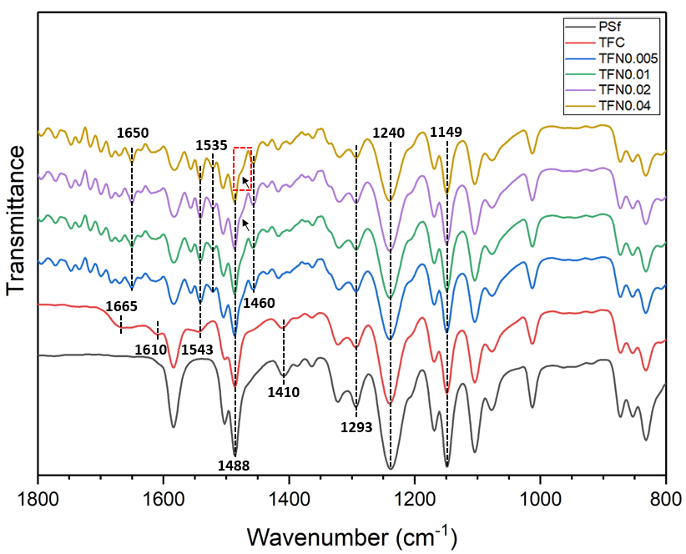
Figure 7: FTIR spectra representing the distinctive peaks of the TFC and TFN membranes.
The membrane surface roughness was examined using AFM. The three-dimensional AFM images of the substrate, TFC and TFN membrane surfaces are illustrated in Figure 8. The root mean square values (R_{ms}), mean roughness (R_{a}) and maximum roughness (R_{max}) are presented in Table S1. The typical ridge and valley formations of PA are evidently noticeable on the AFM images of the membranes (Figure 8), which confirm the PA layer formation on the PSf substrate. The average membrane surface roughness increased with an increment in SNW-1 nanoparticles loading. Since identical substrates were utilized for all the membranes, the increase in membrane surface roughness can be ascribed to the existence of SNW-1 nanoparticles in the active layer. The TFC membrane exhibited the smoothest surface with a R_{a} value of 27.9 nm; whereas, TFN0.04 has the roughest surface with a R_{a} value of 52.4 nm. Higher surface roughness is associated with an increase in the specific surface area of the membrane, which is beneficial for enhancing water transport across the membrane.
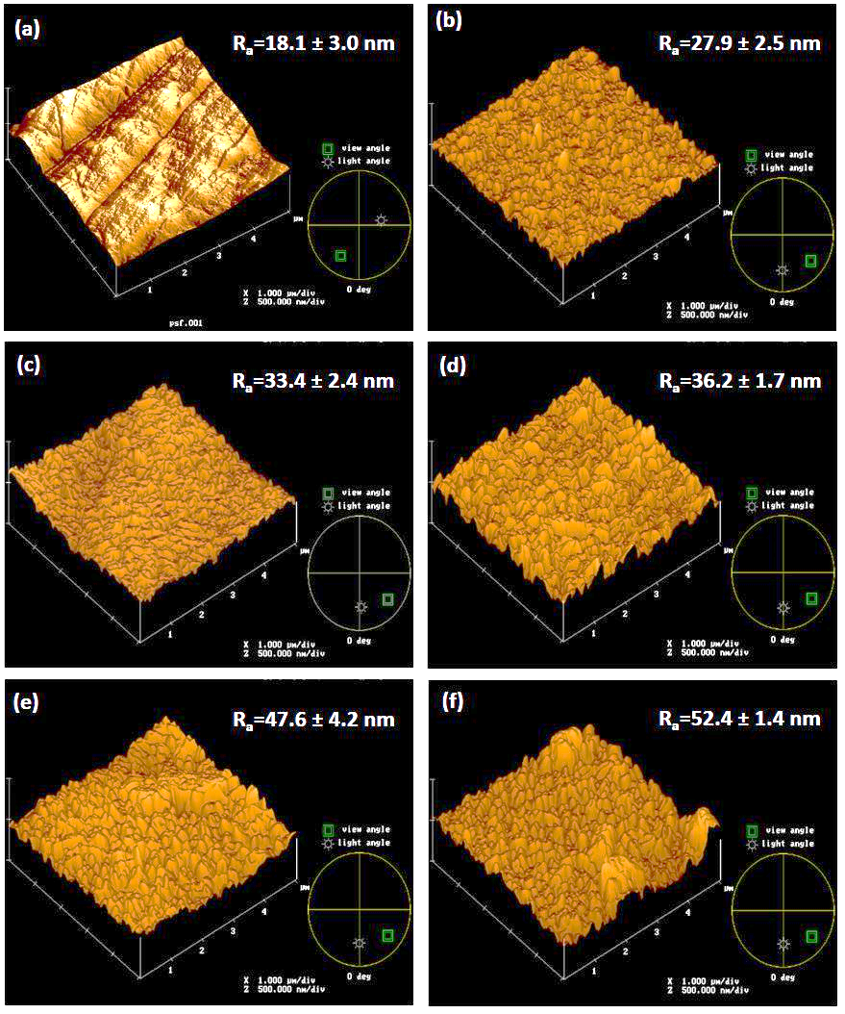
Figure 8: AFM images of (a) PSf substrate, (b) TFC, (c) TFN0.005, (d) TFN0.01, (e) TFN0.02 and (f) TFN0.04 membrane surfaces. The R_{a} values were measured in triplicates.

Membrane surface hydrophilicity is crucial for enhancing the flux across FO membranes. The hydrophilicity of membranes was assessed by evaluating the water contact angles on the membrane surface. The contact angles declined from 65.2° to 53.4° with an increase in the loading of SNW-1 nanoparticles from 0 to 0.04 wt.%, which suggested that incorporation of the hydrophilic amine-rich SNW-1 nanoparticles within the PA layer enhanced membrane surface hydrophilicity (Figure 9); thus, improving the wettability and water permeability of the TFN membranes. Additionally, the SNW-1 nanoparticles could have increased the pore density on the PA layer by reducing its crosslinking degree, which allowed water droplets to spread out on the PA layer easily. Moreover, the embedded SNW-1 nanoparticles in the TFN membranes increased the surface roughness and reduced the thickness of their PA layers, which allowed water molecules to permeate easily through the selective layers. Lastly, the pores of the SNW-1 nanofillers could serve as extra channels for water molecules to penetrate easily through the PA layer [30].

Figure 9: Contact angle measurements for the TFC and TFN membranes.

Performances of TFC FO membranes
The FO performance of the membranes in both the AL-FS and AL-DS orientations is presented in Figure 10. The water fluxes of the TFN membranes under both the orientations increased at higher SNW-1 nanoparticle loadings (Figure 10a) most probably because of enriched hydrophilicity and increased PA selective layer’s free volume. The porous SNW-1 nanoparticles also likely offered more channels for water molecules to pass through; thereby, further enhancing water flux. In addition, the reduced PA layer thickness and increased surface roughness of TFN membranes enhanced the water flux of the TFN membranes by lowering the transport resistance of water molecules across the PA layer [49].
The TFN0.04 membrane demonstrated the highest water flux of 15.4 Lm⁻²h⁻¹ (65% higher compared to the TFC membrane with 9.3 Lm⁻²h⁻¹) in the AL-FS configuration and 27.8 Lm⁻²h⁻¹ (43% higher compared to the TFC membrane with 19.4 Lm⁻²h⁻¹) in the AL-DS configuration with DI water FS and 0.5 M NaCl DS. The absence of ICP in the AL-DS mode when DI water is used as FS resulted in higher water flux in AL-DS configuration than that in the AL-FS configuration. Several earlier studies have established that dilutive ICP considerably reduces the water flux in the AL-FS arrangement due to the decline in the actual osmotic driving force at the interface of the membrane’s dense active layer [50].
The SRSF is the ratio of reverse solute flux to water flux, and it is an important factor for assessing the FO performance with regards to its selectivity. A lower SRSF value is preferable for FO membranes as it implies higher membrane selectivity. Figure 10b presents the SRSF values of the TFC and TFN membranes in both AL-DS and AL-FS arrangements. Integration of SNW-1 nanoparticles slightly reduced the SRSF for the TFN0.005 than that of TFC membrane; whereas, the SRSF for TFN0.01 was observed similar to that of TFC membrane. Despite TFN0.005 and TFN0.01 showing similar selectivity to the TFC membranes, they have greater water fluxes than that of the TFC membrane (Figure 10a), which further supports the earlier statement that incorporation of SNW-1 nanoparticles improved water flux across the membrane while maintaining membrane selectivity. The water flux of TFN0.01 was marginally lower than that of TFN0.05 due to increased resistance to water diffusion caused by the pore blocking effect of the SNW-1 nanoparticles at a loading of 0.01 wt.%.
Nonetheless, increasing the SNW-1 nanoparticles loading beyond 0.01 wt.% significantly increased SRSF as observed for the TFN0.02 and TFN0.04 membranes, and considerably reduced their selectivity in both orientations. The SRSF for TFN0.02 was 0.58 g/L, which further increased to 1.21 g/L for TFN0.04 in the AL-FS orientation and a similar trend was detected for AL-DS orientation. The considerable increase in SRSF values of TFN0.02 and TFN0.04 membranes compared to other membranes suggest that the amount of draw solute diffusing from the DS to FS is relatively high and that the membranes have a looser dynamic pore structure [51]. The reduction in membrane selectivity at higher loadings of SNW-1 nanoparticles could be ascribed to the impeded IP reaction between MPD and TMC due to the interference of SNW-1 particles, which formed a non-uniform and less dense PA layer with a reduced cross-linking degree and greater fractional free volume [52]. Therefore, it is desirable to maintain SNW-1 particle loading below 0.01 wt.% for FO applications as overloading of SNW-1 nanoparticles can produce defective TFN membranes with solute passages [53]. Based on the FO performance, the TFN0.005 membrane can be considered to be optimal among all the SNW-1 modified TFN membranes as it demonstrated a significant improvement in FO water flux while maintaining the membrane selectivity.

Figure 10: FO performance of the fabricated membranes in the AL-FS and AL-DS configurations: (a) water flux and (b) SRSF (FS: DI water, DS 0.5M NaCl).

Figure 11a represents the FO water flux of TFC and TFN membranes while utilizing DI water as FS and NaCl as DS at concentrations varying from 0.5 to 2 M under AL-FS orientation. As expected, the water fluxes of the FO membranes augmented with an increase in the DS concentration because of the higher osmotic driving force. The water flux of TFN0.005 increased by about 63% (from 12.0 to 19.6 Lm⁻²h⁻¹) when 2 M NaCl was employed as DS, instead of 0.5 M NaCl solution.
The SRSF values of all the membranes, except TFN0.04, remained reasonably stable at all DS concentrations. The SRSF of TFN0.04 increased slightly at higher DS concentrations because overloading of the SNW-1 nanoparticles formed a non-uniform PA layer, which created passages for the transport of solute molecules (Figure 11b).

Figure 11: FO performance of the TFC and TFN membranes at varying NaCl DS concentrations in the AL-FS configuration; (a) water flux and (b) SRSF (FS: DI water)

Membrane transport parameters
The transport parameters of the TFC and TFN FO membranes are summarized in Table 1. The addition of SNW-1 nanoparticles in the selective layer increased the A and B values of all the TFN membranes. For example, the TFN0.005 demonstrated about 97% improvement in the pure water permeability compared to that of the TFC membrane due to the increased membrane hydrophilicity resulting from the addition of SNW-1 nanoparticles as fillers. Additionally, the porous structure of SNW-1 nanoparticles could have also offered more passageway for the transportation of water molecules across the membrane. The trend in the A values is in good conformity with the membrane water fluxes data presented in Figure 10a. The B values of the SNW-1 nanoparticles-incorporated membranes also increased with the A values owing to the reduced cross-linking degree and non-uniform formation of the PA layer. For instance, TFN0.04 membrane showed the highest A value of 5.17 Lm⁻²h⁻¹bar⁻¹ (almost 5.7 times more than that of TFC membrane), but at the cost of membrane selectivity that resulted in its B value increasing 21 times more that of the TFC membrane.
The intrinsic selectivity ratio (B/A), which is a crucial FO parameter for membrane selectivity, is also presented in Table 1. A lower B/A ratio usually indicates higher membrane selectivity. The B/A ratio of the TFN0.005 and TFN0.01 membranes were marginally lower than that of TFC membrane; thus, indicating the enhanced selectivity of the PA layer upon the addition of SNW-1 nanoparticles in low concentrations. Despite TFN0.005 and TFN0.01 having similar B/A values, the A value of TFN0.01 was marginally lower than that of TFN0.005 because the permeation of water molecules through the membrane was impeded by the saturation of SNW-1 nanoparticles in the PA layer at a loading of 0.01 wt.% [54].
However, the B/A ratio of modified membranes increased when the SNW-1 nanoparticle loading was increased beyond 0.01 wt.% due to the defective PA layer formation. The reduction in membrane selectivity for SNW-1 nanoparticle loading greater than 0.01 wt.% is evident from the sudden increase in B/A values of TFN0.02 and TFN0.04. The highest B/A ratio was observed for the TFN0.04 membrane (1.11 bar). The TFN0.005 can be considered to be the most selective in comparison to other membranes as it demonstrated the lowest B/A ratio of 0.26 bar among all the membranes. The B/A ratio of the TFN membranes show a good agreement with the SRSF values as discussed earlier (Figure 10b).
Table 1: Transport properties of the prepared TFC and TFN FO membrane.
Membranes | A  (Lm⁻²h⁻¹bar⁻¹) | B  (Lm⁻²h⁻¹) | B/A  (bar)
TFC | 0.90 | 0.27 | 0.30
TFN0.005 | 1.77 | 0.46 | 0.26
TFN0.01 | 1.47 | 0.42 | 0.29
TFN0.02 | 4.82 | 2.32 | 0.48
TFN0.04 | 5.17 | 5.73 | 1.11

Table 2 compares the water flux and specific reverse salt flux of the membranes prepared in this work with those reported in the literature at various FS and DS concentrations. It can be observed that the FO performance of the membranes prepared in this study is acceptable and requires a lower nanoparticle loading compared to those reported in the literature. Thus, COF nanoparticles can be considered as potential fillers for developing high-performance FO membranes.
Table 2: Comparison between the performance of the FO membranes prepared in this work and those reported in the literature (AL-FS orientation).
Membrane | Active layer filler | Feed solution | Draw solution | J_{w}  [LMH] | SRSF  [g/L] | Reference
TFC (control) | N/A | DI water | 0.5 M NaCl | 9.33 | 0.31 | This work
TFN0.005 | 0.005 wt.% SNW-1 | DI water | 0.5 M NaCl | 12.0 | 0.29 | This work
TFN-U2 | 0.1 wt.% UiO-66 | DI water | 1.0 M NaCl | 20.7 | 0.21 | [26]
TFN0.1 | 0.1 wt./v% zeolite | DI water | 1.0 M NaCl | 17.5 | 0.46 | [28]
TFN0.05 | 0.05 wt./v% TiO₂ | 10 mM NaCl | 2.0 M NaCl | 20.0 | 0.45 | [55]
TFN0.05 | 0.05 wt./v% NH₂-TNT | 10 mM NaCl | 0.5 M NaCl | 17.82 | 0.12 | [56]
HTI-NW | N/A | 10 mM NaCl | 0.5 M NaCl | 5.7 | 0.32 | [56]
CTA-W | N/A | 10 mM NaCl | 0.5 M NaCl | 5.0 | 0.58 | [57]

Conclusions
The TFN FO membranes were prepared by integrating SNW-1 nanoparticles in the PA layer using the IP technique. The surface hydrophilicity of the TFN membranes improved with an increment in SNW-1 nanoparticle loading due to the amine functional groups of SNW-1 nanoparticles. Moreover, the formation of strong amide bonds between the SNW-1 nanoparticles and PA layer improved the particle-membrane stability that is expected to minimize particle loss. The improvement in water flux at higher SNW-loading is associated with the increased membrane surface hydrophilicity, higher porosity, thinner PA layer and higher specific membrane surface area. The SRSF of all the membranes remained reasonably stable at all concentrations of draw solution (0.5 to 2 M NaCl solution), except for the TFN0.04 membrane. The high SRSF of TFN0.02 and TFN0.04 can be associated with the formation of defective and loose PA layer caused by the hindered IP reaction of the MPD with TMC. The TFN0.005 membrane was considered to be the optimal membrane demonstrating a water flux and SRSF of 15.6 Lm⁻²h⁻¹ and 0.31 g/L, respectively when tested with DI water as FS and 1 M NaCl as DS in AL-FS configuration. These results suggest that SNW-1 nanoparticles are potential fillers for fabricating TFN FO membranes for separation applications.

Acknowledgment
The research conveyed in this paper was supported by King Abdullah University of Science and Technology (KAUST), Saudi Arabia, through the Competitive Research Grant Program – CRG2017 (CRG6), Grant # URF/1/3404-01.

References
[1] T.-S. Chung, S. Zhang, K.Y. Wang, J. Su, M.M. Ling, Forward osmosis processes: Yesterday, today and tomorrow, Desalination 287 (2012) 78-81. https://doi.org/10.1016/j.desal.2010.12.019.
[2] N. Akther, A. Sodiq, A. Giwa, S. Daer, H.A. Arafat, S.W. Hasan, Recent advancements in forward osmosis desalination: A review, Chemical Engineering Journal 281 (2015) 502-522. http://dx.doi.org/10.1016/j.cej.2015.05.080.
[3] A.Y. Gebreyohannes, E. Curcio, T. Poerio, R. Mazzei, G. Di Profio, E. Drioli, L. Giorno, Treatment of Olive Mill Wastewater by Forward Osmosis, Separation and Purification Technology 147 (2015) 292-302. https://doi.org/10.1016/j.seppur.2015.04.021.
[4] W.J. Lee, P.S. Goh, W.J. Lau, C.S. Ong, A.F. Ismail, Antifouling zwitterion embedded forward osmosis thin film composite membrane for highly concentrated oily wastewater treatment, Separation and Purification Technology (2018). https://doi.org/10.1016/j.seppur.2018.07.009.
[5] J.L. Soler-Cabezas, J.A. Mendoza-Roca, M.C. Vincent-Vela, M.J. Luján-Facundo, L. Pastor-Alcañiz, Simultaneous concentration of nutrients from anaerobically digested sludge centrate and pre-treatment of industrial effluents by forward osmosis, Separation and Purification Technology 193 (2018) 289-296. https://doi.org/10.1016/j.seppur.2017.10.058.
[6] L. Chekli, N. Pathak, Y. Kim, S. Phuntsho, S. Li, N. Ghaffour, T. Leiknes, H.K. Shon, Combining high performance fertiliser with surfactants to reduce the reverse solute flux in the fertiliser drawn forward osmosis process, Journal of Environmental Management 226 (2018) 217-225. https://doi.org/10.1016/j.jenvman.2018.08.024.
[7] X. Liu, J. Wu, C. Liu, J. Wang, Removal of cobalt ions from aqueous solution by forward osmosis, Separation and Purification Technology 177 (2017) 8-20. https://doi.org/10.1016/j.seppur.2016.12.025.
[8] T.-S. Chung, L. Luo, C.F. Wan, Y. Cui, G. Amy, What is next for forward osmosis (FO) and pressure retarded osmosis (PRO), Separation and Purification Technology 156 (2015) 856-860. https://doi.org/10.1016/j.seppur.2015.10.063.
[9] D.I. Kim, J. Choi, S. Hong, Evaluation on suitability of osmotic dewatering through forward osmosis (FO) for xylose concentration, Separation and Purification Technology 191 (2018) 225-232. https://doi.org/10.1016/j.seppur.2017.09.036.
[10] N. Akther, S. Daer, S.W. Hasan, Effect of flow rate, draw solution concentration and temperature on the performance of TFC FO membrane, and the potential use of RO reject brine as a draw solution in FO–RO hybrid systems, Desalination and Water Treatment 136 (2018) 65-71.
[11] M. Eyvaz, T. Aslan, S. Arslan, E. Yüksel, İ. Koyuncu, Recent developments in forward osmosis membrane bioreactors: A comprehensive review, Desalination and Water Treatment 57 (2016) 28610-28645.
[12] N. Pathak, S. Li, Y. Kim, L. Chekli, S. Phuntsho, A. Jang, N. Ghaffour, T. Leiknes, H.K. Shon, Assessing the removal of organic micropollutants by a novel baffled osmotic membrane bioreactor-microfiltration hybrid system, Bioresource Technology 262 (2018) 98-106. https://doi.org/10.1016/j.biortech.2018.04.044.
[13] G. Han, S. Zhang, X. Li, T.-S. Chung, Progress in pressure retarded osmosis (PRO) membranes for osmotic power generation, Progress in Polymer Science 51 (2015) 1-27. https://doi.org/10.1016/j.progpolymsci.2015.04.005.
[14] R. Thiruvenkatachari, M. Francis, M. Cunnington, S. Su, Application of integrated forward and reverse osmosis for coal mine wastewater desalination, Separation and Purification Technology 163 (2016) 181-188. https://doi.org/10.1016/j.seppur.2016.02.034.
[15] N. Akther, S. Daer, Q. Wei, I. Janajreh, S.W. Hasan, Synthesis of polybenzimidazole (PBI) forward osmosis (FO) membrane and computational fluid dynamics (CFD) modeling of concentration gradient across membrane surface, Desalination 452 (2019) 17-28. https://doi.org/10.1016/j.desal.2018.11.003.
[16] G.T. Gray, J.R. McCutcheon, M. Elimelech, Internal concentration polarization in forward osmosis: Role of membrane orientation, Desalination 197 (2006) 1-8. https://doi.org/10.1016/j.desal.2006.02.003.
[17] T. Alejo, M. Arruebo, V. Carcelen, V.M. Monsalvo, V. Sebastian, Advances in draw solutes for forward osmosis: Hybrid organic-inorganic nanoparticles and conventional solutes, Chemical Engineering Journal 309 (2017) 738-752. https://doi.org/10.1016/j.cej.2016.10.079.
[18] W. Xu, Q. Chen, Q. Ge, Recent advances in forward osmosis (FO) membrane: Chemical modifications on membranes for FO processes, Desalination 419 (2017) 101-116. http://dx.doi.org/10.1016/j.desal.2017.06.007.
[19] V. Dalvi, Y.P. Tang, C. Staudt, T.S. Chung, Influential effects of nanoparticles, solvent and surfactant treatments on thin film nanocomposite (TFN) membranes for seawater desalination, Desalination 420 (2017) 216-225. https://doi.org/10.1016/j.desal.2017.07.016.
[20] S. Lim, M.J. Park, S. Phuntsho, L.D. Tijing, G.M. Nisola, W.-G. Shim, W.-J. Chung, H.K. Shon, Dual-layered nanocomposite substrate membrane based on polysulfone/graphene oxide for mitigating internal concentration polarization in forward osmosis, Polymer 110 (2017) 36-48. https://doi.org/10.1016/j.polymer.2016.12.066.
[21] Q. Liu, J. Li, Z. Zhou, J. Xie, J.Y. Lee, Hydrophilic mineral coating of membrane substrate for reducing internal concentration polarization (ICP) in forward osmosis, Scientific Reports 6 (2016). 10.1038/srep19593.
[22] P. Zhao, B. Gao, Q. Yue, S. Liu, H.K. Shon, Effect of high salinity on the performance of forward osmosis: Water flux, membrane scaling and removal efficiency, Desalination 378 (2016) 67-73. https://doi.org/10.1016/j.desal.2015.09.028.
[23] H.M. Hegab, A. ElMekawy, T.G. Barclay, A. Michelmore, L. Zou, C.P. Saint, M. Ginic-Markovic, Fine-tuning the surface of forward osmosis membranes via grafting graphene oxide: Performance patterns and biofouling propensity, ACS Applied Materials & Interfaces 7 (2015) 18004-18016. 10.1021/acsami.5b04818.
[24] A. Tiraferri, C.D. Vecitis, M. Elimelech, Covalent binding of single-walled carbon nanotubes to polyamide membranes for antimicrobial surface properties, ACS Applied Materials & Interfaces 3 (2011) 2869-2877. 10.1021/am200536p.
[25] A. Soroush, W. Ma, Y. Silvino, M.S. Rahaman, Surface modification of thin film composite forward osmosis membrane by silver-decorated graphene-oxide nanosheets, Environmental Science: Nano 2 (2015) 395-405. 10.1039/C5EN00086F.
[26] D. Ma, S.B. Peh, G. Han, S.B. Chen, Thin-film nanocomposite (TFN) membranes incorporated with super-hydrophilic metal–organic framework (MOF) UiO-66: Toward enhancement of water flux and salt rejection, ACS Applied Materials & Interfaces 9 (2017) 7523-7534. 10.1021/acsami.6b14223.
[27] M. Ghanbari, D. Emadzadeh, W.J. Lau, H. Riazi, D. Almasi, A.F. Ismail, Minimizing structural parameter of thin film composite forward osmosis membranes using polysulfone/halloysite nanotubes as membrane substrates, Desalination 377 (2016) 152-162. http://dx.doi.org/10.1016/j.desal.2015.09.019.
[28] N. Ma, J. Wei, R. Liao, C.Y. Tang, Zeolite-polyamide thin film nanocomposite membranes: Towards enhanced performance for forward osmosis, Journal of Membrane Science 405 (2012) 149-157. http://dx.doi.org/10.1016/j.memsci.2012.03.002.
[29] J.-Y. Lee, S. Qi, X. Liu, Y. Li, F. Huo, C.Y. Tang, Synthesis and characterization of silica gel–polyacrylonitrile mixed matrix forward osmosis membranes based on layer-by-layer assembly, Separation and Purification Technology 124 (2014) 207-216. https://doi.org/10.1016/j.seppur.2014.01.029.
[30] M. Tian, Y.-N. Wang, R. Wang, A.G. Fane, Synthesis and characterization of thin film nanocomposite forward osmosis membranes supported by silica nanoparticle incorporated nanofibrous substrate, Desalination 401 (2017) 142-150. https://doi.org/10.1016/j.desal.2016.04.003.
[31] D. Emadzadeh, W.J. Lau, T. Matsuura, M. Rahbari-Sisakht, A.F. Ismail, A novel thin film composite forward osmosis membrane prepared from PSf–TiO2 nanocomposite substrate for water desalination, Chemical Engineering Journal 237 (2014) 70-80. https://doi.org/10.1016/j.cej.2013.09.081.
[32] M. Huang, Y. Chen, C.-H. Huang, P. Sun, J. Crittenden, Rejection and adsorption of trace pharmaceuticals by coating a forward osmosis membrane with TiO2, Chemical Engineering Journal 279 (2015) 904-911. 10.1016/j.cej.2015.05.078.
[33] X. Feng, X. Ding, D. Jiang, Covalent organic frameworks, Chemical Society Reviews 41 (2012) 6010-6022. 10.1039/C2CS35157A.
[34] H. Furukawa, O.M. Yaghi, Storage of hydrogen, methane, and carbon dioxide in highly porous covalent organic frameworks for clean energy applications, Journal of the American Chemical Society 131 (2009) 8875-8883. 10.1021/ja9015765.
[35] S. Wan, J. Guo, J. Kim, H. Ihee, D. Jiang, A photoconductive covalent organic framework: Self‐condensed arene cubes composed of eclipsed 2D polypyrene sheets for photocurrent generation, Angewandte Chemie International Edition 48 (2009) 5439-5442. doi:10.1002/anie.200900881.
[36] H. Fan, J. Gu, H. Meng, A. Knebel, J. Caro, High‐flux membranes based on the covalent organic framework COF‐LZU1 for selective dye separation by nanofiltration, Angewandte Chemie International Edition 57 (2018) 4083-4087. doi:10.1002/anie.201712816.
[37] S.-Y. Ding, J. Gao, Q. Wang, Y. Zhang, W.-G. Song, C.-Y. Su, W. Wang, Construction of covalent organic framework for catalysis: Pd/COF-LZU1 in Suzuki–Miyaura coupling reaction, Journal of the American Chemical Society 133 (2011) 19816-19822. 10.1021/ja206846p.
[38] J.-R. Li, J. Sculley, H.-C. Zhou, Metal–organic frameworks for separations, Chemical Reviews 112 (2012) 869-932. 10.1021/cr200190s.
[39] M.G. Schwab, B. Fassbender, H.W. Spiess, A. Thomas, X. Feng, K. Müllen, Catalyst-free preparation of melamine-based microporous polymer networks through Schiff base chemistry, Journal of the American Chemical Society 131 (2009) 7216-7217. 10.1021/ja902116f.
[40] A. Tiraferri, N.Y. Yip, A.P. Straub, S. Romero-Vargas Castrillon, M. Elimelech, A method for the simultaneous determination of transport and structural parameters of forward osmosis membranes, J. Membr. Sci. 444 (2013) 523-538. https://doi.org/10.1016/j.memsci.2013.05.023.
[41] J. Wei, C. Qiu, C.Y. Tang, R. Wang, A.G. Fane, Synthesis and characterization of flat-sheet thin film composite forward osmosis membranes, Journal of Membrane Science 372 (2011) 292-302. https://doi.org/10.1016/j.memsci.2011.02.013.
[42] C. Wang, Z. Li, J. Chen, Z. Li, Y. Yin, L. Cao, Y. Zhong, H. Wu, Covalent organic framework modified polyamide nanofiltration membrane with enhanced performance for desalination, Journal of Membrane Science 523 (2017) 273-281. https://doi.org/10.1016/j.memsci.2016.09.055.
[43] C.Y. Tang, Y.N. Kwon, J.O. Leckie, Effect of membrane chemistry and coating layer on physiochemical properties of thin film composite polyamide RO and NF membranes: I. FTIR and XPS characterization of polyamide and coating layer chemistry, Desalination 242 (2009) 149-167. https://doi.org/10.1016/j.desal.2008.04.003.
[44] M. Amini, M. Jahanshahi, A. Rahimpour, Synthesis of novel thin film nanocomposite (TFN) forward osmosis membranes using functionalized multi-walled carbon nanotubes, Journal of Membrane Science 435 (2013) 233-241. https://doi.org/10.1016/j.memsci.2013.01.041.
[45] H.-R. Chae, J. Lee, C.-H. Lee, I.-C. Kim, P.-K. Park, Graphene oxide-embedded thin-film composite reverse osmosis membrane with high flux, anti-biofouling, and chlorine resistance, Journal of Membrane Science 483 (2015) 128-135. https://doi.org/10.1016/j.memsci.2015.02.045.
[46] Z. Tan, S. Chen, X. Peng, L. Zhang, C. Gao, Polyamide membranes with nanoscale Turing structures for water purification, Science 360 (2018) 518-521. 10.1126/science.aar6308.
[47] Y. Song, P. Sun, L.L. Henry, B. Sun, Mechanisms of structure and performance controlled thin film composite membrane formation via interfacial polymerization process, Journal of Membrane Science 251 (2005) 67-79. https://doi.org/10.1016/j.memsci.2004.10.042.
[48] P.S. Singh, S.V. Joshi, J.J. Trivedi, C.V. Devmurari, A.P. Rao, P.K. Ghosh, Probing the structural variations of thin film composite RO membranes obtained by coating polyamide over polysulfone membranes of different pore dimensions, Journal of Membrane Science 278 (2006) 19-25. https://doi.org/10.1016/j.memsci.2005.10.039.
[49] D. Emadzadeh, W. Lau, T. Matsuura, A. Ismail, M. Rahbari-Sisakht, Synthesis and characterization of thin film nanocomposite forward osmosis membrane with hydrophilic nanocomposite support to reduce internal concentration polarization, Journal of Membrane Science 449 (2014) 74-85. 10.1016/j.memsci.2013.08.014.
[50] X. Liu, H.Y. Ng, Double-blade casting technique for optimizing substrate membrane in thin-film composite forward osmosis membrane fabrication, J. Membr. Sci. 469 (2014) 12-126. https://doi.org/10.1016/j.memsci.2014.06.037.
[51] X. Wu, R.W. Field, J.J. Wu, K. Zhang, Polyvinylpyrrolidone modified graphene oxide as a modifier for thin film composite forward osmosis membranes, Journal of Membrane Science 540 (2017) 251-260. http://dx.doi.org/10.1016/j.memsci.2017.06.070.
[52] X. Li, T.-S. Chung, T.-S. Chung, Effects of free volume in thin-film composite membranes on osmotic power generation, AIChE Journal 59 (2013) 4749-4761. doi:10.1002/aic.14217.
[53] Z. Wang, Z. Wang, S. Lin, H. Jin, S. Gao, Y. Zhu, J. Jin, Nanoparticle-templated nanofiltration membranes for ultrahigh performance desalination, Nature Communications 9 (2018) 2004. 10.1038/s41467-018-04467-3.
[54] M. Rastgar, A. Shakeri, A. Bozorg, H. Salehi, V. Saadattalab, Highly-efficient forward osmosis membrane tailored by magnetically responsive graphene oxide/Fe3O4 nanohybrid, Applied Surface Science 441 (2018) 923-935. https://doi.org/10.1016/j.apsusc.2018.02.118.
[55] M. Amini, A. Rahimpour, M. Jahanshahi, Forward osmosis application of modified TiO2-polyamide thin film nanocomposite membranes, Desalination and Water Treatment 57 (2016) 14013-14023. 10.1080/19443994.2015.1065441.
[56] D. Emadzadeh, W.J. Lau, M. Rahbari-Sisakht, H. Ilbeygi, D. Rana, T. Matsuura, A.F. Ismail, Synthesis, modification and optimization of titanate nanotubes-polyamide thin film nanocomposite (TFN) membrane for forward osmosis (FO) application, Chemical Engineering Journal 281 (2015) 243-251. https://doi.org/10.1016/j.cej.2015.06.035.
[57] J. Wei, C. Qiu, C.Y. Tang, R. Wang, A.G. Fane, Synthesis and characterization of flat-sheet thin film composite forward osmosis membranes, Journal of Membrane Science 372 (2011) 292-302. https://doi.org/10.1016/j.memsci.2011.02.013.

Nawshad Akther and Sungil Lim equally contributed to this work.
Corresponding author: A/Prof. Ho Kyong Shon Email: hokyong.shon-1@uts.edu.au; Tel.: +61 2 9514 2629; Fax: +61 2 9514 2633.

