Twenty years of Information Systems Frontiers

Ghassan Beydoun¹, Babak Abedin¹, José M. Merigó^{1,2}, Melanie Vera²
¹School of Information, Systems and Modelling, Faculty of Engineering and Information Technology, University of Technology Sydney, 81 Broadway, Ultimo 2007, NSW, Australia
²Department of Management Control and Information Systems, School of Economics and Business, University of Chile, Av. Diagonal Paraguay 257, 8330015 Santiago, Chile
Emails: Ghassan.Beydoun@uts.edu.au; Babak.Abedin@uts.edu.au; Jose.Merigo@uts.edu.au; mevera@fen.uchile.cl

How to cite this paper: Beydoun, G., Abedin, B., Merigó, J.M. et al. Inf Syst Front (2019). https://doi.org/10.1007/s10796-019-09925-x

Abstract
Information Systems Frontiers is a leading international journal that publishes research at the interface between information systems and information technology. The journal was launched in 1999. In 2019, the journal celebrates the 20th anniversary. Motivated by this event, this paper aims to review this first twenty years of publication record to uncover trends most influential on ISF. The analysis considers various metics including citation structure of the journal, most-cited papers, the most influential authors, institutions and countries, and citing articles. Importantly, the paper presents a thematic analysis of the publications that appeared in ISF in the past 20 years. The thematic analysis is evidenced by two sources of data: First, a bibliometric analysis highlighting core topics within the past 20 years is presented. Second, a semantic analysis of keywords introduced by the authors themselves is applied.

Keywords: Bibliometrics; Web of Science; co-citation; VOS viewer.

- Introduction
Founded in 1999, Information Systems Frontiers (ISF) is a respected and highly cited journal. With a 2017 impact factor of 3.323, the journal has emerged as a quality outlet for publishing IS research by scholars from all over the world. The journal is highly ranked in various ranking systems. For example, Scimago Journal & Country recently upgraded ISF rank from Quarter 2 (Q2) to Quarter 1 (Q1) in Information Systmes, and the Australian Deans of Business Council (ABDC) ranks ISF in the ‘A’ category. ISF has enjoyed a consistent increase in the number of published articles from 1999 until today.
Motivated by the 20th anniversary of ISF, this paper reviews ISF papers between 1999 and 2018. This uncover the trends that have had more influence. The analysis considers a wide range of issues including the publication and citation structure of the journal, most-cited papers, the most influential authors, institutions and countries, and citing articles. Importantly, the paper presents a thematic analysis of the publications that appeared in ISF in the past 20 years. The thematic analysis is evidenced by two sources of data: First, a bibliometric analysis highlighting core topics within the past 20 years is presented. Second, a semantic analysis of keywords introduced by the authors themselves is applied. This will show that ISF is steadily concerned with core IS topics such as Enterprise Architectures and IS use and at the same time it is maintaining currency with emerging topics of increasing importance such as IS for social good, analytics and Internet of Things (IoT).
The aim of this paper is two folds: First is to provide an overview of the bulk of ISF papers. Second is to uncover trends in an evidence-based fashion. We use a bibliometric analysis to fulfil the first aim and at the same time provide early evidence towards uncovering key trends. For the IS community, uncovering trends in the emphasis across IS would be most instructive. Towards this, the paper will first provide a bibliometric analysis that is essentially a data extraction process. This will be followed by a correlation analysis supported by a visual analysis. Finally, an IS-based thematic analysis using keywords of each publication will be used to achieve the overall aim of the paper.
Hence, this paper is organised as follows: Section 2 presents the bibliometric methods and descriptive results. Section 3 presents the correlation analysis and a graphical mapping of the bibliographic material of ISF by using the visualization of similarities (VOS) viewer software. Section 5 analyzes the thematic structure of the journal, and Section 6 ends the paper summarizing the main conclusions and findings.

- Bibliometric Analysis
2.1. Bibliometric Methods
In order to develop the bibliometric analysis, we first define the bibliometric indicators that we used in the analysis. Various indicators have been used in the literature (Alonso et al. 2009; Ding et al. 2014). This study aims to provide a simple and complete overview of the publications of the journal. Various interests and potential perspectives of readers are accomodated. There is no single indicator that can totally represent the results of a set of documents. Each expert may evaluate the results in different ways according to his or her interpretation. Some experts may give more importance to the number of publications as a measure of productivity while some other ones may give more relevance to the number of citations as a measure of popularity and influence. Many other indicators could also be considered. This work aims to provide different perspectives by presenting each analysis considering several representative indicators. It focuses on the number of publications and citations, the number of cites per paper, citation thresholds and the h-index. In some specific cases, the work also considers some other indicators including the world university ranking in the Shanghai and QS rankings and the results per capita at the country level.
The search process uses the Web of Science Core Collection database and analyses all ISF publications between 1999 and 2018. ISF has been available in Web of Science since 2001. Hence, the search identifies all results between 2001 and 2018. Nevertheless, for documents published between 1999 and 2000, the work develops a manual search by using the Cited Reference Search tool of Web of Science Core Collection. Here, the search identifies all the documents that have received at least one citation in Web of Science Core Collection. In addition, for those documents that have zero citations in Web of Science, the study identifies them through the webpage of the journal (https://link.springer.com/journal/10796).

  - Bibliometric Results
ISF has published 855 documents between 1999 and 2018 if only considering articles, reviews and letters. Note that ISF has also published approximately eighty documents classified as editorials and corrections. Since these documents are not strictly a scientific contribution, they are not included in the bibliometric analysis. The 855 documents considered in the analysis have received 9888 citations up to august 2018. Thus, the cites per paper ratio of ISF is 11.56. The h-index is 43. That is, of the 855 documents, 43 have received 43 citations or more and the same time there are not 44 documents that have received 44 citation or more. Figure 1 presents the annual number of papers published each year in ISF. This increased from around twenty articles per year during the first years to eighty documents in the last years.
Table 1 presents several annual citation thresholds that the papers published in ISF has reached over time. Currently, 1% of the articles published in ISF have obtained more than one hundred citations and 4% more than fifty citations. Around 60% of the papers have received at least five citations and more than 95% of the documents at least receive one citation. ISF publications are clearly having a strong academic impact. The most cited papers published in ISF according to Web of Science Core Collection are shown in Table 2.

Figure 1. Annual number of papers published in ISF

Table 1. Annual citation structure of ISF
Year | TP | TC | ≥100 | ≥50 | ≥25 | ≥10 | ≥5 | ≥1
1999 | 23 | 163 | 0 | 0 | 1 | 6 | 11 | 16
2000 | 29 | 859 | 2 | 4 | 7 | 16 | 25 | 29
2001 | 34 | 778 | 0 | 5 | 12 | 20 | 31 | 34
2002 | 26 | 213 | 0 | 0 | 2 | 7 | 14 | 26
2003 | 29 | 592 | 2 | 3 | 6 | 12 | 20 | 28
2004 | 25 | 329 | 1 | 2 | 3 | 6 | 12 | 22
2005 | 24 | 356 | 1 | 1 | 2 | 10 | 19 | 24
2006 | 31 | 527 | 0 | 1 | 6 | 18 | 25 | 31
2007 | 37 | 489 | 0 | 1 | 4 | 18 | 31 | 37
2008 | 44 | 1117 | 1 | 6 | 13 | 33 | 39 | 44
2009 | 43 | 534 | 0 | 1 | 7 | 17 | 30 | 43
2010 | 46 | 740 | 0 | 4 | 8 | 24 | 35 | 46
2011 | 48 | 565 | 0 | 2 | 5 | 17 | 32 | 48
2012 | 65 | 577 | 0 | 0 | 6 | 16 | 37 | 65
2013 | 52 | 355 | 0 | 0 | 1 | 17 | 31 | 48
2014 | 59 | 478 | 0 | 1 | 3 | 14 | 31 | 56
2015 | 84 | 908 | 2 | 2 | 6 | 19 | 41 | 76
2016 | 68 | 190 | 0 | 0 | 0 | 3 | 12 | 55
2017 | 86 | 128 | 0 | 0 | 0 | 2 | 8 | 50
Total | 855 | 9888 | 9 | 33 | 92 | 275 | 484 | 778
% | 100% | - | 1.12% | 4.11% | 11.46% | 34.25% | 60.27% | 96.89%
Abbreviations: TP and TC = Total papers and citations; ≥100, ≥50, ≥25, ≥10, ≥5, ≥1 = Number of papers with equal or more than 100, 50, 25, 10, 5 and 1 citations.

As Table 2 shows (full list of references in Appendix I), the paper by Klaus et al. (2000) on enterprise resource planning (ERP) has attracted the highest citation. This paper was one of the earliest studies in the IS field that tried to synthesize the literature to explore what and their benefits ERPs are about. Ross and Vitale (2000) paper on ERP ranks forth in the list and highlights that information systems integration is still a relevant topic to IS scholars in 2019.
Table 2. The 20 most cited documents in ISF
R | TC | Title | Author/s | Year | Citations per year
1 | 211 | What is ERP? | Klaus, H; Rosemann, M; Gable, GG | 2000 | 12.41
2 | 190 | The Internet of Things - A survey of topics and trends | Whitmore, A; Agarwal, A; Xu, LD | 2015 | 95.00
3 | 178 | The Internet of things: a survey | Li, S; Xu, LD; Zhao, S | 2015 | 89.00
4 | 160 | The ERP revolution: surviving vs. thriving | Ross, JW; Vitale, MR | 2000 | 9.41
5 | 135 | E-government adoption: A cultural comparison | Carter, L; Weerakkody, V | 2008 | 15.00
6 | 127 | Powering e-Learning in the new millennium: An overview of e-Learning and enabling technology | Zhang, DS; Nunamaker, JE | 2003 | 9.07
7 | 126 | Propagation models for trust and distrust in social networks | Ziegler, CN; Lausen, G | 2005 | 10.50
8 | 123 | An integrated framework for service quality, customer value, satisfaction: Evidence from China`s telecommunication industry | Wang, YG; Lo, HP; Yang, YH | 2004 | 9.46
9 | 114 | Combinatorial information market design | Hanson, R | 2003 | 8.14
10 | 99 | Workflow automation: Overview and research issues | Stohr, EA; Zhao, JL | 2001 | 6.19
11 | 91 | Understanding the behavior of mobile data services consumers | Hong, SJ; Thong, JYL; Moon, JY; et al. | 2008 | 10.11
12 | 85 | Evaluation on crowdsourcing research: Current status and future direction | Zhao, Y; Zhu, Q | 2014 | 28.33
13 | 85 | Challenges and obstacles in sharing and coordinating information during multi-agency disaster response: Propositions from field exercises | Bharosa, N; Lee, JK; Janssen, M | 2010 | 12.14
14 | 85 | Implementing enterprise resource planning systems: the role of learning from failure | Scott, JE; Vessey, I | 2000 | 5.00
15 | 78 | Prediction markets as decision support systems | Berg, JE; Rietz, TA | 2003 | 5.57
16 | 77 | Investigating mobile wireless technology adoption: An extension of the technology acceptance model | Kim, S; Garrison G | 2009 | 9.63
17 | 76 | The impaction of cultural differences in offshore outsourcing - Case study results from German-Indian Application development projects | Winkler, J; Dibbern, J; Heinzi, A | 2008 | 8.44
18 | 71 | Service quality and perceived value`s impact on satisfaction, intention and usage of short message service (SMS). | Lai, TL | 2004 | 5.46
19 | 66 | Supply Chain Operations Reference Model version 5.0: A new tool to improve supply chain efficiency and achieve best practice | Stephens, S | 2001 | 4.13
20 | 65 | Enterprise architecture analysis with extended influence diagrams | Johnson, P; Lagerstrom, R; Narman, P; et al. | 2007 | 6.50

Both Klaus et al. (2000) and Ross and Vitale (2000) papers made a number of foundamental suggestions for guiding research as well as teaching, which led to a lot of attention within IS and other diciplines. Furthemore, while just recently published in 2015, the papers by Whitmore and colleagues and Li, Xu, and Zhao on the Internet of Things rank second and third in the above table, which highlights the overwhelming interest in this topic.
Table 3 presents the 20 most cited documents in ISF. Fornell and Lacker (1981) paper on evaluating structural equation models with unobservable variables and measurement error is the most highly cited publication in this table. This paper is actually very highly cited in many other diciplines, thanks to its foundamental and practical guides on the use of structural equation models for business, technology, and social science research. Next in the list is Davis (1989)’s popular Technology Acceptance Model (TAM), followed by Hevner’s (2004) paper on design science in Information Systems research, which undoubtedly have inspired and impacted many studies in IS and other diciplines over the past decades.
Table 3. Top 20 most cited documents in ISF publications
Rank | Year | First author | Reference | Vol | Page | Type | TC | Co-citations
1 | 1981 | Fornell C | J Marketing Res | V18 | P39 | A | 42 | 41
2 | 1989 | Davis FD | MIS Quart | V13 | P319 | A | 37 | 34
3 | 2004 | Hevner AR | MIS Quart | V28 | P75 | A | 29 | 23
4 | 2003 | Podsakoff PM | J Appl Psychol | V88 | P879 | A | 25 | 25
5 | 1991 | Ajzen I | Organ Behav Hum Dec | V50 | P179 | A | 24 | 22
6 | 1989 | Davis FD | Manage Sci | V35 | P982 | A | 24 | 23
7 | 1995 | Rogers E | Diffusion Innovation |  |  | B | 23 | 20
8 | 2003 | Venkatesh V | MIS Quart | V27 | P425 | A | 23 | 23
9 | 1992 | Delone WH | Inform Syst Res | V3 | P60 | A | 22 | 21
10 | 2003 | Delone WH | J Manage Inform Syst | V19 | P9 | A | 19 | 18
11 | 1975 | Fishbein M | Belief Attitude Inte |  |  | B | 18 | 18
12 | 1989 | Eisenhardt KH | Acad Manage Rev | V14 | P532 | A | 17 | 11
13 | 2000 | Gefen D | Communications Ass I | V4 | P1 | A | 17 | 17
14 | 1991 | Moore GC | Inform Syst Res | V2 | P192 | A | 16 | 16
15 | 1978 | Nunnally JC | Psychometric Theory |  |  | B | 16 | 15
16 | 1994 | Miles M | Qualitative Data Ana |  |  | B | 15 | 11
17 | 2003 | Rogers EM | Diffusion Innovation |  |  | B | 15 | 14
18 | 1995 | Taylor S | Inform Syst Res | V6 | P144 | A | 15 | 15
19 | 2001 | Alavi M | MIS Quart | V25 | P107 | A | 14 | 12
20 | 1988 | Anderson JC | Psychol Bull | V103 | P411 | A | 14 | 14

From the journal point of view (right side of Table 4), the self-citations of ISF are the most common ones which is a very common result for most of the journals. Other journals citing frequently ISF are Computers in Human Behavior, Decision Support Systems, Expert Systems with Applications and Enterprise Information Systems. Whilst most of the top citing journals are IS or IT journals, it is also worth noting that some other journals with a broader scope, specially in computer science, also appear among the Top 30.

Table 4. Citing articles of ISF: countries and journals
Country | TP | Journal | TP
USA | 1114 | Information Systems Frontiers | 278
China | 808 | Computers in Human Behavior | 71
UK | 418 | Decision Support Systems | 62
Australia | 291 | Expert Systems with Applications | 58
South Korea | 267 | Enterprise Information Systems | 54
Spain | 256 | Int J Information Management | 41
Taiwan | 251 | IEEE Access | 36
Germany | 233 | Int J Production Economics | 36
Canada | 201 | J Network and Computer Applications | 36
India | 154 | Int J Production Research | 32
Netherlands | 136 | MIS Quarterly | 32
Italy | 124 | Information Management | 31
France | 115 | European J Information Systems | 30
Iran | 111 | Government Information Quarterly | 30
Malaysia | 106 | Internet Research | 30
Finland | 81 | J Systems and Software | 29
Saudi Arabia | 71 | Telematics and Informatics | 29
Brazil | 68 | Information Technology Management | 28
Greece | 67 | Industrial Management Data Systems | 27
Sweden | 67 | Sensors | 27
Turkey | 67 | Future Generation Computer Syst | 26
Austria | 64 | Information and Software Technology | 26
Portugal | 62 | Behaviour Information Technology | 23
Japan | 57 | Information Science | 23
Norway | 52 | J Computer Information Systems | 23
New Zealand | 50 | Tech Forecasting Social Change | 23
Pakistan | 49 | Int J Mobile Communications | 22
Denmark | 46 | Business Information Syst Engin | 21
South Africa | 42 | Electronic Commerce Res Applic | 21
U Arab Emirates | 42 | J Management Information Syst | 21

- Correlation Analysis and Graphical Mapping
VOS (Visualisation of Similarities) viewer (Van Eck and Waltman, 2010) is a computer software that collects the bibliographic material and builds graphical maps by using bibliographic coupling, co-citation and co-occurrence of keywords (Blanco-Mesa et al. 2017; Cancino et al. 2017). We use VOS to produce a graphical mapping of bibliographic couplings in ISF. Recall that bibliographic coupling occurs when two documents cite the same third work (Kessler, 1963). Co-citation appears when two studies receive a citation from the same third work (Small, 1973). Co-occurrence of author keywords measures the most common keywords and those that appear more frequently in the same documents (Laengle et al. 2018).
First, let us consider co-citation of journals. That is, when two journals receive a citation from the same third journal (Merigó et al. 2018). The graph visualizes the most cited journals among all citations generated by ISF and the networks represent the co-citations between journals. Figure 2 presents the results for ISF considering a minimum citation threshold of 20 citations and visualizing the one hundred strongest co-citation links. Excluding the self-citations, MIS Quarterly continues to be the journal most cited in ISF. Some other highly cited journals in ISF are Communications of the ACM, Information Systems Research, Decision Support Systems and Management Science. A more interesting coupling analysis is on the most common keywords of ISF. This is very useful in order to see the leading topics that are published in the journal. For doing so, the work uses co-occurrence of author keywords (Gaviria-Marin et al. 2018) in order to identify the most frequent keywords in ISF and connect through a network visualization those keywords that appear frequently in the same articles. Figure 3 presents the results considering a minimum threshold of 3 occurrences and the one hundred strongest connections.

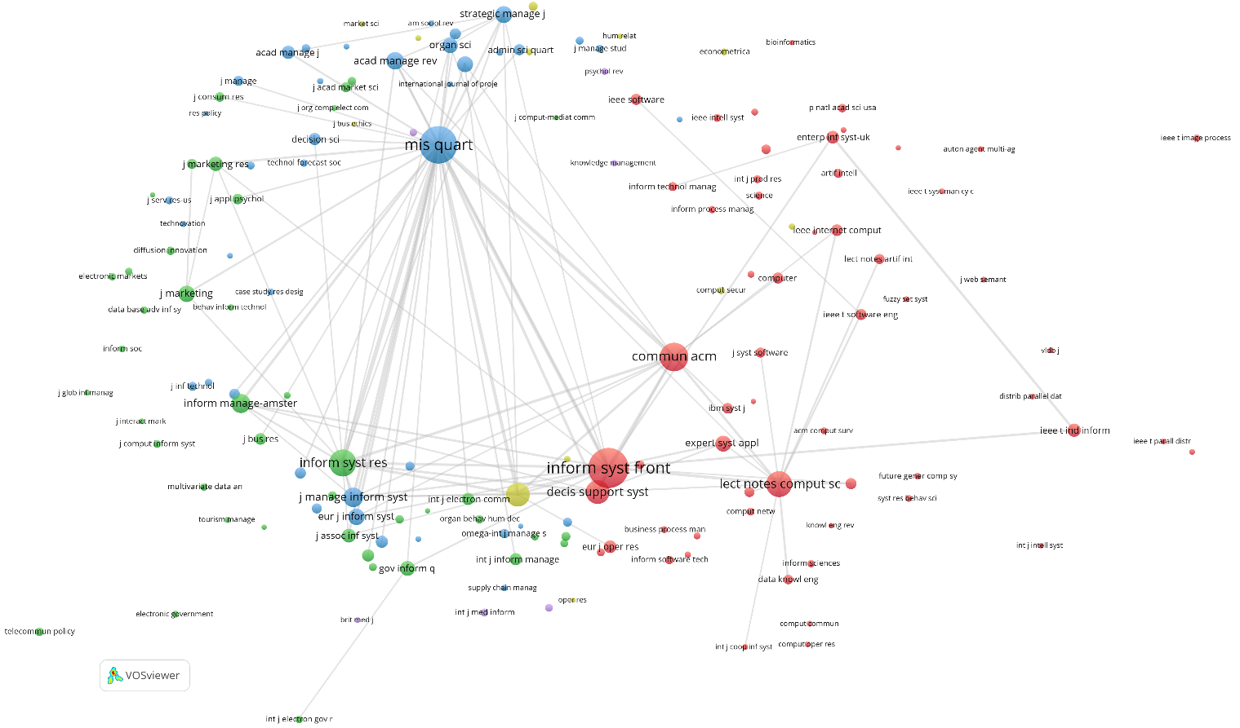Figure 2. Co-citation of journals in ISF 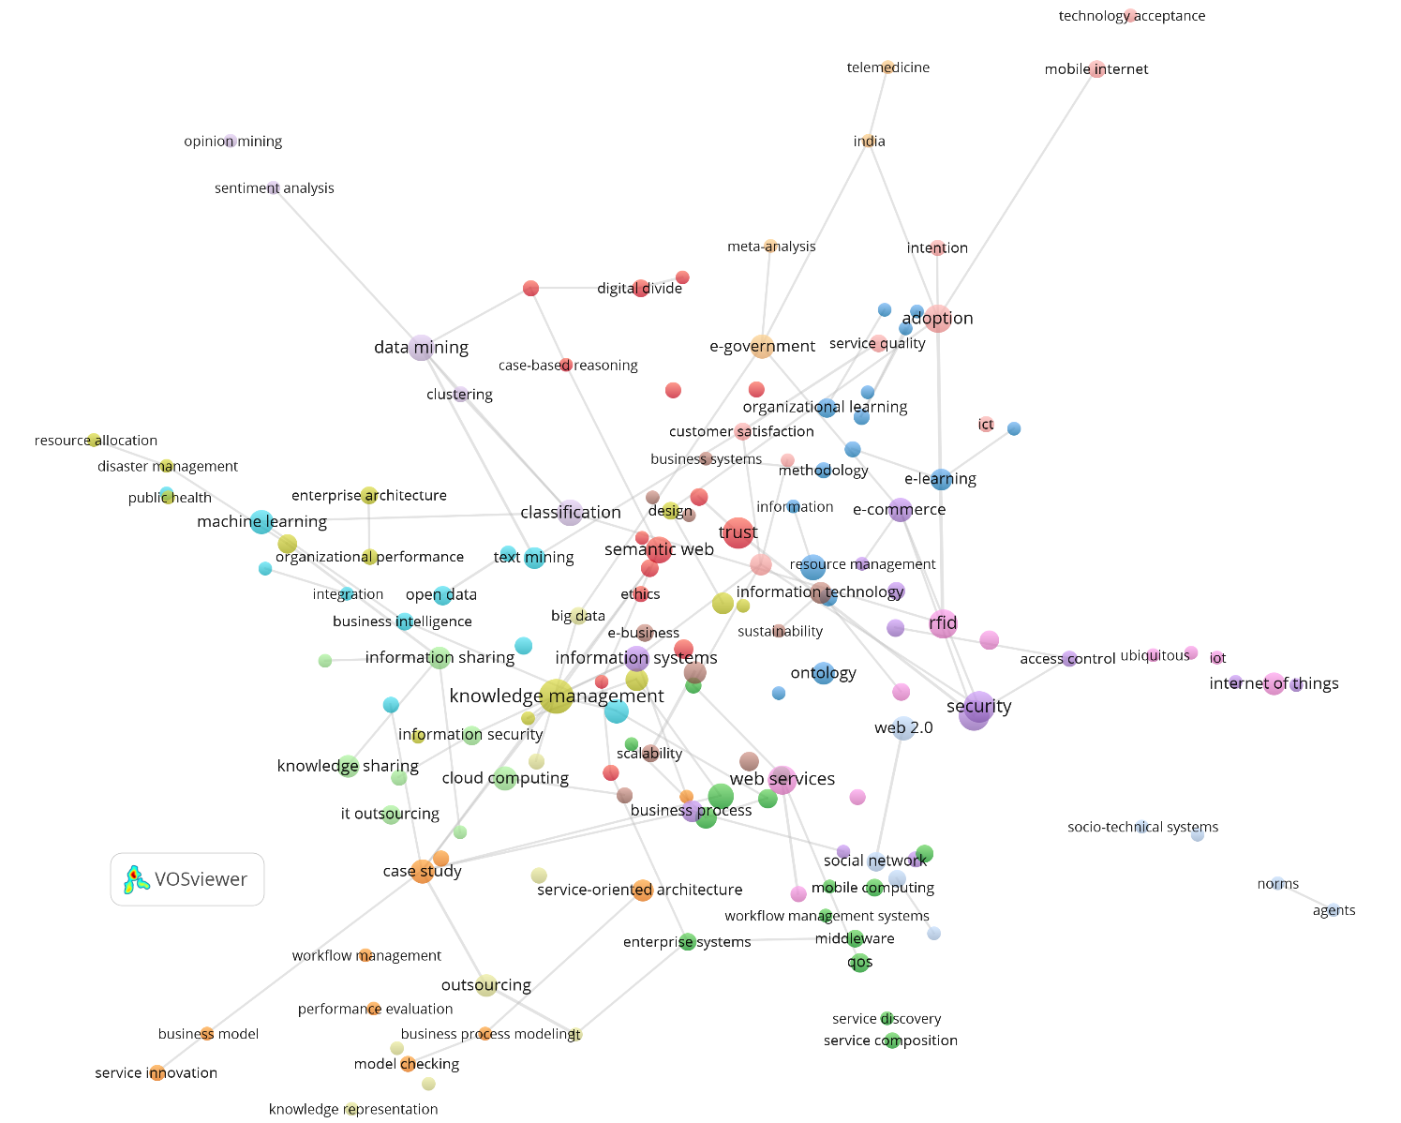
Figure 3. Co-occurrence of author keywords in ISF
Knowledge management is the most common keyword according to the author selection made for classifying their articles. Some other popular keywords are Security, Trust, Privacy, Semantic Web, and Webs Services. Keywords in this Figure were then led to the making of the highlevel themese in Table 5.
Next, let us see how the popularity of keywords has evolved through time by considering two different periods: 2003-2012 and 2013-2017. Figures 4 and 5 shows the results considering a minimum threshold of three occurrences and one hundred co-occurrence links.
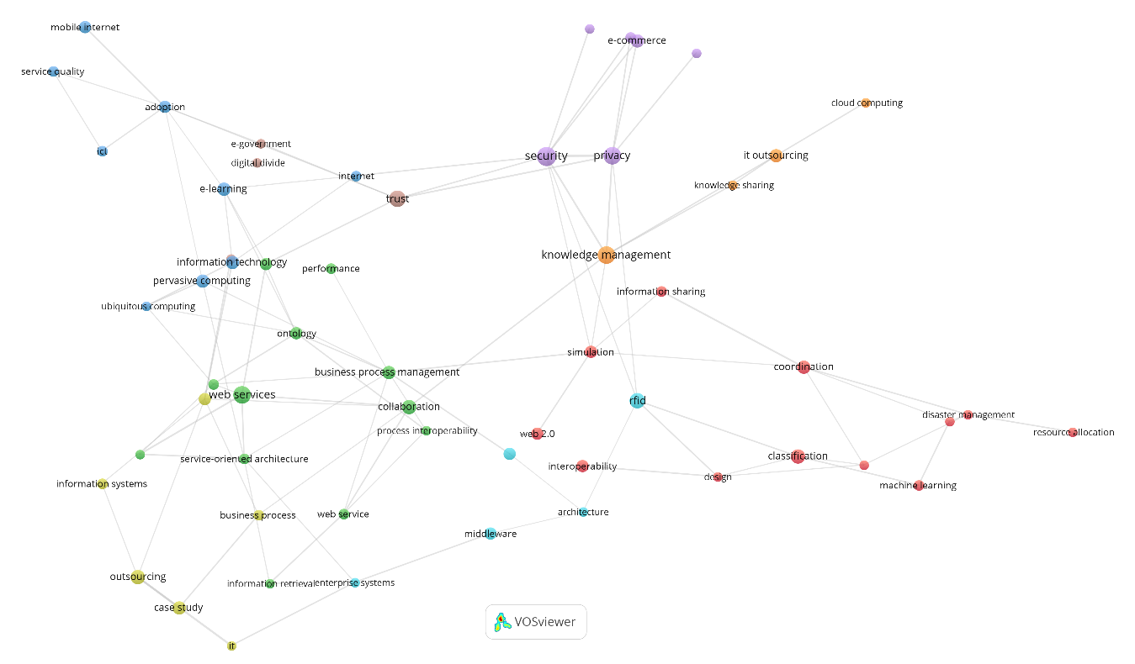
Figure 4. Co-occurrence of author keywords in ISF: 2003-2012
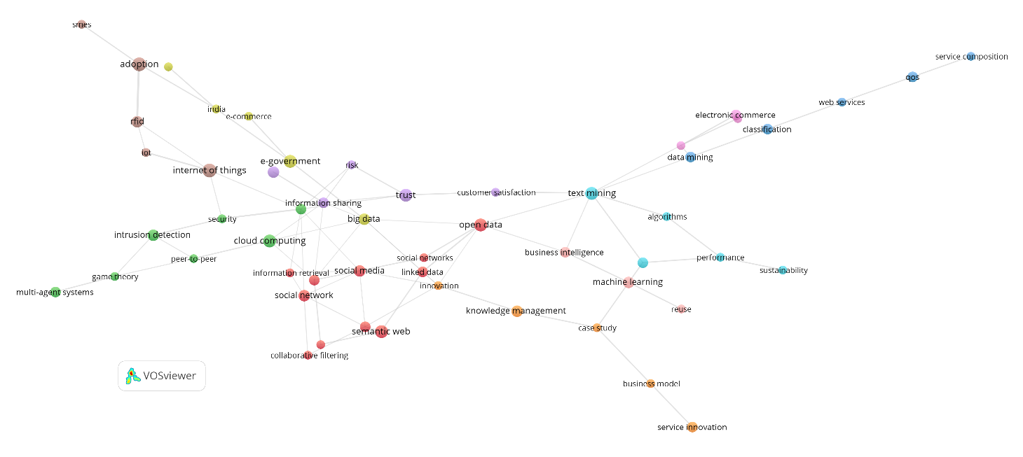
Figure 5. Co-occurrence of author keywords in ISF: 2013-2017

The above figures show the dynamic and changing state of the journal over the period of the study. During the last five years, many new emerging keywords, especially those related to modern technologies, have appeared in the journal. A comparison of the most frequent keywords reveal that the focus of IS research has shifted from Knowledge Management, Information Sharing, and Business Process Management research and in the 2003-2012 period to Open Data, Business Intelligence, Social Media, and Intenet of Things in 2013-2017 range. Interestingly, keywords related to Security and Privacy have almost equally received authors’ attention in both Figure 4 and 5. This reflects the importance of research on IS security, and suggests that there are still various problems in this domain worth investigation.

- Thematic Analysis Based on Keywords
We generalized the keyword analysis into a thematic analysis. A total of 3200 keywords as well as the number of their frequency of use were extracted and recorded in an Excel file. Keywords in our context are empirical attributes of the papers (as used by the authors in the ‘keywords’ list). In the earlier analysis paper (Bang 2015), keywords were synthesized using semantic analysis tools on the introductions of the papers. In our analysis, semantic analysis is applied to synthesize the themes, as described in what follows. Two IS experts, first and second author, undertook a semantic analysis on these keywords. This consisted of the following four steps:
- Given that the majority of keywords only occurred once in our list, it was important to group them for extracting high level themes. Thus, each expert independently went through the keywords. Keywords with frequencies higher than 4 were selected for identifying high level themes. The keywords used were the ones identified by the authors by the paper (and used in Scopus for indexing).
- The experts then grouped keywords into ‘themes’ based on their similarities. Each expert independently chose a name for each theme.
- The experts then met and discussed disagreements. A reconciliation took place, which led to 10 themes with their underlying keywords.
- Next, these themes were used to group additional keywords occurred from 1999 to 2017 to further increase the coverage beyond the cut-off of frequency of 4.

The list was turned into a 2 D structure (the Table 5 below). A detailed list of top keywords within each theme is shown in Appendix I.

Table 5. Common themes in ISF: General and temporal
Theme | 1999-2002 | 2003-2006 | 2007-2010 | 2011-2014 | 2015-2018 | Total
Knowledge Management | 19 | 2 | 12 | 17 | 19 | 69
IS Risk Management | 2 | 11 | 19 | 29 | 19 | 80
IT Based Services | 8 | 14 | 21 | 11 | 11 | 65
IS Use | 13 | 18 | 39 | 31 | 35 | 136
Operations Management | 12 | 2 | 13 | 14 | 17 | 58
Analytics | 7 | 8 | 16 | 15 | 47 | 93
Web of Future | 1 | 3 | 8 | 30 | 34 | 76
IS Research Methods & Theories | 5 | 6 | 10 | 11 | 11 | 43
IoT and Ubiquitous Computing | 7 | 9 | 21 | 13 | 24 | 74
Enterprise Computing & Architecture | 5 | 11 | 9 | 18 | 17 | 60

As the above Table shows, IS Use has ranked the highest in terms of frequency of the corresponding keywords during the past two decades. This reflects that despite recent changes in the technology space, IS scholars have been steadily concerned with core IS topics over the life of the journal. Other stable streams of research in ISF are Operations Management, Knowledge Management, and Enterprise Architectures; this represents a firm interest in researching these topics in the IS and ISF community over this period. This is also evident from Table 2, as the papers by Klaus et al. (2000) as well as Ross and Vitale (2000) on ERP and Carter and Weerakkody (2008) on IT Use are amongst top cited papers in ISF.
On the other hand, interest in IoT and Ubiquitous Computing, IS Risk Management, Analytics, and Web of Future have enjoyed the sharpest increase over the same period of time among contributors. This is evidenced by Whitemore et al. (2015) and Li et al. (2015) listed as top five cited papers in ISF in Table 2 on the subject of IoT as well as Ziegler & Lausen (2005)’s paper on social media and trust as one of the top ten cited papers in this list. This shows that ISF is maintaining currency with emerging topics of increasing importance. The consistent increase of keywords within these themes suggest that interest in these topics will continue to the near future, and more studies can be expected within IS security, data analytics, IoT, and social media domains in the coming years.
Furthermore, the journal is increasingly becoming interested in papers that focus on IS societal good, and published a number of articles and special issues in this context. In the April special issue on societal impacts of big data and analytics, Gupta et al. (2018) proposed a simple framework that conpcetualizes analytics for societal impact through (i) data and infrastructure, (ii) techniques for big data analysis and interpretation, and (iii) application domain, including areas such as environment, disaster response, life style, and resource management. In its next issue, the journal examined the good, the bad, and the ugly aspects of social media platforms. It brought together a range of disciplines for the development of knowledge regarding the adoption, use, impact, and potential of these platforms (Dwivedi et al., 2018), and covered issues such as self-disclousure, sharing political content, and impact of social media on consumers’ acculturation and purchase intentions. Next, the journal hosted two special issues on the important topics of Distaster Management (DM) and Emergency Releief. The focus of the former was on how we use theories to provide assessment methods of DM readiness, and what are the theoretical challenges that are associated with integration of social media in DM information systems (Beydoun et al., 2018, Abedin & Babar, 2018). While the latter examined the empirical results of various social media technologies such as Twitter, Facebook and WhatsApp for extracting vital and actionable information from social media content in disaster situations (Ghosh et al., 2018).
Finally, the number of studies concerned with IS research methods and theories have had a gradual increase in the past twenty years. This reflects ISF community’s increasing awareness and appreciation of theories and methodologies in IS research. A deeper analysis of keywords within this theme shows that case strudy, simulations, and design scienceare in particular popular methods of analysis amongst ISF authors.

5. Conclusion
This paper examined the focus of ISF over the past 20 years. The analysis revealed that ISF topics are largely into two groups: one group represents the anchor of ISF within the traditional IS themes. Another group reflects ISF research adapting and responding to key trends. Within the anchor group, are these topics: Operations Management, Knowledge Management, and Enterprise Architectures. This dichotomy was also reflected in an earlier study, Dwivedi et al. (2009), which examined a decade of Information Systems Frontiers research. The new themes we identified include IoT and Ubiquitous Computing, IS Risk Management, Analytics, and Web of Future. Interestingly, some of these were also subject of special issues flagged in that older survey Dwivedi et al. (2009) (e.g. Information Dynamics, Cyber Law, Knowledge Discovery in High Throughput Biological Domains, and Secure Knowledge Management).
Indeed, credit to the editorial team, this shows an underlying strategy to ensure that ISF is maintains currency and a firm IS identity. Indeed, the IS identity has also been reinforced lately in an increase in the number of studies concerned with IS research methods and theories have had a gradual increase in the past twenty years. Furthermore, the journal is increasingly becoming interested in papers that focus on IS societal good, and has published a number of special issues on topics such as how IS can contribute to emergency relief and disaster management, the bad, good, and ugly side of social media, and the societal impacts of big data analytics. We anticipate that these topics will feature more strongly within the next decade of ISF.

References
Abedin, B., & Babar, A. (2018). Institutional vs. non-institutional use of social media during emergency response: A case of twitter in 2014 Australian bush fire. Information Systems Frontiers, 20(4), 729-740.
Alonso, S., Cabrerizo, F.J., Herrera-Viedma, E., & Herrera, F. (2009). H-index: A review focused on its variants, computation, and standarization for different scientific fields. Journal of Informetrics, 3(4), 273-289.
Bang, C.C. (2015). Information Systems Frontiers: Keyword analysis and classification. Information Systems Frontiers, 17, 217–237.
Beydoun, G., Dascalu, S., Dominey-Howes, D., & Sheehan, A. (2018). Disaster Management and Information Systems: Insights to Emerging Challenges. Information Systems Frontiers, 20(4), 649-652.
Blanco-Mesa, F., Merigó, J.M., & Gil-Lafuente, A.M. (2017). Fuzzy decision making: A bibliometric-based review. Journal of Intelligent & Fuzzy Systems, 32(3), 2033-2050.
Cancino, C., Merigó, J.M., Coronado, F., Dessouky, Y., & Dessouky, M. (2017). Forty years of Computers & Industrial Engineering: A bibliometric analysis. Computers & Industrial Engineering, 113, 614–629.
Davis, F.D. (1989). Perceived usefulness, perceived ease of use, and user acceptance of information technology. MIS Quarterly, 13, 319–339.
Ding, Y., Rousseau, R., & Wolfram, D. (2014). Measuring scholarly impact: Methods and practice, Springer, Switzerland.
Dwivedi, Y.K., Lal, B., Mustafee, N., & Williams, M.D. (2009). Profiling a decade of Information Systems Frontiers’ research. Information Systems Frontiers, 11, 87–102.
Dwivedi, Y. K., Kelly, G., Janssen, M., Rana, N. P., Slade, E. L., & Clement, M. (2018). Social Media: The good, the bad, and the ugly. Information Systems Frontiers, 20 (3), 1-5.
Fornell, C., & Larcker, D.F. (1981). Evaluating structural equation models with unobservable variables and measurement error. Journal of Marketing Research, 18, 39–50.
Gaviria-Marín, M., Merigó, J.M., & Popa, S. (2018). Twenty years of the Journal of Knowledge Management: A bibliometric analysis. Journal of Knowledge Management, 22, 1655-1687.
Ghosh, S., Ghosh, K., Ganguly, D., Chakraborty, T., Jones, G. J., Moens, M. F., & Imran, M. (2018). Exploitation of Social Media for Emergency Relief and Preparedness: Recent Research and Trends. Information Systems Frontiers, 20(5), 901-907.
Gupta, A., Deokar, A., Iyer, L., Sharda, R., & Schrader, D. (2018). Big data & analytics for societal impact: Recent research and trends. Information Systems Frontiers, 20(2), 185-194.
Hevner, A.R., March, S.T., Park, J., & Ram, S. (2004). Design science in information systems research. MIS Quarterly, 28, 75–105.
Kessler, M.M. (1963). Bibliographic coupling between scientific papers. American Documentation, 14(1), 10-25.
Klaus, H., Rosemann, M., & Gable, G.G. (2000). What is ERP? Information Systems Frontiers, 2, 141–162.
Laengle, S., Modak, N.M., Merigó, J.M., & de la Sotta, C. (2018b). Thirty years of the International Journal of Computer Integrated Manufacturing: A bibliometric analysis. International Journal of Computer Integrated Manufacturing, 31(12), 1247-1268.
Li, S., Xu, L.D., & Zhao, S. (2015). The internet of things: A survey. Information Systems Frontiers, 17, 243–259.
Merigó, J.M., Pedrycz, W., Weber, R., & de la Sotta, C. (2018). Fifty years of Information Sciences: A bibliometric overview. Information Sciences, 432, 245-268.
Ross, J.W., & Vitale, M.R. (2000). The ERP revolution: Surviving vs thriving. Information Systems Frontiers, 2, 233–241.
Small, H. (1973). Co-citation in the scientific literature: A new measure of the relationship between two documents. Journal of the American Society for Information Science, 24, 265–269.
Van Eck, N.J., & Waltman, L. (2010). Software survey: VOSviewer, a computer program for bibliometric mapping. Scientometrics, 84(2), 523-538.
Whitmore, A., Agarwal, A., & Xu, L.D. (2015). The Internet of Things – A survey of topics and trends. Information Systems Frontiers, 17, 261–274.
Ziegler, C.N., & Lausen, G. (2005). Propagation models for trust and distrust in social networks. Information Systems Frontiers, 7, 337–358.

Appendix I -
Berg, J. E., & Rietz, T. A. (2003). Prediction markets as decision support systems. Information systems frontiers, 5(1), 79-93.
Bharosa, N., Lee, J., & Janssen, M. (2010). Challenges and obstacles in sharing and coordinating information during multi-agency disaster response: Propositions from field exercises. Information Systems Frontiers, 12(1), 49-65.
Carter, L., & Weerakkody, V. (2008). E-government adoption: A cultural comparison. Information Systems Frontiers, 10(4), 473-482.
Hanson, R. (2003). Combinatorial information market design. Information Systems Frontiers, 5(1), 107-119.
Hong, S. J., Thong, J. Y., Moon, J. Y., & Tam, K. Y. (2008). Understanding the behavior of mobile data services consumers. Information Systems Frontiers, 10(4), 431.Li, S., Da Xu, L., & Zhao, S. (2015). The internet of things: a survey. Information Systems Frontiers, 17(2), 243-259.
Johnson, P., Lagerström, R., Närman, P., & Simonsson, M. (2007). Enterprise architecture analysis with extended influence diagrams. Information Systems Frontiers, 9(2-3), 163-180.
Kim, S., & Garrison, G. (2009). Investigating mobile wireless technology adoption: An extension of the technology acceptance model. Information Systems Frontiers, 11(3), 323-333.Klaus, H., Rosemann, M., & Gable, G. G. (2000). What is ERP?. Information systems frontiers, 2(2), 141-162.
Lai, T. L. (2004). Service quality and perceived value's impact on satisfaction, intention and usage of short message service (SMS). Information Systems Frontiers, 6(4), 353-368.
Ross, J. W., & Vitale, M. R. (2000). The ERP revolution: surviving vs. thriving. Information systems frontiers, 2(2), 233-241.
Scott, J. E., & Vessey, I. (2000). Implementing enterprise resource planning systems: the role of learning from failure. Information systems frontiers, 2(2), 213-232.
Stephens, S. (2001). Supply chain operations reference model version 5.0: a new tool to improve supply chain efficiency and achieve best practice. Information Systems Frontiers, 3(4), 471-476.
Stohr, E. A., & Zhao, J. L. (2001). Workflow automation: Overview and research issues. Information Systems Frontiers, 3(3), 281-296.
Wang, Y., Lo, H. P., & Yang, Y. (2004). An integrated framework for service quality, customer value, satisfaction: Evidence from China's telecommunication industry. Information systems frontiers, 6(4), 325-340.
Winkler, J. K., Dibbern, J., & Heinzl, A. (2008). The impact of cultural differences in offshore outsourcing—Case study results from German–Indian application development projects. Information Systems Frontiers, 10(2), 243-258.
Whitmore, A., Agarwal, A., & Da Xu, L. (2015). The Internet of Things—A survey of topics and trends. Information Systems Frontiers, 17(2), 261-274.
Ziegler, C. N., & Lausen, G. (2005). Propagation models for trust and distrust in social networks. Information Systems Frontiers, 7(4-5), 337-358.
Zhang, D., & Nunamaker, J. F. (2003). Powering e-learning in the new millennium: an overview of e-learning and enabling technology. Information systems frontiers, 5(2), 207-218.
Zhao, Y., & Zhu, Q. (2014). Evaluation on crowdsourcing research: Current status and future direction. Information Systems Frontiers, 16(3), 417-434.

