Pre-publication version:

Brady, B., Kneebone, I. I., & Bailey, P. B. (accepted 2018). Validation of the Five Facet Mindfulness Questionnaire Among Community-Dwelling Older Adults. Mindfulness.

This paper is not the copy of record and may not exactly replicate the authoritative document published in the journal.

Validation of the Five Facet Mindfulness Questionnaire Among Community-Dwelling Older Adults

Brooke Brady¹, Ian I. Kneebone² and Phoebe E. Bailey¹

¹School of Social Sciences and Psychology, Western Sydney University, Sydney, Australia
²Discipline of Clinical Psychology, Graduate School of Health, University of Technology Sydney, Sydney, Australia

Abstract
The 24-item Five Facet Mindfulness Questionnaire – Short Form (FFMQ-SF) was developed to measure five facets of dispositional mindfulness: observing, describing, acting with awareness, non-judgment of inner experience, and non-reactivity to inner experience. The FFMQ-SF is increasingly used with older adult populations, despite not having been appropriately validated for such use. The present study examined the psychometric properties of the FFMQ-SF among community-dwelling older adults (N = 210). The five subscales of the FFMQ-SF were found to be internally consistent. Convergent validity analyses revealed that all five facets of mindfulness were negatively correlated with negative affect, and all facets except for non-judgment were positively correlated with positive affect. Similarly, all facets except for non-judgment were positively correlated with cognitive reappraisal emotion regulation tendencies. Only describing, acting with awareness, and non-judgment were negatively correlated with expressive suppression tendencies. The original five-factor structure of the FFMQ-SF was supported by confirmatory factor analyses. The two-factor higher order structure of the FFMQ-SF was also supported. Overall, the results support the psychometric properties of the FFMQ-SF for use with older adult samples.

Keywords: Mindfulness; Older Adults; Validation; Psychometric Properties; Emotion Regulation

Validation of the Five Facet Mindfulness Questionnaire Among Community-Dwelling Older Adults
The global population is aging rapidly. According to the United Nations (2015), virtually every country in the world is experiencing accelerating growth in the proportion of adults over the age of 60 years. By 2030, the number of people in the world aged over 60 is projected to grow by 56% to 1.4 billion. Preparing for social shifts associated with the aging boom is essential, including research into supporting healthy aging. Mindfulness, defined as non-judgmental present-moment awareness and attention (Kabat-Zinn, 1994), has been identified as one potentially important tool for maintaining wellbeing in older age (Prakash et al., 2014).
While no dominant theory of mindfulness considers developmental shifts in older adulthood, theories of emotion and aging offer some insight into potential improvements in dispositional mindfulness in older age (Charles & Carstensen, 2007; Urry & Gross, 2010). Socioemotional Selectivity Theory (SST; Charles & Carstensen, 2007) for instance posits that aging is associated with a greater awareness of the limited nature of time left to live and a shift away from future-oriented goals toward more emotionally meaningful present-moment goals. This present moment awareness and purposeful direction of attention to maintain emotional wellbeing is consistent with recent models of mindfulness. Indeed, research suggests that dispositional mindfulness increases with age (Hohaus & Spark, 2013). Among older adults, mindfulness is associated with reduced anxiety, depression and stress ratings (Geiger et al., 2016), as well as improvements in executive functioning (Mallya & Fiocco, 2016), protection from stress (de Frias & Whyne, 2015) and pain acceptance (Geiger et al., 2016). Consistent with these findings, Prakash et al. (2014) have suggested that mindfulness-based therapies, with a focus on present-focused attention and regulation of reflexive operations of the mind, have the potential to enhance the cognitive operations of older adults.
One of the most commonly administered measures of mindfulness, the Five Facet Mindfulness Questionnaire (FFMQ; Baer et al., 2006; 2008; Bohlmeijer et al., 2011) measures five distinct facets of mindfulness: Observing, defined as the tendency to notice and attend to internal and external experiences; Describing, defined as the ability to label internal experiences; Acting with Awareness, defined as the ability to attend to experiences of the present moment; Non-Judgement of Inner Experience, defined as the tendency to take a non-evaluative stance toward thoughts and feelings; and Non-Reactivity to Inner Experience, defined as the ability to let thoughts and feelings come and go without getting caught up or carried away by them.
A 24-item short form of the FFMQ (FFMQ-SF; Bohlmeijer et al., 2011) demonstrated comparable internal consistency as well as better model fit compared to the original measure for a correlated five factor model, likely due to the removal of low-loading items. The FFMQ-SF also demonstrated better model fit compared to the original version for a hierarchical five factor model with a single overarching mindfulness factor, although acceptable model fit was attained for both measures. The FFMQ-SF has been used to measure dispositional mindfulness among community-dwelling older adults who experience memory complaints (Chan, 2015), and sleep disturbances (Black et al., 2015), as well as depressed older adults living in assisted care (Di Toro, 2016), but its psychometric properties have yet to be assessed among healthy community-dwelling older adults.
More recently, a two-factor higher order structure of the FFMQ among non-meditators has been proposed. Tran, Glück, and Nader (2013) explored the higher order factor structure of the FFMQ in Austrian community and student samples in light of theory that proposes that mindfulness is comprised of two broad constructs, self-regulated attention and orientation to experience (Bishop et al., 2004). Using exploratory structural equation modelling, the authors found that acting with awareness and non-judgement of inner experience loaded highest on the orientation to experience factor. Observe loaded highest on the self-regulated attention factor, and both describe and non-reactivity to inner experience loaded high on both higher order factors. The two-factor hierarchical structure demonstrated good model fit, which has been replicated in large samples of German and Spanish meditators (Tran et al., 2014). While a two-factor higher order structure of the FFMQ appears to fit the data from predominantly young samples, it is not clear whether this extends to community-dwelling older adults or the FFMQ-SF.
In light of theories of emotion regulation and aging mentioned earlier, it is both interesting and informative to explore convergent validity between FFMQ-SF subscale scores, affective states and emotion regulation tendencies among older adults. Research using younger student and community samples indicated that describing, acting with awareness, non-judgment, and non-reactivity to inner experiences are positively correlated with life satisfaction (Christopher et al., 2012) and negatively correlated with depression and anxiety (Tran et al., 2013). Observing was not related to life satisfaction, depression or anxiety. In a depressed sample, all five facets of mindfulness were positively correlated with good mental health (Bohlmeijer et al., 2011). Further in a younger adult community sample, the tendency to regulate emotion by suppressing emotional expressivity was negatively correlated with all five facets of mindfulness measured by the FFMQ, whereas regulating emotion by reappraising emotional experiences was positively correlated with observing, describing, and non-reactivity to inner experience only (Tran, Glück, & Nader, 2013).
The current study aimed to assess the internal consistency, convergent validity and factor structure of the FFMQ-SF among community-dwelling older adults. Based on previous psychometric studies, theories of socioemotional aging, and empirical data supporting the successful use of mindfulness in older age, it was hypothesized that: (a) The FFMQ-SF would demonstrate satisfactory internal consistency; (b) The FFMQ-SF would demonstrate adequate convergent validity, that is the five sub scales of the FFMQ-SF would be positively correlated with positive affect and cognitive reappraisal tendencies, and negatively correlated with negative affect and expressive suppression tendencies; (c) A five-factor (observe, describe, act aware, non-judgement, non-reactive) structure would be confirmed for the FFMQ-SF; and (d) Testing of the hierarchical structure of the FFMQ-SF will provide stronger evidence for a hierarchical model with two higher-order factors compared to a hierarchical model with one higher-order factor.

Method

Participants
A total of 213 older adult volunteers (M age 65.51 years, age range 60 to 89 years; 45% female) were recruited for a short “Emotional Life Survey”. Data from three participants was removed: one due to missing data, one due to current diagnosis of Alzeimer’s disease, and one due to self-reported “impaired consciousness”. Five participants reported experiencing at least one stroke. Nine participants reported the presence of a current mood disorder. Data from these participants were included in analyses in order to maintain the representativeness of the current sample. After exclusions, data from 210 older adults were included in analyses. 81% of the sample were Caucasian, 4.8% African, 4.3% East or south East Asian, 3.3% South Asian, 3.8% Latin, Central and South American, and 3% ‘Other’ ethnicity. 63.3% reported their religion as Christianity, 2.4% Buddhism, 1.9% Hinduism, 1.9% Islam, 1.4% Judaism, 26.7% no religion, and 2.4% other religion. 58.1% reported their marital status as married, 16.2% single, 12.4% divorced, 9.5% widowed and 1% dating. 32.9% of the sample had completed at least some graduate schooling, 60.1% at least some college, 13.8% had attained their High School Certificate or equivalent, and 3.3% had completed some High School or less.
Participants who completed the survey in person were recruited via a university research volunteer database. Online participants were recruited via advertisements on MicroWorkers and Mechanical Turk. MicroWorkers is a crowd sourcing platform used to recruit participants for short online tasks which has been validated for use collecting data from Australian participants (Crone & Williams, 2016). Mechanical Turk is Amazon’s international crowd sourcing platform commonly used for online psychological research, which was used to collect data from participants residing in the Australia and New Zealand region. A geographic restriction was placed on “Turker” location in an attempt to ensure that online respondents where from a similar socio-cultural background to participants who completed the study in person at a large Australian University.
Procedure
Twenty-five participants completed the survey in person at the university, and 185 completed the survey online. Data from face-to-face and online participants were combined in light of evidence that online and paper versions of questionnaires return similarly reliable results (Ritter, Lorig, Laurent, & Matthews, 2004). This research was approved by the Western Sydney University Human Research Ethics Committee (approval number H11503). Participant responses to the Emotion Regulation Questionnaire (ERQ; Gross & John, 2003) reported in this study have been used in a separate study to validate the psychometric properties of the ERQ.

Measures
Five Facet Mindfulness Questionnaire – Short Form (FFMQ-SF; Bohlmeijer et al., 2011)
The 24-item FFMQ-SF evaluates five facets of dispositional mindfulness, including observing, describing, acting with awareness, non-judgment of inner experiences, and non-reactivity to inner experiences. Sample items include: “I pay attention to physical experiences, such as the wind in my hair or sun on my face (Observe)”, “I’m good at finding the words to describe my feelings (Describe)”, “I find myself doing things without paying attention (Act Aware)”, “I disapprove of myself when I have illogical ideas (Non-Judgment)”, “I watch my feelings without getting carried away by them (Non-Reactivity)”. Respondents are asked to rate their agreement with items using a five-point Likert-type scale from 1 (never or very rarely true) to 5 (very often or always true). After reverse coding of negatively worded items, higher scores on each subscale indicate greater mindfulness. The development and psychometric properties of the FFMQ-SF were reviewed earlier in this article. Table 1 displays measures of Cronbach’s alpha for the FFMQ-SF subscales in the present sample.
Positive and Negative Affect Schedule – 10 (PANAS-10; Mackinnon et al., 1999)
The PANAS-10 is a ten-item scale designed to measure the experience of positive (inspired, alert, excited, enthusiastic, determined) and negative (afraid, upset, nervous, scared, upset) emotional states. Respondents are asked to indicate how frequently they have experienced the emotions in the last few weeks using a Likert-type scale from 1 (very slightly or not at all) to 5 (Extremely). Item responses are summed for each subscale resulting in a single positive affect score and a single negative affect score. Higher scores on each subscale indicate greater experience of affect. In the initial validation study, age was not found to impact the factor structure or factor correlations among a large sample (N = 2651) of adults, including older adults (Mackinnon et al., 1999). The positive and negative affect subscales of the PANAS-10 were found to be internally consistent in the present sample (Cronbach’s alphas of .84 and .91, respectively).
Emotion Regulation Questionnaire (ERQ; Gross & John, 2003)
The Emotion Regulation Questionnaire is comprised of 10-items designed to measure trait tendencies to regulate emotion using either suppression or reappraisal; each of which is the basis of one of two subscales. The reappraisal subscale includes six items measuring tendency to control emotions by changing the way one thinks about emotional events. An example item is “When I want to feel more positive emotion, I change the way I’m thinking about the situation”. The suppression subscale includes four items that measure the tendency to control emotion by suppressing one’s behavioral expression. An example item is “I control my emotions by not expressing them”. Respondents are asked to rate their agreement with items using a 7-point Likert-type scale from 1 (strongly disagree) to 7 (strongly agree). Scores are averaged for the items within each scale to provide a single reappraisal score and a single suppression score, ranging from 1 to 7. High scores on each subscale indicate higher trait reappraisal and suppression, respectively. The ERQ has been validated in a sample of older women (John & Gross, 2004). The reappraisal and suppression subscales of the ERQ were found to be internally consistent in the present sample (Cronbach’s alphas of .90 and .82, respectively).

Data Analyses
Internal consistency of the five subscales of the FFMQ-SF was evaluated using Cronbach’s alpha. Pearson’s product moment correlations were used to evaluate convergent validity between FFMQ subscales and positive and negative affect as measured by the PANAS-10 (Mackinnon et al., 1999), as well as trait reappraisal and suppression as measured by the ERQ (Gross & John, 2003).
Factor structure was assessed using CFA as this method allows for pre-specification of the number of factors as well as the relationship between factors and indicators (Brown, 2014), which is appropriate when evaluating a well-established measure. CFA was performed using AMOS 25 (Arbuckle, 2017). A two-stage approach to factor analysis was employed. First, a five-factor correlated model was considered to determine if the proposed five facet structure of the FFMQ-SF demonstrated acceptable model fit among an older community-dwelling sample. Second, the hierarchical structure of the FFMQ-SF was explored to determine whether a one- or two-factor higher order structure offers best fit for older adults. In all CFA analyses, items were used as individual indicators, rather than parcelled in small groups of items as in previous research (Baer et al., 2006; 2008). Including items as individual indicators allows for examination of the relationship between individual items and factors in a scale that can be missed when items are parcelled (Bandolos & Finney, 2001; Christopher et al., 2012; Worthington & Whittaker, 2006). Model fit was assessed using chi-square, the comparative fit index (CFI; Bentler, 1990), Tucker-Lewis Index (TLI; Tucker-Lewis, 1973), and the root-mean-square error of approximation (RMSEA; Steiger & Lind, 1980). Model fit was considered acceptable when chi square was non-significant, CFI and TLI values above .90 (Kline, 2004), and RMSEA below .08 (Browne & Cudeck, 1993).

Results

Internal Consistency
Table 1 displays reliability results, mean scores and scale inter-correlations. Overall, the five subscales of the FFMQ-SF demonstrated acceptable internal consistency in older adults. Alpha values ranged from .72 for the non-reactivity to inner experience subscale to .85 for both the acting with awareness and non-judgment of inner experience scales.

Convergent Validity
As shown in Table 2, all mindfulness subscales were positively correlated with positive affect, except for non-judgment. All subscales of the FFMQ were negatively correlated with negative affect, except for observing. The other four facets of mindfulness demonstrated small to moderate correlations, indicating that strengths in at least four facets of mindfulness are associated with reduced negative affect among older adults.
Four facets of mindfulness (excluding non-judgment) were positively correlated with cognitive reappraisal tendencies. Although, the correlation between acting with awareness and reappraisal was low (r = .15, p < .05). Three facets of mindfulness (describing, acting with awareness, and non-judgment) were negatively correlated with suppression tendencies. Observing and non-reactivity were not related to suppression among older adults.

Factor Structure
Model fit statistics for all tested models are displayed in Table 3. First, model fit for the original five-factor correlated model was assessed. Inspection of the modification indices revealed high indices among a number of the item error terms from the describing factor. To combat this, error terms for a number of describing items were allowed to co-vary. The correlated five-factor model demonstrated acceptable model fit. Standardized item loadings, factor correlations and error co-variances for the five-factor model are displayed in Figure 1.
Next, the higher order structure of the FFMQ-SF was considered. The one-factor higher order model, treating the five facets of the FFMQ-SF as indicators of a single mindfulness construct, was found to be acceptable based on CFI and RMSEA fit statistics. However, TLI was just below the recommended value of .90. Figure 2 displays standardized parameters for the one-factor higher order model of the FFMQ. The two-factor higher order model, where the five facets of the FFMQ-SF were treated as indicators of orientation to experience and/or self-regulated attention, demonstrated better model fit, with CFI, TLI and RMSEA values all within the recommended range. Figure 3 displays standardized parameters for the two-factor higher order model of the FFMQ.

Discussion
The FFMQ-SF is a commonly cited measure of dispositional mindfulness, however, the reliability and validity of this measure among healthy, community-dwelling older adults had not previously been explored. The results of the present study confirm the internal consistency of the five subscales of the FFMQ-SF among this sample for the first time. Indeed, the findings are broadly in line with our hypotheses. Convergent validity is supported by associations with affect and emotion regulation. Confirmatory factor analysis supports the five-factor structure of the FFMQ-SF. Preliminary evidence consistent with a two-factor higher order structure of the FFMQ-SF was also found. Overall, the FFMQ-SF appears to be a valid and reliable measure of dispositional mindfulness for use with older adults.
The five subscales of the FFMQ-SF demonstrated acceptable internal consistency among older adults. This is in-line with previous research assessing this measure among adult clinical samples (Bohlmeijer, et al., 2011; Veehof et al., 2011). The subscales of the FFMQ-SF were also found to be inter-correlated which supports the notion that, like the original FFMQ, they measure related but distinct constructs (Baer et al., 2006; 2008).
Convergent validity was explored with the PANAS-10 (Mackinnon et al., 1999) and the ERQ (Gross & John, 2003). Positive correlations were found between positive affect and all mindfulness subscales except for non-judgment of inner experience. Negative affect was negatively correlated with scores on all five facets of the FFMQ-SF. However, the negative correlation between negative affect and observing was negligible. This result adds to growing evidence for a complex relationship between observing and negative symptomology. For example, Baer et al (2008) found that observing and negative symptomology were negatively correlated among experienced meditators, uncorrelated among both community samples and those who are highly-educated, and positively correlated among a student sample. These results are also broadly consistent with research that has demonstrated a positive correlation between dispositional mindfulness and positive mental health (Bohlmeijer et al., 2011).
Cognitive reappraisal was found to be positively correlated with all mindfulness facets measured by the FFMQ-SF except for non-judgment of inner experience. This is understandable insofar as adaptive emotion regulation often requires the purposeful (conscious or otherwise) judgment of emotional experiences in order to decide which emotions are to be experienced and when (Gross, 1998). In addition, the positive correlation between cognitive reappraisal and acting with awareness was weak. Overall, these findings are in line with previous research using the original FFMQ which reported positive correlations between cognitive reappraisal and observing, describing and non-reactivity among a younger adult community sample (Tran, Glück, & Nader, 2013).
While previous research has reported that the tendency to regulate emotion by suppressing emotional expression is negatively correlated with all five facets of mindfulness as measured by the original FFMQ (Tran, Glück, & Nader, 2013), we found that expressive suppression was negatively correlated with ratings on the describing, acting with awareness and non-judgment of inner experience facets only. The absence of a relationship between maladaptive expressive suppression and mindful observing and non-reactivity in the present sample may contribute to understanding of the protective influence of emotion regulation in older age. That is, a well-documented prioritisation of emotional wellbeing using present moment awareness and purposeful direction of attention in older adulthood (Charles & Carstensen, 2007). Future research should explore age-related differences in the association between dispositional mindfulness and emotion regulation tendencies.
CFA showed good model fit for a correlated five-factor structure of the FFMQ-SF among older adults, which is in line with past research using depressed and fibromyalgia samples (Bohlmeijer et al., 2011), as well as earlier studies exploring the factor structure of the original FFMQ (Baer et al., 2006; 2008).
Support for a two-factor higher order structures was found. The correlation between higher-order factors was low, which confirms that self-regulated attention and orientation to experience are distinct higher-order constructs among older adults. This is consistent with past research that has investigated the higher order structure of alternative forms of the FFMQ (Tran, Glück, & Nader, 2013; 2014), and provides evidence that the more recently developed short form maintains the intended factor structure among older community-dwelling adults.
Limitations and Future Research
A potential limitation of the present study is that we did not assess the meditation experience of the older adults sampled. Previous research (Baer et al., 2008) has demonstrated that the factor structure of the original FFMQ is different among meditator and non-meditator samples. Future research should explore the impact of mindfulness experience on the factor structure of the FFMQ-SF among healthy community-dwelling older adults. Future research should also investigate the psychometric properties of the FFMQ-SF among older adult samples that experience common age-related clinical symptoms. While this measure has been used to measure dispositional mindfulness among older clinical samples (Black et al., 2015; Chan, 2015; Di Toro, 2016), no previous study has examined the validity of the measure for such use. The temporal stability (test re-test reliability) and sensitivity of the measure to change (e.g., though therapy) should also be established in older adults.
In light of the rapidly aging global population, this study aimed to validate a commonly used measure of dispositional mindfulness, the FFMQ-SF, for use among healthy community-dwelling older adults. Overall, the results support the FFMQ-SF as a valid and reliable measure of five facets of mindfulness for use with healthy older adult samples. All five subscales of the FFMQ-SF were found to be internally consistent. Convergent validity analyses revealed expected relationships between mindfulness facets and positive affect, negative affect, and emotion regulation tendencies. The original five-factor structure of the FFMQ-SF was supported by confirmatory factor analyses. The two-factor higher order structure of the FFMQ-SF was also supported. Future research should explore whether mindfulness experience impacts the factor structure of the FFMQ-SF among a larger older adult sample, as well as those with common age-related clinical symptoms.

Compliance with Ethical Standards
Funding: This study was funded by the Australian Research Council (grant number DP130101420). The ARC had no role in the study design, collection, analysis or interpretation of the data, writing the manuscript, or the decision to submit the paper for publication.
Ethical approval: All procedures performed in studies involving human participants were in accordance with the ethical standards of the Western Sydney University IRB committee (approval number H11503) and with the 1964 Helsinki declaration and its later amendments or comparable ethical standards.
Informed consent: Informed consent was obtained from all individual participants included in the study.

Author Contributions
BB: designed and executed the study, completed the data analyses, and wrote the paper. IK: collaborated with the design and writing of the study. PB: collaborated with the design and writing of the study.

References
Arbuckle, J. L. (2017). IBM SPSS AMOS 24 User Guide. Chicago, IL: Smallwaters.
Baer, R. A., Smith, G. T., Hopkins, J., Krietemeyer, J., & Toney, L. (2006). Using self-report assessment methods to explore facets of mindfulness. Assessment, 13(1), 27-45. doi: 10.1177/1073191105283504
Baer, R. A., Smith, G. T., Lykins, E., Button, D., Krietemeyer, J., Sauer, S., ... & Williams, J. M. G. (2008). Construct validity of the five facet mindfulness questionnaire in meditating and non-meditating samples. Assessment, 15(3), 329-342. doi: 10.1177/1073191107313003
Baer, R. A., Smith, G. T., & Allen, K. B. (2004). Assessment of mindfulness by self-report: The Kentucky Inventory of Mindfulness Skills. Assessment, 11(3), 191-206. doi: 10.1177/1073191104268029
Balzarotti, S., John, O. P., & Gross, J. J. (2010). An Italian adaptation of the emotion regulation questionnaire. European Journal of Psychological Assessment, 26, 61-67. doi: 10.1027/1015-5759/a000009
Bandalos, D. L., & Finney, S. J. (2001). Item parceling issues in structural equation modeling. In G. A. Marcoulides and R. E. Schumacker (Eds.) New Developments and Techniques in Structural Equation Modeling (p. 269-285). London, UK: Psychology Press.
Bentler, P. M. (1990). Comparative fit indexes in structural models. Psychological Bulletin, 107, 238-246.
Bishop, S. R., Lau, M., Shapiro, S., Carlson, I., Anderson, N. D. et al. (2004). Mindfulness: A proposed operational definition. Clinical Psychology, 11, 230-241.
Black, D. S., O’Reilly, G. A., Olmstead, R., Breen, E. C., & Irwin, M. R. (2015). Mindfulness meditation and improvement in sleep quality and daytime impairment among older adults with sleep disturbances: a randomized clinical trial. JAMA Internal Medicine, 175(4), 494-501.
Bohlmeijer, E., ten Klooster, P. M., Fledderus, M., Veehof, M., & Baer, R. (2011). Psychometric properties of the five facet mindfulness questionnaire in depressed adults and development of a short form. Assessment, 18(3), 308-320. doi: 10.1177/1073191111408231
Brown, T. A. (2014). Confirmatory factor analysis for applied research. New York, NY: Guilford Publications.
Brown, K. W., & Ryan, R. M. (2003). The benefits of being present: mindfulness and its role in psychological well-being. Journal of Personality and Social Psychology, 84(4), 822-48. doi: 10.1037/0022-3514.84.4.822
Browne, M. W., & Cudeck, R. (1993). Alternative ways of assessing model fit. Sage Focus Editions, 154, 136-136.
Chadwick, P., Hember, M., Mead, S., Lilley, B., & Dagnan, D. (2005). Responding mindfully to unpleasant thoughts and images: Reliability and validity of the Mindfulness Questionnaire. As cited in RA Baer, GT Smith, & Allen, KB (2004). Assessment of mindfulness by self-report: The Kentucky Inventory of Mindfulness Skills. Assessment, 11, 206-216.
Chan, M. Y. (2015). A Mindfulness Programme for People with Dementia in Care Homes: A Feasibility Pilot Study. Doctoral dissertation, University College London.
Charles, S. T., & Carstensen, L. L. (2007). Emotion regulation and aging. In J. J. Gross (Ed) Handbook of emotion regulation (pp. 307-327). New York: Guilford Press.
Christopher, M. S., Neuser, N. J., Michael, P. J., & Baitmangalkar, A. (2012). Exploring the psychometric properties of the five facet mindfulness questionnaire. Mindfulness, 3, 124-131. doi: 10.1007/s12671-011-0086-x
Crone, D. L., & Williams, L. A. (2016). Crowdsourcing participants for psychological research in Australia: A test of MicroWorkers. Australian Journal of Psychology, 69(1), 39-47. doi: 10.1111/ajpy.12110
de Frias, C. M., & Whyne, E. (2015). Stress on health-related quality of life in older adults: The protective nature of mindfulness. Aging & Mental Health, 19(3), 201-206. doi: 10.1080/13607863.2014.924090
Di Toro, B. M. (2016). A pilot study of feasibility factors in mindfulness-based cognitive therapy in depressed primary care patients (Order No. 10112687). Available from ProQuest Dissertations & Theses A&I. (1794655942). Retrieved from https://search-proquest-com.ezproxy.uws.edu.au/docview/1794655942?accountid=36155
Geiger, P. J., Boggero, I. A., Brake, C. A., Caldera, C. A., Combs, H. L., Peters, J. R., & Baer, R. A. (2016). Mindfulness-based interventions for older adults: a review of the effects on physical and emotional well-being. Mindfulness, 7(2), 296-307.
Gross, J. J. (1998). The emerging field of emotion regulation: An integrative review. Review of General Psychology, 2(3), 271-299. doi: 10.1037/1089-2680.2.3.271
Gross, J. J., & John, O. P. (2003). Individual differences in two emotion regulation processes: implications for affect, relationships, and well-being. Journal of Personality and Social Psychology, 85(2), 348-362. doi: 10.1037/0022-3514.85.2.348
Hayes, A. M., & Feldman, G. (2004). Clarifying the construct of mindfulness in the context of emotion regulation and the process of change in therapy. Clinical Psychology: Science and Practice, 11(3), 255-262. doi: 10.1093/clipsy.bph080
Hohaus, L. C., & Spark, J. (2013). 2672–Getting better with age: do mindfulness & psychological well-being improve in old age? European Psychiatry, 28, 1-13. doi: 10.1016/S0924-9338(13)77295-X
John, O. P., & Gross, J. J. (2004). Healthy and unhealthy emotion regulation: Personality processes, individual differences, and life span development. Journal of Personality, 72(6), 1301-1334. doi: 10.1111/j.1467-6494.2004.00298.x
Kabat-Zinn, J. (1994). Wherever you go. There You Are: Mindfulness Meditation in Everyday Life. New York, NY: Hachette Books.
Kline, R. B. (2004). What's wrong with statistical tests and where we go from here. Carolina, US: East Carolina University.
Mackinnon, A., Jorm, A. F., Christensen, H., Korten, A. E., Jacomb, P. A., & Rodgers, B. (1999). A short form of the Positive and Negative Affect Schedule: Evaluation of factorial validity and invariance across demographic variables in a community sample. Personality and Individual Differences, 27(3), 405-416. doi: 10.1016/S0191-8869(98)00251-7
Mallya, S., & Fiocco, A. J. (2016). Effects of mindfulness training on cognition and well-being in healthy older adults. Mindfulness, 7(2), 453-465. doi: 10.1007/s12671-015-0468-6
Prakash, R. S., De Leon, A. A., Patterson, B., Schirda, B. L., & Janssen, A. L. (2014). Mindfulness and the aging brain: a proposed paradigm shift. Frontiers in Aging Neuroscience, 6. doi: 10.3389/fnagi.2014.00120
Ritter, P., Lorig, K., Laurent, D., & Matthews, K. (2004). Internet versus mailed questionnaires: a randomized comparison. Journal of Medical Internet Research, 6(3), e29. doi: 10.2196/jmir.6.3.e29
Steiger, J. H., & Lind, J. C. (1980). Statistically based tests for the number of factors. Paper presented at the annual meeting of the Psychometric Society, Iowa City, IA.
Tran, U. S., Glück, T.M., & Nader, I.W. (2013). Investigating the five facet mindfulness questionnaire (FFMQ): Construction of a short form and evidence of a two-factor higher order structure of mindfulness. Journal of Clinical Psychology, 69(9), 951-965. doi: 10.1002/jclp.21996
Tran, U. S., Cebolla, A., Glück, T.M., Soler, J., Garcia-Campayo, J., & von Moy, T. (2014). The serenity of the meditating mind: A cross-cultural psychometric study on a two-factor higher order structure of mindfulness, its effects, and mechanisms related to mental health among experienced meditators. PLOS ONE, 9(10), e110192.
Tucker, L. R., & Lewis, C. (1973). A reliability coefficient for maximum likelihood factor analysis. Psychometrika, 38, 1-10.
United Nations (2015). World Populations Prospects: The 2015 Revision. Geneva: United Nations Publications.
Urry, H. L., & Gross, J. J. (2010). Emotion regulation in older age. Current Directions in Psychological Science, 19(6), 352-357.doi: 10.1177/0963721410388395
Walach, H., Buchheld, N., Buttenmüller, V., Kleinknecht, N., & Schmidt, S. (2006). Measuring mindfulness—the Freiburg mindfulness inventory (FMI). Personality and Individual Differences, 40(8), 1543-1555. doi: 10.1016/j.paid.2005.11.025
Worthington, R. L., & Whittaker, T. A. (2006). Scale development research: A content analysis and recommendations for best practices. The Counseling Psychologist, 34(6), 806-838. doi: 10.1177/0011000006288127

Table 1
Reliability, Means, and Pearson’s Product Moment Correlations Between FFMQ-SF Subscale Scores.
 | No. of items | α | M | SD | Observe | Describe | ActAware | NonJudge
Observe | 4 | .77 | 14.31 | 3.17
Describe | 5 | .79 | 17.50 | 3.96 | .33**
ActAware | 5 | .85 | 17.78 | 4.21 | .16* | .56**
NonJudge | 5 | .85 | 16.37 | 4.61 | -.01 | .39** | .55**
NonReact | 5 | .72 | 16.77 | 3.23 | .27** | .44** | .30** | .27**
Note. FFMQ-SF = Five Facet Mindfulness Questionnaire – Short Form; ActAware = Acting with awareness; NonJudge = Non-judgement of inner experience; NonReact = Non-reactivity to inner experience. * = p <.05. ** = p < .01.

Table 2
Pearson’s Product Moment Correlations Between FFMQ-SF Subscale Scores, Affect and Emotion Regulation.
Construct | Observe | Describe | ActAware | NonJudge | NonReact
Positive Affect | .26** | .28** | .27** | .13 | .26**
Negative Affect | -.13 | -.41** | -.55** | -.49** | -.27**
Cognitive Reappraisal | .29** | .28** | .15* | .03 | .21**
Expressive Suppression | -.08 | -.47** | -.34** | -.26** | -.10
Note. FFMQ-SF = Five Facet Mindfulness Questionnaire – Short Form; ActAware = Acting with awareness; NonJudge = Non-judgement of inner experience; NonReact = Non-reactivity to inner experience. * p < .05, ** p < .01.

Table 3
Results of Confirmatory Factor Analyses of the FFMQ-SF Among Community-Dwelling Older Adults.
 | X² | df | CFI | TLI | RMSEA [90% CI]
Correlated five-factor model | 401.895 | 237 | .915 | .901 | .058 [.048, .067]
Hierarchical one-factor model | 426.346 | 242 | .905 | .892 | .060 [.051, .070]
Hierarchical two-factor model | 406.134 | 239 | .914 | .901 | .058 [.048, .067]
Note. FFMQ-SF = Five Facet Mindfulness Questionnaire – Short Form; CFI = comparative fit index; TLI = Tucker-Lewis index; RMSEA = root mean square error of approximation; CI = confidence interval.

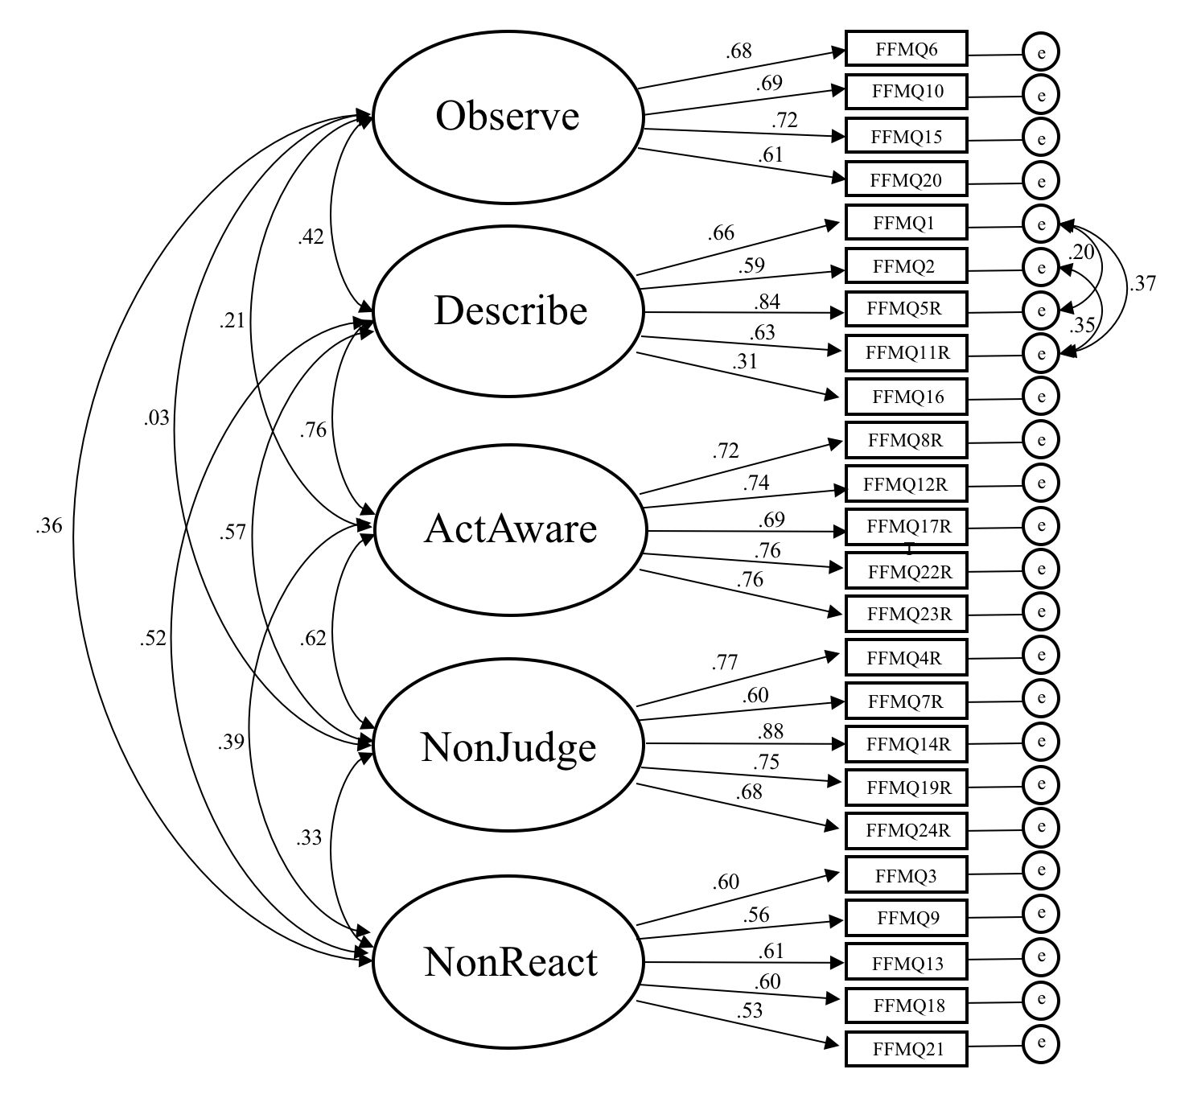
Figure 1. Correlated five-factor structure of the FFMQ-SF in an older adult sample. FFMQ = Five Facet Mindfulness Questionnaire – Short Form; ActAware = Acting with awareness; NonJudge = Non-judgement of inner experience; NonReact = Non-reactivity to inner experience; R = item reverse coded; e = item error term.

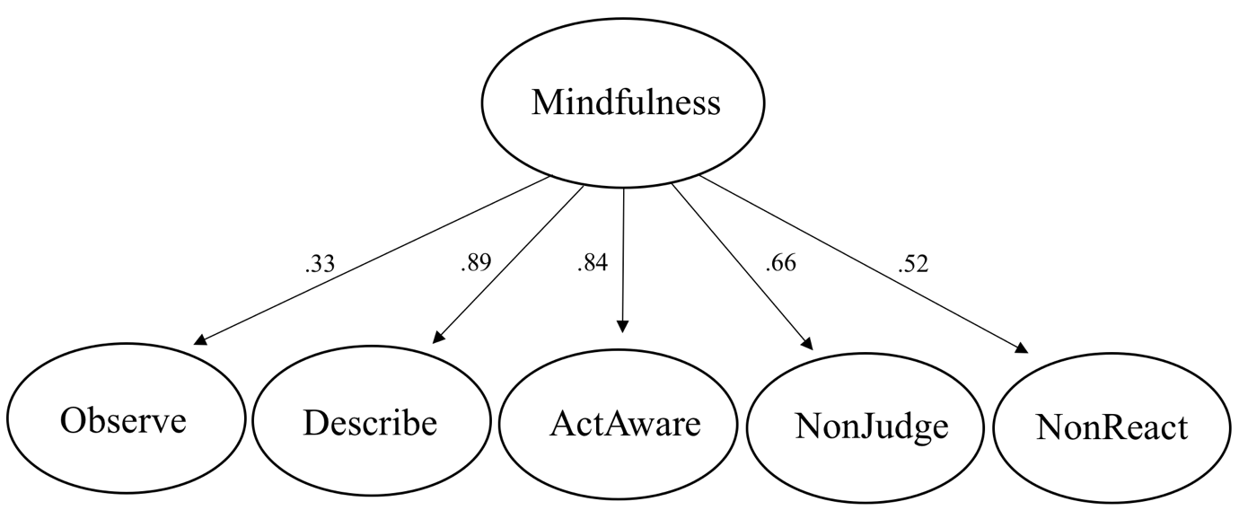
Figure 2. One-factor higher order structure of the Five Facet Mindfulness Questionnaire – Short Form. ActAware = Acting with awareness; NonJudge = Non-judgement of inner experience; NonReact = Non-reactivity to inner experience.

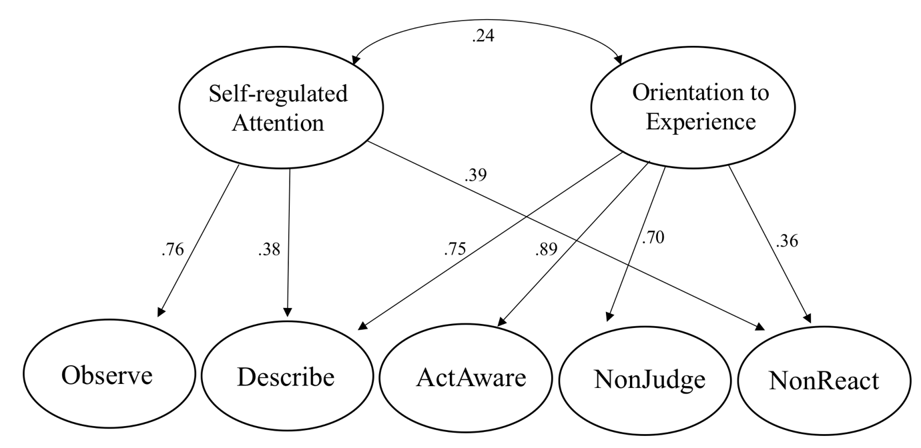
Figure 3. Two-factor higher order structure of the Five Facet Mindfulness Questionnaire – Short Form. ActAware = Acting with awareness; NonJudge = Non-judgement of inner experience; NonReact = Non-reactivity to inner experience.

