Cause Analysis for a New Type of Devastating Flash Flood
Jingming Hou^{1*}, Bingyao Li¹, Yu Tong¹, Liping Ma¹, James Ball², Hui Luo³,
Qiuhua Liang⁴
¹ State Key Laboratory of Eco-hydraulics in Northwest Arid Region of China, Xi’an University of Technology, NO.5 Jinhua Road, Xi’ an, 710048, China
² School of Civil and Environmental Engineering, University of Technology Sydney, New South Wales 2007, Australia
³ Meteorological Bureau of Shaanxi Province, No.102-1 Weiyang Road, Xi' an 710015, China
⁴ School of Architecture, Building and Civil Engineering, Loughborough University, Loughborough, Leicestershire LE11 3TU, UK
* Corresponding author: Prof. Jingming Hou, Xi’an University of Technology, NO.5 Jinhua Road, Xi'an, China, 710048, E-mail: jingming.hou@xaut.edu.cn
Abstract: This work introduces an unprecedented flash flood that resulted in 9 casualties in Shimen Valley, China, 2015. Through filed survey and numerical simulation, the causes of the disaster are systematically analyzed, finding that the intense storm, terrain features and the large woody debris (LWDs) played important roles. The intense storm induced fast runoff and, in turn, high discharges as a result of the steep catchment surfaces and channels. The flood flushed LWDs and boulders downstream until blockage occurred in a contraction section, forming a debris lake. When the debris dam broke, a dam-break wave rapidly propagated to the valley mouth, washing people away. After considering the disaster-inducing factors, measures for preventing similar floods are proposed. The analysis presented herein should help others manage flash floods in mountain areas.
Keywords: Flash flood, Debris dam, Dam break, Large woody debris, Flood management

- Introduction
Floods in mountain areas are a devastating natural disaster, becoming one of the most important restrictive factors for sustainable development of the economy and society in mountain catchments (Weingartner et al. 2003, Tezuka et al. 2014, Thaler et al. 2016). Development of risk management and disaster control measures has been attracting attention by the government, academe and industries (Huang et al., 2018, Delalay et al. 2018). Mountain floods also have the characteristics of truculence, and peakiness due to limited river conveyance and storage capacity.
Although the fact of the growing flood events such as the dam break flood and floods in rivers has been widely known, research on mountain rivers and floods have been rarely reported in detail in the past. However, awareness has increased during the past twenty years (Wohl et al., 2010). Allamano et al. (2009) observed that intense floods in mountain catchment are becoming more frequent and are likely to become more frequent with global warming. Ozturk U. et al. (2018) discovered that the main cause of the flash flood and debris flow in Braunsbach was a series of heavy rainstorms dumping up to 140mm in 2h in May 2016. Bout et al. (2018) studied a flash flood event with landslides and debris flow and detected the cause was the convective storm hitting the North-Eastern part of Sicily, Italy, on 1st October, 2009.
Apart from storms, the dam-break of some barrier lakes caused by earthquakes and landslides are also likely to induce severe floods. Zhou et al. (2012) investigated disaster drivers of the barrier lakes after the Wenchuan Earthquake on May 12, 2008, and suggested some risk mitigation measures. Fan et al. (2018) studied the reactivated landslides in Tangjiawan on September 5, 2016. Some survey and satellite images from 2005, 2008, 2010 and 2015 were used to analyze the evolution of the landslide, investigating some reasons for formation of the barrier. However, dam-break floods were not fully taken into account. Vermuyten E. et al. (2018) presented two extensions of a combination of model prediction control and a reduced genetic algorithm (RGA-MPC) technique to improve the effort of the real-time flood control.
All the mountain-flood events mentioned above are caused by the heavy rainstorm or/and dam-break flows of the debris (primarily earthquake) lakes. This work presents a new type of flash flood caused by chain effects of intense rainfall, barrier dam formed by flushed Large Woody Debris (LWDs) and boulder, as well as the dam-break wave propagation in Shimen Valley, Qinling Mountain, China, in order to depict the characteristics of the flood process, analyze the main disaster drivers and accordingly propose effective mitigating measures.
- The Shimen flood event
On 03/08/2015, a flash flood happened in the mouth of the Shimen Valley, a tributary of Xiaoyu River, Chang’an district, Xi’an City, China, as a result of a very intense storm. As shown in Figure 1, the catchment of Shimen Valley has an area of 2.1 km², a channel length of about 1.7 km with an average slope around 20°.
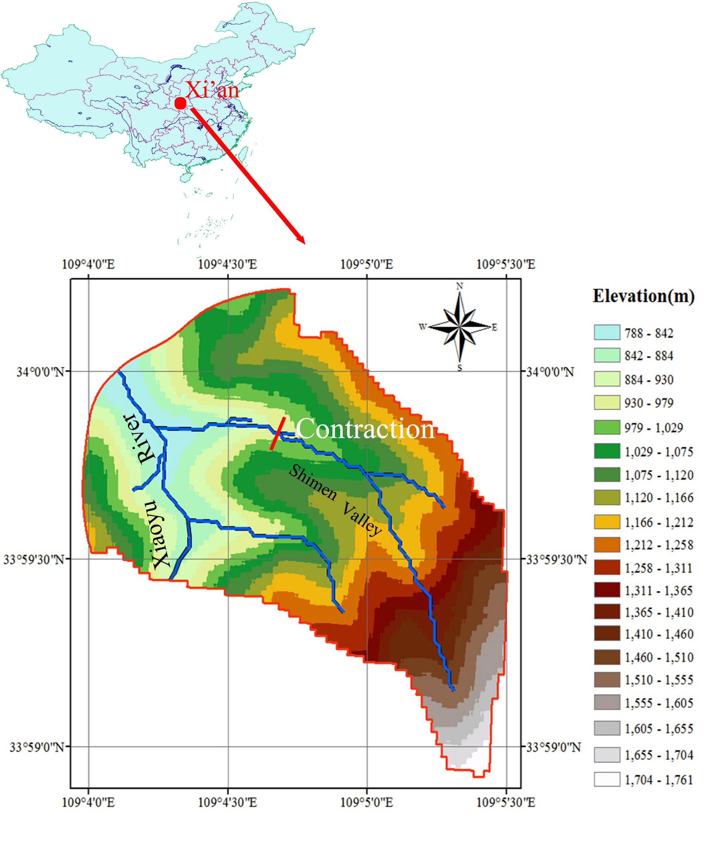
Figure 1 Study area in the catchment of Xiaoyu River
The flood flow from Shimen Valley, a tributary of the Xiaoyu River, washed nine people into the Xiaoyu River, seven of whom were killed with the remaining two missing. The rainfall was 145.7mm, reaching the highest value of a flood event in the 30 year monitored period. Some snapshots after the disaster are shown in Figure 2; these snapshots illustrate large amounts of debris carried by the flood destroyed the road crossing the flow path.
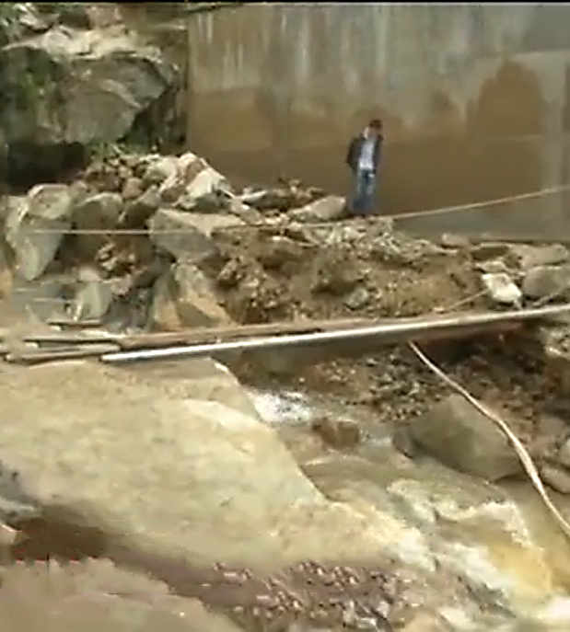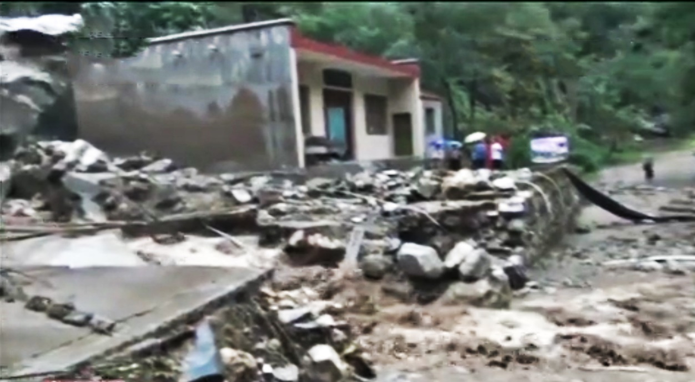
Figure 2 Some debris (a) and destroyed roadbed (b) after the flood event at the mouth of the Shimen Valley
The field survey discovered that a barrier lake was formed at a narrow section of the valley by debris transported by the flash flood. More and more water was stored in the reservoir until it was full. When the water level was high enough to overtop the embankment, a dam break occurred and the wave began to propagate downstream the channel, causing serve flash flooding. Figure 3 shows an aerial view of the study area. It should be noted that the scene of the accident site is different in Figures 2 and 3, as a concrete channel was built after the flood event to raise the capacity of the flow conveyance channel.
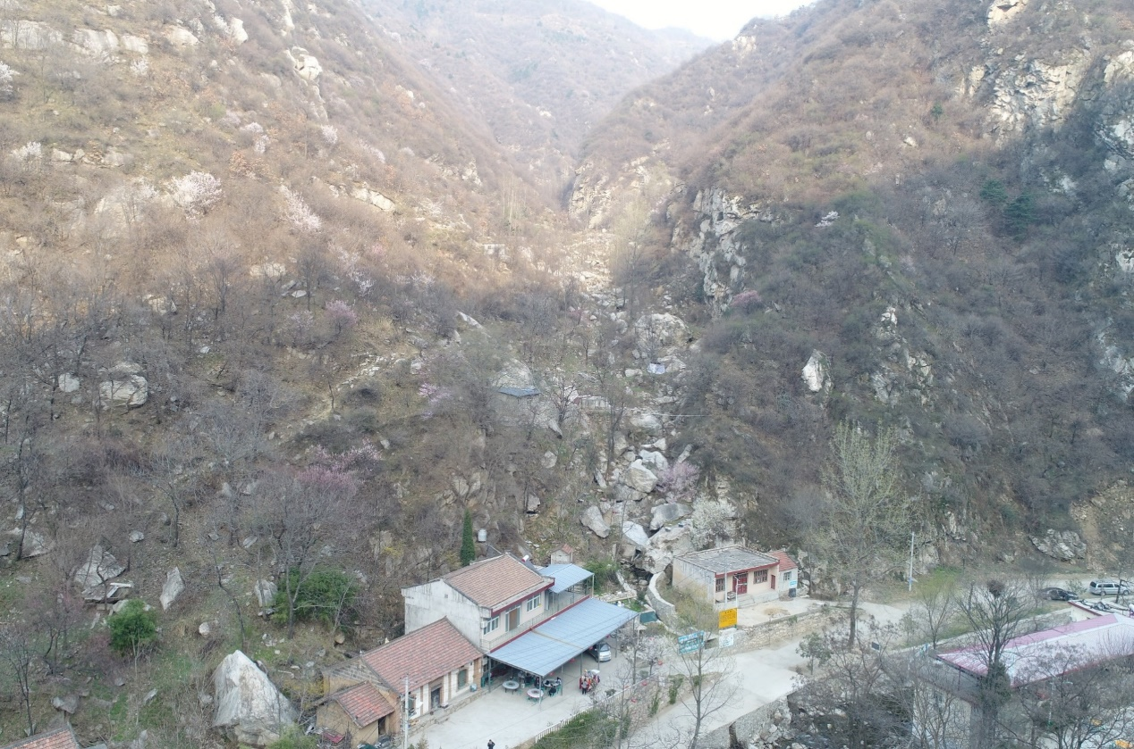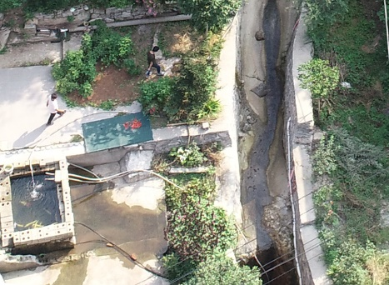
Accident Site
Xiaoyu River
Debris flow
house 1
house 2
Figure 3 The aerial view map of the Shimen Valley and the accident site
According to the filed investigation on 15/03/2018, the flash flood was relevant to the extreme rainfall, the terrain features and the vegetation conditions of the catchment, so the three main reasons leading to the new flood are analyzed in detail.
  - Heavy storm
A flash flood is normally caused by heavy rainfall in a short time, usually less than six hours (National Oceanic and Atmospheric Administration, NOAA, version 2.60). The catchment is located on the north slope of the Qinling Mountains, an important geographical border between the north and south of China, i.e. the transitional zone between subtropical and temperate zones. This area is claimed by He et al. (2012) as a region with high-frequency heavy rain.
In order to understand the precipitation process of the event, the hydrography of the study area is required. As there is no rain gauge in the valley, the closest rain gauge, referred to as Yinzhen, was selected to represent the storm at the Shimen Velley (9.5km from the valley as plotted in Figure 4). The hyetograph at Yinzhen rain gauge is illustrated in Figure 5, indicating the rainfall increased sharply from 17:00 to 18:00, 3rd of August, 2018. The total rainfall was 144.8mm in 5 hours and reached 126.6mm in the first 2 hours. According to the IDF curves of Xi’an City in the form of a Chicago storm type, this rainfall is in a return period of around1000 years. Such intense rainfall would be expected to produce large runoff and in turn lead to serve flooding.
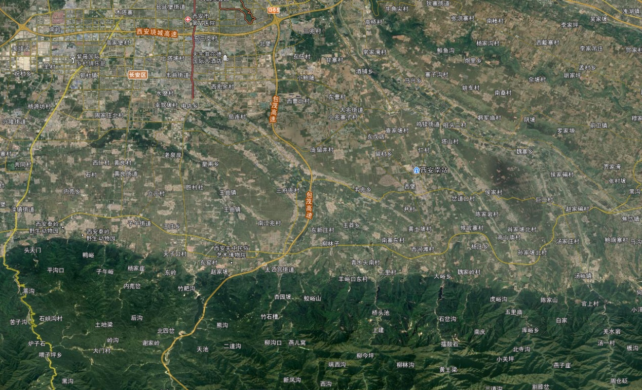
Shimen Valley
Luanzhen
Weiqu
Wutai
Yinzhen
Weizhai
Figure 4 Rain gauges around Shimen Valley
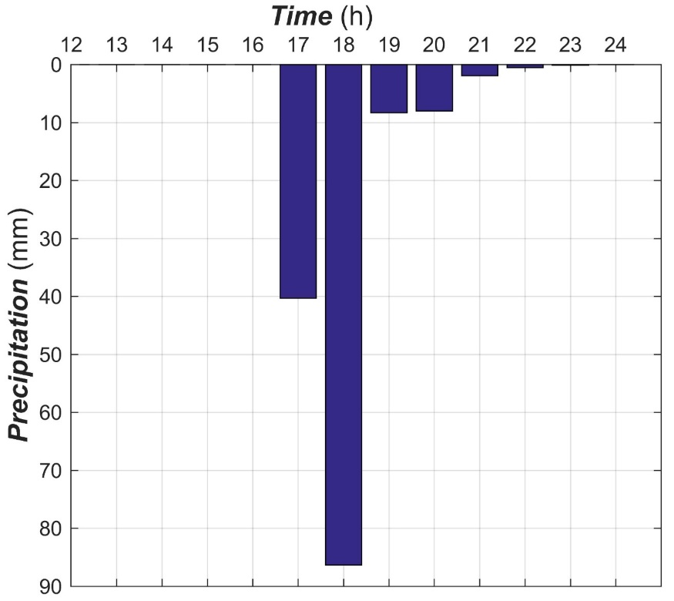
Figure 5 Hyetography in Yinzhen rain gauge on 03/08/2015
  - Terrain features
The terrain features also play a significant role in generating a sever flood. In this work, a high-resolution Digital Elevation Model (DEM) downstream of Shimen Valley was generated from raw data collected using LiDAR from an Unmanned Aerial Vehicle (UAV) (Figure 5). According to the terrain features, two contractions existing in the channel are likely to form debris dams. Once the dam breaks, the dam-break wave will accelerate down the steep channel and cause damage.
Figures 6 and 7 shows the contraction where the debris dam was created. The width of the contraction is about 15m and is much narrower than other parts of the valley. The debris consisting of boulders and trees carried by the flash flood blocked the valley at the contraction. A debris dam was formed and the water began to be stored in the upstream reservoir. The water level increases until the dam cannot hold the pressure at which time, the debris dam breaks and a dam-break wave propagates downstream. Through no direct evident is available, a witness living in the valley mouth reported that there was no water in the channel after about half hour; the discharge usually had a sudden increase once the storm got started. The period with low discharge indicated there was a high likelihood that a dam was formed in upstream reaches and that this dam blocked the main flow.
As plotted in Figures 6 and 7, the side slopes of the catchment are considerably steep. In some cross section, the slope could reach 60 degrees and is prone to induce fast-hydrological responses; that is, the surface runoff moves quickly to the channels. The channel slope in the catchment is also very abrupt as show in Figure 8, with an average value of 1:5 (horizontal to vertical). The rapidly collected water in the channel will be transported efficiently to the catchment outlet and, therefore, is likely to lead to flash floods. This high-velocity flow will sweep the channel and flush boulders and the trees downstream.
The dam-break flow would also be expedited in the steep channel and the water moves to the mouth of the valley. Another contraction in the mouth could concentrate the flow energy like a spout. The flood will spray in the spout area to the river and flush people in the river away.
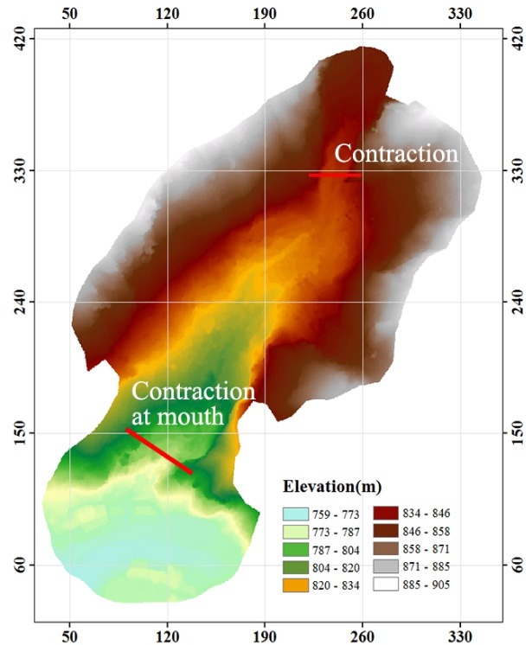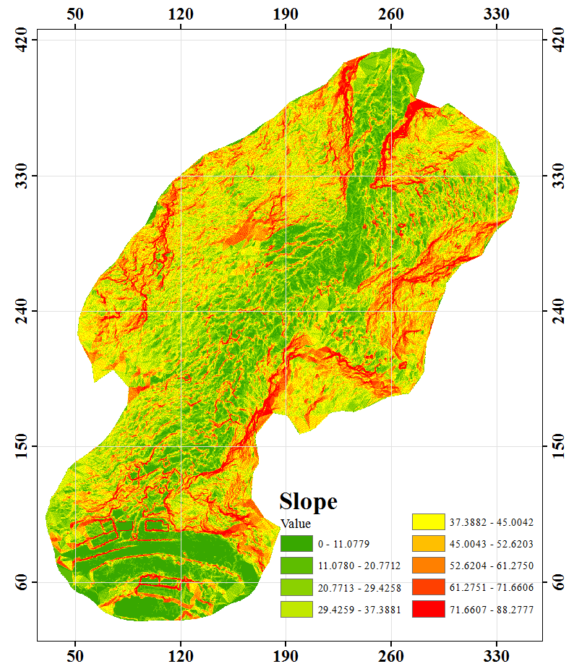
(a) DEM of the study area (b) Slope analysis of the study area
Figure 6 DEM and slope at the key part of Shimen Velley
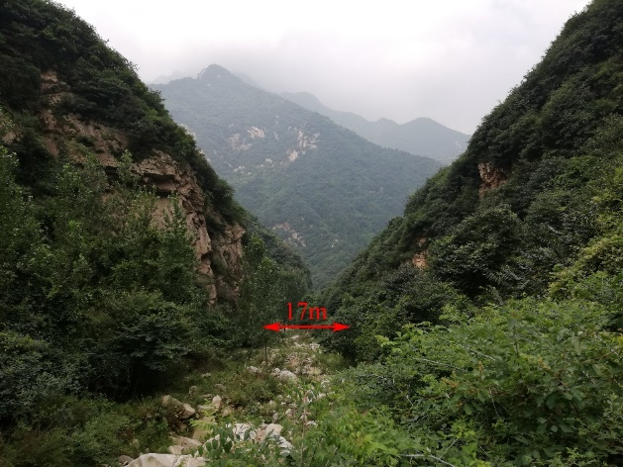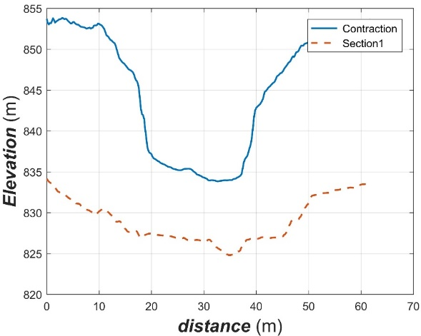
Figure 7 The contraction of the channel and its cross sections
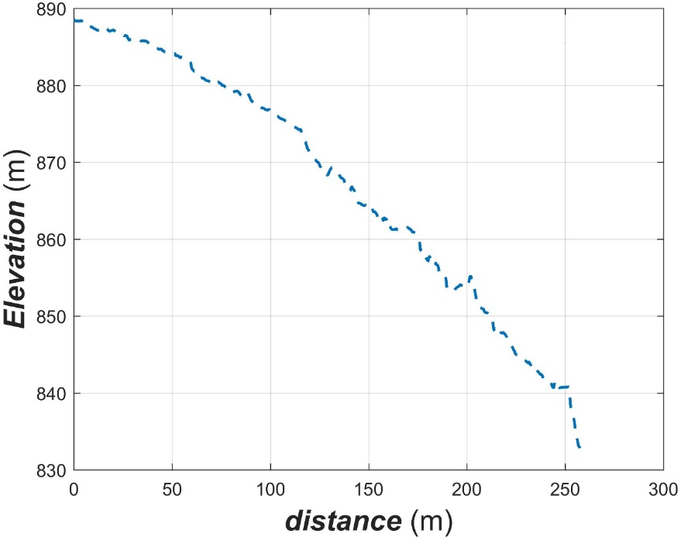
Figure 8 Channel slope of Shimen Valley
  - Thick Vegetation and Boulders
In this disaster, the debris consisted mainly of boulders, rock fragments, logs, sticks, branches and other wood that falls into the channel (see Figure 9). Figure 10 illustrates the thick vegetation cover in the Shimen Valley even in the river channel. Apart from the shrub on the side slope, some trees in the channel were planted by the local residents. Theoretically, the trees can increase surface roughness and reduce flood peaks. But the logs, sticks and branches were distributed in the slopes and river channel, most of them were not cleaned up in time. Once the heavy storm occurs, the fast runoff will carry the Large Woody Debris (LWD) downstream and debris may destroy the living big trees. Some trees growing in the contraction part of the channel would block the LWB and thus form a debris dam together with the boulders.
The boulders, as shown in Figure 9, are another kind of debris source. Once the flood velocity is adequate to carry the big stones, they will move downstream, mixed with the LWDs. When they arrive at the contraction section, the debris gathered and a barrier lake was formed with the carrying action of water. The water will be stored until the dam could not host the water. In this area, the thick trees play an important role for building the dam, since the trees worked as pillars to trap the coming debris.
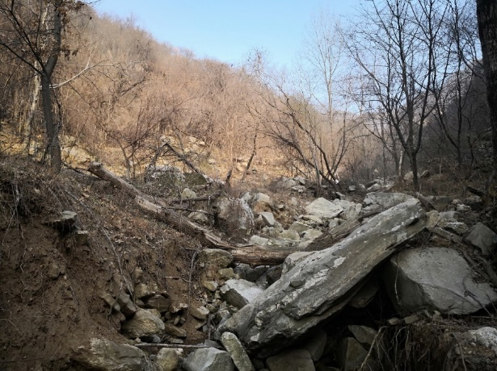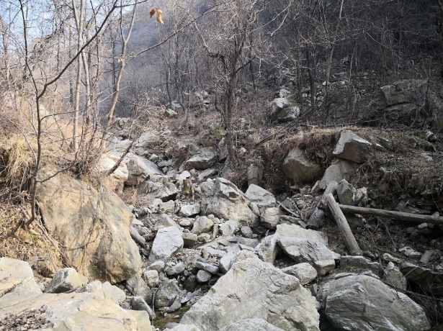
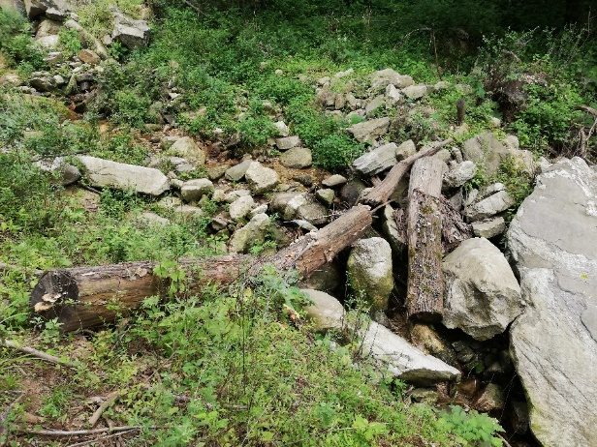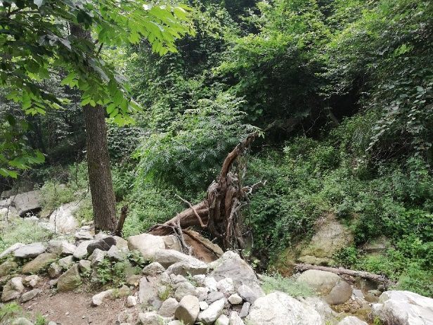
Figure 9 Debris in the channel
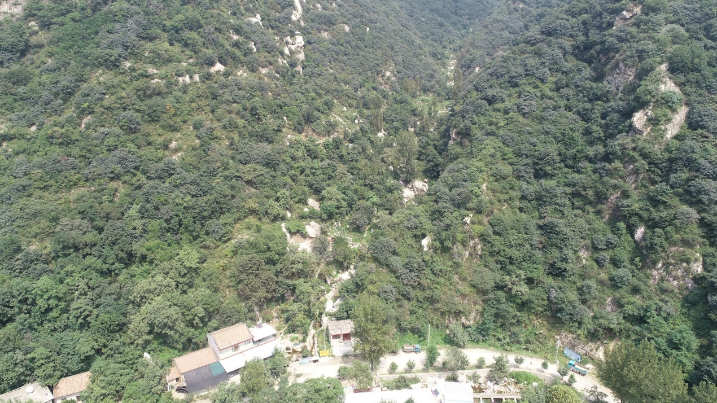
Figure 10 Vegetation cover in the Shimen Valley
In summary, the heavy storm, the terrain features and the debris material of LWD and boulders each made a contribution to the flash flood. The extreme storm triggered the flash flood in the river channel. The fast flood flow will carry the debris material in the form of boulders and the LWDs to the lower reach. A debris dam was created in the contraction area and then breached, leading to an aggravated flood disaster.
- Reproduction of the flood event using a hydrodynamic model
  - Numerical hydrodynamic model
In this work, a numerical hydrodynamic model proposed in Hou et al. (2015) is utilized to compute the process of the dam-break flood propagation. The hydrodynamic model was developed by solving the 2D SWEs numerically, within a framework of a well-balanced cell-center Godunov-type finite volume method. The scheme is able to perform well to capture the shock waves caused by the dam break flow.
  - Dam-break flood simulation
The proposed hydrodynamic model is used to model the process of the dam-break flood. According to the field investigation, a barrier lake with around 7m water depth was formed in the upstream reach about 200m from the accident site. As the real dam beak process is unknown, a sudden breach for the dam, in order to reflect the most dangerous scenario, was assumed to produce the dam-break waves. The initial conditions of the water and bed elevation are shown in Figure 11. To account for topographic features, a DEM with a resolution of 0.2m was applied in the simulation. A constant manning coefficient of 0.02 was adopted to consider the local roughness. The model was run for a simulation period of10 mins to predict the dam-break flood wave propagation.
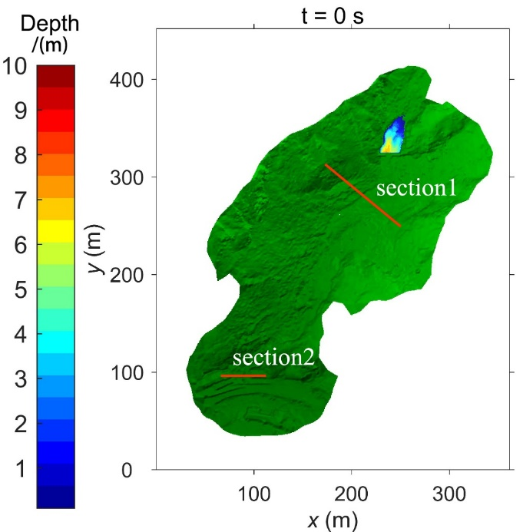
Figure 11 The barrier lake and initial water depth at Shimen Valley
According to the field investigation, photos and videos from the witnesses, the flood in the mouth of the valley reached very high levels; flood marks on the wall of house 2 in Figure 3 is about 2m high. In order to validate the hydrodynamic model, a comparison point was set near the wall. The computed depth hydrograph in Figure 12 shows that the highest predicted depth is nearly 1.8m. Thus, the simulation results is close to the measured water level. Figure 13 also shows the velocity of the flood in the valley mouth at 42s when the flood reaches the highest value. At that time, the velocity around the house is about 9m/s, as Cox et al. (2010) investigate that the limited velocity for adults and children in good conditions is 3m/s, indeed, the kinematic energy is sufficient to cause the accident.
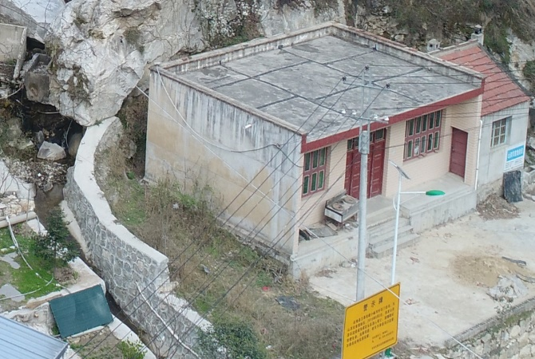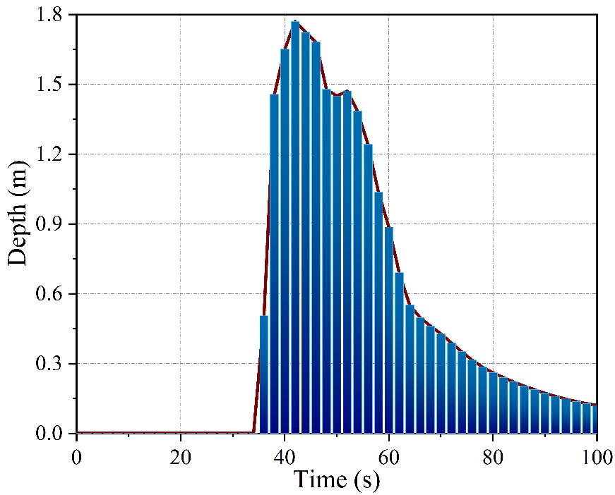
Floodmarks
Figure 12 The flood mark and computed water depth evolution near the house
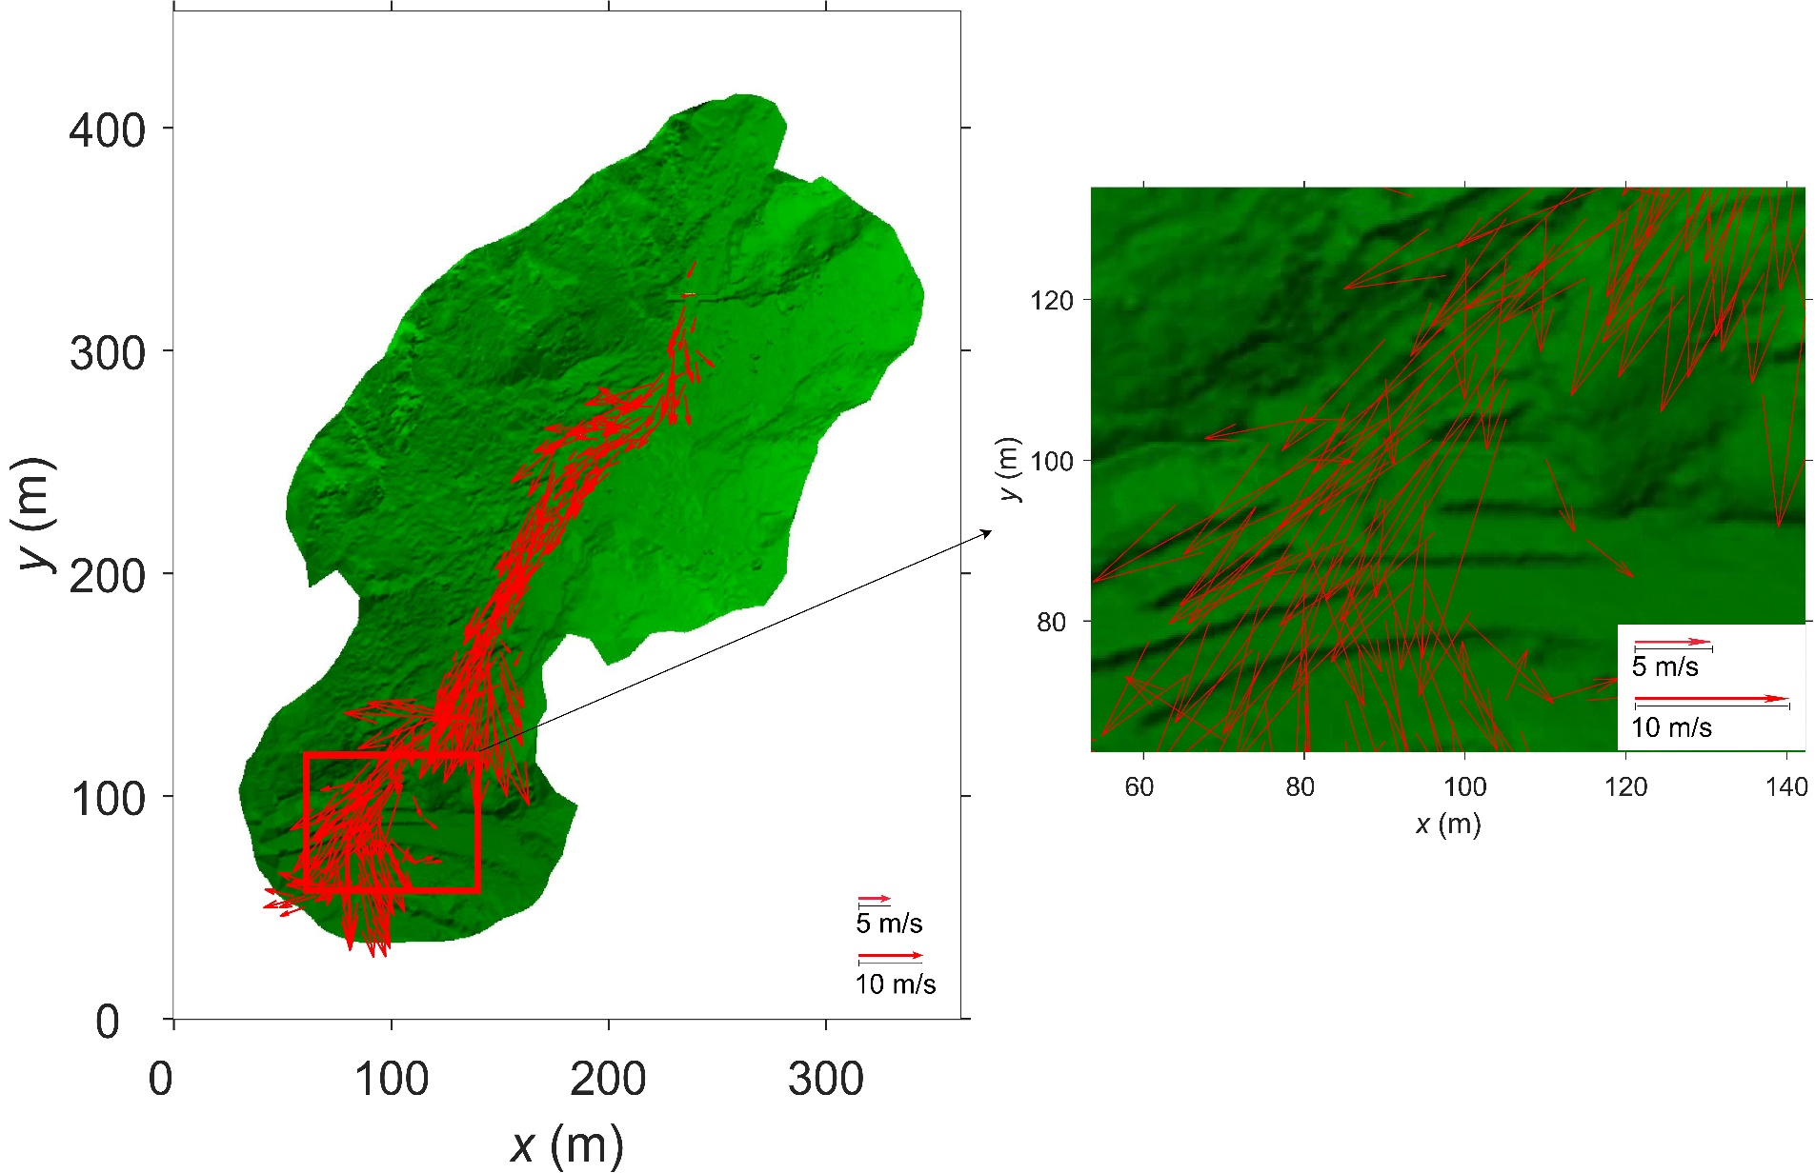
Figure 13 Velocity field distribution at the valley mouth
Figure 14 reveals the computed time series of the flood propagation. When the debris dam broke, the flood rushed downstream in a short time. After less than 30s, the dam-break wave front arrived at the houses of the valley mouth. The locally enlarged pictures in Figure 14 show the dam-break wave front hit two houses. The phenomena is validated against the flood marks and the eyewitness reports. The main stream flowed through the gap between the two houses, causing an energy concentration that resulted in people being flushed into the river.
The detailed hydraulic features of the flood event are illustrated in Figure 15 and Figure 16 where the computed flow discharge and the maximum water depth at the two cross sections under consideration are plotted. The peak discharges of about 118 to 65 m³/s are very rare in this valley. The computed maximum water depth is close to 1.9 m, appearing in section 2. Such a high water depth might be caused by the contraction effect of the houses at the valley mouth.
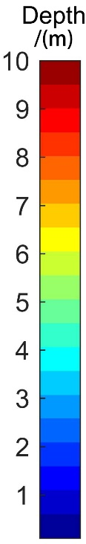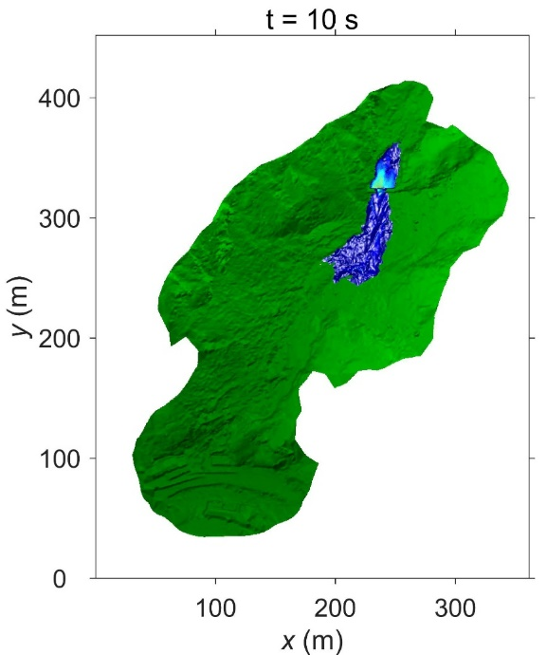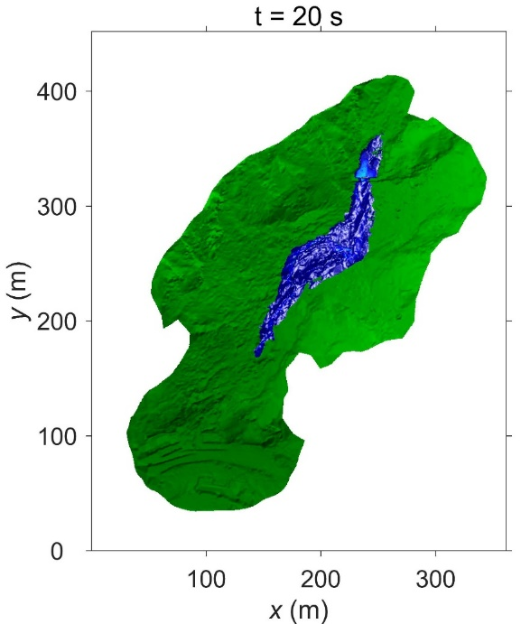
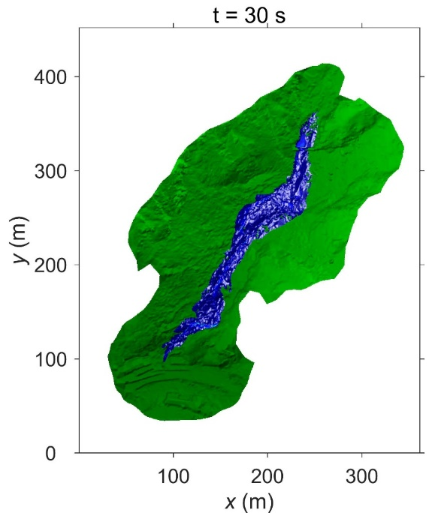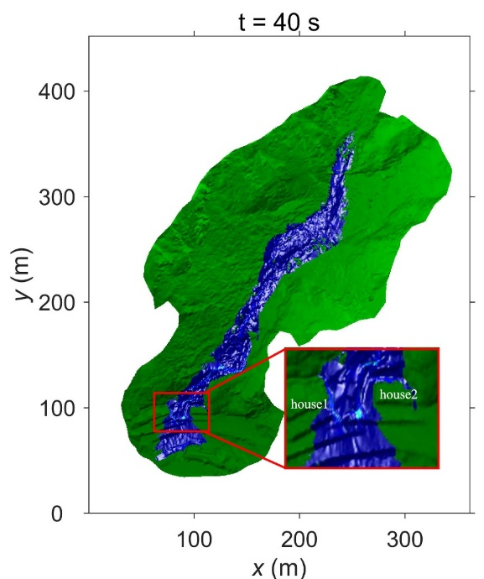
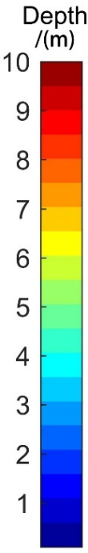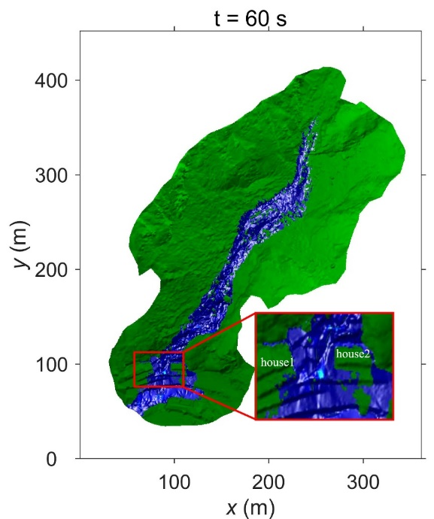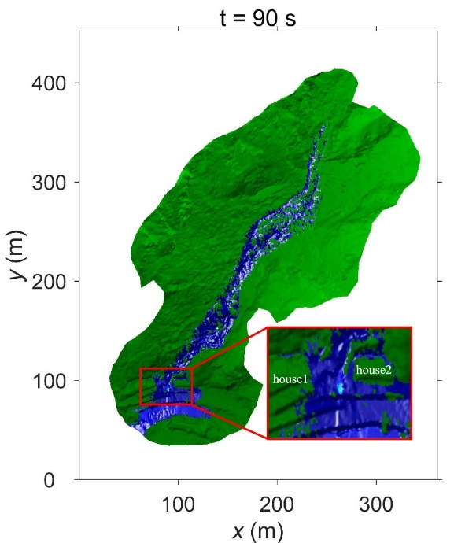
Figure 14 Computed flood propagation process after the dam break
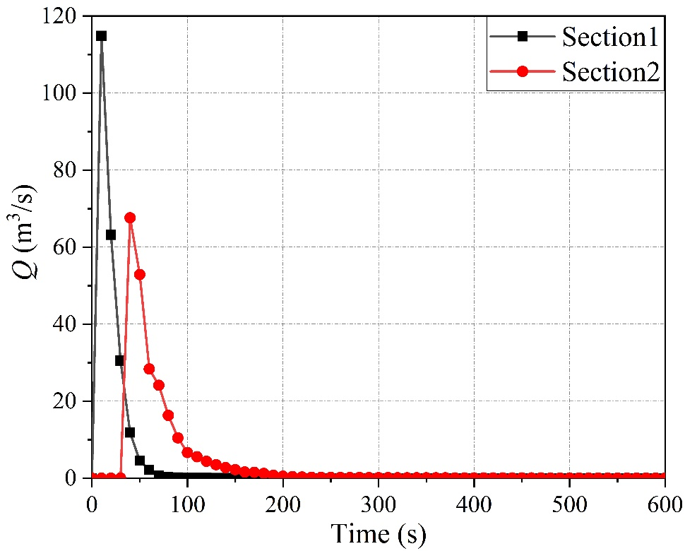
Figure 15 Computed flood discharge at different sections
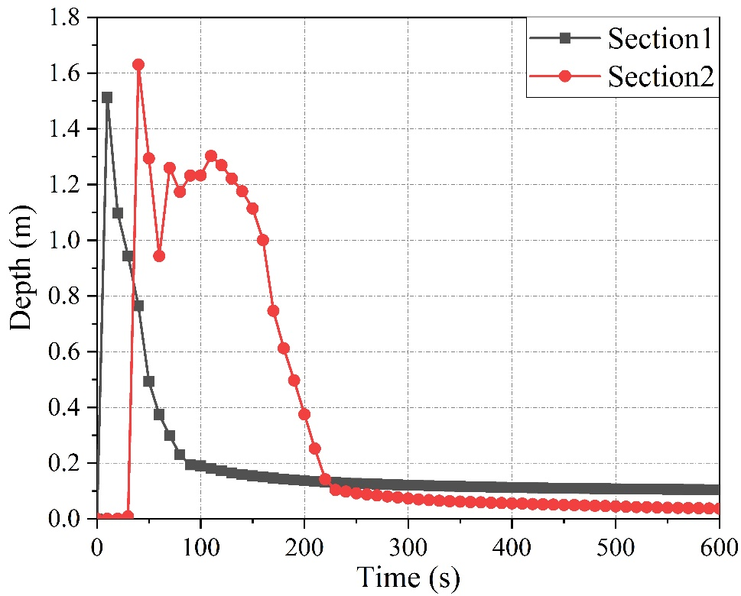
Figure 16 Computed maximum water depth at different sections
- Lessons learned from the event
The flood event considered herein is a type of rare event causing a catastrophic result (9 peoples lost their lives). To avoid similar disasters, analysis of the precipitation, terrain, land cover effects, and human behavior can be used to for development of mitigation plans:
- Apart from the heavy storm, the terrain characteristics are one of the main reasons for formation of the debris dam. The contraction existing in the channel provides a point for trapping of LWDs and boulders. Hence, additional flood risk analyses considering the potential for dam-breaks arising from debris dams is suggested for catchments where contractions in the river channel occur.
- Logs, sticks and branches are scattered over the channel and make an enormous contribution for the LWD forming the debris dam. The timely cleansing of the woody debris in the catchment, especially in the channel, is highly required. For example, an annual patrol can be arranged by the local authority and some big logs could be cut into pieces to avoid the river clogging before the rainy season.
- Since there are two houses at the valley mouth, a contraction occurs at this point in the river, and the flow will be concentrated through the gap between the houses. A nozzle effect takes place, and the velocity will be increased; the intensified kinetic energy and shear stress will flush objects away. Therefore, buildings should not be planned at the valley mouth or leave the enough space for flood routing.
- A road along the river is located next to the valley mouth/outlet. A flood will cross this road into the river. However, there is no protecting measures by the river side; people, therefore, will be prone to be swept into the river. If protecting measures are implemented, the victims will be intercepted and thus are prevented from being drowned. The protecting measures, e.g. guard rails should be designed to convey the water but intercept people, and also host the force arising from debris.
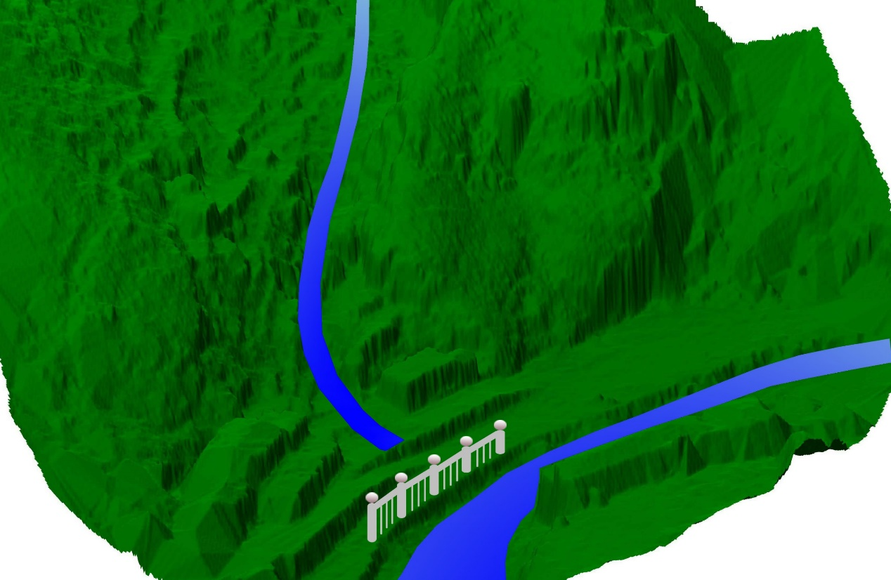
Xiaoyu River
Guardrail
Shimen Valley
Figure 17 Guard rail proposed at the valley mouth along the river
- Conclusion
In this paper, an unprecedented flash flood leading to 9 casualties in Shimen Valley is presented. The causes of the event are analyzed through using filed survey and numerical simulation. The measures how to mitigate the flood risk are proposed. The following conclusions are drawn:
- The flood happened so suddenly and the 9 peoples were flashed into the main river channel from the river side and drown. It is an unprecedented one and may raise alarm bells for preventing this kind of flash flood in mountain areas.
- Regarding the causes of the flood, the heavy storm, special terrain features and the LWDs play important roles. The heavy storm induced the quick runoff and the high discharge in the valley channel, due to the steep slope for the valley and channel. The flood carried the LWDs and the boulder to the downstream reach until the debris was blocked in the contraction section. A debris lake was formed and the water began to store. Then the debris dam broke and the dam-break wave started to propagate to the valley mouth, flushing the peoples.
- According to the disaster-inducing factors, some measures preventing such flood are proposed. For the steep catchment with contraction in the channel, where lie lots of LWDs and boulders, the additional risk assessment should be made to taken into account of the potential debris dam and dam break process. In this case, the houses must not be built at the valley mouth, so as to avoid the man-made contraction which concentrates the flood energy and thus aggravate the disaster. Moreover, the guard rails are suggested to set at the valley mouth and along the river bank, in order to prevent the peoples from being flushing into the water course.
Since it is an ungauged catchment, the detailed hydrological and hydraulic data are not available. To systematically and quantitatively analyze such kind of flood event, the future work is planned to install rain-gauge and discharge meters in the catchment and the long-term data collected can help investigate the mechanism in details.
Acknowledgement
This work is financially supported by the National Key Research and Development Program of China (Grant No. 2016YFC0402704), National Natural Science Foundation of China (Grant No. 19672016), Shaanxi International Science and Technology Foundation of China (Grant No. 2017KW-014) and the Water Conservancy Science and Technology Project of Shaanxi Province (Grant No. 2017SLKJ-14).

Reference
Allamano P, Claps P, Laio F (2009) Global warming increases flood risk in mountainous areas. Geophysical Research Letters 36: L24404. doi: 10.1029/2009GL041395
Bout B, Lombardo L, Westen CJV, Jetten V G (2018) Integration of two-phase solid fluid equations in a catchment model for flashfloods, debris flows and shallow slope failures. Environmental Modelling & Software 105: 1-16. doi: 10.1016/j.envsoft.2018.03.017
Cox R, Shand T, Blacka M (2010) Appropriate Safety Criteria for People in Floods, WRL Research Report 240. Report for Institution of Engineers Australia, Australian Rainfall and Runoff Guidelines: Project 10. 22 p.
Delalay M, Ziegler AD, Shrestha MS, Wasson RJ, Sudmeier-Rieux K, Mcadoo BG, Kochhar I (2018) Towards improved flood disaster governance in Nepal: a case study in Sindhupalchok District. International Journal of Disaster Risk Reduction 31: 354-366. doi: 10.1016/j.ijdrr.2018.05.025
Fan X, Zhan W, Dong X, Western CV, Xu Q, Dai L, Yang Q, Huang R, Havenith HB (2018) Analyzing successive landslide dam formation by different triggering mechanisms: The case of the Tangjiawan landslide, Sichuan, China. Engineering Geology 243: 128-144. doi: 10.1016/j.enggeo.2018.06.016
He H, Zhou J, Peart MR, Chen J, Zhang Q (2012) Sensitivity of hydrogeomorphological hazards in the Qinling mountains, China. Quaternary International 282: 37-47. doi: 10.1016/j.quaint.2012.06.002
Hou J, Liang Q, Zhang H, Hinkelmann R (2015) An efficient unstructured MUSCL scheme for solving shallow water equations. Environmental Modelling and Software 66: 131-152. doi: 10.1016/j.envsoft.2014.12.007
Huang CW, Yang FPY, Huang LH, Chou JF, Lien HC,Chang CW (2018) Optimal design of interception for flood control: an integrated simulation approach. Journal of Hydro-environment Research 19: 103-116. doi: 10.1016/j.jher.2018.02.001
Ozturk U, Wendi D, Crisologo I, Riemer A, Agarwal A, Vogel K, et al (2018) Rare flash floods and debris flows in southern Germany. Science of the Total Environment 626: 941-952. doi: 10.1016/j.scitotenv.2018.01.172
Papalexiou SM, Koutsoyiannis D (2013) Battle of extreme value distributions: a global survey on extreme daily rainfall. Water Resources Research, 49(1): 187-201. doi: 10.1029/2012WR012557
Tezuka S, Takiguchi H, Kazama S, Sato A, Kawagoe S, Sarukkalige R (2014). Estimation of the effects of climate change on flood-triggered economic losses in Japan. International Journal of Disaster Risk Reduction 9: 58-67. doi: 10.1016/j.ijdrr.2014.03.004
Thaler T, Hartmann T, Glade T, Murty TS, Vladimír Schenk (2016) Justice and flood risk management: reflecting on different approaches to distribute and allocate flood risk management in Europe. Natural Hazards 83(1): 129-147. DOI: 10.1007/s11069-016-2305-1
Vermuyten E, Meert P, Wolfs V, Willems P (2018) Model uncertainty reduction for real-time flood control by means of a flexible data assimilation approach and reduced conceptual models. Journal of Hydrology 564: 490–500. doi: 10.1016/j.jhydrol.2018.07.033
Weingartner R, Barben M, Spreafico M (2003). Floods in mountain areas-an overview based on examples from Switzerland. Journal of Hydrology 282(1): 10-24. doi: 10.1016/S0022-1694(03)00249-X
Wohl E (2010). Mountain rivers revisited. AGU Water Resources Monograph, America
Zhou H, Zhang L, Yang X (2012) Factors influencing breach risk of quake lake group. Procedia Environmental Sciences 12(part-PB): 815-822. doi: 10.1016/j.proenv.2012.01.353

