This is the peer reviewed version of the following article: [Identification of a serine protease inhibitor which causes inclusion vacuole reduction and is lethal to Chlamydia trachomatis], which has been published in final form at [10.1111/mmi.12306].
This article may be used for non-commercial purposes in accordance with Wiley Terms and Conditions for Self-Archiving.

Identification of a serine protease inhibitor which causes inclusion vacuole reduction and is lethal to Chlamydia trachomatis

Short title: Essential serine protease for Chlamydia
Sarina Gloeckl^{1#}, Vanissa A Ong^{1#}, Pooja Patel^{1#}, Joel DA Tyndall², Peter Timms¹, Kenneth W Beagley¹, John A Allan³, Charles W Armitage¹, Lynne Turnbull⁴, Cynthia B Whitchurch⁴, Melisa Merdanovic⁵, Michael Ehrmann⁵, Martijn Verdoes⁶, Matthew Bogyo⁶, Wilhelmina M Huston¹*
- Institute of Health and Biomedical Innovation and School of Biomedical Sciences, Faculty of Health, Queensland University of Technology, Kelvin Grove, QLD 4059 Australia
- School of Pharmacy, University of Otago, Dunedin, New Zealand
- The Wesley Research Institute, The Wesley Reproductive Medicine and Gynaecological Surgery Unit, Auchenflower, Brisbane Australia
- Microbial Imaging Facility, The iThree institute, University of Technology Sydney, Sydney, NSW, 2007 Australia
- ZMB, Uni Duisburg-Essen, Essen, Germany

- Department of Pathology, Stanford University School of Medicine, Stanford, CA 94305-5324, USA.
*corresponding author, email: w.huston@qut.edu.au, phone: +61 7 31386258
# SG, VAO, and PP all contributed equally to this work
Summary
The mechanistic details of the pathogenesis of Chlamydia, an obligate intracellular pathogen of global importance, have eluded scientists due to the scarcity of traditional molecular genetic tools to investigate this organism. Here we report a chemical biology strategy that has uncovered the first essential protease for this organism. Application of a unique CtHtrA inhibitor (JO146) to cultures of Chlamydia resulted in a complete loss of viable elementary body formation. JO146 treatment during the replicative phase of development resulted in a loss of Chlamydia cell morphology, diminishing inclusion size, and ultimate loss of inclusions from the host cells. This completely prevented the formation of viable Chlamydia elementary bodies. In addition to its effect on the human C. trachomatis strain, JO146 inhibited the viability of the mouse strain, Chlamydia muridarum, both in vitro and in vivo. Thus, we report a chemical biology approach to establish an essential role for Chlamydia CtHtrA. The function of CtHtrA for Chlamydia appears to be essential for maintenance of cell morphology during replicative phase and these findings provide proof of concept that proteases can be targetted for anti-microbial therapy for intracellular pathogens.

Introduction
Chlamydia are obligate intracellular bacterial pathogens with significant clinical importance. Chlamydia (C.) trachomatis is the most common sexually transmitted bacterial infection world wide and the occular infecting serovars are the most common cause of preventable blindness worldwide (WHO, 2011). In spite of the substantial health burden due to the Chlamydia, comparatively little is known about the organism’s functional pathogenesis and disease mechanisms.
Members of the chlamydiae family are distinguished by an unusual bi-phasic developmental cycle that consists of a small, tough, spore-like, non-replicative extracellular form (termed the elementary body, EB) and the intracellular replicative, metabolically active, non-infectious form (called the reticulate body (RB)). The intracellular phase occurs exclusively in a unique vacuole known as the inclusion vacuole (reviewed (Abelrahman & Belland, 2005)). This developmental cycle and the obligate intracellular nature of the Chlamydia have hampered efforts to develop traditional techniques to genetically manipulate the organism. Although there have been recent developments, including a chemical mutation approach to generate chromosomal mutants (Kari et al., 2011) and successful transformation of the organism with its own plasmid (Wang et al., 2011), biological understanding of this organism remains limited relative to its economic and health impact.
The highly conserved protease HtrA (Chlamydia HtrA; CtHtrA) has been described as having a number of virulence functions for pathogenic bacteria (Chitlaru et al., 2011, Hoy et al., 2010). This protease has been described in C. trachomatis using in vitro and microscopy methods, and potentially functions as both a bacterial cell associated protease and as a secreted virulence factor (from 28 hours post infection) (Huston et al., 2007, Huston et al., 2008, Wu et al., 2011). Our previous investigations into the biochemical mechanism of activation implicated outer membrane protein sequences with activation of the chaperone form, suggesting a potential role in surface protein assembly (Huston et al., 2011). Recently the protease that has been considered to be the major chlamydial pathogenesis factor, (CPAF), has been the focus of controversy as it appears that many of the functions attributed to this protease may have been detected as an artefact of the sample preparation (Chen et al., 2012), including a key function thought critical for viable infectious yield (Heuer et al., 2009).
Other chlamydial virulence factors have also been uncovered using small molecule approaches, including by application of the bacterial type III protein secretion inhibitor (Wolf et al., 2006), and a peptidomimetic to the type III secretion ATPase protein interaction domain (Stone et al., 2011). These studies support the fact that chemical approaches are a powerful strategy to investigate the function of proteins within this unique organism. Here we used a CtHtrA protease inhibitor, JO146, to demonstrate an essential role for CtHtrA in developmental cycle progression during the chlamydial replicative phase. JO146 treatment resulted in chlamydial cell morphology loss, the diminishing of inclusion vacuoles and eventual loss and complete bacterial lethality by failure to develop viable infectious progeny (EBs).

Results
Selective and specific phosphonate inhibitors of CtHtrA are lethal to C. trachomatis when added during the replicative phase of the developmental cycle
A library of 1090 serine protease inhibitors (previously described (Arastu-Kapur et al., 2008, Hall et al., 2011)) was screened against CtHtrA in vitro protease activity. Two inhibitors were identified, JO146 and JCP83 (IC₅₀s: 12.5 μM and 47.19 μM, Fig.1A). Both are peptides with a C-terminal phosphonate ‘warhead’ which reacts irreversibly with the protease active site serine residue (Oleksyszyn & Powers, 1991) (Jackson et al., 1998), and differ only in the P3 position (Val/Ala). Both inhibitors have valine at the P1 position and proline at P2. The two inhibitors were quite selective towards CtHtrA when screened against a series of other serine and HtrA family proteases (Table 1). Inhibition was only observed for HTRA2 and elastase. Neither compound was cytotoxic for McCoy and HEp-2 cells, both common cell lines used for Chlamydia culture. Specifically, no cell lysis or impaired metabolic turnover was detected when the cells were incubated with JO146 or JCP83 for 8 h (Table S1, as described in the supporting data).
The two inhibitors were added to C. trachomatis cultures at different time points throughout the developmental cycle (Fig. 1B; lag ~8h, replication at ~2.4 h per division, EB formation from ~24 h post infection (h PI) (Miyairi et al., 2006)). Viable infectious elementary bodies (inclusion forming units) at completion of the developmental cycle after each of these independent treatments was then determined. As shown in Fig. 1C-F, addition of JO146 or JCP83 resulted in complete or significant (p<0.001) loss of viable elementary body formation when added during the replicative phase. The activity was most effective at higher doses, however, at 16 h PI even 10 μM JO146 had a significant impact on viability with a lower Chlamydia multiplicity of infection (MOI; Fig. 1C, p<0.001). The host cell numbers were the same under each condition so these data indicate that the amount of Chlamydia present (MOI) associates with the effectiveness of the compounds.

The lethality of JO146 for C. trachomatis at 16 h PI does not require host cell protein synthesis, and is not influenced by the type of host cell
Chlamydia viable yield from cell culture improves when a host cell protein synthesis inhibitor (cycloheximide) is used (Thomas et al., 1977). The role of host cell protein synthesis during JO146 inhibition (16 h PI) was tested at an MOI of 0.3 in HEp-2 cells. The viability was determined at 44 h PI and the lethality of JO146 was maintained in the presence of cycloheximide (Fig. 2A).
C. trachomatis is capable of infection and replication within a variety of epithelial cells. The effectiveness of JO146 against C. trachomatis when added at 16 h PI was evaluated in a variety of host cell types with viability determined at 44 h PI (MOI 0.3). There were different yields of C. trachomatis depending on the host cell type infected which was expected (Fig. 2B). There were significantly (p<0.001) higher yields of viable Chlamydia when cultured in McCoy cells; however JO146 was still lethal for C. trachomatis at 100 μM doses in McCoy cells. These data support that JO146 activity is dependent on the amount of Chlamydia present, does not require host cell protein synthesis and is not dependent on the host cell type.

A JO146 activity based probe binds CtHtrA during cell culture
A JO146-Cy5 activity-based probe was used to monitor inhibitor-protein binding throughout the C. trachomatis developmental cycle (Fig. 3A). This probe was synthesised to retain the tri-peptide sequence and phosphonate functional group which binds to the active site serine but has an additional Cy5 fluorophore linked to the N-terminus. Three predominant bands were observed with one additional faint band. A dominant doublet of bands around ~48-50 kDa was observed to be bound by JO146-Cy5 (Fig. 3A). These bands corresponded to the banding pattern of CtHtrA throughout the developmental cycle (western blot shown below, Fig. 3A). This CtHtrA doublet has also been observed previously by another group with their own antibodies (Wu et al., 2011). The high levels of CtHtrA present at time 0, or in the elementary bodies, do not show corresponding high levels of binding of JO146 as it is unlikely that the compound can enter this cellular form of Chlamydia. The next most intense band was at approximately ~37 kDA. Two additional, less intense bands were detected at approximately ~25 kDa and ~125 kDa (Fig. 3A).
Competitive binding assays were conducted to confirm that the JO146-Cy5 activity-based probe bound to the same targets as JO146. C. trachomatis infected and uninfected HEp-2 cells were harvested at 22 h PI and a titration of JO146 was added to either lysed or unlysed cell cultures. JO146-Cy5 was added thirty minutes later. The same bands previously observed in Fig. 3A were also observed (lane 1, Fig. 3B). The binding of JO146-Cy5 to all of these bands except the ~25 kDa band was competitively inhibited by JO146 pre-incubation (Fig. 3B). The ~25, ~37 and ~125 kDa bands were also present in the HEp-2 only cultures. Thus, JO146 appears to bind to two mammalian proteins (~125 kDa and ~37 kDa) and to a doublet band corresponding to CtHtrA. CtHtrA JO146-Cy5 binding was competitively inhibited by the addition of JO146 to live, unlysed cultures supporting the compound entering the inclusion vacuole, as CtHtrA is only detected inside the inclusion vacuole at this time point (Wu et al., 2011).
A JO146-Biotin activity-based probe was used to isolate the bands of interest and confirm their identities by proteomics. The ability to pull down purified recombinant CtHtrA bound to JO146-Biotin using streptavidin beads was confirmed (Supporting data Fig. S1). This approach was then used on chlamydial cell culture lysates. The experiment was conducted at 24 h PI to maximise the yield of chlamydial material present and included controls of HEp-2 lysates only and HEp-2 C. trachomatis lysate without JO146-Biotin. In the experiment where JO146-biotin was pulled down from a HEp-2 C. trachomatis lysate we observed clumping and aggregation. This may suggest that when we are pulling down CtHtrA from a lysate we are actually also pulling down proteins (potentially specific or non-specific substrates) which are bound by CtHtrA. We have previously demonstrated that CtHtrA is a chaperone and protease which can form large oligomeric cages to chaperone substrates (Huston et al., 2011). Therefore, it is likely that under cell lysis conditions CtHtrA binds to many proteins in a chaperone like activity which may not necessarily be specific substrates. Accordingly, several bands were observed in the elution from the pull down which did not correspond to the size of the bands previously detected to be bound by JO146-Cy5 in Fig. 3 (see Fig. 4). CtHtrA was identified as the band in this experiment which was also present at the same size as the predominant band bound by JO146-Cy5 (~48 kDa). Interestingly, we also identified the chlamydial protein MOMP (major outer membrane protein) by mass spectrometry?, however it is possible that this is a post-lysis artefact of CtHtrA binding rather than a genuine CtHtrA substrate or JO146-Biotin target. Two host cell proteins (Myosin-9 and DHX9) were also present in the JO146-biotin pull down (and not the negative controls), however, as suggested for MOMP it is also possible that these are pulled down by CtHtrA (possible artefact given the protein binding capacity of CtHtrA) rather than being direct JO146-biotin or CtHtrA substrates (Fig. 4). However, in spite of these additional bands observed this experiment demonstrates that JO146-biotin does bind to CtHtrA in a cell culture lysate.

The lethality of JO146 treatment relates to the timing of the chlamydial developmental cycle timing
The observed requirement of JO146 addition to be at 16 h PI for complete lethality may be a consequence of the phase of chlamydial growth (i.e. replicative phase), or alternatively may reflect a short term stability of the compound. In order to further investigate why the complete lethality was only observed within a specific time frame further analysis were conducted by firstly, removing the compound during the culture experiments, and secondly extended culturing prior to determining viable infectious yield. JO146 was added to cultures at 16 h PI in an identical experiment to that shown in Fig. 1. JO146 was removed from the cultures by extensive washing at 20 and 24 h PI and viability was determined at 44, 54, and 64 h PI. JO146 treatment at 16 h PI was completely lethal for chlamydial viability, even after extended culturing until 54 and 64 h P (consistent with the Fig. 1 data where viability was measured at 44 h PI;see Fig. 5A). JO146 treatment was still highly effective but not completely lethal when washed out after 4 and 8 h after treatment (20 and 24 h PI respectively) with 1-2 log reduction in viability compared to the controls (Fig. 5B & C). This loss of viability when the compound was washed out 4 and 8 h after addition was partially rescued by extended culture in the absence of the compound (to 54 and 64 h PI) although this was only by ~0.5 log (Fig. 5B & C). To further explore the developmental cycle time point dependency of JO146 lethality, treatments of either isolated chlamydial EBs or host cells prior to commencing the infection was tested. Neither of these treatments was completely lethal (consistent with Fig. 1 data), although some reduction in viability was observed with the host cell JO146 treatment prior to infection (~1 log; Supporting data Fig. S2).
In order to establish if the compound is stable during the mid-developmental cycle conditions where lethality was observed, an in vitro stability experiment using the JO146-Cy5 activity-based probe was conducted. The probe was added to cell culture lysates (16 h PI) cultured under identical conditions as used for the experiment shown in Fig. 1. In this case the cell cultures were lysed prior to compound addition because the JO146-Cy5 activity-based probe is 539 Da larger than JO146 and not likely to be cell permeable. The cultures were then incubated for 4 and 8 h (37°C, 5% CO₂) under the standard culture conditions and the lysates were harvested into SDS-PAGE buffer and examined by SDS PAGE to monitor the presence of the JO146-Cy5 compound. As shown in Fig. 5D, the JO146-Cy5 compound remains present and bound to the same bands during the time of this experiment implying that the critical nature of the timing of the compound addition relates specifically to a developmental cycle feature of Chlamydia rather than stability of the compound after addition.

JO146 treatment results in diminishing chlamydial inclusion vacuole size and eventual loss of inclusions over time in cell culture
JO146 was added to HEp-2 C. trachomatis cultures at 16 h PI and the progression of the inclusion vacuole size was monitored in real time using wide field microscopy. The inclusions appear as non-stained or dark areas inside the cells which, in control cultures (DMSO or media), increased in size over time (Fig. 6, and Video S1). In contrast, during JO146 treatment the inclusions appeared to diminish in size and eventually could not be visualised (Fig. 6A). This was quantified by measuring inclusion size and number of inclusions present confirming that the inclusions decrease in size and number during JO146 treatment (Fig. 6B-C). No significant difference was detected between DMSO and JO146 treatments for number of host cells present and the number of host cells which appear to die with and without an inclusion visible throughout the entire duration of the video (Supporting data, Fig. S3).

Confocal microscopy shows that JO146 treatment results in decreasing inclusion size and loss of chlamydial cellular morphology
The apparent diminishing size and eventual loss of inclusions from the cultures observed by real time microscopy was further examined using immunocytochemistry and confocal laser scanning microscopy. Cultures (MOI 0.3) were fixed and labelled for MOMP, β-actin (phalloidin) and cell nuclei (DAPI)and examined at a series of time points following 100 μM JO146 addition at 16 h PI. Representative images are shown in Fig. 7A-E. The inclusions are much smaller at 24 h PI when treated with JO146 compared to the DMSO controls (Fig. 7F). There appears to be far fewer chlamydial cells within the inclusions, in some cases no discernable cell shapes are apparent at all, compared to the regular and numerous circular cell shapes stained in the DMSO treated controls. These observations were also consistent when the Chlamydia were stained using anti-HtrA antibodies and measured either by Deltavision or Confocal Microscopy (Supporting data, Fig. S4 and S5). Similar observations were made when the cultures were examined using super resolution microscopy (outlined in the supporting data results section and Fig. S6).
This observation of chlamydial inclusion development failure was further investigated by measuring EB formation in the presence of JO146 over time. JO146 treatment at 16 h PI completely prevented the development of viable elementary bodies at all time points at which EBs were detected in the controls (p<0.001; Fig. 7G). This was also consistent with an observed loss of the chlamydial proteins MOMP and CtHtrA without any impact on host actin levels over the same time course (Supporting data Fig. S7). Viability of the host cells was monitored using a Live/Dead fixable flow cytometry assay for the same time points and there was no significant difference in numbers of dead host cells between JO146 (100 μM) treated and DMSO controls (Supporting data, Table S2 and Fig. S8).
Immunofluorescence for MOMP with LAMP1 (late endosome), or SQSTM1 (sequestosome) was conducted at 20 and 24 h PI after JO146 addition (at 16 h PI) to determine if either of the host proteins interacted directly with the JO146-treated inclusions. Additionally live monitoring of lysosome staining using lysotracker was also conducted at 20 and 24 h PI after JO146 addition (at 16 h PI). No recruitment of lysosomes, SQSTM1, or LAMP1 to the chlamydial inclusion was observed regardless of JO146 or DMSO treatment (Supporting data, Fig. S9).

JO146 is effective in vivo using the mouse C. muridarum model of disease
The effectiveness of JO146 treatment in vivo was evaluated using the C. muridarum mouse model of genital tract infection. JO146 and JCP83 inhibited CmHtrA during in vitro assays, although the IC_{50s} were not as low as those for CtHtrA (Table 1). JO146 and JCP83 treatment of C. muridarum infections in in vitro mouse cell culture (McCoy cells) led to a ~2-~2.5 log reduction in viable infectious yield of elementary bodies, with JO146 slightly more effective (Fig. 8A-B). The C. muridarum developmental cycle is complete within 26-30 h, and again the most effective time for JO146 treatment was consistent with the replicative phase. Neither compound was completely lethal when administered during HEp-2 C. muridarum infections although JO146 was the most effective (p<0.001; Supporting data, Fig. S10).
The impact of vaginal treatment with 50 mg/kg of JO146 every second day for 14 days on uninfected mice and on the progression of a vaginal C. muridarum infection was investigated. No toxicity was detected from JO146 treatment of uninfected mice (described in the supporting items). C. muridarum genital infections of progesterone synchronised female BALB/C mice were tested by treating the mice every second day of infection with vaginal administration of DMSO, or 50 mg/kg JO146. Vaginal swabs were collected every third day and the amount of viable Chlamydia shed from the genital tract was determined (Fig. 8C). There was a significant difference (p<0.05) in the total viable Chlamydia shed from 50 mg/kg JO146 treatments compared to DMSO control.

Discussion
A chemical approach to inhibit the serine protease CtHtrA during the chlamydial developmental cycle in human cell culture has demonstrated complete lethality for C. trachomatis. Specifically, treatment of cultures during the replicative phase with a CtHtrA protease inhibitor (JO146) led to complete lethality with no viable elementary bodies detected. This coincided with a loss of chlamydial cell morphology, diminishing inclusion size, and eventual loss of detectable inclusions in the cultures. The lethality occurred independently of the host cell type, host cell protein synthesis, in the absence of any host cell toxicity or death, or any activation of the major pathogen protection pathways (lysosome or autophagy).
The compounds were identified by screening a library of serine protease inhibitor compounds using our previously established CtHtrA protease assay (Huston et al., 2011). The library consisted of a collection of various peptides with war-heads or functionally reactive groups which form a covalent bond with the active site serine. The screen identified two compounds (JO146 and JCP83) from two distinct synthetic sources both with very similar peptide sequences and the same reactive chemistries. When screened against a variety of proteases in vitro, the compounds were quite selective towards CtHtrA. JO146 and JCP83 were demonstrated to be lethal against Chlamydia when added during the replicative phase of the chlamydial developmental cycle. JO146 has a lower IC₅₀ value from the protease assays (compared to JCP83) and was also more effective on the in vitro cultures. Several observations supported a chlamydial target protein was required for the lethality of this compound. The lethal impact of JO146 was not associated with any host cellular toxicity or cell death. This lethality was impacted directly by the multiplicity of infection (amount of Chlamydia present in the cultures), did not require active host cell protein synthesis, and was independent of the host cell type. Although other studies have resulted in several log reductions in viability, this is the first time that any small molecule or inhibitor strategy has resulted in complete lethality to Chlamydia. There is another chlamydial protease (CPAF, chlamydial secreted protease activity factor) that may also be a critical factor for chlamydial growth. CPAF has been put forward as an important protease target for intracellular impairment of chlamydial growth. The authors used a caspase-1 inhibitor (WEHD-fmk) which had previously been shown to inhibit the in vitro CPAF protease activity and demonstrated a 10-fold reduction in viable chlamydial yield when this compound was added at 24 h PI (Christian et al., 2011). The validation of this inhibitor acting directly via binding to CPAF was the presence of golgin-84 cleavage (Christian et al., 2011). However subsequent to this publication considerable doubt has been shed on the role of CPAF during cell culture due to the experimental methods utilised, in particular this more recent work identified that goglin-84 fragmentation may in fact be an artefact of experimental design (Chen et al., 2012). Therefore, it remains unclear if CPAF is an important protease for Chlamydia.
The timing of compound addition during the chlamydial developmental cycle impacted on the effectiveness of JO146 treatment. JO146 was most effective when added at 16 h PI which is the middle of the chlamydial replicative phase of development. JO146 was completely lethal when added at 16 h PI at all concentrations above 10 μM. A dose of 50 μM resulted in a 1-2 log reduction in yield when added at 6, 20 or 24 h PI, but was completely lethal at 16 h PI. This suggests that the CtHtrA function, which is essential for Chlamydia, is a replicative phase-specific function. Whilst we know the chlamydial developmental cycle is asynchronous, the completion of replication by binary fission has been described as quite rapid. Miyairi and co-workers comprehensively characterised the parameters of replication and EB formation for a number of serovars and found that for serovar D, logarithmic replication occurs from approximately 12-24 h PI with a marked halt of replication from approximately 24 h PI onwards (Miyairi et al., 2006). EB formation could be detected from approximately 20 h PI onwards and gradually increased until approximately 40 h PI (Miyairi et al., 2006). Therefore, EB formation is highly asynchronous however the replicative phase is quite tightly defined as between 12 and 24 hr PI. The data presented here strongly supports that JO146 is only effective on those chlamydial cells which are actively replicating or transitioning to EBs, as prior treatment of EBs (Fig. S2) or treatment late during the developmental cycle was not effective. The compound is most effective at 16 h PI, exactly mid-replicative phase, , at 12 h PI not all cells will be replicating and after 24 h PI a significant proportion of the cells will be beginning to transition back to elementary bodies. The removal of JO146 at 24 h PI (8 h after administered) showed a 2.5 log reduction in viability indicating that the most effective phase of inhibition was throughout the replicative phase until EB formation. There may be some other ‘off-target’ impacts on the host cell which could explain the 0.5-1 log reductions in viability observed when JO146 was added early during the developmental cycle (8 h PI) or when some loss of viability was observed during host cell pre-treatment (Supplementary data Fig. S2). However, only the 16 h PI treatment was completely lethal suggesting that the major impact of JO146 is specific to Chlamydia. Interestingly, with extended cultures (54 and 64 h PI) and following removal of the compound at 24 h PI, there was some rescue of viability indicating that the compound may be partially inducing chlamydial persistence (Fig. 5). However, extended culture did not restore any viability when JO146 was not removed from the cultures demonstrating that so long as the compound remains present throughout the replicative phase and during the transition to the EB phase it is completely lethal for Chlamydia. Therefore, these data combined indicate that JO146 is inhibiting a replication phase-specific function which is essential for Chlamydia. Whilst HtrA has been described as a general protein protection protease and chaperone with broad roles in general protein maintenance and stress response in many bacteria, it is also known from other bacteria that quite specific protein substrates of HtrA are essential for viability and pathogenesis of the organism. Perhaps the best described example of this is the Shigella protein IcsA which requires HtrA/DegP for its correct assembly. In the absence of HtrA Shigella does not correctly present IcsA on the surface of the cell, and therefore the IcsA function of recruiting actin to generate actin tails and invade new host cells is impaired in Shigella htrA⁻ mutants leading to virulence attenuation (Purdy et al., 2007). Therefore, in light of these known functions of other bacterial HtrAs and the data presented here it seems likely that JO146 is inhibiting a replication specific function of CtHtrA which is essential for Chlamydia.
The mechanism of chlamydial death observed during this study was unique, with loss of chlamydial cell structure within the inclusion as well as, diminishing the chlamydial inclusion size with eventual loss of any detectable inclusions. This correlated with a complete loss of viable elementary bodies. This chlamydial death and inclusion loss appeared to relate directly to the observed Chlamydia defects and not a host mediated mechanism. Thus, it appears that addition of a CtHtrA inhibitor during the replicative phase of C. trachomatis disrupts the chlamydial developmental cycle, by impacting reticulate body cellular morphology, resulting in the inclusion vacuoles diminishing in size, and being ultimately lost from the cell without viable elementary body formation.
The use of an activity-based probe strategy enabled validation that the compound was selective to CtHtrA and only two other proteins in vivo. The targets of JO146 comprised a protein band corresponding to CtHtrA and two additional mammalian cell protein bands. Competition assays were used to confirm that the activity-based probe binding was consistent with JO146 binding. The band corresponding to CtHtrA was competitively inhibited by prior binding of JO146 during live cell culture, supporting that the compound is accessing the chlamydial inclusion as CtHtrA has only been detected inside the inclusion vacuole at this time point (Wu et al., 2011). A biotin activity-based probe was used in a pull down experiment which further validated that JO146 binds to CtHtrA in the cell culture lysate. These experiments represent the first use of an activity-based probe strategy for any target within Chlamydia and provide key evidence that this compound is relatively specific for CtHtrA.
The observation of loss of chlamydial cell structure, diminishing inclusion sizes, and failure to progress to elementary body formation also supports that this inhibition impacts on replicative phase cellular properties. The loss of cell structure is consistent with our previous in vitro observation that CtHtrA is activated and forms chaperone-like oligomers using outer membrane protein assembly sequences (Huston et al., 2011).
Regardless of the mechanism of chlamydial death, JO146 was also shown to be effective in vivo. JO146 vaginal administration during female mice genital tract infection significantly reduced the viability of C. muridarum. This in vivo effectiveness is an exciting finding supporting the concept that chemical strategies can be applied both to investigate the functional role of proteases in the unique biology of this organism, but can also be applied to demonstrate in vivo significance. This is the first report of an inhibitor or small molecule being successfully applied in vivo for Chlamydia, with all other published inhibitors not yet tested in the animal model.
Together, these findings demonstrate that CtHtrA is essential for Chlamydia replication and provides proof of concept that CtHtrA is a suitable candidate for future drug development.

Experimental Procedures
Protease activity, inhibitor screening, and synthesis
Serine protease activity for CtHtrA was monitored using a previously described in vitro assay with the substrate (MCA-ENLHLPLPIIF-DNP) (Huston et al., 2011). A library of serine protease inhibitor compounds including isocoumarins, and peptides with various war-head chemistry was screened against CtHtrA activity and hits tested against other proteases. The proteases tested included trypsin, chymotrypsin, elastase, and recombinant forms of HTRA1 (human), HTRA2 (human), Escherichia coli DegS and DegP, (using previously published assays (Merdanovic et al., 2010, Wilken et al., 2004)). The lead compounds from the screen were validated by mass spectrometry. JO146 [Boc-Val-Pro-Val^{P}(OPh₂)], JO146-Biotin and JCP83 [Boc-Ala-Pro-Val^{P}(OPh₂)] were synthesised commercially using standard protocols when additional stocks were required (VCare, China). The activity-based probe JO146-Cy5 was synthesised from JO146 by first acidic removal of the tert-butyloxycarbonyl group using a 1/1 mixture of dichloromethane and trifluoroacetic acid for 30 minutes at room temperature. After concentration in vacuo, the resulting free N-terminus was capped with 1 molar equivalent of Cy5-N-hydroxysuccinimide ester and 5 equivalents of N,N-diisopropylethylamine in DMSO for 1 hr to give JO146-Cy5 after HPLC purification. MS (ESI): m/z 570.9 [½(2M+H)]⁺, 1140.8 [M]⁺.

Chlamydia culture
Chlamydia trachomatis serovar D/UW-3/Cx was routinely cultured in HEp-2 cells on DMEM, 10% Fetal calf serum media, at 37°C 5% CO₂. Chlamydia muridarum strain Weiss was routinely cultured in McCoy cells on DMEM, 10% fetal calf serum, at 37°C, 5% CO₂. Ecc1 (an endometrial cancer cell line), and BEAS2b (a human lung epithelial cell line) were cultured on the DMEM, 10% FCS, at 37°C 5% CO₂. Inhibitor experiments were routinely conducted in 48 well plates seeded with 20000 host cells per well 24 hours prior to the Chlamdyia infection. Cycloheximide was not added to any experiments except that in Fig. 2A (1 μg/ml). The viable infectious yield was determined from cultures harvested at the completion of the developmental cycle during which inhibitor treatment was conducted (time of harvest is indicated on the figure). The cultures harvested in SPG were serially diluted and cultured in fresh HEp-2 monolayers at 30 h PI the cultures were fixed and stained for microscopy. The number of inclusions visible at 30 h PI was then determined by counting inclusions from at least 8 representative fields of view in triplicate wells for each serial dilution (with less than 80% infected host cells only considered valid) and extrapolating the field of view size to the size of wells to calculate the total number of inclusions in the well, dilutions and volumes added to the wells were then accounted for to give the viable IFU/ml. Quantitative analysis of viability and morphological properties was conducted using GraphPad Prism, statistical analysis was routinely conducted usign 2-way Anova and Bonferroni post-tests (typically relative to the DMSO control).

Microscopy
C. trachomatis cultures were examined using immunofluorescence using the Leica SP5 Confocal microscope with antibodies against CtHtrA, MOMP (Biodesign), LAMP-1 (AbChem), and SQSTM1 (AbChem), and secondary antibodies conjugated to Alexafluor dyes (Invitrogen) (Huston et al., 2008). Live cell imaging using a Leica AF6000 widefield microscope. The CellTracker concentration was optimised so that it did not penetrate the chlamydial inclusion. 1 μM CellTracker (Invitrogen) was added to cultures grown in glass-bottomed, chamber-welled slides 45 mins before JO146 addition. Images were constructed using the Leica application suite. Where indicated immunofluorescence was also monitored using a Deltavision (personal DV deconvolution microscope) (Applied Precision Inc, Issaquah, WA). 3D structured illumination microscopy (3D-SIM) of the Chlamydia inclusions was conducted using a Deltavision OMX OMX Imaging Sytem with Blaze module as previously described (Strauss et al., 2012). Raw images were processed and reconstructed as previously described (Schermelleh et al., 2008, Gustafsson et al., 2008).

Activity gels, immunoblots, and PAGE
Activity-based probe binding activity in cell culture and cell lysates was monitored using polyacrylamide gel electrophoresis and scanning of the gels using the Li-Cor Odyssey at 700nm. Activity-based probe binding was conducted on cultures from T25 flasks at different time points, whilst the competitive binding assays were conducted on cultures from T80 flasks harvested at 22 h PI. Western blots for CtHtrA and MOMP were conducted as previously described (Huston et al., 2008).

Pull-down and proteomics
JO146-biotin was used for pull-down experiments. Streptavidin Dynabeads (Invitrogen, Australia) were used to pull down from cell culture lysates in accordance with the manufacturers instructions. Cells were firstly harvested form the flasks using trypsin. Cells were then washed in PBS three times to remove the trypsin. The cells were suspended in RIPA buffer (Peirce) and incubated on a turn wheel at room temperature for one hour to lyse the cells. Debri and unlysed cells were removed from the suspension by centrifugation at 10 000 × g for 10 mins. JO146-Biotin or DMSO was added to the lysates and incubated on a turn wheel at room temperature for 30 mins prior to addition of streptavidin Dynabeads. The samples were harvested using a magnetic block to allow buffer changes, 3 PBS washes and 4 PBST washes were conducted prior to elution of bound products from the beads using 0.1% SDS and boiling. Samples were analysed by SDS PAGE prior to gel excision for proteomics.
Gel excised bands were then analysed by the Australian Proteomics Analytical Facility. Gel slices were cut up into smaller pieces. Gels were washed three times with 50% acetonitrile in 50 mM ammonium bicarbonate (NH₄HCO₃) and then dried. Samples were rehydrated with 100 ng of trypsin in 25 mM ammonium bicarbonate then covered with the minimum volume of ammonium bicarbonate. After an overnight digestion at 37 ℃, peptides were extracted twice with a solution containing 50% acetonitrile and 5% formic acid. The extracted digests were vacuum-concentrated, centrifuged then run on 5600. The Sample (10 µL) was injected onto a peptide trap (Michrome peptide Captrap) for pre-concentration and desalted with 0.1% formic acid, 2% ACN, at 5 µL/min for 10 minutes. The peptide trap was then switched into line with the analytical column. Peptides were eluted from the column using a linear solvent gradient from H₂O:CH₃CN (98:2; + 0.1% formic acid) to H₂O:CH₃CN (10:90; + 0.1% formic acid) at 600 nL/min over a 70 min period. The LC eluent was subject to positive ion nanoflow electrospray MS analysis in an information dependant acquisition mode (IDA). In the IDA mode a TOFMS survey scan was acquired (m/z 350-1200, 0.5 second), with ten largest multiply charged ions (counts >150) in the survey scan sequentially subjected to MS/MS analysis. MS/MS spectra were accumulated for 100 milli-seconds (m/z 100-1500) with rolling collision energy (ESI-QUAD-TOF). The peak lists of the LC/MS/MS data were generated using Analyst 2.0 MASCOT script and searched by Mascot against Human and Bacteria databases using MS/MS Ion search. Significance threshold for Human samples was (p<0.01), Bacterial samples (p<0.0005). This work was undertaken at APAF the infrastructure provided by the Australian Government through the National Collaborative Research Infrastructure Strategy (NCRIS).

Animal model
All animal work must have been conducted according to the Australian Code of Practice for the Care and Use of Animals for Scientific Purposes, which has been embodied in the Queensland Animal Care and Protection Act 2001. The purpose of the Code is to ensure the humane care of animals used for scientific purposes, including teaching. QUT is accredited to conduct these activities. Animal ethics approval was granted from the QUT Animal Research Ethics Committee Approval number 1100000607. Female Balb/C mice provided by the Animal Resource Centre (Australia) were infected with 5 x 10⁴ C. muridarum intravaginally. Methodology is described in the supplementary data.

Acknowledgements
This work was funded by Australian NHMRC Project Grant 553020, ARC Linkage Project LP11020007, The Wesley Research Institute, and QUT IHBI MCR Grant. CBW is supported by an NHMRC Senior Research Fellowship. The authors wish to acknowledge techinical assistance from Connor O’Meara with the animal experiments.

References
Abelrahman, Y. M. & R. J. Belland, (2005) The chlamydial developmental cycle. FEMS Microbiology Review 29: 949-959.
Arastu-Kapur, S., E. L. Ponder, U. P. Fonovic, S. Yeoh, F. Yuan, M. Fonovic, M. Grainger, C. I. Phillips, J. C. Powers & M. Bogyo, (2008) Identification of proteases that regulate erythrocyte rupture by the malaria parasite Plasmodium falciparum. Nat Chem Biol 4: 203-213.
Chen, A. L., K. A. Johnson, J. K. Lee, C. Sutterlin & M. Tan, (2012) CPAF: A Chlamydial Protease in Search of an Authentic Substrate. PLoS Pathog 8: e1002842.
Chitlaru, T., G. Zaide, S. D. Ehrlich, I. Inbar, O. Cohen & A. Shafferman, (2011) HtrA is a major virulence determinant of Bacillus anthracis. Mol Micro 81.
Christian, J. G., J. Heymann, S. A. Paschen, J. Vier, L. Schauenburg, J. Rupp, T. F. Meyer, G. Hacker & D. Heuer, (2011) Targeting of a chlamydial protease impedes intracellular bacterial growth. PLoS Pathog 7: e1002283.
Gustafsson, M. G., L. Shao, P. M. Carlton, C. J. Wang, I. N. Golubovskaya, W. Z. Cande, D. A. Agard & J. W. Sedat, (2008) Three-dimensional resolution doubling in wide-field fluorescence microscopy by structured illumination. Biophys J 94: 4957-4970.
Hall, C. I., M. L. Reese, E. Weerapana, M. A. Child, P. W. Bowyer, V. E. Albrow, J. D. Haraldsen, M. R. Phillips, E. D. Sandoval, G. E. Ward, B. F. Cravatt, J. C. Boothroyd & M. Bogyo, (2011) Chemical genetic screen identifies Toxoplasma DJ-1 as a regulator of parasite secretion, attachment, and invasion. Proc Natl Acad Sci U S A 108: 10568-10573.
Heuer, D., A. Rejman Lipinski, N. Machuy, A. Karlas, A. Wehrens, F. Siedler, V. Brinkmann & T. F. Meyer, (2009) Chlamydia causes fragmentation of the Golgi compartment to ensure reproduction. Nature 457: 731-735.
Hoy, B., M. Lower, C. Weydig, G. Carra, N. Tegtmeyer, T. Geppert, P. Schroder, N. Sewald, S. Backert, G. Schneider & S. Wessler, (2010) Helicobacter pylori HtrA is a new secreted virulence factor that cleaves E-cadherin to disrupt intercellular adhesion. EMBO Rep 11: 798-804.
Huston, W. M., J. E. Swedberg, J. M. Harris, T. P. Walsh, S. A. Mathews & P. Timms, (2007) The temperature activated HtrA protease from pathogen Chlamydia trachomatis acts as both a chaperone and protease at 37 degrees C. Febs Letters 581: 3382-3386.
Huston, W. M., C. Theodoropoulos, S. A. Mathews & P. Timms, (2008) Chlamydia trachomatis responds to heat shock, penicillin induced persistence, and IFN-gamma persistence by altering levels of the extracytoplasmic stress response protease HtrA. BMC Microbiol 8: 190.
Huston, W. M., J. D. Tyndall, W. B. Lott, S. H. Stansfield & P. Timms, (2011) Unique residues involved in activation of the multitasking protease/chaperone HtrA from Chlamydia trachomatis. PLoS One 6: e24547.
Jackson, D. S., S. A. Fraser, L. M. Ni, C. M. Kam, U. Winkler, D. A. Johnson, C. J. Froelich, D. Hudig & J. C. Powers, (1998) Synthesis and evaluation of diphenyl phosphonate esters as inhibitors of the trypsin-like granzymes A and K and mast cell tryptase. J Med Chem 41: 2289-2301.
Kari, L., M. M. Goheen, L. B. Randall, L. D. Taylor, J. H. Carlson, W. M. Whitmire, D. Virok, K. Rajaram, V. Endresz, G. McClarty, D. E. Nelson & H. D. Caldwell, (2011) Generation of targeted Chlamydia trachomatis null mutants. Proc Natl Acad Sci U S A 108: 7189-7193.
Merdanovic, M., N. Mamant, M. Meltzer, S. Poepsel, A. Auckenthaler, R. Melgaard, P. Hauske, L. Nagel-Steger, A. R. Clarke, M. Kaiser, R. Huber & M. Ehrmann, (2010) Determinants of structural and functional plasticity of a widely conserved protease chaperone complex. Nature Struct Mol Bbiol 17: 837-843.
Miyairi, I., O. S. Mahdi, S. P. Ouellette, R. J. Belland & G. I. Byrne, (2006) Different growth rates of Chlamydia trachomatis biovars reflect pathotype. J Infect Dis 194: 350-357.
Oleksyszyn, J. & J. C. Powers, (1991) Irreversible inhibition of serine proteases by peptide derivatives of (alpha-aminoalkyl)phosphonate diphenyl esters. Biochem 30: 485-493.
Purdy, G. E., C. R. Fisher & S. M. Payne, (2007) IcsA Surface Presentation in Shigella flexneri Requires the Periplasmic Chaperones DegP, Skp, and SurA. Journal of Bacteriology 189: 5566-5573.
Schermelleh, L., P. M. Carlton, S. Haase, L. Shao, L. Winoto, P. Kner, B. Burke, M. C. Cardoso, D. A. Agard, M. G. Gustafsson, H. Leonhardt & J. W. Sedat, (2008) Subdiffraction multicolor imaging of the nuclear periphery with 3D structured illumination microscopy. Science 320: 1332-1336.
Stone, C. B., D. C. Bulir, C. A. Emdin, R. M. Pirie, E. A. Porfilio, J. W. Slootstra & J. B. Mahony, (2011) Chlamydia Pneumoniae CdsL Regulates CdsN ATPase Activity, and Disruption with a Peptide Mimetic Prevents Bacterial Invasion. Front Microbiol 2: 21.
Strauss, M. P., A. T. Liew, L. Turnbull, C. B. Whitchurch, L. G. Monahan & E. J. Harry, (2012) 3D-SIM Super Resolution Microscopy Reveals a Bead-Like Arrangement for FtsZ and the Division Machinery: Implications for Triggering Cytokinesis. PLoS Biol 10: e1001389.
Thomas, B. J., R. T. Evans, G. R. Hutchinson & D. Taylor-Robinson, (1977) Early detection of chlamydial inclusions combining the use of cycloheximide-treated McCoy cells and immunofluorescence staining. J Clin Micro 6: 285-292.
Wang, Y., S. Kahane, L. T. Cutcliffe, R. J. Skilton, P. R. Lambden & I. N. Clarke, (2011) Development of a transformation system for Chlamydia trachomatis: restoration of glycogen biosynthesis by acquisition of a plasmid shuttle vector. PLoS Pathog 7: e1002258.
WHO, (2011) World Health Organisation http://www.who.int/vaccine_research/diseases/soa_std/ed/index1/html. In., pp.
Wilken, C., K. Kitzing, R. Kurzbauer, M. Ehrmann & T. Clausen, (2004) Crystal structure of the DegS stress sensor: How a PDZ domain recognizes misfolded protein and activates a protease. Cell 117: 483-494.
Wolf, K., H. J. Betts, B. Chellas-Gery, S. Hower, C. N. Linton & K. A. Fields, (2006) Treatment of Chlamydia trachomatis with a small molecule inhibitor of the Yersinia type III secretion system disrupts progression of the chlamydial developmental cycle. Molecular Microbiology 61: 1543-1555.
Wu, X., L. Lei, S. Gong, D. Chen, R. Flores & G. Zhong, (2011) The chlamydial periplasmic stress response serine protease cHtrA is secreted into host cell cytosol. BMC Microbiol 11: 87.

Table 1. Specificity of inhibitor compounds, IC₅₀ of compounds against a range of proteases
 | JO146 |  | JCP83
 | Substrate
Protease | Peptide^{a,b} | Protein^{c} | Peptide | Protein
CtHtrA | 12.5 μM  (± 2.94 μM) | ~200 μM | 47.19 μM (±7.37 μM) | ~500 μM (bcasein)
CmHtrA | 47 μM  (± 7.19 μM) | ~100 μM | 93.69 μM  (± 12.18 μM) | ~400 μM (bcasein)
Chymotrypsin | >500 μM | NA | >500 μM | NA
Trypsin | >500 μM | NA | >500 μM | NA
Elastase | 2.24 μM  (± 0.12 μM) | NA | 0.310 μM  (± 0.22 μM) | NA
DegP | >500 μM | >800 μM | >500 μM | >800 μM (bcasein)
DegS | NA | >500 μM | NA | >500 μM (RseA)
HTRA1 | > 200 μM | >200 μM | >200 μM | ~200 μM (bcasein)
HTRA2 | NA | ~75 μM | NA | ~150 μM (bcasein)
ª Peptide substrates were as follows; chymotypsin: AAF-pNA (SigmaAlrich), trypsin: benzyl DL-R-pNA (SigmaAldrich), elastase: Nmethylsucc – AAPV-pNA (SigmaAldrich), DegP: DPMFKLV-pNA, and HTRA1: (D-Arg)-(D-Arg)-E(EDANS)-GKASPVAFP-K(Dab)-(D-Arg)-(D-Arg).
^{b} IC₅₀s for peptide substrates were determined by FRET or pNA assays with a range of concentrations of compounds. Data analysis conducted using GraphPad.
^{c} Protein based substrate IC₅₀s were estimated from analysing the amount of protein substrate remaining after the assay using Coomassie stained PAGE. Protein substrates used were CtHtrA: β-casein, CmHtrA: β-casein, DegP: β-casein, DegS: RseA (an activator peptide FFF-boc was included in this assay as required), HTRA1: Tau, HTRA2: β-casein.
NA: no substrate of this format is available for this protease.

Figure Legends
Fig. 1. JCP83 and JO146 are lethal to Chlamydia at the replicative phase of the developmental cycle. (A) CtHtrA inhibitors JCP83 [Boc-Ala-Pro-Val^{P}(OPh₂)] and JO146 [Boc-Val-Pro-Val^{P}(OPh₂)] identified during library screen. (B) The chlamydial developmental cycle and CtHtrA expression. (C-F) Viable infectious yield of C. trachomatis at the conclusion of the developmental cycle (44 h post infection (h PI)). HtrA inhibitors were added at different time points following the initial infection. (C) JO146 multiplicity of infection (MOI) 0.3, (D) JO146 MOI 3.0, (E) JCP83 MOI 0.3, and (F) JCP83 MOI 3.0. The bars represent from left to right; white: DMSO control, gray: 0 μM (media only), red: 10 μM inhibitor, green: 50 μM inhibitor, blue: 100 μM inhibitor, and yellow: 150 μM inhibitor. ND: Note that the time 0 compound treatments with JCP83 were not conducted due to limited supply of this compound. Data are presented as mean ± S.E.M, * indicates p<0.05, ***p<0.001 (n = 6 from three independent experiments).

Fig. 2. Host cell protein synthesis and host cell type do not influence the effectiveness of inhibition. (A) Viable infectious yield of C. trachomatis at 44 h PI following cycloheximide (black bars) addition to cultures prior to JO146 addition at 16 h PI (MOI 0.3). The white bars represent a control with no cycloheximide. (B) Viable infectious yield at 44 h PI of C. trachomatis cultured with different host cells treated with JO146 at 16 h PI. The bars represent the cell types McCoy, HEp-2, Ecc1, Beasb2b cells (left to right; MOI 0.3). Data are presented as mean ± S.E.M, * indicates p<0.05, ***p<0.001 (n = 27, data from three independent experiments are included).

Fig. 3. Activity-based probe confirms JO146 binds C. trachomatis proteins including a band at the size corresponding to CtHtrA. (A) JO146-Cy5 binding throughout the developmental cycle. HtrA and MOMP western blots on the samples are shown below the Cy5 scanned gel. Lanes represent time (h PI). (B) JO146 (concentrations indicated above in µM) was added to lysed or unlysed cultures (upper and lower gels respectively) prior to lysis and binding with JO146-Cy5. Lanes represent C. trachomatis infected HEp-2 cells treated with increasing concentrations of JO146 (1-5), uninfected HEp-2 cells with the same concentrations (6-10), purified recombinant CtHtrA (11), and purified recombinant S247A CtHtrA (active site serine mutant) (12). Corresponding CtHtrA immunoblots are shown below each gel.

Fig. 4. JO146-Biotin activity-based probe confirms JO146 is bound to CtHtrA. Samples from a dynabead-streptavidin pull down of JO146-biotin from cell culture lysates are shown. The gel represents three individual pull down experiments, indicated above, where the initial lysate, final wash, and elutions are shown on the Coomassie stained 12% SDS-PAGE. Molecular weight marker sizes are indicated to the left. The proteomic identification of the excised bands from the C. trachomatis infected HEp-2 JO146-Biotin pull down lane is indicated to the right.

Fig. 5. JO146 treatment is most effective when maintained in the culture throughout the replicative and transition to EB developmental cycle phase. (A) SDS-page gel of the JO146-Cy5 bound proteins in a lysate incubated under cell culture conditions for 4 (20 h PI) and 8 h (24 h PI). An in vitro stability assay was carried out where the JO146-Cy5 activity based probe was incubated with lysates of infected (iHEp-2), uninfected HEp-2 (Hep-2) and purified recombinant CtHtrA (CtHtrA) for 4 and 8 h (20 h and 24 h indicated below the gel). (B) Viable infectious yield of Chlamydia after JO146 treatments 16 h PI (compound not removed during the culture). The bars represent from left media only, DMSO, and 100 μM JO146 treatment (not visible i.e. completely lethal) when harvested at 44, 54, and 64 h PI. (C) Viable infectious yield of Chlamydia after JO146 treatments 16 h PI when JO146 was washed out at 20 h PI. The cultures where harvested and viability determined at 44, 54, and 64 h PI. The bars represent (left-right): DMSO, media only, 10 μM, 50 μM, 100 μM JO146. (D) Viable infectious yield of Chlamydia after JO146 treatments 16 h PI when JO146 was washed out at 24 h PI. The cultures where harvested and viability determined at 44, 54, and 64 h PI. The bars represent (left-right): DMSO, media only, 10 μM, 50 μM, 100 μM JO146.

Fig. 6. JO146 treatment leads to diminishing chlamydial inclusion vacuoles. (A) Representative images of the same location in a slide culture of a C. trachomatis infection of HEp-2 cells labelled with CellTracker Blue. Treatment conditions are indicated above (JO146 100 µM) and time to the right. Arrows indicate one example inclusion vacuole for each condition. The figures have had contrast adjustment which was conducted on the whole image for each figure in the series. Representative videos are provided as Video S1. (B) Analysis of real time microscopy of JO146 treatment-impact on C. trachomatis inclusion size. (C) The number of visible inclusions in each field of view for each condition over time. Data are presented as mean ± S.E.M, * indicates p<0.05, ***p<0.001 (n = 14 for the inclusion size, n = 4 for the inclusion numbers). An MOI of 1 was used for the experiment.

Fig. 7. Confocal microscopy analysis of C. trachomatis infected HEp-2 cultures indicates inclusion size diminishes after JO146 treatment (16 h PI). (A-E) Representative images from the time of treatment (16 h PI, E), 4 h after treatment (20 h PI, C & D) and 8 h after treatment 24 h PI A & B) respectively. MOMP is stained green, cell nucleus (DAPI) blue, and β-actin (phalloidin) red. (F) Representation of the inclusion size (µm) of JO146-treated cells (black) and DMSO-treated cells (gray) at each time point. White bars are untreated cells. A minimum of 6 fields of view and 25 inclusions were measured at each time point. Data are presented as mean ± S.E.M, *** p<0.001 (n = 25). (G) Viable infectious yield at various time points PI. Light gray bars represent control cells (no DMSO and no JO146) dark gray bars represent DMSO-treated cells. Cells treated with 100 µM did not show any viable infection.

Fig. 8. Inhibitor treatment is effective in vivo using the mouse model of chlamydial infection. (A) JO146 and (B) JCP83 treatment of C. muridarum McCoy cell cultures resulted in a significant loss of viable Chlamydia. The bars represent from left to right; white: DMSO control, gray: 0 μM (media only), red: 10 μM inhibitor, green: 50 μM inhibitor, blue: 100 μM inhibitor, and yellow: 150 μM inhibitor. (C) JO146 reduced shedding of viable C. muridarum from the vagina of infected mice when administered every second day during an infection. Data are presented as mean ± S.E.M (6 animals, triplicate swabs from each animal at each time point were analysed n = 18).

Fig 1

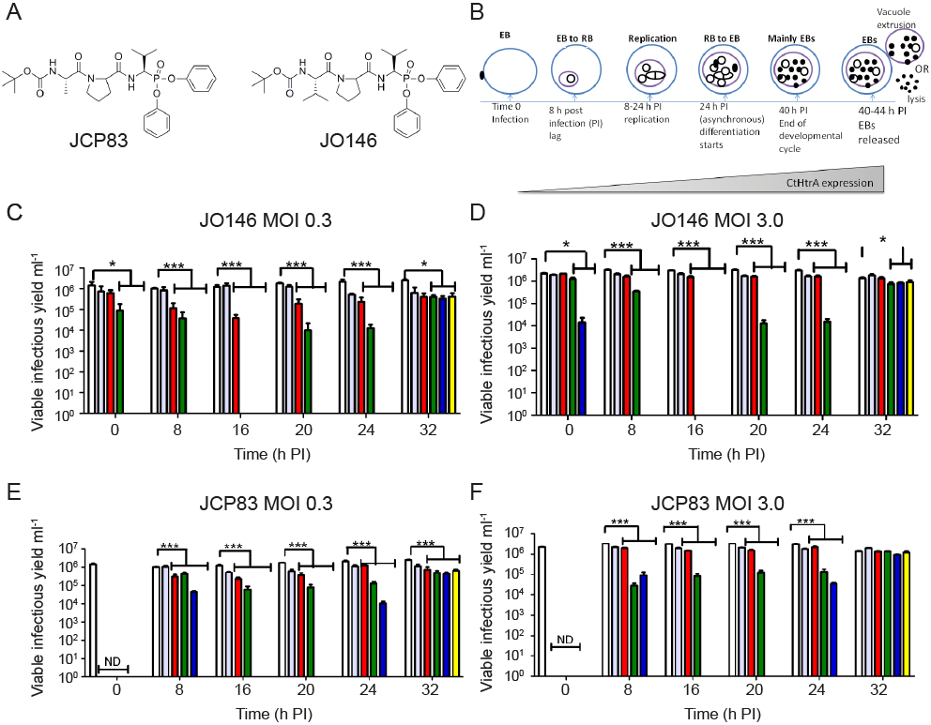

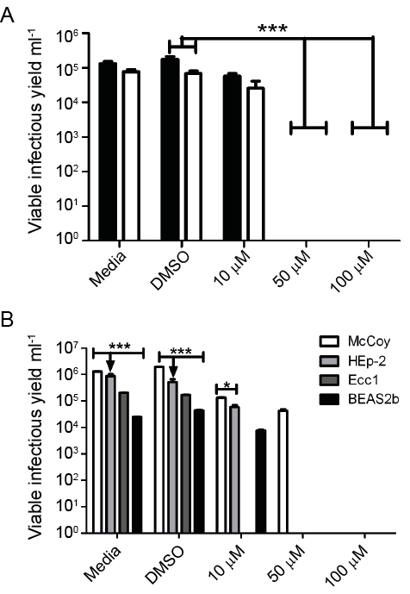
Fig 2

Fig 3

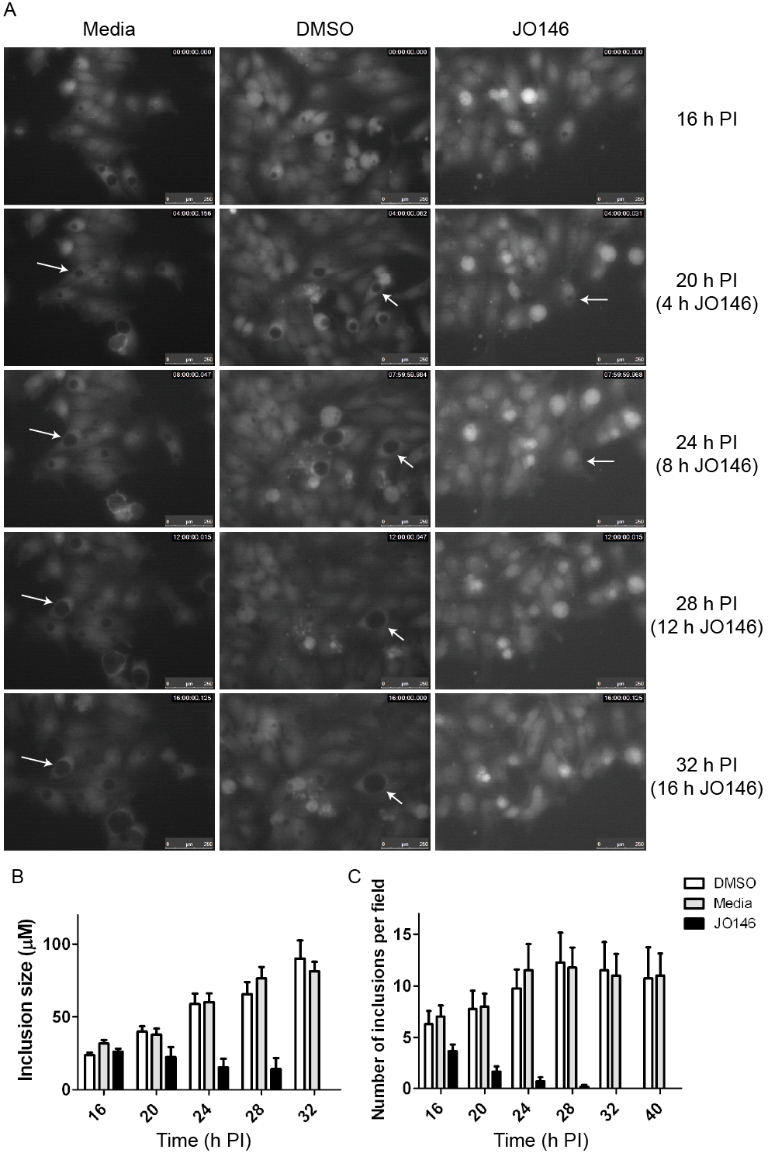

Fig 4

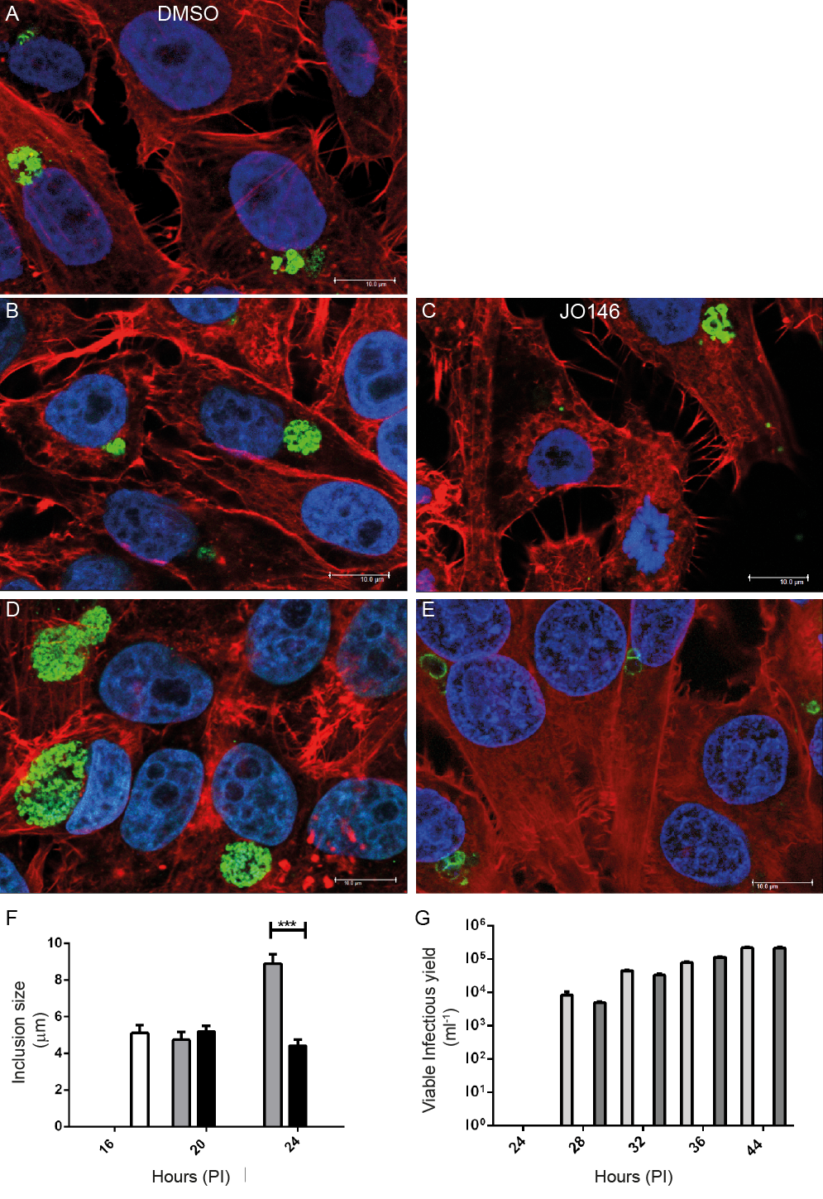
Fig 5

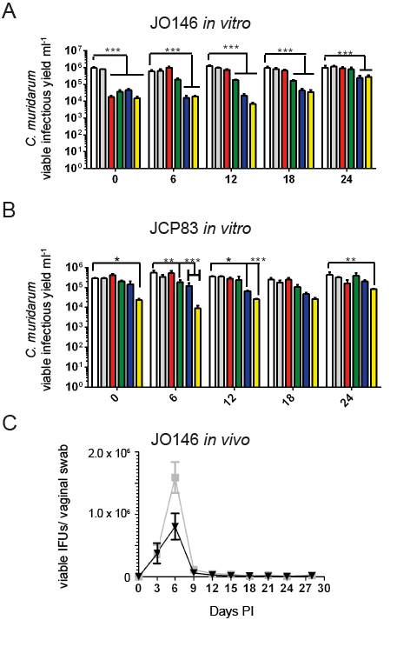
Fig 6

