**Title:**

The cyanobacterium *Cylindrospermopsis raciborskii* is facilitated by copepod selective grazing

**Author Names and Affiliations:**

Ying Hong1*, Michele A. Burford2, Peter J. Ralph1, James W. Udy3 and Martina A. Doblin1

1Plant Functional Biology and Climate Change Cluster, School for the Environment, University of Technology, Sydney, PO Box 123 Broadway, Sydney, NSW, Australia

2Australian Rivers Institute, Griffith University, Nathan, QLD 4111, Australia

3Healthy Waterways, PO Box 13086, George St Brisbane, QLD 4003, Australia

**\*Corresponding Author and Present Address:**

C3 - Plant Functional Biology and Climate Change Cluster

Faculty of Science | University of Technology, Sydney |

PO Box 123 | Broadway NSW 2007 | Australia |

E-mail address: ying.hong@student.uts.edu.au

Tel.: +61 2 95148307;

Fax: +61 2 95144079

**Keywords:**

Cyanobacteria, selective grazing, copepods, 33P, food quality.

**ABSTRACT**

Blooms of the toxin-producing cyanobacterium *Cylindrospermopsis raciborskii* occur in tropical and subtropical lakes during spring-summer but the mechanisms behind bloom formation are unclear. This study tests the hypothesis that *C. raciborskii* accumulations in freshwater systems are facilitated by selective copepod grazing. Prey selection was examined in a series of experiments with *C. raciborskii* and the green alga, *Chlamydomonas reinhardtii,* as well as within natural phytoplankton assemblages. Clearance rates of the copepod *Boeckella* sp. on a *C. raciborskii* diet were 2-4 times lower than that of a common cladoceran *Ceriodaphnia* sp. when both grazers had prey choice. More *C. raciborskii* was cleared by *Boeckella* sp. when in mixed natural phytoplankton assemblages, but the clearance rate declined when nutrient replete *C. reinhardtii* was added, demonstrating that when alternate “high quality” algae were present, so did *C. raciborskii* consumption. The clearance rates of *Boeckella* sp. on two toxic *C. raciborskii* strains were significantly lower than on a non-toxic strain, and on *C. raciborskii* with low cellular P content. When we tested the grazing preference of a copepod dominated mixed zooplankton community on *C. raciborskii* during the early bloom period, clearance rates were relatively low (0.05-0.20 ml individual-1 h-1), and decreased significantly as the proportion of *C. raciborskii* increased above 5%. These results suggest that *C. raciborskii* persistence could be promoted by copepods preferentially grazing on other algae, with significant loss of top-down control as *C. raciborskii* abundance increases.

**INTRODUCTION**

*Cylindrospermopsis raciborskii* is a toxic cyanobacterium that produces a suite of potentially toxic compounds. Some Australian strains of *C. raciborskii* produce an alkaloid cytotoxin, cylindrospermopsin (Saker and Griffiths, 2000), while some Brazilian strains produce saxitoxins (paralytic shellfish poisoning, PSP toxins; Neilan et al. 2003). In addition, strains isolated from Portuguese lakes do not produce any of the known cyanotoxins but show toxicity in mouse bioassays (Saker et al., 2004). *C. raciborskii* blooms (i.e., abundance exceeds 1 x 105 cells ml-1; WHO 2000) under a variety of environmental conditions (Padisák, 1997; Burford and Davis, 2011), making it difficult to predict its proliferation. Several attributes have been suggested to contribute to this cyanobacterium’s ecological success: its competitive nutrient acquisition and storage mechanisms, including its N2-fixing ability, high affinity for phosphorus (P) and ammonium, high P-storage capacity (Padisák, 1997, Isvánovics et al., 2000); (2) wide thermal tolerance (Briand et al., 2004; O’Neil et al., 2011; Sinha et al., 2011), superior shade tolerance and buoyancy (Briand et al., 2002; O’Brien et al., 2009); and (3) resistance to grazing (Padisák, 1997). To date, research to understand the formationof *C. raciborskii* blooms and toxicity has mostly focused on environmental factors, but the importance of food web interactions in influencing blooms has been little investigated (Padisák, 1997; Figueredoet al *.,* 2007).

In the laboratory, both straight and coiled filaments of *C. raciborskii* are readily consumed by meso-zooplankton such as rotifers (Soares et al., 2010; Kâ et al., 2012) and cladocerans (Hawkins and Lampert, 1989; Soares et al., 2009; Panosso and Lürling, 2010; Kâ et al., 2012). However, it is unclear if copepods, particularly calanoid copepods, which are important meso-zooplankton in Australian and South American inland waters (Hawkins, 1988; Bayly, 1993; Boon et al., 1994), selectively graze *C. raciborskii* and thereby influence bloom formation. While copepods shorten filaments of *C. raciborskii* and then ingest them (Bouvy et al., 2001; Kâ et al., 2012), there is limited evidence of *C. raciborskii* consumption within complex algal assemblages.

Consumer diets potentially play an important role in determining community structure (Polis and Strong, 1996). One major model for explaining consumer diets is optimal diet theory (ODT; Sih and Christensen, 2001). ODT theory predicts that predators should: (1) prefer prey that yield more energy per unit handling time; (2) select against lower value prey as the abundance of higher value prey increases; and (3) select/reject prey according to a quantitative threshold rule (i.e.,prey selection is density dependent; Sih and Christensen, 2001). The behavior of temperate calanoid copepods in the laboratory is consistent with ODT (DeMott and Watson, 1991; Burns and Hegarty, 1994). They shift their feeding behaviour depending on prey availability, being selective consumers when food is abundant, but less discriminate when food is more limited (DeMott, 1995). In addition, copepods make prey choices based on taste or perceived nutritional value because contact chemoreceptors near the mouth are used to taste the food before it is ingested or rejected (DeMott, 1989; Paffenhöfer and Lewis, 1990).

In some subtropical Australian reservoirs such as Wivenhoe Dam, there is strong seasonality in prey quantity (and potentially quality) for meso-zooplankton: algal abundance is relatively low during the winter dry season (May to October) and phytoplankton growth is limited by temperature (Muhid, 2010). However, from October to May (spring-summer), seasonal warming results in a 2-3 fold increase in algal abundance (Muhid, 2010). These changes in algal prey are coincident with increasing abundance of *C. raciborskii* (Burford and O’Donohue, 2006; Burford et al., 2007) and an increase in the ratio of copepods to cladocerans (Hong, unpublished data). The correlation between zooplankton composition and *C. raciborskii* abundance leads us to hypothesise that selective consumption by meso-zooplankton could facilitate *C. raciborskii* bloom formation. To test this hypothesis, we set up a series of experiments to examine copepod grazing preferences under different environmental conditions. In feeding trials with cultures and mixed natural algal assemblages, we measured copepod consumption of *C. raciborskii* at different relative abundances of *C. raciborskii* and under different concentrations of total phytoplankton biomass. We also examined whether grazing preferences were related to cellular P-content or toxicity of *C. raciborskii* strains. According to optimal diet theory, we predicted that copepods (and *Boeckella* sp.in particular), would show selection against *C. raciborskii* and that this would be dependent on its relative abundance in both cultured and natural phytoplankton diets. Furthermore, we predicted that clearance rates on low quality food (i.e., P- deficient) or *C. raciborskii* strains that produce cylindrospermopsin (CYN) would be lower than the P-sufficient or non-toxic strains, and that *C. raciborskii* grazing would increase if copepods were acclimated to limiting food conditions.

1. **MATERIALS AND METHODS** 
   1. Experimental organisms

Feeding experiments were conducted using zooplankton collected from Manly Dam (34° 46’3” S, 151º 14’52” E) and Wivenhoe Dam (27° 30’ S and 152° 45’ E), reservoirs situated in New South Wales and southeast Queensland, Australia, respectively. Zooplankton were sampled by vertical net hauls (diameter 0.5 m; mesh size 165 µm). Natural phytoplankton assemblages were collected from the surface using a clean 20 L bucket. On return to the laboratory, zooplankton were maintained in 10-20 L containers of lake water at ambient temperature (21°C) under 10 µmol photons m-2 s-1 with a 12:12 h light-dark cycle for up to 3 d before experiments. Phytoplankton were maintained at 21°C under 40 µmol photons m-2 s-1. Zooplankton were isolated individually using wide-bore plastic pipettes under a dissecting microscope, with similar sized female copepod *Boeckella* sp. (83 ± 6 mm measured from head to caudal rami) and cladocera *Ceriodaphnia* sp. (77 ± 12 mm) selected for experiments.

Monocultures of the green alga *Chlamydomonas* *reinhardtii* (diameter 5.4 ± 1.2 µm) and three strains of *Cylindrospermopsis raciborskii* (diameter 2.9 ± 0.5 µm; filament length 115 ± 89 µm; individual cell length 4 - 7 µm) were maintained in MLA medium at 25 °C under 40 µmol photons m-2 s-1 (see Table 1 for strain information). *C. reinhardtii* was used primarily because it has been used in previous studies (DeMott and Moxter, 1991; Burns and Hegarty, 1994). Pilot studies revealed *C. reinhardtii* is readily consumed by *Boeckella sp.*, with clearance rates being saturated at ~1.0 mg C L-1 (equivalent to 7.4 x 104 cells ml-1). The *C. raciborskii* strains were chosen because they are morphologically similar (all have straight filaments), with one strain being documented as non-toxic (CS-508) and two strains, CS-505 and NPD, producing toxic compounds (Saker *et al.,* 2004; Davis, unpublished data)(Saker *et al.* 2004). Strain NPD was originally isolated from Lake Samsonvale (Queensland, Australia) where *C. raciborskii* occurs regularly in high abundance during the austral summer (Burford and O'Donohue, 2006).

In experiments testing the effect of P-content on copepod prey selection, *C.* *raciborskii* (NPD strain) was cultured with different concentrations of inorganic phosphate. P-sufficient algae were maintained in MLA medium at 25 °C, 40 µmol photons m-2 s-1 with a 12:12 h light-dark cycle, and were transferred into fresh medium every 5 d. P-deficient *C. raciborskii* was prepared with a step-wise series of transfers into P-deplete MLA medium; i.e. exponentially growing cells were transferred from 100% P into 10% P medium, and after 5 days, they were transferred into 0% P medium. P-sufficient and P-deficient cultures were both centrifuged (3500 rpm for 10 min) and the pellets resuspended in fresh medium on each day for 5 d prior to experimentation. Examination of cells after centrifugation confirmed they were intact but we did not measure toxin content prior to use in experiments.

The elemental (C, N, P) content of natural phytoplankton communities and cultures of *C. raciborskii* and *C. reinhardtii* used in the experiments was estimated by filtering known volumes onto pre-combusted glass fibre filters which were stored frozen at -20 °C until analysis. Samples for total phosphorus (TP) were digested using a persulfate digestion procedure. After digestion, TP was analyzed based on the ascorbic acid reduction of phosphomolybdate (Cottingham, 1997). For total carbon and nitrogen analyses, the filters were dried at 50 °C overnight, packaged into tin cups and analysed using an Elemental Analyser and 20-20 IRMS (Europa Scientific). The cell abundance of each strain was estimated using a Sedgwick Rafter cell at 400x magnification under a compound microscope. Cell quotas of C, N and P were then calculated (Table 2).

### Experimental design

* + 1. Strength of selective grazing

To test the hypothesis that calanoid copepods would clear non-filamentous algae more readily than filamentous *C. raciborskii* and that clearance of *C. raciborskii* would be dependent on its relative abundance, we offered *Boeckella sp.* prey mixtures in 2-3 h feeding trials after they had been acclimated to experimental conditions for 1 h. Clearance of each prey type was estimated using a multiple excitation wavelength fluorometer (procedural details are below). Experimental treatments had the same amount of food (1.0 mg C L-1), but the proportion of *C. raciborskii* compared to the chlorophyte *C. reinhardtii* was 0, 20, 40, 60, or 100 %. In a second experiment, treatments had the same amount of *C. raciborskii* (0.5 mg C L-1), but the total food concentration was increased by adding *C. reinhardtii* (to achieve a total food concentration of 1.5, 2.0, or 2.5 mg C L-1).

We then compared clearance rates of similar sized adult copepods (length: 83 ± 6 mm) and cladocerans (length: 77 ± 12 mm) on *C. raciborskii* under non-saturating and saturating phytoplankton biomass. Isolated *Boeckella sp.* and *Ceriodaphnia sp.* were offered 33P-labelled *C. racibor*skii (50 to 100 µCi L-1; 0.5 mg C L-1) in three treatments: (1) mixed in 0.7 µm filtered Manly Dam water (GF/F, Whatman, New Jersey, USA); (2) a natural phytoplankton community (Manly Dam water containing 0.7 mg C L-1), and (3) a natural phytoplankton community (Manly Dam water) enriched with 0.5 mg C L-1 *C. reinhardtii* (total of 1.2 mg C L-1). The natural phytoplankton community was dominated by green algae and diatoms at the time of the experiment, and *C. raciborskii* comprised 100, 42 and 29% of the carbon biomass in the three treatments, respectively. Six adult copepods or cladocera were added into separate 100 ml plastic jars with 50 ml algal food and acclimated for at least 1 h before the experiment was initiated.

Prey selection was also examined in a mixed zooplankton community when offered a natural phytoplankton assemblage containing *C. raciborskii*. The experiment took place in spring (pre-bloom period) when the natural phytoplankton community was composed of diatoms (e.g. *Cyclotella*), cryptophytes (e.g. *Cryptomonas*) and colonial cyanobacteria (e.g. *Aphanocapsa*) but no toxin-producing taxa. Calanoid copepods dominated the zooplankton community (~80% of total abundance, with 20% rotifers and cladocerans). Zooplankton and surface phytoplankton were collected on 7 September 2010 from Lake Wivenhoe and brought back to the laboratory where they were maintained at 21゜C (ambient temperature) for 3 d prior to the experiment. A compound microscope (Olympus BX50, Hamburg, Germany) was used to estimate algal abundance, and feeding treatments (triplicates) were then set up by replacing a portion of the natural phytoplankton community with cultured P-deficient *C. raciborskii* (0% P MLA, see Table 2), similar to dilution experiments. Final treatments therefore had 0, 5, 15 or 100% *C. raciborskii* with relatively constant total food concentration. The entire algal assemblage was labeled with 33P for 1 h, then provided to zooplankton (approximately 15 animals in 50 ml). In a parallel set of controls, zooplankton were fed non-labeled food. Zooplankton clearance was estimated by collecting animals after 30 min and measuring their radioactivity using a liquid scintillation counter (Perkin Elmer, Massachusetts, USA).

To test if selection against *C. raciborskii* would change depending on gut fullness, copepods were held for approximately 6 h in 0.7 µm GF/F filtered Manly Dam water, unfiltered Manly Dam water (~0.7 mg C L-1), or a suspension of *C. raciborskii* (0.5 mg C L-1), or *C. reinhardtii* (0.5 mg C L-1). After the acclimation period, animals were offered 33P labelled *C. raciborskii* (50 to 100 µCi L-1; 0.5 mg C L-1)mixed with unlabelled *C. reinhardtii* (0.5 mg C L-1), and clearance rates on *C. raciborskii* were quantified after 30 min.

#### 2.2.2. Mechanisms of selective grazing

#### After observing selection coefficients < 0.5 in the above studies (indicating feeding preference against C. raciborskii), further experiments were conducted to understand the mechanisms driving prey selection under different conditions.

Copepods were provided one of three 33P-labelled *C. raciborskii* strains (Table 1, each 0.5 mg C L-1), in the presence of unlabelled *C. reinhardtii* (1.0 mg C L-1) and clearance rate was estimated by tracking 33P in copepod consumers. In another experiment, copepods were provided a mixture of unlabelled *C. reinhardtii* (1.0 mg C L-1) and labelled *C. raciborskii* (0.5 mg C L-1) which was either P-sufficient or P-deficient. To test whether the nutrient status caused a change in morphology or whether selectivity was affected by filament length (see Panosso and Lürling, 2010), filaments of *C. raciborskii* (n = 100) were measured using a compound microscope (Olympus BX50, Hamburg, Germany) before experiments.

### Experimental Procedure

* + 1. Estimating clearance rates using multi-wavelength fluorometer

To assess prey selection of copepods, the experimental procedure of Panosso and Lürling (2010) was adapted to increase the experimental volume. In all treatments (conducted in triplicate), one adult copepod was placed into a 10 ml test tube, and there were three controls with no animals for each treatment. Cyanobacterial and chlorophyte abundance in each tube were monitored simultaneously using a PhytoPAM (Walz GmBH, Effeltrich, Germany). Three ml subsamples were removed at the start and end of the experiment (after 2.5 h in the light), and were dark-adapted for 10 min before measuring their Chl*-a* fluorescence. Algal signatures were set up in the blue and green channels using unialgal cultures of *C. raciborskii* and *C. reinhardtii*, respectively, grown under experimental conditions, and Chl-*a* fluorescence was validated with cell counts. Clearance rates (CR) were estimated from the difference in Chl-a fluorescence between the start and end of the experiment and comparison with no zooplankton controls according to the following equation:

CR= Ln (Fc-Ft) *V/T

where Ft is the final Chl-a fluorescence in the zooplankton treatment and Fc is the Chl-a fluorescence in the control after the feeding period T; V is the volume of the incubation (10 ml).

The selection coefficient (α) was calculated according to Burns and Hegarty (1994):

α= CRcyn/(CRcyn + CRgreen)

where CRcyn and CRgreen are the clearance rates on *C. raciborskii* and *C. reinhardtii*, respectively. The selection coefficient is equivalent to Chesson’s alpha (Chesson 1978).

### Experimental procedure with 33P labeled prey

Cultured algae were sampled in exponential phase the day before each experiment and centrifuged at 3500 rpm for 10 min. The pellets were resuspended into P-free MLA medium, and then spiked with carrier-free 33P orthophosphate (1.85 - 3.70 MBq L-1; PerkinElmer, MA, USA) with the initial activity ranging from 50 to 100 µCi L-1. After 24 to 48 h, when cells were considered uniformly labelled, labelled algae were centrifuged and rinsed with P-free MLA medium to remove any unincorporated 33P, and were then resuspended into 10 ml P-free MLA medium. 33P was added in the same quantity to the natural phytoplankton community, and after 1 h, >95% of 33P was taken up. Initial radioactivity was checked by adding 0.5 ml of labelled prey into 4.5 ml scintillation cocktail (Ready Safe™, Beckman Coulter, CA, USA) and measuring 33P activity (> 10,000 dpm; 0.5 – 2.5 mg C L-1) using a liquid scintillation counter (Packard Tri-Carb 2100TR, CT, USA). Unlabelled algae were processed the same way (minus the labeling).

Feeding experiments were initiated by adding 50 ml of 33P labelled algae food into a container. After 30 min, the animals (copepods, *Ceriodaphnia sp.* or mixed zooplankton) were collected onto 100 µm cell strainers (BD Falcon™ New Jersey, USA), rinsed several times with MilliQ water and were pipetted into 6 ml vials (Pico Prias PerkinElmer, MA, USA). Five ml aliquots of food were filtered through 25 mm diameter, 0.6 µm pore size polycarbonate membranes (Steritech, WA, USA). Both animals and algae were digested with 0.5 ml of 0.5 M NaOH, and then 4.5 ml scintillation cocktail was added. The 33P activity of the samples was measured using a liquid scintillation counter.

Zooplankton clearance rates on 33P labelled diets were calculated using the following equation (Bamstedt et al., 2000):

F= (dpmanimal x V) / (dpmalgae x T)

Where dpm animal is the radioactivity associated with each animal, dpmalgae is the radioactivity of V ml of algal food, and T is the incubation time in h.

### Statistical analyses

Selectivity coefficients and clearance rates were compared between treatments using one-way analysis of variance followed by a Tukeys post-hoc test. To meet the assumption of normality for an ANOVA, the data were either square root or natural log transformed and Levene’s test was used to check for homogeneity of variances. The level of significance for all tests was 0.05.

1. **RESULTS**
   1. Strength of selective grazing

Copepods showed a clear selection preference for *C. reinhardtii* in all treatments (Table 3). When overall prey abundance was ≤ 1.0 mg C L-1, copepod clearance rates on *C. raciborskii* were detectable only when *C. raciborskii* relative abundance was ≥ 60% (p < 0.05; Table 3). At total food concentrations ≥ 1.5 mg C L-1 with fixed *C. raciborskii* abundance, copepods showed no clearance of *C. raciborskii* (F1,4 = 77.02, p = <0.001 for 1.5 mg C L-1 and F1,4 = 110.8, p = <0.001 for 2.0 mg C L-1).

Comparison of clearance rates between copepods and similar sized cladocerans showed the cladoceran *Ceriodaphnia sp.* cleared *C. raciborskii* more rapidly (3.14 – 6.87 ml ind-1 h-1) than the copepod *Boeckella sp.* (1.16 – 1.97 ml ind-1 h-1) under both limiting food conditions (filtered lake water (F1,4 = 47.30, p = 0.002) and unfiltered lake water (F1,4 = 15.29, p = 0.02) and non-limiting food conditions (unfiltered lake water supplemented with *C. reinhardtii*; F1,4 = 893.46, p < 0.001, Fig. 1). For cladocerans, *C. raciborskii* clearance rates showed a positive relationship with total food abundance, but this was not the case for copepods (Fig. 1).

Clearance of *C. raciborskii* by the copepod dominated zooplankton community from Lake Wivenhoe declined with an increasing proportion of *C. raciborskii* in a mixed natural phytoplankton assemblage (Fig. 2), ranging from 0.13 ± 0.16 ml ind-1 h-1 when *C. raciborskii* comprised 5 or 15% of the total food biomass, to 0.06 ± 0.02 ml ind-1 h-1 when *C. raciborskii* was the only available prey (F1,4 = 19.84, p = 0.04).

Acclimation of copepods in water with no food and with different prey mixtures greatly affected their feeding selection (Fig. 3). C*. raciborskii* clearance rates were 20-50% greater when copepods were held with no food (mean ± SD; 0.80 ± 0.20 ml ind-1 h-1) or in unialgal suspensions of *C. raciborskii* (F1,4 = 40.68, p < 0.01). *Boeckella* *sp.* cleared less *C. raciborskii* when they were held in unfiltered lake water (0.36 ± 0.02 ml ind-1 h-1) or lake water supplemented with 0.5 mg C ml-1 *C. reinhardtii* (0.60 ± 0.04 ml ind-1 h-1).

* 1. Mechanisms of selective grazing

Experiments designed to test whether copepod feeding preference was different amongst *C. raciborskii* strains of different toxic status or P content showed variable clearance rates. While filament length was slightly shorter in strain NPD (mean ± SD; 90 ± 49 µm) compared to strain CS-508 (111 ± 38 µm) and CS-505 (133 ± 57 µm), the filament lengths of toxic strain CS-505 and non-toxic train CS-508 were not significantly different (F1,110 = 1.57, p = 0.21, Fig. 3A). *Boeckella sp.* cleared the non-toxic strain CS-508 (0.85 ± 0.06 ml ind-1 h-1) approximately 20% faster than the toxic strain CS-505 (0.61 ± 0.06 ml ind-1 h-1, F1,4 = 30.91, p < 0.01) and more than 100% faster than toxic NPD (0.25 ± 0.09 ml ind-1 h-1, F1,4 = 98.85, p <0.01, Fig. 3B). Furthermore, the clearance rate of *Boeckella sp.* on *C. raciborskii* (toxic NPD strain) was significantly lower when the cells had very low P content (0.35 ± 0.02 ml ind-1 h-1, C:P ratio = 467) compared to two treatments with C:P ratios of 117 (F1,4 = 67.37, p < 0.01) and 186 (F1,4 = 28.97, p < 0.01). However, there was no consistent correlation of clearance rate with *C. raciborskii* C:P ratio (Fig. 4B). Furthermore, there was no difference in filament length amongst the cultures with different P status (F2,161 =13.702; P =0.839), averaging 90 ± 13 and 104 ± 10 µm for P-sufficient and P-deficient cultures, respectively (Fig. 4A), indicating the results were not confounded by filament length.

1. **DISCUSSION**

Cyanobacteria are amongst the most abundant algae in subtropical regions throughout the year (Haney, 1987; Boon *et al.,* 1994), suggesting that they may be readily consumed by meso-zooplankton (Kâ et al. 2012). However, this study revealed generally low clearance of the filamentous cyanobacterium *C. raciborskii* by the copepod *Boeckella sp*., and high selection preference for other algae. This indicates that copepod consumers could facilitate *C. raciborskii* accumulation in freshwater reservoirs of subtropical Australia where they comprise ~60% of zooplankton biomass (Matveev and Matveeva, 1997).

Our *a priori* expectation was that *Boeckella sp.* would consume *C. raciborskii*, partly based on the relatively high (> 60%) abundance of this cyanobacterium in Australian subtropical and tropical freshwaters (McGregor and Fabbro, 2000; Burford and O'Donohue, 2006; Burford et al., 2007) but also because both copepod and cladoceran functional groups are capable of handling large prey, including filamentous cyanobacteria (Fulton, 1988; Sommer et al., 2003). Copepods in particular prefer large particles when prey quality is similar (Boon *et al.,* 1994; Price and Paffenhöfer, 1985; Vanderploeg et al., 1988) with the optimum prey size ranging from 10 to 100 µm (Bruce, 2006). *C. raciborskii* (filament length: 40 - 150 µm) is within this preferred size range, but copepods showed a clear preference for consuming the chlorophyte *C. reinhardtii* and other algae in our experiments. Both straight and coiled forms of *C. raciborskii* have been found in samples collected from Wivenhoe Dam. The coiled trichome could present some defense against grazers as it occupies two dimensions, making it more difficult to handle (Vanderploeg et al., 1988). However, the cultured *C. raciborskii* used in this study had straight filaments, so feeding selectivity was unlikely to be influenced by this additional factor.

The greatest selection for *C. raciborskii* by copepods occurred when food was limiting—clearance rates of *C. raciborskii* were at a maximum when prey biomass was low or when animals had empty guts. However, under non-limiting conditions, *Boeckella sp.* consumed the relatively small, spherical cells of *C. reinhardtii* (diameter5 - 10 µm*)* almost 10-fold faster than the large filaments of *C. raciborskii*. Furthermore, consumption of *C. raciborskii* by a mixed zooplankton assemblage also diminished with an increasing proportion of *C. raciborskii*. This result suggests that food quality instead of prey size was a more important influence on prey selection (Fulton, 1988). Generally, cyanobacteria, such as *C. raciborskii*, lack important fatty acids and can produce potentially toxic compounds (Reynolds, 1984; Nogueira et al., 2004). Increasing the quantity and quality of food by supplementing a natural phytoplankton community with *C. reinhardtii* resulted in a decline of *C. raciborskii* consumption by copepods, consistent with the optimal diet model that predicts zooplankton discriminate most strongly against low-quality food when high-quality food is abundant (Burns and Hegarty, 1994; DeMott and Moxter, 1991). The selection against *C. raciborskii* by copepods was further verified by comparing the feeding behavior of the cladoceran *Ceriodaphnia sp.* on *C. raciborskii* under increasing food biomass. In contrast to *Boeckella sp*., *Ceriodaphnia sp.* increased consumption of *C. raciborskii* when total prey abundance increased, demonstrating less selection against *C. raciborskii.*

Our study also demonstrated that copepods distinguished between morphologically similar *C. raciborskii* strains with different toxic status. Clearance rates on two toxic strains were significantly lower than the non-toxic strain, and support the notion that copepods perceive strain-specific signals related to toxicity to avoid ingestion of harmful food. While it is well established that toxins affect the consumption of cyanobacteria by zooplankton (Burns and Hegarty, 1994; DeMott, 1993; Vanderploeg, 1990), calanoid copepods (Burns and Xu 1990) and certain rotifers (Fulton and Paerl, 1987; Gilbert and Durand, 1990) are more tolerant of toxic cyanobacteria compared to cladocerans. Indeed, there is increasing evidence that copepods tolerate exposure to cyanobacterial toxins, showing peaks in abundance in the presence of toxic cells *in situ* (Bouvy et al., 1999). In this study, pre-exposure to *C. raciborskii* resulted in similar rates of *C. raciborskii* consumption compared to animals kept for the same length of time with no food, suggestingthat copepods may not be affected by ~6 h exposure to toxins.

Copepods are less sensitive to P-limitation than cladocera (Elser *et al.,* 2001), so algal P-content may not be a strong influence on copepod diet selection. However, grazing rates of copepods might be affected by low quality food due to nutrient limitation (DeMott, 1989). Our experiments showed copepod clearance rates on *C. raciborskii* were 2-4 times lower when *C. raciborskii* was strongly P deficient compared to cells with greater P content, but it was not consistent with the C:P ratio. Copepods consumed *C. raciborskii* with the highest P quota at a relatively low rate, suggesting not only P content, but other factors influence prey choice by *Boeckella sp*. We focussed on phosphorus in our experiments because previous studies have found algal growth in many Australian subtropical freshwaters to be P-limited and that *C. raciborskii* dominates under periodic low-level dissolved inorganic P enrichment (Posselt et al., 2009). Phosphorus is an important element in food quality for consumers because it is used to construct new biomass (e.g., phospholipid membranes), is involved in cellular energy processes, and therefore affects zooplankton growth and reproduction (Elser *et al.,* 2001; van Donk *et al.,* 2008). In addition, nutrient deficiency may cause some algae to accumulate extracellular polysaccharides and change cell wall thickness (Dickmann et al. 2008; Lürling and van Donk; 1997; Sterner and Hessen, 1994). Mucus secretion and cell structural changes may be important mechanisms for nutrient-stressed phytoplankton to increase their resistance to grazers (van Donk and Hessen, 1993). While we saw no obvious change in *C. raciborskii* morphology under P-deplete conditions, we did note extremely P-deficient cells were a different colour, suggesting low P availability had an effect on photosynthetic pigment production. Furthermore, we observed no mortality during our short-term feeding experiments, but subsequent observations have shown *Boeckella sp.* are susceptible to mortality in the presence of P-deficient toxic *C. raciborskii* strains (Y. Hong, unpublished data). Therefore, further work is suggested to evaluate whether strongly P deficient *C. raciborskii* influence prey perception and palatability by copepods.

Clearance rates of *Boeckella sp.* on *C. raciborskii* ranged from 0.2 to 2 ml ind-1 h-1, in the same order of magnitude as rates of phytoplankton consumption by other freshwater copepod taxa (DeMott and Moxter, 1991). However, under most circumstances, the clearance rates of *Boeckella sp.* on *C. raciborskii* observed in this study were less than 0.6 ml ind-1 h-1, significantly lower than clearance rates of *Boeckella sp.* on other toxic cyanobacteria such as *Microcystis sp*. (>1 ml ind-1 h-1; Matveev and Matveeva, 1997). Based on our results, we would therefore predict low grazing on *C. raciborskii* when the copepod *Boeckella sp.* dominates the zooplankton community, particularly in the summer season when algal abundance is above saturating concentrations and there is a large amount of alternative algal prey. Together, this suggests that copepods facilitate *C. raciborskii* accumulation in aquatic habitats, with selective grazing increasing the risk of bloom occurrence.

**Conclusions**

Our study found that:

* The copepod *Boeckella sp.* showed selection against *C. raciborskii* that became stronger in the presence of high concentrations of alternative, high quality algae and weaker when prey was at sub-saturating concentrations. The cladoceran *Ceriodaphnia* *sp*. was a more effective consumer of *C. raciborskii* compared to *Boeckella sp.*, indicating the potential for zooplankton community composition to affect the strength of top-down processes regulating this toxic cyanobacterium;
* *Boeckella sp.* had greater clearance rates on non-toxic and P-sufficient *C. raciborskii* compared to toxic and P-deficient cells and showed maximum clearance rate of *C. raciborskii* under limiting food conditions;
* Collectively, these results indicate that subtropical systems are at risk of *C. raciborskii* blooms when copepods are the dominant meso-zooplankton, and when algal biomass is non-limiting (> 1.0 mg C L-1).

ACKNOWLEDGMENTS

Funding for this research was provided by Seqwater and the Plant Functional Biology and Climate Change Cluster at the University of Technology, Sydney. Y.H. was supported by a UTS postgraduate scholarship. We thank S. Faggotter at Griffith University for assistance with Wivenhoe Dam field collections, and P. Jones, I. Taylor, J. Singleton, S. Slamet and C. Buckley for Manly Dam collections. Also thanked are B. Reynolds and D. Gale at Seqwater for retrieving historical data to help design experiments, Y. Kobayashi at NSW Office of Environment and Heritage for zooplankton taxonomic analysis, and N. Chen at UTS for assistance in the lab. The comments of the anonymous reviewers are also acknowledged for their contributions to the manuscript.

REFERENCES

Bayly, I. A. E. 1993. The fauna of athalassic saline waters in Australia and the Altiplano of South America: comparisons and historical perspectives." *Saline Lakes V*. Springer Netherlands, 87: 225-231.

Boon, P. I., Stuart, E. B., Green, J. D., Shiel, R. J., 1994. Consumption of Cyanobacteria by Freshwater Zooplankton: Implications for the Success of 'Top-down' Control of Cyanobacterial Blooms in Australia. *Aust. J. Mar. Freshwater Res.,* 45:875-887.

Bouvy, M., Molica, R., De Oliveira, S., Marinho M., Beker, B., 1999. Dynamics of a toxic cyanobacterial bloom (*Cylindrospermopsis raciborskii*) in a shallow reservoir in the semi-arid region of northeast Brazil. *Aquatic Microbial Ecology,* 20: 285-297.

Bouvy, M., Pagano, M., Troussellier, M., 2001. Effects of a cyanobacterial bloom (*Cylindrospermopsis raciborskii*) on bacteria and zooplankton communities in Ingazeira reservoir (northeast Brazil). *Aquatic Microbial Ecology*, 25:215-227.

Briand, J. F., Robillot, C., Quiblier-Lloberas, C., Humbert, J. F., Coute, A., Bernard, C., 2002. Environmental context of *Cylindrospermopsis raciborskii* (Cyanobacteria) blooms in a shallow pond in France. *Water Research*, 36:3183–3192.

Briand, J. F., Leboulanger, C., Humbert, J. F., Bernard, C., Dufour, P., 2004. *Cylindrospermopsis raciborskii* (cyanobacteria) invasion at mid latitudes: selection, wide physiological tolerance, or global warming? *Journal of Phycology*, 40:231-238.

Bruce, L. C., Hamilton, D., Imberger, J., Gal, G., Gophen, M., Zohary, T., Hambright, K.D., 2006. A numerical simulation of the role of zooplankton in C, N and P cycling in Lake Kinneret, Israel. *Ecological Modelling,* 193:412-436.

Burford, M. A., O'Donohue, M. J., 2006. A comparison of phytoplankton community assemblages in artificially and naturally mixed subtropical water reservoirs. *Freshwater Biology,* 51: 973-982.

Burford, M. A., Johnson, S. A., Cook, A. J ., Packer, T. V., Taylor, B. M., Townsley, E. R., 2007. Correlations between watershed and reservoir characteristics, and algal blooms in subtropical reservoirs. *Water research,* 41:4105-4114.

Burford, M. A., Davis T. W., 2011. Physical and chemical processes promoting dominance of the toxic cyanobacterium *Cylindrospermopsis raciborskii*. *Chinese Journal of Oceanology and Limnology,* 29: 883-891.

Burns, C. W., Xu, Z., 1990. Calanoid copepods feeding on algae and filamentous cyanobacteria: rates of ingestion, defaecation and effects on trichome length. *Journal of Plankton Research,* 12:201-213.

Burns, C. W., Hegarty, B., 1994. Diet selection by copepods in the presence of cyanobacteria. *Journal of Plankton Research,* 16: 1671-1690.

Chesson, J., 1978. Measuring preference in selective predation. *Ecology* 59:211-215.

Cottingham, K. L., Knight, S.E., Carpenter, S.R., Cole, J.J., Pace, M.L., Wagner, A.E., 1997. Response of phytoplankton and bacteria to nutrients and zooplankton: a mesocosm experiment. *J. Plankton Res.,* 19:995-1010.

DeMott, W. R. 1989. Optimal foraging theory as a predictor of chemically mediated food selection by suspension-feeding copepods. *Limnology and Oceanography* 34: 140-154.

DeMott, W. R., 1993. Hunger dependent diet selection in suspension-feeding zooplankton. In: *Diet Selection: An Interdisciplinary Approach to Foraging Behavior* (Ed R.N. Hughes). Wiley-Blackwell, London, pp. 102-122.

DeMott, W. R., 1995. Optimal foraging by a suspension-feeding copepod responses to short-termed seasonal-variation in food resources. *Oecologia*, 103:230-240

DeMott, W. R., Moxter, F., 1991. Foraging cyanobacteria by copepods: responses to chemical defense and resource abundance. *Ecology*, 782:1820-1834.

DeMott, W. R., Watson, M. D., 1991. Remote detection of algae by copepods: responses to algal size, odors and motility. *Journal of Plankton Research,* 13: 1203-1222.

Dickman, E. M., Newell J. M., González, M. J., Vanni, M. J., 2008. Light, nutrients, and food-chain length constrain planktonic energy transfer efficiency across multiple trophic levels. *Proceedings of the National Academy of Sciences,* 105: 18408-18412.

Elser, J. J., Hayakawa, K., Urabe, J., 2001. Nutrient limitation reduces food quality for zooplankton: *Daphnia* response to seston phosphorus enrichment. *Ecology*, 82: 898-903.

Figueredo, C. C., Giani, A., Bird, D. F., 2007. Does alleopathy contribute to *Cylindrospermopsis raciborskii* (cyanobacteria) bloom occurrence and geographic expansion? *Journal of Phycology,* 43: 256-265.

Fulton, R. S., 1988. Grazing on filamentous algae by herbivorous zooplankton. *Freshwater Biology*, 20:263-271.

Fulton, R. S., Paerl, H. W., 1987. Toxic and inhibitory effects of the blue-green alga *Microcystis aeruginosa* on herbivorous zooplankton. *Journal of Plankton Research,* 9: 837-855.

Gilbert, J. J., Durand, M. W., 1990. Effect of *Anabaena flos aquae* on the abilities of *Daphnia* and *Keratella* to feed and reproduce on unicellular algae. *Freshwater Biology,* 24: 577-596.

Haney, J. F., 1987. Field studies on zooplankton-cyanobacteria interactions. *New Zealand Journal of Marine and Freshwater Research*, 2: 467-475.

Hawkins, P. R., 1988. The zooplankton of a small tropical reservoir (Solomon Dam, North Queensland). *Hydrobiologia*, 157:105-118.

Hawkins, P., Lampert, W., 1989. The effect of *Daphnia* body size on filtering rate inhibition in the presence of a filamentous cyanobacterium. *Limnology and Oceanography,* 34: 1084-1089.

Isvánovics, V., Shafik, H. M., Présing, M., Juhos, S., 2000. Growth and phosphate uptake kinetics of the cyanobacterium, *Cylindrospermopsis raciborskii* (Cyanophyceae) in throughflow cultures. *Freshwater Biology*, 43:257-275.

Kâ, S., Mendoza-Vera, J. M., Bouvy, M., Champalbert, G., N’Gom-Kâ, R., Pagano, M., 2012. Can tropical freshwater zooplankton graze efficiently on cyanobacteria? *Hydrobiologia*, 679: 119-138

Lürling, M., van Donk, E., 1997. Morphological changes in *Scenedesmus* induced by infochemicals released in situ from zooplankton grazers. *Limnology and Oceanography,* 42: 783-788.

Matveev, V., Matveeva, L., 1997. Grazer control and nutrient limitation of phytoplankton biomass in two Australian reservoirs. *Freshwater Biology*, 38: 49-65.

McGregor, G. B., Fabbro, L. D., 2000. Dominance of *Cylindrospermopsis raciborskii* (Nostocales, Cyanoprokaryota) in Queensland tropical and subtropical reservoirs: Implications for monitoring and management. *Lakes & Reservoirs: Research & Management*, 5:195-205.

Muhid, P., 2010. The role of nutrients with respect to promoting phytoplankton growth and species composition in subtropical reservoir. PhD thesis, Griffith University, Nathan, QLD, Australia.

Neilan, B. A., Saker,M.L, Fastner, J., Törökné, A. and Burns, B. P, 2003. Phylogeography of the invasive cyanobacterium Cylindrospermopsis raciborskii. *Molecular Ecology* 12: 133-140.

Nogueira, I. C. G., Saker, M. L., Pflugmacher, S., Wiegand, C., Vasconcelos, V. M., 2004. Toxicity of the cyanobacterium *Cylindrospermopsis raciborskii* to *Daphnia magna*. *Environmental toxicology*, 19:453-459.

O’Brien, K. R., Burford, M. A., Brookes, J. D., 2009. Effects of light history on primary productivity in a phytoplankton community dominated by the toxic cyanobacterium *Cylindrospermopsis raciborskii*. *Freshwater Biology* 54:272-282.

O’Neil, J., Davis, T., Burford, M., Gobler, C., 2012. The rise of harmful cyanobacteria blooms: The potential roles of eutrophication and climate change. *Harmful Algae,* 14:313-334.

Padisák, J., 1997. *Cylindrospermopsis raciborskii* (Woloszynska) Seenayya et Subba Raju, an expanding, highly adaptive cyanobacterium: worldwide distribution and a review of its ecology. *Arch. Hydrobiol. Suppl*. 107, *Monogr. Stud*.: 563–593.

Paffenhöfer, G, A. and Lewis K, D., 1990. Perceptive performance and feeding behavior of calanoid copepods. *Journal of Plankton Research.* 12: 933-946.

Panosso, R., Lürling, M., 2010. *Daphnia magna* feeding on *Cylindrospermopsis raciborskii*: the role of food composition, filament length and body size. *Journal of Plankton Research*, 32:1393-1404.

Polis, G. A., and Strong, D. R. 1996. Food web complexity and community dynamics. *American Naturalist*, 147: 813-846.

Posselt, A., Burford, M.A., Shaw, G. (2009) Pulses of phosphate promote dominance of the toxic cyanophyte Cylindrospermopsis raciborskii in a subtropical water reservoir. *J. Phycol.* 45(3):540-546.

Price, H. J., Paffenhöfer, G. A., 1985. Perception of food availability by calanoid copepods *Arch.Hydrobiol. Beih. Ergeb. Limnol.,* 21: 115-124.

Reynolds, C. S., 1984. Loss Processes. In: *The Ecology of Freshwater Phytoplankton* (Eds E. Beck; H. J. b. Birks, E. F. Connor). Cambridge University Press, New York, pp. 225-274.

Saker, M. L., Griffiths, D. J., 2000. The effect of temperature on growth and cylindrospermopsin content of seven isolates of the cyanobacterium Cylindrospermopsis raciborksii (Woloszynska) Seenayya and Subba Raju from water bodies in northern Australia. *Phycologia*, 39(4): 349-354.

Saker, M. L., Nogueira, I. C. G., Vasconcelos, V. M., 2004. Distribution and toxicity of *Cylindrospermopsis raciborskii* (Cyanobacteria) in Portuguese freshwaters. *Limnetica,* 23: 145-152.

Sih, A., and Christensen, B. 2001. Optimal diet theory: when does it work, and when and why does it fail? *Animal behaviour*, *61*: 379-390.

Sinha, R., Pearson, L. A., Davis, T. W., Burford, M. A., Orr, P. T., Neilan, B. A., 2012. Increased incidence of *C. raciborskii* in temperate zones-is climate change responsible? *Water research,* 46:1408-1419.

Soares, M. C. S., Lürling, M., Panosso, R., Huszar, V., 2009. Effects of the cyanobacterium *Cylindrospermopsis raciborskii* on feeding and life-history characteristics of the grazer *Daphnia magna*. *Ecotoxicology and Environmental Safety*, 72:1183-1189.

Soares, M. C. S., Lürling, M., Huszar, V. L. M., 2010. Responses of the rotifer Brachionus calyciflorus to two tropical toxic cyanobacteria (*Cylindrospermopsis raciborskii* and *Microcystis aeruginosa*) in pure and mixed diets with green algae. *Journal of Plankton Research,* 32:999-1008.

Sommer, U., Sommer, F., Santer, B., Zollner, E., Jurgens, K., Jamieson, C., Boersma, M., Gocke, K., 2003. *Daphnia* versus copepod impact on summer phytoplankton: functional compensation at both trophic levels. *Oecologia,* 135: 639-647.

Sterner, R W., and Hessen, D. O., 1994. Algal nutrient limitation and the nutrition of aquatic herbivores. *Annual Review of Ecology and Systematics* 25: 1-29.

Vanderploeg, H. A., 1990. Feeding mechanisms and their relation to particle selection and feeding in suspension-feeding zooplanktonIn: *The Biology of Particles in Aquatic Systems*, R.S. Wotton (ed.).CRC Press, Boca Raton, FL, pp. 183-212.

Vanderploeg, H. A., Paffenhöfer, G.A., Liebig, J.R., 1988. *Diaptomus* vs. Net Phytoplankton: Effects of Algal Size and Morphology on Selectivity of a Behaviorally Flexible, Omnivorous Copepod. *Bulletin of Marine Science*, 43: 377-397.

Van Donk, E, and Hessen, D. O., 1993. Grazing resistance in nutrient stressed phytoplankton. *Oecologia*, 93: 508-511.

Van Donk, E., Hessen, D. O., Verschoor, A. M., Gulati, R. D., 2008. Re-oligotrophication by phosphorus reduction and effects on seston quality in lakes. *Limnologica-Ecology and Management of Inland Waters*, 38: 189-202.

Table 1. Origin of algal strains used in this study

|  |  |  |  |  |
| --- | --- | --- | --- | --- |
| **Strain ID** | **Species** | **Toxicity** | **Source** | **Toxin authority** |
| **CS-51** | *C. reinhardtii* | None recorded | ANACC1 |  |
| **CS-508** | *C. raciborskii* | None recorded | ANACC |  |
| **CS-505** | *C. raciborskii* | toxic2 | ANACC | Saker and Griffiths 2000 |
| **NPD** | *C. raciborskii* | toxic | ARI/GU3 | Davis (unpublished data) |

1. Australian National Algae Culture Collection
2. cylindrospermopsin
3. Australian Rivers Institute, Griffith University

Table 2. Cellular carbon, nitrogen and phosphorus content (pg cell-1) of *C. raciborskii* (strain NPD) used in experiments. Note that *C. raciborskii* results are cited per cell but that each filament (the morphological form used in experiments) comprises an average of 15 cells per filament with each cell ranging from 4 - 7 m in length.

|  |  |  |  |  |
| --- | --- | --- | --- | --- |
| Strain | culture medium | C content (pg cell-1) | N content (pg cell-1) | P content (pg cell-1) |
| *C. raciborskii*(NPD) | 0% P MLA | 3.62 ± 0.13 | 0.70 ± 0.00 | 0.02 ± 0.00 |
| *C. raciborskii* (NPD) | 10% P MLA | 5.05 ± 0.22 | 0.96 ± 0.02 | 0.07 ± 0.00 |
| *C. raciborskii* (NPD) | 100% P MLA | 3.19 ± 0.14 | 0.70 ± 0.01 | 0.06 ± 0.00 |
| *C. reinhardtii* | 100% MLA | 15.70 ± 1.03 | 2.21 ± 0.021 | NM2 |
| *C. raciborskii* (NPD) | Filtered LWW3 | 5.14 ± 0.04 | 0.91 ± 0.06 | 0.14 ± 0.00 |
| Lake Wivenhoe water |  | 3.09 ± 0.023 | 0.39 ± 0.033 | 0.13 ± 0.013 |

1. N content at limit of detection
2. not measured
3. Cell quota estimated by microscopic enumeration of phytoplankton cell abundance

Table 3. The selective coefficient (α) of copepod *Boeckella sp.* on the green alga *Chlamydomonas reinhardtii* and the cyanobacterium *Cylindrospermopsis raciborskii* (NPD) when *C. raciborskii* was mixed with *C. reinhardtii* in various proportions, keeping total phytoplankton biomass constant at 1.0 mg C L-1, or alternatively, when *C. raciborskii* (0.5 mg C L-1) was mixed with different amounts of *C. reinhardtii* with increasing total phytoplankton biomass. Data are mean of three replicates ± standard deviation.

|  |  |  |  |  |  |  |
| --- | --- | --- | --- | --- | --- | --- |
| Biomass (mg C L-1) | | | Clearance rate  (ml ind-1 h-1) | | Selection Coefficient (α) | |
|  |  |  |  |  |  |  |
| Total | *C. raciborskii* | *C. reinhardtii* | *C. raciborskii* | *C. reinhardtii* | *C. raciborskii* | *C. reinhardtii* |
| 1.0 | 0.0 | 1.0 | n/a | 1.1 ± 0.22 |  |  |
| 1.0 | 0.2 | 0.8 | 0.0 | 1.4 ± 0.24 | 0.0 | 1.0 |
| 1.0 | 0.4 | 0.6 | 0.0 | 0.9 ± 0.43 | 0.0 | 1.0 |
| 1.0 | 0.6 | 0.4 | 0.2 ± 0.03 | 1.5 ± 0.06 | 0.1 | 0.9 |
| 1.0 | 1.0 | 0.0 | 0.3 ± 0.08 | n/a |  |  |
| 1.5 | 0.5 | 1.0 | 0.0 | 1.5 ± 0.08 | 0.0 | 1.0 |
| 2.0 | 0.5 | 1.5 | 0.0 | 1.3 ± 0.02 | 0.0 | 1.0 |
| 2.5 | 0.5 | 2.0 | 0.0 | 0.8 ± 0.07 | 0.0 | 1.0 |

Figure legends

Figure 1. Clearance rates of copepod *Boeckella sp.* and cladoceran *Ceriodaphnia sp*. on *C. raciborskii* when meso-zooplankton were acclimated in 0.7 µm filtered lake water, lake water (a natural phytoplankton community containing 0.7 mg C L-1) and lake water enriched with 0.5 mg C L-1 *C. reinhardtii* (total of 1.2 mg C L-1), respectively. Data are mean ± SD for three replicates. Different letters above the columns indicate significant differences between treatments, with lower case letters indicating differences between *Boeckella* sp. and upper case letter for *Ceriodaphnia* sp.. The asterisk * indicates a significant difference in clearance rates of copepod *Boeckella sp.* and cladoceran *Ceriodaphnia sp.* in the same prey treatment.

Figure 2. Clearance rates of a copepod-dominated mixed zooplankton community on a natural Lake Wivenhoe phytoplankton community with different proportions of *C. raciborskii*. Data are mean ± SD for three replicates. Different letters above the columns indicate significant differences between treatments.

Figure 3. Clearance rates of copepod *Boeckella sp.* on *C. raciborskii* after copepods were preconditioned for ~6 h in lake water containing a natural phytoplankton community (0.7 mg C L-1 ), 0.7 µm filtered lake water supplemented with *C. reinhardtii* (0.5 mg C L-1) or *C. raciborskii* (0.5 mg C L-1), or 0.7 µm filtered lake water (effectively 0 mg C L-1). 33P labelled *C. raciborskii* (0.5 mg C L-1) were then introduced into experimental jars with unlabelled *C. reinhardtii* (0.5 mg C L-1) and *C. raciborskii* clearance rate measured after 30 min. Data are mean ± SD for three replicates. Different letters above the columns indicate significant differences between treatments.

Figure 4. *C. raciborskii* filament length (A) and copepod *Boeckella sp.* clearance rates (B) on different *C. raciborskii* strains of different toxic status. In each case, *C. raciborskii* (0.5 mg C L-1) was offered with *C. reinhardtii* (1.0 mg C L-1). Data are mean ± SD for three replicates. Different letters above the columns indicate significant differences between treatments.

Figure 5. *C. raciborskii* filament length (A) and copepod *Boeckella sp.* clearance rates (B) on different *C. raciborskii* strains of different P content and C:P status. In each case, *C. raciborskii* (0.5 mg C L-1) was offered with *C. reinhardtii* (1.0 mg C L-1). Data are mean ± SD for three replicates. Different letters above the columns indicate significant differences between treatments.

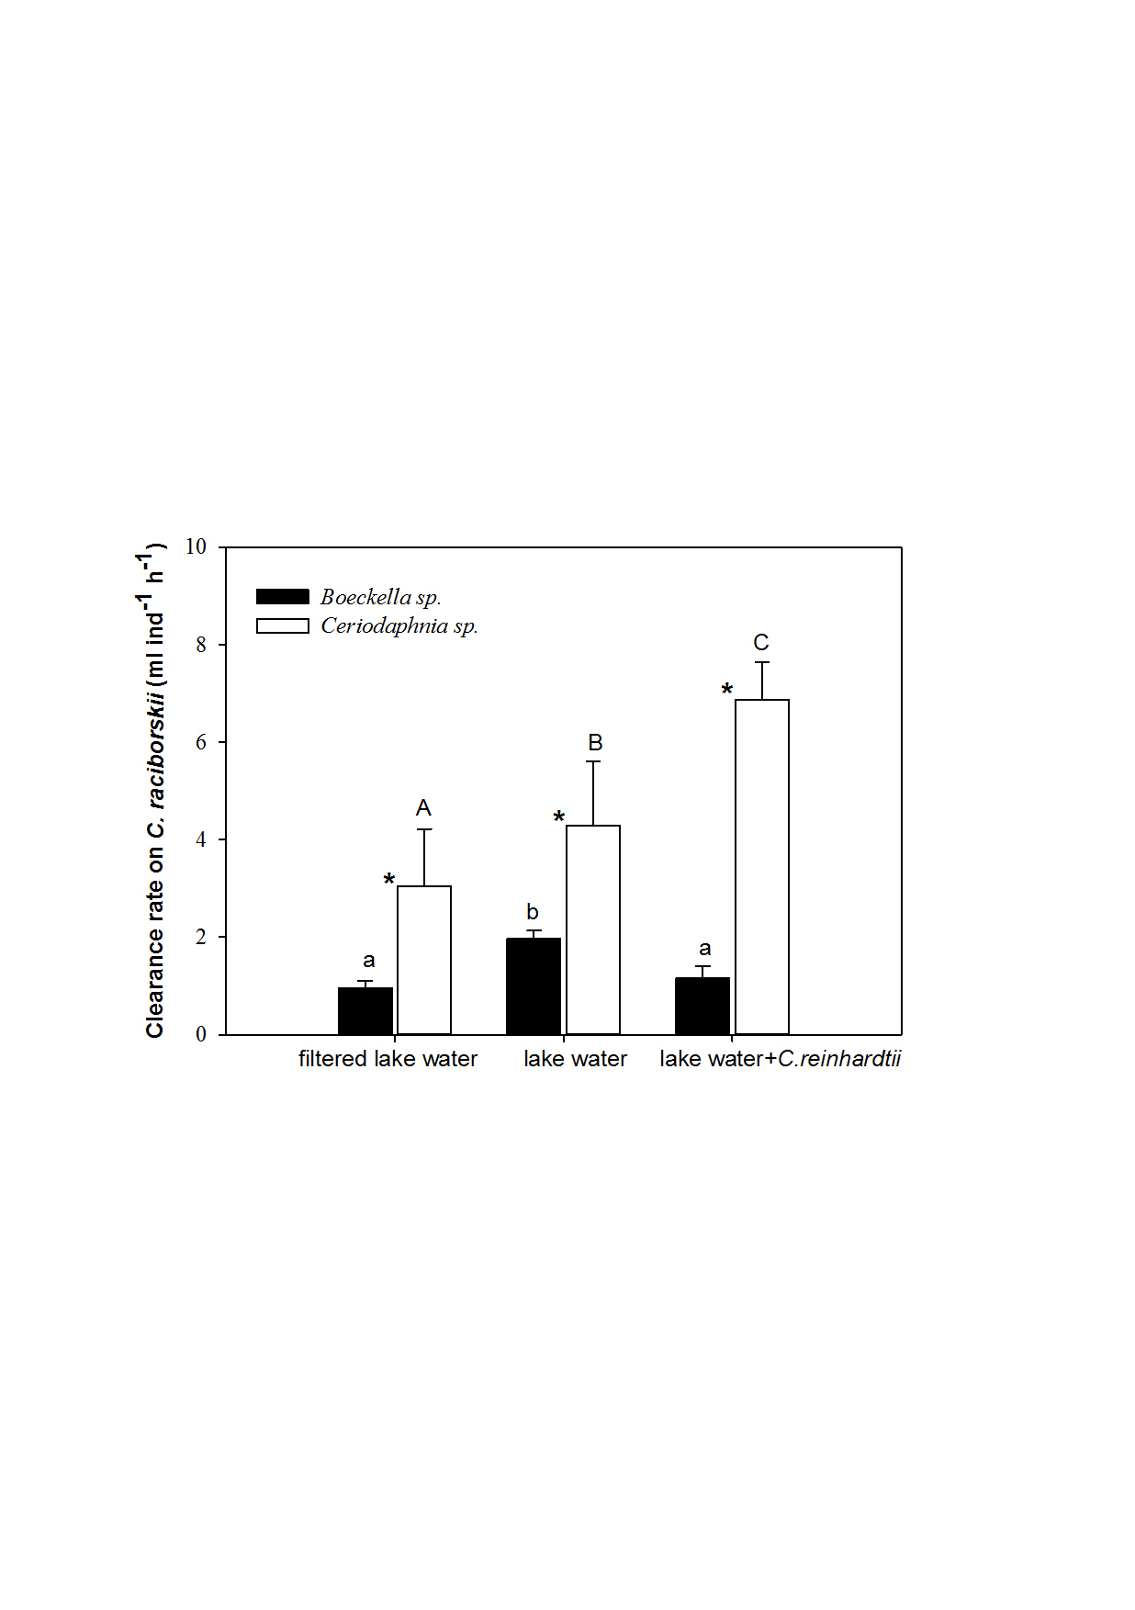

Figure 1

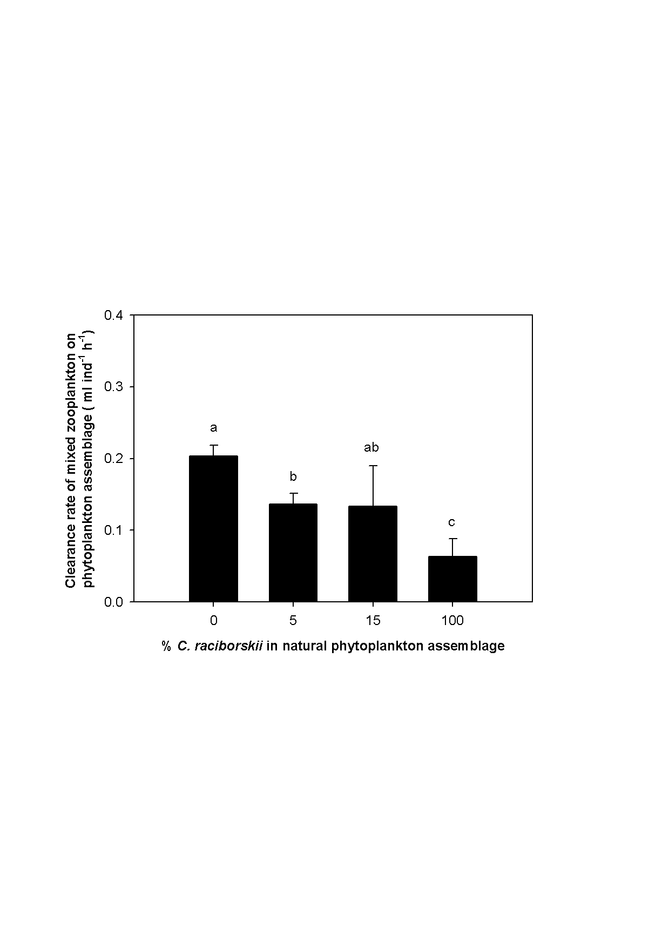

Figure 2

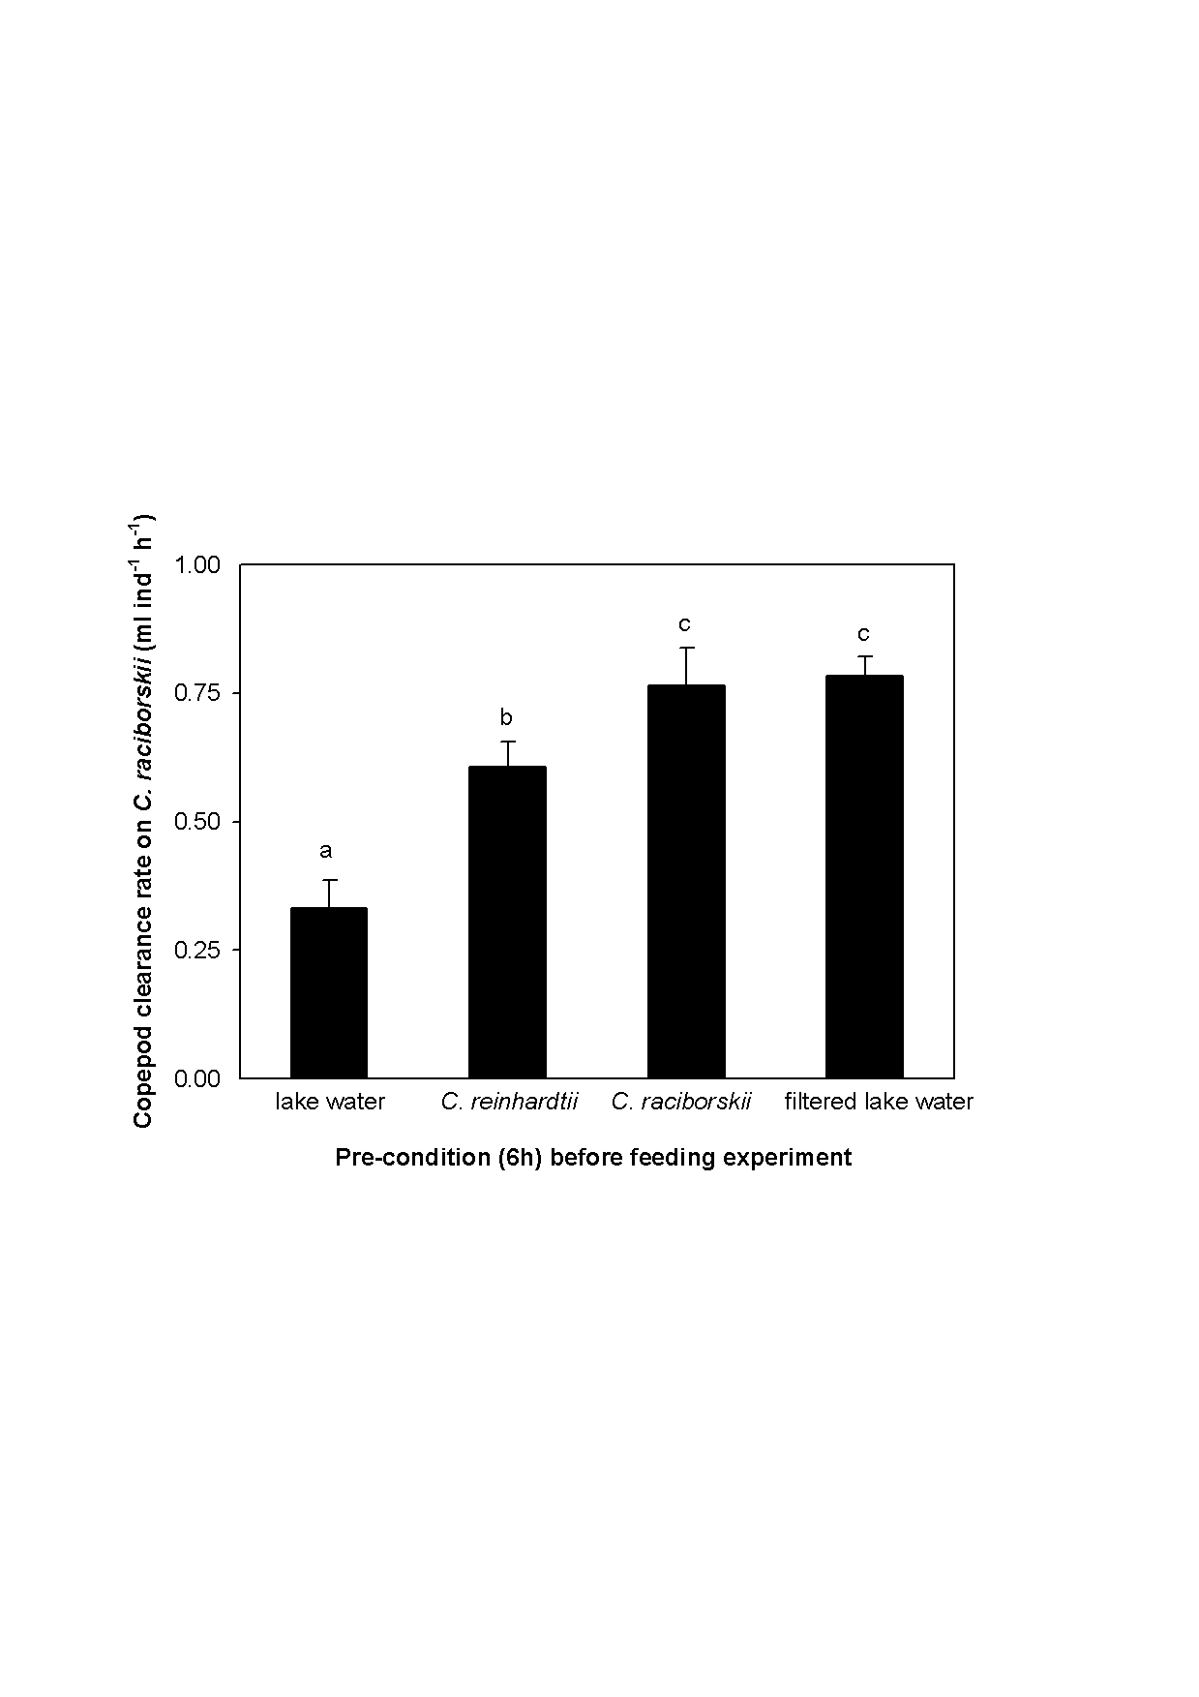

Figure 3



Figure 4



Figure 5