Optimized multilayer indium-free electrodes for organic photovoltaics
Angus R. Gentle*^{,1}, Soniya D. Yambem², Geoff B. Smith¹, Paul L. Burn² and Paul Meredith²
¹ Physics and Advanced Materials and Institute of Nanoscale Technology, University of Technology, Sydney,
PO Box 123, Broadway, NSW 2007, Australia
² Centre for Organic Photonics & Electronics, The University of Queensland,
St Lucia, QLD, 4072, Australia
Received ZZZ, revised ZZZ, accepted ZZZ
Published online ZZZ (Dates will be provided by the publisher.)
Keywords ITO-free, multilayer electrode, organic solar cells, flexible electrode.

Flexible multilayer electrodes that combine high transparency, high conductivity and efficient charge extraction have been deposited, characterised and used as the anode in organic solar cells. The anode consists of an AZO/Ag/AZO stack plus a very thin oxide interlayer whose ionization potential is fine-tuned by manipulating its gap state density to optimise charge transfer with the bulk heterojunction active layer consisting of poly(n-3-hexylthiophene-2,5-diyl) and phenyl-C61-butyric acid methyl ester (P3HT:BC61BM). The deposition method for the stack was compatible with the low temperatures required for polymer substrates. Optimisation of the electrode stack was achieved by modelling the optical and electrical properties of the device and a power conversion efficiency of 2.9% under AM1.5 illumination compared to 3.0% with an ITO-only anode and 3.5% for an ITO:PEDOT electrode. Dark I-V reverse bias characteristics indicate very low densities of occupied buffer states close to the HOMO level of the hole conductor, despite observed ionization potential being high enough. Their elimination should raise efficiency to that with ITO:PEDOT.

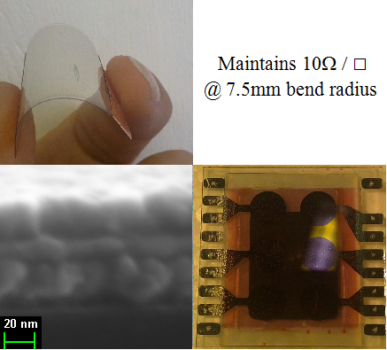
Images of the AZO/Ag/AZO flexible electrodes

Copyright line will be provided by the publisher

1. Introduction
Alternative materials to replace indium tin oxide (ITO) for use in transparent conducting electrodes in organic optoelectronics is an area of great interest for a range of reasons including lower cost and the growing demand on a dwindling supply of indium. Furthermore, ITO and other single layer transparent conductors such as Aluminium-Doped ZnO (AZO) are unsuitable for truly flexible electrodes, while the work function of ITO means that it does not have an ohmic contact with many active layer materials [1] used particularly in organic optoelectronics, and there is the open question of the impact of the ITO electrode on long term device stability [2]. To overcome these deficiencies a number of flexible stack structures have been trialled, including a number of metal oxide/metal/metal oxide sandwich electrodes [3-7]. The total thickness of the stacks is typically below 80 nm, while thicknesses needed for similar sheet resistances with ITO are typically much larger.
Flexible transparent conducting (TC) multilayers have been extensively studied and reviewed in recent years [8,9]. Each different multilayer TC of the forty listed in reference [8] has three layers of the form TCO/metal/TCO with Ag the predominant metal. In thirty-nine out of these forty the two TCOs have identical materials and thicknesses. This anti-reflects the metal film with air on one side. Unfortunately the sub-set of 18 electrodes tried with organic devices apparently retained these air optimized, stand-alone electrodes. They are then no longer optimised since Ag anti-reflection peaks shift once thin organic active layers plus cathode are present. As in this study for an optimized optical response, each layer thickness in the multilayer, including that of the active layer (but not the very thin Ag) , must thus be re-set according to the values of their and the Ag layer’s complex refractive indices at the absorbing wavelengths. One consequence is that the oxide layer thickness on the device side of the Ag must be thinner than in air-optimized multilayers. Inflexible ITO layers in devices are however thick enough that this step does not apply.

Further fine-tuning of the complete structure is still needed to maximise photo-electric response when charge transfer efficiency from electrode to active layer is optimized using a buffer oxide. At this final optimization step fine details of electronic structure in the layer which contacts the hetero-structure comes into play. The electrodes and devices presented here have been examined in terms of this fully integrated approach to maximising performance. This aspect of the study led to a new diagnostic, the result of which is needed in addition to work function or ionization potential to optimize performance. The ideal aim is ohmic flow at the electrode for one carrier polarity, plus complete blocking for opposite charge flow. Departures from ideality have generally been assumed to be absent in most studies to date apart from limited thermal activation. We will see from our diagnostic results that while Poly(3,4-ethylenedioxythiophene) polystyrene sulfonate (PEDOT:PSS) is one of the best contact materials so far studied in terms of approaching ideal rectification, even it may be matched or surpassed by buffer oxides with further refinement. It is not widely appreciated, but this is one reason why ITO/PEDOT:PSS is currently a benchmark for electrode performance. The means by which buffered multilayers can eventually match or exceed that benchmark is an outcome of this study. Contact materials of interest for multilayer electrodes include ITO, AZO, and many metal oxides, of which various molybdenum oxides are the focus here.

2. Optimization when thin oxides buffer multilayer electrodes
A 2011 study [10] involved one molybdenum oxide contacting, one multilayer, ZAZ, with Z = zinc oxide and A = Ag. ZAZ was optimized in air then apparently used directly in a device, which was inverted. Inversion was possible because a top contacting layer of MoO₃ could support the deposition of the ZAZ layer yielding a top facing MZAZ stack. No details are given on the deposition, thickness or properties of the oxide buffer layer, but as here the stack was deposited at room temperature. No attempt seems to have been made to re-tune the MZAZ stack or active layer thickness for the desired anti-reflection or the actual MoO_{x} properties, and this is reflected in the final reduced values of OPV efficiency. This is the only electrode structure we have seen resembling the flexible multilayer electrodes in this study, while we use AZO not ZnO. In addition our devices are not inverted, use a different four layer stack AZO/Ag/AZO/ MoO_{x}, and the three oxide layers plus the device layer are re-tuned in thickness for the device context. We can then examine for the first time the significant impact on device performance of the few occupied MoO_{x} gap states, observed in photo-emission and UPS studies that have been observed above the threshold given by the usual ionization potential value [11]. Our new data also indicates that a few such states also exist above or near the adjacent HOMO level.

This study also builds on an issue for transparent multilayers which has been well known for many years within the window coating industry [12,13,14], but only recently recognised within the OPV community [10, 15, 16 ]. It is advantageous that the material below the Ag layer in the stack be based on un-doped or doped zinc oxide. ZAZ and our AZO/Ag/AZO stack are examples. For the room temperature deposited ZAZ system [10,15] it was shown that the silver deposit achieves faster percolation. We had previously reported the same faster percolation on AZO [14] within a study showing conductivity, and transmittance spectral control were both much improved relative to depositing silver on glass. This was linked to two issues; faster percolation, and the fact that Ag films grow epitaxially on various zinc oxides. The latter reduces electron ohmic loss, which further enhances conductivity and transmittance [14]. These advantages in the OPV context show up by comparing ZAZ and AZO/Ag/AZO, to the flexible MAM electrode in which MoO_{x} is the anti-reflection oxide [5] and TCO layers are absent. The use of MoO_{x} below the Ag lowers electrode conductance relative to depositing on AZO or other zinc oxide based under-layers. A main driver for anti-reflected Ag electrodes has been the need for polymer substrates, hence room temperature deposition of all layers. Thus though many electrode stack options exist [8, 9] the best choices will include ZO and AZO under silver. An alternative to our electrode could thus be replacing the MAM system with either AZO/Ag/M or a ZAM stack, with appropriate different thicknesses either side of the Ag layer. Such a study (published after initial submission of this paper) [15] did benefit from faster Ag percolation. The transmittance of their multilayer, though only ~ 40 nm thick, was however too low in air for a sufficiently low surface resistance. It was also not re-tuned for the 250 nm thick active layer. Thus device efficiency was much lower than found in this study.

In this work we refine the thin multilayer electrode approach by utilising an un-annealed AZO/Ag/AZO sandwich with a top molybdenum oxide interlayer for contact with an organic solar cell active layer. For reasons just noted this is more conductive at a given thickness with higher transmittance than most other un-annealed multilayer electrodes tried to date [5] including on ZnO [15]. While there have been a few studies of AZO/Ag/AZO electrodes for OPV, just one [10] has included an oxide interlayer. Most have had to be annealed at high temperature (500°C) to achieve sufficient sheet resistance and transparency [3]. It is because the lateral conductivity is performed by the silver layer, that it is not a requirement that the oxide layer is highly conductive, it just need to be sufficiently conductive that the vertical conductive path ~30nm through the oxide doesn’t introduce a significant barrier. This work significantly extends the study of AZO/Ag/AZO/metal oxide/ electrodes for flexible OPV. The electrodes here differ in two key ways to most of those previously reported. First by combining low temperature deposition and an AZO base layer the resulting fast electrical percolation and epitaxy of the silver also provides the stack with enhanced mechanical properties relative to multilayers not using ZnO or AZO. This allows it to be strained or bent more easily than ITO or other flexibles (as needed for OPV devices fabricated on flexible substrates). Secondly our extended step-by-step approach to optimization is new. It involves first re-adjusting in a device context the thickness of each of the three oxide layers in the electrode, and the active layer thickness, to account for each layer’s pre-measured complex refractive indices, so as to maximise the resonant cavity absorption and generation rate profile. Then a final optimization step involves the impact of tuning the defect states in the buffer layer. There are clearly a number of materials (organic and inorganic) that could be used for this interlayer. In this work a thin MoO_{x} was used. Additionally the use of a TCO such as AZO allows for direct DC sputtering of the film, which is much more commercially scalable, avoiding the need for RF deposition or reactive sputtering which can severely effect the properties of the underlying silver. As the buffer layers can be sensitive to air exposure, this limits the direct usability of sandwich structures whose outer layer is being used as the buffer layer, this issue can be simply avoided by depositing it at the time of device fabrication similarly to devices on ITO. It appears that this issue is rarely raised due to electrode and device fabrication occurring sequentially within the same facility. In the case of air exposed MAM electrodes, an additional MoO_{x} layer would be required to be deposited before device fabrication to restore the required ionization potential (IP) value, as with air exposure a decrease is seen in MoO_{x}.
A feature of buffer oxides that is not always appreciated is that their conductivity, carrier density and density of occupied states above the valence band is linked to the density of structural defects, which are typically oxygen vacancies [1] but can be other dopants. As defect densities change the ionization potential also changes. This was recently quantified for MoO_{x} as a function of x [17], and it was found that the IP can range from over 5 eV to around 3.5 eV as x varies, i.e. depending of the stoichiometry of MoO_{x} it can be used as part of an anode or cathode. Much higher values of IP = 9.7 eV have been reported for MoO_{x} by Kroger et al [18]. This would be the case if x was very close to zero, so the oxide was almost stoichiometric. It would also need to be crystalline to avoid amorphous valence band tails which reduce IP. Such a high IP value was found to strongly enhance hole injection into a single hole conducting layer compared with using bare ITO [18] but defects were still invoked to explain data. In the organic bulk hetero-junction systems, problems with such a high IP would arise due to the electron conductor coming into contact with the anode. While its LUMO layer energy is of most interest at the cathode, its HOMO layer with IP of order 5.8 eV could exchange holes with such a high IP oxide. This would badly affect performance. However we believe no such very high IP anode electrode device has been made, or if it has its performance has been too poor. Buffer oxides for anodes should have much lower IP than 9.7 eV, but not low enough to allow for electron leakage. Even with a suitable traditional IP value some electron leakage can still occur as we shall demonstrate and explain.
Eliminating or minimising unwanted leakage, for example electrons into the anode, is an issue that has received little attention because it has been assumed that if the reported ionization potential is high enough it will not occur. Details within UPS [11] and photoemission (PE) spectra [19], along with recent theoretical studies of gap states in these oxides [17] indicate clearly that occupied states do exist above the cut-off energies indicated by normal photoemission (PE) and UPS data. These usual values of IP are still useful, but give an incomplete picture of charge transfer in many oxide buffers. If some of these low density but occupied gap states extend not only above levels indicated by the IP value, but to energies near to the p-layer’s
HOMO level, reverse leakage can occur. Thus to maximize performance the oxide buffer gap states must be tuned not just to yield a suitable traditional IP value, but to minimize weak electron leakage. One goal with the buffers was to eliminate the need for organic buffering of ITO, usually with PEDOT:PSS. To match or exceed the performance with ITO/PEDOT:PSS electrodes, reverse leakage into an ITO/oxide or TCO/Ag/TCO/oxide electrode must be as low. Evidence for such reverse leakage with oxide buffers has not however been observed so it has not been considered as an issue affecting performance. This may be because it is not easily discerned under illumination due to its relative magnitude to reverse bias photocurrent. In the dark however it becomes obvious when present, and even occurs weakly with a PEDOT:PSS buffer.
In our work we use MoO_{x} as part of the anode, and as sub-10 nm thicknesses are used, it is ionization potential and not overall conductivity that dominates the choice of x. Another issue with MoO_{x} that is worth noting here is that there is a large shift in threshold electron emission energy from pure (x = 3) oxide once a few oxygen defects are present. This does not mean however, that once defects form we are dealing with a work function in place of an ionization potential as it remains a semiconducting oxide until x ~ 2.6.[17] Past confusion has sometimes arisen because there are two sources of photoemission, which we recently described as IPV and IPD [19], and the associated filled levels can partially overlap in energy. IPV is the traditional valence band emission which usually includes emission from the valence tail if amorphous. IPD arises from the filled oxygen vacancy states which lie in the band gap. For simplicity we will refer to our base electrodes of Oxide-Silver-Oxide as (OSO) and with MoO_{x} buffers as (OSO:MoO_{x}).

3. Material and methods
3.1. Stack Electrode Fabrication
The three layers of the electrode were deposited via room temperature DC magnetron sputtering onto a set of six 25 mm square glass or Dupont Teonex® Q65FA polyethylene naphthalate (PEN) substrates, using 2” sputter targets with a base chamber pressure of 1x10⁻⁶ Torr, with Argon introduced to 1.5 mTorr. The AZO layers were deposited with 0.2 A sputter current, and the Ag layers with 0.1 A. The target to sample working distance was 150 mm, with a rotating stage to ensure uniformity across the electrodes. The 2% AZO target was directed off axis by 100 mm, to increase the AZO film‘s conductivity. Optimum positioning of the sample stage in relation to the AZO target was determined using a non rotating large glass sample, then positioning the rotating sample stage centred on the area of highest conductivity. A shadow mask was used to pattern the AZO/Ag/AZO electrodes. After electrode fabrication the devices were transported to the facilities at the University of Queensland for device fabrication including the evaporated MoO_{x} buffer layer. Thus our device results are representative of air exposed purchased electrodes, rather than non-air exposed single clean room electrode / device fabrication as is often reported.
3.2. Fabrication and characterization of organic solar cells
3.2.1. Materials
Poly(n-3-hexylthiophene-2,5-diyl) P3HT and Poly(3,4-ethylenedioxythiophene) polystyrene sulfonate (PEDOT:PSS) (CLEVIOS™ P VP Al 4083) were purchased from Merck and Heraeus, respectively, while phenyl-C61-butyric acid methyl ester (PC61BM) was purchased from American Dye Source. MoO₃ (purity = 99.99%) and Al (purity = 99.99 %) were purchased from Sigma-Aldrich and Materion, respectively. All commercial products were used as received. Patterned ITO – glass substrates of size 25 x 25 mm were purchased from KINTEC Company.
3.2.2. Thin Film Characterization:
Thicknesses of the evaporated MoO_{x} for initial calibrations were measured with a Veeco Dektak 150 surface profilometer. Witness slides of each layer were also deposited onto Silicon wafers for ellipsometry measurements. Final thicknesses were refined in the optical modelling process.
3.2.3. Device Fabrication:
The following device architectures were fabricated for testing and comparative purposes are shown in Table 1.

Table 1 Device architectures
46nm AZO / 11.5nm Ag/ 10nm AZO/ 10nm MoO_{x}/ 85nm P3HT:PC61BM/Al | (device A)
ITO* /10nm MoO_{x}/ 110nm P3HT:PC61BM/Al | (device B)
ITO* /40nm PEDOT-PSS/ 110nm P3HT:PC61BM/Al | (device C/standard devices)
PEN / 30nm AZO / 11nm Ag/ 23nm AZO / 7nm MoO_{x}/ 110nm P3HT:PC61BM/Al | (device D)
*The ITO coated glass consisted of 23 nm SiO2 / 86 nm ITO Layers

The ITO coated glass pieces were first cleaned with detergent and ultra-sonicated in de-ionised water. This was followed by ultra-sonication in acetone and 2-propanol for 15 mins each before blow-drying with N2. For the standard devices (device C), filtered PEDOT:PSS (0.45 µm PVDF) was spin coated on ITO. To make sure all the films were dry, ITO and ITO-PEDOT:PSS slides were annealed at ~125 º C for 30 minutes and then transferred to a glove box (MBraun nitrogen glove box, O2 < 0.1 ppm; H2O < 0.1 ppm). From this point all device fabrication and testing was done in a glove box environment. For devices A and B, 10 nm of MoO_{x} was deposited in a thermal evaporator at pressure ~ 1 x 10⁻⁶ Torr. Solutions of P3HT (30 mg/mL) and PC61BM (30 mg/mL) were first prepared separately in 1,2-dichlorobenzene and then mixed in equal volumes. They were then filtered using a 0.22 µm PTFE filter. P3HT:PC61BM layers were spin coated on ITO-PEDOT:PSS, AZO-MoO_{x} and ITO-MoO_{x} with different spin speeds to get the desired thicknesses of active layer in each case, with the choice of thickness guided by optical modelling of the complete system. The optical properties of each layer and the final device stack were modelled in WVASE32 v3.818 ellipsometry software using a combination of spectroscopic ellipsometry data aquired using a V-VASE J.A.Woollam ellipsometer and polarised reflectance transmittance measurements using a Perkin Elmer Lambda950 with universal reflectance accessary and polariser drive. They were subsequently dried at 60 °C for 20 minutes. Finally, a 100nm thick layer of Al was deposited by thermal evaporation in vacuum of ~1 x 10⁻⁶ Torr to complete the fabrication. The devices had an active area of 0.2 cm², which was defined using a shadow mask. Post fabrication, the devices were annealed at 180 ºC for 2 minutes before the current-voltage (IV) measurements were taken.
3.3. Device characterisation measurements
An Abet Triple-A (Abet Technologies) solar simulator was used and the solar mismatch of the Xenon lamp (550 W Oriel) spectrum was minimized using an AM1.5G filter. Light intensity at ∼100 mW/cm2 AM1.5G was calibrated by using a National Renewable Energy Laboratory (NREL) - certified standard 2 cm × 2 cm silicon photodiode with a KG5 filter. A Keithley 2400 source measurement unit was used for current-voltage measurements.
4. Results and Discussion
4.1 OSO Characterisation
A high resolution image of the cross-section of a symmetric AZO/Ag/AZO (OSO) stack produced at room temperature on silicon is presented in Fig. 1, with the silver layer clearly distinguished and around 10 nm thick. Fig. 1 also confirms that the total stack is close to 70 nm thick which enables it to be quite flexible and suitable for polymer substrates. Sheet resistance measurements of the OSO stacks gave a value of ~ 10 Ω/□, which was unchanged even when the electrode was bent around a 7.5mm radius cylinder.
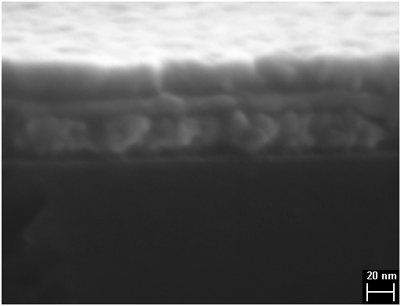
Figure 1 Cross section SEM image of AZO-Ag-AZO structure on a Silicon substrate. Scale bar is 20nm.

In comparison with previously reported evaporated MoO_{x}-Ag-MoO_{x} (MAM) electrodes [5], the OSO stacks presented here have a lower sheet resistance (and higher transmittance) due to the effect of AZO on the growth of the thin silver layer, allowing electrical percolation to occur sooner at a lower mass thickness leading to higher conductivity at that thickness and higher transmittance. For example the Ag mass thickness we use of 11.5 nm yields 8 Ω/□ on AZO, but on glass or MoO₃ it yields 12 to 13 Ω/□. For thinner silver the disparity gets worse, for example at the mass for 11 Ω/□ on AZO we found 26 Ω/□ for the other oxide substrates, with a parallel divergence in transmittance. References showing similar benefits for Ag on AZO or ZnO were noted earlier. In principle deposition of the AZO at higher temperatures would lead to lower sheet resistances of the AZO layer, but would be incompatible with plastic foils, as well as causing adverse effects on the thin silver films conductivity [20] and transparency due to void/island formation. However, the OSO stack is sufficiently conductive, and this coupled with its beneficial impact on the Ag layer makes it superior to most other anti-reflecting oxides. The OSO stack work function was measured to be 4.6 eV, and therefore we chose to use a MoO_{x} layer with x set for an IP of 5.4eV. Details of the instrument used to obtain the photoelectron yield spectra and measure the ionisation potential for different x values can be found in reference [19], and the results were comparable with data from a PESA AC-2 photoelectron spectrometer. A similar layer was also used with the ITO anode. The IP of 5.4 eV provided a good contact with the P3HT:PC61BM active layer and provides an alternative to PEDOT:PPS which is beneficial due to the latter’s acidity. It was found to be important to deposit the MoO_{x} immediately prior to the deposition of the active layer to avoid any lowering of IP. Fig. 2 shows the high transmittance in air of symmetric OSO stacks. The transmittance was found to be higher than ITO in the absorption window of the P3HT:PC61BM active layer. The higher near infrared reflectance of this electrode compared to ITO will also add a secondary benefit by helping to keep the devices cooler than a standard ITO electrode. We found that the MoO_{x} interlayer had little effect on the spectral results shown in Fig. 2.
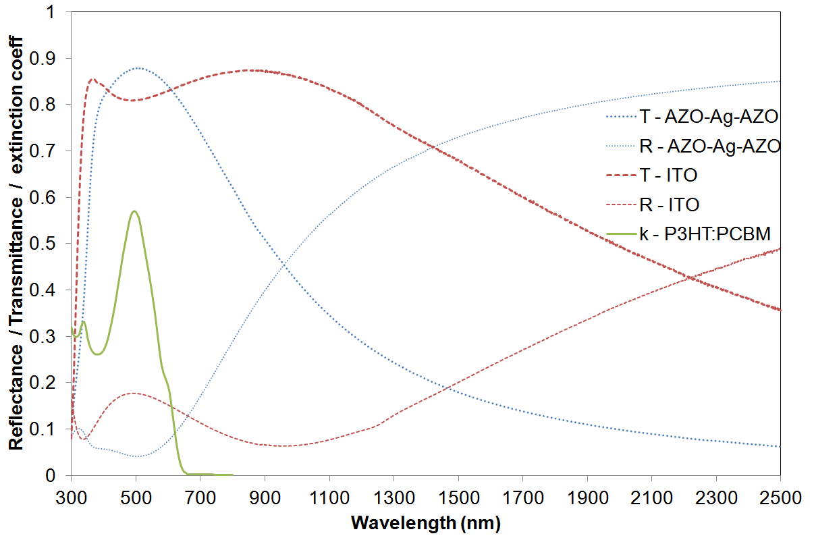
Figure 2 Optical properties of the multilayer electrode. Included is a spectrum for standard ITO film purchased from Kintec glass, along with the extinction coefficient of P3HT:PBM.

4.2 Device performance

With the anode and interlayer fabricated and characterised the next stage in the work was to compare the performance of devices with different anodes, with the device structure and deposition method of the key OSO:MoO_{x} devices of this work summarised in Table 2.

Table 2 Device description
Layer Number | Material | Thickness  [nm] | Deposition Method
6 | Al | 150 | Evaporated | Cathode
5 | P3HT:PC61BM | 85 | Spin Coated | Active Layer
4 | MoO_{x} | 10 | Evaporated | Anode Buffer Layer
3 | AZO | 10 | Sputtered
2 | Ag | 11.5 | Sputtered | Electrode
1 | AZO | 46 | Sputtered | Sheet Resistance:8.4Ω/□
Substrate | Glass

It is important to note that the AZO layers in the test device are asymmetric in thickness to optimise the transparency of the stack and for enabling the total matching of the complex optical admittance to the single AZO layer on the substrate side of the Ag with that of the P3HT:PC61BM layer. The thickness of the device from a cross-section image closely agrees with that found from precision optical modelling. Back side reflectance measurements of the fully encapsulated devices allowed us to confirm that the desired optical properties as established in prior models had been attained. Fig. 3 shows that the AZO/Ag/AZO system absorbs similarly to the others around where the active layer has its peak absorptance (near 500 nm), but is superior in supplying carriers where the active material absorption profile tails off (see Fig. 2), due to the resonant cavity between the aluminium and silver layers, allowing the thickness of the active layer to be significantly thinner. Thus the OSO electrode has the potential for higher generation rates than the other two as observed in Fig. 4.
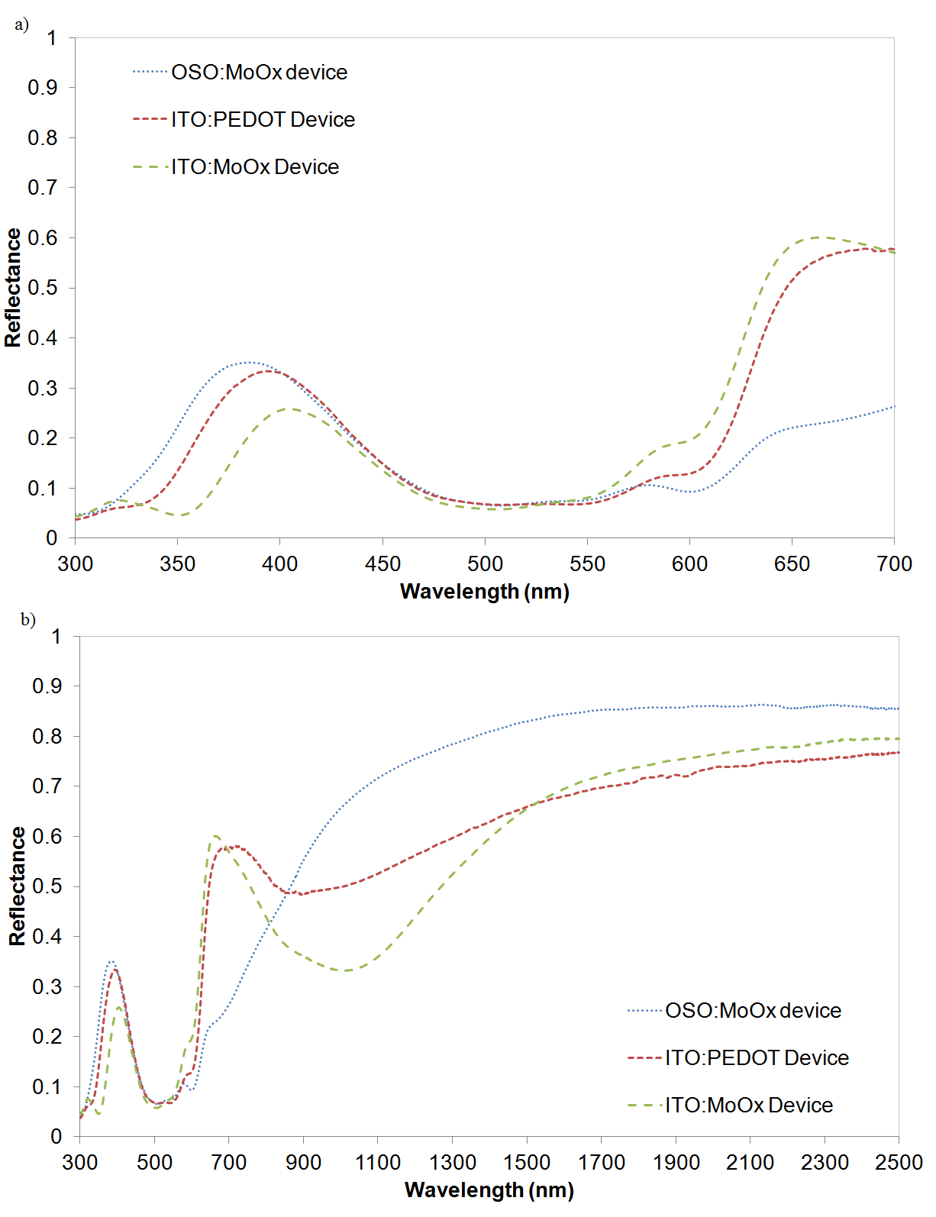
Figure 3 Back reflectance measurement of the three devices, studied above (a) 300-700nm optically active region of OPV Device, (b) 300-2500nm.
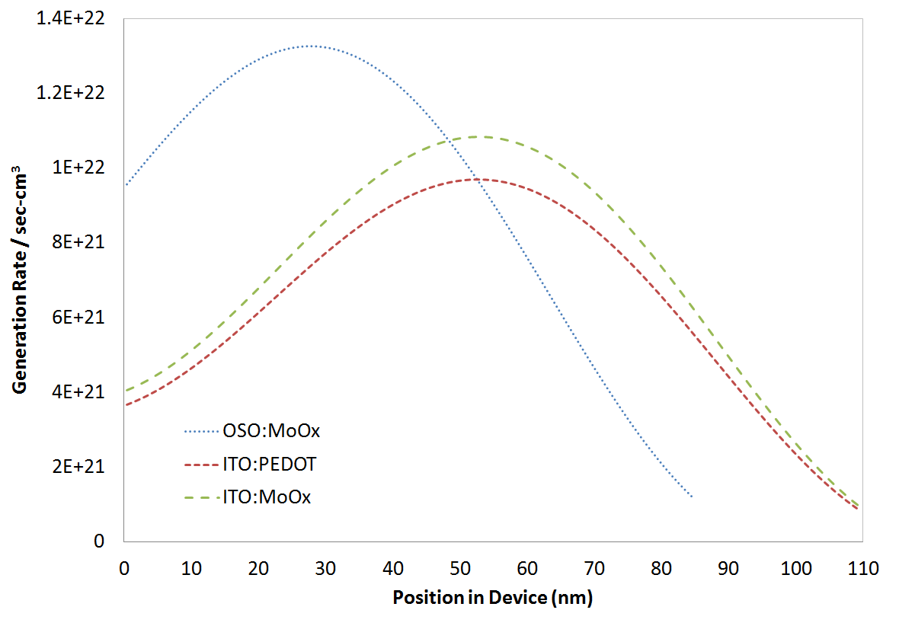
Figure 4 Modelled photo carrier generation rate, position in device active layer relative to the anode. The active layer thickness for the OSO:MoO_{x} device is 85nm thick, while the other two devices it is 110nm thick

Hence, precise knowledge of the thickness of each layer in the electrode is important when modelling the optimum thickness of the active layer in the final device.
I-V characteristics of the four OPV devices with different structures are shown in Fig. 5, with the results summarised with ancillary data on the electrodes in Table 3. It can be seen that the efficiencies for the devices with ITO and the OSO stack with the MoO_{x} interlayer are very close.
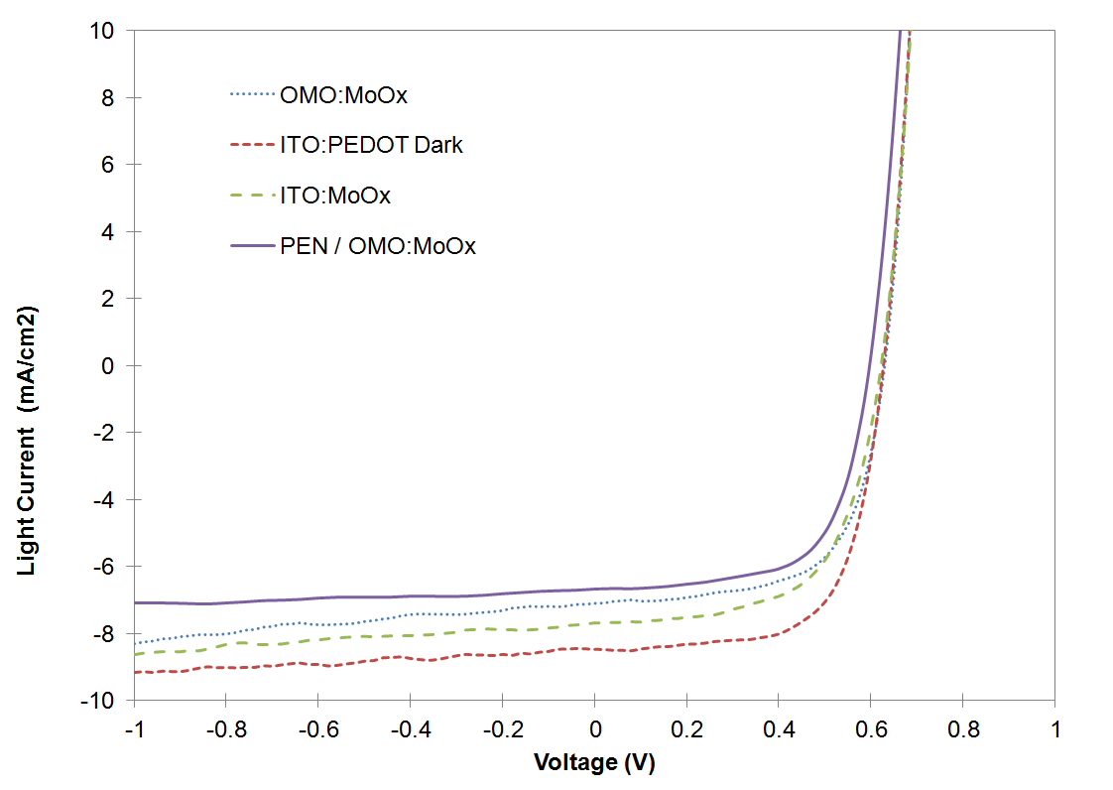
Figure 5 IV response of OPV devices under illumination.

Each is better in different electrical aspects, although both have a lower overall performance than the standard ITO/PEDOT:PSS anodes. In order to determine the origin of these differences, the loss mechanisms of our devices were studied, in particular the dark current as a function of applied voltage as shown in Fig. 6. It is evident that the MoO_{x} interlayer, whose role is energy level match to the P3HT and blocking of electron transfer to the anode, suffers from leakage in reverse bias for both the ITO and OSO devices. In contrast, the ITO/PEDOT:PSS electrode shows negligible leakage until the cell junction approaches breakdown conditions. This explains the better efficiency of the ITO/PEDOT:PSS electrode-based devices. Similar buffer related leakage occurs in the optically optimized PEN based device (table 3).

Table 3. Comparison or electrical performance between thin flexible AZO/Ag/AZO buffered with MoO_{x}, and devices made with two inflexible ITO electrodes, one buffered with PEDOT and one also buffered with MoO_{x}.
Sample | OSO:MoO_{x} | ITO:PEDOT:PSS | ITO:MoO_{x} | PEN/OSO:MoO_{x}
Voc (V) | 0.62 ± 0.00 | 0.61 ±0.01 | 0.61 ± 0.01 | 0.56 ± 0.00
Jsc (mA/cm2) | 6.44 ± 0.37 | 8.17 ± 0.33 | 8.18 ± 0.41 | 6.45 ± 0.19
Fill Factor | 0.63 ± 0.02 | 0.67 ± 0.01 | 0.57 ± 0.05 | 0.65 ± 0.03
R series (Ohm) | 78 ± 7 | 63 ± 6 | 78 ±13 | 100 ± 18
Efficiency (%) | 2.5 ± 0.2 | 3.3 ±0.2 | 2.8 ± 0.3 | 2.3 ± 0.1
Best Efficiency (%) | 2.9 | 3.5 | 3.2 | 2.6
Electrode Sheet Resistance (Ohm/Sq) | 8.4 | 15 | 15 | 10

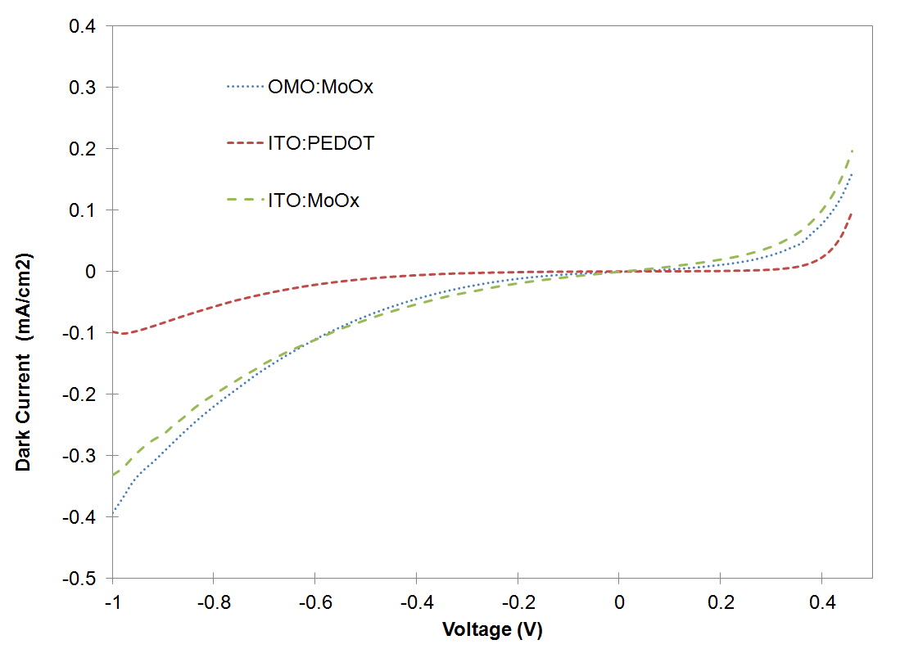
Figure 6 Dark IV plots for devices utilising the three different electrodes on glass.

The observation in Fig. 6 was combined with a study of the charge generation profile of the OSO devices. Transfer-matrix modelling [21] of the electric field and carrier generation rate distributions were carried out, and are plotted in Fig. 4. It is easy to see from this plot and Fig. 6 viewed together the origin of the diminished performance of the OSO/MoO_{x} devices compared with the reference ITO/PEDOT:PSS device. Despite having similar solar energy absorption profiles with depth to the ITO/PEDOT:PPS based device, the carrier generation rate for the devices with OSO stack electrodes is about 2.5 times higher near the anode than with the ITO/PEDOT:PSS or ITO/MoO_{x} electrodes. The leaky nature of the MoO_{x} anode buffer combined with the higher generation rate near the anode results in an unwanted recombination at this electrode. The central energy location of the defect band-gap states in MoO_{x} and the extent of their spread around this energy are known to vary with preparation conditions, and are expected to affect leakage rates.
5. Conclusions
We have successfully shown that AZO/Ag/AZO stack electrodes with a MoO_{x} interlayer are useful as anodes for P3HT:PC61BM bulk heter-junction organic solar cells devices. The use of MoO_{x} as an interlayer at the anode/active layer interface buffer has been demonstrated to be a contributing factor to device performance. Its main benefit is its high ionization potential, but the particular stoichiometry or x- value must be carefully chosen to avoid high recombination rates near the anode. In order to overcome this limitation future work will concentrate upon different deposition conditions for the MoO_{x}, thus altering the MoO_{x} gap state densities which are responsible for charge transfer with the active layer. Alternative metal sub-oxide films with sufficiently high ionization potentials may also reduce anode related losses. Leakage studies in the dark will assist the optimization process.

Acknowledgements This work was supported by the CSIRO Future Manufacturing Flagship: Flexible Transparent Electrodes for Plastic Electronics Cluster which includes The University of Queensland, University of Technology, Sydney and Flinders University.
References
[1.] M. T. Greiner and Z.-H. Lu, NPG Asia Materials 5, e55 (2013).
[2.] Y. Sun, C. J. Takacs, S. R. Cowan, J. H. Seo, X.Gong, A. Roy and A. J. Heeger, Adv. Mater. 23, 2226–2230 (2011).
[3.] H.-K. Park, J.-W. Kang, S.-I. Na, D.-Y. Kim and H.-K. Kim, Solar Energy Materials and Solar Cells 93 (11), 1994-2002 (2009).
[4.] A. Dhar and T. L. Alford, J. Appl. Phys. 112 (10), 103113 (2012).
[5.] H. Jin, C. Tao, M. Velusamy, M. Aljada, Y. Zhang, M. Hambsch, P. Burn and P. Meredith, Adv. Mater. 24, 2572-2577 (2012).
[6.] L. Li, K. S. Hui, K. N. Hui, H. W. Park, D. H. Hwang, S. Cho, S. K. Lee, P. K. Song, Y. R. Cho, H. Lee, Y. G. Son and W. Zhou, Materials Letters 68, 283-286 (2012).
[7.] L. Cattin, M. Morsli, F. Dahou, S. Y. Abe, A. Khelil and J. C. Bernède, Thin Solid Films 518 (16), 4560-4563 (2010).
[8] L. Cattin, J.C. Bernède and M. Morsli, physica status solidi (a) 210 1047-1061 (2013)
[9] C. Guillen and J. Herrero Thin Solid Films 520 1 -17 (2011)
[10] T. Winkler, H. Schmidt, H. Flügge, F. Nikolayzik, I. Baumann, S. Schmale, T. Weimann, P. Hinze, H. Johannes, T. Rabe, S. Hamwi, T. Riedl, W. Kowalsky, Organic Electronics 12 1612-1618 (2011)
[11] M. Vasilopoulou, A.M. Douvas, D.G. Georgiadou, L.C. Palilis, S. Kennou, L. Sygellou, A. Soultati, I. Kostis, G. Papadimitropoulos, D. Davazoglou, and P. Argitis, J Am Chem Soc 134 16178-16181 (2012)
[12]. J. A. Ridealgh, MRS Online Proceedings Library 890, Y01-10 (2005).
[13]. G.B. Smith and C. G Granqvist, "Green Nanotechnology: Solutions for sustainability and energy in the built environment", CRC press (Taylor and Francis), Boca Raton, USA, September, 2010 ISBN 978-1-4200-8532-7.
[14] A.A. Earp and G.B. Smith, J. Phys. D: Appl. Phys. 44, 255102 (8pp) (2011).
[15] S. Das, H.W. Choi, T.L. Alford, Materials Letters 133 183-185 (2014)
[16] T. Winkler, H. Schmidt, et al., Thin Solid Films, 520 4669-4673 (2012)
[17.] G. B. Smith, D. Golestan and A. R. Gentle, Appl. Phys. Lett. 103, 051119 (2013).
[18.] M. Kröger, S. Hamwi, J. Meyer, T. Riedl, W. Kowalsky and A. Kahn, App. Phys. Lett. 95 123301 (2009)
[19.] A. R. Gentle, G. B. Smith and S. E. Watkins, Appl. Surf. Sci. 285, Part B, 110-114 (2013).
[20.] H. C. Kim, T. L. Alford, and D. R. Allee, Appl. Phys. Lett., 81, 4287 (2002).
[21.] G. F. Burkhard, E. T. Hoke and M. D. McGehee, Adv. Mater. 22, 3293 (2010).

* Corresponding author: e-mail angus.gentle@uts.edu.au, Phone: +61 2 9514 2224, Fax: +61 2 9514 2219

