Managing and monitoring radiant and convective heat flows in temperate zone urban environments
J.C. Aguilar¹, A.R. Gentle¹, G.B. Smith^{1,2}
¹Physics and Advanced Materials, University of Technology, Sydney, Australia
²Zero Waste Centre for Sustainable Design & Behaviour, University of South Australia

ABSTRACT
Modeling and experimental techniques for studying the impact of facades and roofing materials plus building layouts, on the UHI and interior energy use have been carried out for Sydney, which has a temperate zone climate. Cool roofing is treated as a multi-parameter sensitivity problem where changes in one of: solar reflectance, sub-roof R-value, and roof thermal mass (via material type or with phase change layers), plus change from cooling to heating season, alter the sensitivity of energy use and external surface temperatures to all of the other design settings. For high-rise layouts the issue of aspect ratio (height/spacing) plus spacing cover were considered. Special attention was paid to the night-time as an indicator of UHI problems and hence to flows of thermal radiation from the sky and from surfaces. Models needed to be accurate on this influence while a low cost, compact and portable technique for monitoring thermal radiation flows has been developed and calibrated using simultaneous full sky data from a pyrgeometer. An additional aspect of cool roofing has recently emerged involving modification to convective flow and cool air flow towards ground from varieties of multilayer roofing, including proliferation of solar modules on urban roofs, and additional layers involving polymer mesh or another solid layer.

Introduction
Measures that lead to large energy savings and significant reductions in the magnitude of peak energy demand in buildings in summer for temperate zones are also among the most effective counter-measures to urban heat island related extremes in these environments. Enhanced exterior surface temperatures at night are a key signature of a growing UHI problem and some of the novel roofing developments presented in this paper are aimed at enhanced cooling of buildings and their exteriors at night as well as in the day. Cooler building elements prior to sunrise can slow down the onset of heat gains the following day but the main benefit of cooler local air at night is it allows natural ventilation and people and interior mass to recover from daytime heat []. Lack of such recovery is one of the main health issues arising from the UHI [ ]. Cool roofing as defined by a low albedo and if possible a low thermal mass has been our prime focus [ , , ] though we have recently also considered the impact of façade materials. Unfortunately the dominant approach to keeping building and vehicle interiors thermally comfortable is via compressor driven heat pumps, which add substantially to exterior thermal discomfort. This contribution to the UHI is increasing as urban population increases and buildings get closer together and rise higher. Reduced interior cooling loads via building design is thus not only about interior thermal comfort but benefits the local environment. Excessive normal insulation or very low U-value is another issue to be considered. It may reduce solar heat gain to interiors but it must as a consequence create a hotter exterior surface to achieve thermal balance which adds to UHI problems. As with energy efficient low-U glazing the best compromise approach is to achieve as much solar reflectance as aesthetics and functionality allow as this keeps surface temperatures down anyway. It is also unnecessary then as we have recently shown [] to have high insulation values and the higher costs it entails. Summer performance is not jeopardized and exterior surfaces stay quite cool. Some “cool” roof designs we mention later can get even “cooler” and may need no insulation. However for temperate climates some roof and façade insulation is needed to cope with winter cold but we have recently shown that the key impact in current Sydney dwellings is not U- value but better control of air exchange rates [ ]. At night in summer this control measure is also very useful but only if the local UHI is countered.

An alternate approach to a high façade U-value can also reduce local UHI and interior heat gain. It involves use of partial “green” roof and/or wall with solar gain reduced by evapo-transpiration from the vegetation. These and high albedo roofs impact the local environment in different ways, both beneficially with each also saving interior energy [ ]. “Green cover” counter-measures are most widely used between buildings where cooler pavement design [ ] is also of value. The spatial organization of multiple arrays of structures in both suburbs and high rise localities needs attention if these aspects are to make better contribution. The aim is to integrate this urban planning issue with economic and population density considerations. We address one study of spatial organization in this paper. Aesthetics is always important and does not have to be sacrificed to achieve better thermal outcomes and can be enhanced for example with partially green facades or cool coloured paint []. A faster uptake of UHI counter-measure technologies will be helped if they have visual appeal. Architects and urban planners are restrained compared to past practice but still have good residual artistic and design freedom, which will grow as knowledge and experience of surface management increases. Novel artistry in living spaces also thrives on novel techniques, which this work will create.

Thermal radiation data and the UHI

Knowing the magnitude of thermal radiation flows is important in quantifying the contribution of both down-welling atmospheric radiation and net upwelling radiation, to the net ability of stored urban heat to escape at night at any point within an urban precinct which has a partial view of the full sky vault. This view is defined by sensor location usually on a facade (height) and neighbouring structure aspect ratios (full height/spacing). Simulation modeling needs at least the down-welling data onto structures or an array of structures. It is also useful to be able to compare simulations with actual radiant flows within canyons both up and down at night. To this end we have developed a low cost, low footprint, and highly portable approach based on the IR thermometric sensor chip shown in figure 1 for accurate monitoring. Data has been tested against an accurate pyrogeometer for full sky down-welling data in the case where the IR chip is oriented at a pre-determined angle to the azimuth [ ] to take account of the increase in intensity of atmospheric radiation as angle to the azimuth increases. All other weather parameters must also be taken into account in any modeling including wind speed and wind directions.
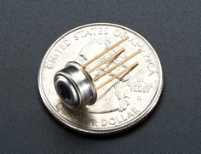
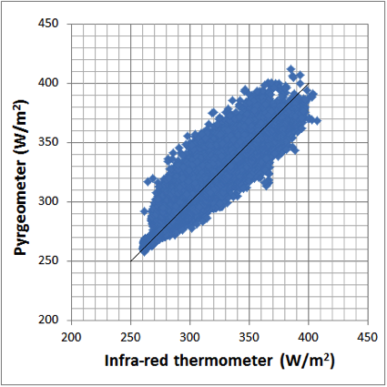
Figure1a. MLX90614 infra-red thermometer. Figure1b. Accurate full sky IR data
IRT [ ]. versus that from the IRT tilted at 35°to the
horizontal. Black line is the equality plot.

From figure 2 it can be seen that on average there is close agreement. With no clouds present errors are usually < 1.5% and are excellent on average at night when UHI effects are of most interest due to having clearer skies. Asymmetry in figure 2 is due to prevailing cloud location and weather onset direction relative to sensor pointing. An ability to discriminate thermal radiance with direction as demonstrated in this study of cloud effects, will be of value in UHI studies. Net thermal radiance (IRin – IRout) and surface temperatures are the two material related parameters of most importance in this work and link closely to local air temperatures.

From a perspective of simulation accuracy we have compared the predictions using pyrgeometer data with those using data from the IR thermometer. Figure 2 shows this comparison for temperatures on a cool roof and in a closed off interior room below the moderately insulated roof over three consecutive warm days of autumn in Sydney. Clear skies and little wind was present making radiation to the sky very significant at night. Overall agreement is excellent and results also indicate that the room is cooled below ambient at night by ~3°C and the roof surface by ~7°C.

Cool roof impacts - interior and exterior inter-play
Studies of cool roofs to date focus mainly on their influence on internal heat gains in summer and on their external environmental influences. The interplay between both is however considerable. As noted factors which influence internal reductions in heat gains also help counter UHI problems. UHI roof impacts involve multiple scales and many cool roofs can also impact on a global scale [edmonds, akbari] in addition to

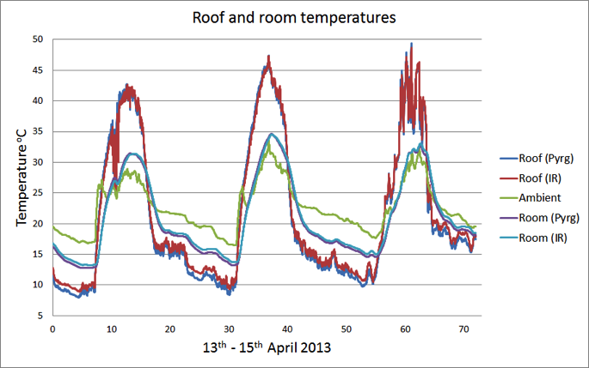

large any energy savings and peak load reduction impacts. At the “close to building” scale we had found in an industry funded study 12 years ago done over 18 months [us skycool] an initially puzzling additional substantial savings in internal cooling load above what was expected using traditional analysis. Two supermarkets from the
same chain and same design located in nearby suburbs in a sub-tropical locality were compared one coated to yield a cool roof with albedo 0.9 and emittance E = 0.84 , and one with a conventional metal deck roof with lower albedo and lower E. About 50% reduction in energy use in the mechanical cooling system at the cool roof site was found relative to the other. However traditional simulation predicted 25% to 35% savings. Our initial hypothesis for the added savings was that air above the cool roof was sufficiently lower to boost the cooling system efficiency. A subsequent test in 2008 of actual temperatures of the two roofs and local air supported this notion [carter] It is also worth noting that the cool roof albedo had fallen but not excessively over 8 years exposure. It also showed from a more detailed simulation taking account of the AC system efficiency as a function of ambient temperature that the close to building heat island from the non-cool roof reduced AC system efficiency by 22% due to average close to building air relative temperature rise of 3°C,and to 4° to 5° at some times. Other sources of gains were needed to explain data and came mainly from a 28% increase when ventilation loads introduced hotter external air. These two mechanisms show that cool coatings on large area roofs do lead cooler exterior air, not just the roof. Further studies are needed to forensically establish the components in and timing of enhanced cooling; for example how much is due to (a) direct daytime reductions from higher solar reflectance (b) night sky cooling of the roof, building mass and surrounds from sub-ambient air flowing off a roof and (c) not adding to local rises in air temperature from much less need to run AC cooling systems?

Other cool roof impacts include thermal mass (lighter cools quicker), convective exchange with local air currents, phase change material, sub-roof R-value (higher means higher roof T) and to some extent surface finish due to its impact on dirt accumulation and its periodic partial removal. Roof glazing where used is also important with its area, optical properties, and U-value relevant. Solar control glazing with medium to good solar reflectance and high outer surface emittance (as in most glasses and most but not all polymers) can contribute to a cool roof while reducing solar internal gains if area not too large.

In such a multi-parameter space multiple approaches to reduced internal heat gain solutions are possible but when cost, plus global and UHI impact are also taken into account best options reduce. In a temperate zone despite cool winters, R > 4 K/(Wm⁻²) is less attractive overall []than a moderate value around 1 to 2 K/(Wm⁻²) provided Asol is low, but must rise if Asol rises. The best overall temperate option seems always to have as high albedo as possible consistent with aesthetics and better ACH control in winter.

Two recent developments on cool roofing are worth noting. They involve two different types of secondary skins one is opaque [ kishor] and the other from our group is air permeable and transparent to thermal radiation using strong but porous polyethylene mesh [us solamt ]. Both can cool the primary roof in the day via air flow between the two layers while the mesh cover creates very cool air which can flow out to help counter the UHI . A cooler night roof cools the interior more at night and this air can also be used to cool the interior directly or just outside air. The comparison experiments in figure 3 with identical primary roofs with cool coatings were night radiation focused so that blocking of heat flow across the roof as in the opaque double layer allowed arise in daytime temperature but this will fall if tat air is allowed to flow and admit natural external breezes as well. If flowing at night it can cool exterior air as it is much cooler than ambient hence counter the UHI more than the opaque roof as it enhances night sky cooling. Furher experiments and modelling are need to explore the relatvive benefits of opaque and porous secondary skins on a roof . It is clear however that both can add susbstantially to energy savings and cooler exteriors when combined with use of cool coatings.

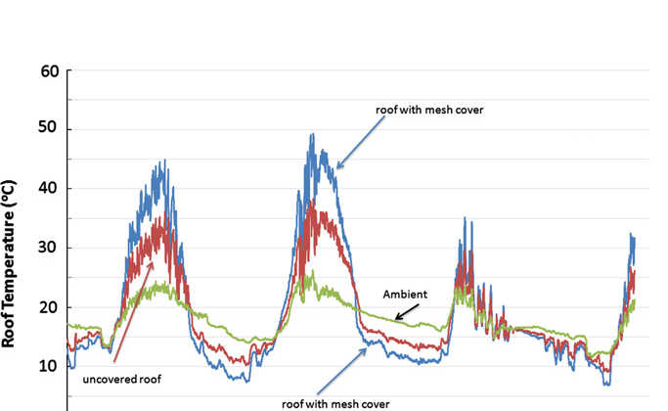

Figure 2.

If the secondary opaque skin is cool coated models showed reduction in total heat flow through the primary skin to the interior per day of order 75% is possible in a hot climate while a cool coated single skin gave savings of order 50% close to what we found for the supermarkets.

The alternate approach to keeping roofs cool is to deploy thin panels of phase change materials (PCM) within the roofing structure . However they are usually close to a steel sheet on the room side and below an insulator layer then an outer steel panel. Thus depending on the insulator thickness and R-value the outer surface may be hotter than the PCM panel by various amounts of PCM. Their main value can be seen in the detailed EnergyPlus simulations [ BC13] shown in figure 4 for a 25°C transition temperature panel used in the roofing of a temperate climate home. It is when the albedo is reduced to the typical values fund in many traditional roofs of below 0.5 or if cool roofing albedo falls to 0.6 or lower due to long term degradation or dirt accumulation. Figure 4 shows that they largely annul the cooling impact of albedo provided a moderate R-value around 1.0 to 1.6 K/(Wm⁻²) is used. If however albedo remains above 0.6 in the long term as we have found in our work, figure 4 shows the cost of PCM used in a roof is hard to justify. It is also important that local climate and outer skin emittance allows on average for the PCM to recharge at night. Lack of clear skies may inhibit this. If the roof remains at 25°C or lower throughout yte day its temperature profile at night and related to that its UHI impact will depend on its mas. Thus we recommend overall that if PCM is used that it be used sparingly to allow both recharge and extra cooling of local air after sunset. It would also be interesting to study within a double skin roof system. Figure 4 shows that with a small to moderate R-value above the PCM layer ther is little extra gain in using athicker PCM than a thin one. The savings from no PCM to the the thinnest are much larger than those with each further increment.

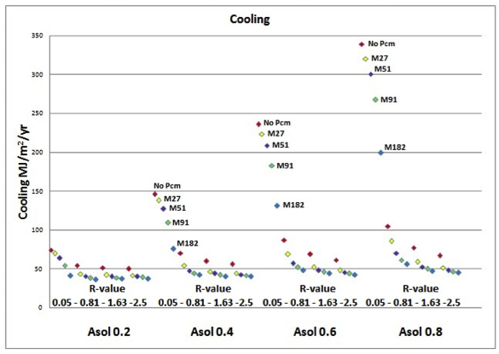

Figure 3 A multi-parameter simulation study of cooling load per annum in a temperate climate home for a set of combinations of different thickness (hence mass) of 25°C PCM panels, and no PCM (top red diamond), a range of R-value of insulation above the PCM and a range of solar absorptance of the outer surface.

Façade and intervening ground temperatures in high rise environments

Central business districts are particularly vulnerable to daytime heat build up and its retention over the following night. A basic simulation study has been made of two key influences (A) The aspect ratio Z = (building spacing)/ (building height), assuming equal height (B) Façade materials mainly window/wall ratios. Temperature profiles from the ground up the façade have been studied at various times. Late night hours were of particular interest to assess heat retention

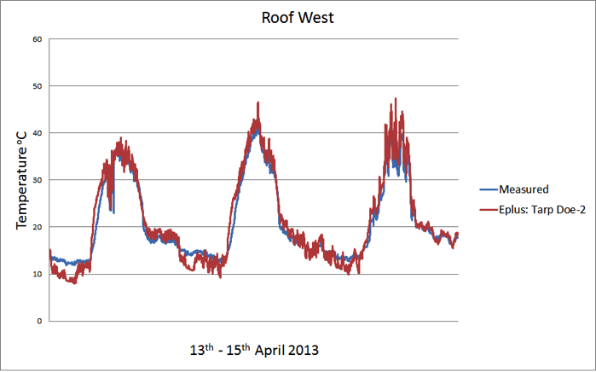

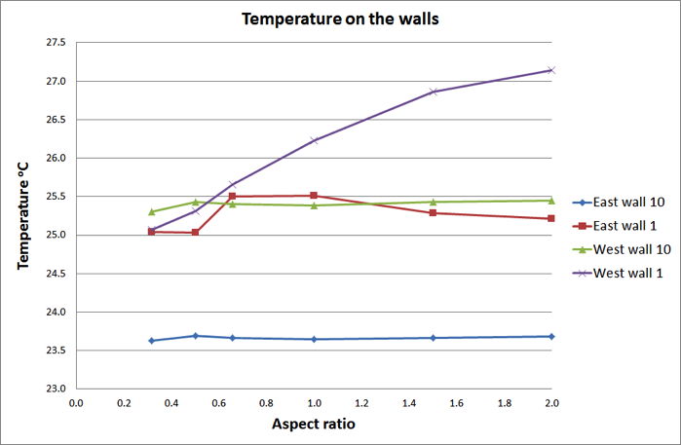

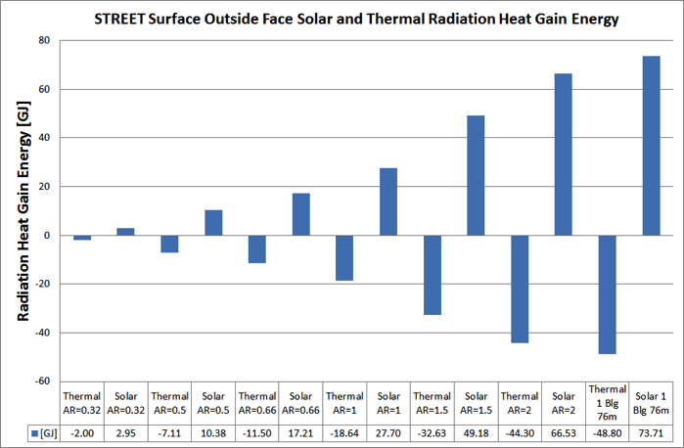

A peer review will follow the manuscript submission. It will be managed in order to allow submission of the final paper by July 15, 2014. The Conference Proceedings with the accepted papers will be distributed to all participants at the Conference venue.
After the Conference, selected papers will undergo a peer-review process for publication in highly esteemed journals. A book covering many topics will also be published to give wide exposure to the conference work.
Please note that only papers with at least one author already registered by July 15, 2014, will be included in the Proceedings. Only one paper per registered author is also allowed, but exceptions will be considered upon motivated request.
Whether or not you use Styles, we prefer that you write your paper right in this document since that will save us a lot of time when we compile the proceedings. To proceed in this helpful way:

- Print this document so you have the guidelines handy as you're writing and formatting.
- Rename this document using the following format: IC2UHI-[three digit reference number]-[first author’s last name]. For example: IC2UHI-201-Smith.
- Replace the title "Third Int. Conf. on Countermeasures to Urban Heat Island: Instructions to Authors for Manuscript Typing" with your own title, and the names of the authors with the actual names; write the first name in full and not just the initial.
- Delete everything after "ABSTRACT" all the way to the end of the document.
- Write your paper right here. Make sure you are in Normal style (12 point Times Roman or Times New Roman). If you copy and paste text from other documents, don't use Control-V to paste; rather, use the Paste command in the Clipboard section of the Home tab (or the equivalent in earlier and/or other versions of Word) and select Text Only. This method preserves the formatting of this template.
- Apply the appropriate Styles in the Styles Gallery to your headings, table titles, and so forth to automatically format them correctly.

If you are not familiar with Styles and templates, you can apply your formatting manually according to the instructions and the model formatting in this document. Manual formatting is not quite as helpful to us as using Styles, but if you follow the guidelines carefully, it will still make a big difference. Many of the instructions below pertain to manual formatting. If you use Styles, most of the formatting will happen automatically.
The headings "Introduction" above and "Overall Formatting" below are examples of Level 1 headings. See the section called "Headings" below.

Overall Formatting
If you follow these instructions, your paper will look professional and identical to other papers in the proceedings. Please proofread your paper carefully. We will not check for or correct errors when preparing the proceedings. For stylistic questions not covered in these guidelines, please follow The Chicago Manual of Style, 16th edition.

Font, Margins, and Pagination
Use 12-point Times Roman or Times New Roman. Your text should be justified. Margins must be 1" top, bottom, and sides.
The maximum paper length is 12 pages. No paper will be accepted if it is longer than 12 pages.
The headings "Font, Margins, and Pagination" above and "Line and Paragraph Spacing" below are examples of Level 2 headings. See the section called "Headings" below.
Do not number your pages!

Line and Paragraph Spacing
Leave one space, not two, between sentences. A Search and Replace will help you fulfill this requirement. Single-space your text, even between paragraphs, and indent the first line of each new paragraph. If you apply the Normal Style to your text, that will happen automatically.

Particular Elements

Title, Authors, and Abstract
Begin your title at the top margin of your paper in 14 point boldface with initial caps. The title should be no more than three lines, each of them centered. Insert a single line before the first author’s name and affiliation. For the authors, use 12 point boldface italic and initial caps. Include each author’s first name (write it in full and not just the initial), middle initial (if desired), last name, and affiliation (with the Country specified between brackets). Do not include street address, zip code, titles, degrees, departments, etc. Start a new line for each author with a different affiliation.
Insert two lines before the next heading, "ABSTRACT.” This heading is 12 point, boldface, and all capital letters. Again, your abstract may be no more than 250 words.

Headings

Using manual formatting. Level 1 headings are 14-point bold with each word capitalized; Level 2 headings are 12-point bold with each word capitalized. Leave a line before and after Level 1 and Level 2 headings. Level 3 headings are 12-point bold and sentence case (initial capital and then lower case); they end with a period. They are flush left and placed in the same line as the following text. Leave a line before a Level 3 heading.

Using Styles. When you apply the Level 1 or Level 2 Heading Style, it automatically inserts a line before and after the heading; you don't have to do it. Similarly, a line is automatically left before a Level 3 Heading. You may have to unbold the text that immediately follows the Level 3 heading. Successive paragraphs under Level 3 headings are automatically indented.

Footnotes
Use footnotes, not endnotes. Footnotes are used for comments and clarification, not for references. Number your footnotes. Place footnote numbers in the text after periods or commas. Footnotes should appear on the page where they are referenced. They should be in 10-point font and left-justified.

Bullets
To create bullets:

- Leave a line before and after bulleted list.
- If you are using Styles, select the items to be bulleted and apply Bullets Style.
- If you are formatting manually, use 9-point bullets indented .25" with a hanging indent of .25".

Tables and Figures
Number tables and figures separately. Number them manually, not automatically. Don't just insert a table or figure; introduce it first in the text by referring to it by number. Center all figures and tables. Line up titles and notes with left side of table or figure.

Equations and Units
Equations must be typed. Allow one line of space above and below. Number the displayed equations consecutively from Eq. (1) to the end of the paper. As shown in Eq. (1), enclose equation numbers in round parentheses and place them flush-right in the column..

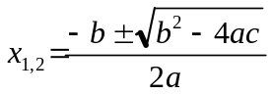 (1)

Do not use the same symbol for two or more different meanings or definitions; similarly, do not use more than one symbol for one variable/parameter.
Each paper may have a nomenclature section that lists in detail and unambiguously all the symbols used in the text and their definitions. The nomenclature section has to be placed at the end of the paper. Each dimensional symbol must have SI units mentioned at the end. All dimensionless groups and coefficients must be indicated as dimensionless after their definitions. All Latin symbols (dimensional and dimensionless) should be listed in an alphabetic order. All Greek and mixed symbols follow the Latin symbols. Subscripts and superscripts follow Greek symbols.
All data (including the ones in tables and figures) must be reported in SI units.

Tables

Using manual formatting. Tables should be centered. The table title is in 12-point font, not bold, not justified, and flush with the left border of the table. If necessary, the title should wrap at the right border of the table. Leave a 6-point space between the table title and the table. The title is in sentence case, i.e., an initial cap and then lower case, and it does not end with a period.
Table headings and text are 12 point and left justified, except in the case of short-form data (e.g., numerical data or Yes/No), where the headings and data may be center justified. Numerical data that is totaled may be right justified. Headings and text as small as 9 point are acceptable in complex tables. Table headings and text are not bold, and they are sentence case, not all initial caps.
Note that the table text is vertically aligned to the center of the cell, but the text in the header row is aligned to the bottom of the cell.
Use 10-point font for table notes and source, and place them immediately below the table, separated by a 6-point space. They are flush with the left border of the table, and if necessary, they wrap at the right border. Source is italicized and followed by a colon. Leave a line between the notes/source and the following paragraph. Table 1 below illustrates justification, cell alignment, and so on.

Using Styles for tables. Apply the Table text Style to the table cells, including the header row. Apply the Table title Style and the Table/figure end matter Style to the title and notes respectively to automatically insert the correct spacing before and after a table title and before and after the source and notes. But you will need to manually indent the table title and notes to line up with the left border of the centered table.

Table 1. Format of Summer Study paper elements
Style | Point size | Attributes including font | Alignment | Spacing
Normal | 12 | Indent paragraphs | Ragged right | Single-spaced within and between paragraphs
Level 1 heading | 14 | Bold, title case | Left | Before: 1 line  After: 1 line
Level 2 heading | 12 | Bold, title case | Left | Before: 1 line  After: 1 line
Level 3 heading | 12 | Bold, sentence case, final period | Left | Before: 1 line  After: In-line
Bullets | 12 | Not bold | 9-point bullets indented .25". .25" hanging indent | Before: 1 line  After: 1 line
Table title | 12 | Above table. Sentence case | Flush with table borders | Before: 1 line  After: 6 points
Table text | 12 | Not bold. Sentence case | Left | Single
Table and figure end matter | 10 | Below table/fig. Not bold. "Source" italicized. | Flush with table/fig borders | Before: 6 points  After: 1 line
Footnotes | 10 | Not bold | Left | Between: 6 points
Paper title | 14 | Bold, title case, no more than 3 lines | Centered | After: 1 line
Author(s) | 12 | Italics, no titles or addresses | Centered | After: 2 lines
Heading: Abstract | 12 | Bold, all caps | Left | After: 1 line
References | 12 | Not bold | .25" hanging indent | Between: 1 line
Selecting the appropriate Style applies many attributes automatically. Source: F. Grossberg, pers. comm.

Figures
Leave a line between the figure and the preceding paragraph. Unlike the titles of tables, figure titles appear below the figure. Figures should be centered. Do not use sidebars. Avoid graphics with dark backgrounds because they do not reproduce well. If you include a picture, use a tif or jpeg file, not a gif. Where possible, use Times New Roman in figures. Legends should be sentence case, with only the first word capitalized.

Using manual formatting. Leave a 6-point space between the bottom of the figure and its title, notes, and source. Use 10-point font for the title, notes, and source. They are flush with the left border of the table, and if necessary, they wrap at the right border. The title is in sentence case, i.e., an initial cap and then lower case. Source is italicized and followed by a colon. Leave a line between these elements and the following paragraph. Figure 1 illustrates these features.

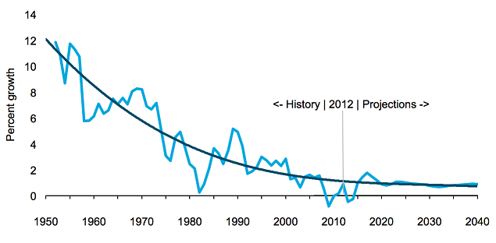
Figure 1. U.S. electricity demand growth, 1950-2040 (percent, 3-year moving average). Figures beyond 2012 are projections and not actual data. Source: EIA 2013.

Using Styles for figures. For the figure title, notes, and source (all of which go beneath the figure), apply the Table/figure end matter Style. It will automatically insert the correct before and after spacing. But you will need to manually indent both ends of the figure title, notes, and source text to line up with the centered figure.

Citations and References

Citations
Citations should appear in the text in parentheses. Cross check your citations and references: every citation should correspond to an item in the references list at the end of the paper, and every reference in the list should correspond to at least one citation in the text.
As explained below, organizations are frequently listed in the references list under an acronym to make them easy to refer to in text citations. Be sure to use this acronym in your citations and, conversely, if you use it in citations, make sure it is listed that way in the references. For example, (EIA 2013) will correspond to a reference that begins "EIA (Energy Information Association). 2013." As a corollary, don't create a citation that doesn’t match the full reference entry. If the full reference is found under EIA, don't use RECS in a citation.
Citations take this form: (Halooka 2012). Only the author's surname is used, and there is no comma between the author and the year. If the author is named in the sentence, the citation can just consist of the year. For example: Halooka (2012) describes the proliferation of energy efficiency programs in Vermont.
For up to three authors, cite all names: (Dooley and Smith 1996) or (Elliott, Laitner, and Pye 1997). Don't use the & symbol, and put a comma before the "and" when you have three authors. When there are more than three authors, use the first author's name followed by et al. For example: (Eenie et al. 2009). Note that et al. is not italicized, not preceded by a comma, but followed by a period. It is short for "et alia," which means "and others."
When the paper refers to more than one work published in the same year by the same author or organization, the items are distinguished in the citations and reference list as, for example, 2012a, 2012b, and so on.
The author-date citation is usually placed just before the period at the end of a sentence: Energy efficiency programs are flourishing in some states (Leo and Lily 2013).
If the sentence draws on more than source, the two citations may be listed together, separated by a semicolon. Energy efficiency programs are flourishing in a number of states and particularly in Vermont (Leo and Lily 2013; Halooka 2012). In compound citations, the order may depend on the order of the data cited in the sentence. If both citations apply to the whole sentence, order them chronologically. If each citation only applies to part of the sentence, place them separately, but just before a punctuation mark if possible: Energy efficiency programs are flourishing in Connecticut (Avrum 2013), and even more so in Vermont (Halooka 2012).
Citations for statistics, quotations, and other specific information should include specific page numbers so your reader can locate and verify the reference. Such citations take this form: (Halooka 2012, 125–26). Note the comma after the date, the lack of "p." for page number, and only the last two digits given for concluding page numbers over 100.
When citing two works by the same author, order them chronologically and separate the years by commas: (Halooka 2010, 2012). If page numbers are included, separate the years by semicolons: (Halooka 2010, 18; 2012, 125-26).

References
List all references for your text, tables, and figures alphabetically by author at the end of the paper. Apply the References Style to format the references list automatically. If you use manual formatting, single space within the reference items, double space between them, and use a hanging indent of .25 inches. Don't number the references.
The general form of a reference to a book or report is as follows: [Author(s)]. [Year]. [Book Title: Subtitle]. [Place of publication]: [Publisher]. For example: Halooka, A. 2010. Energy Efficiency: An American Success Story. New York: Vintage.
Cities of publication should be followed by a comma and the 2-letter postal abbreviation for the state, without periods. Major cities like New York don't require the state. Washington, DC always has the DC.
For a journal article: [Author(s)]. [Year]. "[Title of Article]." [Journal] [volume number] ([issue number]): [page numbers]. For example: Leo, C. and K. Lily. 2013. "Utility-Run Energy Efficiency Programs." Energy Tales 13 (4): 313-45.
Use initials, not full names for authors' first names. For multiple authors, name them all. Don't use "et al." The first author is listed surname first; the others, first name first. List the authors in the order listed in the publication. Use "and," not the & symbol. A comma always precedes the "and." For example: Scooter, J., G. Pickles, and Z. F. Line. 2010. Energy Efficiency 101. Toronto: Knopf.
If a particular author has more than one entry, order them chronologically and use three em dashes in place of the author's name after the first appearance. See the list below for an example. Distinguish multiple entries by the same author in the same year by adding "a," "b," "c," and so on after the year for each successive entry. Order the entries alphabetically. If a particular author has both individual and group entries, list the solo works first and order them chronologically. Then list the group works ordered alphabetically according to the name of the second author.
For congressional bills, reports, and hearings, see the examples below and consult The Chicago Manual of Style (16th ed.), 14.294-297. For state codes and municipal ordinances, see the examples below and consult The Chicago Manual, 14.300.
For online sources, include the date of publication or revision given on the site. Include the access date only if you can't find the publication or revision date. You may hyperlink URLs in the body of your text and in footnotes and references. Inserting the hyperlink will automatically underline the URL and change the font color to blue.
The following list of references provides examples of many of types of sources. Good luck!

Acknowledgments
You can place your acknowledgements here.

Nomenclature (if needed)
Symbol Quantity [SI unit]
A Surface area [m²]
ρ Density [kg/m³]

References

Melexis website or http://learn.adafruit.com

An Act Guaranteeing Governmental Independence, Ky. Rev. Stat. Ann. § 520.020 (LexisNexis 1985) (passed Jan. 3, 1974).
Aroonruengsawat, A., M. Auffhammer, and A. Sanstad. 2012. "The Impact of State Level Building Codes on Residential Electricity Consumption." Energy Journal 33 (2): 31-52.
Bamberger, L. 2010. Scaling the Nationwide Energy Retrofit of Affordable Multifamily Housing: Innovations and Policy Recommendations. Washington, DC: Brookings Institution.
Cotter, C. "The Weakest Link: The Argument for On-Wrist Band Welding." Unpublished manuscript, last modified December 3, 2008. Microsoft Word file.
CPUC (California Public Utility Commission). 2001. California Standard Practice Manual: Economic Analysis of Demand-Side Programs and Projects. http://www.energy.ca.gov/greenbuilding/documents/background/07-j_cpuc_standard_practice_manual.pdf
Downs, A., A. Chittum, S. Hayes, M. Neubauer, S. Nowak, S. Vaidyanathan, K. Farley, and C. Cui. 2013. The 2013 State Energy Efficiency Scorecard. Washington, D.C.: American Council for an Energy-Efficient Economy. http://aceee.org/research-report/e13k .
EIA (Energy Information Administration). 2013. Annual Energy Outlook 2014 Early Release Reference Case; AEO2014 Early Release Rollout Presentation. December 16. Washington, D.C.: U.S. Energy Information Administration. http://www.eia.gov/pressroom/presentations/sieminski_12162013.pdf .
Evanston Public Library Board of Trustees. 2008. "Evanston Public Library Strategic Plan, 2000–2010: A Decade of Outreach." Evanston Public Library. Accessed July 19. http://www.epl.org/library/strategic-plan-00.html.
Gilless, C., K. Brown, and S. Boston. 2013. "Cohort Approach Achieves Results with Small-to-Medium Business in Montana." In Proceedings of the ACEEE 2013 Summer Study on Energy Efficiency in Industry, 5:1–12. Washington, DC: ACEEE.
Higgins, R. C. 1989. Analysis for Financial Management. Homewood, IL: Irwin.
Homeland Security Act of 2002. 2002. 6 U.S.C. § 101.
Johnson, K. and E. Mackres. 2013. Scaling Up Multifamily Energy Efficiency Programs: A Metropolitan Area Assessment. Washington, DC: ACEEE.
Kolwey, N. 2013. Utility Strategic Energy Management Programs. Boulder: Southwest Energy Efficiency Project. http://swenergy.org/publications/documents/Utility_SEM_programs_03-2013.pdf
Molina, M. 2013."A National Review of the Cost of Conserved Energy in Utility Energy Efficiency Programs." Presentation at the 2013 ACEEE National Conference on Energy Efficiency as a Resource. http://aceee.org/conferences/2013/eer/program
Molina, M. 2014 (forthcoming). Still the First Fuel: National Review of Utility-Sector Energy Efficiency Program Cost-Effectiveness. Washington, DC: ACEEE.
Nizza, M. "Go Ahead, Annoy Away, an Australian Court Says." The Lede (blog), New York Times, July 15, 2008, http://thelede.blogs.nytimes.com/2008/07/15/.
NMR (NMR Group, Inc.), Tetra Tech and KEMA. 2011. Cross-Cutting Net to Gross Methodology Study for Residential Programs—Suggested Approaches (Final). Prepared for: Massachusetts Program Administrators. http://www.ma-eeac.org/Docs/8.1_EMV%20Page/2011/2011%20Residential%20Studies/Residential%20MA%20NTG%20Methods%20Final%20072011.pdf
NMR (NMR Group, Inc.) and Research Into Action, Inc. 2012. Regional Net Savings Research, Phase 2: Definitions and Treatment of Net and Gross Savings in Energy and Environmental Policy. Submitted to Northeast Energy Efficiency Partnerships: Evaluation, Measurement and Verification Forum. https://www.neep.org/Assets/uploads/files/emv/NEEP%20-%20Regional%20Net%20Savings%20Report%2012-05-12.pdf
NYSERDA (New York State Energy Research and Development Authority). 2012. New York’s System Benefits Charge Programs Evaluation and Status Report Year Ending December 31, 2011. Albany: NYSERDA. http://www.nyserda.ny.gov/publications/program-planning-status-and-evaluation-reports/-/media/files/publications/ppser/nyes%20program/2012/2011-nyes-evaluation.ashx
Ohio Rev. Code Ann. § 3566 (West 2000).
Plumer, B. 2013. "Americans Are Buying Less Electricity. That’s a Big Problem for Utilities." Washington Post, December 23. http://www.washingtonpost.com/blogs/wonkblog/wp/2013/12/23/americans-keep-buying-less-electricity-thats-a-big-problem-for-utilities/
PSCW (Public Service Commission of Wisconsin). 2010. Memorandum Regarding Quadrennial Planning Process Phase Two—Evaluation Issues. Docket No. 5-GF-191.
RAP (Regulatory Assistance Project). 2011. Revenue Regulation and Decoupling: A Guide to Theory and Application. Montpelier, VT: Regulatory Assistance Project.
SBA (U.S. Small Business Administration). "Am I a Small Business Concern?" Accessed March 29, 2013. http://www.sba.gov/content/am-i-small-business-concern
York, D., P. Witte, S. Nowak, and M. Kushler. 2012. Three Decades and Counting: A Historical Review and Current Assessment of Electric Utility Energy Efficiency in the States. Washington, DC: ACEEE.
United States Census Bureau. 2012a. Historical Data: Intercensal Estimates. Accessed October 2013. Washington, DC: United States Census Bureau. http://www.census.gov/popest/data/intercensal/national/files/US-EST00INT-TOT.csv
——— . 2012b. Historical Data: Pre-1980. Accessed October 2013. Washington, D.C.: United States Census Bureau. http://www.census.gov/popest/data/national/totals/pre-1980/tables/popclockest.txt.

This is an example of a Level 3 heading.

