Article Title: Creative craft-based textile activity in the age of digital systems and practices

Author Name: Dr Gail Kenning

Dr Gail Kenning is an artist, researcher and lecturer at College of Fine Arts, University of New South Wales

Author's generic title (e.g. educator, artist), address: Artist, researcher, educator. University News South Wales Australia

Author address (postal *and* e-mail): [gail@gailkenning.com](mailto:gail@gailkenning.com). [g.kenning@unsw.edu.au](mailto:g.kenning@unsw.edu.au). PO Box 454 Randwick, NSW 2031. Australia

# Abstract

Domestic craft-based textile activities, such as knitting, crochet, hand weaving and lace making are often viewed as being of limited creative potential. The perceived lack of creativity arises, in part, because of the extent to which these activities copy, reproduce and recreate existing pattern forms and use pre-existing templates This paper reports on the findings of an experimental research project that explored the creative potential of crochet lace making using digital media technologies and practices and provides critical analysis of how new technologies, practices and theoretical frameworks have implications for ongoing domestic craft-based textile activities.

# 

# Article Text

Within the ongoing hierarchical relationship between art and craft and within craft, domestic craft-based textile activities such as knitting, crochet, hand weaving and lace making, while valued for their social and cultural contributions, are considered derivative and lacking the originality of fine arts such as painting and sculpture. These activities are subject to such criticism because of a seeming lack of innovation and uniqueness and because they have been perceived as conservative, constrained by tradition and resistant to change [1]. As a result of creativity having been equated with originality and innovation and authenticated through uniqueness, these activities are dismissed as being of limited creative merit and having little creative potential [2]. The view of domestic textiles activities as craft, unintellectual and seemingly the antithesis of the ‘Avant Garde’, is predicated in part on the extent to which these activities copy, reproduce and recreate existing pattern forms and use pre-existing templates, models, diagrams and written instructions [3]. The gendering of domestic textiles activities and the marginalisation of women’s activities are also pertinent to how domestic craft-based textile activities are perceived and valued [4]. However, issues relating to gender are being addressed elsewhere and this paper will primarily focus on the relationship between copying and innovation in domestic craft-based textile activities.

While being subject to criticism such as those summarised above, domestic craft-based textile activities have a long and varied history. Evidence of the manipulation of threads to construct textiles and create patterns can be found across all cultures and throughout recorded history [5]. Significant numbers of women, primarily in developed countries continue to invest substantial amounts of their time and sustained labour on these activities which attests to their ongoing importance. Cultural commentators suggest that these activities are fundamental acts of ‘everyday creativity’ and contribute to discourse relating to the importance of creativity at all levels [6]. In addition to acknowledging the social and cultural importance of these activities, many lace makers, fibre artists, and textile practitioners working with craft-based textile techniques and processes argue that the outcomes and outputs of these activities, and the intellectual input and the creative decisions undertaken, warrant greater aesthetic consideration [7]. The recent popularity of do-it-yourself (DIY) culture, maker culture and ‘fabriculture’ has extended traditional practices. This has resulted in domestic craft-based textile activities being undertaken in public environments, on the streets, as acts of public engagement and activism in the form of ‘yarn-bombing’, ‘guerrilla knitting’ and ‘craftivism’ [8]. Furthermore, craft-based textile activities have been used to explore mathematics and hyberbolic forms and contribute to our understanding of mathematics and science as well as bring awareness to contemporary issues such as Wertheim’s environmental *Hyberbolic coral reef project* [9]. Thus, the innovative potentiality of these activities is far-reaching.

This paper re-examines the potentiality of domestic craft-based textile activities by drawing on phase one of an experimental art research project undertaken by the author as part of a PhD at University of New South Wales, Australia in 2007 [10]. The project uses digital media technologies and practices to explore the creative potential of one form of domestic craft-based textile activity, crochet lace making. The paper then reflects on the findings of the experimental research project and provides a critical analysis of how new technologies, practices and theoretical frameworks have shifted from focussing on the objects produced to also explore processes, practices and relationships. It discusses the implications for domestic craft-based textile activities with regard to how art and digital media theory and practices have prompted a re-evaluation of the acts of copying and reproduction. This offers alternatives to an ‘auratic’ evaluation that focuses attention on the unique object and which inevitably finds these activities, and the objects produced, lacking. This paper argues that domestic craft-based textile activities can offer a wide range of innovative possibilities and have not yet reached their creative potential. It suggests that the application of art and digital media practices and theories can extend domestic craft-based textile activities and develop new fields of creative endeavour.

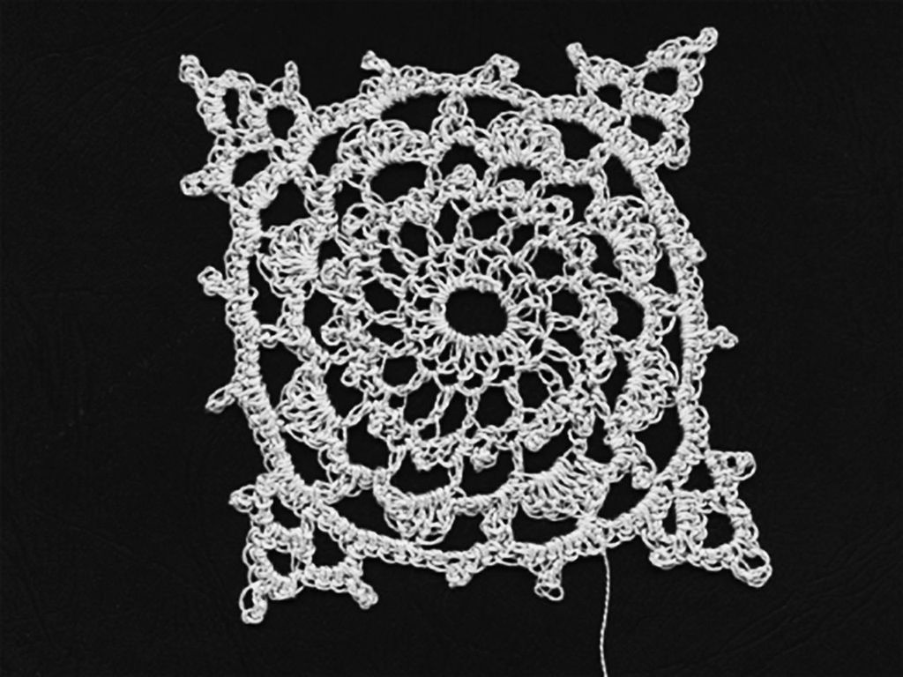

Fig. 1 Conventional crochet lace pattern (Doily) [11].

The experimental art research project focussed on crochet lace patterns, commonly referred to as doilies (see Fig. 1). These are familiar, domestically-produced, hand-made physical pattern forms created from repetitive manual processes and grounded in practices that copy, reproduce and borrow. The patterns created are located within a craft context and reflect a set of long-standing, accepted aesthetic values arising from craft traditions. Because of the free-flowing nature of the crochet technique and the dexterity needed to make crochet lace patterns, machines are not easily able to replicate the process. Thus, they were impacted only minimally by mechanisation and have remained largely stable and consistent throughout periods of technological and social change such as the industrial revolution and globalisation. However, the experimental project suggests that, because of the similarities that exist between the diagrammatic and written pattern instructions for crochet lace and computer programming codes, the digital era may potentially have a greater impact on these pattern forms [12]. Before examining how digital media practices and technologies impact on domestic craft-based textile activities, it is useful to contextualise these activities in relation to innovation, copying and reproduction practices and crochet lace-making activities.

The literature examining what constitutes creativity is extensive and has identified creativity in terms of the product produced, process undertaken, places conducive to creativity, or the characteristics of creative people [13]. This paper will focus on the creative product and process. Mark Runco suggests that recognising creativity occurs when we come to an ‘understanding’ of what is original and effective and in some way novel or innovative [14]. To be considered creative, novelty or innovation needs to be evident in the product or process. However, what is novel or innovative may not be widely recognised as such and may only be considered so by the maker. This then might be considered evidence of *personal creativity*. Alternatively, processes and products may eventuate in a shared valuing of what is innovative or novel and therefore generally be considered creative. Shared values with regard to what is novel and innovative, and therefore creative, are complex social and cultural constructions [15]. We might then suggest that any innovation or novelty in relation to domestic craft-based textile activities has been socially valued less than other activities, such as painting or sculpture, and that this in part is due to the extent that these activities are associated with copying and reproduction practices.

While not uncommon copying has been, and in many areas of production remains, philosophically problematic [16]. Our perceptions of the relationships between the copy and the copied, and between copies, are socially and culturally shaped. Boon draws attention to the paradox of copying, suggesting that copying is pervasive in contemporary culture while also being “subject to laws, restrictions, and attitudes they suggest that it is wrong, and shouldn’t be happening” [17]. While there has been a long and established practice of copying in fine arts and crafts, with artists and designers copying paintings and working from pattern books to develop their skills, greater value and more recognition was given to artists producing original work. Copying and reproducing were associated with training, ‘slavish’ repetition, lack of originality and innovation or, as in the case of painters deliberately creating a fake copy of an original, as fraudulent. The introduction of mechanical technologies that facilitated the proliferation of multiplicities challenged the authenticity of (art) objects valued for individuality and uniqueness. Thus, copying and reproduction were perceived as problematic because of the apparent threat these activities represented to the original and unique. It is this view of copying as problematic that is carried forward into the critiques of domestic craft-based activities [18].

The creative potentiality of copying and reproduction practices began to be recognised before the prolific use of digital media which is now synonymous with these practices. The reaction to copying and reception of multiplicities began to shift by the mid-twentieth century. This can be seen in the response to the work of pop artists such as Warhol and Rauschenberg and minimalists such as Judd. These artists, who foregrounded copying, copies and multiplicities, were perceived as critically engaged artists reflecting twentieth century issues pertaining to, for example, late capitalism, media production and commercialisation [19]. While these artists highlighted the manifold nature of popular culture and lawyers, businesses, and governments, grappled with copyright issues and the problems associated with maintaining scarcity and preserving the unique, craft-based textile activities unreservedly and unconsciously continued to produce, copy and reproduce [20].

A shift of focus away from the object began to occur in a range of fields and disciplines in the second half of the twentieth century. In systems theories, cybernetics, postmodern practices, digital media and new media theories, critical engagement and innovation were being assessed in relation to processes. This foregrounding of systems and processes is addressed in Jack Burnham’s seminal paper on systems aesthetics and can be seen in systems based installation work of artists such as Hans Haacke’s *Condensation Cube* 1965, in interactive artworks such as David Rokeby’s *Very nervous system* and the generative computer-based art works of amongst others Brown, Briscoe and Edmonds as discussed in *White heat, cold logic: British computer art 1960-1980* [21]. These art practices are underwritten by systemic practices that, whether analogue or digital, employ systems and are predicated on copied text, images or code. Copying and repeated actions are fundamental to their production, interaction and reception. They rely on re-creation and reproduction as form, content and structure, but, importantly also have the ability to change and be updated. By applying this shift of focus to domestic craft-based textile activities, we might reassess the level of innovation and creativity involved. But first, it is useful to examine the arguments relating to the creative potential of these activities and how copying impacted on the objects produced.

While craft-based textile activities were subject to criticism for lack of innovation, lace makers, during the twentieth century, most notably in Czechoslovakia, now the Czech republic, Emilie Palickova and Luba Krejci in 1925 and later Charlotte Delwich argued that lace had a greater potential than was being shown and that lace and lace making could be considered more than a craft or hobbyist activity [22]. They claimed that lace making was potentially a profound exploration of the relationship between structure and space and that as artists, they were introducing innovation and originality. In Belgium in 1983 a Lace Biennial was established which aimed to ‘stimulate a critical reflection of lace as it breaks away from its traditional functions and becomes integrated with the multiple aspects of contemporary art’ [23]. However, while lace was seemingly free from utilitarian constraints that impacted other forms of textile activities, for the majority of practitioners, innovation and originality were neither valued nor required in lace making [24]. Experimentation or expressions of individual creativity were actively discouraged and rather than making new or innovative designs, lace-makers primarily recycled existing lace patterns [25]. Those artists who were involved in experimentation and innovation primarily focussed on the exploration of materials and scale [26]. No significant attempts were made to change or exploit techniques, explore the role of pattern in encompassing the relationship between structure and space, or to examine the developmental potential of lace through *pattern as a process* [27]. A result, despite some limited attempts to develop lace making, lace has not changed significantly in more than 500 years [28].

Copying has been endemic in domestic craft-based textile activities, lace making and particularly crochet lace. The crochet technique is believed to have evolved from needlepoint and tambouring and be no more than 200 years old. It was less structured in its implementation than bobbin lace and did not require the maker to closely follow designs marked onto a backing cloth like needle laces. Thus, it became known as ‘lace in the air’ because of the freedom it offered [29]. The process of making stitches from looped threads was easier to learn and master than many earlier techniques and so the crochet technique could be used, not only to create new patterns quickly and effectively, but also to quickly reproduce patterns that had been made using time-consuming techniques [30]. The speed with which the technique could be used to reproduce and recreate patterns enabled production time and costs to be kept to a minimum. Thus, crochet lace making, which was primarily carried out in Ireland as a cottage industry during the potato famine (1845-49), became the primary source of income for many families [31]{Hudson, 2005 #169;Delwich, 1983 #229}. Good prices for lace depended not only on the quality of work, but also on the production of patterns that seemingly offered continuity with other more ‘traditional’ forms of lace. Lace dealers commissioned work and decided which patterns would be made and sold [32].

With the rise of cottage industries in England, Scotland and throughout Europe, documenting patterns became increasingly important [33]. In addition, towards the end of the nineteenth century and the beginning of the twentieth, thread companies began to document patterns and produce and distribute instructional pattern booklets to help expand their sales in the domestic market. Popular women’s magazines became a vehicle for the widespread distribution of diagrammatic and written instructions contributing to the popularity of crochet lace making as a hobby and pastime [34]. As a result formulaic, copy-based crochet lace making became a widespread activity. Popular patterns increasingly became not only style *guides,* but models, prototypes and templates for pattern forms. This, in effect, reduced the range of patterns in circulation and impacted on what would subsequently be produced and reproduced. Overall these practices contributed to a lack of innovation and hegemonic pressure to conform to the extent that the development of the pattern forms appeared to have reached a stasis [35] {Kenning, 2007 #64;Kenning, 2009 #64}.

In order to break away from the perceived flow of tradition influencing crochet lace pattern forms, disrupt the existing accepted aesthetic and to embrace innovation, the experimental research project employed an experimental art practice approach. The project used digital media to facilitate the exploration of evolutionary developments and emergent possibilities and developed into a generative art practice focussing on systems and processes and engaging with a systems aesthetic. The project began to interrogate the systems, processes and structures involved in crochet lace making. As the project developed, it interrogated the pattern structures byreconstructing pattern forms as simulacra using programming scripts. Aesthetic judgement was suspended in order to explore the patterns’ developmental potential arising out of the conjoining of the inherent properties of patterns, textile techniques and the digital environment. The crochet lace patterns were not produced in isolation, but interacted with the digital environment which became part of their developmental and evolutionary path. By translating the patterns into the digital environment and engaging with the pattern forms at their systematic core, the experimental research examined whether the patterns’ developmental path can be altered to create new or emergent pattern forms.

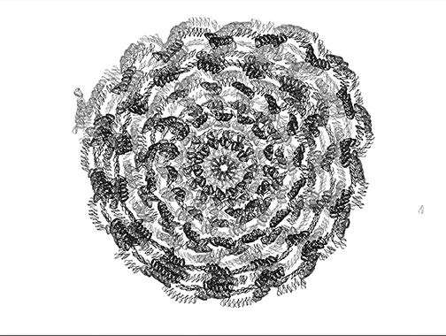

Fig. 2 Crochet Lace Simulacra [36].

The project culminated in a series of crochet lace simulacra created in real-time from programming scripts (see Fig. 2). It utilised algorithms, systems and processes inherent in crochet lace pattern making, digital media technologies (programming scripts, software applications and operating systems), and copying, reproduction and simulation practices. The simulacra produced hybrid pattern forms made up of crochet lace systems and processes, digital media (pixels and vectors) and the digital environment (programming scripts and operating systems). The patterns developed beyond the control and expectations of the author and without authorial intervention, as they impacted and were impacted upon by the systems from which they were constructed and in which they existed. As programming scripts were executed, their flow was interrupted by unplanned events such as system halts or inadequate memory resources, or as a result of formulaic or syntax errors and/or illogical programming statements. This disruption in the flow of the script caused random and chance events, a familiar strategy in Avant Garde art practices to shift the work from the sole authorship of the maker. As the programming script played out, temporal and spatial repetition could be observed in the sequences and/or placement of pattern elements and alternative visual patterns appeared on screen. The majority of patterns generated could be categorised into one of the following seven outcomes: they stalled; stabilised; formed tunnels; imploded; became disconnected; broke into multiple motifs; or radiated (see Fig. 3 which shows an evolved disconnected radiated pattern).

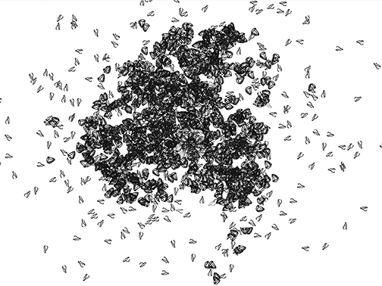

Fig. 3 Evolving crochet lace simulacra [37].

Crochet lace patterns can exist simultaneously as physical instantiations (made from thread, wire, etc.), as algorithmic processes (a system or set of rules for construction), in diagrammatic form (schematic drawings), as code, and as text (the notation of the system of construction). So, while it was possible to reproduce most of the patterns physically, it was not an imperative. The on screen patterns were instantiations existing as crochet lace simulations, not representations. In all of these forms, crochet lace explores pattern. Pattern has been shown to be a highly productive and sophisticated area of research not only in the arts but also in relation to science, mathematics and digital media [38]. There are a number of key properties of pattern that can make it available for change, evolutionary development, and offer emergent potential; including spatial, iterative, modular and/or informational characteristics. The experimental art research project found that crochet lace patterns possess these properties that make pattern available for change and development.

It has been shown throughout this paper that the practices of copying, reproduction and recreating existing patterns and pattern forms have been widespread in domestic craft-based textiles activities. However, it is not necessarily the act of copying in itself that has been restrictive. For example, the experimental research project shows that, in the digital environment, copying by replicating the *process of construction* produced crochet lace simulacra and revealed that in the reconstruction and reinvention of the pattern *systems and processes,* the potential for innovation exists. Conventional crochet lace patterns instantiated physically by hand from text, diagrams or visually from existing patterns can potentially be changed, but these changes are nuanced, whereas in the digital environment large differences can occur between instantiations.

We can then conclude that copying *per se* is not restrictive. So what are the inhibiting factors in relation to these craft activities? Three other issues can be shown to impact on their development. Firstly, legacy *responses* to acts of copying and reproduction propagate dismissive attitudes towards these activities and limit expectations of and by practitioners. Secondly, there has been an ongoing focus on the objects produced and the innovative potentiality of the processes and practices have been underestimated. Thirdly, hegemonic and (historically) economic pressures discourage innovation and experimentation, encourage conformity and deliberately attempt to limit creativity. Therefore, to reach their creative potential –– that is to be recognised as more than examples of *personal creativity* and to show innovation on a broader scale –– these activities can be reframed in light of contemporary discourse in relation to art and digital media theories and practices.

With regard to overcoming legacy responses to copying, we might, for example, draw parallels between practices in crochet lace making and elements of DIY culture, ‘maker’ and participatory culture and by reframing the activities recognise the creative potentiality of copying in domestic craft-based textile activities (Gauntlett; Jenkins). For example, with the availability of easy-to-use copying and reproduction digital technologies, copying practices have become widespread, copying is commonplace, and copy and paste functions operate symbolically [39]. Copying, pasting, reproducing, borrowing, quoting, sampling, re-enacting, recreating and re-inventing is particularly prolific in digital media practices and participatory cultures. Copying and reproduction activities manifest in acts of ‘everyday creativity’, and are creative processes that can lead to highly creative outcomes [40]. Borrowing, quoting, sampling, re-enacting, recreating and re-inventing, while not couched in these terms, are approaches used in crochet lace making [41]. Furthermore, as information about craft activities is shared and exchanged online by participants no longer reliant on the distribution networks of material suppliers and processes, practices, information and memes flow through digital networks and social media sites, creating potential for greater collaborative and participatory creative practice [42].

In refocussing attention to include an exploration of systems and processes to exploit innovative potential, we might consider that while many domestic craft-based textile practitioners produce craft objects, they report that this is not their prime reason for making and that their interest is primarily in ‘being challenged’ and engaging with processes of ‘creativity’ [43]. This is modelled in the digital environment. The experimental art research project found that the digital environment offers this form of pattern-making many opportunities to extend creativity by removing the focus from the physical object and re-focussing attention on the formal pattern process. In the digital environment, the craft-practitioner can relinquish some creative decisions. Patterns can be impacted, not only by the lace-maker, but also by the programming scripts and operating systems within the environment in which the pattern is immersed, or by input from devices or other ‘end-users’. The experimental research project was able to show how a systems aesthetic, together with reproduction and simulation technologies, techniques and practices, can present innovative opportunities. It showed how the digital environment uses complex algorithms to allow iterative processes to be carried out quickly and effectively, enabling large numbers of patterns to be created, ‘mated’ and/or ‘mutated’ and observed. In this environment innovation and authenticity, once located with the object, now resides within the processes and experiences [44].

Overcoming the hegemony that discourages innovation is challenging in relation to domestic craft-based textile activities. As Gauntlett suggested in an exploration of activities he identifies as acts of ‘everyday creativity’, the level and form of creative education undertaken by many participants in craft activities does not provide them with the confidence, means or methods to be innovative, experimental or to challenge perceived expectations [45]. However, digital media provides alternative sites for practitioners to engage in exchanges with other practitioners, to see their work and to share information. There is the potential to locate their own work in relation to others, to see innovative approaches and thus refelect on their own creative potential [46].

As postmodernity has brought about the onset of a societal shift towards an acceptance of copying as a creative act, particularly in relation to digital media practices, and technologies, and a shift in focus in art practice and theoretical frameworks from primarily being on the artist and object to include relations, systems and processes, it is possible to remove the ‘auratic’ lens and reframe these activities in terms of systems aesthetics and digital media theories [47]. In this light, we might see that domestic craft-based textile activities have greater innovative potential than has been perceived and that digital media technologies, processes and practices, can extend domestic craft-based textile creative practices, present new opportunities and suggest new sites for creative endeavour. Importantly, examining these activities in a digital environment does not confine the creative future of these activities to digital media. Furthermore, domestic craft-based textile practices may be in a position to contribute to contemporary art, craft and digital media discourse because of their historical positioning outside of the mainstream art practices and their peripheral relationship to craft, and importantly because of their pre-digital relationship to techniques and practices now synonymous with digital media and art theories and practices and their potential to embrace systems, language and processes that are at the core of contemporary discourse.

# References

# 1. Rowley, Sue. "Craft, Creativity and Critical Practice." Reinventing Textiles, Volume 1: Tradition and Innovation. Vol. 1. 1-20 (1999).

# 2. Rowley [1]

# 3. Boon, Marcus. In Praise of Copying. (Cambridge, Mass.: Harvard University Press, 2010) p. 162 and Dormer, Peter. "The Ideal World of Vermeer's Little Lace-Maker." Design after Modernism. Ed. Thackara, John (London, Thames and Hudson, 1988).

# 4. Bratich, Jack, Z., and Heidi Brush, M. "Fabricating Activism:Craft-Work Popular Culture, Gender." Utopian studies 22.2 (2011) and Parker, Rozsika. The Subversive Stitch : Embroidery and the Making of the Feminine. New ed. (London ; New York: I. B. Taurisr, 2010).

# 5. Washburn, Dorothy Koster, and Donald W. Crowe. Symmetry Comes of Age : The Role of Pattern in Culture. (Seattle: University of Washington Press, 2004) p. xi.

# 6. Gauntlett, David. Making Is Connecting: The Social Meaning of Creativity from diy and Knitting to Youtube and Web2.0. (Cambridge: Polity Press, 2011) and Richards, Ruth. Everyday Creativity and New Views of Human Nature : Psychological, Social, and Spiritual Perspectives. 1st ed. (Washington, DC: American Psychological Association, 2007) p. 27 and Runco, Mark A. "To Understand Is to Create: An Epistomological Perspective on Human Nature and Personal Creativity." Everyday Creativity and New Views of Human Nature : Psychological, Social, and Spiritual Perspectives. Ed. Richards, Ruth. (Washington, DC: American Psychological Association, 2007) p. 91-107.

# 7. Delwich, Charlotte. "First Lace Biennial." 1983. Introduction. Vol 1 (2003).

# 8. Bratich [4]

# 9. Taimin̦a, Daina. Crocheting Adventures with Hyperbolic Planes. (Wellesley, MA: A. K. Peters, 2009) and Wertheim, Margaret, and Christine Wertheim. "Hyberbolic Crochet Coral Reef". (Los Angeles, USA, 2013) Institute for figuring (IFF) http:crochetcoralreef.org accessed 28/5/13 2013.

# 10. Kenning, Gail J. "Pattern as Process: An Aesthetic Exploration of the Digital Possibilities for Conventional, Physical Lace Patterns." Unpublished thesis (College of Fine Arts, University of New South Wales, 2009).

# 11. Kenning [10]

# 12. Kenning [10]

# 13. Runco [6] p. 97.

# 14. Runco [6] p.91.

# 15. Richards [6] and Runco [6]

# 16. Schwartz, Hillel. The Culture of the Copy : Striking Likenesses, Unreasonable Facsimiles. (New York: Zone Books, 1996). P. 251-257

# 17. Boon [3] p. 4.

# 18. Benjamin, Walter. "The Work of Art in the Age of Mechanical Reproduction." Art in Theory 1900-1990: An Anthology of Changing Ideas. Eds. Charles Harrison and Paul Wood (Oxford: Blackwell Publishers, 1968) and Duncam, Paul. "To Copy or Not to Copy: A Review." Studies in art education 4.29 203-10 (1988) and Schwartz [16].

# 19. Svenson, Gene. "Andy Warhol (1930-87) Interview with Gene Svenson." Art in Theory 1900-1990: An Anthology of Changing Ideas. Eds. Charles Harrison and Paul Wood. (Oxford: Blackwell Publishers, 1963)

# 20. May, Christopher. "Between Commodification and ‘Openness’: The Information Society and the Ownership of Knowledge." Journal of Information, Law and Technology (JILT) (2005).

# 21. Brown, Paul, et al. White Heat Cold Logic : British Computer Art 1960-1980. Leonardo. (Cambridge, Mass.: MIT Press, 2008).

# 22. Delwich, Charlotte, "Tenth Lace Biennial Catalogue." (Brussels: Musee De Costume et de la Dentelle 2002 and Delwich [7]

# 23. Delwich [7]

# 24. Shepherd, Rosemary. "Structures of Necessity” - Artists Statement in Exhibition Catalogue. 2001. 10/11/2006. < http://www.lacedaisypress.com.au/philosophy.html> Accessed June 2013 and Shepherd, Rosemary, and Powerhouse Museum. Powerhouse Museum 2nd International Lace for Fashion Award 2001. 2002. http://www.phm.gov.au/pdf_publications/lace.pdf and Waldrep, Mary. "Masterpieces of Irish Crochet Lace : Techniques, Patterns, Instructions." Dover Needlework Series. Ed. Dillmont, Therese De. (New York: Dover Publications, 1986) p. 63.

# 25. Paludan, Lis. Crochet: History & Technique. Loveland, (CO: Interweave Press, 1995) and Simeon, Margaret. The History of Lace. (London: Stainer and Bell, 1979) p. i.

# 26. Earnshaw, Pat. Threads of Lace : From Source to Sink. (Guildford: Gorse Publications, 1989).

# 27. Delwich, Charlotte. " Third Lace Biennial." 1985. Introduction (Brussels: Musee De Costume et de la Dentelle 2002) and Delwich [22] and Shepherd [24]

# 28. Shepherd [22]

# 29. Marks, Ruthie. "History of Crochet". 1997. Crochet guild newsletter. 2012. <http://www.crochet.org/newslet/nl0997a.html> accessed 2013

# 30. Konior, Mary. Heritage Crochet : An Analysis. (London: Dryad Press, 1987) p.14-17 and Marks [29] and waldrep [24] p.5.

# 31. Hudson, S. From Rags to Riches to Revolution: A Social History of 19th Century Irish Lace. From Rags to Riches to Revolution: A Social History of 19th Century Irish Lace. 9th Biennial Symposium 2004: Appropriation, Acculturation, Transformation. (Textile Society of America 2005).

# 32. Simeon [25] p. i.

# 33. Gwynne, J. L. The Illustrated Dictionary of Lace. (Berkeley, Calif.: Lacis Publications, 1997) p. 10.

# 34. Bath, Virginia Churchill. Lace. (Harmondsworth, Eng. ; New York: Penguin Books, 1979)

# 35. Kenning [10]

# 36. Kenning [10]

# 37. Kenning [10]

# 38. Kenning [10]

# 39. Nichols Bill. "The Work of Culture in the Age of Cybernetic Systems." Electronic Culture: Technology and Visual Representation. Ed. Druckrey, Timothy. (New York: Aperture, 1996) p. 121.

# 40. Gauntlett [8] and Jenkins, Henry. Convergence Culture: Where Old and New Media Collide. (New York: New York university press, 2006).

# 41. Paludan [25].

# 42. Kenning G, J. Digital Doilies: A Site of Convergence and Emergence? An Exploration of the Creative Possibilities for Craft-Based Activities Using Digital Media and New Technologies. (International Symposium of Electronic Arts (ISEA) University of Ulster 2009).

# 43. Kenning [10] and Schofield-Tomschin, Sherry, and, Littrell, Mary, A. "Textile Handcraft Guild Participation: A Conduit to Successful Aging." Clothing and Textile Research Journal 2001.19 41-51 (2001):

# 44. Nichols [39]

# 45. Gauntlett [8] p. 8-9.

# 46. Gauntlett [8] and Jenkins [40]

# 47. Burnham, Jack. "Systems Esthetics." Open Systems: Rethinking Art C.1970. 2005. Eds. De Salvo, Donna M., et al. (London: Tate Pub., 1965) p. 183 and Jenkins [42] and Manovich, Lev. The Language of New Media. Leonardo. 1st MIT Press pbk. ed. (Cambridge, Mass.: MIT Press, 2002).