Estimating the reliable residential water substitution from household rainwater tanks

P Mukheibir*¹, T Boyle¹, C Moy¹, S White¹
¹ Institute for Sustainable Futures, University of Technology Sydney, Sydney, Australia
235 Jones St Ultimo, Broadway NSW 2007

*Corresponding author, e-mail pierre.mukheibir@uts.edu.au

Abstract

In Australia, household rainwater tanks have come to be considered as one of the broad potential supply options for meeting household water demands. It has been viewed as an effective way of reducing the supply requirements by water businesses and can potentially defer future capital supply investments. With likely variability of future supplies and demands due to climate change impacts, rainwater tanks also have an important role in building future resilience to shifts in historical trends, and also can potentially play a role in mitigating stormwater damage.

The substitution of mains supplied water by rainwater can vary significantly, with the major factors influencing yields being the roof size to capture the rain, water usage regime (having some level of internal water use) and tank size. Tank performance, with respect to reduced substitution as a result of functionality failure, is seldom included in yield calculations however. A review of a number of studies in Australia has illustrated that the vast majority of field studies have produced qualitative responses on the perceptions of the use of rainwater, the structural integrity of their rainwater capture infrastructure and the end-uses connected to the system.
It was found that the data required to inform the impact of functionality on substitution is currently largely limited to qualitative responses on the perceptions of the use of rainwater tanks, the structural integrity of their rainwater capture infrastructure and the end-uses connected to the system. There is very little in the way of quantitative assessments. This paper offers an interim approach for overcoming this quantitative information gap on the role and extent of functionality failure.

Keywords: End-uses, functionality, rainwater tanks, residential, yield, substitution.

Introduction
The past droughts in Australia have more recently drawn attention to rainwater tanks as one of a potential suite of supply options for meeting household water demands. They potentially have an important role in building future resilience to shifts in historical climate trends by increasing the diversity of supply options. In addition, they are an effective way of potentially deferring future infrastructure investments by water businesses by reducing the future demand on mains supplied water.
The substitution of mains water through a rainwater tank system is directly linked to how well the rainwater capture and end-use connection system is operating. This is referred to in this paper as the as the functionality of the rainwater tank system. The functionality can range from 0% to 100% of the potential substitution with supplied rainwater (rainwater tank system yield). A well-performing rainwater tank system is one that is both operating normally and has been configured to maximise potential mains water substitution (for example, the size of the rainwater tank is suited to the available catchment, and designed to accommodate the available rainfall, appliances are properly connected etc.).
The loss of functionality (or reduced functionality) can be attributed to either total asset failure, or reduced substitution. Total asset failure is defined in this paper as the inability to provide any water for mains water substitution/savings through a complete breakdown of the rainwater supply system. Whereas partial asset failure results in reduced substitution of main supplied water. Reduced substitution is used in this paper to refer to any reduction in potential household potable water savings through noncompliance with regulated installations, poor asset maintenance (partial asset failure) and/or the intentional disconnection of end-uses from the rainwater supply system.
In order to determine the potential substitution of supplied mains water, a number of assumptions need to be made pertaining to both the potential yield from a rainwater tank system and the demand associated with the end-uses of the captured rainwater. In some cases these assumptions can be supported by statistical data, however this is not always the case. As will be discussed in this paper, the research underpinning assumptions of rainwater tank functionality has largely been based on qualitative assessments, and very little in the way of qualitative analysis has been published.
In this paper we present the findings from our inquiry into rainwater tank functionality and suggest the use of an envelope of ‘functionality factors’ to assess the projected substitution for existing rainwater tanks. In doing so, we point to the need for further data to assist in quantifying the affects and frequencies of functionality failure. The paper concludes with a discussion on potential interventions to ameliorate these failures.

ANALYSIS FRAMEWORK
When reliable yields from rainwater tanks are calculated for the purposes of estimating the amount of mains water substitution, the predominant approach is to arrive at a product of the yield assumptions and the end-use substitution assumptions.
Calculations of the yield volumes are based on the average roof area and tank size, which are available from tank registration records. Based on the historic climatic conditions for the area, the average daily rainfall over the year is determined and used to calculate the estimated yield per tank for that area. Based on end-use studies, the potential for mains water substitution is calculated for the appliances such as washing machines, toilets and outdoor use.
This calculation provides an estimate of the substitution potential of a rainwater tank system, and can be scaled up by the number of tanks in a service area to indicate the potential for substitution for that service area (as shown by the right hand side of Figure 1). However, this calculation does not take into account the reduction in substitution due to non-functional or part-functional systems, and could therefor provide an over estimation of the potential substitution for the whole service area.
Much of the published information highlights the poor maintenance of the catchment systems, lift pumps, and disconnected end-uses as key issues (Moglia et al., 2011, 2013). The reduced functionality of a rainwater tank system therefor needs to be considered when estimating the potential to offset future supply side investments (as shown by the left hand side of Figure 1). This paper serves to introduce and discuss these functional failures in a systematic manner.

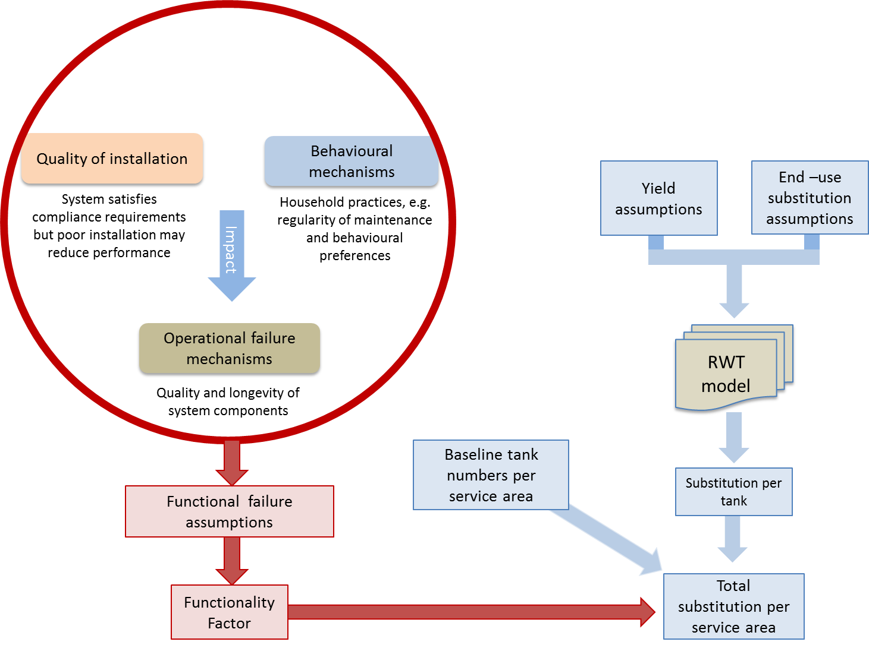

Figure 1: Approach for assessing substitution of mains supplied water with rainwater

DISCUSSION
There are numerous rainwater tanks models being used by utilities and academics for estimating rainwater tank yields. However, it has been found that rainwater tank models generally over estimate rainwater tank system performance, particularly when extrapolating substitution over longer periods. This discrepancy in tank performance between modelled and evaluation studies likely lies in unforeseen or unaccounted failure mechanisms (expressed in this paper as functionality), which appear to be seldom factored into yield calculations (Umapathi et al. 2012).
It was evident, in conducting a literature review of studies that there is a dearth of quantitative information and research relating to the condition of existing tank stock, failure rates of rainwater tanks and the associated reduction in mains water substitution both internationally and in Australia. The vast majority of field studies have produced qualitative responses on the perceptions of the structural integrity of their rainwater capture infrastructure and the end-uses connected to the system. Not much in the way of quantitative data is available, which hampers the estimation of both the functional tank numbers and the potential substitution of supplied mains water.
Private ownership of infrastructure that could be viewed as being for the public good, as in the case of household rainwater tanks, creates a management dilemma for utilities (Moglia et al., 2011). In particular, the generation of data on associated privately owned asset and system conditions is critical to reviewing baseline alternative supply yield forecasts but is problematic for utilities due to issues surrounding privacy.
Rainwater tank functionality
Based mainly on the published qualitative information, issues likely to affect system performance resulting in either reduced substitution or total asset failure have been grouped into three categories:
- quality of installation (e.g. incorrect tank installation, end-use plumbing issues, incorrect placement of downpipes, etc.);
- operational failure mechanisms (e.g. pump failure, failed mains switch device); and
- behavioural factors.

Poor quality installation and system configuration is said to either compound operational failure mechanisms (i.e. increase likelihood of operational failure) or directly result in reduced functionality through ‘pathways’ that lead to reduced substitution. Operational failure mechanisms are determined by the quality and longevity of system components. Both installation quality and operational failure mechanisms can be further compounded by behavioural mechanisms. Studies show maintenance activity and aesthetical preferences (e.g. water colour, noise from pump) to be key determinants of functionality failure. The contribution of each cause of reduced functionality (as presented in Figure 2) is discussed below to highlight their complexity and interrelatedness.
As an important aside, non-compliance with regulations (e.g. development control, plumbing codes) could be considered an additional determinant of system performance. System installations that do not adhere to the household-specific rainwater tank commitments enforced by relevant regulatory authorities include items such as the size of the tank and roof catchment area, and the connection of selected outdoor and indoor uses. For example, a rainwater tank system that fails to supply its intended yield under these regulations, due to an undersized roof collection area or tank, may result in an over estimation of the potential yield from a system and hence an over estimation of the mains water substitution. In one study, a number of household rainwater tank systems were found to be falling short of achieving their intended water substitution due to appliances (washing machines and toilets) not being connected as required by local regulations (Ferguson, 2011). Unlike the aforementioned failure mechanisms, non-compliance does not directly affect the functionality of a rainwater tank system, but the potential yield projections.

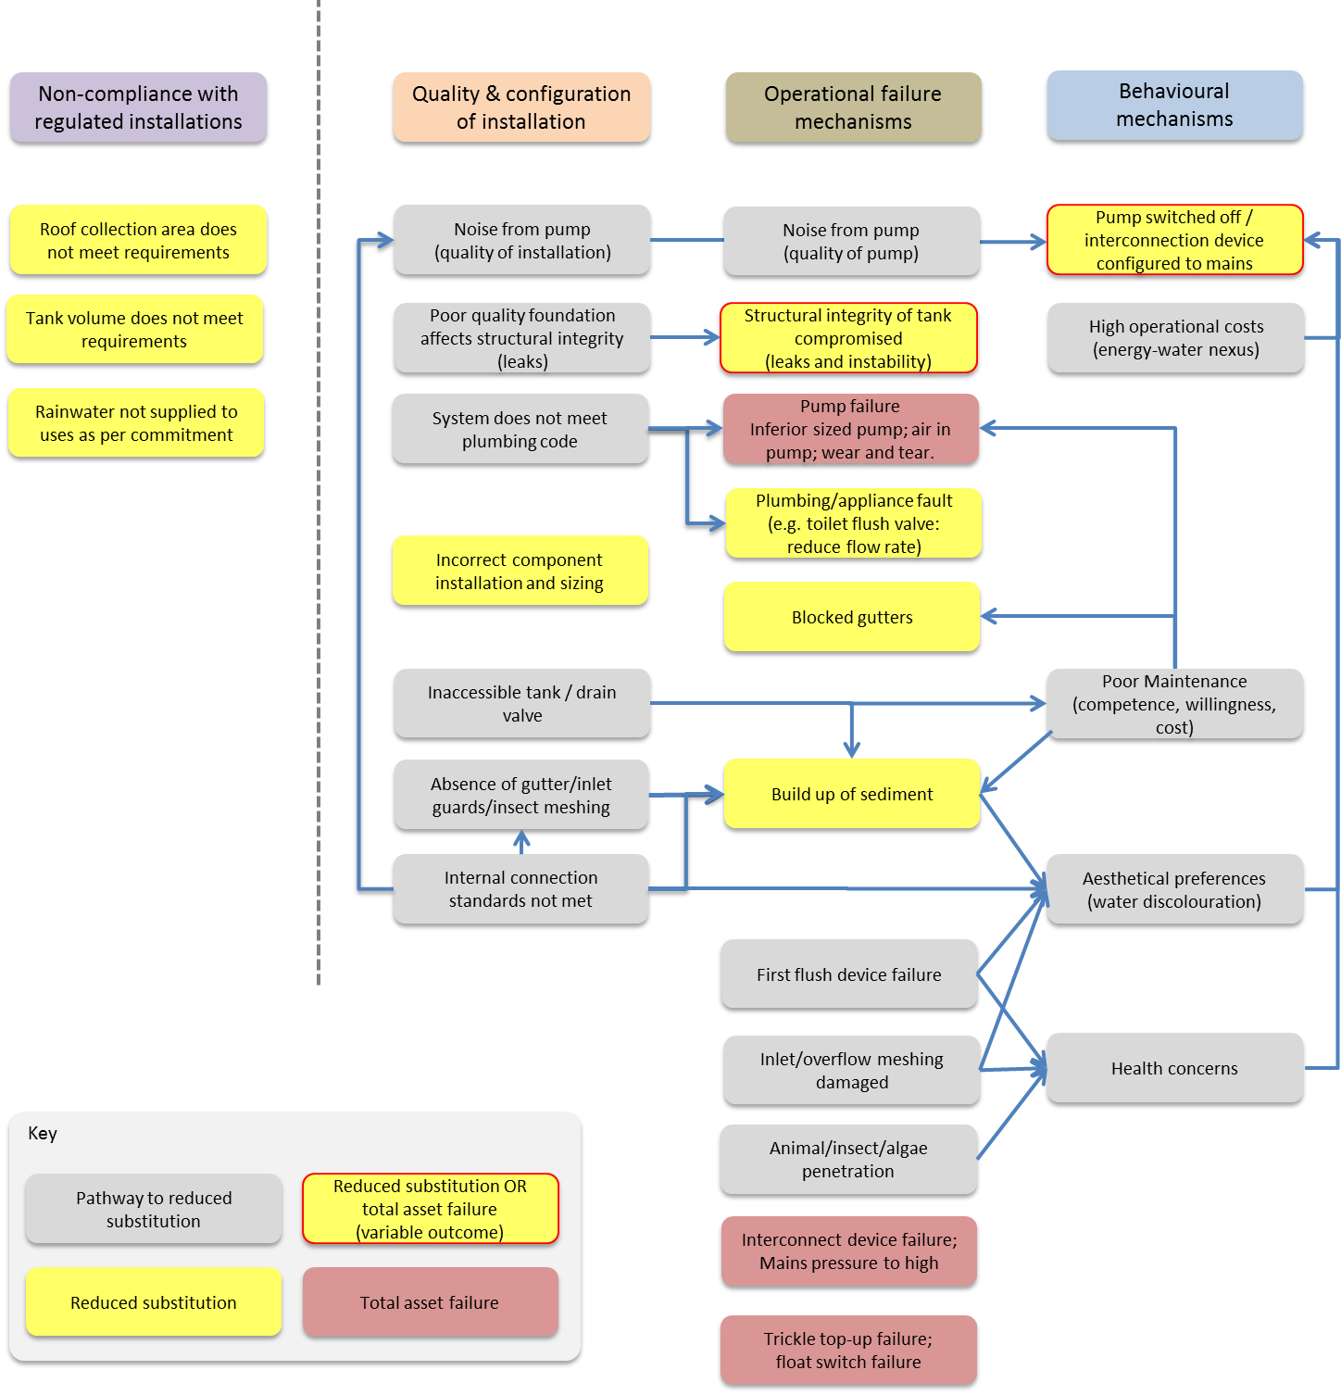

Figure 2: Causes of total asset failure and reduced mains water substitution

Quality and configuration of installation
Published literature on the quality of rainwater system installations and the design sizes and configurations are limited and where available, generally comprises of qualitative data. Poor installation of tanks and associated components is cited as a common theme, owing to low knowledge levels of among plumbers with respect to their understanding of rainwater tank systems, relevant guidelines, regulations and accepted urban residential work standards (Coombes et al., 2004; HWC, 2004; Moglia et al., 2011; SWC, 2011). Consultations with practitioners in the field revealed that two possibilities as a result of poor installation could exist:
- In some cases, rainwater tanks have been poorly installed and not functioned (at all) from the beginning. Arguably in many instances, owners may be unaware that their rainwater tank system is not functioning and as a consequence the problems are not rectified.
- While technically functional, the poor installation reduces (to varying degrees) the volume of rainwater supply and/or the substitution of mains water.
Examples of poor installation include: poor choice of location of the tank and pump, which may produce undesirable noise levels or prevent maintenance activity due to inaccessibility; or poor workmanship that may lead to structural integrity issues sooner than might otherwise be expected.
Operational failure mechanisms
There is very limited independent, longitudinal data on the longevity of rainwater tanks, particularly given that some varieties are a newer technological design (e.g. polyethylene tanks and polymer-lined galvanised steel tanks). A common approach is to take lifespan data of system components to account for operational failure mechanism rates. Modelling rainwater tank failure based solely on system component lifespan data may produce unrealistic outcomes however. This is because the functionality of a rainwater tank is closely tied to household behaviours, in particular, the maintenance regimes. Acknowledging the role and significance of maintenance behaviours in rainwater tank deterioration, Moglia et al ( 2011) simulated the deterioration of rainwater tanks based on a comprehensive survey of 235 plumbers and professionals, see Table 1.

Table 1: Component failure over time reducing yield (Moglia et al., 2011)
Operation failure mechanism | Commissioning (Quality of installation) | Year 1 | Year 2 | Consequence
Blocked gutters/rainwater head leading to overflow | 17% after 1 month | 67% of tanks | 75% of tanks | Reduced substitution
Broken/worn pumps causing reduced lift of water |  | 19% of tanks | 37% of tanks | Reduced substitution / Total asset failure
Structural integrity of the tank compromised |  |  | 5% of tanks | Reduced substitution / Total asset failure

Behavioural mechanisms
The regularity of maintenance, together with aesthetic preferences, are core contributors of functional failure. Social and cultural components that have varying degrees of influence in tank functionality include:
- Pump noise
- Animal/inset/algae penetration
- Health concerns
- Energy costs
- Aesthetical preferences (water discolouration, odours)
- Maintenance (cost, willingness, competence)
Accounting for household practices is an important element of determining rainwater tank yields as practices are considered elastic. Aesthetical preferences, for example, are subject to cultural norms and personal preferences (Moy, 2012) and may be influenced by community education campaigns, socio-economic factors, regulations (e.g. water restrictions), and environmental factors such as drought. The level of rainwater tank maintenance activities is similarly shaped in this regard.
Published field observations report low levels of household rainwater tank maintenance, which decreases the longevity of system components and as such increases the likelihood of reduced functionality (Gardiner, 2009; Tam et al., 2010; Moglia et al., 2011). Other studies have taken to asking householders about their tank maintenance activities. A study by Tilbrook (2009) of 145 households found that only 32% carried out maintenance on gutters, 23% on the first flush device and 39% on the tank inlet. In a survey of 1051 tank owners, half reported having never conducted regular maintenance and indicated they would respond to problems if and when they arose (Gardiner, 2010). As these figures are based on self-reported data, they are assumed to be an over-estimate of actual maintenance activity.
The literature also suggests that voluntary rainwater tank owners are more motivated and hence more likely to maintain their system than those who have been forced to install one because regulations (Gardiner, 2010; Tucker et al., 2011). Tucker et al. (2011) for example, undertook a large-scale survey of 1,984 households in SEQ to investigate attitudes and behaviours of rainwater tank owners, and found participants with mandated RWTs had lower levels of motivation to maintain their tank. Education and maintenance programs could improve this situation in future (Walton et al., 2012).
Improving functionality
The future contribution of rainwater tanks to substitute mains supplied water could be significantly enhanced by improving the functionality of the systems through better maintenance and operation. This could primarily be improved through up-skilling of plumber technical knowledge of installations, as well as maintenance education at the householder level to increase the substitution volumes (Moglia et al., 2013).
It may be considered appropriate where water businesses are reliant on rainwater tanks to meet potable water demands, that they introduce an auditing and repair program to ensure that all tank systems within a service area are fully functional, and that the maximum potential substitution of mains water is realised.

Yield and substitution considerations
A number of key rainwater tank yield and end-use substitution factors influence the volume of mains water saved through substitution. Roof catchment areas will be determined by the roof size, whilst the volume of substituted water is directly related to the level of household demand, and are specific to geography and context.
In terms of available yield, critical assumptions relate to tank size, roof collection size, and system components and configuration (e.g. top-up or interconnect device; gutter guards; leaf diverters).
Many factors influence the pattern and volume of residential water consumption, including water pricing, household income, household size, irrigable outdoor area (e.g. garden, lawn), appliance efficiency, consumption behaviour and water restrictions (Turner et al., 2005; Barrett and Wallace, 2009; Beal et al., 2011). Most of these demand factors will vary according to context and geography (e.g. household occupancy, restrictions, etc.), critically however, studies may only account for some of these demand factors in their analysis and values may be based on empirical data or theoretical assumptions.
Mains water substitutions are also caveated by the method of data generation (e.g. smart metering data versus accumulation metering data); approach to calculating savings; and the duration of data collection (typically this is around one year due to resourcing constraints). Ferguson (2011) notes that relatively short timeframes in particular may either underestimate or overestimate total mains water substitution, depending on which season the monitoring occurs.

Attributing a Functionality Factor
As has been explained in the section above, quantitative data on the condition of existing tank stock is typically unavailable. Data on frequency of failure mechanisms is also generally limited, however system component lifespan data, together with the available (largely qualitative) data on maintenance behaviours can be used to form the basis of assumptions for predicting tank functionality. As stated previously, this data currently comprises primarily of perceptions survey data (Moglia et al., 2011) and literature using self-reported information about household rainwater tank maintenance regimes and attitudes to water use (e.g. Tucker et al. 2011; Gardiner 2010; White 2009; Tilbrook 2009).
Hence, it is not currently possible to draw any quantitative conclusions, or to derive a single factor by which to adjust the calculated potential substitution of mains water by rainwater for reduced functionality. Without such a factor, the likely mains water substitution per service area will be inflated if based on actual tank numbers.
In the interim, it is therefore proposed that a range be determined within which such a factor would most likely fall, thus providing an envelope of potential mains water substitution (as shown in Figure 3). By applying the high and low functionality factors to the calculated rainwater tank substitution, more realistic estimation of the projected mains water substitution can be made.
Using the assessments made by Moglia et al (2011), where after two years the failure rate of the rainwater tank systems surveyed was around 40% (see Table 1), the functionality could therefore be assumed to be around 60%. Therefore a functionality factor envelope of between 50% and 70% would produce a projected substitution range with a sensitivity of ± 10%. This range should be based on local knowledge and judgement until such time as more reliable data has been collected and analysed through locally based onsite inspections and substitution measurements.

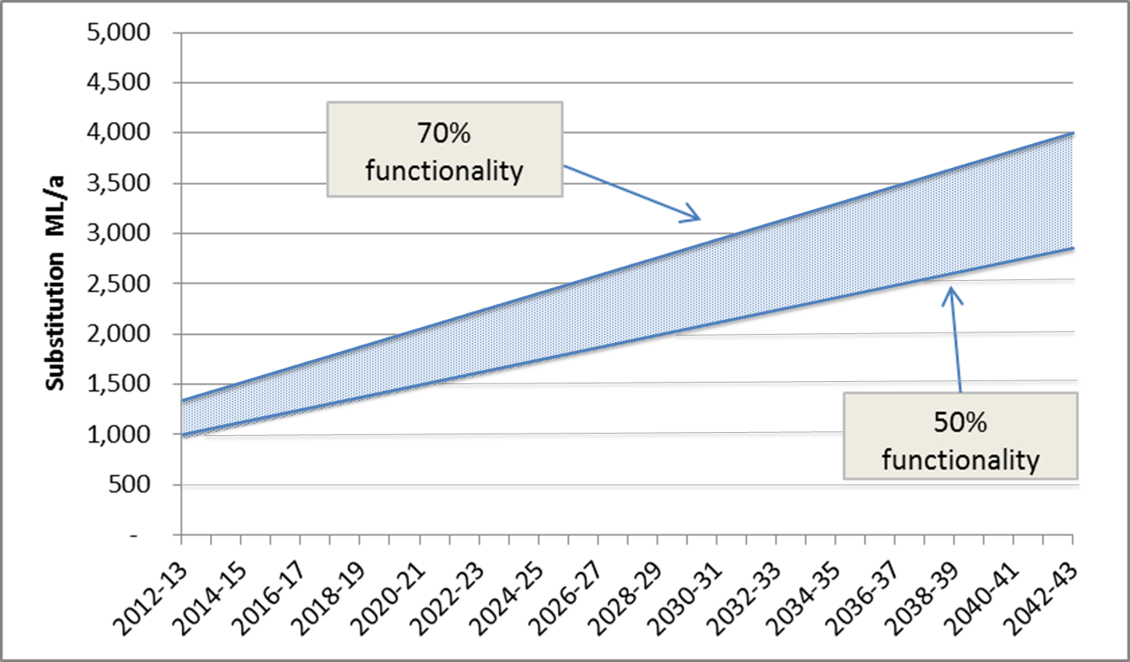
Figure 3: Example of envelope of total substitution

CONCLUSION
The outcome of this study has revealed a data gap in knowledge about rainwater tank functionality and the importance of quantitative field surveys to determine the performance of existing rainwater tank systems. As an interim measure, the use of an envelope of functionality factors provides a transparent approach for estimating the range of the potential mains water substitution. Further statistical relevant surveys and data analysis are needed to assist in quantifying the nature and effects of functionality failure, and would provide a sound statistical basis for applying a single functionality factor. Such sample surveys should include an assessment of the compliance with registered system dimensions (roof area and tank sizes), the structural condition of the system components, and the actual end-use substitution by appliances.
In addition, the role of ongoing maintenance in ensuring the full functionality and longevity of these systems, and hence the continued substitution of mains supplied water cannot be over emphasized.

ACKNOWLEDGEMENTS
Thank you to John Caley and Geoffrey Milne for their technical insights.

REFERENCES
Barrett, G., Wallace, M., 2009. Characteristics of Australian urban residential water users: implications for water demand management and whole of the system water accounting framework. Water Policy 11, 413–426.
Beal, C., Gardner, T., Sharma, A., Barton, R., 2011. A Desktop Analysis of Potable Water Savings from Internally Plumbed Rainwater Tanks in South East Qld. Urban Water Security Research Alliance Technical Report No. 26.
Coombes, P.J., Spinks, A., Evans, C., Dunstan, H., 2004. Performance of Rainwater Tanks at an Inner City House in Carrington NSW During a Drought, in: Water Sensitive Urban Design. pp. 1–12.
Ferguson, M., 2011. Rainwater tank study of new homes - A 12-month one-minute interval data study of rainwater tank water savings and energy use for 52 real life installations. Sydney Water Corporation, Parramatta.
Gardiner, A., 2009. Domestic rainwater tanks: usage and maintenance patterns in South East Queensland. AWA Water 36, 151–156.
Gardiner, A., 2010. Do rainwater tanks herald a cultural change in household water use? Australasian Journal of Environmental Management 17, 100 – 111.
HWC, 2004. Kotara Roof to Creek project. Hunter Water Corporation, Newcastle.
Moglia, M., Tjandraatmadja, G., Sharma, A., 2011. Initial Investigation into the Governance and Management Models for Rainwater Tank Systems. Urban Water Security Research Alliance Technical Report No . 50.
Moglia, M., Walton, A., Sharma, A., Tjandraatmadja, G., Gardner, J., Begbie, D., 2013. Management of urban rainwater tanks. AWA Water 40, 90–95.
Moy, C., 2012. Rainwater Tank Households: Water Savers or Water Users? Geographical Research 50, 204–216.
SWC, 2011. Rainwater tank monitoring report, Sydney Water Corporation, Parramatta. Sydney Water Corporation, Parramatta.
Tam, V.W.Y., Tam, L., Zeng, S.X., 2010. Cost effectiveness and tradeoff on the use of rainwater tank: An empirical study in Australian residential decision-making. Resources, Conservation and Recycling 54, 178–186.
Tilbrook, R., 2009. Rainwater tanks in new housing development: a survey of the issues, knowledge and uses of residents in the Northlakes Estate. A study for Lake Macquarie City Council, NSW; University of Newcastle.
Tucker, D., Mankad, A., Greenhill, M., 2011. Rainwater Tank Adoption in South East Queensland – Factors Influencing Maintenance and Management. Urban Water Security Research Alliance 3rd Science Forum. Brisbane, Australia.
Turner, A., White, S., Beatty, K., Gregory, A., 2005. Results from the largest residential demand management program in Australia. Water Science & Technology: Water Supply 5, 249–256.
Umapathi, S., Chong, M.N., Sharma, A.K., 2012. Evaluation of plumbed rainwater tanks in households for sustainable water resource management: A real-time monitoring study. Journal of Cleaner Production.
Walton, A., Gardner, J., Sharma, A., Moglia, M., Tjandraatmadja, G., 2012. Exploring Interventions to Encourage Rainwater Tank Maintenance. Urban Water Security Research Alliance Technical Report No. 59.
White, I.W., 2009. Decentralised Environmental Technology Adoption : The Household Experience with Rainwater Harvesting. Griffith University.

