Forward Osmosis treatment for volume minimisation of reverse osmosis concentrate from a water reclamation plant and removal of organic micropollutants

Shahzad Jamil ª, Paripurnanda Loganathan ª, Christian Kazner ^{a,b}, Saravanamuthu Vigneswaran ª*

ª University of Technology Sydney, School of Civil and Environmental Engineering, PO Box 123, Broadway, NSW 2007, Australia
(E-mail: shahzad.jamil@student.uts.edu.au; Paripurnanda.Loganathan@uts.edu.au; christian.kazner@uts.edu.au; saravanamuth.vigneswaran@uts.edu.au)
^{b} University of Applied Sciences and Arts of Northwestern Switzerland, School of Life Sciences,
Institute of Ecopreneurship, Gründenstrasse 40, CH-4132 Muttenz, Switzerland
(E-mail: christian.kazner@fhnw.ch)

*Corresponding auther
S. Vigneswaran, University of Technology Sydney, School of Civil and Environmental Engineering, PO Box 123, Broadway, NSW 2007, Australia (saravanamuth.vigneswaran@uts.edu.au)

Highlights
- 5 steps of forward osmosis reduced reverse osmosis concentrate (ROC) volume to 8%
- Flux decline due to membrane fouling was arrested by reducing pH of ROC
- Granular activated carbon (GAC) removed organic micropollutants (OM) from ROC
- GAC pretreatment also reduced forward osmosis draw solution OM concentration

Abstract
Reverse osmosis concentrate (ROC) produced in water reclamation and desalination plants can endanger the environment if it is not treated before discharge. Volume minimisation of ROC can help in its easy disposal. The study examined the use of forward osmosis (FO) with and without granular activated carbon (GAC) fixed-bed adsorption pretreatment for volume minimisation of ROC and removal of organic micropollutants. Five repeated FO steps using 2 or 3 M NaCl as the draw solution reduced the volume of ROC to 8%. With each successive step the flux decreased due to membrane fouling and scaling caused by increased concentrations of organics and inorganics resulting from volume reduction of ROC. However, flux decline was arrested in the second or third step by reducing the pH of the feed solution from 7.0 to 5.0. FO treatment rejected 9 of the 18 organic micropollutants at > 82% and GAC treatment removed 15 of them at >82%. GAC pre-treatment followed by FO treatment removed almost all the organic micropollutants from the ROC. GAC pretreatment also reduced total organic carbon concentration in ROC by adsorption, thus controlling membrane fouling.

Keywords: forward osmosis, inorganic scaling, organic fouling, organic micropollutants, reverse osmosis concentrate

- Introduction
For centuries most countries around the world have enjoyed clean fresh water as an abundant and inexpensive resource. Currently due to climate change and on-going population growth one third of the world’s population is facing water shortages (Shannon et al. 2008), despite abundant availability of water resources containing impure water such as seawater, brackish groundwater, and recycled water. These waters contain different types of contaminants such as heavy metals, micropollutants, salinity and microorganisms, which need to be removed to make these waters suitable for potable uses. Membrane technologies such as reverse osmosis (RO), nanofiltration (NF), ultrafiltration (UF) and microfiltration (MF) play a vital role in removing these contaminants. These technologies, however, generate large volumes of waste streams that require disposal with particular attention to minimising their environmental impact. Reducing the volume of waste streams aiming at zero liquid discharge is an attractive option for minimising the environmental impact and producing better quality product water.
Reverse osmosis is a popular method used worldwide to convert sea water and wastewater into fresh water (Fritzmann et al. 2007). However, the major drawback of this process is the generation of large amounts of highly concentrated brines as an unwanted by-product which can cause environmental problem if discharged untreated. Forward osmosis (FO) has been suggested as a low energy process which can be used to: firstly, extract water from the reverse osmosis concentrates (ROC); and secondly, reduce the volume of ROC for easy handling including the crystallisation of salts (Kazner et al. 2013; Adham et al. 2007). The FO of ROC produces FO permeate which can be used as high quality recycled water provided the major contaminants in ROC are removed. No convincing information is available on whether FO can remove micropollutants which are considered to be toxic to humans and aquatic organisms.
The objectives of this study were to: (1) investigate whether FO is a promising technology to minimise the volume of ROC and produce zero liquid discharge which is easy to handle for safe disposal, and (2) investigate the removal of organic micropollutants from ROC using FO with and without granular activated carbon (GAC) pretreatment.
- Materials and methods

  - ROC Characteristics
Reverse osmosis concentrate was obtained from the Sydney Olympic Park Authority’s (SOPA) MF/RO water filtration plant, which operates with a volumetric feed flow of about 55 m³/h. It has a water recovery of about 80% which leaves a reject stream (ROC) of about 20%. General characteristics of the ROC are presented in Table 1. Micropollutants detected in ROC and their properties are presented in Table 2. The ROC was sampled and stored in glass bottles at 4ºC until required for FO tests.

  - Chemicals and reagents
Analytical grade NaCl supplied by Sigma-Aldrich of minimum assay (99.7%) was employed to prepare the draw solution (DS). Sodium chloride with concentrations of 2 and 3 M was used in all the experiments. The main criteria for selecting NaCl are that it has a high solubility, osmolarity and is simple to reconcentrate with RO without any risk of scaling (Cath et al. 2013).

Table 1. General characteristics of the ROC

Parameters | Units |  | Value
Total organic carbon (TOC) | mg/L |  | 53.0
UV254 | 1/m |  | 0.7
pH |  |  | 7.6
El. conductivity | mS/cm |  | 4.4
Ca²⁺ | mg/L |  | 125.0
Mg²⁺ | mg/L |  | 75.0
K⁺ | mg/L |  | 74.8
Na⁺ | mg/L |  | 640.0
Silica as Si | mg/L |  | 26.0
Br⁻ | mg/L |  | 4.0
Cl⁻ | mg/L |  | 950.0
F⁻ | mg/L |  | 13.9
SO₄²⁻as S | mg/L |  | 106.0
NO₃⁻ as N | mg /L |  | 5.0
Total P | mg /L |  | 6.3

Table 2. Properties of the detected micropollutants and their initial concentration in ROC

Micropollutants | Class | MWª  (g) | Charge^{b}  (pH 7.5) | Conc (ng/L) | Log D^{b}  (pH 7) | Log Kowª  (pH 7) | pKa
Amtriptyline | Anti depressant | 277 | + | 44 | 3.48 | 4.92 | 9.4ª
Atenolol | Beta-blocker | 266 | + | 325 | -1.87 | 0.16 | 9.6^{f}
Caffeine | Stimulant | 194 | 0 | 1030 | -0.11 | -0.07 | 10.4e
Carbamazepine | Anti analgesics | 236 | 0 | 1380 | 2.23 | 2.45 | <1^{c}, <2^{d}
Diclofenac | Analgesics | 294 | - | 250 | 1.48 | 4.51 | 4.1 – 4.2^{c}
Diuron | Herbicide | 233 | 0 | 335 | 2.7 | 3.49 | 1.7^{b}  13.8^{b}
Fluoxetine | Anti depressant | 309 | + | 27 | 2.6 | 4.05 | 10.1^{c}
Gemfibrozil | Lipid regulator | 250 | - | 816 | 1.26 | 4.77 | 4.7^{d}
Ibuprofen | Analgesic | 206 | - | 357 | 1.44 | 3.97 | 4.47^{h}
Ketoprofen | Analgesics | 254 | - | 165 | -0.14 | 3.12 | 4.45ª
Naproxen | Analgesics | 230 | - | 1210 | 0.16 | 3.18 | 4.2^{c}; 4.15ª
Primidone | Therapeutic | 218 | 0 | 234 | 0.55 | 0.91 | 11.7^{b}
Simazine | Herbicide | 202 | 0 | 61 | 2.2 | 2.18 | 1.62ª
Sulfamethoxazole | Therapeutic | 253 | - | 303 | -0.77 | 0.89 | 2.1^{d}; <2^{d}
Triclocarban | Agricultural chemical | 316 | 0 | 62 | 5.06 | 4.9 | 12.7^{g}
Triclosan | Anti- infective | 290 | 0 | 91 | 5.19 | 4.76 | 7.9 ^{c}
Trimethoprim | Anti-infective | 290 | 0 | 618 | 0.94 | 0.91 | 6.6 – 7.2^{c}; 7.12ª
Verapamil | Hypertension | 454 | + | 48 | 2.5 | 3.46 | 8.97^{b}

ªU.S. National library of medicine (http://chem.sis.nlm.nih.gov/chemidplus/rn/52-53-9); ^{b}Calculated with Advanced Chemistry Development (ACD/Labs) Software V9.04 for Solaris; ^{c} Serrano et al. (2011); ^{d}Westerhoff et al. (2005); ^{e}Yang et al. (2011); ^{f}Hapeshi et al. (2010); ^{g}Loftsson, Hreinsdóttir & Másson (2005); ^{h}Thomas (2006); ªMW: molecular weight

  - Analytical methods
The electrical conductivity and pH of the feed solution (FS) and DS of the FO were measured at the beginning and end of the experiments using a manual pH meter (GMH 3430 Greisinger, Germany) and a manual conductivity meter (GMH 3530 Greisinger, Germany,) respectively. The quantitative analysis of anions (Cl⁻) and cations (Na⁺, Ca²⁺) in the experimental samples was done using an ion chromatograph (Metrohm 790 Personal Ion Chromatograph, Herisau, Switzerland). Inductively Coupled Plasma Optical Emission Spectrometry (ICP-OES: Perkin Elmer OPTIMA 7300 DV, USA) was used for the analysis of a wider range of cationic and anionic contaminants. Total organic carbon (TOC) and total inorganic carbon (TIC) were measured using a total organic carbon analyzer (multi N/C 3100, Analytik Jena AG, Jena, Germany).
A Liquid Chromatography-Organic Carbon Detection unit (LC-OCD) (DOC-Labor Dr. Huber, Germany) helped to measure the major fractions of TOC in the samples. This unit is a size–exclusion chromatography combined with organic carbon detection which separates the pool of TOC into major fractions of different sizes, based on the Graentzel thin–film UV-reactor. The four major fractions of compounds are: biopolymers (>20,000 g/mol), humic substances (1200-500 g/mol), building blocks (weathering product of humic substances) (500-350 g/mol), and acids + low molecular weight (LMW) humics (<350 g/mol) (Amy et al. 2011).
Organic micropollutants’ concentrations were determined by solid phase extraction (SPE) and analysis using liquid chromatograph with tandem mass spectroscopy. 5 mL analytes were extracted using 500 mg hydrophilic/lipophilic balance (HLB) cartridges (Waters, Milford, MA, USA). These analytes were separated using an Agilent (Palo Alto, CA, USA) 1200 series high performance liquid chromatography (HPLC) system equipped with a 150 x 4.6 mm, 5 µm particle size, Luna C18 (2) column (Phenomenex, Torrance, CA, USA). Mass spectrometry was done using an API 4000 triple quadrupole mass spectrometer (Applied Biosystems, Foster City, CA, USA) equipped with a turbo-V ion source employed in both positive and negative electro-spray modes. All calibration curves had a correlation coefficient of 0.99 or better.

  - Forward osmosis bench-scale unit
A bench-scale FO unit as shown in Fig. 1 was used for conducting the FO experiments. The FO cell (20 mm width x 3 mm height x 210 mm length) consists of a channel on both sides of the FO membrane which transport the FS from one side of the membrane to the DS on the other side of the membrane. The membrane consists of a cellulose triacetate material with embedded polyester screen support (CTA-ES Membrane 1401270) having a pore size of 0.74 nm obtained from Hydration Technology Innovations, USA (HTI 2012). The cross-flow velocity was maintained across the membrane by adjusting knobs manually using a variable speed drive (Magnetic drive pump 316 SS, Cole-Parmer, USA). The flow rate was monitored using rota-meters (Cole-Parmer) which were installed in a series with pumps along the FS and DS streams in the circuit. A new membrane was used for each test run. The temperature of FS and DS was kept constant at 25.0 ± 0.2°C using a water bath, in which stainless steel coiled pipes were immersed. The water bath was connected to a temperature control system (Thermoline BL-30) to ensure the temperature remained constant.

  - Experimental protocols
The FO system was tested with real ROC from the Sydney Olympic Park WRAMS plant. The tests served to determine the specific fouling potential of the main components of ROC and their impact on the permeate flux. The tests were conducted for 15-16 h with ROC as the FS and different concentrations NaCl as the DS. Conductivity was monitored at the initial and final stages of the experiments. Concentrations of TIC and TOC in the initial and final solutions were analysed to determine the amount of these compounds adsorbed onto the membrane and to identify the compounds causing fouling. The amounts of TIC and TOC adsorbed were assumed to be the differences between the product of their respective initial and final concentrations and normalised volumes. As the ROC had a significant scaling potential, pH adjustment of ROC was studied as a method to reduce the risk of scaling (Jamil 2013: Kazner et al. 2013).

  - ROC volume reduction and rejection of organic micropollutants without GAC pretreatment using FO
The experiment consisted of five steps. In the first step, six litres of ROC were divided into three equal parts and FO was conducted using 2 M NaCl as the DS. In the second and third steps, the three portions of the treated ROC in the first step were combined and used as the FS to further concentrate and reduce the volume of ROC by means of two additional FO processes, one after the other, using again 2 M NaCl as the DS. The pH of the concentrated ROC in the third step was reduced to 5.0 to minimise the potential of scaling (Kazner et al. 2014) and the experiment was continued in a similar manner as the first three steps with two more FO treatments using 2 M and 3 M NaCl as the DS for the fourth and fifth FO steps, respectively. The volume of the ROC after each FO treatment was measured. The concentrations of organic micropollutants in the initial ROC and in the final FO permeate (fifth step) were also measured.

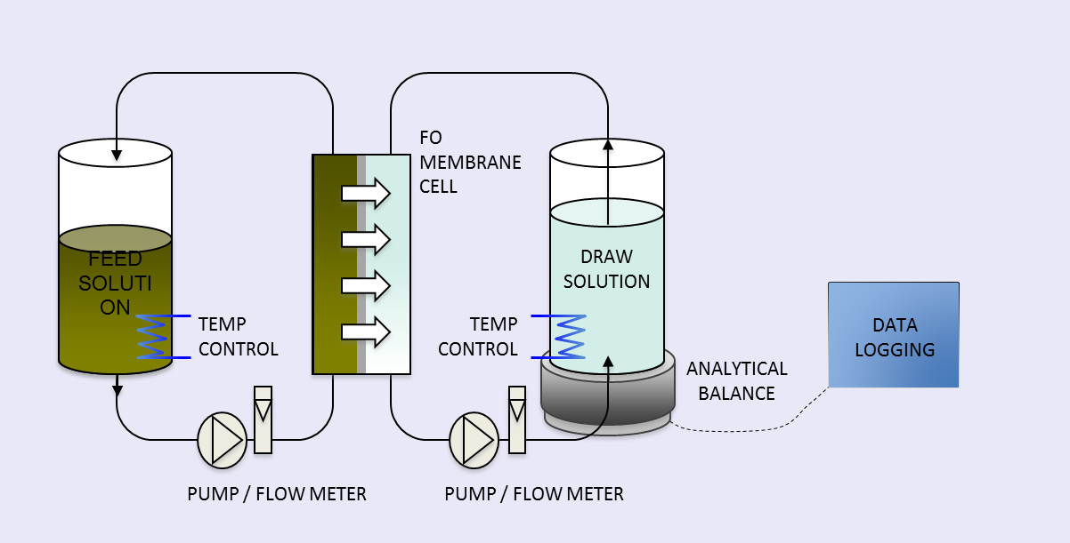

Fig. 1. Flow schematic of the laboratory-scale FO set-up (adapted from Kazner et al. (2013))

  - Removal of TOC by fixed-bed GAC column
TOC usually exists in wastewater as a complex mixture of organic compounds, humic acids and fulvic acids. Granular activated carbon is considered to be one of the best adsorbent employed for removing TOC, and has already been utilised as a medium in filter-adsorbents in many water treatment plants worldwide (Babi et al. 2007). An experiment was conducted using a fixed-bed column (23 cm height, 2.2 cm internal diameter) containing a coal-based GAC to reduce the concentrations of TOC and organic micropollutants in the ROC (Fig. 2). The GAC obtained from James Cummins P/L, Australia had a particle size of 8×30 mesh ASTM and surface area of 1000 ± 50 m²/g. The ROC (8 L) was passed through the column at an upward flow velocity of 32 ml/min using a pump. The bed volume of the column was 87.4 cm².

  - ROC volume reduction and rejection of organic micropollutants using FO after GAC pretreatment
The experiment on volume reduction using FO without GAC pretreatment described earlier was repeated with GAC pretreatment in five steps as done previously. However, this time eight litres of the GAC treated ROC were divided into four parts and FO was conducted using 2 M NaCl as the DS in the first step. To make the FO process more efficient by reducing potential fouling, the pH of the FO after the second step, instead of after the third step as done without GAC treatment, was reduced to 5.0. The volume of the ROC after each FO treatment was measured as before. The concentrations of organic micropollutants in the initial GAC pretreated ROC and in the final permeate (fifth step) were also measured.

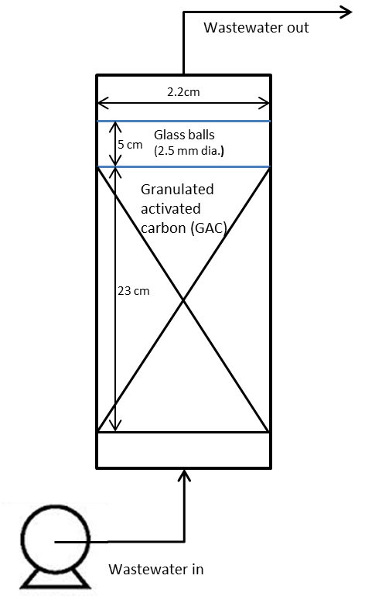

Fig. 2. Fixed-bed GAC adsorption column

- Results and discussion

  - FO without GAC pretreatment
With each step of FO the volume of ROC decreased (Table 3). The final volume of ROC was 8% of the initial volume. This shows that FO can be effectively used to reduce the volume of ROC to a level of zero liquid discharge. As the final volume of ROC is very small it can be easily handled for safe disposal or it can be used to crystallise the salts in ROC for beneficial use.
As the volume of ROC progressively declined with each step of FO, the flux of solution through the membrane also fell (Table 2). The decline of ROC flux as a percentage of baseline flux increased with each step until the pH was reduced at the end of the third step where the percentage decline abated. The flux decline was due to an increase in the concentration of the ROC as a result of volume reduction. The increased concentration of ROC caused fouling of the membrane due to the adsorption of inorganic and organic compounds. The results in Table 4 show that the amount of TIC adsorbed per unit area of membrane (0.45-1.71 mg/cm²) was higher than the TOC adsorbed (0.29-0.76 mg/cm²) during the first three FO steps. This is due to the higher initial TIC concentration in ROC compared to that of TOC. When the pH of the ROC decreased to 5.0, the flux increased and flux decline as a percentage of the baseline solution decreased. This is due to the dissolution of the carbonate precipitates on the membrane and conversion of carbonates as CO₂ gas at the low pH.
Humic acids, building blocks, and acids + low molecular weight organics were the dominant foulants of the FO membrane (Fig. 3). Biopolymers such as polysaccharides contributed less to the fouling, particularly because the ROC had low polysaccharides concentration due to the MF pretreatment in the water filtration plant where the ROC was collected for the study. Due to the high molecular weights of polysaccharides they were easily removed in the MF treatment. The normalised concentrations (normalisation to the original volume of ROC) of the humic acids, building blocks, and acids + low molecular weight organics in solutions decreased compared to the initial concentration with each FO step showing they were adsorbed onto the membrane (Fig. 3).
Inorganic elemental analysis revealed a significant decrease in the normalised concentrations (normalisation to the original volume) of calcium, magnesium, potassium on the cation side and phosphate, carbonate sulphate on the anion side between the initial (FS of FO Step 1) and the final solution (FS of FO Step 5) (Fig. 4). The increase in concentration of sodium and chloride is probably due to diffusion of these ions from the DS containing high concentrations of NaCl to the FS. Modelling of the potential scaling from inorganic compounds at pH 7.5 with PHREEQC confirmed the high risk of poorly soluble salts being formed, particularly calcite, dolomite, and aragonite.

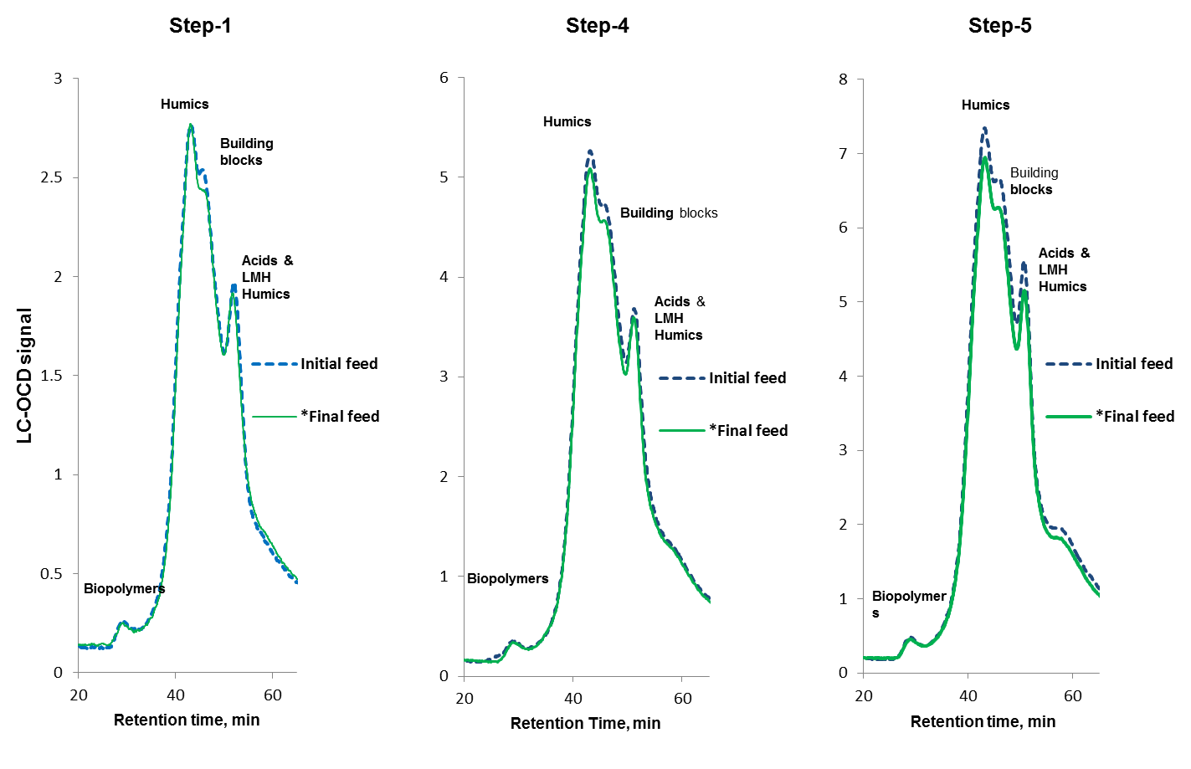
Fig. 3. LC-OCD chromatogram of the initial and final FS after the first, fourth, and fifth step of the FO process without GAC pretreatment (LMW-low molecular weight, *concentration normalised to the initial volume).

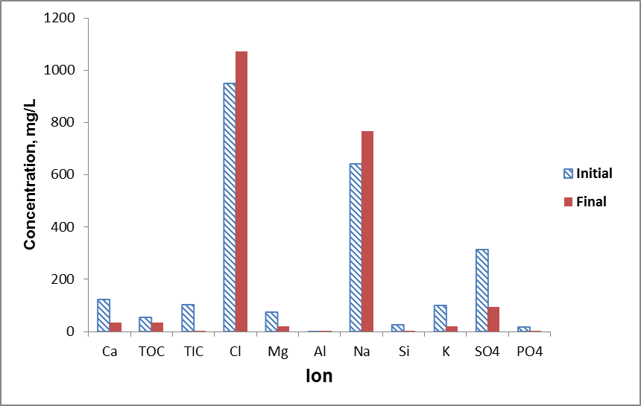

Fig. 4. Concentration of ions in initial FS (FO Step 1) and final FS (FO Step 5) after the final volume normalised to the original volume in FO without GAC pretreatment.

Table 3. Volume reduction of ROC and flux decline during FO without GAC pretreatment

FO step | FS | DS | ROC volume  Initial/Final | Baseline flux (DI* water FS) avg. | Flux with ROC avg. | Flux decline
 |  | mg/L | L | L/m²·h | L/m²·h | %
 | Unadjusted pH 7.5
1 | ROC | 2 M NaCl | 6.00/3.54 | 19.2 | 12.6 | 34.0
2 | ROC | 2 M NaCl | 3.54/2.75 | 19.2 | 9.7 | 49.5
3 | ROC | 2 M NaCl | 2.75/2.10 | 19.2 | 9.1 | 52.6
 | Adjusted pH 5
4 | ROC | 2 M NaCl | 2.10/1.14 | 19.2 | 13.5 | 29.7
5 | ROC | 3 M NaCl | 1.14/0.47 | 22.4 | 12.7 | 43.3
*DI- Deionised

Table 4. Total (T) inorganic (I)) and organic (O) carbon (C) adsorption on membrane during FO without GAC pretreatment (TIC adsorbed at steps 4 and 5 cannot be calculated because part of the TIC was lost to atmosphere as CO₂)

FO step | FS | DS | TOC,  Inital/final | TIC  Initial/fnal | TOC adsorbed | TIC adsorbed | TOC adsorbed | TIC adsorbed
 |  |  | mg/L | mg/L | mg/cm² | mg/cm² | % | %
Unadjusted pH 7.5
1 | ROC | 2 M NaCl | 50.6/76.7 | 103.4/155 | 0.76 | 1.71 | 11.0 | 12.0
2 | ROC | 2 M NaCl | 76.7/94.9 | 155.0/185.6 | 0.29 | 0.90 | 5.0 | 7.0
3 | ROC | 2 M NaCl | 94.9/115.2 | 177.0/212.5 | 0.45 | 0.45 | 7.0 | 4.0
Adjusted pH 5
4 | ROC | 2 M NaCl | 115.2/196.8 | 48.0/39.7 | 0.43 | - | 7.0 | -
5 | ROC | 3 M NaCl | 196.8/439.5 | 15.0/10.2 | 0.43 | - | 8.0 | -

  - FO with GAC pretreatment

With each step of FO the volume of ROC decreased (Table 5) as observed in the case of FO without GAC pretreatment. The final volume of ROC was 8% of the initial volume which is same as for FO without GAC pretreatment. This shows that FO can be effectively used to reduce the volume of ROC to a level of zero liquid discharge even with GAC pretreatment. As the volume of ROC progressively fell with each step of FO, the flux of solution through the membrane also declined (Table 5). The increased concentration of ROC caused fouling of the membrane via the adsorption of inorganic and organic compounds. The results in Table 6 show that the amount of TIC adsorbed per unit area of membrane (1.36-2.10 mg/cm²) was higher than the TOC adsorbed per unit area of membrane (0.12-0.31 mg/cm²) during the first two FO steps as observed in the case of FO without GAC pretreatment. GAC pretreatment greatly reduced TOC in the ROC by adsorption. This is evident in the TOC concentration decreasing from 50.6 mg/L in ROC before GAC treatment to 5.5 mg/L after GAC treatment (Tables 4 and 6).

  - Removal of organic micropollutants

Organic micropollutants occur at elevated concentrations in ROC and therefore they have to be removed if the ROC is to be safely disposed of without any adverse environmental impacts. Furthermore, removal of organic micropollutants will reduce FO membrane fouling which would allow the membrane to be effectively used for a longer period. Table 7 shows the removal of the micropollutants by adsorption onto GAC, and rejection by the FO membrane with and without GAC pretreatment. Only data for the DS concentrations of organic micropollutants at the last step of the FO process are presented. The concentrations obtained for the other steps are similar and therefore they are not presented. The rejection of the micropollutants was calculated as the difference in the amounts of micropollutants in ROC before and after FO using normalised volumes of ROC (i.e normalising the actual concentrations in the reduced volumes of ROC after FO to the original volume of 2 L of ROC). GAC pretreatment alone removed 15 of the 18 micropollutants tested from the ROC at > 82%. FO without GAC pretreatment rejected 9 micropollutants at >82%.

Table 5. Volume and flux decline during FO with GAC pretreatment

FO step | FS | DS | ROC volume (L)-  Initial/Final | Baseline flux (DI* water FS avg. | Flux with ROC avg. | Flux decline
 |  | mg/L | L | L/m²·h | L/m²·h | %
Unadjusted pH 7.5
1 | ROC | 2 M NaCl | 8.0/5.0 | 19.2 | 9.4 | 51.0
2 | ROC | 2 M NaCl | 5.0/4.3 | 18.0 | 11.0 | 39.0
Adjusted pH 5
3 | ROC | 2 M NaCl | 4.3/2.8 | 18.2 | 15.1 | 17.0
4 | ROC | 2 M NaCl | 2.8/1.6 | 18.5 | 13.0 | 31.0
5 | ROC | 3 M NaCl | 1.6/0.6 | 22.4 | 12.0 | 46.0
*DI- Deionised

Table 6. Total (T) inorganic (I) and organic (O) carbon (C) adsorption on membrane during FO with GAC pre-treatment (TIC adsorbed at steps 3, 4 and 5 cannot be calculated because part of the TIC was lost to atmosphere as CO₂)

FO step | FS | DS | TIC  initial/final | TOC, initial/final | TIC adsorbed | TOC adsorbed |  | TIC adsorbed | TOC adsorbed
 |  |  | mg/L | mg/L | mg/cm² | mg/cm² |  | % | %
 | Unadjusted pH 7.5
1 | ROC | 2 M NaCl | 104.0/149 | 5.5/7.0 | 2.10 |  | 0.12 | 10.0 | 11.0
2 | ROC | 2 M NaCl | 149.0/160 | 8.0/9.0 | 1.36 |  | 0.14 | 8.0 | 15.0
Adjusted pH 5
3 | ROC | 2 M NaCl | 47.0/46.0 | 9.0/11.2 | - |  | 0.17 | - | 18.0
4 | ROC | 2 M NaCl | 6.2/7.3 | 11.2/16 | - |  | 0.14 | - | 19.0
5 | ROC | 3 M NaCl | 7.3/5.3 | 16.0/21.3 | - |  | 0.31 | - | 51.0

The three micropollutants which were least removed by GAC were caffeine, trimethoprim, and verapamil at 79.2%, 65.4%, and 58.3 %, respectively. The reason for GAC not being able to remove a very high percentage of caffeine is probably due to its hydrophilic character (negative log D value) (Table 2). GAC being hydrophobic has a preference for the adsorption of hydrophobic compounds (Nguyen et al. 2012). Trimethoprim and verapamil have high molecular weights (Table 2) and therefore they might have not sufficiently penetrated into the pores and cavities in GAC to be adsorbed (Margot et al. 2013). The low hydrophobicity of trimethoprim (log D = 0.94, Table 2) may be an additional reason for only a small percentage being removed. Many micropollutants (gemfibrozil, ibuprofen, ketoprofen, and naproxen) are negatively charged and have low log D values (hydrophilic) (Table 2) but have high adsorption capacity (>97% removal). The reason for this could be that these compounds are adsorbed by other mechanisms such as π-π interaction, specific polar interaction (H-bonding), van der Waals forces (Löwenberg et al. 2014; Margot et al. 2013; Nguyen et al. 2013)
The rejection of micropollutants by FO is poor, especially that of caffeine (44.1%), carbamazepine (52.3%), and diclofenac (52%). The reason for the low rejection of caffeine and carbamazepine may be that their concentrations in ROC were very high (Table 2). Additionally caffeine has a very low molecular weight which may have helped it to pass through the FO membrane. The low rejection of diclofenac in spite of its negative charge may be because of its strong H-bond donor characteristic which attracted it to the membrane (Nguyen et al. 2013).
The FO membrane kept rejecting the micropollutants thus making the ROC more concentrated with micropollutants. This means that only small percentages of the micropollutants entered the DS. However, GAC pretreatment followed by FO reduced the concentrations of the micropollutants both in the ROC and DS. Seventeen out of the 18 micropollutants had concentrations in the DS below the detection limit (Table 7). Therefore the DS was largely free from contamination with micropollutants. However, the DS was highly concentrated with NaCl and therefore it cannot be directly used for human consumption or irrigation of crops. There are, however, two ways in which it can be utilised advantageously. One is to use it as a DS for a future FO process. The other is to treat it by RO to remove the salts so that the RO permeate can be blended with the main stream RO permeate. The ROC resulting from this treatment can be mixed with other ROCs and treated via the FO process. This concept of coupling RO and FO processes has been proposed by Chekli et al. (2012).
Table 7. Concentrations of organic micropollutants in initial ROC, in DS after Step 5 FO, in ROC after GAC treatment only and in DS after Step 5 FO with GAC pretreatment.

 | Reporting level  (ng/L) | Initial conc.  in ROC  (ng/L) | Final conc. in DS  after FO only  (ng/L) | Rejection  by FO only  % | Final conc. after GAC treatment  only  (ng/L) | Removal  after GAC treatment  % | Final conc. in DS  after GAC and FO  (ng/L)
Amtriptyline | 5 | 44 | <5 | >88.6 | <5 | >88.6 | <5
Atenolol | 5 | 325 | 45 | 86.2 | <5 | >98.4 | <5
Caffeine | 10 | 1030 | 576 | 44.1 | 214 | 79.2 | 158
Carbamazepine | 5 | 1380 | 658 | 52.3 | <5 | >99.6 | <5
Diclofenac | 5 | 250 | 120 | 52 | <5 | >98 | <5
Diuron | 10 | 335 | 33 | 90.1 | <10 | >97 | <10
Fluxetine | 5 | 27 | <5 | >81.5 | <5 | >81.5 | <5
Gemfibrozil | 5 | 816 | 260 | 68.1 | <5 | >99.4 | <5
Ibuprofen | 5 | 357 | <5 | >98.6 | <5 | >98.6 | <5
Ketoprofen | 5 | 165 | <5 | >97 | <5 | >97 | <5
Naproxen | 5 | 1210 | 308 | 74.5 | 9 | 99.3 | <5
Primidone | 5 | 234 | 75 | 67.9 | <5 | >97.9 | <5
Simazine | 5 | 61 | <5 | >91.8 | <5 | >91.8 | <5
Sulfamethoxazole | 5 | 303 | 84 | 72.2 | <5 | >98.3 | <5
Triclocarbon | 10 | 62 | <10 | >83.8 | <10 | >83.9 | <10
Triclosan | 5 | 91 | 18 | 80.2 | 17 | 90.8 | <5
Trimethoprim | 5 | 618 | 212 | 65.7 | 214 | 65.4 | <10
Verapamil | 5 | 48 | <5 | >89.6 | 20 | 58.3 | <5

- Conclusions

The study showed that FO is a promising technology for reducing the volume of ROC leading to zero liquid discharge. Five repeated FO steps using 2 or 3 M NaCl as the DS reduced the volume of 6 or 8 litres of ROC to 8%. With each successive step the flux decreased due to increased concentrations of organics and inorganics caused by the volume reduction of ROC which led to membrane fouling and scaling. Humic acids, building blocks, and acids + low molecular weight organics and carbonates of calcium and magnesium were found to have accumulated in the membrane. However, the flux decline was controlled by reducing the ROC pH from 7.0 to 5.0.

Forward osmosis treatment of ROC as FS was successful in rejecting most of the organic micropollutants from ROC due to the membrane operation restricting them going to the DS. However, GAC fixed-bed adsorption pretreatment removed most of the micropollutants from the ROC. GAC pretreatment followed by FO treatment restricted almost all the organic micropollutants from the ROC going to the DS. The removal of individual organic micropollutants varied widely and depended on many factors, such as their molecular weight, charge, hydrophobicity, and H-bonding. Used DS can be reused in subsequent FO treatment processes. Alternatively, after salts have been partially recovered from the used DS by RO treatment, the resultant RO permeate can be blended with the main RO permeate.

Acknowledgements
This study was funded by Australian Postgraduate Award and UTS Research Excellence Scholarship. We acknowledge the support from Sydney Olympic Park Authority and Marie Curie International Outgoing Fellowship.

References
Adham, S., Oppenheimer, J., Liu, L. & Kumar, M. 2007, ‘Dewatering Reverse Osmosis Concentrate from Water Reuse Applications Using Forward Osmosis’, 05-009-01, WateReuse Foundation, Alexandria, VA, USA, ISBN: 978-1-934183-02-1
Amy, G.L., Rodriguez, S.G.S., Kennedy, M.D., Schippers, J.C., Remize, P.J., Barbe, C., Manes, C.L de O., West, N.J., Lebaron, P., van der Kooij, D., Veenendall, H., Schaule, G., Petrowski, K., Huber, S., Sim, L.N., Ye, Y., Chen, V. & Fane, A.G. 2011, ‘Chapter 1. Water Quality Assessment Tools, Membrane Based Desalination, An Integrated Approach (MEDINA), IWA Publishing Alliance House, London SW1H 0QS, UK.
Babi, K.G., Koumenides, K.M., Nikolaou, A.D., Makri, C.A., Tzoumerkas, F.K. & Lekkas, T.D. 2007, 'Pilot study of the removal of THMs, HAAs and DOC from drinking water by GAC adsorption', Desalination, vol. 210, no. 1–3, pp. 215-24.
Cath, T.Y., Elimelech, M., McCutcheon, J.R., McGinnis, R.L., Achilli, A., Anastasio, D., Brady, A.R., Childress, A.E., Farr, I.V., Hancock, N.T., Lampi, J., Nghiem, L.D., Xie, M. & Yip, N.Y. 2013, 'Standard Methodology for Evaluating Membrane Performance in Osmotically Driven Membrane Processes', Desalination, vol. 312, no. 0, pp. 31-8.
Chekli, L., Phuntsho, S., Shon, H.K., Vigneswaran, S., Kandasamy, J. & Chanan, A. 2012, 'A review of draw solutes in forward osmosis process and their use in modern applications', Desalin. Water Treat., vol. 43, no. 1-3, pp. 167-84.
Fritzmann, C., Löwenberg, J., Wintgens, T. & Melin, T. 2007, 'State-of-the-art of reverse osmosis desalination', Desalination, vol. 216, no. 1–3, pp. 1-76.
Hapeshi, E., Achilleos, A., Vasquez, M.I., Michael, C., Xekoukoulotakis, N.P., Mantzavinos, D. & Kassinos, D. 2010, 'Drugs degrading photocatalytically: Kinetics and mechanisms of ofloxacin and atenolol removal on titania suspensions', Water Res., vol. 44, no. 6, pp. 1737-46.
Kazner, C., Jamil, S., Phuntsho, S., Shon, H., Wintgens, T. & Vigneswaran, S. 2014, 'Forward osmosis for the treatment of reverse osmosis concentrate from water reclamation: process performance and fouling control', Water Sci. Technol. , vol. 69, no. 12, pp. 2431-7.
Kazner, C., Jamil, S., Yapici, N., Fujioka, T., Listowski, A., Khan, S., Nghiem, L.D., Vigneswaran, S. & Wintgens, T 2013, 'Behaviour of organic micropollutants in treatment of ROC from water reclamation towards zero liquid discharge', Proceedings of the 8th IWA Micropol and Ecohazard Conference, EAWAG, Zurich, Switzerland, pp. 114–5.
Loftsson, T., Hreinsdóttir, D. & Másson, M. 2005, 'Evaluation of cyclodextrin solubilization of drugs', Int. J. Pharm., vol. 302, no. 1–2, pp. 18-28.
Löwenberg, J., Zenker, A., Baggenstos, M., Koch, G., Kazner, C. & Wintgens, T. 2014, 'Comparison of two PAC/UF processes for the removal of micropollutants from wastewater treatment plant effluent: Process performance and removal efficiency', Water Res., vol. 56, no. 0, pp. 26-36.
Margot, J., Kienle, C., Magnet, A., Weil, M., Rossi, L., de Alencastro, L.F., Abegglen, C., Thonney, D., Chèvre, N., Schärer, M. & Barry, D.A. 2013, 'Treatment of micropollutants in municipal wastewater: Ozone or powdered activated carbon?', Sci. Total Environ., vol. 461–462, no. 0, pp. 480-98.
Nguyen, L.N., Hai, F.I., Kang, J., Price, W.E. & Nghiem, L.D. 2012, 'Removal of trace organic contaminants by a membrane bioreactor–granular activated carbon (MBR–GAC) system', Bioresour. Technol., vol. 113, pp. 169-73.
Nguyen, L.N., Hai, F.I., Kang, J., Price, W.E. & Nghiem, L.D. 2013, 'Coupling granular activated carbon adsorption with membrane bioreactor treatment for trace organic contaminant removal: Breakthrough behaviour of persistent and hydrophilic compounds', J. Environ. Manage., vol. 119, no. 0, pp. 173-81.
Samer Adham, J.O., Li Liu, Manish Kumar 2007, 'Dewatering Reverse Osmosis Concentrate from Water Reuse Applications Using Forward Osmosis '.
Serrano, D., Suárez, S., Lema, J.M. & Omil, F. 2011, 'Removal of persistent pharmaceutical micropollutants from sewage by addition of PAC in a sequential membrane bioreactor', Water Res., vol. 45, no. 16, pp. 5323-33.
Shannon, M.A., Bohn, P.W., Elimelech, M., Georgiadis, J.G., Marinas, B.J. & Mayes, A.M. 2008, 'Science and technology for water purification in the coming decades', Nature, vol. 452, no. 7185, pp. 301-10.
Thomas, T.A., Joss, A. 2006, 'Human Pharmaceuticals, Hormones and Fragrances - The Challenge of Micropollutants in Urban Water Management ', Water Intelligence Online © IWA Publishing / UNIQUE ID: 200610RF1843390930
Westerhoff, P., Yoon, Y., Snyder, S. & Wert, E. 2005, 'Fate of Endocrine-Disruptor, Pharmaceutical, and Personal Care Product Chemicals during Simulated Drinking Water Treatment Processes', Environ. Sci. Technol., vol. 39, no. 17, pp. 6649-63.
Yang, X., Flowers, R.C., Weinberg, H.S. & Singer, P.C. 2011, 'Occurrence and removal of pharmaceuticals and personal care products (PPCPs) in an advanced wastewater reclamation plant', Water Res., vol. 45, no. 16, pp. 5218-28.

