Le Bon Samaritain: A community-based care model supported by technology
Valerie Gay, Peter Leijdekkers, Asif Gill and Karla Felix Navarro
Faculty of Engineering and Information Technology, University of Technology Sydney
PO Box 123, Broadway 2007, NSW, Australia.
{Valerie.Gay, Peter.Leijdekkers, Asif.Gill, Karla.FelixNavarro}@uts.edu.au
Abstract
Background: The effective care and well-being of a community is a challenging task especially in an emergency situation. Traditional technology-based silos between health and emergency services are challenged by the changing needs of the community that could benefit from integrated health and safety services. Low-cost smart-home automation solutions, wearable devices and Cloud technology make it feasible for communities to interact with each other, and with health and emergency services in a timely manner.
Objectives: This paper proposes a new community-based care model, supported by technology, that aims at reducing healthcare and emergency services costs while allowing community to become resilient in response to health and emergency situations.
Methods: We looked at models of care in different industries and identified the type of technology that can support the suggested new model of care. Two prototypes were developed to validate the adequacy of the technology.
Results: The result is a new community-based model of care called ‘Le Bon Samaritain’. It relies on a network of people called ‘Bons Samaritains’ willing to help and deal with the basic care and safety aspects of their community. Their role is to make sure that people in their community receive and understand the messages from emergency and health services. The new care model is integrated with existing emergency warning, community and health services.
Conclusion: Le Bon Samaritain model is scalable, community-based and can help people feel safer, less isolated and more integrated in their community. It could be the key to reduce healthcare cost, increase resilience and drive the change for a more integrated emergency and care system.
Keywords. Software, Telemedicine, Connected health, Community-centred care, Wearable devices, Wireless sensors, Age Care Informatics.
Introduction
The effective care and well-being of a community is a challenging task and, in order to reduce costs and make the community more resilient, there is a need to find alternative ways to empower communities and give them more control of their health care and well-being, in particular in emergency situations. Communities would benefit from integrated health and safety services. In addition, low-cost technology makes it feasible for community members to interact with each other, and with health and emergency services in a timely manner.
Today, members of the community can only turn to health and emergency services when something happens in the community. It is a burden on the emergency and healthcare systems and quite often the community has the capability to support itself and deal with the day-to-day non urgent, non life threatening issues. However there is a need for a new model where the community is more in charge and empowered [1].
With the current model, it is difficult to reach the most isolated people in case of emergency, in particular in remote areas. Emergencies may have financial and welfare impacts on communities and especially on elderly people who quite often live alone and have mobility and health issues [2]. It is important for all the members of the community to receive and understand health and emergency information. Timely emergency information exchange may minimize the adverse impacts on the wellbeing of isolated elderly people [3]. Emergency management agencies provide generic warning information to local communities via formal (e.g. websites, TV, radio) and informal channels (e.g. social networks) [4]. Health services provide generic medical services to ensure the wellbeing of the people impacted by the emergencies. However, such generic warning information and health services need to be personalised to be understood by the different members of the community. In case of emergency, the community, health and emergency services need to collaborate and share their information in an effective manner before, during and after the emergency situation [5].
This paper presents our vision for a new community-based care model called ‘Le Bon Samaritain’ that aims at reducing healthcare and emergency services costs while allowing community to become resilient in response to health and emergency situations. A model is developed using a well-known design research approach, which is appropriate for developing and evaluating proposed model [6].
The paper then discusses the technology supporting the new model. It supports the exchange of information between emergency services, health services and local communities using a wide range of wireless technologies including mobile phones. The technology is suitable to handle unpredictable health and disaster situations, as well as, the demand for additional computing resources, which are required to support the real-time personalised information exchange.

A new model of care ‘Le Bon Samaritain’
Le Bon Samaritain relies on a network of people, ‘Les Bons Samaritains’, willing to help and deal with the basic care and safety aspects of their community. Their role is to make sure that people in their community receive and understand emergency messages coming from the community, emergency and health services.
The Bon Samaritain model uses the concept of good samaritan, someone who comes forward to render assistance in an emergency without expectation of being paid. Bons Samaritains are volunteers in the local community who are willing to help and they operate as a network (i.e. share responsibilities). They volunteer by joining the Bon Samaritain social network. Bons Samaritains are not liable for any damage caused by their well-intentioned acts or omissions. Each Australian state and territory has introduced Good Samaritan legislation. The model adopted in the legislation is reasonably consistent across the jurisdictions, except Queensland. [7]. The Queensland law only provides protection from civil liability for doctors and nurses, and members or employees of listed organisations (such as the volunteer emergency services) [8]
The Bon Samaritain volunteers operate in a community where homes are equipped with technology to receive community, health and emergency information and warnings (e.g. epidemics, bushfire warnings). Alarms can be raised by a community member, automatically by devices and sensors in the house or using a mobile device. Warnings can be displayed or presented using one of the following technologies: TV, radio, mobile phones, smart light bulbs changing color or flashing. The Bon Samaritain system is connected to the existing health and emergency services as shown in figure 1.

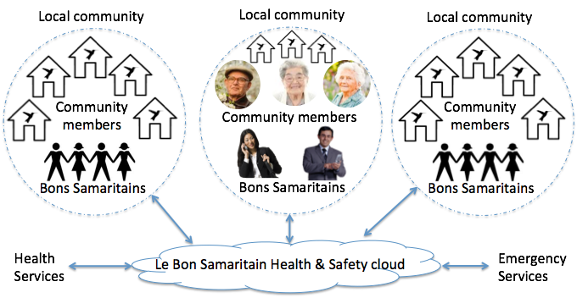
Figure 1. A new model of care combining Health, Emergency and Community services.

In this model, Bon Samaritans deal with non urgent, non life threatening alerts raised in their community and therefore save time (and money) by not involving health and emergency services. Bons samaritains do not replace emergency and health services for urgent life threatening alarms and in those cases, the normal procedures and channels of communication are used. For example, a Bon Samaritain volunteer will act when a member of the community does not react to an alert (e.g. fire alarm) within reasonable time and the volunteer will then go to the person’s residence or phone to check on that person.
We identified 6 alert levels (green - red) inspired by the Triage system commonly used in hospitals [9]. Table 1 shows examples of the various alert levels and interactions between community members, Bon Samaritains and health/emergency services. Using smart home technology, the sensors in a residence can communicate with the Bon Samaritains and emergency/health services if a certain alarm level has been reached.
The model is flexible and can be tailored to a specific community (e.g. rural, urban) and specific needs of that community (e.g. elderly with social isolation problems, fire prone area). The alarm threshold levels in Table 1 are refined in cooperation with the different stakeholders in the community and have to comply with the local regulations. The user gives consent that data collected from sensors will be made available to the Bon Samaritans and emergency/health services for the sole purpose of providing monitoring services. The data is securely stored in the cloud and not accessible by other parties.

Table 1. Examples of Alert levels and interactions

 | Green  0  OK | Lime green  5  Non-urgent | Yellow  4  Semi-urgent:  not life threatening | Amber  3  Urgent:  not life threatening | Orange  2  Emergency: could become life threatening | Red  1  Immediate: life threatening
Community members  ↑↓  Bons Samaritains | OK | e.g. Saw something  /will do something | e.g.Feeling down  Worried  /Will pass by at 2pm | e.g.Locked out of house/  will open the door in 3mn | e.g.Kitchen on fire  /  fire brigade on its way | e.g. Heart attack ambulance called defibrillator on its way called
Community members  ↑↓  Health and emergency services | OK | Info to the Community  e.g. severe thunderstorm expected | Info to the Community  e.g. heavy rain with minor flooding expected | Info to the Community  e.g. bushfire 50 kms from community | Two way info  e.g. Kitchen on fire | Two ways info  e.g. Heart attack
Connected home  ↑↓  Community members and Bons Samaritains | OK | e.g. battery low of smoke detector | e.g. smoke detector not working | e.g. gas leak detected | e.g. heart rate above 150 bpm for elderly person not moving | e.g. Fall detected, no reaction and  heart rate below 50bpm
Connected home  ↑↓  Health and emergency services | none | none | none | none | e.g. gas leak detected by sensors no alarm raised by owner | e.g. fire detected no alarm raised by owner within 2mn
Bons Samaritains  ↑↓  Health and emergency services | none | none | none | Two way info  e.g. potential flooding threatens the community | Two way info  e.g.  Assistance with person being unwell | Two way info. e.g. person has a heart attack. CPR instructions given

Technology to support ‘Le Bon Samaritain’
For the realisation of the Bon Samaritain care model we use a combination of low cost, off-the-shelf sensors and smart-home components to form a ‘connected home’. The sensors can be inside the house or outside (e.g surveillance camera) and are securely connected to the Le Bon Samaritain cloud. Other members of the community are connected to the cloud via their mobile devices or web browser. A member of the community decides what he/she wants to be monitored. The technology used varies from smoke detectors, movement detectors, webcams to wearable devices monitoring someone’s vitals signs such as heart rate and respiration. For rural areas, outdoor infrared sensors can be used to detect approaching bushfires or intrusion detection sensors. The role of the connected home is to gather, filter and analyse the incoming data and to trigger and manage the alarm events based on the layered alert model depicted in Table 1. More importantly, the connected home acts as a social gateway entity that allows the members of the community to interact with each other.

Bon Samaritain volunteers
The data collected by the sensors, as well as, given by community members (e.g. locked myself out of the house) is aggregated, analysed and then presented to the group of Bon samaritains for that particular community. Figure 3 left shows the dashboard for a Bon samaritain responsible for a group of people. A triage system is used for the different alert levels as described in table 1. In this example, a red alert is generated for John Smith because of prolonged high heart rate. The mobile app will automatically alert all Bon samaritains for that community and the first Bon samaritain to react can then decide to call John or go directly to his apartment to check it out. If the alert is life threatening and no Bon samaritain reacts within a certain time interval the alert is forwarded to health or emergency services. A yellow alert is generated for less urgent matters such as being locked out of the apartment. The green status indicates that all is okay and no action needs to be taken. When a member of the community is away or disabled monitoring the offline status is shown.

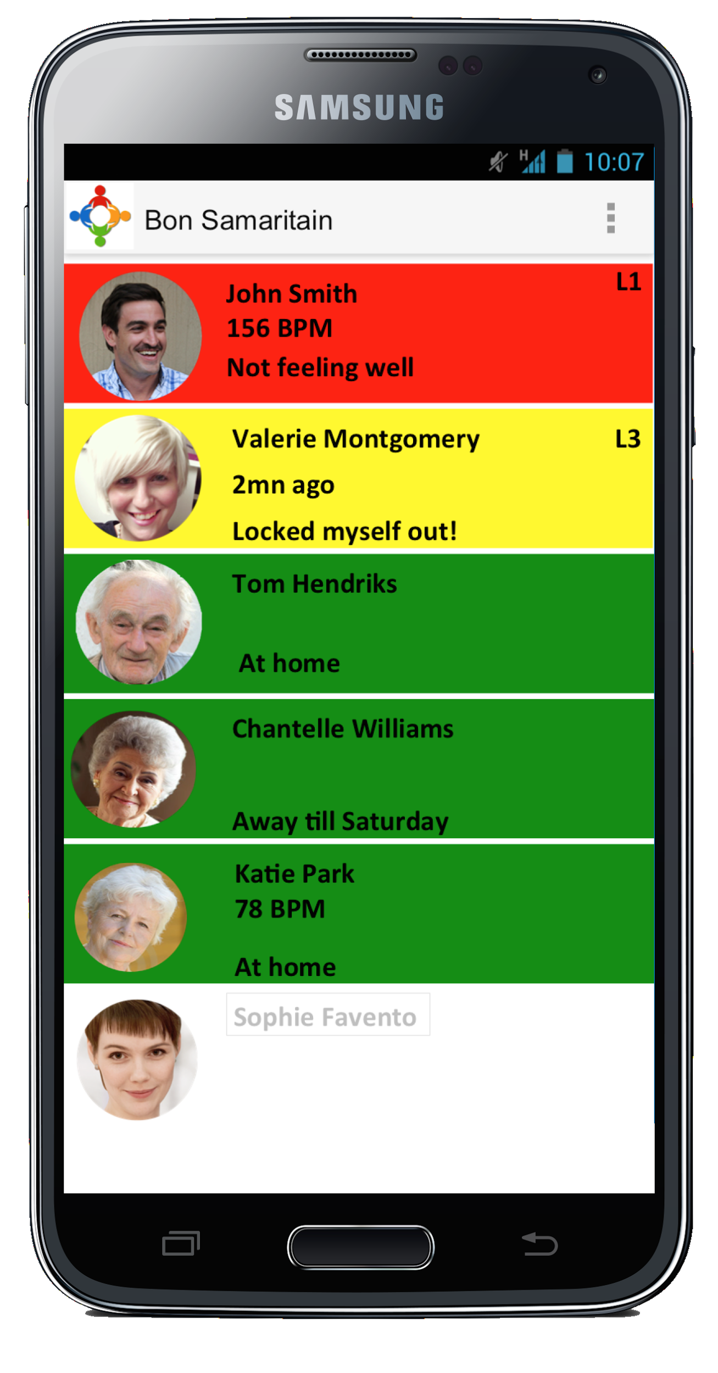 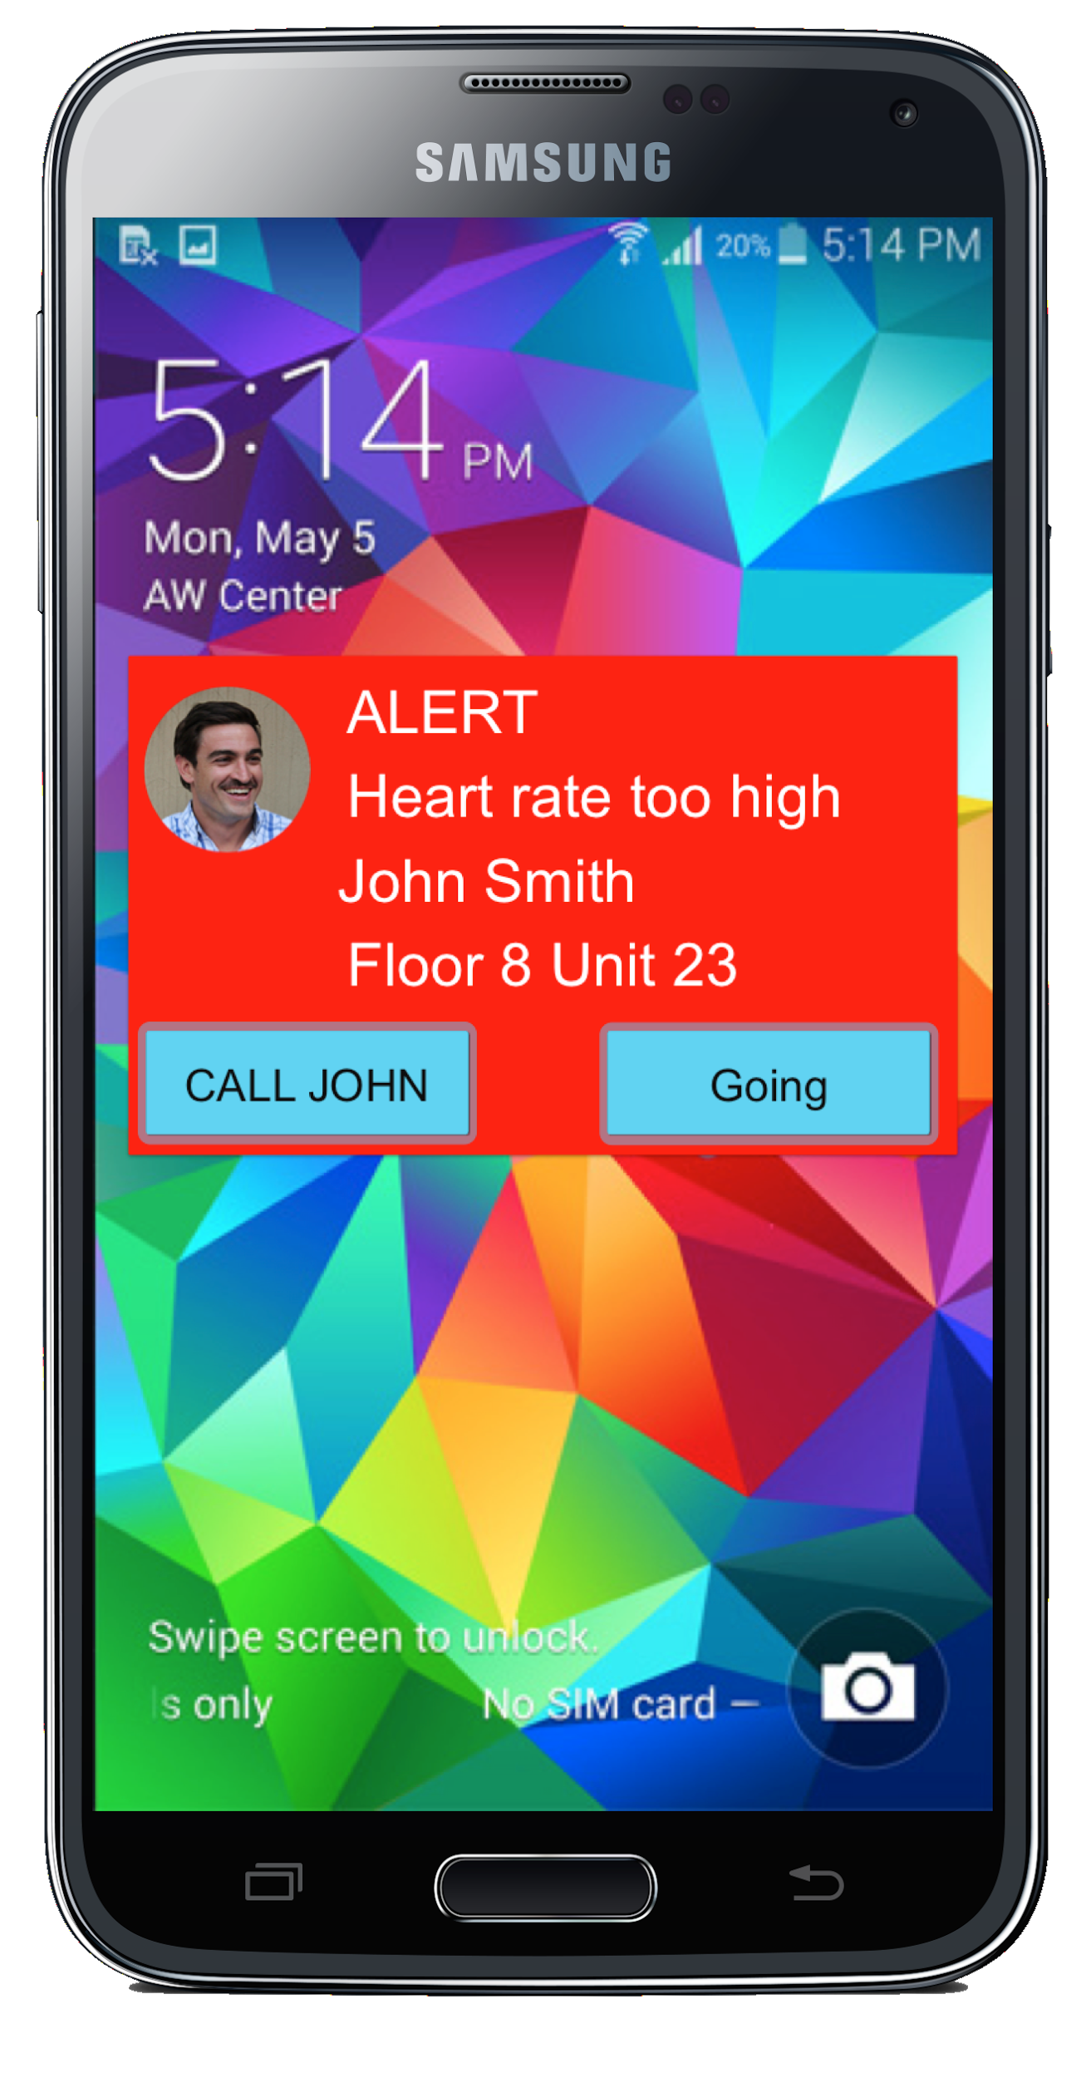
Figure 2. Bon Samaritain dashboard and alarm raised situation.

Bon Samaritain Cloud
The Bon Samaritain Cloud is an on-demand cloud service for information exchange. It enables real-time information exchange between the involved parties such the members of a community, emergency and health service agencies. There are three key information components: local community information, emergency warning and health information. The emergency warning and health information component is enhanced with geolocation and delivers the information to the communities via different channels depending on the situation (e.g. mobile device, TV, radio or smart bulbs). The Bon Samaritain Cloud stores and manages information about the community and health and emergency services. It allows the creation of individual community profiles and each community can manage its own community information. People living in a particular area can join a community and configure the sensors and wearable devices they use and how they want to be monitored. The user can opt-in for one or more community services (e.g. emergency only). Users are in control of what they want to expose to the Bon Samaritain volunteers. The granularity of the consent depends on the category of service chosen and on the community. Each community receives emergency warning and health information alerts applicable to that community. The Bon Samaritain Cloud allows Bon Samaritain volunteers and individual members to send alerts to health and emergency services based on the triage system described above.

Discussion
The new model of care described in this paper has the potential to empower the community and reduces the burden on health and emergency services. The underlying technology presented is currently under development. Earlier prototypes addressing part of the Bon Samaritain solution show that it is feasible to build a low cost, scalable community focused system. In one proof of concept we used a Raspberry-Pi device using 3G network to communicate with the Bon Samaritain Cloud (Google App Engine). The device can be installed anywhere in a home and alerts are shown using lights (red, yellow, green) and/or sound for various alert levels. The prototype provided insight in the applicability and viability of inexpensive devices.
With governments wanting to spend less money on health and emergency services and at the same time a growing population where people live longer we believe that the model proposed in this paper has potential. It goes back in time where community care was normal and where people would look after each other. We give community care a new meaning by using off-the-shelf technology and reconnect people using digital technology but not dismissing the human-to-human interaction when needed. The philosophy is that small problems are solved within the community using Bon Samaritains and only emergency and health services are used when really needed. This should lower the burden on these agencies, save time and money and empower the communities. This initial study highlights that it is technologically feasible. The new model of care is in line with the Natural Disaster Resilience Program [10] whose focus is to enhance the community resilience to crisis situation for sustainable communities across Australia. It can help people feel safer, less isolated and more integrated in their community.
References
- Commonwealth of Australia 2013, National Strategy for Disaster Resilience, Community Engagement Framework, Australian Emergency Management Institute, Commonwealth Attorney-General’s Department. http://www.em.gov.au.
- W. B. Lee, Y. Wang, W. M. Wang, C.F. Cheung, An unstructured information management system (UIMS) for emergency management, Knowledge Management Research Centre, Department of Industrial and Systems Engineering, The Hong Kong Polytechnic University, 2012.
- J. Sutton, and L. Plaen, Backchannels on the From Lines Emergent uses of social media in the 2007 California Wildfires, University of Colorado: Bolder, 2011.
- Royal Commission Report. Queensland Floods Commission Inquiry – Interim Report, 2011, www.floodcommission.qld.gov.au.
- J. Fan, P. Zhang, D.D. Yen, G2G information sharing among government agencies, Information and Management, 2014, 51, pp. 120-128.
- Duffy, A. and O’Donnell F. 1998, ‘A Design Research Approach Presented at AID’98 Workshop on Research Methods in AI in Design’, Lisbon, Portugal, 19 July 1998, pp 20-27 & Published in “Critical Enthusiasm - Contributions to Design Science”, ISBN 82-91917-08-6, Dec’99, pp33-40.
- A.Q. Gill and D. Bunker, Crowd Sourcing Challenges Assessment Index for Disaster Management, Proceedings of the 18th AMCIS 2012, Seattle, USA.
- Civil Law (Wrongs) Act 2002 (ACT) s 5; Civil Liability Act 2002 (NSW) ss 55-58;Personal Injuries (Liabilities and Damages) Act 2003 (NT) s 8; Law Reform Act 1995 (Qld) ss 15 and 16; Civil Liability Act 1936 (SA) s 74; Civil Liability Act 2002 (Tas) ss 35A-35C; Wrongs Act 1958 (Vic) ss 31A-31D; Civil Liability Act 2002 (WA) ss 5AB and 5AD.
- Law Reform Act 1995 (Qld) s 16.
- Victoria Health, better health channel, Emergency department, http://www.betterhealth.vic.gov.au.
- NDRP 2013-15, http://www.mpes.nsw.gov.au/content.php/1269.html.

