Effect of heat-press conditions on electrospun membranes for desalination by direct contact membrane distillation
Minwei Yaoª, Yun Chul Wooª, Leonard D. Tijing^{a,*}, Wang-Geun Shimª, June-Seok Choi^{b}, Seung-Hyun Kim^{c}, and Ho Kyong Shon^{a,*}

ªCentre for Technology in Water and Wastewater, School of Civil and Environmental Engineering, University of Technology Sydney (UTS), P. O. Box 123, 15 Broadway, NSW 2007, Australia
^{b}Environment and Plant Research Institute, Korea Institute of Civil Engineering and Building Technology (KICT), 283, Goyangdae-Ro, Ilsanseo-Gu, Goyang-Si, Gyeonggi-Do 411-712, Republic of Korea
^{c}Civil Engineering Department, Kyungnam University, Wolyoung-dong, Changwon, 631-701, Republic of Korea

*Corresponding authors: H.K. Shon, e-mail: Hokyong.shon-1@uts.edu.au, tel: +61 2 9514 2629; L.D. Tijing, e-mail: Leonard.Tijing@uts.edu.au, tel: +61 2 9514 2652

Keywords: Electrospinning, post-treatment, heat-press, direct contact membrane distillation, desalination

Abstract
Membrane distillation (MD) is considered as a promising next-generation technology for desalination. However, there is no specific membrane designed and engineered for this application yet. Recently, electrospun polymeric membranes have been widely investigated due to their relatively high porosity, high hydrophobicity and controllable pore size. However, the robustness of such membranes is not guaranteed as they are susceptible to wetting in long-term operation. Heat-press treatment is a simple and effective procedure to improve both morphological and mechanical characteristics of the electrospun membrane. Nevertheless, the heat-press technique is not fully investigated although some conditions are applied to the electrospun membrane in previous researches. In this paper, a comprehensive investigation of the effect of heat-press temperature, pressure and duration on the morphological and mechanical characteristics of electrospun membrane is accomplished. Impressive improvement of mechanical strength and liquid entry pressure (LEP) can be achieved after heat-press treatment on the electrospun membranes. It is also found that temperature and duration play more important roles than pressure in heat-press treatment. In addition, it is ascertained that optimal treatment conditions for heat-press includes temperature at 150 ºC, pressure at 6.5 kPa, and duration for 8 h for the present electrospun polyvinylidene fluoride-co-hexafluoropropylene membrane. A decent DCMD permeation flux of 29 LMH and salt rejection of 99.99% can be achieved with the optimally heat-pressed electrospun membranes for desalination at feed and permeate temperatures of 60 and 20 ºC, respectively.

1. Introduction
Water and energy have been recognised as the top two major challenges in the world today and in the coming future. Nowadays, lots of freshwater resources are becoming unrenewable due to climate change and massive human activities. Moreover, the water shortage issues are much more serious in some countries with bad climate and poor economic conditions, so lack of clean water is a great threat to the hygiene of local residents [1].
Desalination is a viable option to obtain freshwater supply stably for coastal countries that are short of fresh water, and currently reverse osmosis (RO) is widely applied in desalination due to its relatively high efficiency. However, the capital and maintenance costs of RO plants are high and large amounts of electrical energy are required for generating high pressure in the process. In addition, RO has negative impact on global environment by carbon dioxide as the generation of electrical energy is very likely fossil-fuel based. RO brine disposal is another major issue that is widely concerned by the society due to their impact on the local ecological system. Therefore, development of new generations of technology is strongly needed for replacement of RO technology [2].
Membrane distillation (MD) has been considered as a promising next-generation technology for desalination because of its higher efficiency and permeation performance independent on the salt concentration [3, 4]. The potential usage of low grade heat such as industrial waste heat or solar heat makes it a more attractive option. The MD mechanism is based on a separation process where water vapor molecules at feed side pass through pores of a hydrophobic membrane and condenses at permeate side [5-8]. The driving force of the vapour molecules is generated by the temperature difference of vapours between both sides of the membrane [9]. Evaporation of liquid water occurs at the membrane interface with the contact of hot solution [10]. The vapour molecular then diffuses through the pores to the other side of interface where it condenses by cool permeate side [11].
However, as an emerging technology, MD has not yet been widely applied in the global water industry due to lack of suitable membranes for long-term operation. Qualities such as strong resistance against wetting and fouling is lacking in current available membranes on the market [12]. At the moment, membranes designed for microfiltration are utilized in MD and they are mainly made of polyvinylidene fluoride (PVDF) due to its high hydrophobicity, good solubility in common solvent, and high resistance against chemicals and heat [10, 13]. Non-solvent-induced phase separation (NIPS) and thermally induced phase separation (TIPS) are the two most common approaches exercised to fabricate membranes. However, these membranes are not good enough for MD processes due to their low flux performance and susceptibility to wetting [14-17]. Thus, recently there is an increasing trend on membrane fabrication with new approaches for MD. Zhang et al. noted that the main challenges for membranes used in MD are to design features including porous structure and superhydrophobic surface for good filtration performance, as well as high mechanical properties for long-term operation [18].
Electrospun membranes possess some appropriate advantages involving high hydrophobicity, high porosity, adjustable pore size, and membrane thickness, which make them attractive candidates as MD membrane [2, 19]. Compared to NIPS and TIPS, electrospinning is a relatively simple technique to fabricate membrane. By applying high electric fields on a polymer solution, millions of fibers are formed joining together to become nonwoven membrane sheet and collected on the collector [19, 20]. Though electrospun membranes have many attractive properties for MD, however, they had some drawbacks limiting its performance, including relatively big pore sizes, low mechanical properties, and LEP compared to the membranes fabricated by casting methods. Thus, there is a requirement to improve these characteristics without sacrificing high porosity and hydrophobicity by some membrane modification approaches [20]. For this reason, post-treatment process, one type of membrane modification procedures, has been widely applied on the electrospun membrane to enhance its morphology and characteristics including robustness and capability against wetting [21, 22]. Previous studies indicated that “heat-press” could enhance the desalination performance by changing mechanical and morphological structure of the membranes in a favourable way [20, 23]. It is expected that higher LEP, higher mechanical strength, lesser thickness, smaller average pore size and more uniform distribution of the pore size can be obtained through this technique.
Though a few studies have utilised heat-press to modify their MD membranes, the post-treatment approach is still not fully investigated (i.e., only few heat-press conditions were used) especially for electrospun membranes. Hence, in this study, the effect of different heat-press conditions such as temperature, pressure, and duration are comprehensively investigated to determine their effects on the electrospun membrane properties and MD performance. The optimal heat-press condition set is then identified and applied on electrospun membranes with various initial thicknesses to check the improvement. MD tests with as-spun, heat-pressed and commercial membranes are conducted and compared regarding permeation flux and salt rejection.

2. Experimental

2.1 Materials
The polymer used for the fabrication of membranes was polyvinylidene fluoride-co-hexafluoropropylene (referred herein as PH, MW = 455,000), and it was purchased from Sigma-Aldrich, USA. Acetone (ChemSupply, Australia) and N,N dimethylacetamide (DMAc, Sigma, USA) were used as solvent. All the chemicals were used as received without further purification. A polypropylene (PP) filter layer purchased from Ahlstrom was applied in each MD experiment as support layer. Commercial microfiltration membrane (pore size = 0.22 µm, porosity = 70%, GVHP) bought from Millipore was used for MD test as a reference.

2.2 Membrane fabrication by electrospinning
PH at 20 wt% was dissolved in a mixed solvent consisting of acetone and DMAc (1:4 acetone/DMAc ratio). To obtain homogenous polymer solution, the mixture was magnetically stirred for 24 h. The prepared PH solution was then stored in a 12 ml plastic syringe fitted with a 21G nozzle (internal diameter = 0.51 µm). Fig. 1 illustrates the configuration of the electrospinning device used in this study. The polymer solution was pulled out of the syringe by the syringe pump and formed whipping fibers within a high voltage electrical field (applied voltage = 21 kV). Then fibers were collected onto the rolling drum after most contained solvent evaporated during the whipping process. During electrospinning process, the nozzle was continuously moving inwards and outwards parallel to the axis of the rotation of the drum. The setting operation conditions for electrospinning were constant throughout the study in all the experimental stage: The distance between the nozzle tip and collector was set at 20 cm. The syringe pump had a pushing rate of 1 ml/h and had been running continuously for 6 h for each membrane sample from Stages 1-3 (see Table 1). In Stage 4, longer durations of electrospinning were utilised for thicker membrane.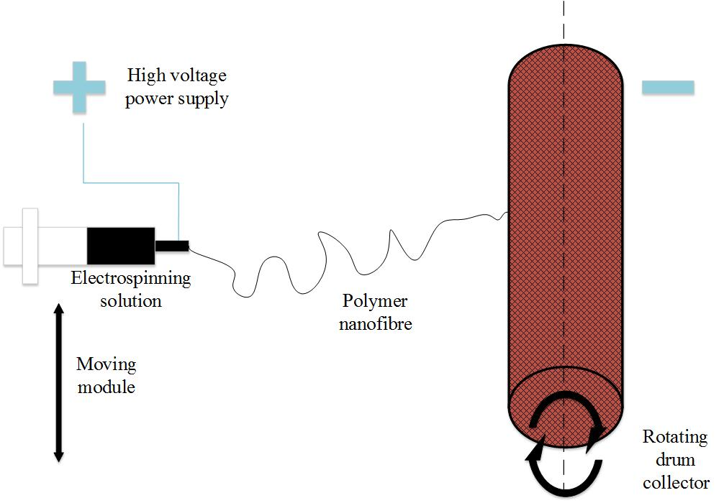
Figure 1. Schematic diagram of the electrospinning configuration.

2.3 Heat-press post-treatment
After electrospinning, the as-spun membranes were removed from the collector and initially dried at 50 ºC for 2 h inside an air flow oven (OTWMHD24, Labec, Australia). Membranes were then fully covered by foils, placed between flat metal plates with dead weight placed on the top plate, and put in a pre-heated oven. In each stage, various conditions (heat-press temperatures of 140, 150, 160, 170 ºC; pressing pressure (i.e., dead weight on top of the membrane) of 0.7, 2.2, 6.5, and 9.8 kPa; and heat-press duration of 1, 2, 4 and 8 h were applied to the membrane as detailed with their name conventions in Table 1. The samples were investigated and compared separately in three consecutive stages classified by the conditions for deeply understanding their effects.
As shown in Table 1, the experiments could be classified into four stages in this study. In Stage 1, four various temperatures were selected and tested. The applied pressure was pre-set to be 2.2 kPa (7 kg dead weight using metal plates over a 15 mm x 20 mm membrane) and 2 h was selected as the duration of the process. Then, in Stage 2 (i.e., effect of heat-press pressure), the treatment temperature was fixed at 150 ºC; then four various pressures were chosen in a wide range to check their effects. The duration of heat-pressure was pre-set to be 2 h. In Stage 3, the temperature and pressure was set at 150 ºC and 2.2 kPa respectively, and the duration varied from 1 h to 8 h. Characteristics of post-treated membranes in each stage were addressed and compared. In Stage 4, optimal heat-press conditions were applied on the membranes with various thicknesses, in the range between 103 to 395 µm. Both as-spun and heat-pressed membranes were characterized. Selected as-spun and heat-pressed membrane samples from Stage 4 were applied in the DCMD for desalination, and their permeation performances (flux and salt rejection) were compared with the commercial membranes (GVHP, 0.22 pore size, and 110 µm thickness).

Table 1. Heat-press conditions and name conventions used in the present study.
Electrospun membrane samples |  | Heat-press conditions
 |  | Temperature (°C) | Pressure (kPa) | Duration (h) | Thickness (µm)
As-spun | Neat | - | - | - | 45
Stage 1 | M0 | 140 | 2.2 | 2 | 43
 | M1 | 150 |  |  | 39
 | M2 | 160 |  |  | 31
 | M3 | 170 |  |  | melted
Stage 2 | M1-A | 150 | 0.7 | 2 | 40
 | M1-B |  | 2.2 |  | 68
 | M1-C |  | 6.5 |  | 37
 | M1-D |  | 9.8 |  | 37
Stage 3 | M1-B-1 | 150 | 2.2 | 1 | 38
 | M1-B-2 |  |  | 2 | 38
 | M1-B-3 |  |  | 4 | 37
 | M1-B-4 |  |  | 8 | 36
Stage 4 | PH1 | - | - | - | 103
 | PH2 |  |  |  | 147
 | PH3 |  |  |  | 224
 | PH4 |  |  |  | 395
 | PH1’ | 150 | 6.5 | 8 | 90
 | PH2’ |  |  |  | 129
 | PH3’ |  |  |  | 195
 | PH4’ |  |  |  | 343

2.4 Characterization
The morphologies of all membrane samples were examined by a scanning electron microscope (SEM, Supra 55vp from Carl Zeiss AG). ImageJ software (National Institutes of Health, USA) was used to analyse the SEM images to work out the average fiber diameter, surface pore size and their distributions, and three SEM images from different spots of the membrane samples were used for each fiber and pore size analysis. Membrane thickness was measured with digital micrometer (IP65, Mitutoyo) and the average value of ten randomly picked spots was calculated for each sample.
Contact angles (CA), a major indicator of hydrophobicity, were measured by Theta Lite 100 (Attension) following sessile drop method [1, 21]. A water droplet around 5~8 ml was released from a needle tip onto the membrane surface. A motion camera was mounted to capture the images at a rate of 12 frames per second. Through the recorded videos, contact angles was analysed with the aid of specific software. To ensure experimental reproducibility, each set of samples were measured in triplicate and the average value of them was taken.
Mechanical properties including maximum stress, strain, and Young’s modulus were measured with bench-type tensile tester (Lloyds). Average values of three runs were taken for each sample.
LEP test was carried on the as-spun and heat-press membrane samples with a homemade setup. A digital gauge was connected to a hollow stainless plate with a pipe, and nitrogen gas was released from the other end of pipe. On the stainless plate, there was a stainless cylinder container that was filled up with deionised (DI) water. The set-up had an effective surface area of 7 cm². The samples were fixed on the top of cylinder by a stainless cap and a lock catch was used to secure the set-up. Pressure displayed on the gauge was recorded when water droplets came out through the membrane during the process of steadily releasing out nitrogen gas. Each sample was tested in triplicate and average data was recorded.
Membrane porosity was defined as the volume of the pores divided by the total volume of the membranes. It was determined by a gravimetric method in this study. After the membranes were immersed in ethanol (Univar 1170 from Ajax Finechem Pty. Ltd.) for adequate time to ensure that the pores fully filled up, the weight (w₁, g) of membrane with ethanol was measured after the residual liquid on the surface was removed. Then the membrane samples were left still in the open air for some time and got weighed (w₂, g) when all the ethanol within them had fully evaporated (i.e., dry condition). The porosity then could be worked out with the following equation:
$$ε_{m}=\frac{{\left(w_{1}-w_{2}\right)}/{ρ_{e}}}{{w_{1}-w_{2}}/{ρ_{e}}+w_{2}/ρ_{ph}}$$
, where $ρ$ _{e} was the density of the ethanol (g/cm³) and $ρ$ _{ph} was the density of the PH (g/cm³) [1].

2.5 Direct contact membrane distillation (DCMD) test
MD is normally applied in four principal configurations: direct contact MD (DCMD), air gap MD (AGMD), vacuum MD (VMD), and sweeping gas MD (SGMD) [6, 9]. This study is focusing on DCMD configuration due to its higher permeation performance and relative ease of set up. The electrospun membranes were tested in DCMD setup shown in Fig. 2. Supported by a PP filter layer, the membrane samples were fixed in the DCMD cell module. The length and width of both feed and permeate channels were 77 mm and 26 mm respectively, making up an effective membrane area of 20 cm². The module was placed horizontally and ran in counter-current mode with feed flow on top side [1,24]. Sodium chloride (NaCl) at a concentration of 3.5 wt% in water was used in the feed side, and its temperature was being maintained at 60 °C by a heating bath. Deionised (DI) water was used in the permeate side, and its temperature was being kept at 20 °C by a chiller. The mass flow rates in both permeate and feed sides were being maintained at 400 ml/min via a gear pump. The running conditions and parameters of DCMD were being kept unchanged in the whole experiment, and each condition of heat-press was tested three times with a new sample for ensuring experimental reproducibility. A desktop computer was set-up to collect the data of temperatures in both feed and permeate sides automatically via thermocouples connected to the flow lines. The flux was calculated by dividing the change of mass in the permeate container by the duration of change while the reading of mass was collected automatically once every minute on the linked electronic balance.
Figure 2. Schematic diagram of DCMD process

3. Results and discussion

3.1 Effect of heat-press temperature on the membranes
PH was used in this study with a melting point of 155-160 ºC as described by the manufacturer [25]. The existence of co-polymer (HFP) reduced the melting point of the PH hence it had a slightly lower melting temperature than pure PVDF. It was because HFP had lower surface tension [26].
In Stage 1, various temperatures were applied on the membranes samples separately. The samples were named as M0, M1 and M2, corresponding to the applied heat-press temperatures of 140, 150 and 160 ºC to the electrospun membranes, respectively.
Figure 3. SEM images of as-spun and heat-pressed PH membrane at magnifications of 10 K and 50 K: (a)as-spun neat membrane (Neat); membranes heat-pressed under (b) 140 °C (M0); (c) 150 °C (M1); and (d) 160 °C (M2).

Fig. 3 shows the morphologies of as-spun and heat-pressed membrane under various temperatures (at 140, 150 and 160 °C) at low and high magnifications. It could be observed that some of the fibers fused together after heat-press treatment was applied, and there were increasing numbers of fused fibers with the increase of the heat-press temperature. From the SEM images, the heat-pressed electrospun fibers were obviously larger than as-spun membranes, and the average surface pore size decreased as the fibers widened, which was also observed by other researchers [27]. The measured surface pore size distributions (PSD) displayed in Fig. 4 showed an obvious trend. It was found that increasing the heat-press temperature could narrow the PSD and decrease the average pore size (Table 2). Similarly, Liao et al. and Wu et al. applied heat-press treatment with similar processes and conditions on PVDF electrospun membranes and obtained smaller pore size of electrospun membranes [23, 27].
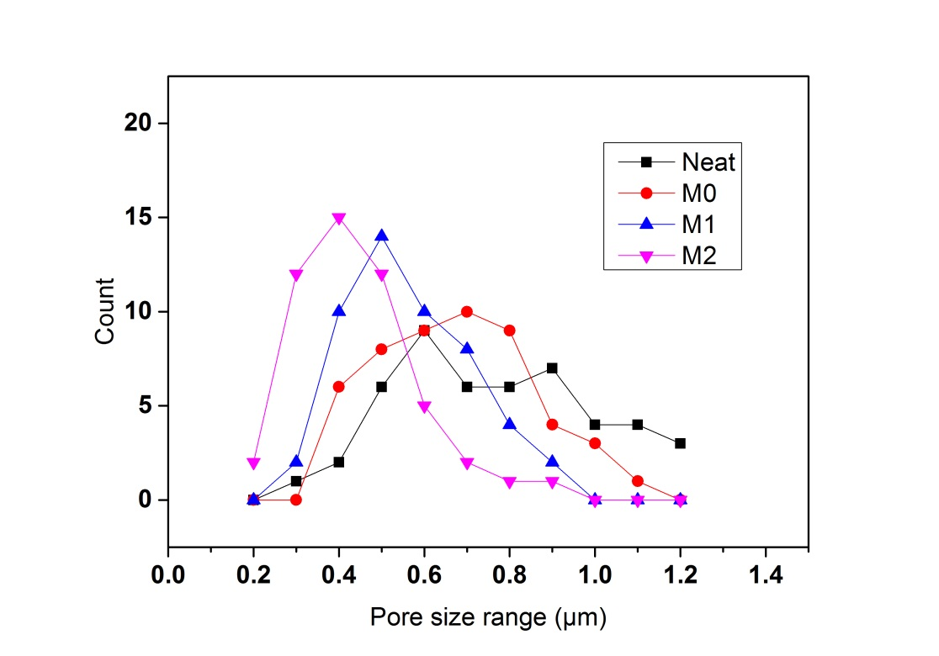
Figure 4. Pore size distributions of as-spun and membrane samples heat-pressed under various temperatures.

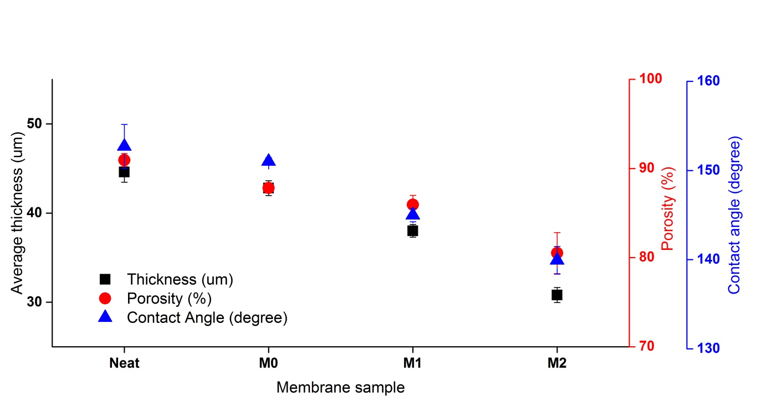
Figure 5. Effects of temperature on thickness, porosity and contact angle
Details of average fiber and surface pore sizes can be found in Table 2 that clearly shows an increase of fiber size and decrease of surface pore size when heat-press temperatures were raised.
The thickness of the heat-pressed membranes was affected by the temperature in an inverse manner, i.e., at higher temperature, thinner membranes were obtained. Membranes without heat-press treatment (i.e., neat or as-spun) had a thickness of 46 µm. After being heat-pressed at 140 ºC, the membrane’s thickness decreased to 41 µm. Further increase of the heating temperature to 150 ºC could make the membrane even thinner. It was assumed that at high temperature multiple layers of fiber in membrane fused together and formed much denser structures, so the membrane became thinner. And further increasing temperature could increase the compaction level [1]. However, when the temperature reached 160 ºC, the thickness decreased sharply to 31 µm. It was believed that partial melting had occurred as some regions of the internal fibrous network melted together [23]. When heat-press temperature reached 170 ºC (higher than the melting temperature), the phenomenon of total melting of the membrane samples could be observed by the naked eyes. Therefore, temperatures over 160 ºC was not applied in Stage 1 experiments. Porosity of membrane shared a similar trend of the thickness. Neat PH had the highest porosity of 92% and the M2 had the lowest porosity of 80% (Table 2). The reduction of the porosity after heat-press was on account of the loss of some voids by compaction.
Fig. 5 shows that the contact angle decreased steadily with the increase in applied heat-press temperature. At the highest tested temperature, i.e. 160 ºC (M2), the CA dropped significantly to 140.0º, indicating that a partial melting of polymer on the surface has occurred (see Fig. 3). Generally, the surface of the membranes became less rough at higher heat-press temperature when the membrane started melting and fusing. It meant that the membrane surface would become less hydrophobic [22, 23].
Table 2. Characteristics of the membranes after heat-press at different temperatures
Parameter/Sample | Neat | M0 | M1 | M2
Fiber size (µm) | 0.39 ±0.12 | 0.55 ±0.19 | 0.69 ±0.24 | 0.75 ±0.30
Surface pore size (µm) | 0.50 ±0.21 | 0.48 ±0.10 | 0.45 ±0.09 | 0.41 ±0.10
Young’s modulus (MPa) | 11.7 ±5.4 | 31.1 ±5.8 | 40.9 ±2.6 | 103.9 ±8.2
Stress at break (MPa) | 3.09 ±0.18 | 10.64 ±0.55 | 12.11 ±0.35 | 16.09 ±1.26
Strain at break | 0.66 ±0.05 | 1.30 ±0.08 | 1.56 ±0.19 | 0.84 ±0.15
LEP (kPa) | 71 ±9 | 65 ±7 | 83 ±4 | 64 ±6

At higher treating temperatures, more fibers could be observed to be fused at interlay points, and they could contribute to both decreased pore size and increase of mechanical strengths. It was found that maximum stress and Young’s modulus increased when temperature was raised. Higher tensile strength and Young’s modulus could be achieved with higher heat-press temperature. Especially, M2 had a much higher Young’s modulus than other samples, due to its greatly changed morphology. The membrane fibers partially melted, fused together, and formed layers of bulk polymer. LEP was greatly improved after heat-press, and the membranes would have better resistance against wetting and improved robustness [28]. LEP of M0 was found to be lower than neat membrane. It was because the membrane was not sufficiently heat-pressed so the morphology such as surface pore size was not adequately enhanced (or narrowed). However, the membrane thickness had decreased and it contributed to a smaller LEP [29]. On the other hand, M2, which had the smallest average pore size, had a decreased LEP as well. It was believed that the cause was significant reduction in thickness due to partial melting. The highest LEP among the tested membranes in this stage was found to be M1 and its value was 83 kPa. The improvement was attributed to its adequate fusion of fiber nodes and hence narrower PSD and smaller pore sizes. Additionally, the CA and thickness of M1 was just slightly reduced.
Based on Stage 1 results, the optimum heat-press temperature condition was found to be at 150 ºC. Thus in Stage 2, we utilised and fixed this condition to check the effect of heat-press pressure.

3.2 Effect of heat-press pressure on the membranes
Heat-press pressure plays an important role in affecting the morphology and characteristics of the membrane, and increasing pressure in heat-press process is expected to influence the membrane properties in a favourable way.
Keeping the heating temperature at 150 ºC and treatment duration for 2 h, four metal plates with mass of 2, 7, 20 and 30 kg were applied on the membrane samples individually, which were equivalent to heat-press pressures of 0.7, 2.2, 6.5 and 9.8 kPa, respectively. The samples were then named as M1-A, M1-B, M1-C and M1-D, respectively.
Figure 6. SEM images of heat-pressed PH membrane at magnifications of 10 K and 50 K: membranes heat-pressed under (a) 0.7 kPa (M1-A); (b) 2.2 kPa (M1-B); (c) 6.5 kPa (M1-C), and; (d) 9.8 kPa (M1-D).

Fig. 6 shows the morphologies of heat-pressed membranes under various pressures. It could be seen that although their surface structures shared similar features and fiber sizes looked nearly identical, more fused joints could be found in heat-pressed membranes under higher pressures. It was assumed that the external pressure could help the fibers fusing with each other. Analysis of surface pore sizes (Fig. 7) indicated that further increasing the pressures could narrow the PSD and reduce the average pore size. However, the samples M1-C and M1-D shared identical PSD and average pore size, and both had more favoured morphologies than the other two samples.
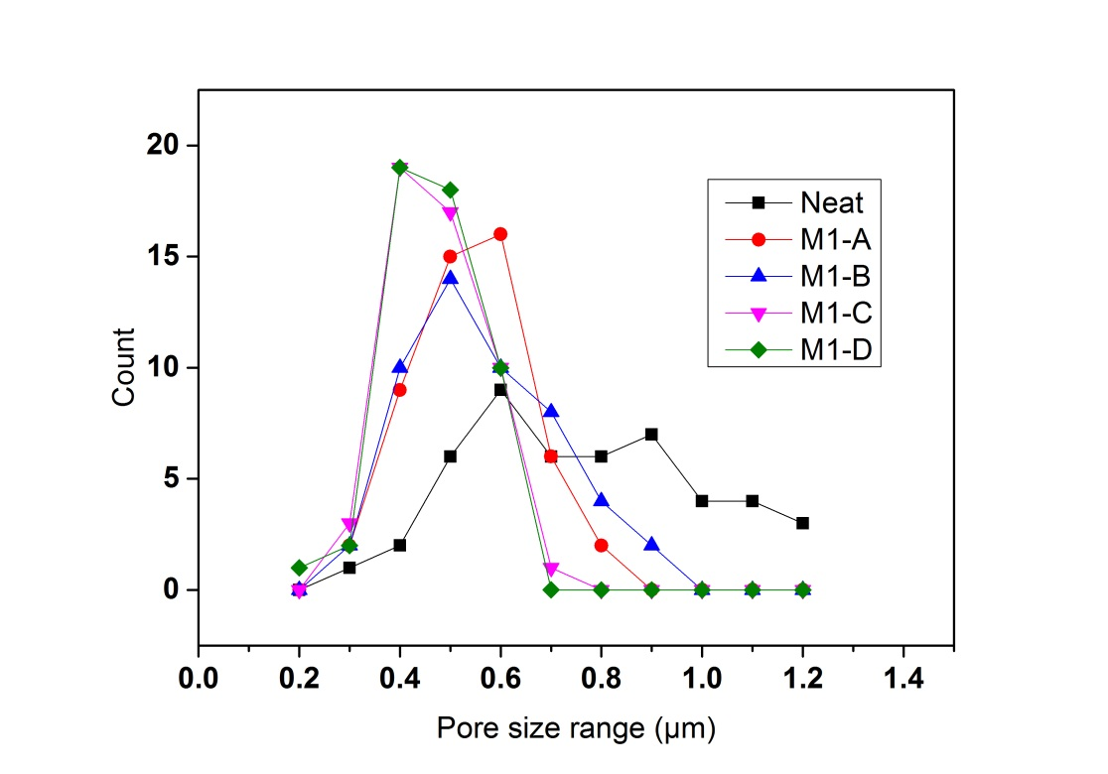
Figure 7. Pore size distributions of as-spun and membrane samples heat-pressed under various pressures.
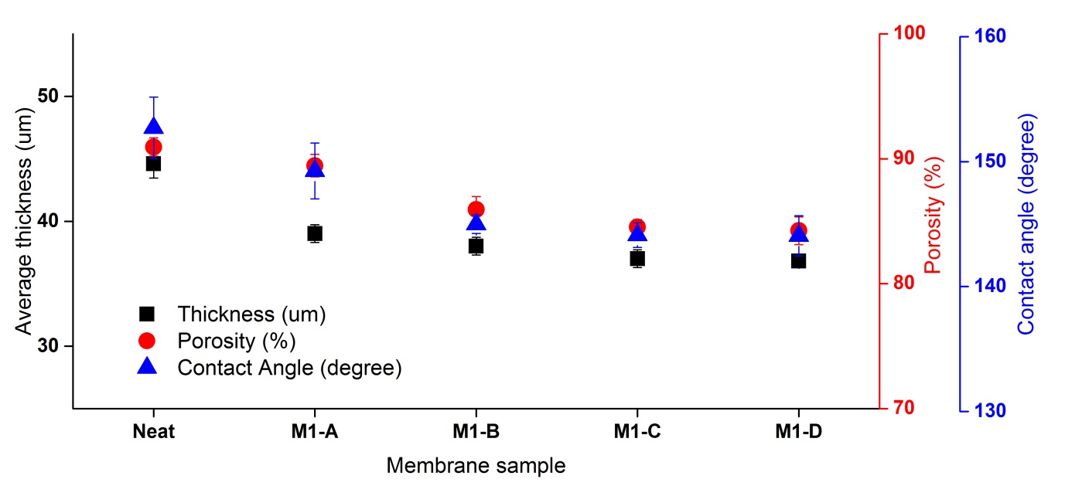
Figure 8. Effects of pressure on thickness, porosity and contact angle
It was observed that increasing pressure resulted in larger fiber size and smaller surface pore size. However, when the applied pressure was further increased beyond the value of 2.2 kPa, the effect of heat-press pressure on fiber sizes tended to become minimal (Table 3). It was also found that the difference of fiber size between M1-C and M1-D was insignificant. The two membrane samples shared very similar average size of 0.70 and 0.73 µm respectively, and their surface pore size was nearly identical (at 0.42 and 0.42 µm, respectively). It could be concluded that further increasing the pressure beyond certain values (6.5 kPa in this study) had no benefits on the characteristics of the membranes. In previous studies, heat-press pressures applied on the samples were also mentioned. Although we could find that only glass plates were applied on the membranes, increase of fiber size and decrease of pore size could be noticed [22, 23]. This meant that a moderate pressure higher than certain values should be sufficient for the heat-press treatment.
As displayed in Fig. 8, heat-press pressure had similar effects on thickness, porosity and contact angle, as all of three characteristics decreased when the applied pressure increased. However, the degree of the decrease was not as large as the tone affected by temperatures discussed in the last section. Additionally, M1-C and M1-D shared very similar values of thickness, porosity and contact angle, which meant that the membranes might have reached its maximum compaction level.
Table 3. Characteristics of the membranes after heat-press at different pressures
Parameter/Sample | Neat | M1-A | M1-B | M1-C | M1-D
Fiber size (µm) | 0.39±0.12 | 0.63±0.18 | 0.69±0.24 | 0.70±0.20 | 0.73±0.20
Surface pore size (µm) | 0.50±0.21 | 0.49±0.11 | 0.45±0.09 | 0.42±0.09 | 0.42±0.13
Young’s modulus (MPa) | 11.7±5.4 | 36.5±6.6 | 40.9±2.6 | 48.5±4.0 | 48.7±6.0
Stress at break (MPa) | 3.09±0.18 | 11.90±1.21 | 12.11±0.35 | 13.29±1.85 | 13.50±0.85
Strain at break | 0.66±0.05 | 1.30±0.08 | 1.56±0.19 | 1.42±0.38 | 1.38±0.19
LEP (kPa) | 71±9 | 73±8 | 83±4 | 93±4 | 89±3

Table 3 also shows that increasing pressure could enhance the mechanical properties greatly. M1-C had a Young’s modulus of 48.5 MPa which was much higher than M1-A. M1-C also had a higher tensile stress, which was the result of the changed morphology after heat-press [1]. However, when the pressure was further increased beyond 6.5 kPa, the increase of both Young’s modulus and maximum stress was found to be negligible. Effect of heat-press pressure on LEP shared similarities with effect of pressure on tensile strength. Although increasing pressure could increase LEP to some degree. However, further increasing pressure beyond 6.5 kPa did not improve LEP significantly because we could see M1-C and M1-D had very similar LEP values. Based on Stage 2 results, a pressure of 2.2 kPa was decided to be used (i.e., M1-B) for next stage experiments.

3.3 Effect of heat-press duration on the membranes
Heat-press duration has not been extensively studied in previous studies [27]. In recent relevant studies, there were two common approaches of heat-press process: the membrane samples were (1) placed in a pre-heated oven for 1 h [23, 26]; or (2) heat-pressed by extremely hot home iron for very short periods (e.g. 1-2 s) [22, 30]. Hence, there was a strong need to explore the effect of durations comprehensively. It was expected that the electrospun fibers could be better fused if the polymer films were heat-pressed for a longer duration, so both the morphology and characteristics might be improved. Thus four durations: 1, 2, 4 and 8 h were applied in post-treatment and their effects were investigated. The relevant samples were named M1-B-1, M1-B-2, M1-B-3 and M1-B-4, respectively.
Figure 9. SEM images of heat-pressed PH membrane at magnifications of 10 K and 50 K: membranes heat-pressed for (a) 1 h (M1-B-1); (b) 2 h (M1-B-2); (c) 4 h (M1-B-3); (d) 8 h (M1-B-4).
In Fig. 9, it can be found that when increasing the durations of heat-press, there would be more fiber fused with each other based on the observations of the changes in morphology. M1-B-4 had most fused fibers than the other samples and a large fused joint could be seen in 50 K magnifications of Fig. 9d, which was rarely found in other samples. Also, heat-pressed membrane for longer duration tended to have larger fiber size and hence smaller surface pore size. It was clearly displayed in Fig. 10 that membranes heat-pressed for 8 h had the narrowest PSD and smallest average pore size.
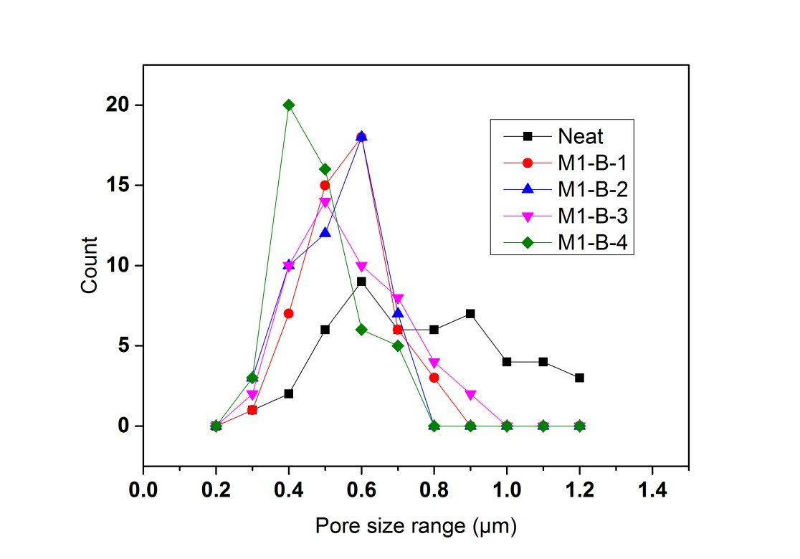
Figure 10. Pore size distributions of as-spun and membrane samples heat-pressed for various durations.

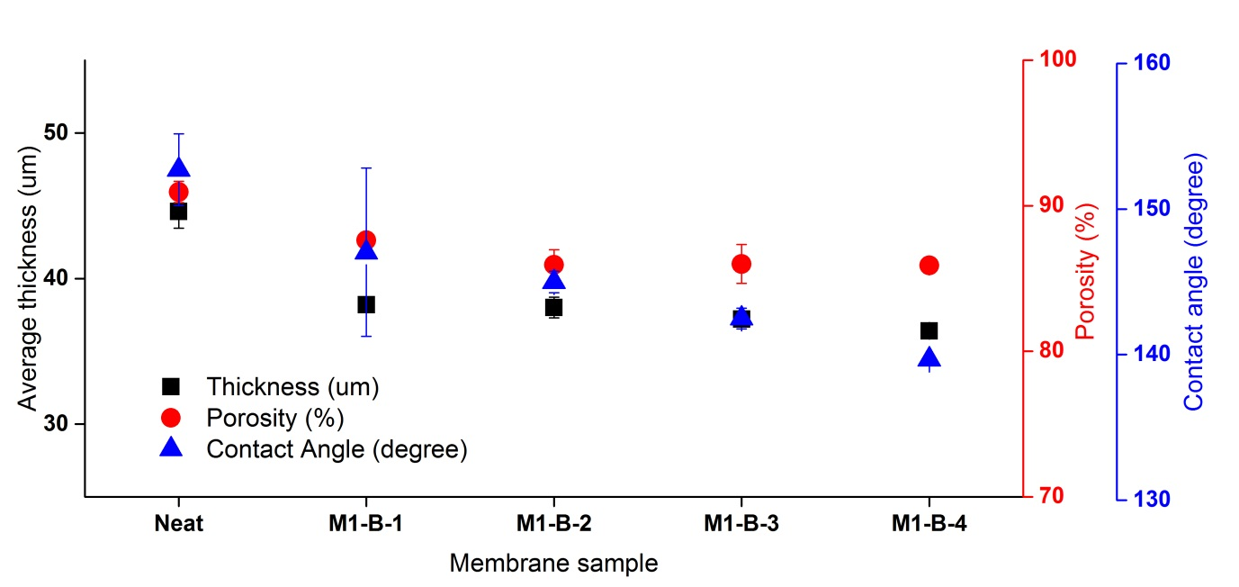
Figure 11. Effects of heat-press pressure on thickness, porosity and contact angle.
Fiber and surface pore size were strongly affected by the duration of the heat-press. It was observed that when membrane samples had been heat-pressed for 8 h, it had the largest fiber size of 0.80 µm and smallest surface pore size of 0.40 µm (Table 4).
Contact angle, porosity and thickness of membranes samples heat-pressed for various durations shared comparable trends. When the durations increased, the values of these characteristics decreased. Thickness and contact angle were affected by the duration more severely. However, it was interesting to point out that further increase of duration beyond 2 h had minimal influence on the porosity.
Table 4. Characteristics of the membranes after heat-press at different durations
Parameter/Sample | Neat | M1-B-1 | M1-B-2 | M1-B-3 | M1-B-4
Fiber size (µm) | 0.39±0.12 | 0.66±0.21 | 0.69±0.24 | 0.69±0.26 | 0.80±0.29
Surface pore size (µm) | 0.50±0.21 | 0.48±0.12 | 0.45±0.09 | 0.45±0.12 | 0.40±0.10
Young’s modulus (MPa) | 11.7±5.4 | 27.9±4.8 | 40.9±2.6 | 41.8±7.9 | 45.7±7.6
Stress at break (MPa) | 3.09±0.18 | 11.26±0.52 | 12.11±0.35 | 12.55±0.16 | 13.28±0.65
Strain at break | 0.66±0.05 | 1.54±0.11 | 1.56±0.19 | 1.55±0.08 | 1.39±0.26
LEP (kPa) | 71±9 | 58±4 | 83±4 | 82±4 | 90±7

The mechanical properties were also affected by the heat-press duration in a positive way. M1-B-1 had a lower tensile strength, indicating that the membrane was not sufficiently compacted and the electrospun fibers were not fully fused. Table 4 shows that M1-B-4 had the highest Young’s modulus and maximum stress. It meant that longer heat-press duration could increase the mechanical properties impressively. Heat-press duration could affect the LEP as well as we could see that M1-B-4 had the highest LEP of 90 kPa. It is interesting to state that M1-B-1 had LEP lower than neat membrane. It could be explained by the fact that the decrease of thickness affected the LEP of membrane negatively and the membrane fibers did not have sufficient time for being fused together to deliver higher resistance against fiber deformations under high pressures [31].

3.4 Effect of heat-press treatment on membrane with various initial thicknesses

In the previous stages (1-3), it could be found that samples of M1, M1-C and M1-B-4 had better PSD, LEP and mechanical properties in each of their belonging group, and their relative controllable conditions were temperature of 150 ºC, pressure of 6.5 kPa and duration of 8 h, respectively. It was assumed that the optimal heat-press condition could be achieved with the combination of the individual optimal conditions. Hence, the combination of 150 ºC, 6.5 kPa and 8 h was considered as the optimal heat-press condition set in this study. In Stage 4, four membranes samples with different initial thicknesses from 103 to 395 µm were exposed to the optimal heat-press conditions. The as-spun membranes were named as PH1, PH2, PH3 and PH4 corresponding to initial membrane thicknesses of 103, 146, 224 and 395 µm, respectively and their corresponding heat-pressed conditions were named as PH1’, PH2’, PH3’ and PH4’.
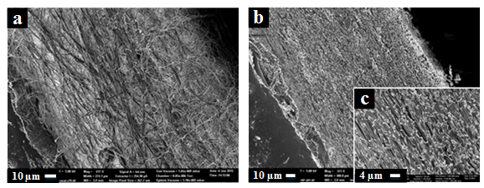Figure 12. Representative SEM cross section images of as-spun, PH3 (a: 400 K) and heat-pressed membrane, PH3’ (b: 350 K; c: 1500 K).

Fig. 12 shows representative cross-section SEM images of membranes before and after heat-press with optimal conditions. The as-spun membrane (Fig. 12a) showed more fluffy structure and thicker thickness while the heat-pressed membrane was thinner and more compact. Generally, more uniform and denser morphology can be observed in heat-pressed membranes and it could contribute to higher LEP, even though the thickness of heat-pressed membrane was obviously lower. The as-spun membranes (PH1 to PH4) have very similar membrane properties except for surface pore size and LEP as lower pore sizes and higher LEP values were obtained with thicker membranes (Table 5). The decreased pore size could be attributed to the increased overlapping, random orientation, and non-woven effect of fibers at higher thickness. Thus, the decrease in pore size would lead to increase in LEP. The trends of fibre and pore size change were similar with Wu et al.’s study [27].

Table 5.Characteristics of the membranes with various thicknesses after heat-press
Parameter/Sample name | PH1 | PH1’ | PH2 | PH2’ | PH3 | PH3’ | PH4 | PH4’
Fibre size (μm) | 0.43±0.24 | 0.68±0.26 | 0.45±0.29 | 0.76±0.27 | 0.43±0.26 | 0.70±0.24 | 0.40±0.23 | 0.64±0.22
Surface pore size (μm) | 0.65±0.29 | 0.42±0.21 | 0.62±0.24 | 0.39±0.16 | 0.61±0.25 | 0.38±0.17 | 0.61±0.16 | 0.35±0.14
Thickness (μm) | 103.4±1.1 | 89.8±1.1 | 146.8±3.0 | 129.0±2.9 | 224.4±4.4 | 194.8±1.9 | 395.2±3.5 | 343.2±2.3
Reduction percentage after heat-press from initial thickness |  | 13.15% |  | 12.13% |  | 13.19% |  | 13.16%
Young’s modulus (MPa) | 15.7±9.4 | 44.7±12.9 | 16.2±1.8 | 36.4±12.2 | 16.4±5.9 | 30.6±4.0 | 20.6±0.6 | 40.0±2.3
Stress at break (MPa) | 6.74±0.32 | 13.29±0.33 | 6.60±0.13 | 13.61±1.07 | 6.31±0.38 | 14.23±1.89 | 10.13±0.47 | 15.91±1.04
Strain at break | 1.54±0.08 | 0.86±0.01 | 1.20±0.02 | 1.09±0.03 | 1.25±0.12 | 0.95±0.42 | 1.87±0.01 | 1.40±0.16
LEP (kPa) | 76.5±2.2 | 97.0±1.4 | 79.0±1.2 | 99.5±0.7 | 88.0±2.0 | 108.5±1.5 | 93.0±2.5 | 116.0±2.4

From Table 5, it could be observed that the percentage reduction (around 13%) of heat-press membrane was consistent regardless the membrane thicknesses. The results agreed with the experiment in the previous stages. Membrane with thickness of 45 μm was heat-pressed into 37 μm, indicating a reduction of around 15% from the initial thickness. However, the reduction percentage was relatively smaller than the ones in other studies. For example, Wu et al. reported a reduction of around 25% [27], and the reduction was over 50% in Liao et al.’s and Lalia et al.’s studies [21, 22]. The variations in results could be attributed to the differences of heat-press approaches and polymer material used.
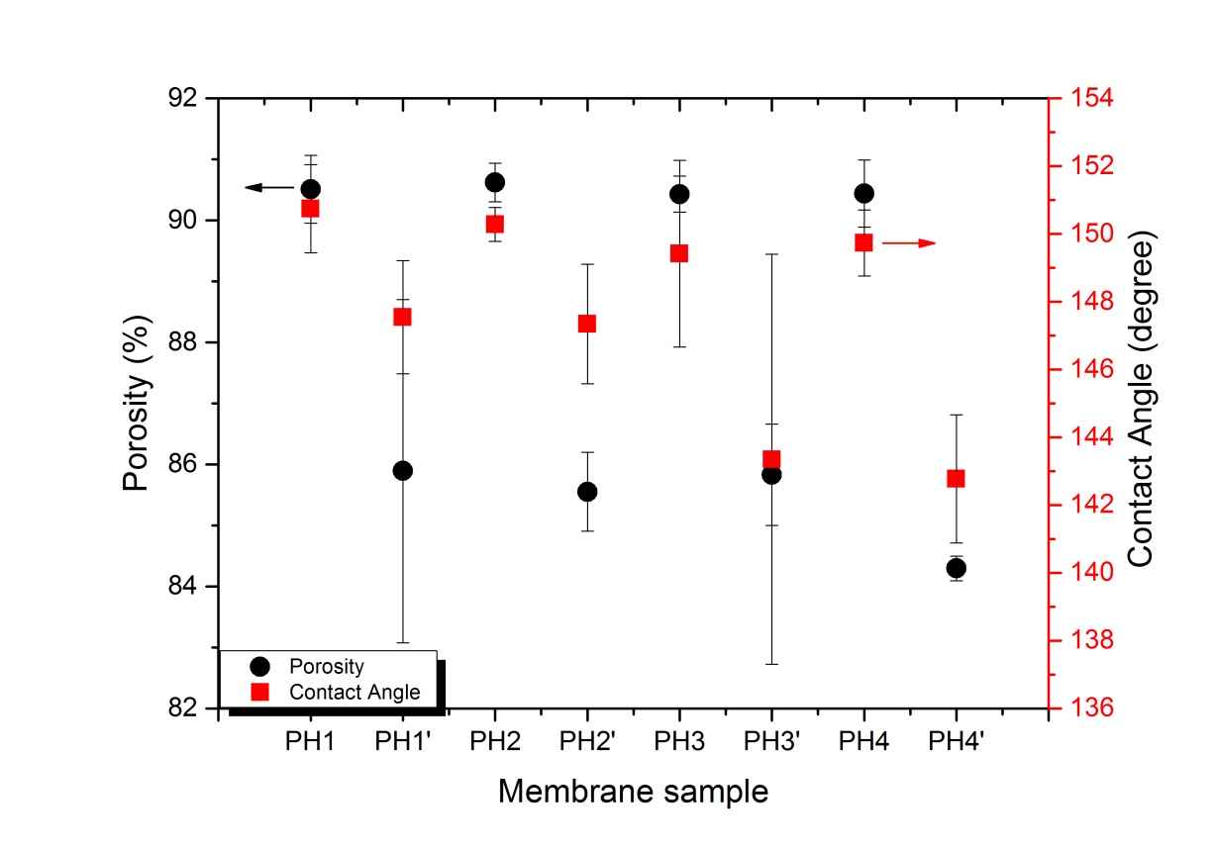
Figure 13. Effects of heat-press with optimal conditions on porosity and contact angles of membranes with various thicknesses
Fig. 13 indicates that porosity and contact angle share similar trend after heat-press treatment. Samples with various thicknesses had decreased porosity and contact angle with respect to increased initial membrane thickness. After heat-pressing, PH1’ had a decreased CA from 151 to 148º, and a decreased porosity from 91 to 87%.PH4’ had a decreased CA from150 to 143º, and a decreased porosity from 90 to 84%. It can be concluded that heat-pressing slightly decreased the porosity and CA of the membranes, but the initial membrane thickness had little effect on porosity and CA.
It was also observed that increasing thickness of membranes could slightly enhance the mechanical strengths of the membranes, and the mechanical properties could be enhanced greatly after heat-pressing method. The maximum stresses at break increased by 57-125% after heat-press compared to their corresponding as-spun membranes. However, the maximum strains at break decreased, which indicated that the polymers turned from elastic to more plastic materials. Also, heat-press could improve the LEP of membranes with various thicknesses. The improvement was consistent, which was around 25% from their as-spun membrane counterpart. The highest LEP of 116 kPa was obtained with PH4’.

3.4 MD performance of heat-pressed electrospun membrane with various thicknesses
Selected heat-pressed electrospun membranes (PH1’, PH2’ and PH3’) and commercial membrane samples were tested and compared in terms of permeation flux and salt rejection in DCMD module for desalination, with feed (3.5 wt% NaCl) and permeate (DI) temperature of 60 ºC and 20 ºC, respectively. Since the heat-pressed membranes had improved characteristics and properties, they are selected for the DCMD tests. Fig. 14 shows the DCMD performance of commercial and heat-pressed membranes. The commercial membrane (GVHP, total membrane thickness of 107 µm) showed a stable flux of 22 L/m²h (LMH) and salt rejection of 99.98% after 8 h of test. On the other hand, the heat-pressed electrospun membranes showed varying results as PH1’ and PH2’ posting higher flux performance (28 and 26 LMH, respectively) compared to commercial membrane, while PH3’ (17 LMH) had lower flux. The main reason for the low flux of PH3’ was its much thicker thickness compared to other samples, which increases the passage length of the vapour through the membrane and thereby added mass transfer resistance. Similarly, the thinner thickness of PH1’ (i.e., after heat-press and compaction) improved its flux performance without sacrificing the salt rejection which was maintained at 99.99%. [27]. Improvement of PSD, thinner thickness and higher LEP contributed more to the enhanced permeation and salt rejection performance. Besides, it was considered that the improvement of mechanical strength could help electrospun membranes being more robust against deformation during long-term operation [32]. Further, the better mechanical strength could reduce the tendency of membrane pores to expand, so it could prevent water being captured in the pores between the fiber layers and lead to an increase in mass transfer resistance [23].
Generally membranes after heat-press treatment at optimal settings had much better performance than the ones before heat-press. Heat-pressed membranes had a stable performance of flux and salt rejection while as-spun had rapidly decreasing in flux and salt rejection in short time. In this study, thickness of heat-pressed electrospun membrane beyond 200 µm was not favoured for DCMD due to its greatly decreased permeability.
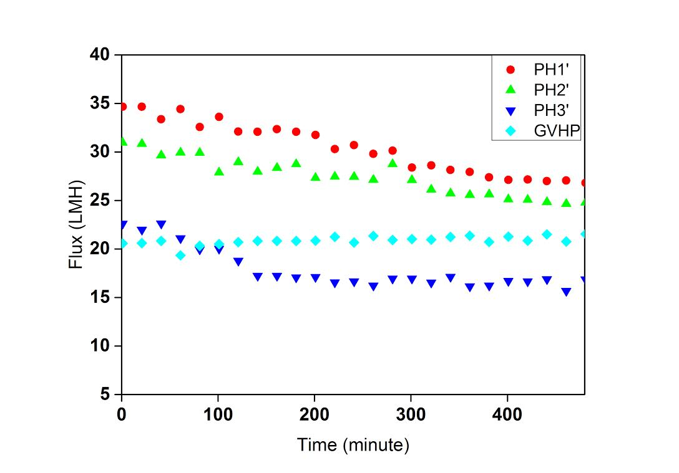
Figure 14. Comparison of DCMD permeation performance of selected membrane samples.

3.4.1 DCMD performance comparison with other studies using heat-pressed membranes
Membrane | Solvent | Method of heat-press | Mean pore size (μm) | Thickness (μm) | Porosity (%) | Feed solution | Feed velocity  (m s⁻¹) |  | Feed temperature (°C) | Permeate temperature  (°C) | Permeate velocity (m s⁻¹) | Permeation flux (LMH) | Salt rejection (%)
5% PVDF with LiCl₂ as additive [23] | DMF/ acetone | placed under glass plate in an oven at 170 ºC for 1 h | 0.21 | 42 | 54 | 3.5 wt% NaCl solution | 0.07 | 50 |  | 20 | 0.14 | 20.6 | -
10% PH [22] | DMAc/ acetone | applied iron on both top and bottom surfaces at 200 ºC for 1-2 s | 0.26 | 110 | 55-60% | 1 wt% NaCl solution | 0.32 | 50 |  | 24 | 0.32 | 20-22 | 98
5% PVDF [27] | DMF/ acetone | placed under glass plate in an oven at 170 ºC for 1 h | - | 27-58 | 80-84% | 10 wt% NaCl solution | 0.31 | 65 |  | 20 | 0.31 | 10-30 | -
20% PH1’ (in this study) | DMAc/ acetone | placed under metal plates in oven at 150 ºC for 8 h | 0.42 | 90 | 86% | 3.5 wt% NaCl solution | 0.07 | 60 |  | 20 | 0.07 | 29 | 99.99
Millipore GVHP PVDF (in this study) | - | - | 0.22 | 110 | - | 3.5 wt% NaCl solution | 0.07 | 60 |  | 20 | 0.07 | 22 | 99.98
Table 6. Comparison of heat-pressed MD flat-sheet membranes for desalination with commercial PVDF membrane

Table 6 shows a comparison of different electrospun membrane characteristics and DCMD flux performance after subjecting to various heat-press treatment approaches. Compared to other results, PH1’ showed very high flux and salt rejection for an 8 h test even it had thicker thickness and running at low flow velocity in both permeate and feed sides. This better performance could be attributed to the slightly wider pore size and high porosity, as both of them were the highest in this table. Considering using the same polymer (PH), heat-press by placing membrane under metal plates in oven at 150 ºC for 8 h had much better effects than by applying iron on both top and bottom surfaces at 200 ºC for 1-2 s, due to less sacrifice of porosity, and, moreover, the fact that short duration of heat-press had minimal effects on the internal layers of electrospun fibers. A sufficient duration of heat-press (with adequate temperature and pressure) could change fluffy internal structure of electrospun membrane into reasonably dense and uniform ones (Fig.12c), and hence improve the mechanical properties and LEP greatly, resulting in impressively high salt rejection for long-term MD test. It was also interesting to point out that in previous studies, relatively low concentration of polymer was applied to obtain membranes with small pore size. However, heat-press treatment could further decrease the pore size and make it lower than optimal range for MD, resulting in low permeate flux. In conclusion, the present result addresses the importance and potential of heat-press on electrospun membrane for improved MD performance.

4. Conclusions

In the present study, the effects of heat-press conditions (temperature, pressure, and duration) on the electrospun polyvinylidene fluoride-co-hexafluropropylene (PH) membrane were comprehensively investigated and membranes that were optimally heat-pressed were tested for DCMD.
Overall, heat-press treatment with optimal conditions could successfully improve the characteristics of the membranes, and hence permeation and salt rejection performance in MD. It was found that heat-press temperature and duration had dominant roles in the post-treatment, while pressure had a relatively minor role. Thickness of heat-pressed membranes <130 μm was considered as the optimal range due to their relatively high permeability. The benefits of heat-pressed membranes included their relatively small surface pore size, high porosity, CA, and LEP. Thickness of electrospun membrane beyond 200 μm was considered not appropriate due to increased mass transfer resistance. It was estimated that electrospun membranes with other polymers could be improved by heat-press treatment with proper conditions for enhanced membrane morphology, characteristics, LEP and tensile strength. In conclusion, heat-press technique is strongly recommended for electrospun polymer membrane to enhance their morphology and characteristics as required by relative applications including membrane distillation.

Acknowledgements
This research was supported by a grant from the Industrial Facilities & Infrastructure Research Program funded by the Ministry of Land, Infrastructure and Transport of the Korean government. The authors also acknowledge the grants from the UTS Chancellor’s Postdoctoral Research Fellowship, ARC Future Fellowship, and the UTS Faculty of Engineering and Information Technology Industry Seed Fund.

References
[1] L.D. Tijing, Y.C. Woo, M.A.H. Johir, J.-S. Choi, H.K. Shon, A novel dual-layer bicomponent electrospun nanofibrous membrane for desalination by direct contact membrane distillation, Chemical Engineering Journal, 256 (2014) 155-159.
[2] A. Alkhudhiri, N. Darwish, N. Hilal, Membrane distillation: A comprehensive review, Desalination, 287 (2012) 2-18.
[3] L.D. Tijing, Y.C. Woo, J.-S. Choi, S. Lee, S.-H. Kim, H.K. Shon, Fouling and its control in membrane distillation—A review, Journal of Membrane Science, 475 (2015) 215-244.
[4] Y.C. Woo, J.J. Lee, L.D. Tijing, H.K. Shon, M. Yao, H.-S. Kim, Characteristics of membrane fouling by consecutive chemical cleaning in pressurized ultrafiltration as pre-treatment of seawater desalination, Desalination, 369 (2015) 51-61.
[5] R. Tian, H. Gao, X.H. Yang, S.Y. Yan, S. Li, A new enhancement technique on air gap membrane distillation, Desalination, 332 (2014) 52-59.
[6] H. Geng, Q. He, H. Wu, P. Li, C. Zhang, H. Chang, Experimental study of hollow fiber AGMD modules with energy recovery for high saline water desalination, Desalination, 344 (2014) 55-63.
[7] A. Boubakri, A. Hafiane, S.A.T. Bouguecha, Application of response surface methodology for modeling and optimization of membrane distillation desalination process, Journal of Industrial and Engineering Chemistry, 20 (2014) 3163-3169.
[8] A. Alkhudhiri, N. Darwish, N. Hilal, Treatment of saline solutions using Air Gap Membrane Distillation: Experimental study, Desalination, 323 (2013) 2-7.
[9] H. Fan, Y. Peng, Application of PVDF membranes in desalination and comparison of the VMD and DCMD processes, Chemical Engineering Science, 79 (2012) 94-102.
[10] Z.-Q. Dong, X.-h. Ma, Z.-L. Xu, W.-T. You, F.-b. Li, Superhydrophobic PVDF–PTFE electrospun nanofibrous membranes for desalination by vacuum membrane distillation, Desalination, 347 (2014) 175-183.
[11] M. Tomaszewska, M. Gryta, A.W. Morawski, A study of separation by the direct-contact membrane distillation process, Separations Technology, 4 (1994) 244-248.
[12] L. Francis, N. Ghaffour, A.S. Alsaadi, S.P. Nunes, G.L. Amy, Performance evaluation of the DCMD desalination process under bench scale and large scale module operating conditions, Journal of Membrane Science, 455 (2014) 103-112.
[13] H.J. Hwang, K. He, S. Gray, J. Zhang, I.S. Moon, Direct contact membrane distillation (DCMD): Experimental study on the commercial PTFE membrane and modeling, Journal of Membrane Science, 371 (2011) 90-98.
[14] J. Ge, Y. Peng, Z. Li, P. Chen, S. Wang, Membrane fouling and wetting in a DCMD process for RO brine concentration, Desalination, 344 (2014) 97-107.
[15] Z.W. Song, L.Y. Jiang, Optimization of morphology and perf ormance of PVDF hollow fiber for direct contact membrane distillation using experimental design, Chemical Engineering Science, 101 (2013) 130-143.
[16] L.D. Nghiem, T. Cath, A scaling mitigation approach during direct contact membrane distillation, Separation and Purification Technology, 80 (2011) 315-322.
[17] S. Goh, J. Zhang, Y. Liu, A.G. Fane, Fouling and wetting in membrane distillation (MD) and MD-bioreactor (MDBR) for wastewater reclamation, Desalination, 323 (2013) 39-47.
[18] J. Zhang, J.-D. Li, S. Gray, Effect of applied pressure on performance of PTFE membrane in DCMD, Journal of Membrane Science, 369 (2011) 514-525.
[19] C. Feng, K.C. Khulbe, T. Matsuura, S. Tabe, A.F. Ismail, Preparation and characterization of electro-spun nanofiber membranes and their possible applications in water treatment, Separation and Purification Technology, 102 (2013) 118-135.
[20] L.D. Tijing, J.-S. Choi, S. Lee, S.-H. Kim, H.K. Shon, Recent progress of membrane distillation using electrospun nanofibrous membrane, Journal of Membrane Science, 453 (2014) 435-462.
[21] Y. Liao, R. Wang, A.G. Fane, Fabrication of bioinspired composite nanofiber membranes with robust superhydrophobicity for direct contact membrane distillation, Environmental Science & Technology, 48 (2014) 6335-6341.
[22] B.S. Lalia, E. Guillen-Burrieza, H.A. Arafat, R. Hashaikeh, Fabrication and characterization of polyvinylidenefluoride-co-hexafluoropropylene (PVDF-HFP) electrospun membranes for direct contact membrane distillation, Journal of Membrane Science, 428 (2013) 104-115.
[23] Y. Liao, R. Wang, M. Tian, C. Qiu, A.G. Fane, Fabrication of polyvinylidene fluoride (PVDF) nanofiber membranes by electro-spinning for direct contact membrane distillation, Journal of Membrane Science, 425-426 (2013) 30-39.
[24] M.M.A. Shirazi, A. Kargari, M. Tabatabaei, Evaluation of commercial PTFE membranes in desalination by direct contact membrane distillation, Chemical Engineering and Processing: Process Intensification, 76 (2014) 16-25.
[25] Properties, in, Sigma-aldrich, 2015. Retrieved from http://www.sigmaaldrich.com/catalog/product/aldrich/427179?lang=en&region=AU
[26] M. Ma, R.M. Hill, J.L. Lowery, S.V. Fridrikh, G.C. Rutledge, Electrospun poly(Styrene-block-dimethylsiloxane) block copolymer fibers exhibiting superhydrophobicity, Langmuir, 21 (2005) 5549-5554.
[27] H.Y. Wu, R. Wang, R.W. Field, Direct contact membrane distillation: An experimental and analytical investigation of the effect of membrane thickness upon transmembrane flux, Journal of Membrane Science, 470 (2014) 257-265.
[28] F.E. Ahmed, B.S. Lalia, R. Hashaikeh, A review on electrospinning for membrane fabrication: Challenges and applications, Desalination, 356 (2015) 15-30.
[29] E. Guillen-Burrieza, A. Servi, B.S. Lalia, H.A. Arafat, Membrane structure and surface morphology impact on the wetting of MD membranes, Journal of Membrane Science, 483 (2015) 94-103.
[30] H. Na, Y. Zhao, C. Zhao, C. Zhao, X. Yuan, Effect of hot-press on electrospun poly (vinylidene fluoride) membranes, Polymer Engineering & Science, 48 (2008) 934-940.
[31] B.S. Lalia, E. Guillen, H.A. Arafat, R. Hashaikeh, Nanocrystalline cellulose reinforced PVDF-HFP membranes for membrane distillation application, Desalination, 332 (2014) 134-141.
[32] M. Essalhi, M. Khayet, Self-sustained webs of polyvinylidene fluoride electrospun nanofibers at different electrospinning times: 2. Theoretical analysis, polarization effects and thermal efficiency, Journal of Membrane Science, 433(0) (2013) 180-191.

