**Combination of Silver Nanoparticles and Curcumin Nanoparticles for Enhanced Anti-biofilm Activities**

Ching-Yee Loo,†‡ Ramin Rohanizadeh,‡ Paul M. Young,† Daniela Traini,† Rosalia Cavaliere,₰ Cynthia B. Whitchurch,₰ and Wing-Hin Lee *†‡

*1Respiratory Technology, Woolcock Institute of Medical Research and Discipline of Pharmacology, Sydney Medical School, The University of Sydney, NSW 2037, Australia*

*2Faculty of Pharmacy, University of Sydney, Sydney, NSW 2006, Australia*

*3The ithree institute, University of Technology Sydney, Ultimo, NSW 2007, Australia.*

\***Corresponding author**:

Dr Wing-Hin Lee

Respiratory Technology, Woolcock Institute of Medical Research and Discipline of Pharmacology,

Sydney Medical School,

The University of Sydney,

NSW 2037, Australia

**ABSTRACT**

Biofilm tolerance has become a serious clinical concern in the treatment of nosocomial pneumonia owing to the resistance to various antibiotics. There is an urgent need to develop alternative antimicrobial agents or combination drug therapies that are effective via different mechanisms. Silver nanoparticles (AgNPs) have been developed as anti-biofilm agent for the treatment of infections associated with the use of mechanical ventilations, such as endotracheal intubation. Meanwhile curcumin, a phenolic plant extract, has displayed natural anti-biofilm properties through the inhibition of bacterial quorum sensing systems. The aim of this study was to investigate the possible synergistic/additive interactions of AgNPs and curcumin nanoparticles (Cur-NPs) against both Gram-negative (*Pseudomonas aeruginosa*) and Gram-positive (*Staphylococcus aureus*) microorganisms. Combination of AgNP sand Cur-NPs (termed as Cur-SNPs) at 100 μg/mL disrupted 50% of established bacterial biofilms (formed on microtiter plates). However, further increase in the concentration of Cu-SNPs failed to effectively eliminate the biofilms. To achieve the same effect, at least 500 μg/mL of Cur-NP alone was needed. Scanning electron microscopy (SEM) and confocal laser scanning microscopy (CLSM) revealed that combination therapy (Cur-SNPs) was the most potent to eradicate pre-formed biofilm compared to mono-drug therapy. These agents are also non-toxic to healthy human bronchial epithelial cells (BEAS2B).

**Keywords:** nanoparticles; *Pseudomonas aeruginosa*; biofilm; *Staphylococcus aureus*; combination therapy

**INTRODUCTION**

Infectious disease is the second most common cause of death while majorities of these deaths are bacterial-related infections. 1, 2 Several reports on antimicrobial therapies failure have emerged owing to the growing bacterial resistance to multiple antibiotics. 2, 3 In cases concerning chronic infections, the failure to achieve complete bacterial eradication with antibiotics is largely due to the switch of bacterial growth mode from free-swimming planktonic cells into sessile community-structured biofilms. Bacterial biofilms are usually protected within a self-made extracellular polymeric substances (EPS) consisting of exopolysaccharide, deoxyribonucleic acid (DNA), and lipid. 4, 5 At this state, biofilms show extreme resistance to most conventional antibiotics (up to 1000-fold resistant) as EPS matrix minimizes the penetration of antibiotics to reach bacteria inside the biofilm via diffusion limitation or neutralization of antimicrobial agents with extracellular polysaccharides. 5-7 In addition, several antibiotics are inefficient to destroy stationary phase cells and biofilm cells which often require low nutrition to survive. 8, 9 Therefore, new approaches emerged for reduction in deaths associated with bacterial infections using multiple antibiotic therapies, which can be additive or synergistic or with the discovery of new drugs with broad-spectrum activity.

This need have led to the resurgence of silver (Ag)-based compound due to the Ag broad activity and possibly far lower inclination to induce bacterial resistance using Ag compared to current antibiotic therapies. It is believed that the probability of bacteria acquiring resistance against Ag are low since Ag+ ions simultaneously acts on multiple sites within bacterial cells. 10 Ag-based compounds are currently used to control bacterial infections in wound dressing and other medical devices such as catheters, orthopedic and prosthetic cardiac devices. 11, 12 Reducing the size of particles improve particles uptake and availability at site of infection. This is evident from numerous reports which demonstrated superior bactericidal activity of AgNPs over Ag+ against both Gram negative and Gram positive microorganisms. 13-15 In comparison to Ag+, many believe additional bactericidal mechanisms specific to AgNPs. These include the direct attachment of nanoparticles onto cell membrane, formation of pits and higher penetration of nanoparticles into cell walls compared to Ag+. 16-18 Furthermore, in a recent study, it was found that applying of high Ag+ concentration had an opposite effect on biofilm removal, while biofilm removal rate using AgNPs was size-dependent. 19

The cytotoxicity of AgNPs is a concern lately as findings revealed that AgNPs killed mammalian cells at concentrations as low as 2–5 μg/mL. 20-22 However, contradictory data has also been reported whereby mammalian cells were still viable at high AgNPs concentration (100 μg/mL). 23 Irrespective of the conflicting cytotoxic data of AgNPs in literature, it is safe to assume that the minimum AgNPs concentration to achieve effective biofilm eradication will cause toxic effect to mammalian cells. For instance, complete removal of biofilm was not achieved even though 200 μg/mL 8-nm AgNPs was administered. 19 Curcumin, active compound found in turmeric, has varied activities, such as anti-cancer, anti-inflammatory, anti-oxidant, and anti-bacterial. This compound is deemed non-toxic for consumption as up to 8 g/day orally could be well tolerated in healthy subjects. Recent studies discovered the ability of curcumin to inhibit the formation of biofilm, particularly in Gram positive microorganisms. Moshe *et al* reported that curcumin (100 μg/mL) effectively blocked the *in vitro* formation of *Staphylococcus aureus* biofilm 24. Curcumin was also equally effective to remove established mature biofilm as revealed in the near complete biofilm eradication at 50 μg/mL dose.24 Curcumin is proposed to exert its anti-biofilm activity via attenuation of quorum-sensing (QS) virulence factors by interfering with the signal molecules-based QS system. 25 Therefore, it is envisaged that the combination therapy using AgNPs and non-toxic curcumin would enhance the anti-biofilm activities while simultaneously exerting low local toxicity to mammalian cells.

This present study evaluated the combination therapy using Cur-NPs and AgNPs against inhibition of biofilm formation and detachment of established biofilms. For this, we have fabricated combination of Cur-NPs and AgNPs (referred as Cur-SNPs) with average size of 30 nm using solvent and anti-solvent precipitation method. The release kinetics of curcumin and Ag+ as well as anti-biofilm activities of the combination compounds were accessed in this study.

**MATERIALS AND METHODS**

**Materials**

Silver nitrate (AgNO3), gallic acid and curcumin (purity≥80%) were supplied by MP Biomedicals, Australia. Polyvinylpyrrolidone (PVP) and pluronic F-127 were purchased from Sigma, Australia. Deionized water was purified by reverse osmosis (milliQ, Millipore, Australia). All chemicals were used without further purification.

**Preparation of Curcumin Nanoparticles (Cur-NPs), Curcumin Silver nanoparticles (Cur-SNPs) and AgNPs**

Colloids of AgNPs with average diameter of 7 to 15 nm were prepared according to the method as described previously. 19 Cur-NPs were prepared using solvent and anti-solvent precipitation method as described previously. 26 For the preparation of Cur-SNPs, the same procedure was used with a slight modification in which 100 mg of re-dispersed AgNPs was added into the Cur-NPs suspension before the addition of PVP. 26

**Physicochemical Characterization of Nanoparticles**

Particle size and polydispersity index (PDI) of Cur-NPs, Cur-SNPs and AgNPs were determined using dynamic light scattering (DLS) (Malvern Zetasizer Nano ZS, United Kingdom). DLS was performed using Malvern Zetasizer Nano ZS with the following settings: the refractive index for silver and curcumin were 1.35 and 1.41, respectively while the viscosity of water was 0.8872 mPas. 19, 26 Transmission electron microscopy (TEM) was carried out using a JEOL1400 electron microscope operating at 200 kV to observe the shape and sizes of nanoparticles as well as to measure the size distributions of particles using techniques described previously. 27 The presence of curcumin and silver were also determined using Fourier transform infrared spectroscopy, FTIR (Varian 610-IR, Varian Inc., USA). 27

**Quantification of Silver and Curcumin Content**

The concentration of Ag+ release from both AgNPs and Cur-SNPs was determined using atomic absorption spectroscopy (AAS) as described previously (Shimadzu, Japan). 27 Chemical analysis of curcumin was determined via high performance liquid chromatography (HPLC) using 75% of methanol and 25% of acetonitrile as mobile phase at the flow rate of 1 mL/min with isocratic pump at 25 °C using C18 column (Nova-Pak, 150 x 4.6 mm). 26 The HPLC system used was a Shimadzu Prominence UFLC system equipped with an SPD-20A UV-Vis detector, LC-20AT solvent delivery unit, SIL-20A HT Autosampler (Shimadzu, Japan).

***In vitro* Release Study**

For release experiments, AgNPs and Cur-SNPs powders were weighed into scintillation vials containing 10 mL cation adjusted Mueller Hinton broth (CAMHB) solution (pH 7.2) and placed into 37 °C incubator and shaken at 100 rpm/min. At specific time-points, samples were withdrawn and centrifuged at 100,000 g for 30 min at 10 °C. Both supernatant and pellet were used for AAS or HPLC analyses for determination of Ag and curcumin, respectively. 27

In order to understand the release kinetics of both Ag+ and curcumin from polymeric nanoparticles, four kinetic models were considered to fit the experimental data: zero order, first order, Higuchi and Hixson-Crowell. Zero order kinetic is an ideal drug release pattern which describes a prolonged pharmacological action since the release of drug is assumed to be concentration-independent and same amount of drug per unit of time is released. This kinetic model is presented by equation 1: Qt = Q0 + K0 t (1)

First order kinetic model describes a concentration dependent release from a system. In essence, the release of drug is proportional to the concentration of drug present in the system; therefore the amount released decreases with time. Equation 2 describes this model: ln Qt = lnQ0 + K0 t (2)

The drug release behavior of Higuchi model is represented by diffusion process based on Fick’s law and is dependent on square root of time. This model could be summarized in equation 3: Qt = KH * t1/2 (3)

Hixson-Crowell model recognizes that the area of particles’ is proportional to the cube root of its volume (equation 4): Q01/3 – Qt1/3 = K*t (4)

***In vitro* Biofilm Formation and Detachment Assay**

The biofilm formation assay was performed in 96-well microtiter plates in which the microorganisms (*P. aeruginosa* PAO1 and *S. aureus* ATCC 25923) were grown simultaneously with antimicrobial agents (AgNPs, Cur-SNPs or Cur-NPs) (Supplementary Table 1). For AgNPs, the concentrations used corresponded to the amount of Ag present in Cur-SNPs. Prior to each experiment, the freeze-dried powders of Cur-NPs, Cur-SNPs and AgNPs were re-suspended in respective bacterial growth media (and homogenized thoroughly using bath sonicator for 15 min. Briefly, *P. aeruginosa* and *S. aureus* were grown overnight either in CAMHB or tryptic soy broth (TSB) medium, respectively at 37 °C, shaken at 200 rpm and diluted in respective growth media to reach 106 CFU/mL. A 50 µL aliquot of the culture was placed into each well followed with addition of 50 µL Cur-NPs, Cur-SNPs or AgNPs at varying concentrations. The plates were incubated for 24 h without shaking at 37 °C. After 24 h, the plates were subjected to staining with crystal violet (CV) procedures as described previously. 19

The biofilm detachment assay was performed in 96-well microtiter plates using two different wild type bacterial strains (*P. aeruginosa* and *S. aureus*) using method described previously. 19

**Qualitative Imaging of *P. aeruginosa* and *S. aureus* Biofilms using Confocal Laser Scanning Microscopy (CLSM) and Scanning Electron Microscopy (SEM)**

For visual observation of biofilm, samples were analyzed using both CLSM and SEM. Briefly, biofilms were treated with different NPs containing equivalent concentrations of curcumin and were rinsed twice with phosphate buffer saline (PBS). Both control and treated biofilms samples for CLSM observations were prepared according to methods previously. 19, 27 For SEM observation, samples were fixed using 4% paraformaldehyde overnight without staining. After fixation, the samples were dehydrated through a series of graded ethanol baths, dried using a critical-point drier, gold coated and imaged using SEM. For CLSM imaging (Nikon A1), treated samples were washed with PBS, and stained with SYTO9 (Invitrogen, Australia) and finally fixed with 4% paraformaldehyde. The morphologies of biofilms were imaged using oil immersion lens (100 x objective lens and numerical aperture of 1.4). Recorded images were reconstructed by Imaris and presented as 3-dimensional structures.

**Cytotoxicity Evaluation using MTS Assay**

Cytotoxicity assay on human normal bronchial epithelial cells (BEAS2B) was performed to investigate the percentage of cells surviving in AgNPs and/or Cur-NPs. To perform the cytotoxicity assay, BEAS2B cells were cultivated in DMEM F-12 supplemented with 1% non-essential amino acid, 1% L-glutamic acid and 10% fetal bovine serum (FBS) and incubated at 37 °C in CO2 humidified atmosphere. When the cells had reached 80% of confluence, they were trypsinized and seeded into 96-well plates with 50,000 cells per well. The cells were incubated for 24 h to allow attachment of cells on surface. Next, cells were treated with different concentrations of AgNPs or Cur-NPs for 3 days followed with incubation for 4 h at 37 °C in (3-(4,5-dimethylthiazol-2-yl) -5-(3-carboxymethoxyphenyl)-2-(4-sulfophenyl)-2H-tetrazolium, inner salt) (MTS) reagent (Promega, Australia). The colour intensity was measured at 490 nm with microplate reader (POLAstar). The cytotoxicity was expressed as a percentage of viable cells relative to untreated cells.

**Statistical Analysis**

Statistical analysis of data was performed using SPSS Statistics 19 software package. All data were collected (n=5) and the mean values and standard deviations (SD) were calculated. The statistical differences between groups were determined by analysis of variance (ANOVA). The pairwise comparisons of individual group means were performed using Tukey post-hoc analysis. Values of *p* < 0.05 were considered statistically significant.

**RESULTS AND DISCUSSION**

**Physicochemical Characterization of Nanoparticles**

Figure 1 shows the size distribution and morphology of re-dispersed nanoparticles using DLS and TEM, respectively. The sizes of Cur-NPs (Figure 1A) observed under TEM were not significantly different than those measured using DLS (insert of Figure 1A). For instance, Cur-NPs appeared as clusters of round particles at approximately 30 nm under TEM while DLS showed that Cur-NPs had average size and polydispersity index (PDI) of 29.7 nm and 0.022, respectively. Meanwhile, re-dispersed AgNPs appeared un-agglomerated and spherical ranging from 10–35 nm (Figure 1B)which is in accord with our previous data. 19 This was confirmed with particle sizing distribution with a well-defined population of particles with average diameter around 30 nm (insert of Figure 1B). During the fabrication of combined Cur-SNPs, the ratio of curcumin to silver was set at 9 to 1. Both the TEM and DLS of combination Cur-SNPs demonstrated that these nanoparticles were dispersed and approximately 30 nm in diameter (Figure 1C). The freeze-dried Cur-SNPs combination powders were subjected to AAS and HPLC to determine the actual encapsulated curcumin and silver content. Based on the calculation, the curcumin content was 31.5 ± 0.80 μg/mg while the amount of silver present was 4.0 ± 0.5 μg/mg. Therefore the ratio of curcumin to silver was approximately 7.5 to 1. The freeze-dried Cur-NPs and Cur-SNPs powders could be re-dispersed readily in water and the resulting solutions were orange-yellowish in color.

FTIR analysis was undertaken to; i) confirm the presence of curcumin in the prepared Cur-NPs and ii) evaluate the interactions between Cur-NPs and AgNPs. Figure 2 shows the FTIR spectra for pure PVP, raw curcumin, Cur-NPs, Cur-SNPs and AgNPs. A typical FTIR of PVP is characterized by a strong band at 1650 cm-1 which is assigned to amide carbonyl group 28. Other distinguishable peaks of PVP are 1490 and 1419 cm-1 which is due to the vibration of tertiary C-N. The peak at 1457 cm-1 is assigned to CH2 scissors while CH stretching peaks appeared at peaks ranging from 2811 to 2913 cm-1. The peak at 1284 cm-1 corresponds to wagging of CH2. 28 The detailed FTIR vibrational spectra of curcumin had been showed by Kolev *et al*. 29 The peak at 3490 cm−1 is assigned to the stretching vibrations of –OH group in raw curcumin. 29 The appearance of peak at 1624 cm-1 is assigned to predominantly mixed C=C and C=O bonds. Another peak at 1600 cm-1 is attributed to symmetric aromatic ring stretching vibrations of C=C. In addition the vibration of C=O appeared at 1506 cm-1 while enol peaks for C-O and C-O-C appeared at 1272 and 1110 cm-1, respectively 30 (Figure 2 and Supplementary Table 2). In both Cur-NPs and Cur-SNPs, the OH peak of curcumin is shifted to 3384 cm−1 and appeared broader (Figure 2). However, it should be noted that these peaks also overlapped with the –OH group stretching vibration from PVP. Furthermore, strong signals of C=O peaks appeared at 1506 cm-1 in these samples without shifting compared to the curcumin spectrum. The peaks assigned for C-O-C at 1110 cm-1 were also obviously detected in both Cur-NP and Cur-SNPs thus indicating the presence of curcumin encapsulated in polymer nanospheres. 31 Interestingly, while the peak positions for CH2 stretching were constant for all samples the relative peak intensities were changed probably indicating the interaction between curcumin and PVP, thus resulting in differences in chain geometry of CH groups.

Figure3 shows the cumulative release of curcumin and/or Ag+ from three different nanoparticulate samples (AgNPs, Cur-NPs and Cur-SNPs). For Cur-NPs (Figure 3A), a non-linear relationship of curcumin is demonstrated. A rapid release of curcumin (about 20%) occurred in the first 24 h, followed by a gradual release profile to 80% at 360 h of incubation. The rapid release observed during early incubation could be due to dissociations of poorly bound curcumin molecules attached on the surface of polymer capsules or to the curcumin particles that were not fully encapsulated by PVP. Meanwhile for the release of Ag+ from AgNPs, slow oxidation of particles was observed as only 40% of the fractions were in ionized form after 360 h of incubation. Additionally, no burst release of Ag+ was seen (Figure 3C). The general release profile of curcumin and Ag+ were similar to those in Cur-SNPs group with the exception of lower release rate, indicating a partial release inhibition owing to possible nanoparticle-nanoparticle interaction (Figure 3B). Various mathematical equations have been proposed to describe the kinetics of drug release from controlled release formulations. The zero order release model describes the release behavior of drug, which is independent of concentration. Meanwhile, first order kinetics describes direct dependency of drug release on the concentration. Hixson-Crowell model recognizes the influence of the changes in particles’ surface area and diameter to release rate. Higuchi model proposed a direct relationship to drug release from matrix to the square root of time based on Fickian diffusion law. This model generally assumes that the initial drug concentration in matrix is higher than drug solubility and the diffusion only takes place at uni-dimension. The releases of curcumin and Ag+ were fitted to these kinetic models to determine the release kinetics and mechanisms from nanoparticles. The values of these kinetic rates, K and R2, are presented in Table 1. In general, the release behavior for all nanoparticles did not obey zero order and first order kinetics based on the low R2 values obtained. AgNPs or Cur-AgNPs followed Hixson-Crowell kinetics, which demonstrated that the release of Ag+ is limited by the nanoparticles’ dissolution and not through the diffusion from PVP polymer matrix. The most suitable kinetic model to describe the release of curcumin from Cur-NPs is Higuchi matrix model. The comparatively poorer fit for first order model, supported the idea that Cur-NP was dispersed within the PVP polymeric matrix as the kinetic of curcumin release matched the Fickian diffusion.

**Bacterial Attachment and Biofilm Formation Assay**

In our recent finding, it has been established that AgNPs were effective to eradicate established *P. aeruginosa*. 19 We have demonstrated that the higher biofilm removal efficiency of AgNPs compared to ionized form (Ag+) signified the presence of other bactericidal mechanisms of nanoparticles for biofilm removal. 19 For instance, AgNPs could be penetrated and dispersed into biofilm matrix more efficiently compared to Ag+ 19, 32. In this study, a combination therapy using AgNPs and Cur-NPs was used in an attempt to provide enhanced anti-biofilm activities.Curcumin is chosen as a co-therapy compound because this phytochemical turmeric extract exhibits antibacterial activities against wide ranges of planktonic microorganisms. 24, 33, 34 Most studies were concentrated on the effect of curcumin towards free-living planktonic bacteria while the anti-biofilm assessment of curcumin was fairly limited. It is therefore interesting to evaluate the ability of curcumin in the form of nanoparticles as mono-therapy and in combination with AgNPs to inhibit biofilm formation and eradicate mature biofilm. A simple static biofilm assay was performed to assess the effect of these combination compounds on both eradicating established biofilm and inhibiting biofilm formation. It should be noted that equivalent concentration of curcumin or Ag present in the nanoparticles was evaluated in parallel as control using either Cur-NPs or AgNPs alone. For AgNPs, the concentrations used corresponded to the amount of Ag present in Cur-SNPs. The inhibition of biofilm formation was concentration-dependent and strain-dependent (Figure 4). Generally, the treatment of either mono- or combination therapy was less effective against Gram negative bacteria as the inhibition of biofilm formation by *P.* *aeuginosa* was significantly lower compared to *S. aureus*. Cur-NPs were more effective against Gram positive bacteria while exerting minimal inhibitory effect against Gram negative bacteria (Figure 4). As expected, combination of Cur-NPs and AgNPs demonstrated additive effect as they inhibited biofilms formation more effective than that of AgNPs or Cur-NPs alone. The biofilm formation of *S. aureus* was inhibited by 85% when Cur-SNPs were administered at concentration consisting 20 μg/mL curcumin and 2.5 μg/mL Ag. Total inhibition of biofilm formation was observed when Cur-SNPs consisting 30 μg/mL curcumin and 3.75 μg/mL Ag (Figure 4). However as a comparison, the treatment of Cur-NPs alone using the same concentration (20 μg/mL) only resulted in 40% of biofilm inhibition (Figure 4). Cur-NPs could effectively block *S. aureus* biofilm formation at higher concentration (>100 μg/mL). Our data is consistent with previous finding whereby at 100 μg/mL curcumin, biofilm formation of *S. aureus* was 100% inhibited. 24 The authors further suggested that the mechanism of biofilm inhibition by curcumin was due to the inhibition in the process of biofilm formation itself rather than the bactericidal effect 24. This is due to the fact the concentration required to exert inhibition of biofilm formation was much lower than that required to inhibit *S. aureus* growth 24. In addition, Tajbakhsh *et al* reported that the MIC of curcumin against *S. aureus* was 187.5 μg/mL 35. Consistently many studies also demonstrated that at least 100 μg/mL curcumin was required to stop the growth activities of *S. aureus* without bactericidal effect. 33-35 The inhibition of sortase A activity by curcumin at concentrations much lower than MIC suggested that curcumin prevent biofilm attachment rather than killing bacteria within biofilm 36. Furthermore, the attenuation of QS-dependent factors such as exopolysaccharide, alginate, motility behaviors (swimming and swarming) by curcumin indirectly confirmed that curcumin exerts its anti-biofilm activities via the prevention of biofilm formation process itself rather than destroying bacteria. 25, 37 Meanwhile, unexpectedly AgNPs alone was not as effective in reducing the growth and formation of *S. aureus* biofilmeven though high concentration of AgNPs was used (50 μg/mL) (Figure 4).

In addition, this combination therapy (Cur-SNPs) also displayed higher efficacy to entirely block the formation of *P. aeruginosa* biofilm when administered with doses containing 40 μg/mL curcumin and 5 μg/mL Ag. Interestingly, at this concentration no inhibitory activity on *P. aeruginosa* biofilm was observed either using Cur-NPs or AgNPs alone (Figure 4). These results were in good agreement with published data whereby curcumin alone had higher inhibitory effect against Gram positive than Gram negative bacteria. 24, 33, 34 In particular, in a study by Moshe *et al*, curcumin showed only little effect against *P. aeruginosa* biofilm. 24 Contradictory to our data, reports have demonstrated that curcumin displayed anti-biofilm properties against *P. aeruginosa* when used at 1.5–3.0 µg/mL. 25 Results from microarray analyses confirmed that curcumin down-regulated the genes involved in QS and biofilm formation as well as attenuated the virulence of *P. aeruginosa* 25. In view of the variable data, it is therefore possible that the effect of curcumin on *P. aeruginosa* could be species-specific. Taken together, promising results on the enhanced anti-biofilm activities was demonstrated using a combination therapy approach (Cur-SNPs).

**Bacterial Biofilms Eradication Assay**

Figure 5 shows the detachment of pre-formed *P. aeruginosa* and *S. aureus* biofilm colonies grown in their culture media (CAMHB and TSB), after the treatment with different concentrations of Cur-SNPs, AgNPs or Cur-NPs. As shown in Figure 5, the increase of Cur-SNPs concentration up to consisting 80 μg/mL Cur-NPs and 10 μg/mL AgNPs did not contribute to any significant differences in the removal of both *P. aeruginosa* or *S. aureus* biofilm. However, at higher concentrations (400 μg/mL Cur-NPs and 50 μg/mL AgNPs), the biomass of both *P. aeruginosa* and *S. aureus* was reduced by approximately 70%. This data was significantly higher than that of treatments with AgNPs or Cur-NPs alone. At this concentration, the remaining attached *P. aeruginosa* biofilm with AgNPs and Cur-NPs treatment was 60 and 75%, respectively. Meanwhile the remaining *S. aureus* biofilm after AgNPs and Cur-NPs treatment was 76% and 60%, respectively. It should be noted that Cur-NPs was not as effective against Gram-negative bacteria compared to Gram-positive bacteria. About 70% of *P. aeruginosa* PAO1 biofilm remained adhered on the surface of microtiter plates despite using 400 μg/mL Cur-NPs was for treatment (Figure 5).

Visual confirmation on the effect of NP treatment on biofilm detachment was performed using both SEM and CLSM (Figure 6). The concentrations of Cur-SNPs used to treat established *P. aeruginosa* and *S. aureus* biofilms consisted of 400 µg/mL curcumin and 50 μg/mL Ag. To determine that the combination Cur-SNPs demonstrated higher efficacy against pre-formed *P. aeruginosa* and *S. aureus* biofilm, the results were compared with those obtained using treatments with AgNPs and Cur-NPs alone. The concentration of AgNPs and Cur-NPs used was 50 µg/mL and 400 μg/mL, respectively. As observed, significant removal of *P. aeruginosa* was seen after treatment with Cur-SNPs and only small cluster of individual cells remained attached after compared to control. Microcolonies of *P. aeruginosa* were still evidently seen in both Cur-NPs and AgNPs-treated biofilm, thus confirming that the combination Cur-SNPs was more effective to eradicate pre-formed biofilm (Figure 6). Similar trend was also demonstrated for removal of *S. aureus* biofilm. However, qualitatively it seems that AgNPs had negligible effect on *S. aureus* biofilm. The susceptibility of *S. aureus* biofilm to treatments followed the decreasing order: Cur-SNPs > Cur-NP > AgNPs (Figure 6). Figure 7 shows the corresponding number of attached bacterial cells (measured as colony forming unit, CFU) for untreated cells (control) and samples treated with respective AgNPs, Cur-NPs and Cur-SNPs. It is clearly seen that the CFU count for both bacteria follows the decreasing trend: AgNPs ˂ Cur-NPs ˂ Cur-SNPs. For *P. aeruginosa*, the CFU for untreated control was 9.5 × 108 CFU/cm2 while the number of attached *S. aureus* cells was 9.1 × 107 CFU/cm2. The corresponding CFU of *P. aeruginosa* after treatment with AgNPs, Cur-NPs and Cur-SNPs were 4.0 × 107 CFU/cm2, 9.5 × 106 CFU/cm2, and 2.5 × 103 CFU/cm2, respectively (Figure 7A).

Curcumin is an established compound with selective target towards cancer cell lines but benign against healthy cells. In this study, the tolerance of healthy lung epithelial cells against curcumin and/or silver was investigated via concentration-dependent killing MTS assay. The viability of BEAS-2B is concentration-dependent as shown in Figure 8. When cells were treated with low curcumin concentration (20 μg/mL), it is noted that 95% of cells remained viable. At higher concentration (200 μg/mL), all three samples were toxic to cells whereby at least 50–60% of cells were killed. The IC50 values could not be determined in all samples since 50% killing of cells were not reached even at the highest concentration used. The qualitative intracellular uptake of curcumin by BEAS2B was visualized after 24 h at 200 μg/mL equivalent of curcumin concentration using CLSM (Figure 8). The presence of curcumin in cells is based upon the green color intensity since curcumin is a green fluorescent compound at 488 nm. The confocal images showed that cells treated with Cur-NPs and Cur-SNPs demonstrated strong green fluorescence intensity while cells treated with AgNPs did not emit any green fluorescent. Only DAPI-stained nucleus was visible in AgNPs treated BEAS2B cells. The internalization of curcumin into BEAS2B indirectly confirmed the MTS cytotoxicity results in which 40% of cells were killed at high curcumin concentration (Figure 8).

In conclusion, the combination therapy of Cur‐NPs and AgNPs was effective to eradicate established mature biofilm and inhibited biofilm formation. These formulations could be administered either directly as solution to produce rapid alleviation in bacterial infections or as a coating on endotracheal tubes to achieve prolonged, sustained antibacterial effect. Hydrogels of Cur‐SNPs for coatings deposited on endotracheal tubes are currently developed in our laboratory and their performance and bio‐compatibility are investigated.

**ACKNOWLEDGEMENTS**

The authors would like to thank Australian Centre for Microscopy and Microanalysis (ACMM), particularly Ms Delfine Cheng and Ms Naveena Gokoolparsadh for their valuable guidance and advice in microtomy and Ms Roya Bavarian for her help in FTIR analysis. Cynthia Whitchurch is funded by a NHMRC Senior Research Fellowship (571905). Paul Young is funded by an Australian Research Council Future Fellowship (FT110100996).

**REFERENCES**

(1) *World Health Report*; World Health Organization: Geneva, 2011.

(2) Jones, K. E.; Patel, N. G.; Levy, M. A.; Storeygard, A.; Balk, D.; Gittleman, J. L.; Daszak, P., Global trends in emerging infectious diseases. *Nature* **2008,** *251*, 990-993.

(3) Simoes, M., Antimicrobial strategies effective against infectious bacterial biofilms. *Curr. Med. Chem.* **2011,** *18*, 2129-2145.

(4) Ishida, H.; Ishida, Y.; Kurosaka, Y.; Otani, T.; Sato, K.; Kobayashi, H., In vitro and in vivo activities of levofloxacin against biofilm-producing *Pseudomonas aeruginosa*. *Antimicrob. Agents Chemother.* **1998,** *42*, 1641-1645.

(5) Shigeta, M.; Tanaka, G.; Komatsuzawa, H.; Sugai, M.; Suginaka, H.; Usui, T., Permeation of antimicrobial agents through *Pseudomonas aeruginosa* biofilms: A simple method. *Chemotherapy* **1997,** *43*, 340-345.

(6) Hoyle, B. D.; Alcantara, J.; Costerton, J. W., Pseudomonas-Aeruginosa Biofilm as a Diffusion Barrier to Piperacillin. *Antimicrob.Agents Chemother.* **1992,** *36*, 2054-2056.

(7) Elkins, J. G.; Hassett, D. J.; Stewart, P. S.; Schweizer, H. P.; McDermott, T. R., Protective role of catalase in *Pseudomonas aeruginosa* biofilm resistance to hydrogen peroxide. *Appl. Environ. Microb.* **1999,** *65*, 4594-4600.

(8) Fernández, L.; Breidenstein, E. B. M.; Hancock, R. E. W., Creeping baselines and adaptive resistance to antibiotics. *Drug Resist. Updates* **2011,** *14*, 1-21.

(9) Yang, L.; Haagensen, J. A. J.; Jelsbak, L.; Johansen, H. K.; Sternberg, C.; Hoiby, N.; Molin, S., In situ growth rates and biofilm development of *Pseudomonas aeruginosa* populations in chronic lung infections. *J. Bacteriol.* **2008,** *190*, 2767-2776.

(10) Feng, Q. L.; Wu, J.; Chen, G. Q.; Cui, F. Z.; Kim, T. N.; Kim, J. O., A mechanistic study of the antibacterial effect of silver ions on Escherichia coli and Staphylococcus aureus. *J. Biomed. Mater. Res.* **2000,** *52*, 662-668.

(11) Catauro, M.; Raucci, M. G.; de Gaetano, F. D.; Marotta, A., Antibacterial and bioactive silver-containing Na2O x CaO x 2SiO2 glass prepared by sol-gel method. *J. Mater. Sci. Mater. Med.* **2004,** *15*, 831-837.

(12) Crabtree, J. H.; Burchette, R. J.; Siddiqi, R. A.; Huen, I. T.; Handott, L. L.; Fishman, A., The efficacy of silver-ion implanted catheters in reducing peritoneal dialysis-related infections. *Perit. Dial. Int.* **2003,** *23*, 368-374.

(13) Martinez-Castanon, G. A.; Nino-Martinez, N.; Martinez-Gutierrez, F.; Martinez-Mendoza, J. R.; Ruiz, F., Synthesis and antibacterial activity of silver nanoparticles with different sizes. *J. Nanopart. Res.* **2008,** *10*, 1343-1348.

(14) Kora, A. J.; Arunachalam, J., Assessment of antibacterial activity of silver nanoparticles on *Pseudomonas aeruginosa* and its mechanism of action. *World J. Microb. Biot.* **2011,** *27*, 1209-1216.

(15) Kvitek, L.; Panacek, A.; Soukupova, J.; Kolar, M.; Vecerova, R.; Prucek, R.; Holecova, M.; Zboril, R., Effect of surfactants and polymers on stability and antibacterial activity of silver nanoparticles (NPs). *J. Phys. Chem. C* **2008,** *112*, 5825-5834.

(16) Sondi, I.; Salopek-Sondi, B., Silver nanoparticles as antimicrobial agent: a case study on E-coli as a model for Gram-negative bacteria. *J. Colloid Interf. Sci.* **2004,** *275*, 177-182.

(17) Raffi, M.; Hussain, F.; Bhatti, T. M.; Akhter, J. I.; Hameed, A.; Hasan, M. M., Antibacterial characterization of silver nanoparticles against *E. coli* ATCC15224. *J Mater. Sci. Technol.* **2008,** *24*, 192-196.

(18) Lok, C. N.; Ho, C. M.; Chen, R.; He, Q. Y.; Yu, W. Y.; Sun, H. Z.; Tam, P. K. H.; Chiu, J. F.; Che, C. M., Proteomic analysis of the mode of antibacterial action of silver nanoparticles. *J. Proteome Res.* **2006,** *5*, 916-924.

(19) Loo, C. Y.; Young, P. M.; Cavaliere, R.; Whitchurch, C. B.; Lee, W. H.; Rohanizadeh, R., Silver nanoparticles enhance *Pseudomonas aeruginosa* PAO1biofilm detachment. *Drug Dev. Ind. Pharm.* **2014,** *40*, 719-729.

(20) Hussain, S. M.; Hess, K. L.; Gearhart, J. M.; Geiss, K. T.; Schlager, J. J., In vitro toxicity of nanoparticles in BRL 3A rat liver cells. *Toxicol. in Vitro* **2005,** *19*, 975-983.

(21) Bar-Ilan, O.; Albrecht, R. M.; Fako, V. E.; Furgeson, D. Y., Toxicity Assessments of Multisized Gold and Silver Nanoparticles in Zebrafish Embryos. *Small* **2009,** *5*, 1897-1910.

(22) Kim, H. R.; Kim, M. J.; Lee, S. Y.; Oh, S. M.; Chung, K. H., Genotoxic effects of silver nanoparticles stimulated by oxidative stress in human normal bronchial epithelial (BEAS 2B) cells. *Mutat. Res.* **2011,** *726*, 129-135.

(23) Samberg, M. E.; Loboa, E. G.; Oldenburg, S. J.; Monteiro-Riviere, N. A., Silver nanoparticles do not influence stem cell differentiation but cause minimal toxicity. *Nanomedicine* **2012,** *7*, 1197-1209.

(24) Moshe, M.; Lellouche, J.; Banin, E., Curcumin : a natural antibiofilm agent. In *Science and Technology against microbial pathogens: research, development and evaluation*, Mendez-Vilas, A., Ed. World Scientific Publishing Company: Singapore, 2011.

(25) Rudrappa, T.; Bais, H. P., Curcumin, a Known Phenolic from Curcuma longa, Attenuates the Virulence of *Pseudomonas aeruginosa* PAO1 in Whole Plant and Animal Pathogenicity Models. *J. Agric. Food Chem.* **2008,** *56*, 1955-1962.

(26) Lee, W.-H.; Bebawy, M.; Loo, C.-Y.; Luk, F.; Mason, R. S.; Rohanizadeh, R., Fabrication of Curcumin Micellar Nanoparticles with Enhanced Anti-Cancer Activity. *J. Biomed. Nanotechnol.* **2015,** *11*, 1093-1105.

(27) Loo, C.-Y.; Young, P. M.; Lee, W.-H.; Cavaliere, R.; Whitchurch, C. B.; Rohanizadeh, R., Non-cytotoxic silver nanoparticle-polyvinyl alcohol hydrogels with anti-biofilm activity: designed as coatings for endotracheal tube materials. *Biofouling* **2014,** *30*, 773-788.

(28) Borodko, Y.; Habas, S. E.; Koebel, M.; Yang, P.; Frei, H.; Somorjai, G. A., Probing the Interaction of Poly(vinylpyrrolidone) with Platinum Nanocrystals by UV-Raman and FTIR. *J. Phys. Chem. B* **2006,** *110*, 23052-23059.

(29) Kolev, T. M.; Velcheva, E. A.; Stamboliyska, B. A.; Spiteller, M., DFT and experimental studies of the structure and vibrational spectra of curcumin. *Int. J. Quantum Chem.* **2005,** *102*, 1069-1079.

(30) Mohan, P. R. K.; Sreelakshmi, G.; Muraleedharan, C. V.; Joseph, R., Water soluble complexes of curcumin with cyclodextrins: Characterization by FT-Raman spectroscopy. *Vib. Spectrosc.* **2012,** *62*, 77-84.

(31) Mohanty, C.; Sahoo, S. K., The in vitro stability and in vivo pharmacokinetics of curcumin prepared as an aqueous nanoparticulate formulation. *Biomaterials* **2010,** *31*, 6597-6611.

(32) Wirth, S. M.; Lowry, G. V.; Tilton, R. D., Natural Organic Matter Alters Biofilm Tolerance to Silver Nanoparticles and Dissolved Silver. *Environ. Sci. Technol.* **2012,** *46*, 12687-12696.

(33) Mun, S.-H.; Joung, D.-K.; Kim, Y.-S.; Kang, O.-H.; Kim, S.-B.; Seo, Y.-S.; Kim, Y.-C.; Lee, D.-S.; Shin, D.-W.; Kweon, K.-T.; Kwon, D.-Y., Synergistic antibacterial effect of curcumin against methicillin-resistant *Staphylococcus aureus*. *Phytomedicine* **2013,** *20*, 714-718.

(34) Bhawana; Basniwal, R. K.; Buttar, H. S.; Jain, V. K.; Jain, N., Curcumin Nanoparticles: Preparation, Characterization, and Antimicrobial Study. *J. Agric. Food Chem.* **2011,** *59*, 2056-2061.

(35) Tajbakhsh, S.; Mohammadi, K.; Deilami, I.; Zandi, K.; Fouladvand, M.; Ramedani, E.; Golandam Asayesh, G., Antibacterial activity of indium curcumin and indium diacetylcurcumin. *Afr. J. Biotechnol.* **2008,** *7*, 3832-3835.

(36) Hu, P.; Huang, P.; Chen, M. W., Curcumin reduces *Streptococcus mutans* biofilm formation by inhibiting sortase A activity. *Arch. Oral Biol.* **2013,** *58*, 1343-1348.

(37) Packiavathy, I. A. S. V.; Priya, S.; Pandian, S. K.; Ravi, A. V., Inhibition of biofilm development of uropathogens by curcumin – An anti-quorum sensing agent from Curcuma longa. *Food Chem.* **2014,** *148*, 453-460.

Table 1 Kinetics parameters of Ag+ and curcumin release from Cur-NPs, Cur-SNPs or AgNPs, respectively

|  |  |  |  |  |  |  |  |  |
| --- | --- | --- | --- | --- | --- | --- | --- | --- |
| Sample | Zero order | | First-order | | Higuchi | | Hixson-Crowell | |
| K0 (%min-1) | R2 | K1 (min-1) | R2 | KH (%min-1/2) | R2 | KHC (%min-1) | R2 |
| Cur-NPs |  |  |  |  |  |  |  |  |
| curcumin | 0.1905 | 0.7619 | 0.0018 | 0.8779 | 4.0908 | 0.9310 | 0.0137 | 0.8236 |
|  |  |  |  |  |  |  |  |  |
| Cur-SNPs |  |  |  |  |  |  |  |  |
| curcumin | 0.1738 | 0.8851 | 0.0013 | 0.9547 | 3.5408 | 0.9731 | 0.0115 | 0.9240 |
| Ag+ | 0.0997 | 0.9770 | 0.0005 | 0.9812 | 1.9091 | 0.9496 | 0.0553 | 0.9994 |
|  |  |  |  |  |  |  |  |  |
| AgNPs |  |  |  |  |  |  |  |  |
| Ag+ | 0.1381 | 0.9850 | 0.0008 | 0.9772 | 2.6113 | 0.9330 | 0.0081 | 0.9832 |
|  |  |  |  |  |  |  |  |  |

**Figure captions**

**Figure 1** TEM images and corresponding particle size distribution of (A) Cur-NPs, (B) AgNPs; and (C) Cur-SNPs.

**Figure 2** FTIR spectra (800–4000 cm−1) of Cur-SNPs, AgNPs, Cur-NPs, raw curcumin and pure PVP for A) 800–4000 cm−1 and (B) 800–1800 cm−1.

**Figure 3** Percentage of cumulative release of A) curcumin from Cur-NPs, b) curcumin and Ag+ from Cur-SNPs and C) Ag+ from AgNPs

**Figure 4** Inhibition of biofilm formations of *P. aerugionosa* (white bar) and *S. aureus* (grey bar) grown for 24 h in the wells of 96-microtiter plates in the presence of either Cur-SNPs, Cur-NPs or AgNPs. **The concentration in bracket denotes the concentration of Ag.

**Figure 5** Volume reduction of preformed biofilm colonies of *P. aerugionosa* (white bar) and *S. aureus* (grey bar) grown for 24 h in the wells of 96-microtiter plates supplemented with CAMHB or TSB, respectively. The preformed biofilm colonies were treated with different concentrations of Cur-SNPs, AgNPs and Cur-NPs and the remaining attached biofilms were stained with CV. **The concentration in bracket denotes the concentration of Ag.

**Figure 6** CLSM and SEM images of *P. aeruginosa* and *S. aureus* biofilms non-treated and treated with Cur-SNPs, Cur-NPs and AgNPs.

**Figure 7** Colony forming unit (CFU) of (A) *P. aeruginosa* and (B) *S. aureus­* after treatment with Cur-SNPs, Cur-NP or AgNPs.

**Figure 8 (A)** CLSM images showing the qualitative internalization of curcumin into BEAS2B cells. The appearance of green fluorescence color within cells indicates the presence of curcumin since this compound exhibits auto-fluorescence at 488 nm.

(B) Dose dependent cytotoxicity using MTS assay of Cur-NPs, AgNPs, and Cur-SNPs against BEAS2B cell lines. Data are means ±SD of three independent replicates. ** the x-axis only presents the concentration of curcumin present in Cur-SNPs.

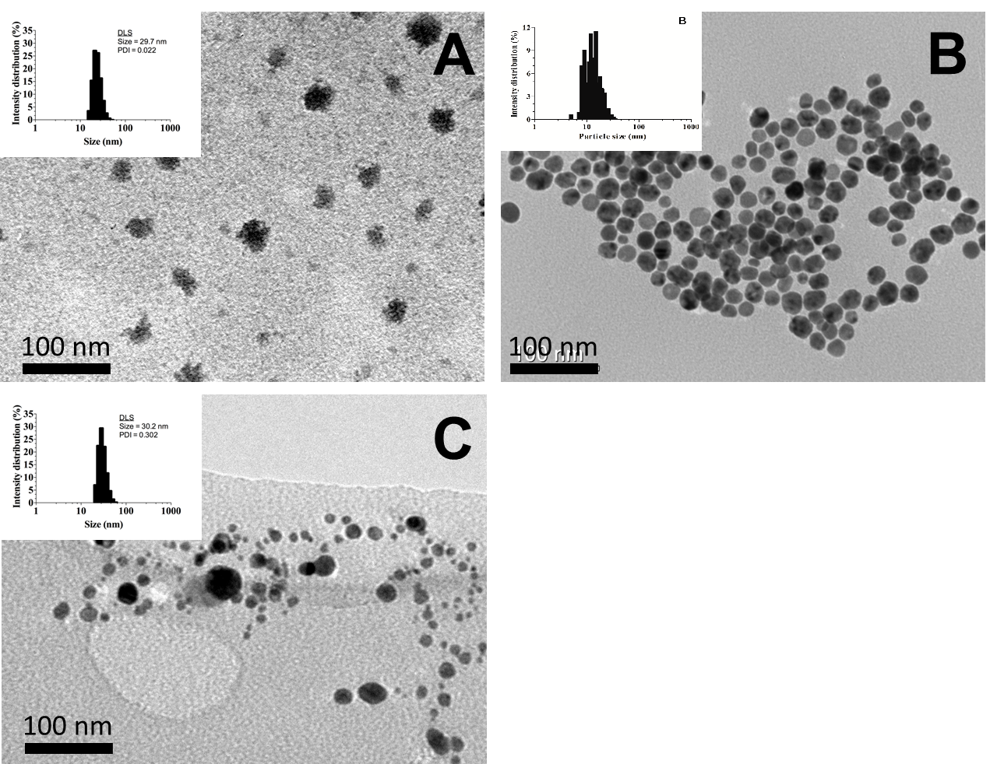

Figure 1

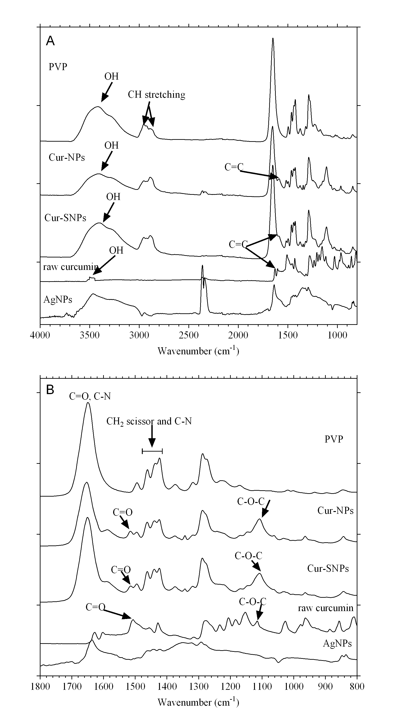Figure 2

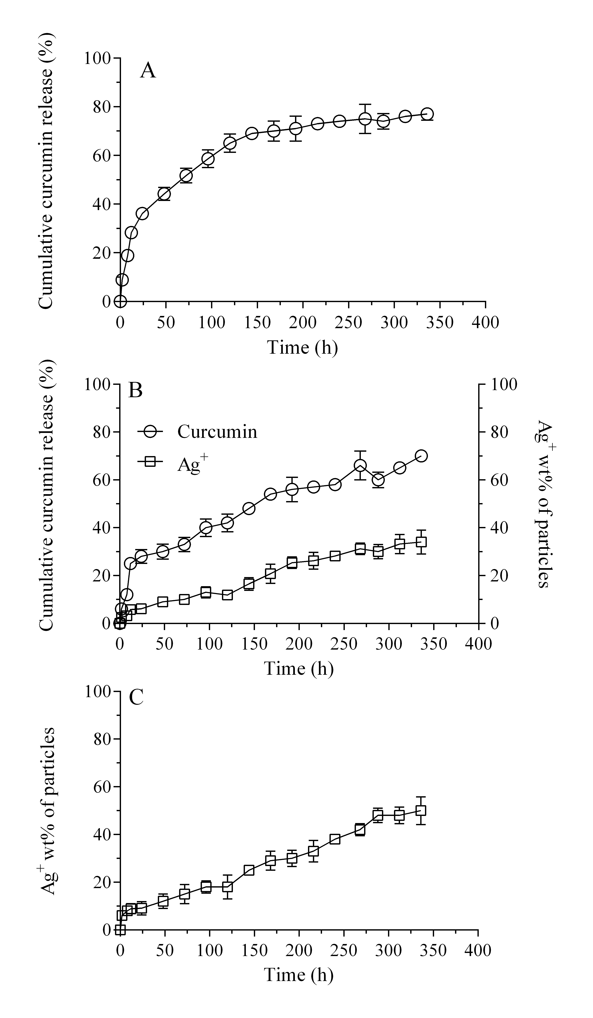

Figure 3

C:\Users\jloo\Dropbox\personal\Judy's work related stuffs\Paper 4 -Curcumin and silver nanoparticles\Manuscript and figures\Revision\Figure 4.tif

Figure 4

C:\Users\jloo\Dropbox\personal\Judy's work related stuffs\Paper 4 -Curcumin and silver nanoparticles\Manuscript and figures\Revision\Figure 5.tiff

Figure 5

C:\Users\jloo\Dropbox\personal\Judy's work related stuffs\Paper 4 -Curcumin and silver nanoparticles\Manuscript and figures\Revision\Figure 6.tif

Figure 6

C:\Users\jloo\Dropbox\personal\Judy's work related stuffs\Paper 4 -Curcumin and silver nanoparticles\Manuscript and figures\Revision\Figure 7.tif

Figure 7

C:\Users\jloo\Dropbox\personal\Judy's work related stuffs\Paper 4 -Curcumin and silver nanoparticles\Manuscript and figures\Revision\Figure 8.tif

Figure 8