# How are the new documents of social networks shaping our cultural memory

# Abstract

**Purpose**—This paper examines how keeping the records of social network (SNS) communications for secondary analysis institutes a new type of memory practice, one that seeks both to capture shared public memories and form new cultural understandings.

**Design/methodology/approach**—Using a framework of documentary and memory practices the study conducts a qualitative content analysis of SNS communications collected from Facebook, GooglePlus and Twitter during a national event. It combines a content analysis of the communications with the analysis of their materiality and form to investigate potential contributions of SNS to social and cultural memory including their subsequent custodianship.

**Findings—**The study finds that the message architecture and metadata of different social networks is comparable and collectively evidences differing aspects of social events to document their unique discourse. Findings demonstrate the contribution SNS is making to social memory and a framework for understanding how SNS in being incorporated into cultural memory practice is presented.

**Originality/value—**This is one of the few studies that analyses a range of messages from differing SNS in order to understand their impact on cultural memory and the documentary practices of memory institutions.

**Keywords**—Documentation, Social Networks, Collective memory, Cultural memory, Documentary practice, Historical perspectives

**Paper type—**Research paper

# Introduction

This paper stands at a decisive moment in the history of social media and presents significant questions for the documentary practices of society’s ‘memory’ institutions. This moment occurred in April 2010 when the U.S. Library of Congress announced that it would be collecting the Twitter archive as a record of contemporary life (Raymond, 2010). By committing the institutional resources of the library to the acquisition, organization and preservation of social media, and in particular the short message communications of social networking sites (SNS) like Twitter, the Library’s announcement flagged a significant shift in thinking about social media: large-scale interpersonal communications between individuals do more than inform our understanding of the present, they present evidence of contemporary life that should be collected and maintained for their historic value as part of society’s memory.

In order to illustrate the importance of this decision, the paper examines the social media commentary concerning a specific event in March 2012, when the Murrumbidgee River, in Australia, flooded. During the flood the local community marked the crisis in real time SNS communications with recollections of a flood that had occurred well before their lifetime. They compared the high watermark of the current flood with a flood that occurred in 1852: recording it as the “#1in160yearflood,” “the worst in almost 160 years,” and “CBD evacuated due to floods at 160 year high.” That the worst flood in living memory was named in a spike of Facebook, GooglePlus and Twitter communications in response to an immediate and potentially life-threatening crisis is remarkable because it occurred in the first few hours of an event where people had little recourse to the documentary record and no time for historic analysis. Somehow events that had first been recorded in a handful of telegrams and newspapers in 1852 were remembered now, surfacing as ‘new’ memories in SNS. In this context the role of social networks for understanding the past extends beyond its place as a record to its role in a constitutive social process of actively constructing shared memories.

The new collecting policy and the historical event sit at opposite ends of our understanding of collective memory. One, which lives in the everyday interactions and communications of people, is being recorded and shared anew as people extend the bounds of their community through SNS. The other exhibits a deliberate archival consciousness to store and analyse the evidence of contemporary society so it can be transmitted overtime. The two share an inextricable relationship as personal memories materialize in new forms of collectible text that, when kept, will in turn shape our culture and remembering.

How then are society’s memories taking shape in SNS, and what roles do or should ‘memory institutions’ play? To address this question, this paper presents a qualitative media analysis of SNS communications collected during the flooding of the Murrumbidgee River in March 2012. At the height of the flood, communications were sampled from three major public social networks, Facebook, GooglePlus and Twitter and analysed in order to understand how SNS communications contribute to social discourse and a record of the event.

The study asks

* how are the short messages of SNS similar to other historic ‘social’ records?;
* what characteristics of the SNS document support or limit its use as a record?;
* how are SNS communications shaping our cultural memory?; and
* how are the related processes of documentation constituted as a social, cultural memory practice?

That the emergence of SNS creates new ways of documenting and remembering society is, in principle, very exciting, but currently the social and institutional arrangements for this are very unclear. It is therefore fundamental that a solid research agenda be built around the documentary evidence of memory embodied in these new communications; questions about how and, indeed if, SNS communications should be collected and preserved within a formalised, publicly available, memory system needs to be included in this agenda. Our study, focussing on SNS enables us to identify some of the vexed issues facing memory institutions vis-à-vis the collection of this media and the challenges in understanding its collection as a documentary practice; such insights underpin a proposed model for valuing the collecting of social media as a memory practice. The following sections examine the concept of social media as documents of memory and the role that memory institutions might, through their documentary practices, contribute to collective and cultural memories.

# Memory institutions and the collection of social media

The memory institutions of the GLAM sector (galleries, libraries, archives and museums) exemplify what Giddens (1984) described as structured social practices in the *longue durée*, and should be understood for their role in the social construction of memory, most particularly at a time when new communication technologies are altering social structures and society’s understanding of memory. Practice in memory institutions is premised on the development of procedures that allow externalised human communications to be sifted through, censured, interpreted, revised and transmitted over time. It is not an objective activity independent from society but a process—of forgetting and remembering—that happens *in vivo*,as part of social experience (Debray, 2000, p. 11). The theoretical importance of a practice-oriented view to our research is central. Our approach focuses on the activity of written communication between people and the material form of its mediation (Nicolini, 2013); most particularly we focus on the role that SNS takes to shape our understanding of memory practice . If we accept that memory institutions are not the stable and unerring pillars of society, but are organisations that actively test and revise their processes and procedures as the social, political and technological landscape changes, then we must ask how the current landscape, with its new forms of communications and interactions, is changing the material structure of society’s memory practices.

## Collecting SNS

Memory institutions adapted to the first generation of the Web by adopting new technologies and changing practice so that traditional collecting procedures could be extended to the digital domain. Criteria for cultural significance were translated into new contexts; online exhibitions were added to traditional modes of display and storytelling; public web pages were designated as collectable because they were published within the jurisdiction of an institution and their form (as printed publications of government, celebrities and public commentators) held a degree of familiarity (Cathro *et al.*, 2001). The Library of Congress’ decision to preserve the entire Twitter archive however, heralds a tectonic shift for this practice. The documents of SNS are part of a second generation of Internet communications so distinct from Web 1.0 that they are hard to ascribe to recently established norms of digital acquisition, preservation and dissemination.

The central defining characteristic of Web 2.0 is the shift to a broad canvass of applications that enable the creation and exchange of user-generated ‘social’ content (Kaplan and Haenlein, 2010). All share conditions of sociability and use the same underlying Internet architecture to include embedded text, still and moving images, audio files and links to other online content (van Dijck, 2013). How to order, group and make sense of the records of social media so that they can be archived and shared for secondary use, are questions that are only just beginning to be asked. As a starting point, demarcating social media into various categories makes analytical sense; it allows the meaning of the communications to be considered in terms of form, infrastructure, contents, contexts and relationships for people. In this study we have followed van Dijck’s (2013) initial separation of social media into broad classes and focussed our analysis on records collected from social networking sites (SNS—Facebook, GooglePlus, Google’s social media platform and Twitter), distinguishing SNS for the time being from other user generated content services outside of our analysis such as YouTube, social e-commerce services and social games (van Dijck, 2013).

The enormous numbers of people contributing to SNS attests to a significant space in the cultural economy (de Certeau, 1984) and the importance of these sites in transforming contemporary culture. It is not simply that the personal statements of so many people can provide a profound insight into how we are living and thinking, these social networks are changing *how* we live and think, by transforming the “procedures, bases, effects, and possibilities of collective activity” (ibid., p. xiv); and it is these social conditions of change that require SNS communications to be prioritised and preserved for society’s memory (Manovich, 2012; Buckland, 2013). While the contemporary analysis of large sets of topical communications from SNS is a clear indicator of the global significance of their evidentiary role, what concerns us more is the long term preservation of these mass communications for the purposes of society’s memory. At the moment many new ‘historic’ records from Facebook and Twitter, for example the Arab Spring and the Queensland Floods, sit outside the custody of public institutions and are being lost. The challenges for collecting institutions are immense, differences between types of documents, including published and unpublished, are blurring, they are more dynamic and often produced only for the short-term as “the emphasis in the digital archive shifts to regeneration, (co)produced by online users for their own needs.” (Ernst and Parikka, 2013)..Memory institutions are responding by accessing, publishing, monitoring and trialling the collection of SNS documents.

Since commencing the Twitter archive the Library of Congress has collected more than 170 billion tweets or 133 terabytes of personal communications (Library of Congress, 2013). From the outset it has been challenged over the cultural worth of this collection and issues associated with personal privacy and intellectual property rights, yet support for the preservation of the Twitter archive as a “legacy to humanity’s future” has been upheld (Raymond, 2010). The Library has not yet provided access to the collection, concentrating instead on establishing the information architecture that will allow the collection to be managed over the long-term, and is now working with GNIP the largest provider of real-time aggregated social media data feeds and recently acquired by Twitter, to develop a research and scholarship focused search interface (Library of Congress, 2013).

The Twitter Archive represents only a small part of SNS communications and other activities in memory institutions are underway to ensure broader representation and use, this includes the selective collection of Facebook communications at the Library of Congress and You Tube video by the National Archives of the UK. Table 1 presents some examples of collecting initiatives that are being trialled by public institutions that join a range of projects monitoring and collecting SNS for social research, “… opening up questions about using, collecting and archiving social media to record a historical event as it is happening” (Miles, 2012).

Table 1 Memory institutions monitoring and trialling the collection of SNS

|  |  |
| --- | --- |
| **Institution** | **Collecting** |
| Library of Congress | The Twitter Archive: all public tweets since 2006. The archive is collected through the intermediary GNIP and is likely to be made available via an interface built on the GNIP search API. |
| South Carolina State Library | SCSL Social Media Library and Archive, all tweets, Facebook posts and YouTube content generated by the official accounts of South Carolina’s State agencies including communications from citizens and made available through the intermediary ArchiveSocial in order to meet Freedom of Information obligations. |
| Museum of London | A targeted collection of Twitter communications collected during the London Olympics #citizencurators project. The archive has been presented as an exhibition and digital objects from the project have joined the Museum’s collection. |
| State Library of NSW, Australia | The State Library of NSW, Australia, is one of a number of government agencies evaluating Vizie as tool for collecting social media. Vizie searches multiple platforms for relevant tweets/blogs/posts, and provides summaries of social media activities that are supported by visual display and allows communications to be isolated for collection. |
| Arcomem project, European Union | TheArchive Community Memories (Arcomem) project is developing sustainable methodologies and tools for collecting social media in community based context of their creation. It is establishing practices for selective content-based appraisal and collection, semantic description for access and retrieval and publication into the ‘memory stream’ of collecting institutions |
| International Internet Preservation Consortium (IIPC) | The Twittervane project, led by the British Library investigates the use of Twitter to build a web archive collection. In-house software collects tweets and supports the evaluation of linked URLs by which curators evaluate significant web resources. |

Another project, the Europeana Foundation’s 1914-1918 is enabling social engagement through SNS by actively constituting social memory as the public contribute personal recollections of events such as World War One that shaped their families (Europeana, 2013). The implications of these pilot projects for memory institutions and the full extent of institutions collecting SNS are currently unknown. The evidential role of these collections to research that might extend beyond their initial use, to areas including historiography, is far from settled, but it is clear that the topics, events and themes flagged in social networks are being seen as significant to the public record. There is an immediate need to better understand where SNS communications might be situated, within traditional understandings of *documents, records and archives,* and in so doing further address questions about the role of social media in documentation and memory practice.

# SNS as document and documentation

Understanding SNS communications as documents is perhaps less a question about its form (what kind of document does it correspond to?) and more a question of *what is documented w*hen we collect the communications. If as Briet (1951, 2006, p. 10) says a document is “any concrete or symbolic indexical sign [indice], preserved or recorded toward the ends of representing, of reconstituting, or of proving a physical or intellectual phenomenon”, then a strong case can be made that the records preserved from SNS communications are documents. In a literal sense documents are evidentiary with a value that resides in the social act (the transactions, agreements, decisions) they inscribe (Ferraris, 2013). In official and legislative terms SNS communications are increasingly deemed to be documents of this order. In the public sector, they are considered to be records of business that should be archived (The White House, 2012; Sherman, 2011). Government records agencies including NARA in the United States (2010) and the State Records of New South Wales in Australia (2013) have recognised the documentary status of SNS records, and scholarship in archives is examining the challenges SNS present as an official record (Doran, 2012). In the literature of SNS, scholars have accepted, almost intuitively, the status of communications as documents (Becker *et al.*, 2012) with the terms ‘user-contributed documents’ and ‘user-generated content’ being used to describe the items attached to SNS messages (e.g. photographs, websites) and the meaning that is carried in the messages (Woolley *et al.*, 2010). Social media in this sense continues a tradition of documentation within humanist scholarship as evidence and the empirical foundation of research (Lund, 2010).

Documents are however not solely evidentiary, they are created by people to express all manner of activity; they inform, instruct, demonstrate, teach, constitute and record human action, as Lund (2010) demonstrates when tracing the etymology of the term—documentation is a characteristic human endeavour. This view is reinforced in UNESCO’s definition of a document, as “that which “documents” or “records” something by deliberate intellectual intent” (Edmondson, 2002, p. 8). Unlike other types of heritage artefacts, documents are characterised by a content and form that consist of signs (text, codes, sounds, images) that can be conserved, reproduced and transported and that result from a deliberate documentation process (Edmondson, 2002).

Isolating the concept of the document to a simple content-container view is difficult (Lund, 2010; Nunberg, 1996), and particularly for SNS communications where the concrete form of a document is embodied in the meaningful arrangement of bits (Buckland, 1998); this form is neither apparent or bound. SNS communications are not stable and unitary artefacts like books, newspapers, correspondence, and diaries, but can be constantly changed and repackaged into “morselized”, quantifiable, structured components (Nunberg, 1996). Yet there is a materiality to the SNS document that is constituted by the architecture of the digital text, its supporting infrastructure and the parameters of the discourse of communication that we examine in detail in section 5. SNS communications are the foundation of a new paradigm where the “exact trajectories formed by billions of cultural expressions, experiences, texts, and links” are combined to document and inform (Manovich, 2012, p. 263). Nunberg (1996) has argued that this changing conception of information requires a greater attention to the practices that surround the documentary forms so that the preservation of substantial, contextual and meaningful detail is ensured.

SNS communications occur in continuous real-time streams that are dependent not only on the service user (whether the author, the intended audience, or a multitude of unintended readers), but also the service provider. While most messages appear only momentarily as instances on a screen, each message includes additional unseen information created for business purposes and computer processing (e.g. structural metadata and additional machine-generated information like timestamps and geographical location) that may never be displayed. Each message occurs in relation to an extensive social network of communications that is dependent on relationships shared between people and links to other documents; many messages are composite multimedia documents (incorporating links to audio or video). Each authored message is delivered with additional contextual and peripheral content that might involve third party services, and may or may not be important (invitations, meetings, content sensitive advertising). Furthermore, both the underlying architecture of the SNS communications and the infrastructure of the service managing it are constantly changing. Holding all the possible documents of SNS, in their enormous quantities, endless varieties and states would be incomprehensible. Collecting and managing SNS is possible only when it is considered as part of an *intentional process of documentation*.

For the purpose of our analysis Fairthorne’s contention that a document is “any representation of messages that is treated as a unit of discourse within the social environment concerned” (Fairthorne 1972, cited in Houser, 1986) seems most appropriate. This consideration removes the possibility of any fixed rigidity to documents, which are at best, reference points in time that provide access to a past discourse and inform present ones. Thus, when memory institutions work on procedures for acquiring, organising, categorising the meaningful contents of documents they are providing observations about the social discourses represented. In a similar vein SNS messages should not be viewed as the complete document for any given discourse; they are little more than a few captured moments, whose importance is to offer up an additional and different approach to thinking about the way people engage in the public sphere that can be captured, shared and reused as part of society’s memory. Information contained in documents cannot be understood as some kind of independent entity; it needs to be understood from within the rubric of practice, based on context and a perspective that addresses the question of “what shapes and configures them” (Frohmann, 2004, p. 405). We have applied this same concern in our research, seeking to identify uniformity in the themes and structures informing expressions of memory as they occur in SNS communications.

# Scene setting in SNS

Social media has presented the opportunity for almost everyone to become an author. The consumers of texts are now also the producers but, when it comes to SNS, what kind of document are they writing? Explanations of SNS media stimulate comparison with traditional types of documents either as a vehicle for scene setting or as a mechanism for analysis (Good, 2013), and there are obvious parallels between the brief 140 character missives of Twitter and telegrams that were also constrained in length mainly because of cost, but also by convention with telegram forms often showing statements like “Message goes here. Be brief” (Macy, 2009). The fleeting temporality of the activity stream in Facebook, Twitter and GooglePlus even has a sense of the ephemeral about it. SNS communications, like traditional ephemera, seem to serve only minor and transient roles in everyday life and are often overlooked as documents because they lack any self-evident literary or artistic value (Twyman, 2008). Yet in our study of communications during the Murrumbidgee floods, we found an abundance of announcements, pamphleteering and organising taking place in Facebook and Twitter for town meetings, sandbagging drives and charity fund raising events, that seem representative of a new digital ephemera now replacing older printed media and this too could be preserved for the new processes and uses of technology it evidences.

Comparisons between diaries, journals and Facebook are often made. Sinn and Syn’s study of Facebook as medium for personal documentation concludes that Facebook is a rich repository of “personal identities and histories” where users document their lives in great detail (2014, p. 120). Functionally the similarities are direct—both provide a personal record of the author’s experiences, attitudes and observations to events relating to their life. Yet even here the comparisons are limited. When asked, Facebook users did not consider that they were documenting their own lives, they saw Facebook as a means of networking and sharing stories (ibid.). However many of the same users noted that they did not keep diaries or journals outside Facebook and this perhaps, more than anything else, speaks to its importance.

Sinn and Syn’s comparison of SNS communications with documents that typically populate the original materials (diaries, journals, manuscripts) and special collections (ephemera, newspapers) of memory institutions should not be surprising. SNS communications are the authentic personal expression of individuals recording their everyday experience and, “…information professionals, especially archivists who traditionally take care of important personal records and other documentary heritage for public history, cannot overlook this wealth of information about contemporary life” (ibid.). Yet despite the strong parallels between the function of diaries and Facebook, SNS is neither a digital imitation of all that preceded it, nor simply an old format transposed to a new medium. Facebook is different, “…in fact if it wasn’t it wouldn’t get any users” (Shirky, 2008); it is a new way of communicating that is driven by new business models, technologies and social conventions taking place within it (e.g. friending, liking, sharing, poking) and, like a traditional archive, often making most sense only within the context of its discourse. And yet there is a point at which scholars are re-evaluating the primary purposes of SNS communication and are assessing it for the secondary roles that it may serve as part of an institutionalised memory practice (Sköld, 2015). It is at that point that comparisons to media that have traditionally served to document record and store our memory are most compelling.

# The Murrumbidgee flood as SNS document

Our starting point for understanding the role that SNS is beginning to play in documented memory and the subsequent practices of collecting institutions, is a study of SNS communications collected during the Australian Murrumbidgee floods of March 2012 that examines their place as a social document, the discourse that the communications support and the nature of the evidence they present. Our analysis follows the narrative arc of communication in SNS shared among the residents of the region’s largest city, Wagga Wagga (abbreviated to ‘Wagga’) as they experienced the crisis. On 5 March the residents of Wagga were evacuated following predictions that the Murrumbidgee River would breach the 10.7 metre high levee with catastrophic impact. Our case study tracked the event as it was documented in three social network services, Facebook, GooglePlus and Twitter, over a period of 48 hours from the time evacuation orders were given at 9pm on Monday 5 March until the city was reoccupied on Wednesday 7 March (Scifleet *et al.*, 2013). The aim was to understand how the information architecture and metadata of the messages could contribute to acquisition, arrangement and analysis of the social interactions that were taking place and the extent to which personal experience and recollections contributed, almost instantaneously, to the creation of new public records.

Our study used the GNIP social media aggregator which allows a maximum of 10,000 messages to be collected every 24 hours; however we restricted the sample to a much smaller size and focused on an in-depth qualitative investigation. We commenced sampling activity streams from Facebook, GooglePlus and Twitter at 11:30 pm on 5 March, two and a half hours after citizens were ordered to evacuate Wagga and continued until reoccupation. We sampled 100 messages from each SNS at approximately 6-hour intervals for 48 hours, concluding at 12:10am on the morning of 8 March, resulting in 700 messages each from Facebook, GooglePlus and Twitter.

Each of the three social networking services is received in a mostly uniform, standardized format (JSON and XML based activity streams standard version 1.0); while there is some variation in the underlying architecture and metadata of the messages (Table 2) there is enough commonality to allow for a comparative analysis of messages originating from quite distinct services to take place. This access to standardized, readable messages is also an important consideration for document preservation not only because it allows us to work with comparable documents from multiple sources, *but* because it allows us to consider the collected media as a documentary record informing the same social discourse.

Table 2 The major metadata elements (architecture) across the three services sampled

|  |  |  |  |  |  |  |  |
| --- | --- | --- | --- | --- | --- | --- | --- |
| **Service** | **Author** | **Content** | **Type of post** | **Time & date** | **Supporting metadata** | **Device** | **Geo location\*** |
| Facebook | **✓** | **✓** | **✓** | **✓** | **✓** | **✓** | **✓** |
| Twitter | **✓** | **✓** | **✓** | **✓** | **✓** |  | **✓** |
| GooglePlus | **✓** | **✓** | **✓** | **✓** | **✓** |  | **✓** |
| *Geo-location is available only with author permission; in our sample most people had not granted permission | | | | | | | |

While the shared metadata standard facilitates document management and analysis, any suggestion that the technological infrastructure of a message defines SNS as a genre would be far too reductive (Lüders *et al.*, 2010). In our study it became apparent that authors exhibit differing patterns of communication in each of the three SNS and are creating different types of social documents. However, it is our view that understanding the sociality of a document requires analyzing more than the text from a communication; understanding of the structure and form of the content is essential for knowing how the conventions and practices of the media enable and restrict communication. Examining Facebook, GooglePlus and Twitter together makes good analytical sense because it allows us to explore similarities and reveal differences in content and form.

Our approach to analysis is qualitative and interpretative with a focus on how the evidence supports an understanding of changing memory practice. We commenced from the viewpoint that the information architecture framing a message is integral to understanding it and combined a qualitative analysis of the subject-content of the messages with an analysis of their materiality and form. The approach we take builds on the work of communicative genre (Orlikowski and Yates, 1994) and qualitative content analysts (Altheide, 1996) by categorizing and reporting on the communicative intent of the messages, i.e. the topic described in the message (the Wagga floods) and its purpose (e.g. to share a photo or news story). While our findings present descriptive statistics about the communications, moving beyond statistical data to understand the symbolic and latent elements of communication is essential for understanding the complexity of SNS messages where the structural elements are not easily separated from meaning; for example, whether a #hashtag is being used to classify the subject of message or as an affective device can only be decided through qualitative analysis. Furthermore our study found that ‘hashtagging’ serves an important communicative role by constructing the ‘space’ that enables a shared dialogue (Scifleet et al., 2013).

## The evidentiary role of the document architecture

The functional role of metadata and architecture in SNS activity streams is primarily computational but the evidentiary role cannot be overlooked, especially as many of the elements used in the communication are being utilised by researchers for social network analysis, investigating geographic patterns of distribution or, counting tags and mentions to address research questions. Their analysis, and therefore the meaning that the documents provide, is framed by (an often hidden) form. The elements include details about authorship, the type of message that it is and its attributes (a note, a bookmark or an image file), and whether (and how often) a message is liked, mentioned elsewhere or shared. This core information is supported by additional structural, descriptive and administrative metadata that allows collections of SNS messages to be interpreted and processed; the time and date a message was created and revised, uniform resource locaters and unique identifiers for the message, the author’s profile, and links to related information (e.g. URL’s for shared news items). It includes service specific elements such as tags and signifiers (#, @, RT in Twitter) telling us how a message was described and communicated, and about the device on which the message was created, often including the coordinates (geo-location) of the place from which the message was sent (Table 2).

In essence, the metadata of the document is codifying a cultural narrative that is informed by a contemporary epistemology centered on the ‘revolutionary’ change that the large-scale quantitative analysis of massive amounts of public communication brings to understanding our world. Yet government authorities and regulators are also prioritizing the importance of metadata analysis for individual communications (e.g. as evidence in law). In time we may need to look back to the records of SNS under a different light to understand the historical processes of change that are occurring now. Then, the same material trace that metadata provides may serve different purposes, with information about document creation, authorship, provenance, composition and use constituting valuable evidence about our social history.

At issue is the information that is being made available in the record. Despite current conformity with an underlying standard, SNS metadata is far from stable. Intermediary services, such as GNIP are enriching and restricting parts of the underlying document architecture so that they can differentiate and sell *entirely* different sets of information with different levels of access and service. With more and more research projects, public, private and corporate, archiving SNS communications, a critical understanding of the availability, arrangement and production of communications is imperative—the record archived by a regional institute may be a different record from that held by the Library of Congress.

The role that metadata plays as the material form of SNS communications seems to have passed by collecting agencies, since it is rarely discussed. To address this, memory institutions may need to develop multiple strategies. There is a need for more public-private partnerships between agencies, such as that established between GNIP, Twitter and the Library of Congress, to coordinate collection. Importantly, there is a need to develop a high-level metadata standard that will allow the large sets of SNS communications that are being collected to be uniformly described, treated and managed at the collection level (Scifleet et al., 2013).

## The transliteration of form

Our analysis of the common themes in communications (Figure 1) coalesced around several aspects of the Wagga flood—expressing anxiety (e.g. warning about the of the evacuation; questioning the capacity of the levee to hold?), broadcasting and updating information of the unfolding crisis (e.g. discussing the current height of the river), signalling support and expressing appreciation of volunteers and emergency officials (e.g. joining the brigades of volunteers filling the sandbags that would be used to hold the levee), finally, showing signs of humorous relaxation as the crisis was averted (e.g. with jokes about politician’s visits to the regional city). Noteworthy in this thematic analysis were the parallels evident between different platforms and different forms of social documents.

In Facebook authors took advantage of the liberal format to write more extensively and personally; their online profiles tended to correspond more closely with their ‘real life’ and this was evidenced in their continuous engagement with the unmediated social structures of friends and family, rather than the mediated community brought together around a critical event that we observed as more prominent in Twitter. The documents of Facebook, when compared with earlier forms of social documents could be thought of as being more like personal letters or sharable diaries used to update distant family members on the safety and whereabouts of loved ones. Twitter authors, who often represent themselves only with avatars, appear for the most part to be a broadcaster or deliverer of the digital telegram, telegraphing and broadcasting news and facts.

In GoogePlus document sharing was different again, more like the ‘in-group’ conversations that authors have within a particular circle of friends, a circle that provides a “stage and an audience for whom we tailor self-representations, disclosing what we see fit” (Kairam *et al.*, 2012, p. 1065). These different aspects of the documents can be seen overlayed in our analysis of communicative intent in Figure 1. Noteworthy characteristics are the consistent reportage from Twitter (announcing the evacuation and the state of emergency, sharing news coverage, reporting on visitors) that contrasts with the subjective and emotive accounts of Facebook (community spirit, support, conditions in the local community—Wagga), and the momentary spikes of humour and interest catching the attention of GooglePlus in-groups (the evacuation, spiders).

Figure 1 Documentary types by SNS

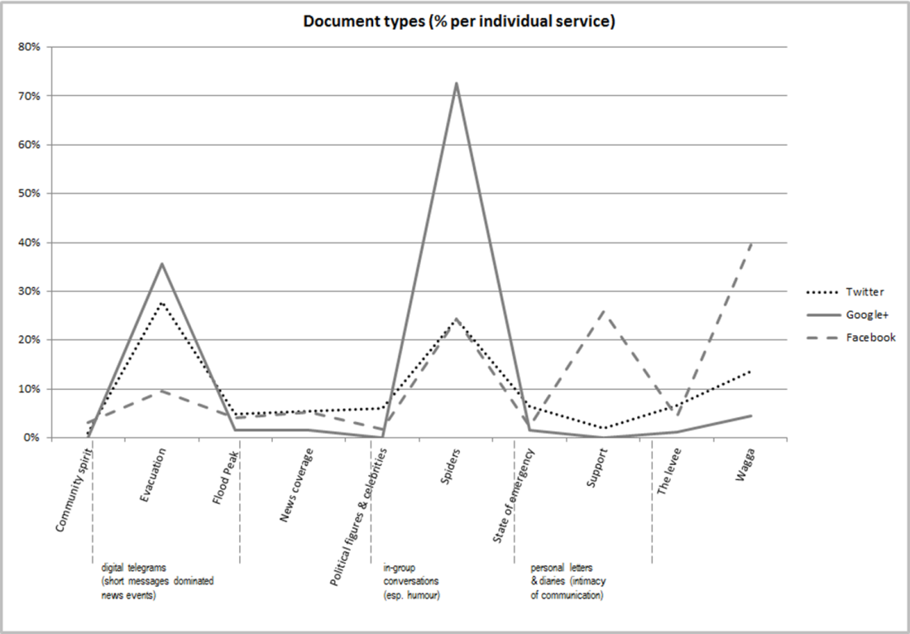

We have already noted the parallels that are drawn between earlier forms of social documents and the new forms in SNS. In our view, these comparisons are more than just the selection of analogous metaphors for sense making; what appears to be taking place is the transliteration of documents from one form to another. The purpose, roles and functions of social documents, like diaries, journals and correspondence are still in place, but they are transforming as new writing systems with fundamentally different modes of production are adopted for these purposes.. Understanding the historical continuity of form allows us to analyse new conventions in document production and enhances our understanding of the record. It can inform everything from determinations about the nature of what is being collected, to policies for governance, deposit, fair use and preservation. Witnessing these transformations and maintaining the historical link between early social documents with their contemporary equivalents is an essential role for collection practice.

## Limitations of the evidence

The communication conventions of SNS both support and limit the type of evidence that is documented. Facebook messages are often replied to with the simple acknowledgment of a ‘like’ (the “thumb up” sign), a new communication device showing an audience has read and responded to a message by expressing their affinity for it, but the depth of understanding that this kind of sign provides is narrow. In our study ‘likes’ almost always signaled support or appreciation for the author and their message, either by adding to an expression of support for flood victims or by appearing in response to interesting images and humorous remarks that an author shared. In Twitter, the RT (re-tweet) and @ ‘mentions’ can provide a similar function. They signify complex human interaction that is not easily accounted for; for example, when we reviewed a sample of Facebook messages concerning the Wagga floods months after the original download, it showed an increase in the number of ‘likes’, demonstrating a limitation of counting the ‘likes’ when we did. Once SNS data is collected, it is bound; it is no longer part of a continuing social discourse but has become a static record fixed in time with a start and an end. While aggregate measures of value such as the Klout influence scores represented by likes and re-tweets may be useful as evidence of social influence at a point in time, it complicates documentary custodianship where there is a need for recordkeeping that accurately describes the collection and its boundaries.

SNS messages from all three services were coded for their communicative intent (Table 3), that is whether the author intended to share an open comment about the flood or whether the message was intended specifically as a reply or message to someone (i.e. participating in a conversation) or whether it was a request for information or help. The analysis clearly shows the main reason authors communicated during the crisis was to share information about current conditions during the flood crisis and associated happenings. In Twitter, 37 of the first 40 messages were broadcasts from the NSW State Emergence Service or police, these were quickly followed by a group of messages from the Australian Broadcasting Authority’s local radio news resending emergency announcements. These in turn, were shared by the population, most of whom communicated only once during the crisis.

Table 3 The spectrum of primary communicative intent during the Wagga floods

|  |  |  |  |  |
| --- | --- | --- | --- | --- |
| **Primary intent** | **Purpose** | **Tw** | **G+** | **Fb** |
| Comment | Open remark about event or topic | 26% | 34% | 43% |
| Comment mention | Remark includes an @mention to another person’s profile | 8% | 0% | 0% |
| Conversation | Communication including @mentions is clearly a conversation | 5% | 1% | 7% |
| Share | Share or broadcast information about event topic broadly | 60% | 64% | 46% |
| Request | Direct request for information or support (e.g. help) | 1% | 1% | 4% |

Our analysis shows news media and government agencies are using Twitter as an information broadcast mechanism and that the authority of news media in social networks is significant. Of *all* Facebook messages, 15.5% (including photographs) had origins that were attributable to either news media or government sources. Of the documentary types shown in Figure 1, 5.18% of Facebook and 5.44% of Twitter messages were *about* news coverage. Indeed one advantage of collecting the SNS record may be its ability to stand as an historic record documenting what news, events, topics and sources, resonated most with people at the time.

The proportion of link sharing to images or news stories in SNSs is also high: in our sample 68.9% of Twitter messages and 46.8% of GooglePlus contained links. The full extent of information sharing in Facebook is much harder to gauge because Facebook ‘internalises’ links bringing information about linked pages directly into its own document architecture. From the information available, it is not always possible to track back to the origin. With SalahEldeen and Nelson (2012) raising the serious problem of broken links to the web pages, videos and photographs documenting the Egyptian revolution (Arab Spring), it may well be that the most important surviving document about an event is the views and opinions expressed in the SNS document.

## How the communicative space structures discourse

By extending our analysis beyond the primary intention of communication and identifying the topics that author’s communicated about, our study reveals a compelling story of the flood that is evidenced entirely through the public discourse of the social networks (Figure 2).

Figure 2: Evacuation to reoccupation: prevalent topics over time

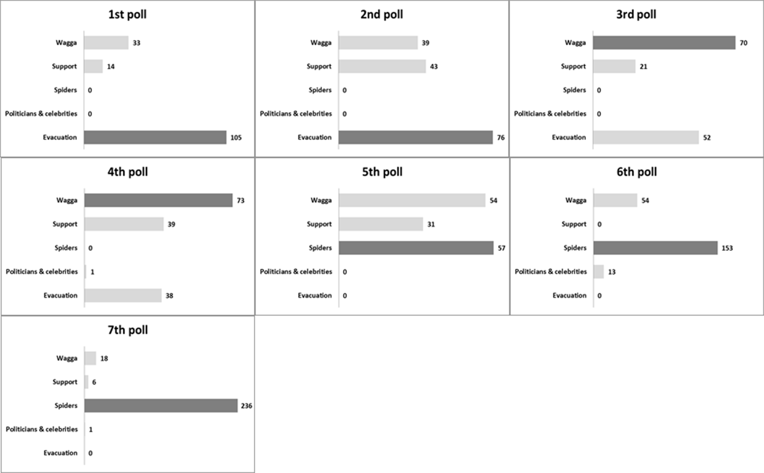

The narrative arc is straightforward enough. News to evacuate *Wagga* was the overarching theme of the first 24 hours. Attention then turned to the impact of the crisis and an increasing number of messages expressed their *support* and prayers for family, friends and the community-at-large. As the tide of the event turned and it became clear that the levee would hold, communications took on a much lighter tone, with jokes about visits to the region by *politicians and celebrities* a typical outlet. On 6 March an unusual natural phenomenon began as millions of usually unnoticed wolf *spiders* seeking safety, rose from the ground casting webs and creating a stunning visual effect of fields that seemed covered by snow. By 7 March the topic of ‘spiders’ appeared like a collective sigh of relief with people expressing amazement, awe and arachnophobia; a possible sign the floods were no longer a danger was the report of the spiders in the Huffington Post “Weird News” section (Campbell, 2012).

Importantly, message authors also adapted the architecture and conventions of SNS in inventive ways to establish meaning, often expressing humour. In our study just over 56 per cent of all Twitter messages carried a #hashtag and 6 per cent used multiple #hashtags; yet it was clear authors were using these for purposes other than the Twitter sanctioned purpose of categorizing tweets to “…help them show more easily in Twitter search” (Twitter, n.d.); as shown in Table 4, there are at least four uses of #hashtags.

Table 4 Use of #hashtags in Twitter

|  |  |  |
| --- | --- | --- |
| **Type** | **Descriptions** | **% occurrences** |
| Classify | Deliberately assigned to a message for the purpose of grouping texts together for identification and discovery e.g*. #nswfloods* | 53.3% |
| Content | Used to describe the message, often emphasing novel points of interest, but not intentionally for identification and discovery e.g “I saw the spiders #ballooning” | 27.2% |
| Affective | Used to describe message content affectively, often rhetorically and humorously e.g *#freakingmeoutalittle*, used with ‘spiders’ | 17.0% |
| Extend | Incorporated expressly within the sentence of a message, extending topical content e.g. *Politicians and journos inundate Wagga Wagga. Expected to exceed #MadeleinePulver #bombhoax levels by 6pm* | 2.5% |

This adaptation of convention is more than language play. While lines between different ways of using #hashtags can blur; generally the #hashtag served as one of a number of devices used by authors (along with @, RT), not only for expressing semantics, but for bringing people into the ‘material space’ of the conversation, just as though it were a room. In essence, people are using the textual devices of social networking to create spaces and shape relationships and in doing so, sometimes defining differing ‘tribes’ (Facebook, GooglePlus and Twitter) with customs that establish conventions for sharing memories.

Table 5 Structuring social space in Twitter

|  |  |  |
| --- | --- | --- |
| **Type** | **Intent** | **Example** |
| Joining | Personally joining an ongoing conversation by retweeting | Retweet - Wagga Wagga has already been split in two with the flood water at the moment... It will now be known as "Wagga And Wagga"! **#WaggaFloods** |
| Naming | Using the *@* convention to name someone as topic or subject for a conversation | I was stood up by the Wagga Mayor on air today. Guess he had more important people to chat to. **@JuliaGillard** |
| Adopting | Adopting/adapting communication devices for new idioms and new compositions | **Dear Feckbook,** Please stop sending me pictures of spiders, post-floods in Wagga. Thank you**. #freakingmeoutalittle #Igetit #lotsofspiders** |

# SNS and memory practice

Our analysis of the Murrumbidgee flood is built from a collection of SNS messages documenting a crisis that was, for many, the worst in living memory. The communications show people actively resurrecting a collective memory from 1852—the Murrumbidgee flood 160 years earlier—and joining this to a new record by exchanging recollections, stories, photographs and jokes in a shared space. This stream of communication, and many others like it, is not simply ephemeral, it is a complex and significant social record created by people utilising a medium that enables everything from writing to publishing and sharing personal correspondence with images and items of note. When collected, each stream of messages presents a collectively authored document bound only by the social discourse it represents and the limitations of the technology and services used. Figure 3 presents our conceptualisation of this exchange between 1) a new socio-technological infrastructure that mediates the everyday experience of people, and 2) the formal documentary practice of memory institutions. Such a conceptualisation contributes to our understanding of *how individual memories are communicated and enter into a collective memory to be selected and valued as cultural records*.

Figure 3 Conceptual framework for documenting SNS memories

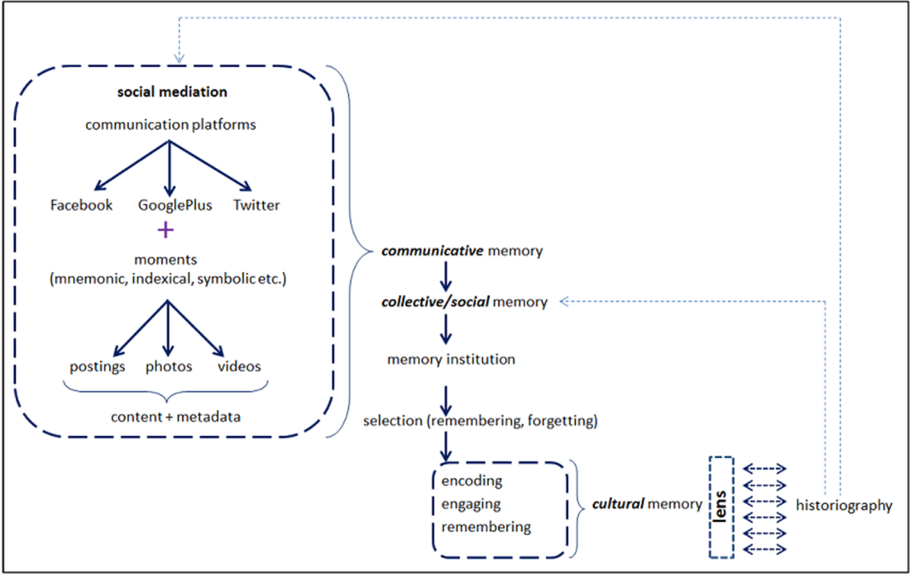

Online social networks in our model are mediated spaces that allow individual and personal (affective) experiences (*moments recorded and shared*) to join with the experience of others in a social discourse where communal events are remembered and re-remembered. The architecture of communication supports a more formal, conscientious ordering and recalling of past events and an institutionalisation from where they can be reconstituted anew (van Dijck, 2004). Each aspect contributes to a virtuous cycle in people’s embodied memories that are mediated and shared through media systems and re-embodied as the living memory of communities.

Our understanding of this as a *documentary* *memory* *practice* rests on the work of the French sociologist Maurice Halbwachs (1950) who extended conceptualisations of memory from individual acts of cognition to an understanding of *collective memory* as the remembering of an active past constructed through the shared experience of people in their social life. Halbwachs emphasised how the objects and spaces of our world (our grandfather’s chair, our home, our streets) come to bear on the memories we share with our family and community. He considered collective memory to be a social reality distinct from the metaphors of written history (in Yerushalmi, 2012). Memories are held collectively because they are embedded in the spaces people occupy (e.g. our street) and the relationship of people to their spaces. The signs and symbols that people attach to a space often outlast the objects and this contributes to the longevity of shared memory (Halbwachs, 1950, p. 142). Memory in this sense is “the place a group occupies [and] is not like a blackboard, where one may write and erase figures at will … it is the structure and life of their society” (ibid., p. 130). In Halbwachs’ view, the transmission of memory across generations is not reliant on keeping records because it resides *in* the affective connections between people and their environment. It seems reasonable to extend that understanding to the communications and social interactions of SNS, where the architecture of network services provides a space for engagement.

Our research has demonstrated how the material framework of SNS contributes to people’s sense of belonging within a discourse and social space for sharing of memories. More recently, the commemoration of WW1 online and, in Australia, the gathering of 3000 Cyclone Tracy survivors in Facebook to commemorate, grieve and share memories 40 years after the 1974 disaster, is supporting our findings (Fisher, 2014). Yet our enquiry seeks to understand how the fluidity, instability and impermanence of Halbwachs’ ‘blackboard’ will document historic events and serve society’s memory. To do this our model of documented memory has followed the later distinctions that Jan Assmann has brought to Halbwachs’ work by deconstructing the central concept of *collective memory* into two: the *communicative memory* that people share through oral transmission and the more conscientious preservation of records of significance as *cultural memory* (Assmann, 2008b). The exchanges we have witnessed between people in SNS corresponds to the *communicative memory* that people share with each other in conversation, yet the current trials for collecting SNS raise its profile in *cultural memory as*

“a kind of institution. …exteriorized, objectified and stored away in symbolic forms that, unlike the sounds of words, or sight of gestures, are stable and situation transcendent: They may be transferred from one situation to another and transmitted from one generation to the next” (Assmann, 2008b, pp. 110-111).

The feature that distinguishes *communicative memory* from *cultural memory* is not only its externalisation but the process of documentation involved or, as Geoffrey Bowker (2005, p. 4) describes it, as the creation of an explicit index to the “array of traces of the past that we leave.” It is the deliberate construction and management of “consultable stores” of externalised, objectified and institutionalised records of social life that memory institutions undertake. While the mediative technologies of Twitter, Facebook, and GooglePlus have dramatically altered the mechanisms and processes for housing and communicating memory as text, their mere availability for secondary analysis does not guarantee their survival. While intermediary data services like GNIP are playing an important role in supporting the social locus of communication, it is the documentary practices of memory institutions—now being explored for SNS records—that will serve against the loss of this new contribution to the cultural record (Assmann, 2008a) because it is the mediation of memory institutions that will decide which communications are preserved, how they are organised, what access is provided and what is filtered out—ultimately deciding what will be available in time.

While memory institutions aspire to neutrality by limiting their interpretation of collections to descriptions that support discovery, display and use, the mediation of cultural memory is a social function that should not go unexamined (Debray, 1996). Meaning is made and remade as the embodied memories of people are externalised, preserved, selected and returned to communities, in a process of acculturation that Brockmeier (2002) considers to be fundamentally a narrative giving shape to the temporal dimension of human experience. Communities are framed by the narrative of their shared memories, the telling and re-telling of their stories in order to not forget their past (Bellah *et al.*, 1985). Whether or not the shared memories of the Cyclone Tracy survivors’ Facebook community becomes a lasting record of this event may be dependent on its collection and preservation.

# Conclusion: the challenges for memory institutions

It must be emphasised that the *conceptual framework for documenting SNS memories* (presented in Figure 3) is not intended to be read as a logical model of all the activities that take place in documenting memory, nor is it intended to be followed strictly as a directional flow diagram. We have presented the logic of a constitutive documentary practice witnessed through empirical research that is intended to serve as a guide by locating key actors, agencies and relationships in the construction of social memory. By applying the economy of abstraction that our diagram demands, we have presented a framework that allows an examination of the criteria and conditions for memory practices and their documentation. Theoretically, our research has prioritised the centrality of documentation in any ontology of documents by demonstrating the agency that is always present between the inscribed act (*the document*) and its creators (*the documenters*) and all that this entails.

Among the more vexing issues for researchers and memory institutions are the ethics of collecting authored communications from SNS, which by necessity involves an understanding of ownership and privacy in both legal and moral senses. Much of SNS communication is public, that is, it is published in a public space; in fact each of the SNS platforms has its own rules and norms for commercialisation, privacy, ownership and the sharing of information. Many of these challenge traditional approaches to custodianship, legal deposit and fair use and, with so much new research taking place, memory institutions will need to return to and review collection policies for SNS communications in consultation with the social networking services that are now integral to the cultural economy. While public-private partnerships are developing between social media aggregators, issues surrounding the costs of subscription services to access public, published texts and the right of institutions other than the Library of Congress to provide access to permanent collections of SNS communications need to be addressed. While at the moment accessing the public and published communications of social networking sites may satisfy the requirements of most human research ethics policies, there are shades of grey surrounding a researcher’s right to access these written communications simply because they occur in a public space. The right to informed consent, public privacy and the line between observation and surveillance require urgent attention.

Once the decision to collect SNS communications has been made, a primary challenge for memory institutions is to establish the mechanisms for 1) enabling acquisition, search, discovery and the long-term preservation of the documents, and 2) encoding and metadata practices that are essential to digital preservation; these mechanisms are yet to be established. Since metadata for search and retrieval should be the basis of metadata for preservation and access, both policies should be articulated from the beginning of a collection project that aims to support long term preservation and interoperability of datasets (Small *et al.*, 2012, p. 191).

While there is little in the literature about the mechanics of the preservation of SNS content, there is a body of developing best practices for the preservation of other digital content embedded in the OAIS (Open Archival Information System) preservation model, including the use of open formats, preservation metadata for authenticity, provenance and context and we consider this a direction for further research. The European Union’s Arcomem project (2015) is one of the more innovative responses to this challenge so far, in its aim to support memory institutions like archives, libraries and museums in the age of the Social Web by developing sustainable methodologies, tools and archival practices for collecting SNS communications while preserving information about the community based context in which they were created. One of the more complex issues and our future research directions focuses on subject and event based criteria as an approach to collection that is distinct from the Library of Congress’s ‘whole of archive’ approach.

There is however, in 2015, still much to be done. As Clifford Lynch (2005, para.15) has noted there are research questions about the preservation of digital content that are “*cultural, public policy, and ethical questions about how and what we remember and forget, about when and how it is appropriate to invest in ensuring the survival of memory*”. Social media and social networking sites challenge many of the prior orthodoxies of cultural memory practice by forming a new kind of dynamic institution where networks of people and communications form the record. The impact of this on our personal and collective memories, the custodianship of the cultural record and the shape of history, is a research agenda that needs to be explored.

# References

Altheide, D. L. (1996), "Process of qualitative document analysis", in Altheide, D. L. and Schneider, C. J. (eds), in *Qualitative media analysis*, Sage Publications, Thousand Oaks, Calif., pp. 22-24.

Arcomen, (2015), *About Arcomen*, available at: http://www.arcomem.eu/about/ (accessed 15 May 2015).

Assmann, A. (2008a), "Canon and archive", in Erll, A. and Nünning, A. (eds), in *Cultural memory studies: An international and interdisciplinary handbook*, Walter de Gruyter, New York, pp. 97-107.

Assmann, J. (2008b), "Communicative and cultural memory", in Erll, A. and Nünning, A. (eds), in *Cultural memory studies: An international and interdisciplinary handbook*, Walter de Gruyter, New York, pp. 109-118.

Becker, H., Iter, D., Naaman, M. and Gravano, L. (2012), 'Identifying content for planned events across social media sites', *Proceedings of the Fifth ACM International Conference on Web Search and Data Mining*, ACM, Seattle, WA, pp. 533-542.

Bellah, R. N., Madsen, R., Sullivan, W. M., Swidler, A. and Tipton, S. M. (1985), *Habits of the heart: individualism and commitment in American life,* University of California Press, Berkeley, CA.

Bowker, G. C. (2005), *Memory practices in the sciences,* MIT Press, Cambridge, MA.

Briet, S. (1951, 2006), *What is documentation?: English translation of the classic French text,* trans. Day, R. E., Martinet, L. and Anghelescu, H. G. B., Scarecrow Press, Oxford.

Brockmeier, J. (2002), "Remembering and forgetting: Narrative as cultural memory", *Culture & Psychology,* Vol. 8 No. 1**,** pp. 15-43.

Buckland, M. (1998), "What is a digital document", *Document Numérique,* Vol. 2 No. 2**,** pp. 221-230.

Buckland, M. (2013), "Cultural heritage, memory institutions, and technology", paper presented at *Conference on Technology, Culture and Memory (CTCM)*, 12-14 November, Recife, Brazil, available at: http://people.ischool.berkeley.edu/~buckland/CTCMBuckland.pdf (accessed 15 May 2015).

Campbell, A. (2012), "Spiders Blanket Wagga Wagga, Australia after Flooding", *Huffington Post*, 10 March 2012, available at: http://www.huffingtonpost.com.au/entry/spiders-wagga-wagga-australia_n_1335332.html?section=australia

Cathro, W., Webb, C. and Whiting, J. (2001), "Archiving the web: The Pandora Archive at the National Library of Australia", paper presented at *Preserving the Present for the Future Web Archiving Conference*, 18-19 June, Copenhagen, available at: http://www.nla.gov.au/openpublish/index.php/nlasp/article/view/1314/ (accessed 15 May 2015).

de Certeau, M. (1984), *The Practice of Everyday Life,* trans. Rendell, S., University of California Press, Berekley, LA.

Debray, R. (1996), *Media Manifestos: On the Technological Transmission of Cultural Forms,* trans. Rauth, E., Verso, London.

Debray, R. (2000), *Transmitting culture,* trans. Rauth, E., Columbia University Press, New York.

Doran, C. (2012), 'Governing the social network: How US federal department and agency records management policies are addressing social media content', *Proceedings of the 45th Hawaii International Conference on System Science (HICSS)*, IEEE, pp. 2299-2308.

Edmondson, R. (2002), *Memory of the World: General guidelines to safeguard documentary heritage*, UNESCO. Information Society Division, Paris, available at: http://unesdoc.unesco.org/images/0012/001256/125637e.pdf (accessed 15 May 2015).

Ernst, W. and Parikka, J. (2013), *Digital memory and the archive,* University of Minnesota Press, Minneapolis, MN.

Europeana, (2013), *Your family history of World War One, Europeana 1914-1918*, available at: http://www.europeana1914-1918.eu/en/ (accessed 15 May 2015).

Ferraris, M. (2013), *Documentality. Why it is neccessary to leave traces,* Fordham University Press, New York.

Fisher, A. (2014), "Cyclone Tracy survivors use social media to support each other", *ABC News [online]*, 2 December, available at: http://www.abc.net.au/news/2014-12-02/cyclone-tracy-survivors-find-solace-in-social-media/5933196

Frohmann, B. (2004), "Documentation redux: prolegomenon to (another) philosophy of information", *Library Trends,* Vol. 52 No. 3**,** pp. 387-407.

Giddens, A. (1984), *The constitution of society: Outline of the theory of structuration,* University of California Press, Berkeley, CA.

Good, K. D. (2013), "From scrapbook to Facebook: A history of personal media assemblage and archives", *New Media & Society,* Vol. 15 No. 4**,** pp. 557-573.

Halbwachs, M. (1950), "Space and the Collective Memory", in *The Collective Memory* Harper Colophon Books, New York, pp. 1-14.

Houser, L. (1986), "Documents: The domain of library and information science", *Library & Information Science Research,* Vol. 8 No. 2**,** pp. 163-188.

Kairam, S., Brzozowski, M., Huffaker, D. and Chi, E. (2012), 'Talking in circles: selective sharing in Google+', *Proceedings of the SIGCHI Conference on Human Factors in Computing Systems*, ACM, pp. 1065-1074.

Kaplan, A. M. and Haenlein, M. (2010), "Users of the world, unite! The challenges and opportunities of social media", *Business Horizons,* Vol. 53 No.**,** pp. 59-68.

Library of Congress (2013), *Update on the Twitter Archive at the Library of Congress [white paper]*, The Library of Congress, Washington D.C., available at: http://www.loc.gov/today/pr/2013/files/twitter_report_2013jan.pdf (accessed 15 May 2015).

Lüders, M., Prøitz, L. and Rasmussen, T. (2010), "Emerging personal media genres", *New Media & Society,* Vol. 12 No. 6**,** pp. 947-963.

Lund, N. W. (2010), "Document, text and medium: concepts, theories and disciplines", *Journal of Documentation,* Vol. 66 No. 5**,** pp. 734-749.

Lynch, C. A. (2005), "Where Do We Go From Here? The Next Decade for Digital Libraries", *D-Lib Magazine,* Vol. 11 No. 7/8.

Macy, B. (2009), "Is Twitter Telegram 3.0?", *Pistachio Micro sharing Macro results,* weblog post, 14 January 2009, available at: http://pistachioconsulting.com/is-twitter-telegram-30/ (accessed 14 December 2014).

Manovich, L. (2012), "Trending: The promises and the challenges of big social data", in Gold, M. K. (ed.), in *Debates in the Digital Humanities*, University of Minnesota Press, Minneapolis, pp. 460–475.

Miles, E. (2012), "Can the museum collect tweets?", *#citizencurators,* weblog post, 11 September 2012, available at: https://citizencurators.wordpress.com/2012/09/11/can-the-museum-collect-tweets/ (accessed 15 May 2015).

National Archives and Records Administration (NARA) (2010), *A report on Federal Web 2.0 use and record value*, Washington DC, available at: http://www.archives.gov/records-mgmt/resources/web2.0-use.pdf (accessed 3 May 2015).

Nicolini, D. (2013), *Practice theory, work, and organization: An introduction,* Oxford University Press, Oxford, UK.

Nunberg, G. (1996), "Farewell to the information age", in Nunberg, G. (ed.), in *The future of the book*, University of California Press, Berkeley, pp. 103-136.

Orlikowski, W. J. and Yates, J. A. (1994), "Genre repertoire: The structuring of communicative practices in organizations", *Administrative Science Quarterly,* Vol. 39 No. 4**,** pp. 541-574.

Raymond, M. (2010), ""How Tweet it is! Library acquires entire Twitter Archive"", *Library of Congress Blog,* weblog post, 14 April 2010, available at: http://blogs.loc.gov/loc/2010/04/how-tweet-it-is-library-acquires-entire-twitter-archive/ (accessed 13 May 2015).

SalahEldeen, H. and Nelson, M. L. (2012), "Losing my revolution: How many resources shared on social media have been lost", paper presented at *Theory and Practice in Digital Libraries, 23-27 September*, Paphos, Cyprus, available at: http://arxiv.org/pdf/1209.3026.pdf (accessed 10 May 2015).

Scifleet, S., Henninger, M. and Albright, K. (2013), "When social media are your source", *Information Research: An International Electronic Journal [online],* Vol. 18 No. 3, available at http://www.informationr.net/ir/18-3/colis/paperC41.html#.VtY31Pl95aQ

Sherman, M. (2011), "E-discovery rules applied to social media: what this means in practical terms for businesses", *Social Media Law Blog,* weblog post, 18 January 2011, available at: http://web.archive.org/web/20111103184241/http://www.socialmedialawupdate.com/tags/document-retention-policies/ (accessed 15 May 2015).

Shirky, C. (2008), "It's not information overload. It's filter failure", speech, *Web 2.0 Expo, New York, 16-29 September 2008*, available at: http://www.youtube.com/watch?v=LabqeJEOQyI (accessed 10 May 2015).

Sinn, D. and Syn, S. Y. (2014), "Personal documentation on a social network site: Facebook, a collection of moments from your life?", *Archival Science,* Vol. 14 No. 2**,** pp. 95-124.

Sköld, O. (2015), "Documenting virtual world cultures: Memory-making and documentary practices in the City of Heroes community", *Journal of Documentation,* Vol. 71 No. 2**,** pp. 294-316.

Small, H., Kasianovitz, K., Blanford, R. and Celaya, I. (2012), "What your tweets tell us about you: Identity, ownership and privacy of Twitter data", *International Journal of Digital Curation,* Vol. 7 No. 1**,** pp. 174-197.

State Records (2013), *Strategies for Managing Social Media Information [draft]*, State Records of New South Wales, Sydney, Australia, available at: http://futureproof.records.nsw.gov.au/ (accessed 3 May 2015).

The White House (2012), *Managing Government Records [Presidential Memorandum]*, available at: http://www.whitehouse.gov/the-press-office/2011/11/28/presidential-memorandum-managing-government-records (accessed 3 May 2015).

Twitter, (n.d.), *Using hashtags on Twitter*, available at: https://support.twitter.com/articles/49309 (accessed 15 May 2015).

Twyman, M. (2008), "The long-term significance of printed ephemera", *RBM: A Journal of Rare Books, Manuscripts and Cultural Heritage,* Vol. 9 No. 1**,** pp. 19-57.

van Dijck, J. (2004), "Mediated memories: personal cultural memory as object of cultural analysis", *Continuum: Journal of Media & Cultural Studies,* Vol. 18 No. 2**,** pp. 261-277.

van Dijck, J. (2013), *The culture of connectivity: A critical history of social media,* Oxford University Press, New York.

Woolley, J. K., Limperos, A. M. and Oliver, M. B. (2010), "The 2008 presidential election, 2.0: A content analysis of user-generated political Facebook groups", *Mass Communication and Society,* Vol. 13 No. 5**,** pp. 631-652.

Yerushalmi, Y. H. (2012), *Zakhor: Jewish history and Jewish memory,* University of Washington Press, Seattle, WA.