A comprehensive review of hybrid forward osmosis systems: performance, applications and future prospects
L. Chekli ª, S. Phuntsho ª, J.E. Kim ª, J. Kim ^{b}, J.Y. Choi ^{c}, J.S. Choi ^{d}, S. Kim ^{e}, J.H. Kim ^{b}, S. Hong ^{f}, J. Sohn ^{g} and H.K. Shon ^{a, *}
ª School of Civil and Environmental Engineering, University of Technology, Sydney, (UTS), Post Box 129, Broadway, NSW 2007, Australia
^{b} Department of Environment Science and Engineering, Gwangju Institute of Science & Technology (GIST), Republic of Korea
^{c} Hyorim Industries Inc., Yatap-dong, Bundang-gu, Seongnam-city, 513-2, Gyeonggi-do, Republic of Korea
^{d} Environmental and Plant Engineering Research Division, Korea Institute of Civil Engineering and Building Technology (KICT), 283, Goyangdae-Ro, Ilsanseo-Gu, Goyang-Si, Gyeonggi-Do, 411-712, Republic of Korea
^{e} Department of Civil Engineering, Pukyong National University, 45 Yongso-ro, Nam-gu, Busan 608-737, Republic of Korea
^{f} School of Civil, Environmental & Architectural Engineering, Korea University, 1, 5-ka, Anam-Dong, Sungbuk-Gu, Seoul 136-713, Republic of Korea
^{g} Civil and Environmental Department, Kookmin University, Seoul 136-702, Republic of Korea

Abstract:
Forward osmosis (FO) has been increasingly studied in the past decade for its potential as an emerging low-energy water and wastewater treatment process. However, the term “low-energy” may only be suitable for those applications in where no further treatment of the draw solution (DS) is required either in the form of pretreatment or post-treatment to the FO process (e.g. where the diluted DS is the targeted final product which can be used directly or simply discarded). In most applications, FO has to be coupled with another separation process in a so-called hybrid FO system to either separate the DS from the final product water or to be used as an advanced pre-treatment process to conventional desalination technologies. The additional process increases the capital cost as well as the energy demand of the overall system which is one of the several challenges that hybrid FO systems need to overcome to compete with other separation technologies. Yet, there are some applications where hybrid FO systems can outperform conventional processes and this study aims to provide a comprehensive review on the current state of hybrid FO systems. The recent development and performance of hybrid FO systems in different applications have been reported. This review also highlights the future research directions for the current hybrid FO systems to achieve successful implementation.
Keywords: Forward osmosis, Hybrid systems, Draw solution, Desalination, Wastewater treatment.

Contents
1 Introduction 4
2 Hybrid FO systems: Performance and applications 9
2.1 Seawater and brackish water desalination 9
2.1.1 Hybrid systems for the recovery of DS 9
2.1.2 FO as an advanced desalination pretreatment process 14
2.1.3 Hybrid FO systems as an alternative to conventional desalination process 17
2.2 Wastewater treatment 24
2.2.1 OMBR-RO hybrid systems 24
2.2.2 Other hybrid systems for wastewater treatment 25
2.3 Simultaneous wastewater treatment and seawater desalination 30
2.4 Other applications 33
2.4.1 Management of high-salinity feedwaters 33
2.4.2 Fertigation 35
2.4.3 Osmotic microbial desalination cells 36
2.4.4 Sludge dewatering 38
2.4.1 Protein enrichment 38
3 Conclusions and Future prospects 39

Abbreviations
BSA: bovine serum albumin; BWRO: brackish water reverse osmosis; CA: cellulose acetate; CAc: citric acid; CQDs: carbon quantum dots; CTA: cellulose triacetate; DS: draw solution; ED: Electrodialysis; EDTA: Ethylenediaminetetraacetic acid; FDFO: fertiliser driven forward osmosis; FO: forward osmosis; FS: feed solution; GAC: granular activated carbon; rGO: reduced graphene oxide; HF: hollow fibre; ICP: internal concentration polarization; IPN: interpenetrating network; LCST: lower critical solution temperature; LPRO: low pressure reverse osmosis; MBC: membrane brine concentrator; MD: membrane distillation; MDC: microbial desalination cells; MED: multi effect distillation; MF: microfiltration; MNPs: magnetic nanoparticles; MSF: multi stage flash; MW: molecular weight; NF: nanofiltration; OD: osmotic dilution; OMBR: osmotic membrane bioreactor; OMDC: osmotic microbial desalination cells; PA: polyamide; PAA: polyacrylic acid; PAFO: pressure-assisted forward osmosis; PRO: pressure-retarded osmosis; PV: photovoltaic; RO: reverse osmosis; ROSA: reverse osmosis system analysis; RSF: reverse solute flux; SPS: switchable polarity solvents; SWRO: seawater reverse osmosis; TDS: total dissolved solids; TEM: transmission electron microscopy; TFC: thin-film composite; TMA: trimethylamine; TOC: total organic carbon; TrOCs: trace organic compounds; UF: ultrafiltration; VMD: vacuum membrane distillation; WHO: world health organization; ZLD: zero-liquid discharge.

Introduction
The continuous and exponential growth of population has raised considerable concerns on the sustainability of water and energy resources [1-4]. Therefore, one of the main challenges of this century is in meeting the increasing water demand at low-energy cost. In fact, water and energy are closely linked together since the production of clean water is still an energy-intensive process while generating power often requires a fair amount of water [5, 6]. The development of low-energy separation technologies for clean water production is therefore crucial and has gained an increasing interest in the last few decades. Nowadays, membrane technologies are the most widely used methods to produce clean water and, among them, reverse osmosis (RO) is currently the most promising membrane separation process for desalination [7]. The state-of-the-art RO technology has significantly improved the scope for the use of saline water and impaired wastewater effluent as an alternate source of water to augment fresh water or to reduce pressure on freshwater resources [8]. However, the energy required for seawater RO has almost reached a plateau, and any more efforts towards reducing energy consumption requires additional processes thereby increasing the total cost of the final water. Besides, even if RO desalination plants consume significantly less energy than it was three decades ago, it still remains an energy-intensive process due to the high hydraulic pressure required to surpass the osmotic pressure of the saline feed water [8, 9]. Finally, RO suffers from severe membrane fouling which greatly affects its long-term performance and the management of concentrated brine is still a major environmental issue. Therefore, any low energy desalination technologies could make desalination more affordable and have a significant impact in meeting the increasing water demand.
In the last decade, forward osmosis (FO) has gained increased attention as an emerging membrane technology. Therefore, many contributions have been made to improve the overall FO process efficiency from both academic researchers and industries [3, 6, 10, 11]. The principle of FO process relies on using the natural osmotic process to draw the water molecules across a semi-permeable membrane from a saline feed water to a higher concentrated solution, namely the draw solution (DS). The driving force is therefore created naturally by the difference in osmotic pressure between the DS and the feed solution (FS). This offers several advantages over conventional hydraulic pressure-driven membrane processes (e.g. RO) such as lower energy requirements and reduced membrane fouling potential [12]. In fact, in the FO process, the absence of applied hydraulic pressure has not only the potential to reduce both capital and operation cost but can also be beneficial for fouling control compared to pressure-driven membrane processes. Besides, in most cases, fouling in the FO process has been found to be physically reversible which reduces the need for chemical cleaning like the RO process [13, 14].
However, FO technology still suffers from some major technological barriers. The first barrier is the lack of suitable membranes designed for the FO process. The conventional membranes such as RO membranes are asymmetric and was proved not suitable for the FO process as it aggravates concentration polarisation effects, some of which are not only unique to the FO process but also pose a significant decrease in process efficiency [12]. However, significant progress has been made in FO membrane fabrication recently, with thin film composites (TFC) FO membrane now reaching comparatively higher water flux than the existing commercial cellulose triacetate (CTA) FO membrane [15, 16]. The second barrier is the separation of the produced water from the DS and its reconcentration and recovery, especially when high quality water is required (e.g. for drinking water production). In fact, the separation and recovery of the DS require an additional processing unit, which can consume energy and therefore still remains a significant challenge for drinking water applications [17-19]. The success of FO for potable purpose will therefore greatly depend on how easily and efficiently the draw solute can be separated from the water after the FO process, once the DS is fully diluted.
Therefore, early FO studies focused on finding efficient draw solute recovery methods and therefore started to develop hybrid FO systems (i.e. FO coupled with another physical or chemical separation process). These initial bench-scale studies (e.g. [20]) were aimed at evaluating the performance of recovery processes for specific/novel draw solutions. Recent review papers on the FO process have been published on the development of either draw solution or their recovery methods [6, 11, 17]. However, in the last couple of years, several hybrid FO systems have been developed for various applications including seawater and brackish water desalination (about 60%), wastewater treatment (about 13%) or both (i.e. simultaneously, about 13%) (Figure 1a). Other applications include fertigation, protein concentration or dewatering of RO concentrate. Table 1 shows the different configurations of hybrid FO systems where FO has been integrated into the existing or combined processes to either replace conventional pre-treatment technologies or as a post-treatment to reduce the volume of industrial waste. In fact, it has been demonstrated that FO used as a pre-treatment process can improve the overall efficiency of conventional desalination processes in applications with challenging feed waters (i.e. having high salinity, high fouling potential or containing specific contaminants) [21]. One good example is the coupling of FO with Membrane Distillation (MD) to desalinate waters that are usually challenging for MD alone. Using this hybrid FO-MD system, FO is used as a pre-treatment to reduce inorganic scaling and/or organic fouling which have adverse effect on the MD process whereas the latter is used to recover and reconcentrate the DS using low-grade heat [22]. FO coupled with Nanofiltration (NF) has also been recently proposed [23] in the context of fertiliser driven forward osmosis (FDFO) since FO, as a standalone process, was not able to produce water with acceptable nutrient concentrations for direct fertigation.

Table 1: A comparison of different configurations of hybrid FO systems.
Schematic of hybrid FO systems | Details | Examples
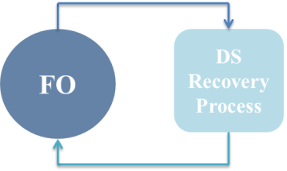 | Bench-scale studies to evaluate the performance of a recovery process for a specific/novel draw solution | Ultrafiltration (UF) for the recovery of magnetic nanoparticles (MNPs)
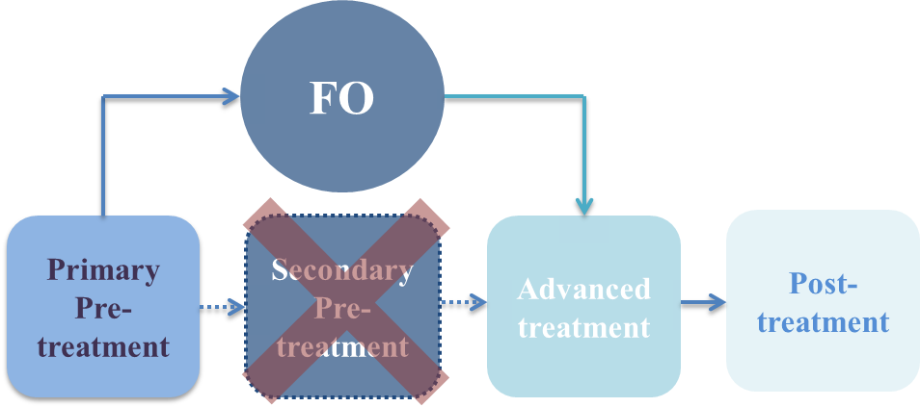 | FO is tested as an alternative pre-treatment to conventional separation technologies and integrated in existing processes | Hybrid FO-RO system whereby FO is tested as an advanced desalination pretreatment process
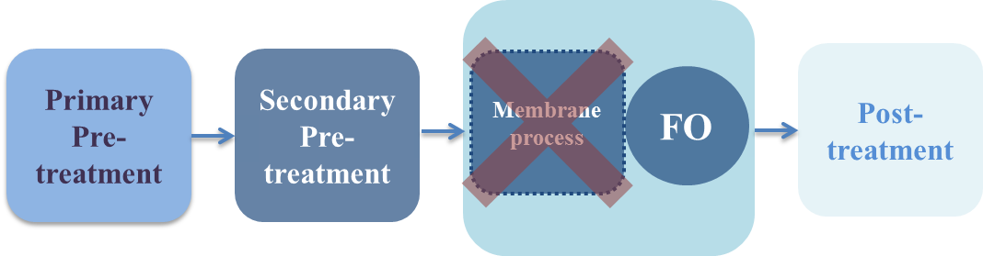 | FO is tested as an alternative process to conventional membrane technologies and integrated in existing processes | FO integrated into membrane bioreactor (MBR) to potentially replace conventional processes such as UF
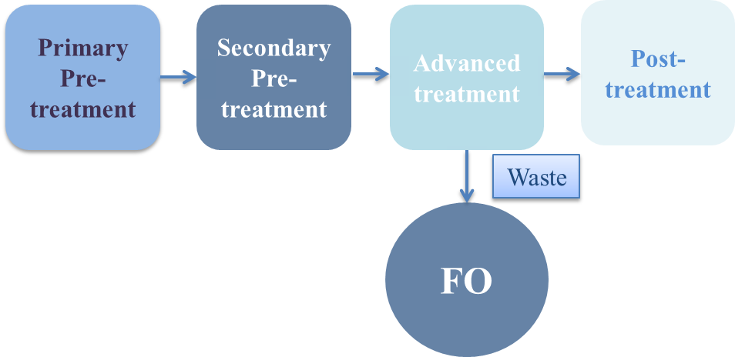 | FO is tested as a post-treatment process to reduce the volume of waste generated by conventional processes | Hybrid RO-FO system whereby FO is used to concentrate RO brine in conventional seawater desalination plant
 | Standalone FO process requires additional post-treatment to meet standard requirements | Hybrid FDFO-NF process to meet the standards for irrigation

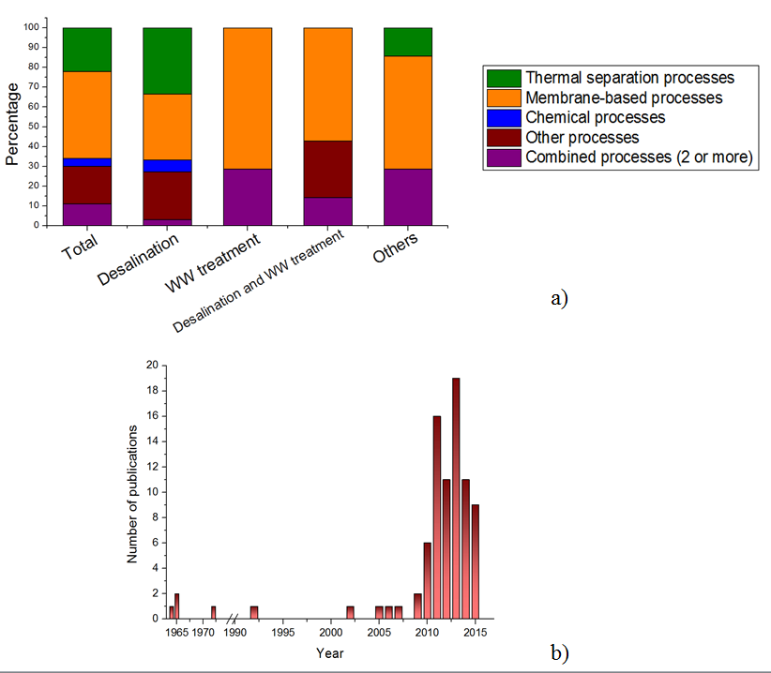
Figure 1: Overview of hybrid FO systems from the late 1960s: (a) distribution of applications and coupled systems and (b) number of academic publications. The number of academic publications on FO is calculated based on the Web of Science and Google Scholar databases. N.B. WW: Wastewater.
However, despite the increasing number of publications in the last decade (Figure 1b) and recent advancements in the hybrid FO systems, there are still several challenges that need to be overcome to achieve successful industrial application of this technology. In fact, in a recent review focusing on the energy efficiency of the FO process, it was demonstrated that the hybrid FO-RO process consumes more electric energy than RO alone and therefore the term “low energy process” often attributed to FO may only be appropriate in few applications where FO presents apparent advantages over conventional separation processes [21]. Osmotic dilution (OD) is one good example and is receiving increasing attention for its energy reduction potential [24]. In fact, in the OD approach, the diluted DS is the targeted product. Therefore, no additional process is needed for DS recovery, eliminating one of the major issues impeding the commercialisation of the full-scale FO process: lowering the energy cost of the DS recovery process. Recently, OD has been proposed for the simultaneous treatment of wastewater (i.e. feed solution) and seawater (i.e. draw solution) [25-27] and integrated in a conventional seawater desalination plant (i.e. coupled with seawater RO (SWRO)). Another recent study investigated the feasibility of dual-stage FO/PRO for the osmotic dilution of shale gas wastewater [28]. These early lab-scale and pilot-scale studies showed that the hybrid OD-RO system would be very promising for full-scale practical implementation. Aiming this objective, the FO-RO hybrid Desalination Research Center (FOHC, Kookmin University, Korea) has recently initiated an ambitious 5-year project “ONE Desal” (Osmosis-based, No fouling, Energy-efficient Desalination), bringing together academic and industrials with the aim of constructing and operating the first FO-RO hybrid process plant with a capacity of 1000 m³/day and an energy consumption target of 2.5 kWh/m³ (i.e. 35% less than conventional SWRO) for the simultaneous treatment of impaired water and seawater. This USD $28 million budget desalination project includes 3 core projects (Figure 2) which aim at (i) developing and optimising the hybrid FO-RO system at lab-scale and pilot-scale, (ii) developing efficient and low-cost pre-treatment technologies and finally (iii) designing and operating the first FO-RO hybrid process plant. Further details on the benefits of OD-RO system will be provided in the discussion section.
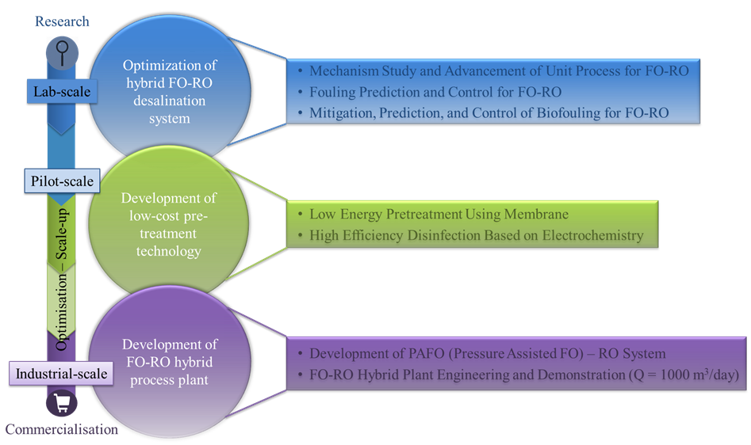
Figure 2: ONE Desal project overview: From lab-scale development and optimisation to hybrid FO-RO plant operation.
Providing a comprehensive and up-to-date review on the recent development and performance of hybrid FO systems is highly needed but has not yet been presented. In the present work, we have conducted a comprehensive and critical review on the existing hybrid FO systems and their performance in different applications. This review also addresses the strategies and prospects for future research area on hybrid FO systems.

Hybrid FO systems: Performance and applications

Seawater and brackish water desalination

Hybrid systems for the recovery of DS
The development of hybrid FO desalination processes has started as early as the 1960s [29-31]. These studies were mainly reported in the form of patents in which it is stated that FO is coupling with a heating process to separate the volatile DS from the produced water. Later, McGinnis developed a continuous two-stage FO desalination process whereby a volatile compound used as DS was removed from the product water by standard means such as heating [32]. In these early studies, hybrid FO systems were mainly designed for the purpose of DS recovery and little is known about the actual performance of the system.
Many years later, McCutcheon et al. [33] and McGinnis et al. [34] developed a novel thermolytic DS (i.e. NH₄HCO₃) which was integrated to a hybrid desalination process consisting of FO desalination and DS recovery heating process. Results from a chemical process modelling software showed that this hybrid desalination process can achieve an average water recovery rate of 64% with an electrical power requirement of typically less than 0.25 kWh/m³ (FO desalination process only) [9]. However, the energy consumption (i.e. heat requirement) of the thermal DS recovery process was more than 75 kWh/m³ (i.e. with a single distillation) rendering this desalination process unpractical unless sources of waste heat can be available to power the regeneration process. The other critical limiting factor of this hybrid desalination system relies on the high reverse draw solute permeation (Table 2) as well as the presence of trace ammonia in the final product water. In fact, it has been found that thermal distillation of diluted thermolytic DS is not able to produce product water that meets the drinking water standard of 1.5 mg/L for ammonia defined in the 4th edition Guidelines for Drinking Water Quality (World Health Organization - WHO).
To circumvent the issue related to thermolytic solutes, alternative DS were tested for seawater desalination. For instance, Yen et al. [35] investigated the performance of organic compounds; both neutral and charged 2-methylimidazole based compounds as DS in a hybrid FO-MD desalination system (Table 2). Although a water flux of about 8 LMH was achieved across the MD membrane, this class of DS exhibited high reverse solute flux (i.e. up to 80 g/m².h). Besides, the cost of synthesis of such compounds is very high. Guo et al. [36] also investigated the performance of the hybrid FO-MD system for seawater desalination and recovery of Na⁺-functionalized carbon quantum dots (Na-CQDs) utilised as DS. The MD process was used to reconcentrate the diluted Na-CQDs at an operating temperature of 45°C. A low water flux of about 3.5 LMH was maintained after the fifth cycle but almost negligible reverse draw solute permeation was observed. Recently, Alnaizy et al. [37, 38] investigated a FO process integrating chemical precipitation for desalination. The proposed DS recovery method consisted of metathesis precipitation reaction with barium hydroxide followed by reaction with sulphuric acid. Results showed that the DS (i.e. CuSO₄) cannot produce enough osmotic pressure to desalinate seawater but could be a suitable candidate for brackish water desalination [39]. However, low water fluxes were reported when synthetic brackish water was used as feed as the FO process was severely affected by concentration polarization effect. Also, trace heavy metal ions in the product water make it unsuitable for direct application and thus, further purification process may be required. Finally, the recovery process consumes a large amount of chemicals making this system unlikely feasible. However, barium sulfate (BaSO₄) is one by-products of this process and claims to have several commercial applications (e.g. used as a thickener in oil well drilling fluids for crude oil and natural gas exploration) which could provide some benefits to this process if correctly extracted.
Recently, new class of DS, such as magnetic nanoparticles (MNPs) or polymer hydrogels, has been developed and they showed promising performance for potential application in desalination. In fact, studies demonstrated that these DS exhibit very high osmotic pressure (i.e. much higher than the osmotic pressure of seawater) and many efforts have been made to find suitable and efficient recovery process to separate these DS from the product water.
Warne et al. [40] were the first to propose a hybrid FO-magnetic field system but very few data were provided in their study to demonstrate the feasibility of this hybrid system integrating hydrophilic MNPs as DS. The same year, Chung and co-workers successfully applied this hybrid system for desalination application [41-45]. Moderate performances were achieved in terms of water fluxes (up to 18 LMH) [44, 45] but the reverse draw solutes permeation was lower compared to conventional inorganic compounds such as NaCl and MgCl₂ due to the larger size of MNPs. In terms of recovery, it was observed that under high-strength magnetic field, MNPs have a strong tendency to agglomerate which decreases significantly the performance of the FO process. Ultrasonication was used to overcome this issue but was not able to completely restore the DS efficiency [42]. Ling et al. [43] proposed a hybrid system consisted of FO combined with low strength magnetic field with a view to reduce the agglomeration of MNPs. The performance of this hybrid system remained constant after 5 cycles of reuse but was very poor in terms of water flux (i.e. < 2 LMH). Besides, the synthesis of MNPs appears to be complex which likely increases the cost and there is no data available on the quality of the product water. In fact, due to the polydispersity of the MNPs (i.e. in terms on size), their recovery by magnetic field is only partial since the magnetic force of smaller MNPs is not predominant and hence, sometimes, smaller MNPs could pass through the magnetic field [46]. Therefore, it is very likely that the final product water could still contain MNPs and requires further treatment to meet the drinking water standard. The synthesis of MNPs having mono disperse or narrow size distribution may be able to solve this issue. Ling and Chung [46] alternatively assessed the performance of ultrafiltration (UF) to recover magnetic nanoparticles (MNPs) (~ 5 nm diameter based on transmission electron microscopy (TEM) measurements). UF was tested as a DS recovery method for this study as it combines a small enough membrane pore size (i.e. 1-1.5 nm) to recover the MNPs and a low operating pressure (i.e. around 5 bars). Results showed that MNPs can be recovered up to 5 cycles via UF process without significant alteration (i.e. size and osmotic pressure). However, the smaller MNPs (~ 1 nm diameter) passed through the UF membrane and therefore synthesis of MNPs suspension with narrower size distribution is required. Electric fields have also been investigated as a recovery method for MNPs [47]. In fact, electric fields have been used to collect and recover colloid particles during wastewater treatment and the recovered colloidal nanoparticles did not show irreversible changes [48, 49]. Besides, it has been demonstrated that nanoparticles having increased conductivity via surface dissociation display enhanced responses to the electric field. Inspired by this, Ling and Chung [47] explored the use of surface-dissociated nanoparticles as DS in a hybrid FO desalination process. The hybrid system consisted of FO coupled with an electric field integrated to a nanofiltration (NF) system. The electric field (i.e. operated at a voltage of less than 70 V) was employed to regenerate the negatively charged nanoparticles while the NF system (i.e. operated at a pressure of 5 bar) was used to recover the product water and reconcentrate the alkaline solution (i.e. Na⁺ and Ca²⁺). This concentrated alkaline solution was used to dissolve and dissociate the nanoparticles prior to be reinjected in the FO process. Results of this study showed that the water flux as well as the size of the MNPs remained quite stable, even after 5 cycles. However, as pointed by Luo et al. [17], the use of NF to reconcentrate the alkaline solution may not be feasible since Na⁺ and Ca²⁺ cannot be totally rejected by the NF membrane. Besides, the alkaline solution entering the NF unit may undermine the life of the membrane as well as the corrosion of pumps, pipes and fillings. Finally, the energy cost of this hybrid system has not been evaluated.
Ge et al. recently tested the hybrid FO-UF desalination system for the recovery of polyelectrolytes of polyacrylic acid sodium (PAA-Na) [50, 51]. Experimental results on the hybrid FO-UF process showed that this hybrid process can achieve high water fluxes with very low reverse solute fluxes. A high PAA-Na rejection (i.e. >99%) was obtained by UF process for recycling and further reuse by FO process. The recycled DS by the UF process showed reasonable repeatable performance and indicated no aggregation problems in comparison with MNPs. However, at high concentration, PAA-Na solution has a very high viscosity, limiting the application of this hybrid process at ambient conditions. To overcome this issue, MD was proposed as an alternative DS recovery method since MD works at higher temperature but this hybrid FO-MD system was only applied for wastewater treatment application [50]. More recently, Zhao et al. [52] investigated the recovery of thermoresponsive co-polymers with MD for desalination application. An average permeate water flux of 2.5 LMH was achieved after three recycles with high quality of product water. The advantage of using MD to recycle the thermoresponsive co-polymers relies on the high operating temperature (i.e. 50°C) at which the osmotic pressure of the DS decreases due to the agglomeration of the polymer chains. The decreasing osmotic pressure leads to higher water vapour pressure which considerably promotes the separation of water from the DS.
Ge et al. [53, 54] also tested a new class of DS consisted of hydroacid complexes of citric acid (CAc) which feature several interesting characteristics such as expanded configurations, abundant hydrophilic groups and ionic species. NF was assessed for the recovery of CAc and results showed that NF membrane achieved a high rejection rate for this DS, up to 90% while the FO desalination process produced a water flux of up to 17.4 LMH with 2.0 M Fe-CAc as DS and synthetic seawater (i.e. 3.5 wt.% NaCl) as feed (Table 2).
Recently, innovative DS recovery methods have been proposed following the development of polymer hydrogels which are able to extract and release water in response to environmental stimuli (e.g. temperature, pressure or light) [55]. One interesting response to these stimuli is the change of this polymer from hydrophilic to hydrophobic property in the process releasing the water. This unique property is particularly advantageous as its recovery is very easy with minimum energy consumption (compared to membrane or thermal processes). In a more recent study [56], polymer hydrogels were combined with light-absorbing carbon particles to enhance their heating and dewatering properties under exposure to sunlight at an irradiation intensity of 1.0 kW/m². The use of solar energy instead of conventional heating process to regenerate the hydrogels can significantly reduce the overall cost (i.e. energy and capital costs). The study (e.g. [57]) however observed that the water released by the hydrogels when exposed to sunlight comes mainly in the vapour state and therefore, additional condensation process will be required to recover water in the liquid form which will ultimately incur an increase of the overall cost of the process. In terms of performance, both studies by Li’s group [55, 56] showed that the polymer hydrogels can produce high osmotic pressure of about 2.7 MPa at 27 °C, however, the performance of the FO process was very poor at room temperature, with water fluxes ranging from 0.55 to 1.1 LMH only. This water flux is significantly (i.e. more than an order of magnitude) lower than that of hybrid system using thermolytic solution. This lower water flux with hydrogels is likely due to the poor diffusivity through the membrane support layer resulting in severe ICP. Increasing the temperature to 50 °C did improve the performance but required a high hydraulic pressure of 30 bars during the dewatering process. Composite hydrogels with reduced graphene oxide (rGO) were also developed as an alternative to carbon particles to enhance the FO performance [58]. Composite hydrogels with rGO demonstrated greater swelling degrees and better shape adaptability which proved to be highly beneficial in terms of water transport from the membrane to the particle layer. Hydrogels with 1.2 wt% rGO showed the highest performance (Table 2) but the water flux remained significantly lower than that produced by smaller DS.
In a more recent study, Cai et al. [57] designed thermally responsive hydrogels with a semi-interpenetrating network (semi-IPN) structure for brackish groundwater desalination. Water fluxes ranging from 0.12 to 0.18 LMH were achieved after 5 hours operation. A moderate temperature variation of 15°C (e.g. between room temperature 25°C and 40°C) was found enough to dewater the hydrogels for continuous operation. The study has also found that performance can be enhanced by increasing the FO membrane/hydrogels contact area due to significantly faster water absorption. In that view, the authors suggested the use of hollow fiber (HF) FO membranes where semi-IPN hydrogels can be coated onto the outside surface of the membrane (i.e. shell side) for quasi-continuous FO desalination as shown in Figure 3.
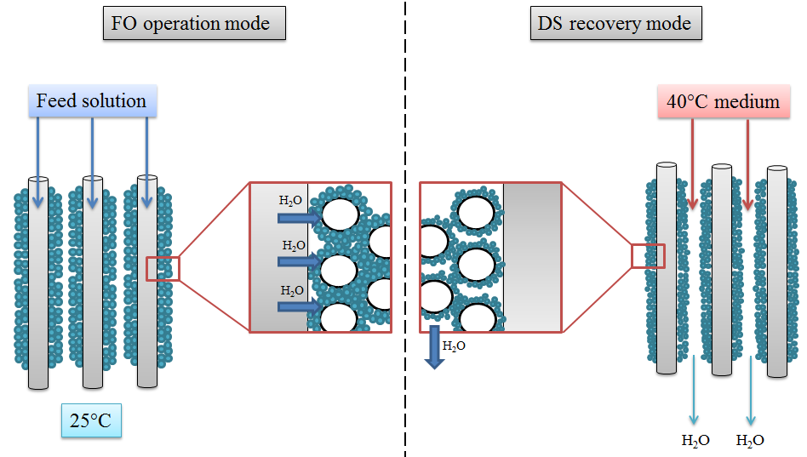
Figure 3: Schematic diagram of hollow fiber FO membrane integrating semi-IPN hydrogels as DS for desalination (adapted from [57]). In this configuration, the only driving force for desalination (apart from the energy required to pump the FS through the lumen of the fibers) comes from the periodic temperature modulation (i.e. from 25°C to 40°C). This temperature variation can be obtained using warm air generated from industrial waste heat to reduce the energy requirement of the overall process.
Razmjou et al. [59] evaluated the effect of hydrogels particle size (i.e. ranging from 2 µm up to 1000 µm) on the FO performance as well as the efficiency of both gas pressure and heating stimuli on the release of water from the swollen hydrogels. Results showed that small hydrogel particles (i.e. 2 – 25 µm) were able to produce higher water flux (i.e. up to 1.5 LMH) than the larger particles (i.e. 500 – 1000 µm) and this was explained by the higher contact surface between the membrane and the smaller hydrogel particles due to their larger surface-to-volume ratio. The authors also found that gas pressure stimulus (i.e. 600 kPa gas pressure) was more effective for dewatering large particles whereas temperature stimulus (i.e. 60°C) was more effective with small particles. Results also indicated that the amount of water recovered by gas pressure stimulus was significantly higher than that using mechanical pressing (i.e. 30 bar hydraulic pressure) which is more relevant if applied at industrial scale. Razmjou and co-workers also studied the effect of incorporating MNPs into the hydrogel network and using magnetic heating as an alternative stimulus to recover the water from the swollen hydrogels [60]. This study demonstrated that faster and more effective deswelling can be achieved using magnetic heating over conventional heating since the heat was more evenly distributed throughout the hydrogel network. The dewatering process through magnetic heating was found to be dependent of both the MNPs loading and the intensity of the magnetic field. The liquid water recovery through magnetic heating, although still low (i.e. 53%), was significantly higher than that obtained via conventional heating (i.e. 7 %). One other practical problem with hydrogels could be in the modular design where hydrogels DS can be fed to the membranes. The DS chamber thickness may have to be much larger to accommodate hydrogels in the process thereby increasing the process footprint.
More recently, due to the low water flux and dewatering ability of conventional macroscale hydrogels, Hartanto et al. [61] synthetised sub-micron size hydrogels (i.e. 200-300 nm) via surfactant-free emulsion polymerization. Their study demonstrated that “microgels” performed significantly better than macroscale hydrogels with water flux observed up to 23.8 LMH and 20 LMH after 3 cycles and liquid water recovery of 72.4% showing their potential as the next generation of DS for FO desalination.

FO as an advanced desalination pretreatment process

Hybrid FO-RO systems
The first hybrid FO-RO system was proposed by Yaeli [62] who developed a system combining FO process and low pressure RO (LPRO) process for the recovery of glucose. In this study, the hybrid system was suggested as an alternative to standalone RO which suffered from high fouling tendency. FO was therefore used as a pre-treatment to reduce the fouling propensity of feedwater in the subsequent RO process. The diluted glucose solution from the FO process was fed to a RO unit where a LPRO membrane separates potable water from the glucose solution. A loose RO membrane was used because of the relatively large molecular weight of glucose molecules. The recovery in this process was found limited due to the relatively low osmotic efficiency of glucose which also created high ICP effect due to its large molecular size and thus high diffusion coefficient.
Yangali-Quintanilla et al. [63] assessed the performance of FO combined with LPRO for the desalination of the Red seawater. Their results showed that the energy consumption associated with the hybrid FO-LPRO was within an estimated range of 1.3-1.5 kWh/m³, which is only 50% of that consumed by standard high pressure standalone seawater RO (SWRO) process (i.e. 2.5-4 kWh/m³). Thus this hybrid FO-LPRO system is clearly an attractive consideration from an energy-saving stand point of view. The comparison of energy consumption between RO and FO-LPRO is presented in Figure 4.
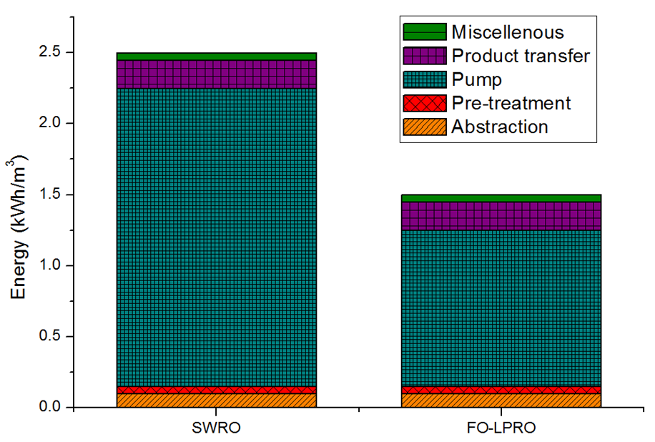
Figure 4: Comparative estimation of energy cost for SWRO and hybrid FO-LPRO.
In another recent paper comparing the performance of hybrid FO-RO system with standalone RO process [64], it was reported that RO can be effectively used as DS recovery process due to its high salt rejection and high water recovery. In the hybrid FO-RO system, the FO process effectively operates as a pre-treatment for RO process by rejecting a wide range of contaminants helping to mitigate membrane fouling and scaling in the RO process [65] which, in turn, recovers and reconcentrates the diluted DS from the FO process. In fact, FO used as a pre-treatment was found to enhance the performance of conventional desalination technologies (e.g. RO) and can surpass the current pre-treatment technologies that are currently not designed to remove dissolved solids [8]. The benefit of FO pre-treatment to remove dissolved solids can also assist RO in meeting the demanding drinking water quality standards. In fact, there are two types of dissolved contaminants for which RO process does not demonstrate total rejection and which present a health risk even at trace levels: trace organic compounds (TrOCs) and boron. In a recent review article on the performance of FO membranes in rejecting TrOCs [66], it was explained that the hybrid FO-RO system demonstrates significantly high TrOCs rejection (i.e. >99%) due to the dual barrier provided by both membrane processes, especially using impaired waters sources. Besides, it was also demonstrated that FO process alone can achieve higher rejection of TrOCs than RO process [67]. Similarly, in a recent bench-scale study [68], FO process showed higher boron rejection than RO process mainly due to the reverse salt flux in the FO process that likely reduced boron flux. In fact, the diffusion of boron through the FO membrane was found to be inversely related to the extent of reverse draw salt diffusion. In another study [69], simulation results showed that boron removal through the hybrid FO-RO desalination system can be more energy efficient than the conventional two-pass RO process. However, it was also emphasized that the rejection of these contaminants may ultimately result in their accumulation in the DS when a closed-loop system is used (i.e. when RO is simultaneously used to produce high quality water and recover the DS) [22, 70]. This will likely lead to the contamination of the product water and therefore additional methods need to be developed to reduce cumulative contaminant accumulation. To date, adsorption by granular activated carbon (GAC), UV₂₅₄ light oxidation [22] and ion exchange [69] have been suggested to reduce accumulated contaminants.
Pressure-assisted forward osmosis (PAFO) whereby an additional hydraulic pressure is applied in the feed side of the FO process can also provide additional savings in the subsequent process when implemented in a FO-RO hybrid system for seawater desalination. In fact, additional water recovery from PAFO will result in further reduction in the energy cost in RO due to further dilution of the DS beyond the osmotic equilibrium. The highly diluted DS after PAFO process will also further reduce the fouling propensity of water in the RO process. A recent study by Blandin et al. [71] demonstrated that the total cost of PAFO-RO hybrid system (under moderate applied pressure – less than 6 bar) is lower than the FO-RO configuration due to the higher water flux produced by the PAFO process as well as the lower RSF allowing higher water recovery. In the context of OD, if PAFO is used instead of FO in the hybrid FO-RO system, it can provide better stabilisation of the system performance related to the changes in the feed water properties. In fact, the water flux in FO process decreases with the feed water temperature. In PAFO, the hydraulic pressure helps to maintain the same water flux at lower feed water temperature without changing the DS concentration. Although PAFO requires more energy than FO, this can be counteracted with capital and operational costs for increasing the DS concentration.
Finally, in a study by Bamaga et al. [72], it was explained that, due to the low water flux produced by the currently available FO membranes, the hybrid FO-RO system would only be economically suitable for desalination of feed water with high fouling or scaling potential such as brackish water and wastewater. This suggests that future research on the hybrid FO-RO system should focus on the development of novel FO membranes, combining higher water flux, lower fouling propensity and higher fouling reversibility that could enable FO to become an advanced pre-treatment process.

Hybrid FO-MSF/MED system
Multi-stage flash (MSF) and multi-effect distillation (MED) are desalination technologies commonly employed in the Middle Eastern countries where feed waters generally have high-salinity, high temperature and high impurity. The pre-treatment of feed water is therefore crucial for these processes to mitigate the fouling potential of the feed water by reducing the natural organic matter as well as the suspended solids. In most cases, however, pre-treatment processes are not designed to remove dissolved solids which are responsible for scaling, a major issue for thermal process [21]. In both MSF and MED, the deposition and accumulation of scale materials on the surface of heat exchangers decrease the heat transfer efficiency, minimizing the operating temperatures and overall system recovery [73, 74]. NF has been suggested as a pre-treatment since NF membranes have the ability to remove divalent ions responsible for the scaling on the heat exchangers [74]. However, the use of NF was found to increase the operating costs (even at high recovery rate) as well as fouling propensity because it is a pressure-driven membrane process [75, 76].
Therefore, FO has been recently tested as an alternative pre-treatment to remove both dissolved organic materials as well as dissolved inorganics from the feed water. Altaee et al. [75, 77, 78] carried out modelling on hybrid FO-MSF and FO-MED systems for seawater desalination and simulation showed that FO used as a pre-treatment significantly reduced the concentrations of multivalent ions in the feed water which reduces the scaling effect on the heat exchangers; enabling these thermal processes to work at higher temperatures and water recovery rates.

Hybrid FO systems as an alternative to conventional desalination process
Al-Mayahi and Sharif [79] were the first to suggest, in a patented work, the use of hybrid FO systems for desalination. Later, Tan and Ng [80] evaluated the performance of the hybrid FO-NF system as an alternative process to conventional desalination process (i.e. standalone RO process). The salt rejection rate of the NF membrane was very high for all tested DS, up to 97.9% for Na₂SO₄. Water fluxes of about 10 LMH were achieved by both FO and NF processes (Table 2). Results from this study also indicated that a single-pass NF was not sufficient to produce product water that meets the TDS requirements for drinking water quality defined by the WHO. However, after the second-pass NF, the permeate water quality (i.e. only when using MgSO₄ and Na₂SO₄ as DS) was within the recommended TDS guidelines. Zhao et al. [81] also tested the hybrid FO-NF system but for the desalination of brackish water. Their study showed that this hybrid system has many advantages over conventional standalone RO process such as higher permeate quality (i.e. salt rejection of about 97.7% and TDS concentration reduced to 10 mg/L), higher flux recovery after cleaning (without using chemicals), less fouling tendency leading to less flux decline and finally lower operating pressure (i.e. less than 10 bars against 30 bars with RO membrane).
Electrodialysis (ED) has been commercialised for the past few decades for small and medium-scale plants for the purpose of brackish water desalination [82]. ED is another membrane separation process which uses pairs of cation and anion exchange membranes alternatively in an electric field to remove salt ions and some charged organic compounds [82]. ED is not a pressure-driven process and does not require an energy conversion step which is a significant advantage over conventional membrane separation process such as RO. Besides, ED has less membrane fouling and scaling tendency which can be both mitigated easily via chemical cleaning or by reversing the polarity of the electric field in the case of scaling [83, 84]. However, the cost of electrodes and ion exchange membranes remains high and ED membranes have a short lifetime when exposed to a strong electrical field and are therefore unsuitable for desalination of high saline feedwater [83].
To date, only one study has been reported on the hybrid FO-ED system [85] where alternative solar energy was employed to power the ED systems. The use of photovoltaic (PV) cells with ED has been proposed for many years for use in areas where solar energy is readily available in order to reduce the carbon footprint of the process [82]. In this study, the hybrid FO-ED system was tested for brackish water and wastewater treatment. Results showed that this hybrid system can produce high quality permeate water, meeting the drinking water standard and the cost of water production was estimated around 3.3-4.9 euros/m³ (based on 300 days of production per year and assuming a daily water production of 130 L) for a small size portable system (Table 2).

Table 2: Summary of hybrid FO desalination systems
Hybrid system | Draw solution | Membrane type(s) for FO process | FO performance | Remarks | Ref.
FO-Heating (~60°C) | NH₄HCO₃ | Commercial flat sheet RO and cellulose triacetate (CTA) FO membranes (lab-scale studies) and polyamide (PA) thin-film composite (TFC) FO membrane (pilot-scale study) | Water flux: 7.2 LMH; Reverse salt flux: 18.2 g/m².h at 2.8 MPa (lab-scale studies). Water flux: 2.6 LMH, system recovery of 66% and more than 99% total dissolved solids (TDS) removal (Pilot-scale study) | Energy efficient process (i.e. specific energy consumption of the hybrid system is significantly lower than other thermal distillation methods) with high water recovery rate but water quality does not meet the WHO standard for ammonia | [9, 33, 34, 86]
FO-MD | 2-methylimidazole-based compounds | Commercial CTA flat sheet FO membrane | Water flux: 0.1 to 20 LMH (2.0M DS and DI water as feed). Reverse salt flux: 5 to 80 g/m².h | A water flux of about 8 LMH was achieved across the MD membrane. ICP effects were higher when using the 2-methylimidazole-based compound with divalent charge. High reverse salt flux and cost of synthesis remains high. | [35]
FO-MD | Na⁺-functionalized carbon quantum dots (Na-CQDs) | Commercial TFC FO membrane | Water flux: about 3.5 LMH after the fifth cycle. Almost negligible reverse draw solute permeation. | Better performance compared to NaCl. Inexpensive, chemically inert and biocompatible. | [36]
FO-Magnetic field | Thermosensitive MNPs | Commercial flat sheet CTA FO membrane | Water flux: < 2 LMH. Performance of MNPs remains stable after 5 cycles. | Separation of MNPs under lower strength magnetic field which significantly decreased their agglomeration. Costly and complex synthesis. No information on permeate water quality. | [43]
 | Functionalised MNPs |  | Water flux: 10-17 LMH (PRO mode) and 7-9 LMH (FO mode) with PAA-MNPs at different sizes 3.6-21 nm and DI water as feed water. 9 LMH (FO mode) and 13 LMH (PRO mode) with 0.065 M PEG-(COOH)₂ MNPs and DI as feed water. The water flux dropped to 10.3 LMH (PRO mode) after 9 cycles. | Straightforward and energy efficient process, high water recovery rate but slightly drop of water flux due to agglomeration of the MNPs | [44, 87]

Hybrid system | Draw solution | Membrane type(s) for FO process | FO performance | Remarks | Ref.
FO-UF | Modified magnetic nanoparticles (PAA-MNPs) | Commercial CTA flat sheet FO membrane | Water flux (PRO mode): Up to 17 LMH with 0.08 mol/L PAA-MNPs and DI water as feed. | MNPs remained active even after 5 cycles of UF recovery without any alteration. This hybrid system requires lower energy consumption compared to RO and NF. However, the smaller MNPs pass through the UF membrane and therefore synthesis of MNPs suspension with narrower size distribution is required. | [46]
FO-Electric field-NF | Surface-dissociated MNPs | Commercial flat sheet CTA FO membrane | Water flux: Up to 2 LMH after 5 cycles (PRO mode) with synthetic brackish water as feed. | High water recovery rate and good draw solutes recovery rate but complicated operating procedures | [47]
FO-UF | Polyelectrolytes (e.g. PAA-Na) | Commercial CTA flat sheet FO membrane | Water flux (PRO mode): 6 LMH with 0.72 g/mL PAA-Na as DS and seawater as feed. | High water recovery rate. Various molecular weights (MW) and expanded polymer structure allowing DS regeneration via low-pressure UF process. High rejection rate (>99%) for PAA with MW of 1800 Da. However, poor salt rejection for DS with low MW. | [51]
FO-MD | Thermosensitive co-polymers | Commercial CTA flat sheet FO membrane | Water flux: Up to 4 LMH with 33.3 wt. % DS and synthetic seawater (i.e. 0.6 M NaCl) as feed. Reverse salt flux: 2 g/m².h. | Average water flux (after MD) of 2.5 LMH was achieved after three recycles and high quality of permeate water was produced. MD process operated at 50°C at which the osmotic pressure of the polymer DS was lowered due to the agglomeration of the polymer chains. This could support the DS regeneration from the product water. | [52]
FO-NF | Hydroxyl acids of citric acid (CAc) (Fe-CAc; Co-CAc and Co2-CAc) | CA, TFC on polyethersulfone supports (TFC-PES) and polybenzimidazole and PES dual layer (PBI-PES) hollow fibre membranes | Water flux: Up to 17.4 LMH with 2.0 M Fe-CAc as DS and synthetic seawater (i.e. 3.5 wt. % NaCl) as feed. 90% rejection rate for Fe-CAc by NF membrane. | Low operating pressure (i.e. 10 bars), low reverse draw solute and high rejection rate (i.e. more than 90%) | [53, 54]
FO-Stimuli to heating combined with hydraulic pressure | Hydrogels | Commercial flat sheet CTA FO membrane | Water flux: 0.30 to 0.96 LMH with 2000 ppm NaCl as feed. Very low water recovery rates (i.e. less than 5%). | Environmental-friendly and relatively energy efficient process but low liquid water recovery rate. Unsuitable for applications that require continuous FO process | [55]
FO-Stimuli to heating | Semi-interpenetrating network (IPN) - Hydrogels | Commercial flat sheet CTA FO membrane | Water flux: Ranging from 0.12 to 0.18 LMH after 5 hours operation which is 1.5-3 times higher than conventional hydrogels. Better performance can be achieved by increasing membrane/hydrogel contact area. | At 40°C, the semi-IPN hydrogels quickly released nearly 100% of the water absorbed during the FO drawing process. Drawing and dewatering cycles are highly reversible. However, very low water flux (i.e. less than 0.5 LMH). | [57]

Hybrid system | Draw solution | Membrane type(s) for FO process | FO performance |  | Remarks | Ref.
FO-Stimuli response to sunlight | Composite hydrogels reduced graphene oxide | Commercial flat sheet CTA FO membrane | Water flux: Up to 3.1 LMH with 2000 ppm NaCl as feed. Water recovery up to 44.3% at 1.0 kW/m² with 1h exposure time. |  | Environmental-friendly and relatively energy efficient process but low liquid water recovery rate and low water flux. Unsuitable for applications that requires continuous FO process | [58]
 | Composite hydrogels light- carbon particles | Commercial flat sheet CTA FO membrane | Water flux: Up to 1.32 LMH with 2000 ppm NaCl as feed. Up to 100% water recovery rate when solar light is used with 1h exposure time at a solar irradiation of 1.0 kW/m². |  |  | [56]
FO-Stimuli response to gas pressure | Hydrogels | Commercial flat sheet CTA FO membrane | Water flux: Up to 1.5 LMH with 2000 ppm NaCl as feed. Gas pressure stimuli worked better for large particles whereas temperature stimuli are more effective with small particles. |  |  | [59]
FO-Stimuli response to magnetic heating | Magnetic hydrogels | Commercial flat sheet CTA FO membrane | Water flux: Up to 1.5 LMH with 2000 ppm NaCl as feed. 53% liquid water recovery via magnetic heating compared to only 7% under convection heating. |  |  | [60]
FO-Stimuli to heating | Functionalised thermo-responsive microgels | Commercial flat sheet CTA FO membrane | Water flux: Up to 20 LMH after 3 cycles (decrease of 13% compared to initial flux). |  | A high water flux up to 23.8 LMH and high water recovery ability of 72.4% were achieved. | [61]
FO-RO | Glucose | Not reported | Not reported |  | Limited water recovery due to the low osmotic efficiency of glucose which also created high ICP effect due to its large molecular weight. | [62]
FO-LPRO | Red seawater | Commercial CTA flat sheet FO membrane | After 10 days of continuous FO operation, 28% of flux decline was observed (initial water flux of 5 LMH) but membrane cleaning (hydraulically cleaned) allowed 98.8% water flux recovery. |  | Energy cost of this hybrid system is only 50% (∼1.5kWh/m³) of that used for high pressure SWRO desalination | [63]
FO-MSF/MED | Concentrated Brine | No experimental results – Modelling studies only |  |  | Simulation results showed that FO demonstrates good performance for the removal of divalent ions from feed solution which mitigates the scaling on the surface of heat exchangers. FO-MED system is less energy intensive and has greater recovery rate compared to FO-MSF | [75, 77, 78]
FO-NF | Various DS tested both inorganic and organic salts | Commercial flat sheet CTA FO membrane |  | Water flux: 10 LMH for both FO and NF processes. Salt rejection by FO membrane up to 99.4% for all DS tested. | Water flux of about 10 LMH was observed for both FO and NF processes. High salt rejection (i.e. up to 97.9% for NF process) and good quality product water (i.e. meeting the drinking water TDS standard). | [80]

Hybrid system | Draw solution | Membrane type(s) for FO process | FO performance | Remarks | Ref.
FO-NF | Divalent salts (MgCl₂, Na₂SO₄) | Commercial CTA flat sheet FO membrane | Water flux: 8-12 LMH (FO and PRO mode tested). Higher fluxes were obtained with PRO mode but flux decline was more pronounced (most probably related to membrane fouling). Salt rejection of the diluted DS: 97.7%. | Lower operating pressure, less flux decline due to membrane fouling, higher flux recovery after cleaning, higher quality of product water compared to standalone RO process. | [81]
FO-ED | NaCl | Commercial CTA flat sheet FO membrane | Water flux: Up to 3.5 LMH (simulation not experimental) with 1M NaCl as DS and brackish water or wastewater as feed and assuming 130 L/day product water. | Energy efficient process when ED powered by solar energy. High quality produced water meeting potable water standards but high capital cost and unsuitable to desalinate high saline water | [85]

Wastewater treatment

OMBR-RO hybrid systems
Membrane bioreactors (MBRs) composed of low-pressure membrane processes such as microfiltration (MF) or UF are becoming the preferred wastewater clarification technology for non-potable reuse applications. This is mainly due to the higher and consistent effluent quality they can produce compared to conventional treatment processes [88]. However, one of the main limitation of MF and UF membranes is the poor rejection rate of low molecular weight constituents such as TrOCs, ions and viruses [89]. Besides, the energy demand of MBRs is higher than conventional wastewater treatment, especially due to the need to apply pressure as well as due to membrane fouling with both MF/UF membranes and RO membranes caused by the presence of natural organic matter and biofouling [90]. To circumvent these limitations, many recent studies investigated the potential of FO membranes as an alternative to MF and UF in MBRs. This osmotic MBR (OMBR) provides an ideal multi-barrier protection which can be used for indirect or direct potable reuse applications [90-95]. In fact, the main advantages of integrating FO membranes into bioreactors instead of conventional low-pressure membrane processes are their lower energy consumption (driving force is generated by the osmotic pressure of the DS), their lower membrane fouling propensity and higher rejection of macromolecules, ions and TrOCs from the wastewater [27, 65, 96-99]. OMBRs consist of a submerged FO membrane in a bioreactor containing activated sludge and continuously fed with wastewater. Usually, a high-salinity DS such a concentrated NaCl or pre-treated seawater is used and in some studies, RO has been integrated into the hybrid OMBR system to reconcentrate the diluted DS and produce ultrapure water (e.g. [91, 100]).
Despite the several advantages and applications of OMBRs, several studies have identified that one of the major limitations of this hybrid system is the cumulative accumulation of dissolved solutes in the feed stream and other dissolved constituents inside the reactor as they are highly rejected by the FO membrane [91, 95, 101]. Accumulation of draw solutes in the bioreactor also occurs due to the reverse diffusion of draw solutes to the bioreactor through the FO membrane. These generally result in lowering the osmotic pressure difference (or driving force) across the FO membrane and thus lowering the water flux as well as affecting the microbial activity inside the bioreactor at elevated solute dissolved concentration [102]. Some recent studies [100, 103] have proposed salt accumulation models and their results showed that the solids retention time (SRT) is the main factor responsible for the steady state salt concentration in the reactor. A short SRT may therefore contribute to a reduction in the salts concentration in the bioreactor. However, this will also limit the biological nitrogen removal and reduce the water recovery [104].
To circumvent this issue, Wang et al. [105] and Holloway et al. [106] proposed an alternative hybrid system where either MF or UF membranes are incorporated in parallel to the FO membrane into the bioreactor. In this hybrid system, the dissolved constituents are continuously removed by the MF/UF membrane from the reactor. The beneficial nutrients such as nitrogen and phosphorous can also be recovered from the reactor since they are rejected by the FO membrane. The addition of the MF membrane inside the bioreactor showed increasing total organic carbon (TOC) and NH₃-N removals by the activated sludge process as a result of decreasing salt concentration inside the bioreactor diverted by the MF process thereby helping improve the microbial activity [105]. Results from the long-term (i.e. 4 months) UF-OMBR-RO study showed that a water flux ranging from 3.8 to 5.7 LMH was achieved over the first 3 weeks of operation and then stabilised to 4.8 LMH for more than 80 days when the UF membrane operation started. The most interesting to note is that this hybrid process did not require any membrane cleaning during the 124 days of operation. The stable flux was attributed to the UF system drawing the dissolved constituents from the bioreactor which significantly reduced FO membrane fouling compared to conventional OMBR. In fact, the average removal of total nitrogen, total phosphorous and chemical oxygen demand from the bioreactor was greater than 82%, 99% and 96% respectively. The high phosphorous removal efficiency from the bioreactor enabled to recover phosphorus from the UF permeate at concentration higher than 50 mg/L which can then be potentially extracted for beneficial non-potable reuse applications. At the same time, the high quality of the RO permeate met the drinking water standard making the product water suitable for potable reuse application. Therefore, the benefits offered by simultaneous recovery of nutrients and production of drinking water by this hybrid system could offset the increase of capital and operating costs associated with this additional UF process.
The only issues associated with these two hybrid systems are: i) the effluent quality from UF or MF membranes, especially the TOC concentration, might exceed the wastewater treatment plant effluent standards and ii) the fouling reduction methods for MF/UF and FO membranes may be different and applying them in the same bioreactor may prove to be complicated [107]. One of the alternatives to the use of MF or UF membranes to mitigate the membrane fouling issue may be to adopt a separate sludge concentrator (e.g. sedimentation basin) to increase the sludge retention time without accumulating salts inside the bioreactor [107].
Alternatively, the issue related to the detrimental salt accumulation inside the bioreactor may be solved by adding an additional driving force to the osmotic pressure such as in the PAFO process in which the reverse salt flux is lowered compared to the FO process. This may be a better and more-cost effective alternative than the hybrid UF-MF-OMBR systems. However, it has to be pointed out that the PAFO process cannot operate in the submerged-type configuration since the additional hydraulic pressure cannot be applied to the feed solution inside the bioreactor.

Other hybrid systems for wastewater treatment
Su et al. [108] developed a novel cellulose acetate (CA) hollow fibre (HF) FO membrane for wastewater treatment. In their study, the FO process was combined with NF for the DS recovery. Results showed that the NF membrane performed well in terms of DS rejection, with up to 99.6% rejection rate and minimal reverse draw solute was observed in the FO process due to the high molecular weight of the DS (i.e. sucrose). Water fluxes in the FO process ranging from 6.5-9.9 LMH were achieved when using synthetic wastewater as feed solution (Table 3). Later, the same group [109] synthesised a novel polymer (i.e. CA propionate or CAP) to prepare dual-layer HF FO membrane for wastewater treatment. In this study, MD was tested as DS recovery process instead of NF since the MD system would be more economical, especially if waste or low quality heat is available nearby the treatment plant. Results showed that CAP-based HF membranes delivered much higher water fluxes and lower reverse salt fluxes than CA-based membranes due to its reduced salt diffusivity and salt partition coefficient. The FO and MD processes delivered similar water fluxes (i.e. 12.6 LMH and 13.0 LMH for FO and MD process respectively) when synthetic wastewater was used as FS.
As discussed in the previous section, PAA-Na solution developed by Ge et al. [50, 51] displayed a very high viscosity, limited its application at ambient conditions with the hybrid FO-UF system. To overcome this issue, MD was tested as an alternative DS recovery instead of UF since it can operate at higher temperature (i.e. 50-80°C) [50]. Water fluxes of up to 40 LMH (i.e. FO permeate flux) were achieved with low reverse draw solute (Table 3). Experiments conducted on the FO-MD system showed that the optimum performance was achieved when the water transfer rates of FO and MD were similar. Finally, they demonstrated that this hybrid FO-MD system integrating polyelectrolytes as DS was suitable (i.e. overall process was stable and repeatable) for dye wastewater treatment. Other successful wastewater treatment applications that have been explored for the hybrid FO-MD system include direct sewer mining [22], water recovery from oily wastewater [110] and water reclamation from shale gas drilling flow-back fluid [111].
Several studies have investigated the potential for FO process to remove trace pollutants such as pharmaceuticals and personal care products [65, 67, 70, 96, 99] and results from these studies confirmed the good performance of the FO process for the rejection of these contaminants. However, none of these studies addressed the issue of FO concentrate disposal and management since feed concentrate following the FO process contains a relatively high level of these compounds. Liu et al. [112] recently proposed to integrate electrochemical oxidation into the FO process in order to simultaneously reject trace pharmaceuticals from the feed wastewater and reduce their concentration in the final feed concentrate. Results from this study demonstrated that this hybrid system can reject the trace antibiotics from the feed wastewater (i.e. rejection rate of 98%) as well as reducing their concentration in the final concentrate (i.e. 99% removal) at the same time.
The coagulation or destabilisation process is currently the most widely used and economical approach water treatment since it does not require hydraulic or thermal energy [113]. The coagulation relies on the interaction of oppositely charged suspended and dissolved colloids giving a rise to a natural destabilisation effect and the formation of micro-particles which subsequently form larger and heavier structures called flocs. These flocs can then be easily removed via a simple sedimentation process. The most commonly employed coagulants for water and wastewater treatment are aluminium sulfate (Al₂(SO₄)₃), ferric chloride (FeCl₃), polyaluminum chloride (PACl) and polyferric sulfate (PFS) [114]. In 1972, Frank [115] showed that Al₂(SO₄)₃ can be used as DS to desalinate seawater since it can produce a high osmotic pressure. However, the proposed separation method (i.e. precipitation followed by centrifugation) was not economically practical. Since Al₂(SO₄)₃ is positively charged, it can thus be destabilised in the presence of negatively charged colloids. Therefore, Liu et al. [116] recently proposed the use of negatively charged magnetic nanoparticles (i.e. core-shell Fe₃O₄ nanoparticles coated with silicon dioxide – Fe₃O₄@SiO₂) to destabilise Al₂(SO₄)₃. In this study, the FO process is used to concentrate wastewater using Al₂(SO₄)₃ as the DS. After the FO process, the diluted DS is destabilised by the negatively charged magnetic nanoparticles which can then be recovered by applying an external permanent magnetic field without using energy input. However, there is currently no information on the actual process performance and moreover, the overall regeneration process seems complicated since it involves the use of CaSO₄ and H₂SO₄ which can potentially deteriorate the final water product even at trace level. Besides, the synthesis of Fe₃O₄@SiO₂ is not an easy process which may likely increase the overall cost of the process.

Table 3: Summary of hybrid FO systems for wastewater treatment
Hybrid process | Draw solution | Membrane type(s) for FO process | FO performance | Remarks | Ref.
OMBR-RO | Inorganic salts | Commercial CTA flat sheet FO membrane | Water flux: 5.5 LMH (MgSO₄) to 10.9 LMH (KCl) at 2.8 MPa. Reverse draw solute: 1.2 g/m².h (MgSO₄) to 22.0 g/m².h (KBr) at 2.8 MPa. | Higher water flux compared to that obtained with organic salts but lower salt rejection. | [20]
 | Organic salts | Commercial CTA flat sheet FO membrane | Water flux: 8.3-9.4 LMH at 2.8MPa. Reverse draw solute: 1.1-6.0 g/m².h at 2.8 MPa. | High salt rejection (about 99%) but energy intensive and relatively high replenishment cost compared to inorganic salts. | [100]
UF-OMBR-RO | RO concentrate | Commercial CTA flat sheet FO membrane | Water flux: Ranging from 5.7 to 3.8 LMH over the first 3 weeks of operation and then average flux of 4.8 LMH once the UF membrane operation started with 26 g/L NaCl as DS and activated sludge as feed. | The novel hybrid system performed well in terms of nutrient recovery and salt rejection and membrane fouling was significantly reduced compared to conventional OMBR. A stable flux of 4.8 LMH was achieved over the duration of the investigation (i.e. 120 days) without a single membrane cleaning. This was attributed to the UF system drawing salts from the bioreactor which reduced FO membrane fouling. | [105, 106]
FO-NF | Sucrose | Double skinned CA HF FO membrane | Water flux: 6.5-9.9 LMH with 0.5M sucrose as DS and wastewater (i.e. 200-2000 mg/L mixed metal ions) as feed. Minimal reverse draw solute. | High salt rejection (i.e. 99.6%) due to sucrose high molecular weight. | [108]
FO-MD | MgCl₂ | CAP HF FO membrane | Water flux: 13-13.7 LMH with 0.5 M MgCl₂ and synthetic wastewater (i.e. heavy metal ions) as feed. Minimal reverse draw solute. | Great potential for this newly developed CAP HF FO membrane for the application in wastewater reclamation. | [109]
Hybrid process | Draw solution | Membrane type(s) for FO process | FO performance | Remarks | Ref.
FO-MD | Polyelectrolytes (PAA-Na) | CA HF membrane | Water flux: Up to 40 LMH (at 80°C with 0.6 g/mL DS and acid orange 8 as feed). Reverse salt flux: Up to 0.14 g/m².h. | No DS leakage to product water after MD process. Most efficient performance when the water transfer rate of FO matched that of MD. Suitable (i.e. process stable and repeatable) for dye wastewater treatment. | [50]
FO-MD | NaCl | Commercial CTA flat sheet FO membrane | Water flux: 8 LMH with 1.5 M NaCl as DS and sewage as feed. | Water flux of 8 LMH was achieved. Recovery rate of 80%. Trace organic compounds (TrOCs) can migrate across FO membrane and accumulate in the draw solution but when system is coupled with GAC and UV, it can remove more than 99.5% of TrOCs. Low-cost energy can be used as heat source. | [22]
FO-MD | NaCl | CTA TFC HF FO membrane | Water flux: About 25 LMH with 2.0 M NaCl as DS and oily wastewater (i.e. 4000 ppm petroleum) as feed; Up to 40 LMH at 60°C and DI water as feed. Reverse salt flux: Up to 7.3 g/m2.h (DI water as feed). | Water flux of more than 14 LMH was achieved for FO after 30 hours of operation. Stable water flux of 6 LMH for MD process. Recovery rate of more than 90%. Fouling was found to increase with petroleum concentration. Acetic acid concentration increased in draw solution which decreased its osmotic pressure. | [110]
FO-MD | NaCl, KCl and MgCl₂ | Commercial CTA flat sheet FO membrane | Water flux: Up to 23 LMH with 3.0M KCl as DS at 25°C and pre-treated shale-gas drilling flow-back fluid as feed. Acceptable reverse salt flux. | KCl was identified as a suitable DS for this application offering high water flux and tolerable reverse salt flux. Water recovery up to 90% was achieved by this hybrid system with high quality product water (i.e. drinking water standard) | [111]
Electrochemical oxidation integrated FO process | NaCl | Commercial CTA flat sheet FO membrane | Water flux: Up to 14 LMH with 2.0 M NaCl DS and synthetic wastewater (containing antibiotics) as feed. | Integration of electrochemical oxidation into FO process can improve the rejection of trace antibiotics from the feed wastewater (i.e. rejection rate of 98%) as well as reduce their concentration in the final concentrate (i.e. 99% removal). | [112]

Simultaneous wastewater treatment and seawater desalination
One efficient way to moderate the energy requirement during RO desalination is via the dilution of the highly saline feed stream since it will reduce the osmotic pressure that needs to be overcome to produce RO permeate [117]. The relatively low salinity of most impaired and reclaimed waters makes them good candidates for such dilution purposes [118]. However, direct dilution/combination of both streams may contaminate and alter the chemistry of the feed stream to the desalination process, likely aggravating membrane fouling and subsequently lowering product water quality. Therefore, pre-treatment of impaired water before desalination of diluted saline water becomes a necessity.
Recently, researchers started to explore and assess the treatment performance and economics of the FO-RO hybrid process for simultaneous treatment of impaired/reclaimed water and seawater for reuse [26, 119-122]. In the first FO process, the impaired water is used as feed solution and pre-treated seawater is used as DS which is subsequently diluted and transferred to RO to produce clean potable water. The concentrated impaired water from the first FO unit can be then transferred to the second FO process where concentrated brine from the RO process is used as DS. The osmotically diluted RO brine can be either recycled back to the RO process or discharged to the environment because its environmental impact has been mitigated [123]. The concentrated impaired water can be further dewatered to recover nutrients for use as fertilizer or returned to the wastewater treatment plant for retreatment. This hybrid FO-RO process was estimated to achieve favourable economic returns during operation, with up to 63% recovery (i.e. by FO-RO and assuming SWRO plant operates at 50% water recovery rate) from the impaired water stream. Beyond 63% recovery, the capital costs associated with increasing required membrane area for osmosis could counter-balance the saving from reduced energy consumption of the SWRO process [26]. This is because the osmotic pressure of the seawater limits the water flux the FO membrane can generate using wastewater effluent as feed. An example schematic of this hybrid process plant (FO-RO-FO configuration) with simultaneous treatment of seawater and wastewater is shown in Figure 5. Alternative configurations have been recently suggested [122] in which either the two FO processes are replaced by PRO or only the second FO process is replaced by PRO to achieve higher overall water recovery (i.e. up to 80%) and reduced energy consumption (i.e. up to 23%). The FO-PRO configuration was preferred to the PRO-PRO variation since, for the latter, the increase in capital cost (i.e. + 11%) and space footprint (i.e. + 112%) (compared to conventional SWRO plant) outweighs the benefits of reduced energy consumption as shown in Table 4. Finally, the economic feasibility of a hybrid PRO-RO system was also assessed for the simultaneous treatment of seawater and wastewater [124]. Results showed that inorganic fouling within the support layer of the PRO membrane was a major limitation of this system and caused substantial flux decline. Anti-scaling pre-treatment was tested and proved to be very effective for improving the water flux by inhibiting calcium phosphate scaling. The authors also suggested that future research should focus on the development of high fouling resistant PRO membrane to support the practical application of the PRO-RO system.
Table 4: Quantitative comparison of total energy consumption, total capital costs and space footprint for the different configurations and conventional SWRO plant (adapted from [122]).
Configuration | Conventional SWRO | FO-PRO | PRO-PRO
Specific energy consumption (kWh/m³) | 1.35 | 1.07 | 1.04
Energy recovery from PRO (kWh/m³) | N.A. | 0.09 | 0.23
Total capital cost (US$/m³) | 0.096 | 0.0874 | 0.1066
Space footprint (8'' spiral wound elements) | 5405 | 10380 | 11460

In all hybrid FO-RO configurations discussed above, FO operates in the OD mode and therefore does not require closed loop DS reconcentration. Instead, the process can operate with both the feed and draw solution in a once through flow configuration [10] offering the true benefits of FO as a low energy process as it eliminates the energy costs associated with the DS reconcentration process and reduces the operational complexities [97]. This hybrid process can achieve several benefits related to energy consumption and product water quality: (i) seawater is being diluted before RO desalination, which reduces the energy cost of desalting the seawater; (ii) pre-treatment of impaired water reduces the fouling propensity of water in the RO stage; (iii) provides multi-barrier protection of product water since contaminants present in the impaired water are prohibited from entering the product water through two established barriers: FO membrane and then RO membrane units and finally (iv) an opportunity for safe reuse of impaired water can be realized.
The hybrid FO-RO system is still at its early stage of development and many challenges are yet to be overcome before acquiring commercial potential. In fact, due to the small difference in osmotic pressure between the wastewater feed and the seawater draw solutions, the produced water flux is quite low and therefore, to increase the process water recovery, large membrane area will be required thereby increasing the process footprint and capital cost [121]. The societal negative perception associated with the reuse of impaired water for drinking water production is another challenge which may impede the successful commercialisation of this promising hybrid system [24].

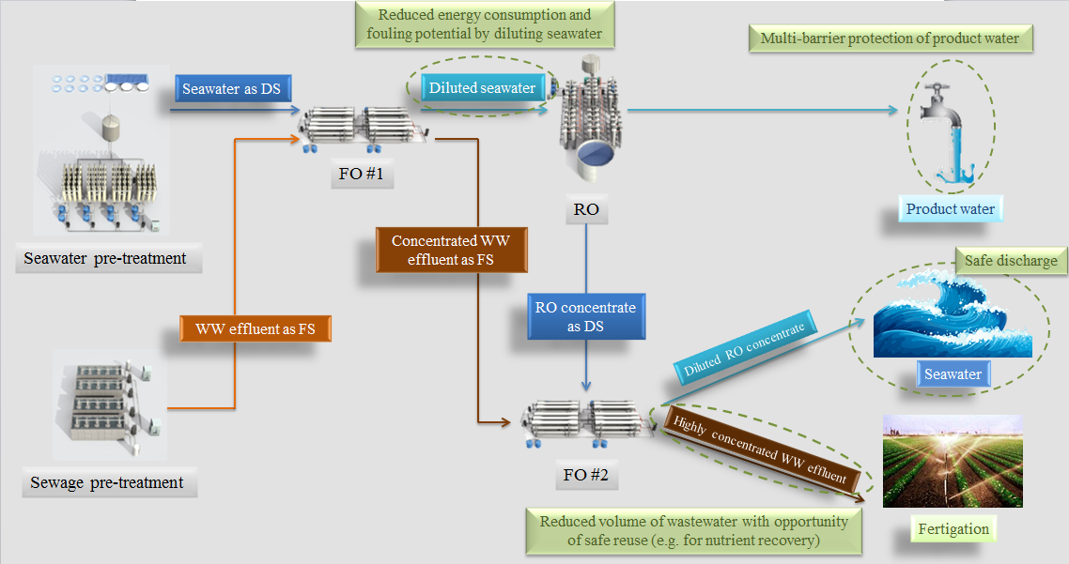
Figure 5: Schematic of an OD-RO hybrid process plant for simultaneous treatment of wastewater and seawater desalination (DS: Draw solution; FS: Feed solution; RO: Reverse osmosis; WW: Wastewater).

Other applications

Management of high-salinity feedwaters
The management and disposal of hypersaline waters (i.e. >40,000 ppm TDS) such as RO brines or flow back wastewater produced during fracking in the shale and gas industry still continue to pose significant environmental issues. These challenging waters are generally made up of waste flow with high concentration of both inorganic and organic compounds [125, 126]. Since FO has been proved to be a very efficient process for the treatment of challenging feedwaters [21], some recent studies have evaluated the performance of hybrid FO systems for this particular application.
Oasys Water Inc. recently demonstrated the use of a thermal-based hybrid FO system at pilot-scale for the treatment of high salinity (i.e. >70,000 ppm TDS) shale gas produced water [86, 127]. Results showed that this hybrid system can achieve feedwater recoveries similar (i.e. > 60%) to those of evaporative brine concentration technologies and the final product water met the surface water discharge criteria in terms of TDS, chlorides, barium and strontium. Besides, the energy (i.e. thermal energy) use by this pilot was 275 kWh/m³ of product water which is more than 50% less than that estimated for a conventional evaporator with similar electrical energy inputs (i.e. about 8 kWh/m³). Finally, it was found that RO, although requiring less specific energy when desalting lower salinity feeds, was not able to treat the high salinity feedwater used in this study demonstrating the advantage of FO to treat challenging feedwaters. Oasys Water also announced recently the future setup of another similar hybrid system for the treatment and concentration of RO brine [128]. The hybrid FO-distillation system could be integrated to provide a zero-liquid discharge (ZLD) facility designed as a membrane brine concentrator (MBC) as depicted in Figure 6. The MBC system is ideal for the oil and gas industry and can achieve up to 85% water recovery, discharging brine with salt concentration up to 25%.
The treatment of hypersaline wastewater solution produced during shale gas extraction has also been investigated recently by Altaee and Hilal [28]. In their modelling study, the authors proposed a dual-stage FO/PRO system for simultaneous osmotic dilution of fracking wastewater from shale gas industry and power generation. Their study showed that this hybrid system can sufficiently dilute the saline wastewater either for direct disposal or for further treatment by conventional membrane or thermal processes (e.g. RO). In the FO/PRO processes, effluent wastewater was used as feed solution to reduce its volume and minimise its environmental impact. Finally, their modelling results showed that, higher power generation (i.e. 2.65 times higher) could be achieved with the PRO-FO system compared to the FO-PRO system without impacting the final concentration of the saline wastewater. However, their study lacked any experimental data and was therefore limited to only simulation results.
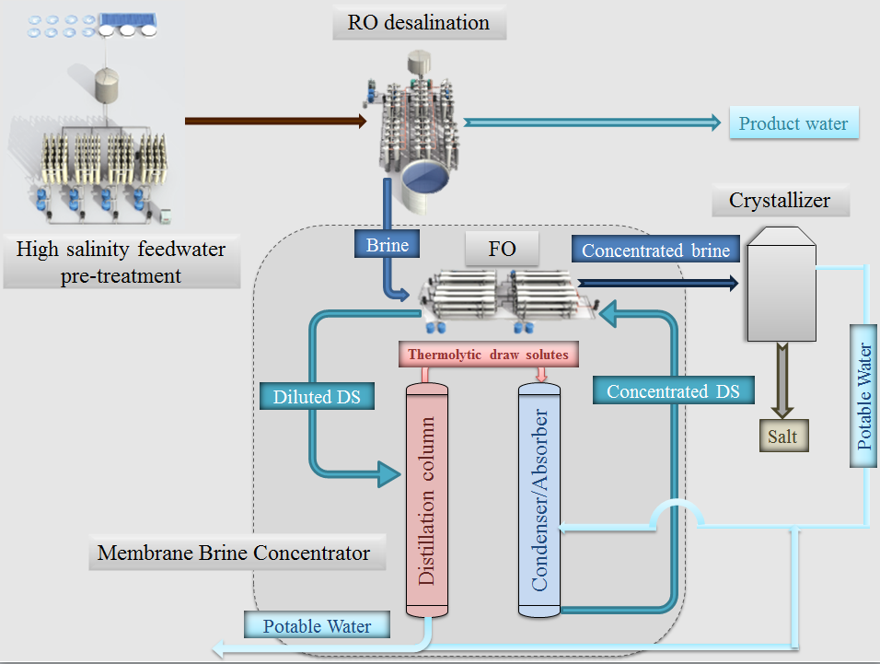
Figure 6: Schematic of a zero-liquid discharge membrane brine concentrator using a hybrid FO system with thermolytic DS (adapted from [21]).
Conventional membrane technologies for brackish water treatment (e.g. RO) can generally achieve up to 75% recovery rate [129, 130]. Because of the issue related to the management and disposal of concentrated brine, especially for inland desalination, higher water recovery rate is desirable in order to reduce the volume of concentrated brine. Aiming this objective, Altaee and Hilal [131] proposed a “trihybrid” NF-FO-Brackish water RO (BWRO) system for inland brackish water desalination. In their system, pre-treated brackish waters having different concentrations (i.e. from 1 to 2.4 g/L) are fed to a NF system for the removal of most divalent ions and some monovalent ions and the produced concentrated brine is sent to the FO system for further concentration. In the FO system, the concentrated brine from the BWRO system is used as DS while the permeate water produced by BWRO can be directly used or mixed with the NF permeate to adjust the TDS of the product water depending on the targeting application. The performance of both NF and BWRO was predicted using the ROSA software while the performance of FO membrane was estimated using a pre-developed software [78]. The simulation results showed that this trihybrid system can achieve a recovery rate of more than 90% depending on the quality of the feed water. Results also showed that the recovery rate positively correlates with the DS concentration based on the 0.25-0.5 M NaCl DS concentration used in this study. It was also found that NF is solely responsible for 75% of the total recovery rate. The energy requirements of each individual membrane process were evaluated and results indicated that 80% of the total power consumption was due to the BWRO process which also required 2-3 times more membranes than FO and NF systems. This result indicates that BWRO might not be the best candidate for this trihybrid system. Since this hybrid system was mainly designed for arid and semi-arid regions where thermal processes are very common for desalination, solar-powered MD system may be more suitable [82].

Fertigation
Increased attention has been received recently on the concept of fertiliser drawn FO (FDFO) process. The novelty of the FDFO approach is that, the final diluted fertiliser DS can be directly used for irrigation or fertigation as it contains the essential nutrients for plant growth. Different types of fertilisers have been tested [132, 133] and it was found that, despite the high water fluxes obtained in these studies, the final nutrient concentration of the diluted fertiliser exceeded the threshold for direct fertigation depending on the TDS of the feed water used. This limit in the final fertiliser concentration was attributed to the fact that FO is a concentration-based process and therefore, the dilution of the DS cannot continue beyond the concentration or osmotic equilibrium [134].
In order to circumvent this issue, NF has recently been integrated to the FDFO process [132] in order to meet the acceptable nutrient concentrations for direct fertigation after brackish groundwater desalination. In this study, NF was suggested either as a pre or a post-treatment for FDFO in order to reduce the concentration of nutrients in the final product water [23]. Results from this study showed that a water flux of up to 10 LMH can be achieved when using NH₄Cl as the DS and synthetic brackish groundwater as feed water. The quality of the produced water was suitable for fertigation when NF was integrated to the FDFO process using brackish groundwater with relatively low TDS (i.e. less than 4000 g/L). Further dilution or post-treatment would be required if brackish water with high TDS content is used as feed water.
Pressure-assisted forward osmosis (PAFO) has been recently introduced as a novel alternative system to overcome the limitations of the actual FO operations such as low water flux and high reverse salt flux [71, 135-145]. This standalone FO system relies on the pressurization of the FS of the conventional FO system. The PAFO system takes advantage of this additional hydraulic driving force to enhance permeate flux as well as further dilute the DS beyond the point of osmotic equilibrium without the supplement of an additional separation process [139]. The hydraulic pressure on the feed side is expected to not only increase the permeate water flux, but also reduce the specific reverse solute flux. Accordingly, PAFO has potential to tackle current limitations of FO and may have many other application areas. Therefore, in a recent FDFO study [139], PAFO was tested since it could potentially eliminate the need for further post-treatment. In fact, the additional water flux generates in the process can enhance the final fertiliser DS dilution beyond osmotic equilibrium making the final product water suitable for direct fertigation as shown in Figure 7.
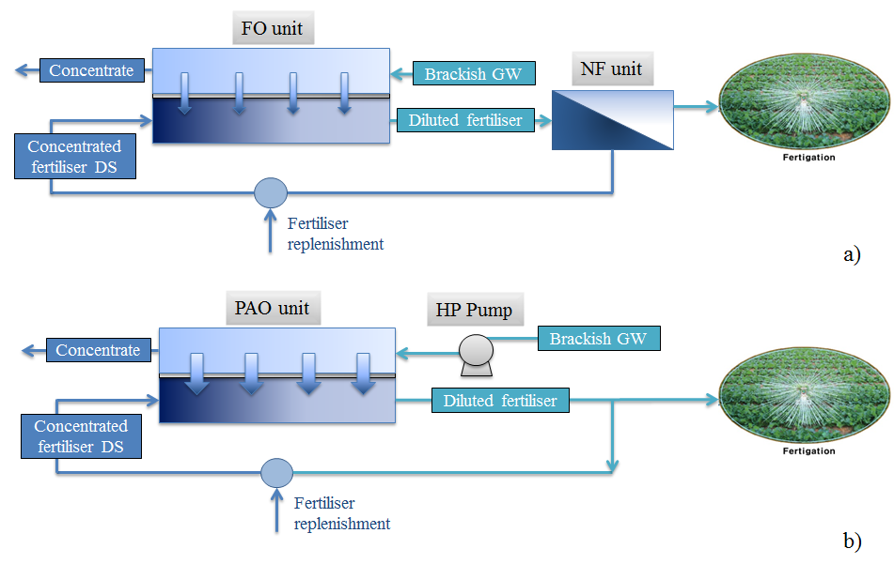
Figure 7: Schematic diagrams of (a) hybrid FDFO-NF desalination process with NF as post-treatment process (adapted from [23]) and (b) FDPAO desalination process (adapted from [139]).
In this study, it was observed that the gain in water flux was higher at lower DS concentration which indicates that PAFO could be more effective when the DS concentration is closer to the osmotic equilibrium (i.e. when the driving force is significantly reduced). It was also demonstrated that the use of PAFO (instead of NF) can enhance the final osmotic dilution of the fertiliser DS by producing water flux beyond the osmotic equilibrium [139]. Therefore, the final diluted fertiliser DS is expected to meet the acceptable nutrient concentrations for direct fertigation. Accordingly, PAFO has the potential to be applied as a standalone process without the need of additional NF as post-treatment process thereby reducing the overall process footprint. Besides, any additional increase in the energy required to operate PAFO (which is expected to be larger than FO) may be compensated by reduced capital cost due to the elimination of NF membranes and also reduced FO membrane area since PAFO is operated at higher water fluxes.

Osmotic microbial desalination cells
Microbial desalination cells (MDC) are a novel desalination method in which the electrical power required for desalination can be substantially reduced or eliminated by using exoelectrogenic microorganisms which can generate an electrical potential from the degradation of organic matter. This electrical potential can then be utilised to desalinate water by transporting ions through ion-exchange membranes. A typical MDC consists of three chambers: the anode, the middle desalination chamber and the cathode; separated by two membranes: the anion-exchange membrane and the cathode-exchange membranes. When wastewater is used as the source of organic matter, this system can achieve three simultaneous targets: desalination, wastewater treatment and energy production [146]. Different membranes have been proposed for this system; including FO membrane. In osmotic MDC (OMDC), the FO membrane replaces the anion-exchange membrane separating the anode and middle chamber [147, 148] and desalination is accelerated by driving the water to the salt water chamber from the anode chamber (i.e. containing the microorganisms) as shown in Figure 8.
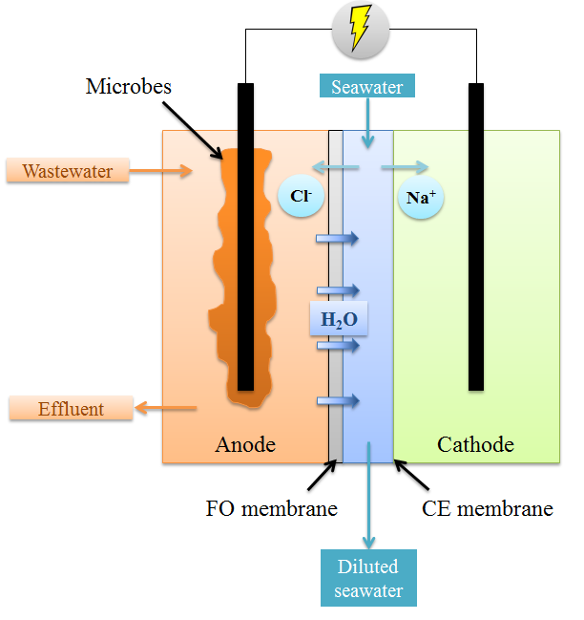
Figure 8: Schematic diagram of an osmotic microbial desalination cell for simultaneous wastewater treatment, seawater desalination and electricity generation (adapted from [147]).
Zhang et al. [148] were the first to introduce the concept of OMDC. Results from their study showed that the OMCD system can generate more electricity than conventional MDC processes when NaCl is used as DS. This difference is even more notable at higher NaCl concentration (i.e. from 20 g NaCl/L to 116 g NaCl/L). However, the use of seawater as DS instead of NaCl resulted in lower electricity production which was mainly attributed to the presence of nonconductive compounds in seawater. This also affected the water flux across the FO membrane due to the lower osmotic pressure of the seawater compared with the pure NaCl solution. Overall, this system was able to achieve a 28% reduction of seawater salinity which could potentially benefit a downstream desalination process such as RO. In a more recent study [147], the OMDC system showed a 63% conductivity reduction using 35 g/L sea salt solution (i.e. NaCl only). Results from this study also demonstrated a significant desalinated water recovery of more than 50%. The authors found that the main issue related to OMDC when applied to real wastewaters would be membrane fouling but this has not yet been investigated. Membrane fouling in OMDC systems is expected to be very similar to bioreactor systems such as OMBR but need to be fully evaluated in future studies.

Sludge dewatering
Due to the large production of sludge during conventional activated sludge process, sludge dewatering is inevitable to reduce its volume for handling as it represents approximately 50-60% of the total operating cost of wastewater treatment plant [149]. Various advanced technologies have been tested to improve the sludge dewatering process such as ultrasonication [150] or advanced oxidation process [151] but all these processes are limited by the high operating costs. Recently, FO has been tested as an alternative low-energy process for sludge dewatering [152-154]. Holloway et al. [155] proposed a hybrid FO-RO system for the concentration of anaerobic digester. Although a high water recovery of up to 75% and high water flux were achieved using a highly concentrated draw solution (i.e. 70 g/L NaCl), the energy consumption of the RO process (about 4 kWh/m³) was observed to be one of the main limitations of this system. In a more recent study [153], the seawater was used as DS for the concentration of sludge using two stage FO process with the objective of producing sludge for use as fertiliser. However, the high reverse salt flux and membrane fouling due to cake layer formation were sees as some of the major obstacles. Hau et al. [156] proposed a hybrid FO-NF system for potential application in sludge dewatering. Results showed that FO performances, in terms of water flux and reverse salt flux, were better when using EDTA as DS over conventional NaCl or seawater. Besides, FO successfully rejected nutrient compounds from the feed sludge with removal efficiency of more than 90%. Finally, NF membrane was able to recover the DS with a rejection rate of up to 93%. However, the water flux was only constant for the first hours of operation and then quickly declined due to the increased deposition of sludge cake layer on the FO membrane, the concentrated feed and the diluted DS.

Protein enrichment
Enriching and separating proteins still remains technically and economically challenging because most proteins are heat sensitive and chemically unstable. Yang et al. [157] developed a dual-layer hollow fiber FO membrane and their study showed that the FO process was able to enrich lysozyme product to high purity without denaturing the protein due to the low reverse salt flux of the DS. Later, Ling and Chung [41] developed a dual-stage hybrid FO system in which proteins are concentrated in a first FO process (i.e. FO1) and RO brines is used as DS in the second FO process (i.e. FO2) to reconcentrate the FO1 DS. Minimal reverse salt flux was observed in FO1 due to the large size of the MNP DS which helped in maintaining the proteins intact and stable during their enrichment process. More recently, Wang et al. [158] tested the hybrid FO-MD system for potential application in protein (i.e. bovine serum albumin (BSA)) concentration. A water flux of up to 5 LMH was achieved using 1.5 M NaCl as DS and 0.1 g/L BSA as feed. However, reverse draw solute was quite high (i.e. up to 15 g/m².h). Similarly to Ge et al. [50], the authors indicated that this hybrid system was stable in continuous operation when the dehydration rate across the FO membrane was similar to the water vapour rate across the MD membrane.

Conclusions and Future prospects
As reviewed in this study, FO generally has to be coupled with other process to either separate the DS from the product water (e.g. for drinking water production), to enhance the performance of conventional separation process by reducing inorganic scaling or organic fouling (i.e. FO is used as a pre-treatment process), to improve the permeate quality (e.g. FO can provide an additional barrier for some contaminants that are not completely removed by traditional separation process), or to reduce the total energy cost if low-cost energy sources are used to power the DS recovery process (e.g. solar-powered MD or using waste heat from a thermal plant for the recovery of thermolytic DS). Despite the apparent increased energy demand and capital cost due to the additional process, there are some situations where hybrid FO systems have been shown to surpass or improve other conventional separation technologies as summarised below and in Figure 9:
- Hybrid FO system could potentially consume less total energy compared to a standalone separation process especially for those applications where the source of water for treatment has extreme characteristics. The FO-MD hybrid system using thermolytic solution as DS is a promising application for the treatment of feed water with high salinity and high scaling potential. The FO-MD hybrid process becomes even more attractive when low-cost thermal energy sources such as solar thermal energy, industrial waste heat, etc. are easily available. However, from the point of view of commercialization of the technology, there are still several limitations that need to be overcome before MD can be implemented in the industries. These limitations include membrane pore wetting, low feed recovery rate and finally the uncertainty related to the availability of low-cost heat energy sources and the economic costs.
- FO process can be effectively used as an advanced pre-treatment process in a hybrid desalination system to reduce inorganic scaling and organic fouling in the combined membrane or thermal process. The benefit for the coupled process is that, the post-FO process is exposed only to the DS which has negligible scaling and fouling potential and therefore can achieve higher water recovery by operating at higher pressure (e.g. RO or NF) or temperature (e.g. MSF/MED). The apparent benefit of FO over conventional pre-treatment processes relies on its lower fouling propensity and higher fouling reversibility, making it the ideal candidate especially for treating challenging feed waters. However, to achieve commercial potential for the FO hybrid process, the future research should focus on the development of novel membranes with improved fouling resistance to increase its long-term performance. Modification of membranes with antimicrobial nanomaterials (e.g. carbon nanotubes, graphene or graphene oxide, etc.) already showed promising biofouling resistance.
- The practical application of the osmotic dilution, that simultaneously treats impaired water while indirectly diluting seawater before the RO process, is also very promising. The low water flux delivered by the existing commercialised FO membranes could however limit its application at larger scale due to the likely increase in the membrane capital cost. Further optimisation on membrane permeability, rejection and the packing density of FO membrane modules will likely enable this hybrid system to compete with current hybrid treatment process such as NF-RO hybrid process. The development of low-cost pre-treatment processes to reduce the energy requirement of the overall hybrid system should also be the focus of future research and hence many challenging research projects such as ONE Desal project are necessary to realise this FO-RO hybrid desalination technology.
- The smart and innovative draw solutes such as magnetic nanoparticles (MNPs) and stimuli-responsive polymer hydrogels are attractive for numerous niche FO applications and have been effectively integrated into different hybrid FO systems. Polyelectrolyte-coated MNPs have demonstrated promising performances in terms of water flux; however further improvement both in terms of water flux and their reuse life is necessary to make it suitable for commercial application. Their regeneration via low-pressure driven membrane process (i.e. Hybrid FO-UF system) is particularly promising; however, there is a need to develop approaches to synthesize monodisperse MNPs suspension since polydispersed MNPs sample are not completely rejected by the UF membrane. Hydrogels have attractive properties of responding to environmental stimuli such as temperature, light or pressure for their recovery and regeneration; nevertheless, they demonstrate poor performances in terms of water flux and recovery. The suitability of hydrogels for large-scale application in the membrane modules is not only practically challenging but also increase pumping cost due to the highly viscous nature of the DS. More work is needed to reduce its polymer size and viscosity so that its interfacial contact with the membrane active layer can be increased. In fact, the current hydrogel does not seem to be practical for continuous application on the support layer side of the membrane due to poor diffusivity through the support structure.

Figure 9: Summary of the benefits of current hybrid FO systems and direction of future research.
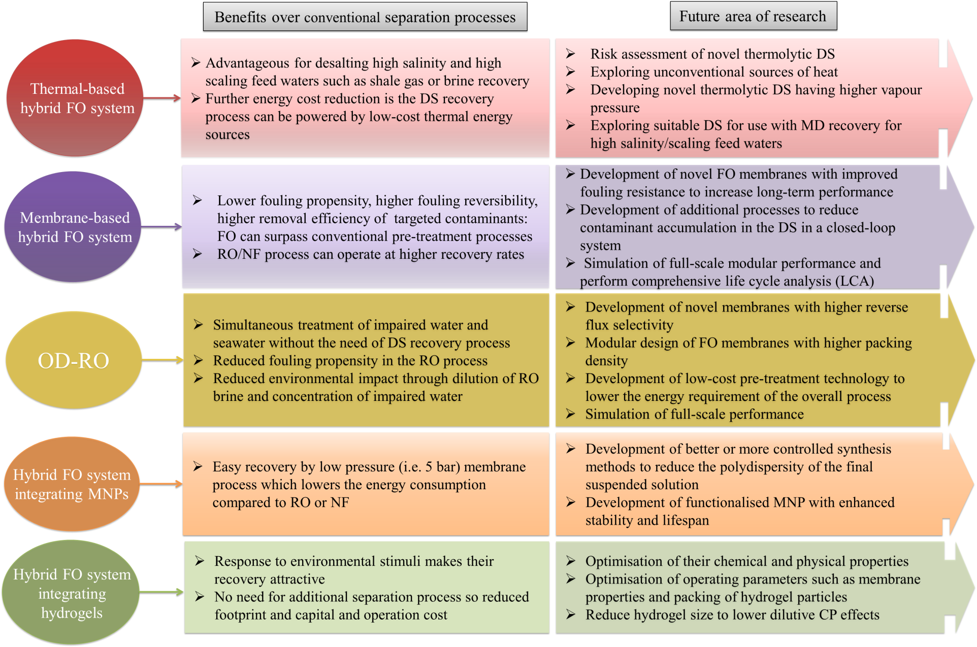
Acknowledgements
This research was supported by a grant (code 14IFIP-B087385-01) from Industrial Facilities & Infrastructure Research Program funded by Ministry of Land, Infrastructure and Transport of Korean Government and the Australian Research Council (ARC) through Future Fellowships (FT140101208).
References
1. M.A. Shannon, P.W. Bohn, et al., Science and technology for water purification in the coming decades, Nature 452 (2008) 301-310.
2. M. Elimelech and W.A. Phillip, The future of seawater desalination: energy, technology, and the environment, Sci. 333 (2011) 712-717.
3. S. Zhao, L. Zou, et al., Recent developments in forward osmosis: opportunities and challenges, Journal of Membrane Science 396 (2012) 1-21.
4. T.-S. Chung, S. Zhang, et al., Forward osmosis processes: yesterday, today and tomorrow, Desalination 287 (2012) 78-81.
5. R.L. McGinnis and M. Elimelech, Global challenges in energy and water supply: the promise of engineered osmosis, Environ. Sci. Technol. 42 (2008) 8625-8629.
6. Q. Ge, M. Ling, et al., Draw solutions for forward osmosis processes: developments, challenges, and prospects for the future, Journal of Membrane Science 442 (2013) 225-237.
7. K.P. Lee, T.C. Arnot, et al., A review of reverse osmosis membrane materials for desalination—Development to date and future potential, Journal of Membrane Science 370 (2011) 1-22.
8. L.F. Greenlee, D.F. Lawler, et al., Reverse osmosis desalination: water sources, technology, and today's challenges, Water Res. 43 (2009) 2317-2348.
9. R.L. McGinnis and M. Elimelech, Energy requirements of ammonia–carbon dioxide forward osmosis desalination, Desalination 207 (2007) 370-382.
10. T.Y. Cath, A.E. Childress, et al., Forward osmosis: principles, applications, and recent developments, Journal of Membrane Science 281 (2006) 70-87.
11. L. Chekli, S. Phuntsho, et al., A review of draw solutes in forward osmosis process and their use in modern applications, Desalin. Water Treat. 43 (2012) 167-184.
12. J.R. McCutcheon and M. Elimelech, Influence of concentrative and dilutive internal concentration polarization on flux behavior in forward osmosis, Journal of Membrane Science 284 (2006) 237-247.
13. Y. Kim, M. Elimelech, et al., Combined organic and colloidal fouling in forward osmosis: fouling reversibility and the role of applied pressure, Journal of Membrane Science 460 (2014) 206-212.
14. S. Lee, C. Boo, et al., Comparison of fouling behavior in forward osmosis (FO) and reverse osmosis (RO), Journal of Membrane Science 365 (2010) 34-39.
15. R. Wang, L. Shi, et al., Characterization of novel forward osmosis hollow fiber membranes, Journal of Membrane Science 355 (2010) 158-167.
16. N.Y. Yip, A. Tiraferri, et al., High performance thin-film composite forward osmosis membrane, Environ. Sci. Technol. 44 (2010) 3812-3818.
17. H. Luo, Q. Wang, et al., A review on the recovery methods of draw solutes in forward osmosis, Journal of Water Process Engineering 4 (2014) 212-223.
18. K. Lutchmiah, A. Verliefde, et al., Forward osmosis for application in wastewater treatment: A review, Water Res. 58 (2014) 179-197.
19. R.V. Linares, Z. Li, et al., Forward osmosis niches in seawater desalination and wastewater reuse, Water Research 66 (2014) 122-139.
20. A. Achilli, T.Y. Cath, et al., Selection of inorganic-based draw solutions for forward osmosis applications, Journal of Membrane Science 364 (2010) 233-241.
21. D.L. Shaffer, J.R. Werber, et al., Forward osmosis: Where are we now?, Desalination 356 (2015) 271-284.
22. M. Xie, L.D. Nghiem, et al., A forward osmosis–membrane distillation hybrid process for direct sewer mining: System performance and limitations, Environ. Sci. Technol. 47 (2013) 13486-13493.
23. S. Phuntsho, S. Hong, et al., Forward osmosis desalination of brackish groundwater: Meeting water quality requirements for fertigation by integrating nanofiltration, Journal of Membrane Science 436 (2013) 1-15.
24. L.A. Hoover, W.A. Phillip, et al., Forward with osmosis: emerging applications for greater sustainability, Environ. Sci. Technol. 45 (2011) 9824-9830.
25. C. Boo, M. Elimelech, et al., Fouling control in a forward osmosis process integrating seawater desalination and wastewater reclamation, Journal of Membrane Science 444 (2013) 148-156.
26. T.Y. Cath, N.T. Hancock, et al., A multi-barrier osmotic dilution process for simultaneous desalination and purification of impaired water, Journal of Membrane Science 362 (2010) 417-426.
27. N.T. Hancock, P. Xu, et al., Towards direct potable reuse with forward osmosis: Technical assessment of long-term process performance at the pilot scale, Journal of Membrane Science 445 (2013) 34-46.
28. A. Altaee and N. Hilal, Dual-stage forward osmosis/pressure retarded osmosis process for hypersaline solutions and fracking wastewater treatment, Desalination 350 (2014) 79-85.
29. J.S. Batchelder, Heat exchange apparatus, 1965, Google Patents.
30. D.N. Glew, Process for liquid recovery and solution concentration, 1965, Google Patents.
31. R.A. Neff, Solvent extractor, 1964, Google Patents.
32. R.L. McGinnis, Osmotic desalination process, 2011, Google Patents.
33. J.R. McCutcheon, R.L. McGinnis, et al., Desalination by ammonia–carbon dioxide forward osmosis: influence of draw and feed solution concentrations on process performance, Journal of Membrane Science 278 (2006) 114-123.
34. R.L. McGinnis, J.R. McCutcheon, et al., A novel ammonia—carbon dioxide forward (direct) osmosis desalination process, Desalination 174 (2005) 1-11.
35. S.K. Yen, M. Su, et al., Study of draw solutes using 2-methylimidazole-based compounds in forward osmosis, Journal of Membrane Science 364 (2010) 242-252.
36. C.X. Guo, D. Zhao, et al., Na+-functionalized carbon quantum dots: a new draw solute in forward osmosis for seawater desalination, Chem. Commun. 50 (2014) 7318-7321.
37. R. Alnaizy, A. Aidan, et al., Copper sulfate as draw solute in forward osmosis desalination, Journal of Environmental Chemical Engineering (2013)
38. R. Alnaizy, A. Aidan, et al., Draw solute recovery by metathesis precipitation in forward osmosis desalination, Desalin. Water Treat. 51 (2013) 5516-5525.
39. R. Alnaizy, A. Aidan, et al., Copper sulfate as draw solute in forward osmosis desalination, Journal of Environmental Chemical Engineering 1 (2013) 424-430.
40. B.B. Warne, R.; Mayes, E.; Oriard, T.; Norris, I., Water purification method using a field separable osmotic agent., 2010,
41. M.M. Ling and T.-S. Chung, Novel dual-stage FO system for sustainable protein enrichment using nanoparticles as intermediate draw solutes, Journal of Membrane Science 372 (2011) 201-209.
42. M.M. Ling and T.-S. Chung, Desalination process using super hydrophilic nanoparticles via forward osmosis integrated with ultrafiltration regeneration, Desalination 278 (2011) 194-202.
43. M.M. Ling, T.-S. Chung, et al., Facile synthesis of thermosensitive magnetic nanoparticles as “smart” draw solutes in forward osmosis, Chem. Commun. 47 (2011) 10788-10790.
44. M.M. Ling, K.Y. Wang, et al., Highly water-soluble magnetic nanoparticles as novel draw solutes in forward osmosis for water reuse, Ind. Eng. Chem. Res. 49 (2010) 5869-5876.
45. Q. Ge, J. Su, et al., Hydrophilic Superparamagnetic Nanoparticles: Synthesis, Characterization, and Performance in Forward Osmosis Processes, Industrial & Engineering Chemistry Research 50 (2011) 382-388.
46. M.M. Ling and T.-S. Chung, Desalination process using super hydrophilic nanoparticles via forward osmosis integrated with ultrafiltration regeneration, Desalination 278 (2011) 194-202.
47. M.M. Ling and T.-S. Chung, Surface-dissociated nanoparticle draw solutions in forward osmosis and the regeneration in an integrated electric field and nanofiltration system, Ind. Eng. Chem. Res. 51 (2012) 15463-15471.
48. M.Y.A. Mollah, R. Schennach, et al., Electrocoagulation (EC)—science and applications, J. Hazard. Mater. 84 (2001) 29-41.
49. J.D. Bass, X. Ai, et al., An Efficient and Low‐Cost Method for the Purification of Colloidal Nanoparticles, Angew. Chem. Int. Ed. 50 (2011) 6538-6542.
50. Q. Ge, P. Wang, et al., Polyelectrolyte-promoted forward osmosis–membrane distillation (FO–MD) hybrid process for dye wastewater treatment, Environmental Science & Technology 46 (2012) 6236-6243.
51. Q. Ge, J. Su, et al., Exploration of polyelectrolytes as draw solutes in forward osmosis processes, Water Res. 46 (2012) 1318-1326.
52. D. Zhao, P. Wang, et al., Thermoresponsive copolymer-based draw solution for seawater desalination in a combined process of forward osmosis and membrane distillation, Desalination 348 (2014) 26-32.
53. Q. Ge and T.-S. Chung, Hydroacid complexes: a new class of draw solutes to promote forward osmosis (FO) processes, Chem. Commun. 49 (2013) 8471-8473.
54. Q. Ge, F. Fu, et al., Ferric and cobaltous hydroacid complexes for forward osmosis (FO) processes, Water Res. 58 (2014) 230-238.
55. D. Li, X. Zhang, et al., Stimuli-responsive polymer hydrogels as a new class of draw agent for forward osmosis desalination, Chem. Commun. 47 (2011) 1710-1712.
56. D. Li, X. Zhang, et al., Composite polymer hydrogels as draw agents in forward osmosis and solar dewatering, Soft Matter 7 (2011) 10048-10056.
57. Y. Cai, W. Shen, et al., Towards temperature driven forward osmosis desalination using Semi-IPN hydrogels as reversible draw agents, Water Research 47 (2013) 3773-3781.
58. Y. Zeng, L. Qiu, et al., Significantly enhanced water flux in forward osmosis desalination with polymer-graphene composite hydrogels as a draw agent, Rsc Advances 3 (2013) 887-894.
59. A. Razmjou, G.P. Simon, et al., Effect of particle size on the performance of forward osmosis desalination by stimuli-responsive polymer hydrogels as a draw agent, Chem. Eng. J. 215 (2013) 913-920.
60. A. Razmjou, M.R. Barati, et al., Fast deswelling of nanocomposite polymer hydrogels via magnetic field-induced heating for emerging FO desalination, Environ. Sci. Technol. 47 (2013) 6297-6305.
61. Y. Hartanto, S. Yun, et al., Functionalized thermo-responsive microgels for high performance forward osmosis desalination, Water Res. 70 (2015) 385-393.
62. J. Yaeli, Method and apparatus for processing liquid solutions of suspensions particularly useful in the desalination of saline water, 1992, Google Patents.
63. V. Yangali-Quintanilla, Z. Li, et al., Indirect desalination of Red Sea water with forward osmosis and low pressure reverse osmosis for water reuse, Desalination 280 (2011) 160-166.
64. A. Altaee, G. Zaragoza, et al., Comparison between forward osmosis-reverse osmosis and reverse osmosis processes for seawater desalination, Desalination 336 (2014) 50-57.
65. N.T. Hancock, P. Xu, et al., Comprehensive bench-and pilot-scale investigation of trace organic compounds rejection by forward osmosis, Environmental Science & Technology 45 (2011) 8483-8490.
66. B.D. Coday, B.G. Yaffe, et al., Rejection of trace organic compounds by forward osmosis membranes: a literature review, Environ. Sci. Technol. 48 (2014) 3612-3624.
67. M. Xie, L.D. Nghiem, et al., Comparison of the removal of hydrophobic trace organic contaminants by forward osmosis and reverse osmosis, Water Res. 46 (2012) 2683-2692.
68. C. Kim, S. Lee, et al., Boron transport in forward osmosis: Measurements, mechanisms, and comparison with reverse osmosis, Journal of Membrane Science 419 (2012) 42-48.
69. D.L. Shaffer, N.Y. Yip, et al., Seawater desalination for agriculture by integrated forward and reverse osmosis: Improved product water quality for potentially less energy, Journal of Membrane Science 415 (2012) 1-8.
70. A. D'Haese, P. Le-Clech, et al., Trace organic solutes in closed-loop forward osmosis applications: Influence of membrane fouling and modeling of solute build-up, Water Res. 47 (2013) 5232-5244.
71. G. Blandin, A.R.D. Verliefde, et al., Opportunities to reach economic sustainability in forward osmosis–reverse osmosis hybrids for seawater desalination, Desalination 363 (2015) 26-36.
72. O. Bamaga, A. Yokochi, et al., Hybrid FO/RO desalination system: Preliminary assessment of osmotic energy recovery and designs of new FO membrane module configurations, Desalination 268 (2011) 163-169.
73. B. Van der Bruggen and C. Vandecasteele, Distillation vs. membrane filtration: overview of process evolutions in seawater desalination, Desalination 143 (2002) 207-218.
74. A.N.A. Mabrouk and H.E.-b.S. Fath, Techno-economic analysis of hybrid high performance MSF desalination plant with NF membrane, Desalin. Water Treat. 51 (2013) 844-856.
75. A. Altaee and G. Zaragoza, A conceptual design of low fouling and high recovery FO–MSF desalination plant, Desalination 343 (2014) 2-7.
76. T. Mezher, H. Fath, et al., Techno-economic assessment and environmental impacts of desalination technologies, Desalination 266 (2011) 263-273.
77. A. Altaee, A. Mabrouk, et al., A novel forward osmosis membrane pretreatment of seawater for thermal desalination processes, Desalination 326 (2013) 19-29.
78. A. Altaee, A. Mabrouk, et al., Forward osmosis pretreatment of seawater to thermal desalination: High temperature FO-MSF/MED hybrid system, Desalination 339 (2014) 18-25.
79. A. Al-Mayahi and A. Sharif, Solvent removal process, 2006, Google Patents.
80. C. Tan and H. Ng, A novel hybrid forward osmosis-nanofiltration (FO-NF) process for seawater desalination: draw solution selection and system configuration, Desalin. Water Treat. 13 (2010) 356-361.
81. S. Zhao, L. Zou, et al., Brackish water desalination by a hybrid forward osmosis–nanofiltration system using divalent draw solute, Desalination 284 (2012) 175-181.
82. C. Charcosset, A review of membrane processes and renewable energies for desalination, Desalination 245 (2009) 214-231.
83. T. Xu and C. Huang, Electrodialysis‐based separation technologies: A critical review, AIChE journal 54 (2008) 3147-3159.
84. A. Galama, M. Saakes, et al., Seawater predesalination with electrodialysis, Desalination 342 (2014) 61-69.
85. Y. Zhang, L. Pinoy, et al., A natural driven membrane process for brackish and wastewater treatment: photovoltaic powered ED and FO hybrid system, Environ. Sci. Technol. 47 (2013) 10548-10555.
86. R.L. McGinnis, N.T. Hancock, et al., Pilot demonstration of the NH 3/CO 2 forward osmosis desalination process on high salinity brines, Desalination 312 (2013) 67-74.
87. Q. Ge, J. Su, et al., Hydrophilic superparamagnetic nanoparticles: synthesis, characterization, and performance in forward osmosis processes, Ind. Eng. Chem. Res. 50 (2010) 382-388.
88. J. Arévalo, G. Garralón, et al., Wastewater reuse after treatment by tertiary ultrafiltration and a membrane bioreactor (MBR): a comparative study, Desalination 243 (2009) 32-41.
89. J. Ottoson, A. Hansen, et al., Removal of viruses, parasitic protozoa and microbial indicators in conventional and membrane processes in a wastewater pilot plant, Water Research 40 (2006) 1449-1457.
90. E. Cornelissen, D. Harmsen, et al., Membrane fouling and process performance of forward osmosis membranes on activated sludge, Journal of Membrane Science 319 (2008) 158-168.
91. A. Achilli, T.Y. Cath, et al., The forward osmosis membrane bioreactor: a low fouling alternative to MBR processes, Desalination 239 (2009) 10-21.
92. A. Alturki, J. McDonald, et al., Performance of a novel osmotic membrane bioreactor (OMBR) system: flux stability and removal of trace organics, Bioresource technology 113 (2012) 201-206.
93. M.S. Nawaz, G. Gadelha, et al., Microbial toxicity effects of reverse transported draw solute in the forward osmosis membrane bioreactor (FO-MBR), Journal of Membrane Science 429 (2013) 323-329.
94. H. Zhang, Y. Ma, et al., Influence of activated sludge properties on flux behavior in osmosis membrane bioreactor (OMBR), Journal of Membrane Science 390 (2012) 270-276.
95. J. Zhang, W.L.C. Loong, et al., Membrane biofouling and scaling in forward osmosis membrane bioreactor, Journal of Membrane Science 403 (2012) 8-14.
96. R.V. Linares, V. Yangali-Quintanilla, et al., Rejection of micropollutants by clean and fouled forward osmosis membrane, Water Res. 45 (2011) 6737-6744.
97. N.T. Hancock and T.Y. Cath, Solute coupled diffusion in osmotically driven membrane processes, Environ. Sci. Technol. 43 (2009) 6769-6775.
98. A.A. Alturki, J.A. McDonald, et al., Removal of trace organic contaminants by the forward osmosis process, Separation and Purification Technology 103 (2013) 258-266.
99. X. Jin, J. Shan, et al., Rejection of pharmaceuticals by forward osmosis membranes, J. Hazard. Mater. 227 (2012) 55-61.
100. K.S. Bowden, A. Achilli, et al., Organic ionic salt draw solutions for osmotic membrane bioreactors, Bioresour. Technol. 122 (2012) 207-216.
101. W.C. Lay, Q. Zhang, et al., Study of integration of forward osmosis and biological process: membrane performance under elevated salt environment, Desalination 283 (2011) 123-130.
102. L. Ye, C.-y. Peng, et al., Determination effect of influent salinity and inhibition time on partial nitrification in a sequencing batch reactor treating saline sewage, Desalination 246 (2009) 556-566.
103. D. Xiao, C.Y. Tang, et al., Modeling salt accumulation in osmotic membrane bioreactors: implications for FO membrane selection and system operation, Journal of Membrane Science 366 (2011) 314-324.
104. C.B. Ersu, S.K. Ong, et al., Impact of solids residence time on biological nutrient removal performance of membrane bioreactor, Water Research 44 (2010) 3192-3202.
105. X. Wang, B. Yuan, et al., Integration of micro-filtration into osmotic membrane bioreactors to prevent salinity build-up, Bioresour. Technol. 167 (2014) 116-123.
106. R.W. Holloway, A.S. Wait, et al., Long-term pilot scale investigation of novel hybrid ultrafiltration-osmotic membrane bioreactors, Desalination 363 (2015) 64-74.
107. S.H. Park, B. Park, et al., Modeling full-scale osmotic membrane bioreactor systems with high sludge retention and low salt concentration factor for wastewater reclamation, Bioresour. Technol. (2015)
108. J. Su, T.-S. Chung, et al., Enhanced double-skinned FO membranes with inner dense layer for wastewater treatment and macromolecule recycle using Sucrose as draw solute, Journal of Membrane Science 396 (2012) 92-100.
109. J. Su, R.C. Ong, et al., Advanced FO membranes from newly synthesized CAP polymer for wastewater reclamation through an integrated FO‐MD hybrid system, AIChE Journal 59 (2013) 1245-1254.
110. S. Zhang, P. Wang, et al., Sustainable water recovery from oily wastewater via forward osmosis-membrane distillation (FO-MD), Water Res. 52 (2014) 112-121.
111. X.-M. Li, B. Zhao, et al., Water reclamation from shale gas drilling flow-back fluid using a novel forward osmosis–vacuum membrane distillation hybrid system, Water Science & Technology 69 (2014) 1036-1044.
112. P. Liu, H. Zhang, et al., Integrating electrochemical oxidation into forward osmosis process for removal of trace antibiotics in wastewater, J. Hazard. Mater. Article in Press (2015)
113. A. Matilainen, M. Vepsäläinen, et al., Natural organic matter removal by coagulation during drinking water treatment: A review, Adv. Colloid Interface Sci. 159 (2010) 189-197.
114. J. DeWolfe, Guidance manual for coagulant changeover2003: American Water Works Association.
115. B.S. Frank, Desalination of sea water, 1972, Google Patents.
116. Z. Liu, H. Bai, et al., A low-energy forward osmosis process to produce drinking water, Energy & Environmental Science 4 (2011) 2582-2585.
117. P. Glueckstern and M. Priel, A hybrid SWRO/BWRO desalination plant, Desalination 115 (1998) 203-209.
118. C. Lew, J. Hu, et al., Development of an integrated membrane process for water reclamation, Water Science & Technology 51 (2005) 455-463.
119. T. Cath and A. Childress, Systems and methods for forward osmosis assisted desalination of liquids, USA patent# Pub, NO Patent US2,006.
120. T.Y. Cath, J.E. Drewes, et al., A novel hybrid forward osmosis process for drinking water augmentation using impaired water and saline water sources, Water Research Foundation (2009)
121. N.T. Hancock, N.D. Black, et al., A comparative life cycle assessment of hybrid osmotic dilution desalination and established seawater desalination and wastewater reclamation processes, Water Res. 46 (2012) 1145-1154.
122. V.S. Sim, Q. She, et al., Strategic co-location in a hybrid process involving desalination and pressure retarded osmosis (PRO), Membranes 3 (2013) 98-125.
123. A. Achilli, T.Y. Cath, et al., Power generation with pressure retarded osmosis: An experimental and theoretical investigation, Journal of Membrane Science 343 (2009) 42-52.
124. D.I. Kim, J. Kim, et al., Pressure retarded osmosis (PRO) for integrating seawater desalination and wastewater reclamation: Energy consumption and fouling, Journal of Membrane Science 483 (2015) 34-41.
125. H. Ng, L. Lee, et al., Treatment of RO brine-towards sustainable water reclamation practice, (2008)
126. K.B. Gregory, R.D. Vidic, et al., Water management challenges associated with the production of shale gas by hydraulic fracturing, Elements 7 (2011) 181-186.
127. B.D. Coday, P. Xu, et al., The sweet spot of forward osmosis: Treatment of produced water, drilling wastewater, and other complex and difficult liquid streams, Desalination 333 (2014) 23-35.
128. FO: RO's new best friend in (2014) Water Desalination Report.
129. C. Garcia, F. Molina, et al., 7 year operation of a BWRO plant with raw water from a coastal aquifer for agricultural irrigation, Desalin. Water Treat. 31 (2011) 331-338.
130. R.L. Stover, Industrial and brackish water treatment with closed circuit reverse osmosis, Desalin. Water Treat. 51 (2013) 1124-1130.
131. A. Altaee and N. Hilal, High recovery rate NF–FO–RO hybrid system for inland brackish water treatment, Desalination 363 (2015) 19-25.
132. S. Phuntsho, H.K. Shon, et al., A novel low energy fertilizer driven forward osmosis desalination for direct fertigation: evaluating the performance of fertilizer draw solutions, Journal of Membrane Science 375 (2011) 172-181.
133. S. Phuntsho, H.K. Shon, et al., Fertiliser drawn forward osmosis desalination: the concept, performance and limitations for fertigation, Reviews in Environmental Science and Bio/Technology 11 (2012) 147-168.
134. S. Phuntsho, S. Hong, et al., Osmotic equilibrium in the forward osmosis process: modelling, experiments and implications for process performance, Journal of Membrane Science 453 (2014) 240-252.
135. G. Blandin, A.R.D. Verliefde, et al., Validation of assisted forward osmosis (AFO) process: Impact of hydraulic pressure, Journal of Membrane Science 447 (2013) 1-11.
136. J. Duan, E. Litwiller, et al., Solution-diffusion with defects model for pressure-assisted forward osmosis, Journal of Membrane Science 470 (2014) 323-333.
137. K. Lutchmiah, D.J.H. Harmsen, et al., Continuous and discontinuous pressure assisted osmosis (PAO), Journal of Membrane Science 476 (2015) 182-193.
138. Y. Oh, S. Lee, et al., Effect of hydraulic pressure and membrane orientation on water flux and reverse solute flux in pressure assisted osmosis, Journal of Membrane Science 465 (2014) 159-166.
139. S. Sahebi, S. Phuntsho, et al., Pressure assisted fertiliser drawn osmosis process to enhance final dilution of the fertiliser draw solution beyond osmotic equilibrium, Journal of Membrane Science 481 (2015) 63-72.
140. M. Shibuya, M. Yasukawa, et al., Effects of operating conditions and membrane structures on the performance of hollow fiber forward osmosis membranes in pressure assisted osmosis, Desalination 365 (2015) 381-388.
141. T. Yun, Y.-J. Kim, et al., Flux behavior and membrane fouling in pressure-assisted forward osmosis, Desalin. Water Treat. 52 (2014) 564-569.
142. K. Lutchmiah, E.R. Cornelissen, et al., Water recovery from sewage using forward osmosis, Water Science & Technology 64 (2011) 1443-1449.
143. B.D. Coday, D.M. Heil, et al., Effects of transmembrane hydraulic pressure on performance of forward osmosis membranes, Environ. Sci. Technol. 47 (2013) 2386-2393.
144. T. Yun, Y.-J. Kim, et al., Effect of applied pressure on water flux in forward osmosis: Membrane types and operation conditions, in The 7th Conference of Aseanian Membrane Society 2012: Busan, Korea.
145. T. Yun, S.-M. Park, et al., Effect of external pressure and feed/draw solution velocity on flux characteristics in hollow fiber forward osmosis membrane, in The 5th International Desalination Workshop2012: Jeju, Korea.
146. Y. Kim and B.E. Logan, Microbial desalination cells for energy production and desalination, Desalination 308 (2013) 122-130.
147. B. Zhang and Z. He, Integrated salinity reduction and water recovery in an osmotic microbial desalination cell, Rsc Adv. 2 (2012) 3265-3269.
148. F. Zhang, K.S. Brastad, et al., Integrating forward osmosis into microbial fuel cells for wastewater treatment, water extraction and bioelectricity generation, Environ. Sci. Technol. 45 (2011) 6690-6696.
149. L. Appels, J. Baeyens, et al., Principles and potential of the anaerobic digestion of waste-activated sludge, Progress in energy and combustion science 34 (2008) 755-781.
150. X. Feng, J. Deng, et al., Dewaterability of waste activated sludge with ultrasound conditioning, Bioresource technology 100 (2009) 1074-1081.
151. G. Zhen, X. Lu, et al., Enhanced dewaterability of sewage sludge in the presence of Fe (II)-activated persulfate oxidation, Bioresource technology 116 (2012) 259-265.
152. R.V. Linares, Z. Li, et al., Water harvesting from municipal wastewater via osmotic gradient: an evaluation of process performance, Journal of Membrane Science 447 (2013) 50-56.
153. N.C. Nguyen, S.-S. Chen, et al., Application of forward osmosis on dewatering of high nutrient sludge, Bioresource technology 132 (2013) 224-229.
154. H. Zhu, L. Zhang, et al., Feasibility of applying forward osmosis to the simultaneous thickening, digestion, and direct dewatering of waste activated sludge, Bioresource technology 113 (2012) 207-213.
155. R.W. Holloway, A.E. Childress, et al., Forward osmosis for concentration of anaerobic digester centrate, Water Research 41 (2007) 4005-4014.
156. N.T. Hau, S.-S. Chen, et al., Exploration of EDTA sodium salt as novel draw solution in forward osmosis process for dewatering of high nutrient sludge, Journal of Membrane Science 455 (2014) 305-311.
157. Q. Yang, K.Y. Wang, et al., A novel dual-layer forward osmosis membrane for protein enrichment and concentration, Separation and Purification Technology 69 (2009) 269-274.
158. K.Y. Wang, M.M. Teoh, et al., Integrated forward osmosis–membrane distillation (FO–MD) hybrid system for the concentration of protein solutions, Chem. Eng. Sci. 66 (2011) 2421-2430.

