Towards Optimized and Reconstructable Sampling Inspection of Pipe Integrity for Improved Efficiency of NDT
L. Shi, J. Valls Miro
Centre for Autonomous Systems, University of Technology Sydney, NSW, Australia
Lei.Shi-1@uts.edu.au, Jaime.VallsMiro@uts.edu.au
Abstract: This work proposes a sampling inspection framework for point measurement Non-destructive testing (NDT) of pipelines to improve the time and cost efficiency. Remaining pipe wall thickness data from limited dense inspection is modelled with spatial statistics approaches. The spatial dependence and other requirements provide a reference for selecting a most efficient sampling inspection scheme. With the learned model and the selected sampling scheme, the effort on inspecting the rest of pipeline will be significantly reduced from dense inspection to sampling inspection, and the full information can be recovered from these samples while maintaining a reasonable accuracy. The recovered thickness map can be used as an equivalent measure to the dense inspection for subsequent structural analysis for failure risk estimation or remaining life assessment.
Keywords: Non-destructive testing; sampling inspection; spatial correlation; Gaussian Processes
Introduction
For the water industry who usually owns and maintains a large volume of pipelines, Non-destructive testing (NDT) inspection and the prediction of a pipe's remaining life are important procedures in developing effective renewal programs towards reducing the incidence of catastrophic failures. A common practice in the NDT of pipelines are to measure the remaining wall thicknesses with internal or external point measurement tools. An intense thickness map providing full coverage of a pipe segment can be evaluated through stress analysis and the minimum value of the segment is an indication of the time-to-penetration. However, depending on the tool being utilised, dense inspection can be costly and time consuming, or even infeasible in some cases. Therefore, limited research has been undertaken to address the issue of sampling inspection for the prediction of maximum pit depth (Khalifa et al., 2013) or the evaluation of pipe integrity (Ostrowska, 2006). To the best knowledge of the author, none of the current sampling inspection frameworks have systematically considered various practical requirements, targeted at recovering the original data and comprehensively evaluated with real data.
This research aims to address the following three questions: 1) how much redundancy there is in the pipe wall thickness map? 2) how we can develop and determine a guided sampling inspection scheme to improve the efficiency of NDT inspection? 3) how we can robustly reconstruct a dense thickness map from its sampling inspection?
Material and Methods
In NDT for pipelines, sampling inspection is a cost-efficient alternative to dense inspection. Various spatial sampling patterns exist in literature under the context of improving the efficiency of NDT whilst preserving the information for pipe integrity analysis. The most straightforward one is the regular inspection scheme which does not require adaptive adjustment and iterations (Ostrowska, 2006). However, appropriate prior knowledge about the defects distribution is essential in designing such a scheme (Ostrowska, 2006). Although there are works on data adequacy and designing complicated inspection schemes, the method of building the prior knowledge and information reconstruction from samples are rarely tackled.
Spatial statistics approaches like Spatial Processes have been previously employed in terrain and surface modeling (Kroese et al., 2013) (Vasudevan et al., 2009). In this study, we propose modeling the remaining wall thickness map from limited dense inspections with Gaussian Processes to capture and approximate the data dependence with a specifically designed composite anisotropic covariance function (Shi et al., 2015 & 2016). The model can be regarded as a multivariate Gaussian distribution which models the distribution of the thickness values and the spatial correlation between the thickness values of any two locations. The model by itself has the capability of inferring the original dense data from the sample data (Rasmussen et al., 2006), and the correlation strength pattern contained in the model provides a guidance for designing the sampling inspection schemes.
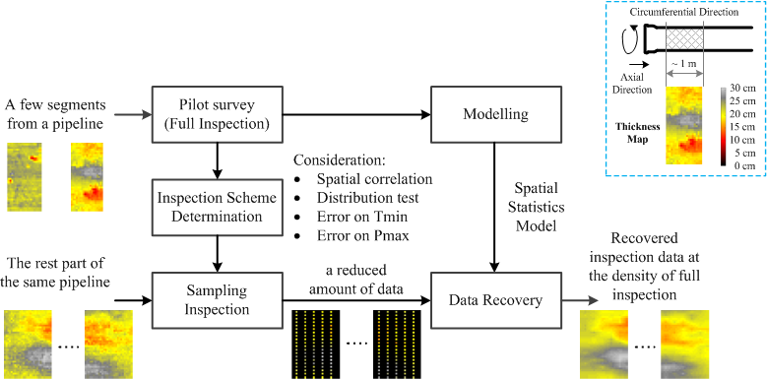
Figure 1 The flow chart of the proposed sampling inspection approach.
Top-right corner: an explanation of the thickness map
The flow chart of the proposed sampling inspection approach is depicted in Figure 1, and explained in more details as the following procedure:
a. Carry out a pilot survey on the targeted pipeline (a few dense local inspection)
b. Based on the local inspection results (a),
b.1 Build a spatial statistics model (Shi et al., 2015 & 2016) and assess the spatial
correlation pattern
b.2 Determine the optimised sampling inspection scheme, considering
  - Spatial correlation of thickness values
  - Distribution consistence of the thickness values
  - The worst case scenario error on the minimum wall thickness (Tmin)
  - The worst case scenario error on the maximum patch size (Pmax)
c. Apply the sampling inspection scheme (b.2) on any pipe segment belonging
to the rest part of the same pipeline
d. Apply the spatial statistics model (b.1) on the data collected in sampling
inspection (c) to recover the original data for the subsequent analysis
Some of the above-mentioned consideration like maximum pit depth (Khalifa et al., 2013), minimum remaining wall thickness (Schneider, 2009), and critical patch (Ji et al., 2015) arise from practical concerns in analysing the inspection data.
The evaluation is carried out on the ground truth data which consist of the thickness maps of 12 pipe segments extracted from a 1.5 km long DIN600 cement lined cast iron (CICL) pipe at Strathfield, NSW, Australia. This was provided by Sydney Water as a test-bed for the Advanced Condition Assessment and Pipe Failure Prediction Project (VallsMiro et al., 2014). Pipe wall thickness profiles are produced through processing high-resolution geometric 3D laser scans of both the outer and inner surfaces of the exhumed segments (Skinner et al., 2014). Each thickness map is 800 mm (pipe length) by 2050 mm (pipe circumference). In order to reflect the real-world situation, the reference data is averaged out at the spatial resolution of 50 mm by 50 mm to mimic the output of an external NDT sensor (Ulapane et al., 2014).
The study was done in a cross-validation manner to guarantee a fair test (Hastie, 2009). The thickness maps of the 12 pipe segments, as shown in Figure 2, are divided into 3 batches according to the stages in which they were excavated. In each cross-validation round, one batch (4 pipe segments, dense inspection) is used as the pilot survey result and the rest two remaining batches (8 pipe segments) are treated as the test data on which inspections are performed.
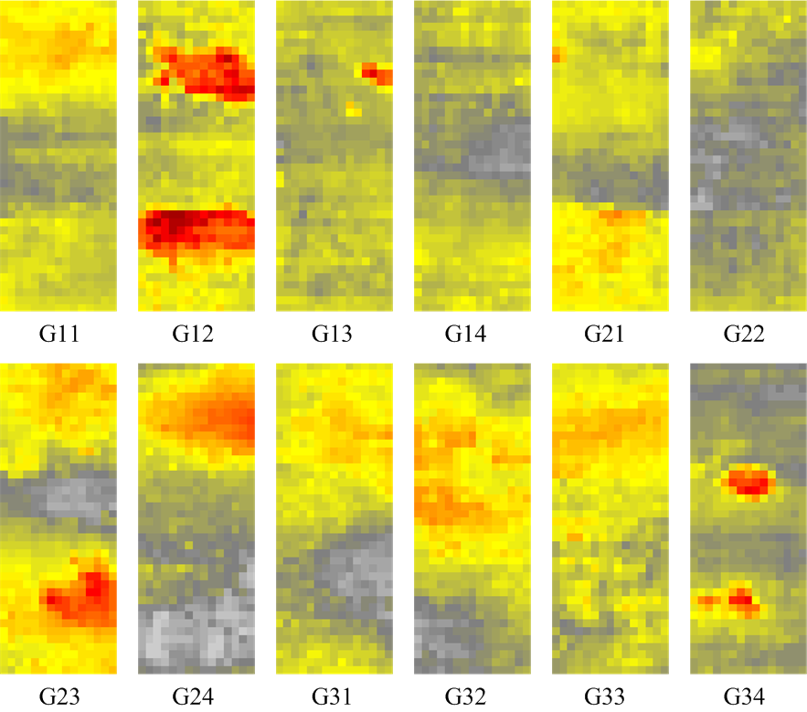
Figure 2 The ground truth data. The 12 pipe segments are divided into 3 batches according to
the stages in which they were excavated. Gxy – the y^{th} pipe segment in the x^{th} batch
Specifically, experiments are performed to find the optimise sampling inspection scheme with which the sample data and the recovered data satisfy the following requirements:
- When applying the determined sampling inspection scheme on the same pipe segment, and considering all possible different starting points, any two collected non-overlapping datasets are from the same continuous thickness distribution
- For the same pipe segment, when comparing the minimum remaining wall thickness (Tmin) in the original thickness map and all possible recovered thickness maps, the worst case absolute error < 3 mm (about 10% of the nominal wall thickness)
- For the same pipe segment, when comparing the identified maximum patch size (Pmax) in the original thickness map and all possible recovered thickness maps, the worst case absolute error < 150 mm (about 3 times the length of the sensor’s footprint)
- For the same pipe segment, when comparing the Root-mean-square error (RMSE) between the original thickness map and all possible recovered thickness maps, the worst case absolute error < 2 mm (about 5% of the nominal wall thickness)
In this study, a patch is defined as an ellipse approximation of an isolated area of which the thickness values are under 14 mm (about 50% of the nominal wall thickness). Please note that the criteria parameters are selected based on experience instead of referring to a particular standard. According to the definition of a patch, an automatic patch extraction algorithm is developed to detect the maximum patch size (i.e. the maximum length of the major axis of the fitted ellipses) from the thickness data. For example, within the ground truth data, patches are identified in 5 out of the 12 thickness maps, as shown in Figure 3.
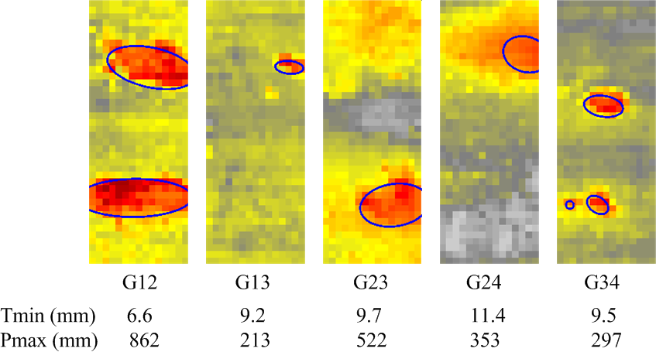
Figure 3 Patch detection results on the ground truth maps
To make the statement that two datasets are from the same thickness distribution, hypothesis tests such as two-sample Kolmogorov-Smirnov test (Massey, 1951) will be applied on the two datasets to examine whether the null hypothesis (they are from the same continuous distribution) will be rejected at 5% significance level.
Results and Discussion
Various experiments on the pilot survey stage on the available data indicate that:
- The correlation pattern of thickness measurements suggests that the correlation decays slower in the axial direction and faster in the circumferential direction (Shi et al., 2015). An example of the correlation map is visualised in figure 4. The point in the centre represents any thickness measurements and the change of the colour illustrates how the correlation strength decays with distance. Therefore, ideally the circumferential direction needs to be sampled more frequently than the axial direction.
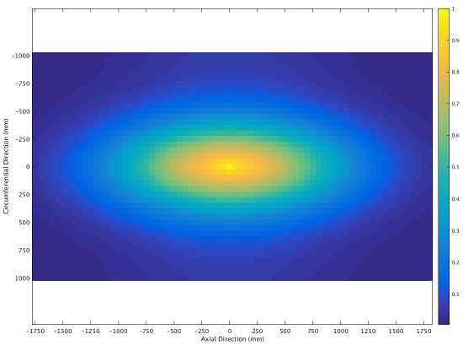
Figure 4 An example of the correlation map – the strength of correlation measured by Pearson product-moment correlation coefficient versus spatial location
- At least 10% of the original data is required to be sampled so that by following certain inspection patterns, any two non-overlapping datasets sampled from the same thickness map are from the same continuous thickness distribution.
- The worst case error on the minimum remaining wall thickness (Tmin) < 3 mm is the most challenging requirement. Based on the pilot survey, at least 50% of the original data needs to be sampled so that by following certain inspection patterns the requirement on the worst case Tmin error can be satisfied.
Figure 5 shows three regular inspection schemes for sampling 50% of the original data. In the pilot survey stage and with cross-validation, Scheme A succeeds in meeting all requirements for most of the cases and Scheme B & C succeed in all cases; Scheme C shows slightly better performance. In addition, according to the correlation pattern, Scheme B & C are more reasonable choices in comparison to Scheme A which samples less frequently in the circumferential direction.
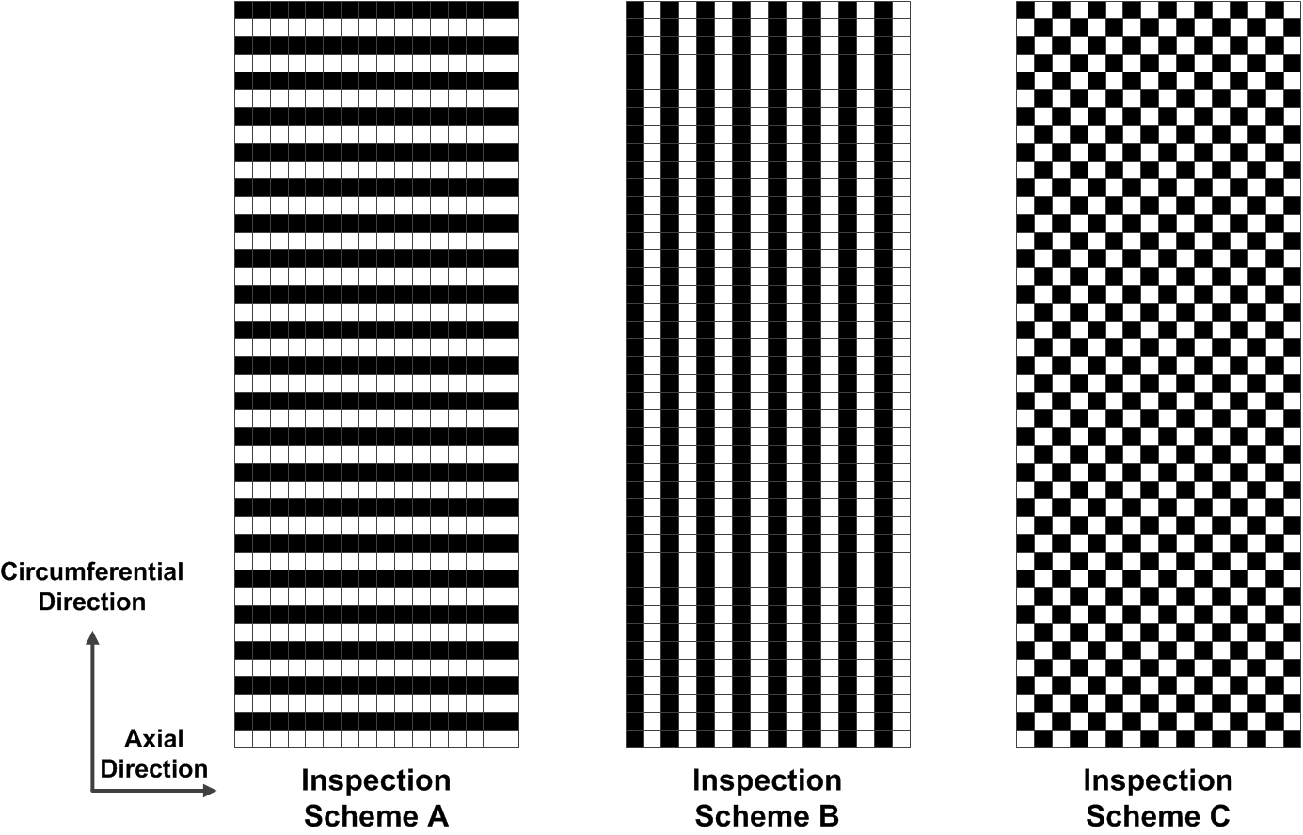
Figure 5 Three regular sampling inspection schemes which provide 50% of the data

The worst case performance of the selected inspection schemes on the test data (the data which was not used in the pilot survey) are presented quantitatively in table 1. In this experiment, each worst case represents the worst case of 48 tests. Although Scheme A is not a qualified choice, the results are also produced for comparison purposes. As expected, according to table 1 inspection Scheme A does not meet the set requirements; and Scheme C demonstrates more competitive performance than Scheme B, even though they both meet the set requirements. In practice both Scheme B and Scheme C have their own advantages: Scheme C is more likely to provide more accurate results while Scheme B is more efficient as it requires less localisation effort to achieve the inspection pattern.
Table 1 Comparison of three regular inspection schemes which provide 50% of the original data
Inspection Scheme | Maximum worst case absolute Tmin error (mm) | Maximum worst case absolute Pmax error (mm) | Maximum worst case RMSE (mm)
A | 3.8 | 520 | 1.1
B | 2.4 | 97 | 1.0
C | 2.4 | 60 | 0.9
As table 1 is a summary of a series of iterative tests with cross-validation, an example of a more detailed test results is provided in table 2. In this particular test set, data from batch 1 (G11, G12, G13 and G14) serves as the pilot survey results to determine the inspection scheme, and Scheme C (assuming it was selected) is applied on the rest of the 8 thickness maps. Table 2 shows the evaluation results by comparing the recovered data (from the sample data) against the original data. For example, on pipe segment G21, considering all possible datasets collected with sampling Scheme C, in the worst case the recovered thickness maps have an absolute Tmin error of 1.1 mm and / or an absolute Pmax error of 58 mm.
Table 2 Evaluation results of a test set: batch 1 for pilot survey and batch 2 & 3 for test
Test Data | Real  Tmin | Real Pmax | Predicted  Tmin | Worst case abs. Tmin Err. | Predicted  Pmax | Worst case abs. Pmax Err. | Worst case RMSE
G21 | 14.7 | 0 | 13.8 ~ 15.8 | 1.1 | 0 ~ 58 | 58 | 0.5
G22 | 19.6 | 0 | 19.6 ~ 19.6 | 0.0 | 0 ~ 0 | 0 | 0.5
G23 | 9.7 | 522 | 9.7 ~ 10.1 | 0.5 | 510 ~ 540 | 18 | 0.6
G24 | 11.4 | 353 | 11.4 ~ 12.2 | 0.8 | 319 ~ 343 | 34 | 0.5
G31 | 15.6 | 0 | 15.2 ~ 15.6 | 0.5 | 0 ~ 0 | 0 | 0.5
G32 | 15.0 | 0 | 14.4 ~ 14.6 | 0.7 | 0 ~ 0 | 0 | 0.5
G33 | 16.1 | 0 | 16.1 ~ 16.1 | 0.0 | 0 ~ 0 | 0 | 0.6
G34 | 9.5 | 297 | 9.5 ~ 9.9 | 0.4 | 259 ~ 288 | 37 | 0.6
Figure 6 provides two examples of the sampling, recovery and basic analysis results. These were the worst situations with respective sampling schemes on the original thickness maps which are shown in the first column. In Example 1, relatively large patches are captured in the recovered sampling inspection data, whereas in Example 2, the relatively small patch is better preserved only in Scheme C.
Conclusions
This work presents and evaluates a sampling inspection framework for point measurement NDT of pipelines.
The contribution of this research work include:
- Proposal of a sampling inspection framework,
- Proposal of a set of requirements for determining inspection schemes
- Development of a data recovery mechanism
- Evaluation of the proposed framework with an actual dataset and a set of example requirements which are close to the reality
On a specific dataset we determined that in order to recover the original data to a certain accuracy, the circumferential direction of the pipe needs to be sampled more frequently in comparison to the axial direction. The worst case error on the minimum remaining wall thickness is the most challenging requirement to meet. Eventually, 50% of the data and certain sampling inspection patterns are required to achieve a set of pre-defined requirements.
The significance of this work lies in its potential of providing a theoretical basis and a practical procedure for determining an optimised sampling inspection scheme to improve the efficiency of NDT, and its reconstruction capability. Experimental results are presented to demonstrate the effectiveness of the proposed framework.
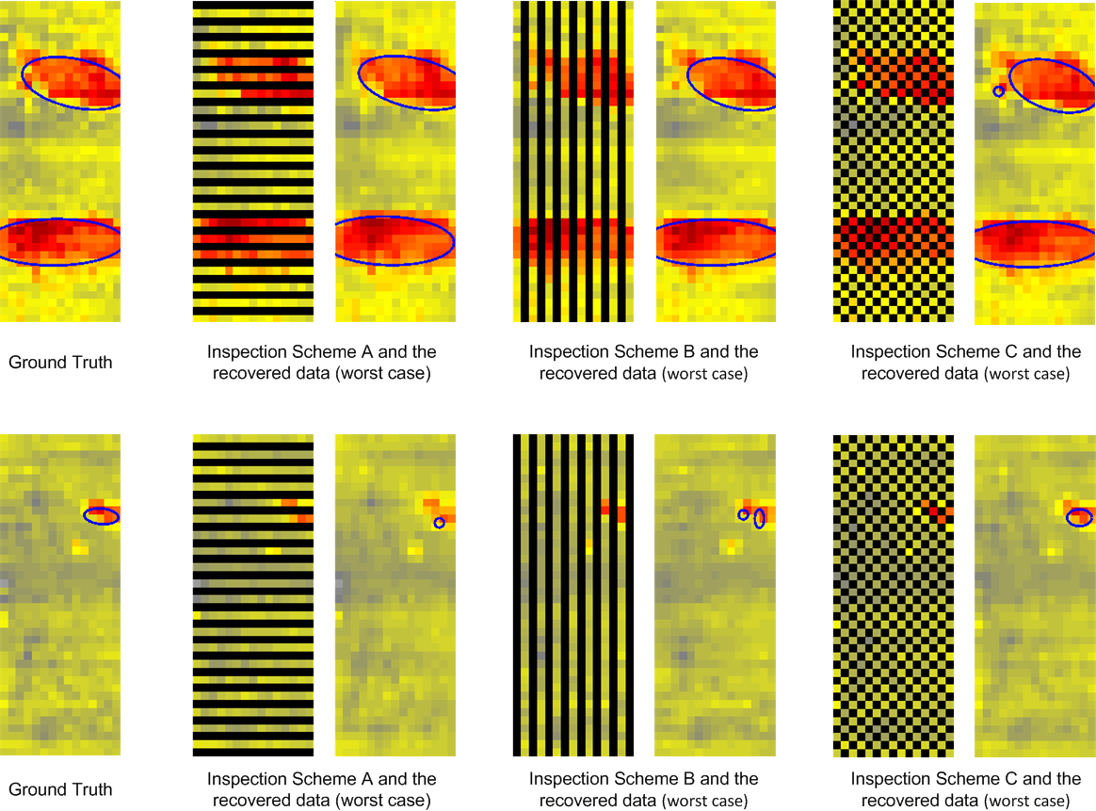
Figure 6 Visualisation of the sampling inspection results and the recovered data

Acknowledgement
This work is an outcome from the Critical Pipes Project funded by Sydney Water, Water Research Foundation USA, Melbourne Water, Water Corporation (WA), UK Water Industry Research Ltd, South Australia Water, South East Water, Hunter Water, City West Water, Monash University, University of Technology Sydney and University of Newcastle.
References
Hastie T., Tibshirani R., Friedman J. (2009). The Elements of Statistical Learning: Data Mining, Inference, and Prediction. Springer New York, pp. 241 - 245.
Ji J, Zhang C, and Jayantha K. (2015). Prediction of stress concentration factor of corrosion pits on buried pipes by least squares support vector machine. Engineering Failure Analysis. 55, pp. 131-138.
Khalifa M., Khan F., and Haddara M. (2013). Inspection sampling of pitting corrosion. Insight - Non-Destructive Testing and Condition Monitoring. 55 (6), pp. 290-296(7)
Kroese D. P. and Botev Z. I. (2013). Spatial process generation, in Lectures on Stochastic Geometry, Spatial Statistics and Random Fields, Volume II: Analysis, Modeling and Simulation of Complex Structures, V. Schmidt, Ed. Springer-Verlag.
Massey, F. J. (1951). The Kolmogorov-Smirnov Test for Goodness of Fit. Journal of the American Statistical Association. 46 (253), pp. 68–78.
Rasmussen C. E. and Williams C. K. I. (2006). Gaussian Process for Machine Learning. Cambridge: MA:MIT press, pp. 7–32.
Ostrowska, A. (2006). Simulating Inspections on Corroded Surfaces. Master Thesis, Institute of Applied Mathematics, Delft University of Technology, Delft, Netherlands.
Schneider, C. (2009). Application of Extreme Value Analysis to Corrosion Mapping Data. 4th European-American Workshop on Reliability of NDE.
Shi L., Sun L., Vidal-Calleja T., and Valls-Miro J. (2015). Kernel-Specific Gaussian Process for Predicting Pipe Wall Thickness Maps. In proceedings of the Australasian Conference on Robotics and Automation (ACRA).
Shi L., Valls-Miro J., Zhang T., Vidal-Calleja T., and Sun L. (2016). Constrained Sampling of 2.5D Probabilistic Maps for Augmented Inference. In proceedings of the IEEE/RSJ International Conference on Intelligent Robots and Systems (IROS).
Skinner, B., Vidal Calleja, T., Valls-Miro, J., de Bruijn, F. & Falque, R. (2014). 3D Point Cloud Upsampling for Accurate Reconstruction of Dense 2.5D Thickness Maps. In proceedings of the Australasian Conference on Robotics and Automation (ACRA).
Ulapane, N., Alempijevic, A., Vidal-Calleja, T., Valls-Miro, J., Rudd, J. & Roubal, M. (2014). Gaussian Process for Interpreting Pulsed Eddy Current Signals for Ferromagnetic Pipe Profiling. In proceedings of the 9th IEEE Industrial Electronics and Applications (ICIEA), pp. 1762-1767.
Valls-Miro, J., Vidal-Calleja, T., De Bruijn, F., Ulapane, N., Wijerathna, B., Su, D., Rajalingam, J., Wood, R. and Vitanage, D. (2014). A Live Test-bed for the Advancement of Condition Assessment and Failure Prediction Research on Critical Pipes. Water Asset Management International. 10(2) pp. 3-8.
Vasudevan, S., Ramos, F., Nettleton, E., Durrant-Whyte, H., and Blair, A. (2009), Gaussian Process Modeling of Large Scale Terrain. In proceedings of IEEE International Conference on Robotics and Automation (ICRA), pp. 1047-1053.

