Understanding The Key Attributes for a Successful Innovation Culture

Professor. Stephen Burdon,
Faculty of Engineering and IT
University of Technology Sydney
PO Box 123, Broadway,
NSW, Australia
Email: stephen.burdon@uts.edu.au

Dr. kyeong kang,
Faculty of Engineering and IT
University of Technology Sydney
PO Box 123, Broadway,
NSW, Australia
Email: kyeong.kang@uts.edu.au

Dr. Grant Mooney
Faculty of Engineering and IT
University of Technology Sydney
PO Box 123, Broadway,
NSW, Australia
Sydney, NSW 2007, AU
Email: grant.mooney@uts.edu.au

ACKNOWLEDGEMENT

The authors would like to thank Australian Information Industry Association for supporting this research.
Biographical Notes
Professor Steve Burdon is currently a Professor of Strategic Management & Technology at the University of Technology, Sydney, and Visiting Professor at Cass Business School, London. His research interests are Corporate Strategy, Disruptive Technology, Innovation and Government Digital Economy Policy. He has published more than 50 journal articles, conference papers and book chapters in these areas. Steve is currently working on research projects for the BBC (UK), and The CEO Circle, Australia. He has also been an advisor to UK and Australian Government Ministers, and a number of leading Australian corporations including Telstra, Westpac and KPMG. He is a Fellow of the Australian Institute of Company Directors, Australian Institute of Management (AIM) and the Institution of Engineers Australia. He previously held the position of Group Managing Director of Telstra and Managing Director of British Telecom, Asia Pacific.
Dr. Kyeong Kang is an academic and course coordinator for Bachelor of Science in IT (IS Management major)) at University of Technology Sydney. She is an expert in Innovative Digital Culture in E-service System Design particularly in E-commerce and E-government. Her research focus is not only limited to the system innovation but also towards positive impacts on people and society. She has completed several industry and internationally collaborated research projects. She has published over 20 journal articles and book chapters. She has edited a book in E-commerce. She is an executive member of the Korean Science and Engineering Association (Australia-New Zealand Chapter), and her research is widely published and cited.

Dr Grant Mooney is a lecturer at the University of Technology Sydney. He holds a Bachelor of Mathematics and Masters of Business as well as a PhD in Computer Science. His research interests include business innovation, organizational leadership and project management around which he has published two books, various conference papers and in journals such as Journal of Entrepreneurship: Research and Practice, International Journal of Innovation and Research and Journal of Service Theory and Practice. Attaining nearly 30 years commercial and management experience in such firms as IBM, J.D. Edwards and Deloitte Consulting Group (to name just a few) he has previously held roles as regional manager, general manager and managing director within various multi-national information technology and services firms before transitioning into academia.

Understanding The Key Attributes for a Successful Innovation Culture

ABSTRACT

This paper presents the results and findings of a research project on innovation culture in Australian information technology sector organisations. The primary objective of this study was to establish the determinants of a successful enterprise innovation culture in organisations with a strong industry reputation for radical innovation initiatives. We obtained 244 responses from 102 member organisations of the Australian Information Industry Association (AIIA). The survey explored the internal and external characteristics of a successful innovative organisation. Both employees' and competitors' perspectives on “what makes a particular organisation a successful innovator” were the main focus. Our findings indicated that the absence of a successful innovation culture is a serious impediment to growth and success. However, preferences for the key innovation culture attributes varied significantly by executive functions, size of the organization and type of ownership structure. Thus, a mix of key innovation attributes should be deployed and tailored to each organisation, based on their industry and strategic objectives.

Keywords: Innovation Success, Success Culture, and Innovation Attributes

Understanding The Key Attributes for a Successful Innovation Culture

Stephen Burdon, Kyeong Kang and Grant Mooney

INTRODUCTION

Establishing an enterprise innovation culture is critical for enabling agile processes, product and service development to be successful in a competitive business environment. Unfortunately, many senior business leaders remain focused on digital advancement to achieve their performance goals (McKinsey, 2014). While digital advancement is an innovation enabler, fostering an enterprise innovation culture geared towards growth should be a complementary organisational endeavor for sustained business growth and competitive advantage. This is a challenging feat; unique approaches are required for different types of businesses, and it will be necessary to nurture cultural traits of individuals towards achieving a collaborative and successful innovation culture.
An objective analysis of the organisation is the first step. Individuals and communities typically tweak a few procedural issues that may deliver gains that are difficult to measure. Identifying the real change agents is the key to value creation and nurturing innovation culture within a given organisational setting. This study looked at external and internal characteristics of innovative organisations, using a targeted survey to define cultural traits for successful innovation. Both employees' and competitors' perspectives on, “what makes a particular organisation a successful innovator” were also explored. The primary objective of this study was to establish the determinants of a successful enterprise innovation culture with a strong industry reputation for radical innovation initiatives.
The survey was designed to tease out organisational cultural traits according to employees’ roles, organisation type and size. It also considered the importance of specific attributes, such as organizational size, definition of strategic intent and commitment of resources to successful innovation.
The survey was distributed to the commercial members' executives of the Australian Information Industry Association (AIIA). We chose to research the AIIA members because most of them were from the information technology and services sectors. Other members include technology-oriented companies from other sectors such as retail banking, airlines and universities. 244 responses were received from 102 member organisations. The survey responses were analysed to derive measures for innovation attributes.

Related literature

- Innovation Culture

Historically, as a business grows and achieves leadership position in its market, barriers of entry for competitors are high for a limited period of time. As other players strive to catch up, over time more competitors increase their market share. However, fast moving competitive business environments today face a stream of emerging technologies, with new products and services requiring agility and constant adaptation by all players in the market. Innovative ability is critical for an early entrant in the market and also a primary reason for growth and success (Schein, 2010; Xiao and Dasgupta, 2005, Kang, 2010).
Many organisations are aware that they need to establish certain cultural traits to achieve successful innovation. However, executives mistakenly tend to focus on advancing workplace digitalisation in the quest for achieving innovation – this alone rarely creates enterprise innovation culture. It has been reported that up to 5% of current business costs are being invested towards organisation digital advancement at any point of time. However, this is just one of the enablers for innovation and by no means, the only one (McKinsey, 2014). Market expansion may be achieved through digitalisation because of greater customer engagement, but in order to achieve and nurture innovation culture, a balance of human cultural attributes, adoption of new technologies and successful business strategies needs to be finetuned and pursued.

Consider the fact that, the larger organisation, the more likelihood there is that an individual may come up with a creative idea. It is unlikely that the end product or service will be an outcome of the individual alone; rather a successful outcome will be due to teamwork enabled by cultural attributes of the organisation, collaboration enabled by technology and harnessing this idea towards fulfillment of a business strategy (Manz et al, 2009; Manz et al, 2009; Koen et al, 2011). A sustained generation of ideas and successful business outcomes will be viewed as successful innovation, both internally and externally. These ideas could be new procedures, products or services that generate value to the organisation in the form of growth and returning superior financial metrics.
“Culture” is a self-sustaining pattern of behavior, thinking, beliefs, and feelings in a given organisational environment (Saunlere, 2013). A superior enterprise innovation culture enables promotion of an honest transfer of executive leaderships' vision or business strategies to non-executives' perception, ensuring a rapid feedback, development and refinement of ideas followed by action through collaboration. The collaboration may be enabled by digital technologies, while actions lead to growth and superior financial metrics. This process of sustained translation of ideas into action is perceived both internally and externally as successful innovation. Innovation includes new ideas in processes, products and services yielding significant benefits to individuals throughout the organisation and externally. Successful action and collaboration fosters learning, attitudes and an organisational culture that enables the innovation processes to repeat sustainably, and the greater outcome for the organization is that, it allows executives to see beyond current issues and gleam into future prospects (Mohammadisadr et. al, 2012; Chesbrough, 2010Dobni, 2008; Schein, 2004; Helriegel and Woodman, 2001).

- Organisational culture and Innovation Success
Organisational culture comprises both shared understanding of issues and shared perceptions of its members. Organisational culture also helps individuals to differentiate between acceptable and unacceptable behaviors within a given context, and it also governs the ways in which an organisation deals with individual performance issues such as failure, mishaps, success and rewards, as a system (Pearce et al, 2009; Schein 2010; Remneland-Wikhamn, 2011). Further, organisational culture plays an important role in day-to-day actions undertaken by individuals and in decision-making, such as, “what magnitude of risk is acceptable”, “expectations for reward” and “effective teamwork”.
Some organisational traits identified by Shaker et al, (2004) for innovation success were cultural orientation of employees, decentralisation of processes, higher use of strategic controls and a lower emphasis on financial controls. These traits enabled employees to make mistakes and learn effectively from their environment under management-controlled conditions. Christensen and Anthony (2005) took a similar view, labelling these traits as “continuous innovation support”. Other organisational culture studies in innovation success have further identified role, organisational structure, task and resources as contributors to its success (Prahalad and Ramaswamy, 2004; Mortara et al, 2010; Pheysey, 1993; Katzenbach et al, 2014)). When roles, organisational structure, tasks and resources align favorably in an organisation, it leads to innovation success. In addition to these internal attributes, innovation success is further influenced by external factors, such as maturity of industry sector and overall economic conditions. To a large extent, it is a perception both externally and internally, with higher profit margins, superior financial metrics, high morale and recognition from peers and competitors, representing clear measurable outcomes (Burdon et al, 2013; Faems et al, 2005; Foster and Kaplan, 2001). However, the absence of one or more of these outcomes doesn't necessarily means that an organisation is not innovative. In many cases, small successes and innovations in the current time may yield higher returns in the future, when market and economic conditions improve. Others, take the view that innovation can be supported by use of management tools to enable collaboration, control risk taking, convert ideas into action and provide incentives to individuals satisfying innovation targets (Saunlere, 2013, Mooney, 2009; Faems et al, 2005; Gumnusluolu and Ilsev, 2008).
Many researchers are of the opinion that management approaches and processes can be implemented to foster favourable social and cultural settings to encourage innovation, leading the organisation towards measurable success with improved financial metrics (Damonpore, 2002, Chesbrough, 2010; Christine et al, 2002; Druker, 2000). Such approaches can succeed, particularly in larger organisations. It is universally accepted that the right 'social settings' and 'organisational culture' ensure that, not only, new and improved products and services are delivered to the customers, but also sustained improvements in service provisions, better business processes, an evolving business model, recognised organisational brand and improved communications at all levels (Christensen et al, 2005; Henderson; 2006; Vermeulen, 2010; Jaruzelski et al, 2011). Further, these achievements are not possible without a purposeful search for opportunities, the successful outcomes of which we recognise as innovation (Drucker, 2000; Grabher et al, 2008; Hamel, 2009; Vaccaro , 20010; Remneland-Wikhamn, 2011).
Innovation can be described as radical or incremental innovations, requiring different processes, knowledge, resources, and personnel performance. Radical innovation creates changes and upheavals either in the market or in the mainstream (Davila et al, 2005; Henriques, 2009; Jaruzelski et al, 2011; Saunière, , 2013). Incremental innovation on the other hand is described as continuous improvements in a stable market. It is highly dependent on the size of the organisation. Usually small companies empower managers to find the key ‘person or persons’, combining this with internal ‘activities’. The selected key person(s) and activity enables rapid implementation of risky ideas that lead to radical innovation. In large companies, where processes, knowledge, resources and personnel are much more structured, organisational aspects such as structure, size, business processes and more specialised functions are significant factors in regulating activities and slowing the pace of innovation (McKinsey, 2014; Chandan and Urhuogo, 2012). It should be noted that these are generalisations rather than the rules. There are always exceptions and it is possible that large organisations may be more successful in innovation and small organisations more bureaucratic. Organisational culture is the key to successful innovation and helps in shaping executives’ decisions, such as encouraging others, even in the face of adversity, to persist with efforts in risky situations to yield longer term outcomes that can be seen as innovation.
At a higher level, there are four major necessary components in an innovation framework: individual entrepreneurs, a cohort (a group of similarly trained professionals), organisational culture and national policy. These components provide social and technical conditions that foster creativity, invention and rapid development of ideas. Critically, the culture as determined by individuals and as a group, leads to transformation of creative ideas, rapid implementation and eventually results in innovation success.

APPROACH

In the context of this study, the greater the gap between a 'new idea' and the 'current state of the technology', the more natural it is for executives to dismiss that the idea is irrelevant when considering the risk of implementation (Swanson and Ramiler, 2004). Taking on the risk and persisting with implementation leads to success, termed as innovation; and the greater the gap between the idea and the state of current technology, the more radical is the innovation. In the initial stages of innovation, there are no measurable outcomes, but perceptions of achievements within and about the organisation do exist. Hence, discovering different perceptions within and about the organidation is likely to lead to indications of future innovation success. Thus, in this paper, we explored how executives and external entities viewed “innovation” in an organisation presently, and foreseeable future innovation success.
We conducted a survey exploring innovation indicators and applied quantitative and qualitative methods to analyse the survey results. Executives from the information industry sector were asked to score the attributes of their own organisation culture and also that of competing organisations. This enabled us to explore the executives’ personal views about how successful their own organisation was relative to their competitors in regards to innovation. We were also able to understand their levels of organisational achievements through overall ratings, perceived levels of achievements, organisational structure, business turnover, etc., relate them to commercial success and at what level their innovation was perceived to be. We explored different factors such as ownership types and roles related these to organisational culture leading to innovation success (Figure 1). The qualitative approach further enabled us to correlate key attributes and characteristics of successful innovation culture.
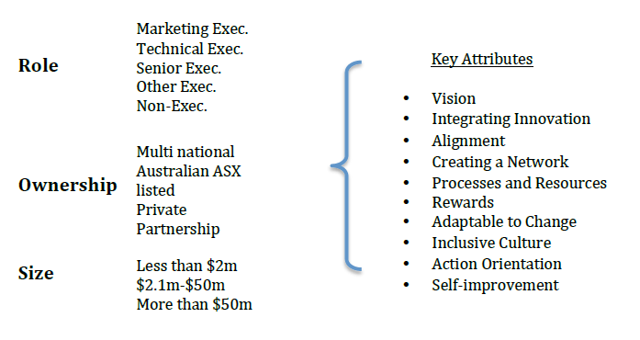

Figure 1. Key innovation attributes by different roles and ownerships

- Data collection and measurements

A questionnaire was designed for executives in the information industry to explore the level of innovation in their own organisation and perceptions of their competitors. The nine survey questions were a mix of demographic questions for use in categorising the respondents’ roles and defining the size of their organisation, apart from questions for gauging perceptions of innovation attributes. The respondents were provided with multiple-choice options and open-ended questions. The online survey was sent to the Australian Information Industry Association (AIIA) commercial members' executives in the last quarter of 2013. We received 244 responses from 102 organizations.
Each respondent was asked to nominate the top three most innovative organisations in their industry sector, with reasons for their ranking, and compare their own organisation to industry leaders. An earlier research by AON Hewitt (McKinsey, 2012) covered a wider range of industries in Australia. Their results indicated that only 25% of organisations judged themselves as innovative, compared to a figure of 78% information industry organisations. This was a clear indicator that compared with Australian businesses across all industries, the information industry sector organisations were viewed as successful innovators with enterprise cultures that fostered innovation.
The survey also explored key cultural attributes thought to be essential for innovation in organisations (McKinsey, 2012). The respondents were asked to assess their own organisations’ ability to meet ten attributes as outlined in Table 1 below.

Key Attributes | Questions
Vision | My organisation has a well-defined vision, goals and strategic intent.
Integrating Innovation | My organisation has been successful in weaving innovation achievement into the fabric of the business.
Alignment | My organisation is successful in communicating and aligning employee activities to the strategic plan.
Creating a network | My organisation has built a network of innovation resources internally and externally.
Processes & Resources | My organisation provides processes, time and/or funds for innovative projects.
Rewards | My organisation actively encourages and rewards people who generate and/or drive new ideas.
Adaptable to Change | My organisation is adaptable and easily embraces change.
Inclusive Culture | People in my organisation see themselves as an interlinked community, not just a company of employees.
Action Orientation | My organisation values ‘doing’, taking risks and experimenting, over detailed and methodical planning.
Self-Improvement | My organisation encourages learning and self-improvement in its people and allows sufficient freedom for this.

Table 1. Ten key attributes for enterprise culture (McKinsey, 2012)
Ratings for responses to questions corresponding to different innovation attributes were correlated with various segments of the survey to examine different aspects of innovation culture.

Findings

- How innovative are the organisations according to different executive functions?
Survey respondents assessed their own organisations’ enterprise culture, and when these scores were correlated with the organisational growth rate (as a surrogate for success), even for organisations that were not growing, 62.1% of the respondents thought they had innovation culture. Over 85% of respondents from growing organisations believed their organisation had an innovation culture. As long as organisations are growing, growth rate itself seems to be irrelevant as an indicator for successful innovation (Mooney, 2009). However, these results also strongly indicate that the absence of innovation culture is a serious impediment to growth and innovation success. Organisations viewed as innovative, both externally and internally, returned superior financial performance with average net profit margin of 20%.
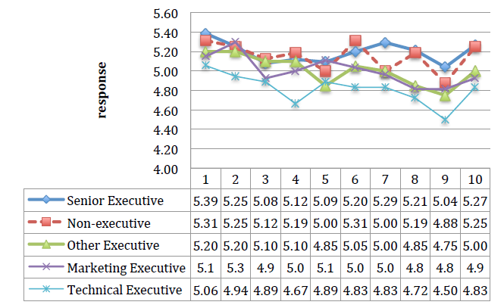
Figure 2. Perceptions of Innovation Ability by Executive Function

Figure 2 illustrates how the different functional executive roles had varying perceptions about the key innovation attributes within their organisations. Technical executives on average gave the lowest ratings for the ten innovation attributes. In comparison, non-technical executives gave higher scores, particularly the senior executives and non-executives.

- How innovative are the organisations by ownership structure?
Privately-owned Australian organisations scored well on innovation, closely followed by the multi-national companies. Overall, Australian partnership organisations scored highest on the innovation attributes, followed by Australian private organisations, then Multinationals with an Australian presence, and lastly, Australian ASX-listed organisations. The differences between the highest- and lowest-scored categories by ownership structure were large – over 10%. The attributes with the largest differences were the ‘ability of the organisation to communicate and align employee activities to the strategic plan’, followed by ‘ability to create an inclusive interlinked culture’, and their ‘ability to encourage learning and self-improvement in its people’.
Australian partnerships’ average scores were highest at 5.26, while AXS-listed companies were worst with only 4.50. Average scores across all ownership types was 5.08 (see Figure 3).
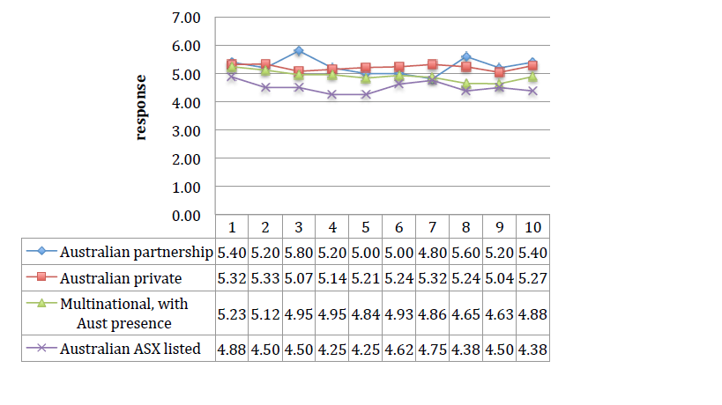
Figure 3. Perceptions of Innovation Ability by Ownership Structure

Australian partnerships scored high on attribute 3 ‘alignment’ and attribute 8 ‘inclusive culture’ compared to other types of organisations. Australian private companies scored well for attribute 5 ‘process and resources’, attribute 6 ‘rewards’ and attribute 7 ‘adaptable to change’. ASX-listed companies scored poorly for attribute 4 ‘creating a network’ and attribute 5 ‘process and resources’ – this contributed towards their rating as lowest amongst all the types of organisations.

The ratings indicated that overall, Australian partnerships took innovation more seriously than the other business structures, while Australian ASX-listed organisations were the least focused on innovation.

  - Innovation attributes by Organisation Structure
Self-improvement was the highest-rated innovation attribute in partnership organisations, which were rated as most innovative overall. We postulate this is most likely due to their flat structures of close-knit professionals. Partnerships also tend to be agile at adapting to changing market conditions. Highly-motivated individuals across a flat structure support an innovation culture that evolves naturally and enables the development of new ideas in rapid succession, without needing approvals from other layers. Larger companies scored significantly lower in all key innovation attributes; by implication, the culture in these organisations is less conducive to innovation. Multinationals were found to be better than ASX-listed companies. Figure 3 above summarises the differences in scores for innovation attributes. Smaller companies on average have superior engagement. Partnership structures were more successful at innovation than other privately-owned companies. The leadership within these smaller private companies is usually more entrepreneurial and open to seeking radical innovation.
Multinationals and ASX-listed companies focus on development, execution and implementation of great ideas. In contrast, partnerships and privately-owned companies believed they were high achievers in the area of being growth-focused proactive organisation. Private companies and Partnerships strongly believed in development of ideas, engagement of talent and were more growth focused. In contrast to public companies, privately-owned companies achieved higher innovation outcomes from great ideas. Privately-owned companies also focused strongly on employees’ individual capabilities critical for forming cohesive innovation team cultures.
In summary, there was a significant difference between the scores for both Australian private and partnership organisations compared with that of the multinationals and ASX-listed organisations. Private and partnership organisations scored significantly higher across the board, and their employees had much more positive views of their innovation culture. There was a 20% difference in the scores for inclusive culture of multinationals and ASX-listed organisations.
Comparisons between multinationals and ASX-listed organisations were also interesting. There was over a 10% difference in scores for the two attributes 'creating a network' and 'processes & resources', with ASX-listed organisations scoring poorly. It appears that multinationals have established a culture that mitigates some of the inherent disadvantages of size and innovate effectively compared to their ASX-listed counterparts.

  - Innovation attributes by Size of Organisations
The structure of the Australia-New Zealand technology sector has a higher proportion of what could be called smaller organisations. Because of this, to enable comparison between organisations of different sizes, three categories were drawn up based on annual turnover:
- Less than $2.0 million (small)
- $2.1 million to $50.0 million (medium)
- More than $50.0 million (large)
The small organisations achieved the highest scores in six of the innovation attributes, while medium-sized organisations did so in four. The 'self-improvement' attribute were scored highly by both small- and medium-sized organisations. 'Vision', 'processes and resources', 'rewards', 'adaptable to change' and 'self-improvement' were also scored highly by medium-sized organisations. In general small- and medium-sized organisations had a higher requirement for 'processes & resources' and 'rewards', possibly to motivate their employees towards innovation activities. In contrast, large organisations scored higher for 'processes & resources'; it could be that large organisations are more well-resourced and structured for innovation.
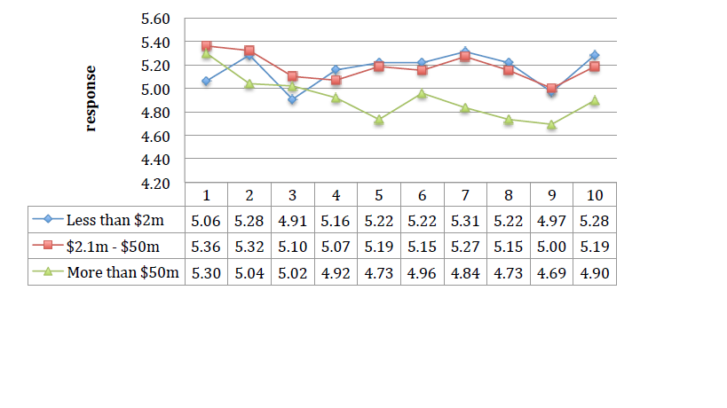

Figure 4. Perceptions of Innovation Ability by Size of Annual Turnover

  - Executive Functions - impact on Innovation
Senior executives in general gave higher scores for their own innovation culture, over and above the other executives in their organisation (Figure 2). They rated the attributes of “Adaptable to change” and “Self-improvement” as the highest priority. This suggests that senior executives take more responsibility for innovation, have a better sense of the consequences of changes and possess a broader view of innovation. Contrary to our expectations, technical executives rated the attribute of “action orientation” lower, compared to senior and marketing executives. Technical executives were also more pessimistic about innovation levels in their organisation. The key strengths of successful organisations appear to be their executives' ability to harness internal talent for developing new ideas, and having 'procedures & resources' in place to execute these ideas well.

DISCUSSIONS

- Perspectives and Key attributes of Innovation
Our findings suggest that organisations would do well to engage with the innovation attribute of 'Vision'; all executives scored this attribute highly for innovation culture. However, marketing and other executives preferred 'Integrating innovation' while technical executives preferred 'Reward' as a vehicle to deliver innovation and gave it an equal importance as 'Vision' (see Figure 5). The survey also indicated that most executives prefer to have a process in place for radical innovation. Australian private and partnership organisations focused more on 'integration' and 'alignment'. The private organisations preferred weaving innovation into the fabric of their businesses, while partnerships focused on communication and alignment of employee activities with their strategic plans.

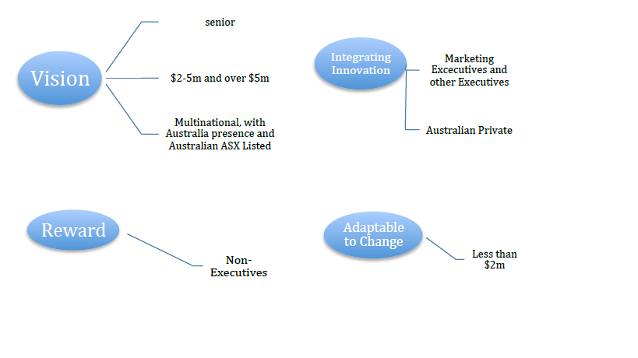
Figure 5. Perspectives and key attributes of innovation by Role, Ownership Structure and Size of Annual Turnover

Large organisations focused more on 'Vision'. The findings clearly indicated that different sized organisations chose to adapt different vehicles for innovation culture. Smaller organisations preferred to be objective, and innovate through adaptability and easily embracing change. This preference can constrain the organisation’s innovation strategy, if it moves on before the benefits of innovation are realised.

2) Nomination from contributors for being innovative
Only one large organisation, Google, stood out for being nominated by its competitors as the most innovative organisation. Many well-known leading organisations in the retail banking, telecommunications and airlines sectors received surprisingly low scores for being innovative from their professional peers. Respondents chose Google because of its success in the attributes of ‘Development of great ideas’ (25%), and ‘Execution and implementation of great ideas’ (22%).
Multinationals and Australian ASX-listed organisations achieved markedly lower nominations for being innovative than their smaller private and partnership counterparts. These results lend credence to the hypothesis that larger organisations have to work harder to build innovation cultures and management processes to support these cultures. Both segments however, got lower scores for ‘Creating a network’ and ‘Processes & resources’. The multinationals with an Australian presence received higher scores on average than Australian ASX-listed organisations. This suggests that the primarily USA-owned multinationals have a better innovation culture. Interestingly, they were given higher ratings by respondents from other organisations for growth and success.
The findings also indicated that organisations that promoted 'self-improvement' and had an ‘Inclusive Culture' were much likely to have well-developed innovation cultures, and were recognised for this both internally and amongst other companies externally. The third most important attribute for innovation success nominated by respondents was the organisation’s ability to 'engage talent'.

CONCLUSIONS

Our study has shown that the absence of successful innovation culture is a serious impediment to growth and success. Preferences for requirements for some key innovation attributes for innovation culture varied significantly by executive functions, size of the organization and type of ownership structure.
This study also confirmed that Australian technology organisations are highly innovative and focused on radical innovation, particularly of new products and services, even in organisations that showed no growth. Participants strongly believed that their employer organisations had very good innovation cultures with both executives and employees agreeing that there were processes in place to be innovative. A strong innovation culture was seen as essential for success in the technology industry. The need for continual innovation for new products was clearly understood and established, together with a high level of urgency in the technology sector’s work culture.
The findings also enabled us to identify key attributes that were seen as important for creating innovation culture. We found no one single approach to innovation that would fit all organisations. A mix of key innovation attributes needs to be deployed and tailored to organisation, industry and strategic objectives. The collection of these key attributes can best be described as a toolbox, from which the appropriate mix and emphasis of attributes may be selected.

With intensifying global competition and rapid waves of change in digital developments, increasingly many more industries will feel the effects, and require innovation cultures to stay competitive and relevant. In addition, businesses need an understanding of digital initiatives that are necessary for innovation success. Although this study has examined innovation culture from the perspective of the information technology sector, it has useful lessons for all industries and will encourage more research input into this area.

Acknowledgements
The authors would like to express thanks and gratitude to the reviewers for their timely review and their constructive and helpful comments.
References

Burdon, S.W., Al-Kilidar, H. & Mooney, G.R. (2013). 'Evaluating an Organization's Cultural Readiness for Innovation', International Journal of Business Innovation and Research, vol. 7, no. 5, pp. 572-589.

Chandan, Harish C. and Urhuogo, Irikefe. (2012). "Organizational Challenges for Innovation in Information Systems" SAIS 2012 Proceedings.
Chesbrough. H. (2010). Business model Innovation: Opportunities and barriers, Elsevier.

Christensen. C. Anthony, S. (2005). Building Your Internal Growth Engine, HBR, Strategy & Innovation, Jan/Feb.

Christensen. C, Raynor. M. (2003). The Innovator’s Solution, HBSP
Dey. D. R, 2012, Special Edition on Innovation in Organizations, Illuminations, November 2012.

Davila T, Estein M and Sheldon R. (2005). making Innovation work: How to make it, measure it and profit from it, Prentice Hall.

Drucker, P. (2000). The Discipline of Innovation, HBR. Financial Data, 2009/2010.

Faems, D., Looy, B.V. and Debackere, K. (2005) “Interorganizational collaboration and
innovation: toward a portfolio approach”, Journal of Product Innovation Management, Vol. 22 No.
3, pp. 238-250.

Foster, R. and Kaplan, S. (2001) Creative Destruction, Doubleday Publishing, New York.
Gottlieb, J. and Willmott, P. (2014) “The digital tipping point”, McKinsey Global Survey Results,
McKinsey&Company, NJ.

Grabher, G., Ibert, O. and Flohr, S. (2008) “The neglected king: the customer in the new
knowledge ecology of innovation”, Economic Geography, Vol. 84 No. 3, pp. 253-280.

Gumusluoglu, L. and Ilsev, A. (2009) “Transformational leadership, creativity and organizational
innovation”, Journal of Business Research, Vol. 62 No. 4, pp. 461–473.

Hamel, G. (2009) ‘Moon Shots for Management’, Harvard Business Review, Vol. 87 No. 2, pp.
91-98.

Henderson, R. (2006) “The innovator’s dilemma as a problem of organizational competence”, Product Innovation Management, Vol. 23, pp. 5-11.

Henriques, A. (2009). “When radical innovation is not plausible”, available at http://innovomics.wordpress.com/tag/innovation/page/4/

Jaruzelski, B., Loehr J. and Holman, R. (2011) “Global innovation 1000: why culture is key”,
Strategy + Business, Booz & Co., Vol 65, available at
http://www.strategy
business.com/article/11404 (Accessed 30 April 2014).

Kang, K. (2010). 'Considering Culture in Designing Web Based E-commerce' in Kyeong Kang
(ed), E-Commerce, In-Tech, Vukovar, Croatia.

Katzenbach, J., von Post, R. and Thomas, J. (2014) “The critical few: components of a truly effective culture”, Strategy+Business, Spring No. 74, pp. 1-9.

Koen, A., Bertels, H.M. and Elsum, I. (2011) “The three faces of business model innovation:
challenges for established firms”, Research-Technology Management, Vol. 54 No. 3, pp. 52- 59.

Lewrick, M. and Raeside, R. (2010) “Transformation and change process in innovation models:
start-up and mature companies”, International Journal of Business Innovation and Research, Vol.
4 No. 6, pp. 515-534.

Manz, C.C., Pearce, C.L., and Sims Jr, H.P. (2009) ‘The Ins and Outs of Leading Teams: An
Overview’, Organizational Dynamics, Vol. 38 No. 3, pp. 179–182.

McKinsey. (2012). Global Survey: Making Innovation Structures Work, McKinsey & Company,
McKinsey Insight, available at: http://www.mckinsey.com/insights/organization

McKinsey. (2014), McKinsey Global Survey results: The Digital Tipping Point, McKinsey &
Company, McKinsey.

Mooney, G.R. (2009), Enterprise Creativity and innovation, 1, Lambert Academic Publishing,
Berlin Germany.

Mortara. L, Slacik. I, Napp. J. J, Minshall. T. (2010). Implementing open innovation: cultural
issues, Int. J. Entrepreneurship and Innovation Management, Vol. 11, No. 4.

Newman. I, Ridenore. C. S, Ridenore. C. (1998). Qualitative-Quantitative Research Methodology:
Exploring the Interactive Continuum, Southern Illinois University Press; 1st edition.

Pearce, C.L., Manz, C.C., and Sims Jr, H.P. (2009) “Where Do We Go From Here?: Is Shared Leadership the Key to Team Success?,” Organizational Dynamics, Vo. 38 No. 3, pp. 234–238.

Prahalad, C.K. and Ramaswamy, V. (2004b) “Co-creation experiences: the next practice in value creation”, Journal of Interactive Marketing, Vol. 18 No. 3, pp.5-14.

Pheysey, D.C. (1993), Organizational Cultures: Types and Transformation, Rutledge, New York.

Remneland-Wikhamn, B. (2011) “Path dependence as a barrier for ‘Soft’ and ‘Open’
innovation”, International Journal of Business Innovation and Research, Vol. 5 No. 6, pp.
714-730.

Saunière, J-C, (2013) “Innovation that counts”, World Watch, No. 2,
PriceWaterhouseCoopers, pp. 6-7.

Shaker, Xahar & Hayton. (2004), Entrepreneurship in Family vs. Non-Family Companies,
Entrepreneurship Theory & Practice, Summer.

Schein E H, (2010). Organizational culture and Leadership, 4th Ed, John Wiley & Son
Manz, C. C., Pearce, C. L. & Sims Jr, H. P., 2009, 'The Ins and Outs of Leading Teams: An Overview,' Organizational Dynamics, 38 (3), 179–182.

Vaccaro, A., Parente, R. and Veloso, F. M. (2010) “Knowledge management tools, inter
organizational relationships, innovation and firm performance”, Technological Forecasting &
Social Change, Vol. 77, pp. 1076-1089.

Vermeulen, F., Puranam, P. and Gulati, R. (2010) “Change for change’s sake”, Harvard
Business Review, Vol. 88 No. 6, pp. 70-76.

