Will the bombings of August 11 and 12 Burst Thailand’s Tourism Bubble ?
David Beirman
By the end of 2015 Thailand was firmly established as the most popular international tourist destination in SE Asia. In 2015 a record number of just under 30 million international tourists (29.88 million) visited Thailand. These tourists directly contributed some US$45 billion to Thailand’s economy. International tourism directly contributes 8 % of Thailand’s GDP. According to the World Travel and Tourism Council, tourism’s direct and indirect indirect contribution to Thailand’s economy was US$88 billion or 18% of GDP. By any economic or statistical measure, tourism is extremely important to Thailand. However, Thailand’s recent history has demonstrated that tourism’s contribution to Thailand’s wealth has a fragile quality. Although there has been significant overall growth in tourism arrivals since 2001, periods of growth have been punctuated by a number of year on year declines due to fears of pandemics (SARS in 2003) natural disasters (the 2004 Tsunami) political and civil unrest (the 2010 Riots) and the military coup of 2014.
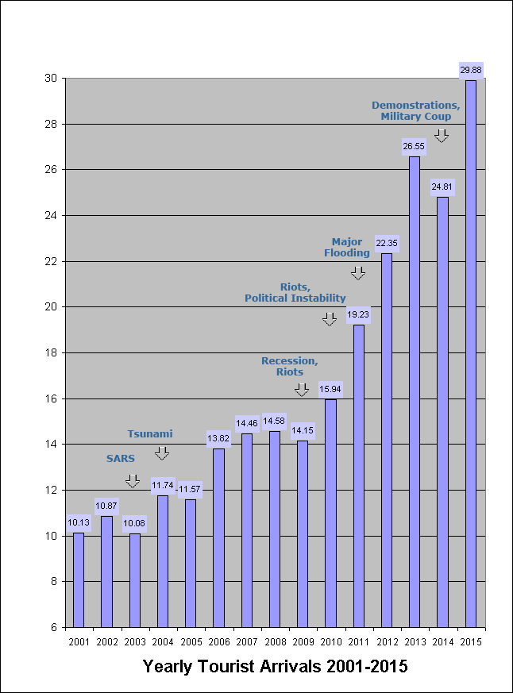
International Tourism Arrivals Thailand 2001-2015 Source Thai Tourism Authority

Tourism arrivals in Thailand during The first half of 2016 indicated accelerated growth in tourism for 2016. Since the 2014 military coup, Thailand had been relatively free of politically motivated violence apart from the attack against the Erawan Shrine in Bangkok in August 2015. Although there were a significant number of foreign casualties in that attack, it was not regarded as an attack which deliberately targeted tourists.
The bomb attacks of 11 and 12 August 2016 targeted a number of key tourism centres in Southern Thailand including Hua Hin, a resort city popular with wealthy Thais and many international tourists. Bombs also hit Phuket, one of Thailand’s leading tourist centres and Surat Thani which is a popular gateway town for tourists heading to Kho Sanui. 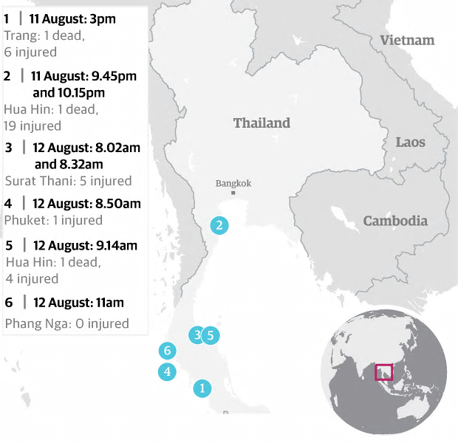
Map source The Guardian 13 August 2016
The bombings killed 4 people and wounded 35 of whom 10 of the injured were tourists. Thailand’s Prime Minister, Prayut Chan-o-cha has called for calm and ordered security to be upgraded in areas popular with tourists. The Thai Tourism Authority held a press conference on August 12 in which TAT Governor Mr Yuthasak Supasorn announced that the Thai Tourism Authority was establishing a Situation Monitoring Centre and a “We Care Campaign” to ensure the safety of tourists in Thailand.
The situation monitoring centre is intended to coordinate and disseminate information about safety measures for tourists through TAT’s international network of offices.
The Thai Tourism Authority has a long record of immediate responses to crisis events affecting tourists in Thailand. It closely monitored events during the 2010 Red Shirt protests providing tourists and intending visitors with information of unsafe and safe areas within Bangkok, During the Thai floods of late 2011 TAT provided up to date information of the status of transport and accommodation infrastructure in Thailand. The concept of a situation monitoring centre is hardly new in Thailand but its announcement immediately following the bombings was symptomatic of the Thai Tourism Authority’s anxiety to be seen to be in control of the situation as a confidence boosting measure directed at prospective tourists and the Thailand’s tourism industry stakeholders.
There has already been significant coordination in response to the attacks between The Thai Tourism Authority the Pacific Asia Travel Association (the Asia Pacifics’ largest transnational tourism association) which is fortuitously based in Bangkok. PATA and TAT have undertaken close coordination in talking up tourism safety to Thailand since the bombing.
Thailand’s tourism industry and the Thai Tourism Authority are well aware of the high stakes involved in maintaining the good reputation of Thailand as a safe and welcoming destination for tourists from all over the world. Acts of terrorism over the past year have resulted in significant slumps in international tourist visitation to affected destinations including France, Belgium, Tunisia and Turkey.
One of the immediate concerns for Thailand is the difficulty in establishing who was responsible for the August 1/12 bombings. To date, no organisation has claimed responsibility for the bombing attacks. Although Thai authorities suspect the bombings were conducted either by political opponents of the current military regime or Muslim separatists based in Thailand’s southern provinces bordering Malaysia there is no compelling evidence to date which points to either of these groups.
For opponents of Thailand’s current military regime, tourism is the perfect soft target. Tourists are easy to identify and many are associated with hedonistic lifestyles that more conservative Thais resent. The consequences of targeting tourists through acts of terrorism can result in rapid loss of business to tourism related enterprises. Leisure tourists normally predisposed to visit Thailand can quickly choose to avoid Thailand and travel elsewhere in SE Asia.
Thailand’s ability to mount a credible counter-terrorism campaign in response to bombings will depend on the ability of the Thai security forces to identify and neutralise those responsible for the August bombings. Promising increased security measures to assuage tourist concerns over terrorism is meaningless until the identity of the perpetrators can be established.
The August bombings raise one very significant challenge for the Thai Tourism Authority. TAT has a very good record in responding to negative events and tourism crises. However it has consistently avoided adopting a proactive approach to tourism risk management. PATA and Thai based tourism risk management experts including Dr Bert Van Walbeek (recently awarded an honorary doctorate by the University of West London for his service to tourism risk and crisis management)) have frequently called on the Thai Tourism Authority to provide pre-arrival advice on safety and security threats to tourists visiting Thailand. Prior to the 2014 military coup the Thai Tourism Authority was preparing to adopt these proposals supported by Thailand’s tourism industry but changes in TAT’s leadership following the coup meant the idea was dropped.
The Thai Tourism Authority is preparing to undertake a global promotional blitz following the August bombings. However, re-establishing the confidence of international tourists about the safety of destination Thailand will require measures far more substantive measure than bells, whistles and the resurrection of a situation monitoring centre.

