Open porous hydrophilic supported thin-film composite forward osmosis membrane via co-casting for treatment of high-salinity wastewater

Gang Chen¹, Renxiao Liu ^{1, 2}, Ho Kyong Shon³, Yanqiang Wang⁴, Jianfeng Song ^{1, 2}, Xue-Mei Li^{1*}, Tao He^{1*}

¹ Laboratory for Membrane Materials and Separation Technology, Shanghai Advanced Research Institute, Chinese Academy of Sciences, Shanghai 201203, China
² University of Chinese Academy of Sciences, Beijing 100049, China
³Centre for Technology in Water and Wastewater, School of Civil and Environmental Engineering, University of Technology, Sydney (UTS), P.O. Box 123, 15 Broadway,
NSW 2007, Australia
⁴ The Walt Disney (China) Co., Ltd. Disney Research China, Shanghai 200031, China

*Corresponding authors
Phone: 0086-21-20325162, Fax: 0086-21-20325034, email: het@sari.ac.cn (T. He), afmgroup@126.com (X.-M. Li)

Abstract:
High-performance thin film composite (TFC) forward osmosis (FO) membranes with a low degree of internal concentration polarization (ICP) are critical for concentrating high-salinity wastewaters. This report focuses on the preparation of TFC FO membranes via a sacrificial approach. In order to improve the FO flux, hydrophilicity and morphology of the support membrane were mainly investigated. The hydrophilicity of the polysulfone (PSF) substrate was tuned by blending with sulfonated poly (ether ether ketone) (SPEEK), and the resulting SPEEK blended PSF membrane was denoted as SPSF substrate. The pore structure of the SPSF membrane was tailored by the application of a co-casting technique, which yielded a TFC membrane with a structure parameter (S) of 191 µm. In contrast, the TFC membranes based on the PSF and SPSF substrates through single layer casting showed the S values of 527 µm and 361 µm, respectively. These results indicate that the combined hydrophilicity and open pore structure are responsible for the lowered S value. Further application of the hydrophilic substrate based TFC membranes in the treatment of high salinity wastewaters (10 wt%) demonstrated the highest initial water flux (28.3 L/m²·h) with a water recovery rate of 53.2% in comparison to the TFC membrane based on the pristine PSF through the single layer casting. This new method paves a way to generate high-performing FO membranes.

Keywords: forward osmosis; co-casting; hydrophilic support; shale gas produced water; high-salinity brine;

1. Introduction
Hydraulic fracturing is an effective technology in the exploration of shale gas, an important unconventional natural gas, which has been considered as an essential component of the global energy system to ensure sustainable energy supply . However, hydraulic fracturing process discharges large amounts of high-salinity flowback and produced water with total dissolved solids (TDS) ranging up to 400,000 mg/L , and frequently the water contains a wide spectrum of organic compounds. Conventional physical, chemical, and biological treatment technologies are confront of large footprint and high capital and operational costs, and therefore energy and cost efficient processes are needed to be developed .
In contrast to pressure-driven processes, forward osmosis (FO), a diffusion based membrane process, utilizes the osmotic pressure difference as the driving force for the transport of water through the membrane. FO is characterized by its low operational pressure, low fouling tendency, easy operation, process safety and small footprint . Desalination of high-salinity wastewater using FO processes has been demonstrated in literatures . Similar to other membrane processes, the performance of the FO membrane is vital. However, a desired high FO flux has not been obtained during treatment of high-salinity produced water, which has been mostly attributed to the negative influence of internal concentration polarization (ICP). For example, Cath et al. investigated the FO treatment of high salinity wastewater from oil and gas exploration . Further, Oasys Water reported the treatment of high-salinity brine streams and wastewater with average TDS of 73,000 ± 4200 mg/L from oil & gas exploration using an FO processes. In our group, FO processes were selected to treat shale gas drilling flowback fluids and underground brine . In particular, we have found that when a high salinity feed was used, the FO flux was much lower due to the severe dilutive ICP in the draw side, concentrative external concentration polarization (ECP) in the feed side, and reverse solute flow from the draw to the feed solution. Therefore, development of membranes with reduced ICP plays an important role in treatment of feed streams with high-salinity through FO process.
Membrane structure and property determine the degree of ICP that takes place within the porous support of a FO membrane, which cannot be mitigated by enhancing the operating conditions . Membrane structure parameter is normally taken as a direct indication of the degree of ICP, which is determined by the membrane porosity, tortuosity and thickness. We have found that improving the porosity of the substrate layer via a co-casting technique can effectively reduce the membrane structure parameter . Also, it has been demonstrated that membrane substrate wettability also affects FO flux in that wettability of the substrate determines the effective areas for mass transport . More specifically, intrinsically hydrophilic materials can improve the wetting of a membrane pores leading to enhanced effective areas for osmotic flow to take place and consequently an increased membrane flux. For instance, hydrophilic nylon 6,6 substrate was used as support for TFC membrane preparation. The resulting TFC membranes showed improved water flux due to increased wetting pores . Similarly, Tang’s group reported reduced structure parameters of the polysulfone substrate by incorporation of porous zeolite nanoparticles, resulted from the improved surface porosity and wettability . Sulfonated poly (ether ether ketone) (SPEEK) is a hydrophilic polymer, which could be utilized to control the wetting property of the substrate membrane. Chung and coworkers demonstrated that addition of SPEEK to PSF improved the hydrophilicity of the substrate, and the water flux of resultant TFC FO membrane increased by 50% compared to the pristine membrane.
Co-casting has been demonstrated as an effective engineering approach to increase the porosity and pore connectivity of the substrate . Modification of the membrane morphology has been systematically investigated and demonstrated He et al . When a PSF/DMAC solution was co-cast above a PEI solution, during the immersion phase separation process, the PEI sublayer acts as an additional solvent reservoir and promotes formation of finger-like macrovoids to penetrate across the PSF layer . After phase separation and membrane formation, the PEI delaminated from PSF layer, resulting in a PSF support membrane with an open bottom surface morphology, consequently a higher porosity. Results have shown that the structural parameter of the TFC co-cast membrane was reduced. Based on above arguments, it can be seen that the increase in the support membrane hydrophilicity and porosity separately can effectively improve the membrane performance. It would intriguing to see the effects of combined effects of improved porosity and hydrophilicity. However, application of co-casting to form hydrophilic substrate has not yet been reported for the preparation of TFC membrane.
In order to improve the FO flux when feed water salinity is high, the combination of porosity and hydrophilicity in the substrate for TFC FO membrane is investigated. TFC FO membranes were prepared using a SPEEK blended hydrophilic substrate using a co-casting approach. The single layer cast membrane was used for comparison where morphologies, porosity, and water permeability of the substrates were analyzed. TFC membranes based on these substrates were characterized, and their performance in RO and FO processes were evaluated. Finally, the FO performance in concentrating synthetic produced water was examined in order to confirm the effects of co-casting and substrate hydrophilicity.

2. Materials and methods
2.1 Materials
SPEEK with a sulfonation degree of 77% was supplied by Shanghai Erane Tech. Co. Ltd. Polysulfone (PSF, P-3500NT) was purchased from Solvay. Polyetherimide (PEI M1000) was supplied by GE. PSF and PEI particles were dried at 65 ºC for 24 h in an oven before usage. N,N-dimethyl acetamide (DMAc), N-methyl pyrrolidone (NMP), n-hexane, polyethylene glycol (PEG 400), NaCl, KCl, KHCO₃, CaCl₂, MgCl₂, BaCl₂·2H₂O, and SrCl₂·6H₂O were purchased from Sinopharm Chemical Reagent Co. Ltd. m-phenylenediamine (MPD, purity > 99% and trimesoyl chloride (TMC, purity 98%) were obtained from Sigma-Aldrich. All chemicals were used as received unless stated otherwise.
2.2 Membrane substrates preparation
PEI/NMP (17/83 wt.%), PSF/SPEEK/PEG400/DMAC (18/0.5/8/73.5 wt.%) and PSF/PEG400/DMAC (18/8/74 wt.%) solutions were separately prepared in a jacketed flask at 65ºC for 24 h. After filtered and degassed, two distinguish approaches, single casting and co-casting methods, were adopted for preparation of support for FO membranes. Detailed information of the two casting protocols can be found in our previous publications . Membrane substrates fabricated using the single-layer casting approach are denoted as PSF (without SPEEK) and SPSF (with SPEEK), respectively.
For the preparation of membrane support through co-casting process, the PEI/NMP mixed solution was first cast onto a dried and clean glass plate with the casting knife height of 50 μm; simultaneously the PSF solutions with SPEEK were casted on the top of the PEI solution using another casting knife of 250 μm. Then, the nascent double-layers film was swiftly transferred into a water bath with tap water at 30 ± 1ºC for phase inversion. During phase inversion, it was found that the PEI layer was automatically delaminated from the PSF layer. The left PSF layer (named as SPSFco) was rinsed thoroughly in DI water and then stored in a plastic box with DI water for further usage.
2.3 Preparation of polyamide TFC-FO membranes
The polyamide separated layer was synthesized on the top of the membrane support by interfacial polymerization . Briefly, the support layer was tailored and fixed onto the plexiglass frame with no wrinkle on the membrane surface. The substrate surface was dried by a nitrogen stream gun and subsequently immersed in the aqueous solution containing 2 wt.% MPD for 120 s. Then the excess MPD solution was removed, and the substrate surface was blown dry again under a stream of nitrogen. Afterwards, the absorbed MDP support was homogeneously contacted with a 0.15 wt.% TMC solution in n-hexane for 60 s. Subsequently, the nascent TFC membrane was left at room temperature for 120 s for solvent evaporation before further cross-linking in an oven at 95ºC for 180 s. Finally, the resultant membranes were rinsed completely and stored in plastic box with DI water for further experimental tests.

2.4 Membrane characterization
2.4.1 Morphology, contact angle, porosity and pore size
Scanning electron microscope (SEM) images of membrane samples were acquired by a field-emission scanning electron microscope (FESEM) (Hachi S-4800). Membrane samples were dried in an oven under the temperature of 30ºC before test. Cryogenic breaking of membranes samples in liquid nitrogen was adopted for cross-section SEM imaging.
Static state contact angle of the dried membrane substrates was estimated through a contact angle goniometer (Maist Drop Meter A-100P) equipped with a high speed charge-couple device (CCD) camera via a sessile drop approach. Detailed analysis followed our previous publication and the reported value was an average of at least three sets of data with a standard deviation of less than 5% . Porosity (ε) of the membrane substrate was measured using a weighing approach . Pore size distribution of membrane supported layers was determined by capillary flow porometry (Porolux 1000) . All the data reported in this work are average values with standard variation of less than 10%.
2.4.2 Pure water permeability coefficient and salt rejection of the TFC membranes
The pure water permeability coefficient (A), solute permeability coefficient (B), and salt rejection (R_{s}) of the TFC membranes were determined using a RO test setup (Sterlitech Corporation) according to the method reported in our previously work (See to the Supporting information for detailed experimental data) .
2.4.3 Membrane structure parameter of TFC membrane
The membrane structural parameter (S) is dependent on the solute diffusivity (D) and solute resistivity (K), which can be determined by membrane porosity (ε), membrane thickness (t_{s}) and membrane tortuosity (τ) :
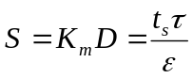 (1)
In FO process (AL-FS mode), the solute resistivity K can be determined according to the equation below.
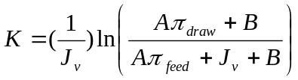 (2)
where π_{feed} and π_{draw} represent the osmotic pressure of the feed solution near the membrane surface and the bulk draw solution, respectively. Here, π_{feed} was considered as zero as DI water was used as the feed in AL-FS mode (Eq 2).

2.5 FO concentration of the synthetic produced water
Synthetic produced water was prepared according to the composition listed in Table 1, which is the typical compositions of the produced water from the shale gas site. However, while preparing the synthetic wastewater, crystals were observed, and consequently it was pre-filtrated through a filter paper with the mean pore size of about 20 µm to get rid of sediment. The constant saturated NaCl solution was adopted as the draw solution. Figure 1 exhibits the schematic plot of the homemade FO device. The tailor-made test element consisted of two same half-cells with dimensions of 30 mm in width, 80 mm in length and 4 mm height. Two hydrophilic polymeric open mesh spacers were inserted in channels of the two cells, respectively, to mitigate the ECP and also to provide mechanical support to the test TFC FO membranes. The flow velocity of both feed and draw solutions was controlled at 4.2 cm/s by two magnetically driven gear pumps for all the experiments for the concentration of the high salinity brine through FO process. The temperature of both feed and draw solutions was controlled at 25 ± 1 ºC using a constant temperature circulating bath. The membrane active layer faces the feed solution and draw solution was donated as AL-FS mode and AL-DS mode, respectively.
The weight change of the feed tank with the initial feed volume of 1 L was recorded through a digital balance (CP4202C, Ohaus Corporation) and logged by a computer for data analysis. The FO water flux (J_{v}) was obtained according to the volume change of the feed solution (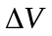, L) at every time interval (5 min) divided by the effective membrane surface area (A), considering the permeate water density as 1.0 kg/L:
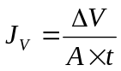 (3)
The concentration factor (CF) is defined as the ratio between the initial feed volume (V₀) and the feed volume (V_{t}) at time t, which represents the increase in the feed concentration as the FO process was operated in a batch mode where both the draw solution and feed solution are recycled continuously:
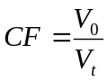 (4)
The water recovery rate was determined by dividing the decreased volume of the feed solution over the initial volume of the feed solution.

Table 1 Compositions for the synthetic produced water
Compound | K⁺ | Na⁺ | Ca²⁺ | Mg²⁺ | Ba²⁺ | Sr²⁺ | Cl⁻ | HCO₃⁻ | TDS
Concentration  (mg/L) | 685 | 28,902 | 6,754 | 525 | 1,998 | 1,063 | 60,645 | 108 | 100,680

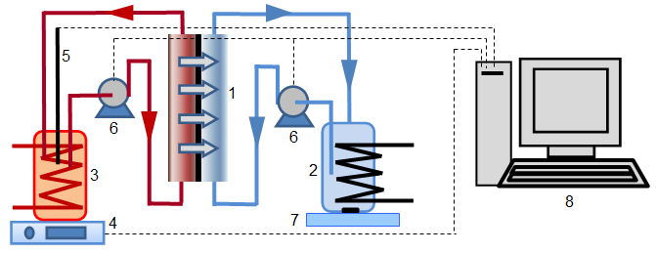
Figure 1 Schematic photograph of the forward osmosis experimental device (1. membrane module; 2. draw solution container; 3. feed container; 4. balance; 5. conductivity transmitter; 6. gear pump; 7. stirrer; 8. data collection and analysis system).

3. Results and discussion
3.1 Membrane substrates fabricated by single layer casting and co-casting approaches
Figure 2 shows the SEM photographs of the top surface, bottom surface, and cross-section of the PSF substrate with and without SPEEK produced by single layer casting and co-casting approaches. The top surface of PSF, SPSF and SPSFco substrates are all porous. However, the surface pore density of SPSF substrates with SPEEK appears to be higher than the PSF substrate. The reason for this phenomenon is possibly that SPEEK polymer aggregated faster toward to the surface due to its low density and hydrophilicity during phase inversion. The cross-section morphologies of the membrane substrates are quite different as shown in the second column. The PSF substrate showed thin sponge-like top skin surface and finger-like macrovoids from the top to the bottom surface, while SPSF support displayed mainly sponge structure with macrovoids close to the bottom surface. The thick sponge-like structure observed in the SPSF substrate indicates that the presence of hydrophilic polymers may inhibit the growth of macrovoids. Interestingly, the cross section image of SPSFco support is quite similar to that of the PSF support except that the finger like macrovoids are penetrating deeper into the top surface and through the bottom surface. Morphology difference of the three PSF substrates is also distinctive at the bottom surface. The PSF substrate has small pores, in direct contrast to the bigger pores of the SPSF substrate and the largest, open pores of the SPSFco substrate. This open pore structure was obtained through the co-casting process, which not only sustained the growth of the macrovoids, but also made the bottom pores of the SPSFco substrate open.
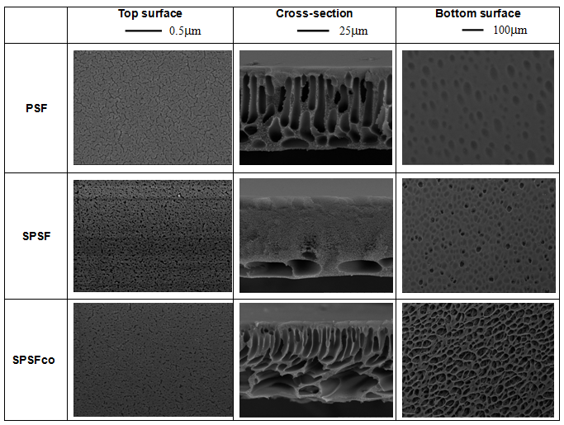
Figure 2 SEM photographs of the PSF, SPSF and SPSFco substrates fabricated by single layer casting (PSF, SPSF) and co-casting approaches (SPSFco).

Table 2 summarized the characteristics of the three substrates. The mean pore size of the pristine PSF substrate appears to be the lowest, while the SPSFco substrate showed the highest, which is good agreement with the SEM observation. However, the difference is less than 10%. This is expectable because the mean pore size is mostly determined by the dense skin layer, which did not show significant difference according to the SEM image. However, the pure water permeability (PWP) and porosity of the membranes were varied with different substrates. The PWP of the substrates was in the order of PSF< SPSF<< SPSFco. The significantly higher PWP of the SPSFco could be a combined result of higher mean pore size, higher porosity, thinner dense skin layer, and improved wettability.

Table 2 Properties of PSF, SPSF and SPSFco substrate membranes*
Properties | PSF | SPSF | SPSFco
Pure water permeability (L/m²·h·bar) | 216 ± 15 | 298 ± 24 | 521 ± 40
Porosity (%) | 72.7 ± 1.6 | 76.3 ± 8.4 | 85.9 ± 4.6
Thickness (μm) | 51 ± 1 | 55 ± 1 | 55 ± 1
Contact angle (°) | 79 ± 2 | 72 ± 1 | 73 ± 1
* refer to the supporting information for the experimental data. The mean pore size was in the range between 0.31-0.34 microns.
3.2 Characterization and performance of the TFC FO membranes
3.2.1 RO-like skin layers
Synthesis of the polyamide separated layer on the membrane substrate is according to the interfacial polymerization reaction between TMC and MPD at the oil-water interface . Figure 3 shows the top surface and the cross-section morphologies of the separated layer of the TFC membranes formed on the PSF, SPSF and SPSFco substrates, respectively. Similar leaf-like morphology was observed on all the TFC membrane surfaces, which is good agreement with the well-documented morphology of polyamide layer composing typical ridge and valley structures on the PSF support . Morphologies of polyamide layers were also analyzed by atomic force microscopy (AFM). It was found that the polyamide layers have similar mean roughness of about 58.4 nm irrespective of the substrates. Comparison of the PSF membranes with different wettability and porosity revealed that the incorporation of SPEEK in the PSF substrate did not prohibit the polyamide layer formation on the membrane surfaces.

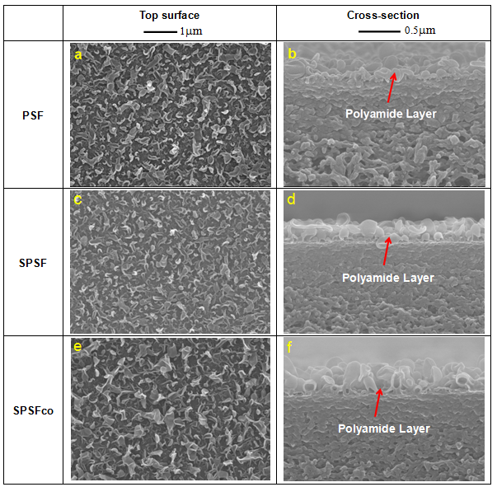
Figure 3 Top (a, c, e) and cross section (b, d, f) SEM images of the polyamide layers on different TFC-FO membranes: PSF-TFC (a, b); SPSF-TFC (c, d); and SPSFco-TFC membrane (e, f).
3.2.2 Intrinsic separation performance of the TFC FO membranes
Pure water permeability coefficient (A) and solute (NaCl) permeability coefficient (B) of the PSF-TFC, SPSF-TFC and SPSFco FO membranes are summarized in Table 3. The PSF-TFC membrane showed an A value of 1.64 L/m²h·bar. The SPSF-TFC membrane with a hydrophilic substrate prepared by single casting method exhibited a higher A value of 2.02 L/m²h·bar, compared with PSF-TFC membrane, whereas the SPSFco-TFC membrane showed the highest A value of 2.16 L/m²h·bar. This result indicates that increasing the wettability of the substrates can effectively improve the water permeability of the resulting TFC membranes. But in the meanwhile the solute permeability coefficients of the TFC membranes increased from 0.07 L/m²h for the PSF-TFC membrane to 0.16 L/m²h for the SPSF_{co}-TFC membrane, indicative of a reduced salt rejection. This is consistent with the trend of salt rejection decrease from 98.4% to 96%. Compared with TFC membrane with hydrophobic substrate also prepared by a co-casting method [23], the TFC membrane with hydrophilic substrate fabricated by the co-casting approach exhibited a higher A value, similar B value and slightly lower salt rejection, indicating that water permeability can be significantly improved with hydrophilic substrate.
Table 3 Intrinsic separation performance of the TFC FO membranes
FO  membrane | Water permeability, A  (L/m²h·bar) | Solute permeability, B  (L/m²h) | Rejection* (%) | Reference
PSF-TFC | 1.62 ± 0.22 | 0.07 ± 0.05 | 98.4 ± 1.06 | This study
SPSF-TFC | 2.02 ± 0.22 | 0.11 ± 0.03 | 97.5 ± 0.80 | This study
SPSF_{co}-TFC | 2.16 ± 0.13 | 0.16 ± 0.05 | 96.0 ± 1.50 | This study
PSF_{co}-TFC | 1.61 ± 0.03 | 0.20 ± 0.05 | 98.5 ± 0.30
* Transmembrane pressure: 3 bar. Refer to the supporting information for the experimental data.

3.2.3 FO performance and structural parameter
Table 4 lists the TFC FO membranes performance tested in AL-facing-FS mode using 0.5 M NaCl as draw solution. The water flux of 12.1 L/m²h was obtained for the PSF TFC FO membrane. Interestingly, the SPSF TFC membranes showed 30% of flux increase over the PSF TFC membrane, whereas a nearly 100% flux increase was observed for the SPSFco TFC FO membrane (22.4 L/m²h). This is much more than that reported in the previous literatures listed in Table 4. The flux is the result of membrane intrinsic water permeability (A) and the effective osmotic pressure gradient across the membrane. Because the A value of SPSFco TFC membrane increased compared to PSF TFC membrane, the flux increase was expected. However, the effective osmotic pressure gradient may also vary depending on the situation of internal and external concentration polarization. In the AL-FS mode, dilutive ICP occurred in the membrane support as a result of water flow from the feed to the draw side. The degree of ICP is directly responsible for the effective osmotic pressure gradient. For membranes with a less degree of dilutive ICP, a higher effective osmotic pressure gradient is generated, which leads to a higher flux.
The fact that the SPSFco TFC membranes exhibited a much higher water flux is mostly ascribed to a less significant ICP because of its higher porosity of the substrate. Further results on the structural parameter (S) and mass transfer coefficients (K_{m}) of TFC FO membranes are tabulated and also compared in Table 4. The PSF TFC membrane had the large S value of 527 μm and the K_{m} value of 0.316 s/μm, while the S and K_{m} values of the SPSF were reduced to 365 μm and 0.235 s/μm, respectively, with the SPEEK existing in the substrate fabricated by a single casting approach. Surprisingly, it was found that TFC membranes based on the SPSFco substrate prepared by the co-casting method consisted of the smallest S value (191 μm) and K_{m} value (0.12 s/μm). Comparing with the S and K_{m} values reported in literatures listed in Table 4, the SPSFco TFC membrane also exhibited relatively low S value, indicating that the SPSFco TFC membrane was exposed to less severe ICP during FO process. It should be noted that membrane characteristics were obtained from different conditions (Table 4), therefore the difference in the values are mainly referred as indicative. The membrane performance will be tested in order to confirm this.
Table 4 Comparison of TFC membranes for the FO process with previous literatures in AL-facing-FS model
S/N | FO membrane | Water flux  (J_{v}, L/m²h) | K_{m}  (s /μm) | Structure  parameter  (S, μm) | Draw solution | Feed solution | Reference
1 | PSF TFC | 12.1 ± 0.5 | 0.316 ± 0.066 | 527 ± 105 | 0.5 M NaCl | DI water | This work
2 | SPSF TFC | 15.8± 2.1 | 0.235 ± 0.041 | 365 ± 61 | 0.5 M NaCl | DI water | This work
3 | SPSF_{co} TFC | 22.4± 2.1 | 0.120 ± 0.031 | 191 ± 47 | 0.5 M NaCl | DI water | This work
4 | PSF_{18wt%}-TFC | 6.2 ± 2.8 | - | 2677 ± 2189 | 1 M NaCl | DI water
5 | PSF-TFC-D1ª | - | 0.157 ± 0.017 | 234 ± 25 | 1 M NaCl | DI water
6 | PSF-TFC-D2ª | - | 0.142 ± 0.012 | 210 ± 18 | 1 M NaCl | DI water
7 | SPES_{50wt%}/PES-TFC-3^{b} | 35.1 | 0.162 | 245 | 2 M NaCl | DI water
8 | SPEK_{50wt%}/PSU-TFC^{c} | 35 | 0.0071 | 107 | 2 M NaCl | DI water
9 | MWCNT_{2wt%}/PES-TFC^{d} | 12.8 | 1.268 | 2042 | 2 M Glucose | 0.01 M NaCl
10 | MMT/PES-TFCe | 28.39 | 0.522 | 790 | 2 M NaCl | DI water
11 | zeolite0.5wt%/PSf -TFC | ≈40 | 0.225 ± 0.039 | 340 ± 60 | 2 M NaCl | DI water
12 | TiO₂0.5wt%/PSf -TFC | 17. 1 | 0.285 | 420 | 0.5 M NaCl | DI water
13 | TiO₂0.6wt%/PSf -TFC | 18.81 | 0.204 | 300 | 0.5 M NaCl | DI water
14 | HNTs0.5wt%/PSf-TFC^{f} | 27.7 | 0.244 | 370 | 2 M NaCl | 10 mM NaCl
15 | PVP_{0.5wt%}/PSF-TFC-1^{g} | 9.53-9.01 | 0.461 ± 0.091 | 710 ± 140 | 0.5 M NaCl | 10 mM NaCl
16 | PVP_{0.5wt%}/PSF-TFC-2 | 12.0-14.9 | 0.435 ± 0.110 | 670 ± 170 | 0.5 M NaCl | 10 mM NaCl
ª D: double-blades
^{b} SPES: sulphonated polyethersulfone
^{c} SPEK: sulphonated poly(ether), PSU: polysulfone
^{d} MWCNT: multiwalled carbon nanotube
^{e} MMT: montmorillonite
^{f} HNTs: hydrophilic halloysite nanotubes
^{g} PVP: poly vinylpyrrolidone
The effects of DS concentration (NaCl) on water flux of TFC membrane were investigated as depicted in Figure 4. The increase of the flux with the DS was observed. However, because of the presence of dilutive ICP and the reverse diffusion of solute to the feed, the water flux was not linearly related to the DS concentration. As discussed above, the SPSFco should have a less severe ICP because of its low structure parameter, thereby its flux is expected to be about twice as high as PSF-TFC membrane. However, the flux difference was smaller when increasing the DS concentration. At 4 M DS concentration, the water flux of PSF, SPSF and SPSFco membranes was 42.5 L/m²·h, 45.2 L/m²·h and 55.4 L/m²·h, respectively (Figure 4a).
Flux changes of the membranes are shown in Figure 4b with DS of different concentrations. In the AL-DS mode, when deionized water was selected as the feed, there was negligible CP in the feed due to the negligible salt concentration. When the DS concentration was low, the flux of the process was mostly determined by the A value of the membrane and the osmotic pressure across the membranes. The similar water flux for the three membranes at DS concentrations of 0.5 and 1 M was observed. With DS concentration increasing, the reverse salt flux becomes significant owing to the increased water flux. As a result, the salt concentration in the feed increased dramatically close to the active layer. With the progress of the FO process, ICP is expected in the support layer, which would significantly lower the effective osmotic pressure gradient across the membrane. The severer the ICP is, the more flux deviation is expected. As shown in Figure 4b, a nearly linear flux against the DS concentration is observed for the SPSFco TFC membrane. The SPSF TFC membrane showed less deviation than the PSF. In contrast, the PSF showed the most serious deviation from linearity. This observation again implies that a hydrophilic support layer is beneficial for the flux enhancement and a hydrophilic substrate prepared by co-casting can benefit both from the hydrophilicity and from the open bottom structure with much improved FO performance and reduced ICP.
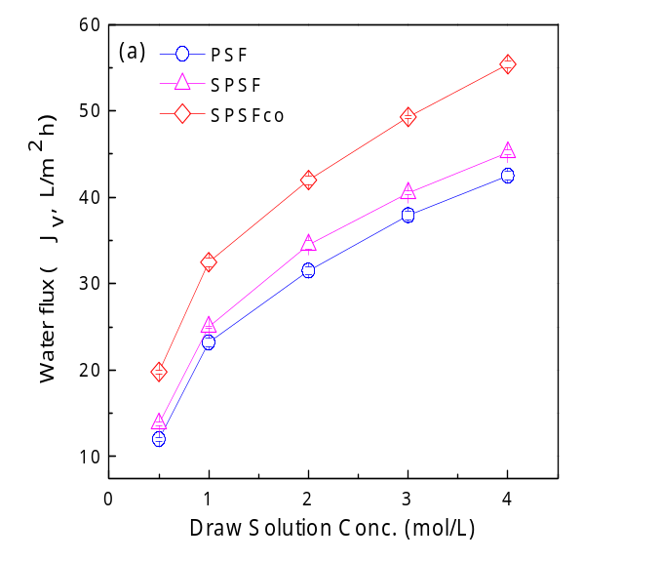
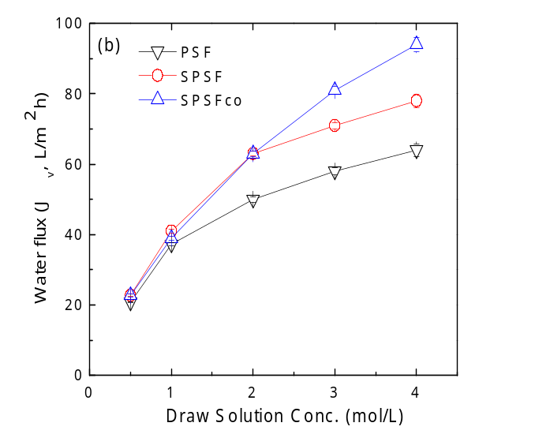.
Figure 4 The relationship between water flux and draw solution (sodium chloride) concentration using DI water as feed in (a) AL-FS mode and (b) AL-DS mode.

Reverse flux selectivity of the FO membranes is defined by the ratio between water flux (J_{v}) and reverse solute flux (J_{s}), which can be used to assess the FO membrane selectivity. A high J_{v}/J_{s} value is desirable and represents a low reverse solute flux and high membrane selectivity. In this study, the results of the reverse flux selectivity (J_{v}/J_{s}) of various TFC membranes tested in both AL-FS and AL-DS modes are shown in Figure 5. The value of reverse flux selectivity ranged from 8.3 L/g to 6.6 L/g in AL-FS mode and from 11.11 L/g to 8.33 L/g in AL-DS mode for PSF TFC membranes (Figure 5a) within the DS concentration range (0.5 – 4 M) was investigated. While the value of reverse flux selectivity of SPSF (Figure 5b) ranged from 6.7 L/g to 5.9 L/g in AL-FS mode and from 7.8 L/g to 5.9 L/g in AL-DS mode. For SPSFco TFC membranes (Figure 5c), the value of reverse flux selectivity ranged from 7.2 L/g to 6.3 L/g in AL-FS mode and from 7.2 L/g to 6.3 L/g in the AL-DS mode. The reverse flux selectivity curve of PSF TFC membrane is slightly higher than those of SPSF and SPSFco TFC membranes. The reverse flux selectivity is related to the FO water flux and selectivity of polyamide separated layer. The theoretical reverse flux selectivity can be determined according to the equation below:
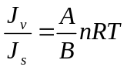
Where n is the number of dissolved species created by the draw solute (2 for NaCl), R is the ideal gas constant, and T is the absolute temperature. As listed in Table 3, the B value of PSF TFC membrane is much smaller than that of SPSF and SPSFco TFC membranes, while the difference of the A values is relatively smaller, which causes the J_{v}/J_{s} in the order of PSF TFC > SPSF TFC > SPSFco TFC.

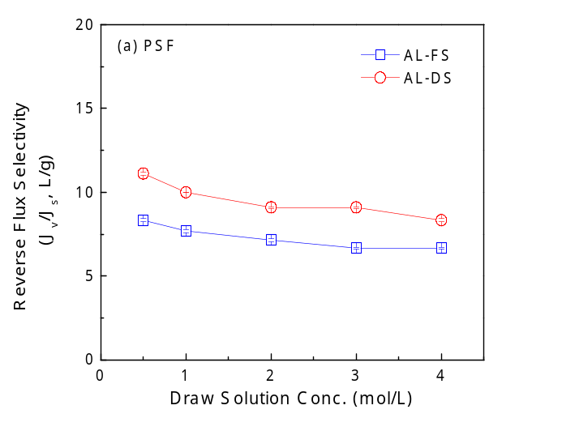
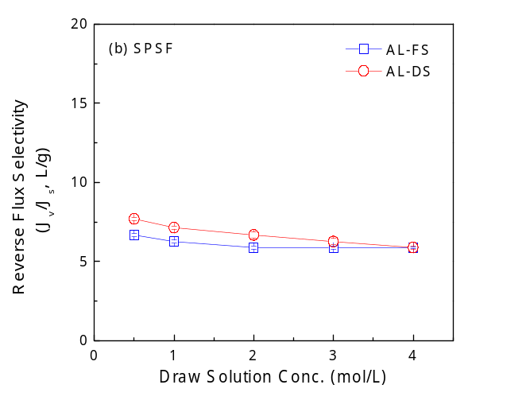
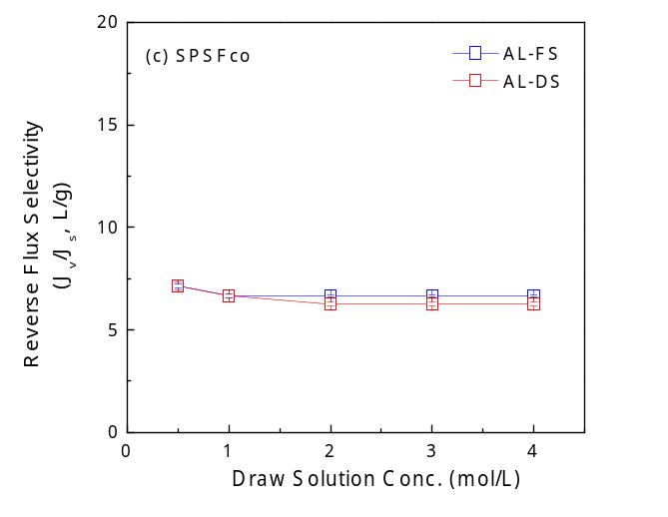
Figure 5 Reverse flux selectivity of (a) PSF, (b) SPSF and (c) SPSFco TFC membranes as a function of draw solution (NaCl) concentration (DI water as the feed) in AL-FS mode and AL-DS mode.

3.3 Water reclamation from the synthetic produced water
The performances of SPSFco, SPSF and PSF TFC membranes from the synthetic produced water through the FO process for water reclamation are shown in Figure 6. The FO flux decreased as the concentrating time went by. As the FO operational time increased, the water recovery rate increased, while as the feed concentration increased, the effective osmotic pressure gradient decreased, resulting in the reduced FO flux. Figure 6 shows that the FO flux of the co-cast membranes was the highest and the FO flux of the PSF membrane was the lowest. The SPSFco membrane showed the highest water recovery, which was in line with the FO water flux. When comparing the TFC FO membranes based on PSF and SPSF substrates, both FO water flux and the water recovery demonstrate that the addition of SPEEK into the substrate improves the FO performance when treating high salinity water. The low membrane structure parameter of SPSFco TFC membrane (S = 191 μm) significantly reduced the degree of ICP and the effective osmotic pressure difference across the active layer in comparison to the other membranes (SPSF, S = 365 μm, and PSF, S = 527 μm). To sum up, the present results show that for concentrating high salinity water, the increase of both the hydrophilicity and the porosity is an effective approach to improve the FO flux. The increase in the FO flux will save largely the capital cost and footprint for investing FO technology, which may promote the application of the FO process in the oil/gas industry.
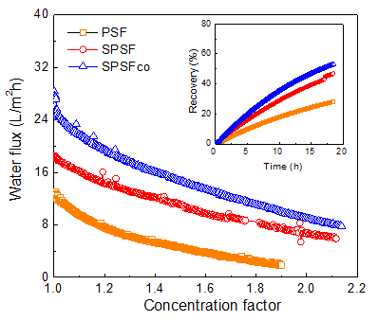

Figure 6 Flux and water recovery as a function of concentration factor during FO concentration of the synthetic produced water (feed solution: synthetic produced water, draw solution: saturated NaCl, temp: 25ºC, flow volume: 300 mL/min for lumen, 1800 mL/min for shell)

4. Conclusions
In this study, TFC FO membranes were prepared based on PSF/SPEEK blend substrates through single-layer casting and co-casting methods for application in FO concentration of synthetic shale gas produced water. The main objective of introducing a sacrificial-layer (co-casting) approach in preparation of membrane substrates is to improve substrate porosity and hydrophilicity and to reduce the degree of ICP of the TFC membranes. The following specific conclusions have been drawn from this study:
- Addition of SPEEK into PSF effectively increased water flux of the resulting TFC membrane due to enhanced substrate hydrophilicity.
- Substrates prepared via co-casting approach showed bottom surface with open pores structure improved porosity, which resulted in significantly reduced membrane structure parameter of TFC membranes.
- Substrates with combined hydrophilicity and open pore structure were achieved by co-casting of hydrophilic SPSF. The resultant TFC FO membrane (SPSF_{CO}) exhibited excellent intrinsic separation properties (A value: 2.16 L/m²·h·bar; B value: 0.16 L/m²·h; S value: 191 μm).
- The TFC FO membrane based on the co-casting method exhibited superior FO performance in concentration of high salinity brine due to the combined hydrophilicity and open bottom structure, which may provide a new direction for the development of FO membranes with excellent performance.

Abbreviations and Symbols
A pure water permeability coefficient, L/m²h·bar
AL-DS active layer facing draw solution
AL-FS active layer facing feed solution
B solute permeability coefficient, L/m²h
CF concentration factor
D solute diffusivity, cm²/s
DMAc N,N-dimethyl acetamide
FO forward osmosis
ICP internal concentration polarization
J_{s} reverse salt diffusion, g/m²h
J_{v} FO water flux, L/m²h
K solute resistivity, s/μm
MPD m-phenylenediamine
NMP N-methyl pyrrolidone
P pressure, bar
PEG polyethylene glycol
PEI polyetherimide
PSF polysulfone
PWP pure water permeability, L/m²h·bar
RO reverse osmosis
Rs salt rejection, %
S structure parameter, μm
SPEEK sulfonated poly(ether ether ketone)
SPSF polysulfone blended with SPEEK
SPSFco polysulfone blended with SPEEK via co-casting approach
TDS total dissolved solids, mg/L
TFC thin-film composite
TMC trimesoyl chloride
t_{s} substrate thickness, μm
ε substrate porosity, %
τ substrate pore tortuosity, %

Acknowledgments
The authors thank National Natural Science Foundation of China (U1507117, 21507142), National Key Basic Research Program of China (973 Program, 2012CB932800), TMSR from Chinese Academy of Sciences (XDA02020100), ARC Future Fellowship (FT140101208) and Disney Research China for partial financial support.

Supporting data
Detailed experimental supporting data for this manuscript are listed below in Table S1 to S4.
Table S1. Porosities of PSF, SPSF and SPSFco substrates
Substrate | Porosity (%)
Substrate | 1 | 2 | 3 | 4 | 5 | 6 | 7 | Average | St.Dev.
PSF | 71.8 | 71.8 | 74.6 |  |  |  |  | 72.7 | 1.6
SPSF | 67.4 | 82.4 | 82.4 | 82.4 | 66.9 |  |  | 76.3 | 8.4
SPSFco | 83.5 | 81.9 | 80.2 | 88.4 | 89.9 | 85.5 | 92.6 | 85.9 | 4.5

Table S2. Pure water permeability A, salt permeability coefficient B, and salt rejection results for the RO runs carried out in this study under the stated feed concentrations and conditions.
Membrane | Feed and concentration  (ppm NaCl) | Applied Pressure  (bar (atm)) | Pure water Permeability A  (L /m².h.bar) | Salt Permeability Coefficient B  (L /m².h) | Salt Rejection  (%)
PSF-TFC-1 | 1000 | 3(2.94) | 1.81 | 0.13 | 97.2
PSF-TFC-2 | 1000 | 3(2.94) | 1.67 | 0.03 | 99.2
PSF-TFC-3 | 1000 | 3(2.94) | 1.38 | 0.05 | 98.8
Avg. |  |  | 1.62 | 0.07 | 98.4
St. Dev. |  |  | 0.22 | 0.05 | 1.06
PSFSs-TFC-1 | 1000 | 3(2.94) | 2.14 | 0.15 | 96.7
PSFSs-TFC-2 | 1000 | 3(2.94) | 1.76 | 0.10 | 97.4
PSFSs-TFC-3 | 1000 | 3(2.94) | 2.16 | 0.09 | 98.3
Avg. |  |  | 2.02 | 0.11 | 97.5
St. Dev. |  |  | 0.22 | 0.03 | 0.80
PSFSco-TFC-1 | 1000 | 3(2.94) | 2.27 | 0.12 | 97.7
PSFSco-TFC-2 | 1000 | 3(2.94) | 2.19 | 0.15 | 94.7
PSFSco-TFC-3 | 1000 | 3(2.94) | 2.02 | 0.21 | 95.6
Avg. |  |  | 2.16 | 0.16 | 96
St. Dev. |  |  | 0.13 | 0.05 | 1.5

Table S3. FO water flux and performance ratio for all the FO runs carried out in this study under the stated conditions.
Membrane | Feed | Draw Solute and Concentration  (M) | AL-FS
Membrane | Feed | Draw Solute and Concentration  (M) | Jv  (L/m².h) | Js/Jv  (g/L)
PSF-TFC-1 | DI | 0.5M NaCl | 11.5 | 0.19
PSF-TFC-2 | DI | 0.5M NaCl | 12.2 | 0.15
PSF-TFC-3 | DI | 0.5M NaCl | 12.5 | 0.13
Avg. |  |  | 12.1 | 0.16
St. Dev. |  |  | 0.5 | 0.03
SPSF-TFC-1 | DI | 0.5M NaCl | 18 | 0.2
SPSF-TFC-2 | DI | 0.5M NaCl | 13.8 | 0.2
SPSF-TFC-3 | DI | 0.5M NaCl | 15.5 | 0.2
Avg. |  |  | 15.8 | 0.2
St. Dev. |  |  | 2.1 | 0
SPSFco-TFC-1 | DI | 0.5M NaCl | 23.7 | 0.12
SPSFco-TFC-2 | DI | 0.5M NaCl | 19.9 | 0.15
SPSFco-TFC-3 | DI | 0.5M NaCl | 23.5 | 0.21
Avg. |  |  | 22.4 | 0.16
St. Dev. |  |  | 2.1 | 0.05

Table S4. Summary of structural parameters (K, S, t_{s} and ε/τ ) of the membranes used in this study.
Membrane | Solute Resistivity to Diffusion K (μm/s) | Structural Parameter S  (μm) | Thickness  t  (μm) | Porosity Parameter  ε/τ
PSF-TFC-1 | 0.381 | 638 | 50 | 0.078
PSF-TFC-2 | 0.319 | 513 | 52 | 0.101
PSF-TFC-3 | 0.249 | 430 | 56 | 0.130
Avg. | 0.316 | 527 | 53 | 0.103
St. Dev. | 0.066 | 105 | 3 | 0.026
SPSF-TFC-1 | 0.188 | 295 | 56 | 0.189
SPSF-TFC-2 | 0.263 | 402 | 60 | 0.149
SPSF-TFC-3 | 0.255 | 398 | 56 | 0.141
Avg. | 0.235 | 365 | 57 | 0.159
St. Dev. | 0.041 | 61 | 2 | 0.026
SPSFco-TFC-1 | 0.111 | 177 | 53 | 0.299
SPSFco-TFC-2 | 0.155 | 244 | 55 | 0.225
SPSFco-TFC-3 | 0.094 | 153 | 55 | 0.359
Avg. | 0.120 | 191 | 54 | 0.294
St. Dev. | 0.031 | 47 | 1 | 0.067

References
[1] J. Kim, G.J. Moridis, Numerical analysis of fracture propagation during hydraulic fracturing operations in shale gas systems, International Journal of Rock Mechanics and Mining Sciences, 76 (2015) 127-137.
[2] R.M. Holt, E. Fjær, J.F. Stenebråten, O.-M. Nes, Brittleness of shales: Relevance to borehole collapse and hydraulic fracturing, Journal of Petroleum Science and Engineering, 131 (2015) 200-209.
[3] B.W. Stewart, R.C. Capo, C.S. Kirby, Geochemistry of unconventional shale gas from formation to extraction: Petrogenesis, hydraulic fracturing, and environmental impacts, Applied Geochemistry, 60 (2015) 1-2.
[4] M. Gu, K.K. Mohanty, Effect of foam quality on effectiveness of hydraulic fracturing in shales, International Journal of Rock Mechanics and Mining Sciences, 70 (2014) 273-285.
[5] M. Tian, Y. Yin, C. Yang, B. Zhao, J. Song, J. Liu, X.-M. Li, T. He, CF4 plasma modified highly interconnective porous polysulfone membranes for direct contact membrane distillation (DCMD), Desalination, 369 (2015) 105-114.
[6] D.L. Shaffer, L.H. Arias Chavez, M. Ben-Sasson, S. Romero-Vargas Castrillon, N.Y. Yip, M. Elimelech, Desalination and reuse of high-salinity shale gas produced water: drivers, technologies, and future directions, Environ. Sci. Technol. , 47 (2013) 9569-9583.
[7] G. Chen, Z. Wang, L.D. Nghiem, X.-M. Li, M. Xie, B. Zhao, M. Zhang, J. Song, T. He, Treatment of shale gas drilling flowback fluids (SGDFs) by forward osmosis: Membrane fouling and mitigation, Desalination, 366 (2015) 113-120.
[8] D.L. Shaffer, J.R. Werber, H. Jaramillo, S. Lin, M. Elimelech, Forward osmosis: Where are we now?, Desalination, 356 (2015) 271-284.
[9] T. Cath, A. Childress, M. Elimelech, Forward osmosis: Principles, applications, and recent developments, Journal of Membrane Science, 281 (2006) 70-87.
[10] S. Zhao, L. Zou, C.Y. Tang, D. Mulcahy, Recent developments in forward osmosis: Opportunities and challenges, Journal of Membrane Science, 396 (2012) 1-21.
[11] B.D. Coday, N. Almaraz, T.Y. Cath, Forward osmosis desalination of oil and gas wastewater: Impacts of membrane selection and operating conditions on process performance, Journal of Membrane Science, 488 (2015) 40-55.
[12] J. Minier-Matar, A. Hussain, A. Janson, R. Wang, A.G. Fane, S. Adham, Application of forward osmosis for reducing volume of produced/Process water from oil and gas operations, Desalination, 376 (2015) 1-8.
[13] S. Kumar, C. Guria, A. Mandal, Synthesis, characterization and performance studies of polysulfone/bentonite nanoparticles mixed-matrix ultra-filtration membranes using oil field produced water, Separation and Purification Technology, 150 (2015) 145-158.
[14] B.D. Coday, P. Xu, E.G. Beaudry, J. Herron, K. Lampi, N.T. Hancock, T.Y. Cath, The sweet spot of forward osmosis: Treatment of produced water, drilling wastewater, and other complex and difficult liquid streams, Desalination, 333 (2014) 23-35.
[15] K.L. Hickenbottom, N.T. Hancock, N.R. Hutchings, E.W. Appleton, E.G. Beaudry, P. Xu, T.Y. Cath, Forward osmosis treatment of drilling mud and fracturing wastewater from oil and gas operations, Desalination, 312 (2013) 60-66.
[16] R.L. McGinnis, N.T. Hancock, M.S. Nowosielski-Slepowron, G.D. McGurgan, Pilot demonstration of the NH3/CO2 forward osmosis desalination process on high salinity brines, Desalination, 312 (2013) 67-74.
[17] X.M. Li, B. Zhao, Z. Wang, M. Xie, J. Song, L.D. Nghiem, T. He, C. Yang, C. Li, G. Chen, Water reclamation from shale gas drilling flow-back fluid using a novel forward osmosis-vacuum membrane distillation hybrid system, Water science and technology : a journal of the International Association on Water Pollution Research, 69 (2014) 1036-1044.
[18] G. Chen, Z. Wang, X.-M. Li, J. Song, B. Zhao, S. Phuntsho, H.K. Shon, T. He, Concentrating underground brine by FO process: Influence of membrane types and spacer on membrane scaling, Chemical Engineering Journal, 285 (2016) 92-100.
[19] J. Song, X.-M. Li, Z. Li, M. Zhang, Y. Yin, B. Zhao, D. Kong, G. Chen, T. He, Stabilization of composite hollow fiber nanofiltration membranes with a sulfonated poly(ether ether ketone) coating, Desalination, 355 (2015) 83-90.
[20] H. Choi, K. Zhang, D.D. Dionysiou, D.B. Oerther, G.A. Sorial, Influence of cross-flow velocity on membrane performance during filtration of biological suspension, Journal of Membrane Science, 248 (2005) 189-199.
[21] P. Xiao, L.D. Nghiem, Y. Yin, X.-M. Li, M. Zhang, G. Chen, J. Song, T. He, A sacrificial-layer approach to fabricate polysulfone support for forward osmosis thin-film composite membranes with reduced internal concentration polarisation, Journal of Membrane Science, 481 (2015) 106-114.
[22] Y. Wang, T. Xu, Anchoring hydrophilic polymer in substrate: An easy approach for improving the performance of TFC FO membrane, Journal of Membrane Science, 476 (2015) 330-339.
[23] L. Huang, J.R. McCutcheon, Hydrophilic nylon 6,6 nanofibers supported thin film composite membranes for engineered osmosis, Journal of Membrane Science, 457 (2014) 162-169.
[24] N. Ma, J. Wei, S. Qi, Y. Zhao, Y. Gao, C.Y. Tang, Nanocomposite substrates for controlling internal concentration polarization in forward osmosis membranes, Journal of Membrane Science, 441 (2013) 54-62.
[25] G. Han, T.-S. Chung, M. Toriida, S. Tamai, Thin-film composite forward osmosis membranes with novel hydrophilic supports for desalination, Journal of Membrane Science, 423-424 (2012) 543-555.
[26] X.-M. Li, Y. Ji, Y. Yin, Y.-Y. Zhang, Y. Wang, T. He, Origin of delamination/adhesion in polyetherimide/polysulfone co-cast membranes, J. Membr. Sci. , 352 (2010) 173-179.
[27] Y. Ji, X.-M. Li, Y. Yin, Y.-Y. Zhang, Z.-W. Wang, T. He, Morphological control and cross-flow filtration of microfiltration membranes prepared via a sacrificial-layer approach, J. Membr. Sci. , 353 (2010) 159-168.
[28] X.M. Li, Y. Ji, T. He, M. Wessling, A sacrificial-layer approach to prepare microfiltration membranes, J. Membr. Sci. , 320 (2008) 1-7.
[29] M.H.V.M. T. He, H Strathmann, M. Wessling, Preparation of composite hollow fiber memebranes: co-extrusion of hydrophilic coatings onto porous hydrophobic support structures, Journal of Membrane Science, 207 (2002) 143-156.
[30] B.-H. Jeong, E.M.V. Hoek, Y. Yan, A. Subramani, X. Huang, G. Hurwitz, A.K. Ghosh, A. Jawor, Interfacial polymerization of thin film nanocomposites: A new concept for reverse osmosis membranes, J. Membr. Sci. , 294 (2007) 1-7.
[31] G. Han, S. Zhang, X. Li, N. Widjojo, T.-S. Chung, Thin film composite forward osmosis membranes based on polydopamine modified polysulfone substrates with enhancements in both water flux and salt rejection, Chem. Eng. Sci. , 80 (2012) 219-231.
[32] L. Shi, S.R. Chou, R. Wang, W.X. Fang, C.Y. Tang, A.G. Fane, Effect of substrate structure on the performance of thin-film composite forward osmosis hollow fiber membranes, J. Membr. Sci. , 382 (2011) 116-123.
[33] C. Yang, X.-M. Li, J. Gilron, D.-f. Kong, Y. Yin, Y. Oren, C. Linder, T. He, CF4 plasma-modified superhydrophobic PVDF membranes for direct contact membrane distillation, Journal of Membrane Science, 456 (2014) 155-161.
[34] C. Yang, M. Tian, Y. Xie, X.-M. Li, B. Zhao, T. He, J. Liu, Effective evaporation of CF4 plasma modified PVDF membranes in direct contact membrane distillation, Journal of Membrane Science, 482 (2015) 25-32.
[35] J.G. Wijmans, J.P.B. Baaj, C.A. Smolders, The mechanism of formation of microporous of skinned membranes produced by immersion precipitation, Journal of Membrane Science, 14 (1983) 263-274.
[36] I.L. Alsvik, K.R. Zodrow, M. Elimelech, M.-B. Hagg, Polyamide formation on a cellulose triacetate support for osmotic membranes: Effect of linking molecules on membrane performance, Desalination, 312 (2013) 2-9.
[37] N. Widjojo, T.-S. Chung, M. Weber, C. Maletzko, V. Warzelhan, A sulfonated polyphenylenesulfone (sPPSU) as the supporting substrate in thin film composite (TFC) membranes with enhanced performance for forward osmosis (FO), Chemical Engineering Journal, 220 (2013) 15-23.
[38] A.K. Ghosh, E.M.V. Hoek, Impacts of support membrane structure and chemistry on polyamide–polysulfone interfacial composite membranes, Journal of Membrane Science, 336 (2009) 140-148.
[39] A. Tiraferri, N.Y. Yip, W.A. Phillip, J.D. Schiffman, M. Elimelech, Relating performance of thin-film composite forward osmosis membranes to support layer formation and structure, J. Membr. Sci. , 367 (2011) 340-352.
[40] X. Liu, H.Y. Ng, Double-blade casting technique for optimizing substrate membrane in thin-film composite forward osmosis membrane fabrication, Journal of Membrane Science, 469 (2014) 112-126.
[41] S. Sahebi, S. Phuntsho, Y.C. Woo, M.J. Park, L.D. Tijing, S. Hong, H.K. Shon, Effect of sulphonated polyethersulfone substrate for thin film composite forward osmosis membrane, Desalination, (2015).
[42] Y. Wang, R. Ou, Q. Ge, H. Wang, T. Xu, Preparation of polyethersulfone/carbon nanotube substrate for high-performance forward osmosis membrane, Desalination, 330 (2013) 70-78.
[43] D. Emadzadeh, W.J. Lau, A.F. Ismail, Synthesis of thin film nanocomposite forward osmosis membrane with enhancement in water flux without sacrificing salt rejection, Desalination, 330 (2013) 90-99.
[44] D. Emadzadeh, W.J. Lau, T. Matsuura, M. Rahbari-Sisakht, A.F. Ismail, A novel thin film composite forward osmosis membrane prepared from PSf–TiO2 nanocomposite substrate for water desalination, Chemical Engineering Journal, 237 (2014) 70-80.
[45] D. Emadzadeh, W.J. Lau, T. Matsuura, A.F. Ismail, M. Rahbari-Sisakht, Synthesis and characterization of thin film nanocomposite forward osmosis membrane with hydrophilic nanocomposite support to reduce internal concentration polarization, Journal of Membrane Science, 449 (2014) 74-85.
[46] M. Ghanbari, D. Emadzadeh, W.J. Lau, H. Riazi, D. Almasi, A.F. Ismail, Minimizing structural parameter of thin film composite forward osmosis membranes using polysulfone/halloysite nanotubes as membrane substrates, Desalination, 377 (2016) 152-162.
[47] J. Wei, C. Qiu, C.Y. Tang, R. Wang, A.G. Fane, Synthesis and characterization of flat-sheet thin film composite forward osmosis membranes, J. Membr. Sci. , 372 (2011) 292-302.

