Building Social Awareness for Teens and Young Adults with Autism via Gamification
Valerie Gay, Peter Leijdekkers and Allan Pooley
University of Technology Sydney
PO box 123, Broadway NSW 2007
Valerie.Gay@uts.edu.au
Abstract: Teens and young adults, and in particular those on the spectrum, are in one of the most challenging phases of their life in terms of dealing with complex emotions and situations. Using serious games, it is possible to put the players in virtual situations and give them feedback in a ‘fun’ and non-threatening way. This may make it easier for them to learn to deal with social situations in the real life and understand better social norms and complex relationships.
Our objective is to build such a game by modifying already popular video game. We use the game mechanisms to allow the player to have conversations that dynamically change depending on their input. Characters in the game can be manipulated to project certain facial expressions and body language.
We created a tangible video game learning resource that can be trialed to investigate its value to build social awareness.

Keywords: Game-based learning, Autism, Role-play, Social awareness.

- Introduction
Autism Spectrum Disorders (ASD) describe a range of conditions typically characterized by social deficits, communication difficulties, stereotyped or repetitive behaviours and interests, and in some cases, cognitive delays. A Survey of Disability, Ageing and Carers (SDAC) conducted in 2012 by the Australian Bureau of Statistics (ABS) [1] found that approximately 1 in 200 people within the Australian population, had an Autism Spectrum Disorder.
A commonly observed trait among children and adults with Autism Spectrum Disorders (ASD) is a deficit in the ability to connect socially, identify the emotions of others and communicate effectively. Serious games may significantly increase their understanding of their emotions, social norms and complex relationships and might allow then taking control. It could also help their carers or educators to better understand the children or young adults and make better informed decisions. This is of major importance for their integration in social groups.
Our research team has identified a gap in game offerings for high functioning autistic teens and young adults since they respond well to apps, do not suffer extremely narrow interest and are less prone to be overwhelmed by complex multimedia material.
There is a need to provide ways to educate young adults and teenagers and help them understand social norms and complex relationship. We use a popular video game to fulfill an education purpose: to train the social competence in youths and adults with ASDs. We use of role-playing game as a means to simulate situations. This may lead to both better understanding, and also a means of discussing the situation for parents and carers. Using a popular game may offer an opportunity for the parents and siblings to play with the teen or young adult and be involved in the learning process. Both familiar and novel situations can be presented in at a level of abstraction, which promotes higher level thinking about the interactions.
First, this paper reviews the current apps and serious games for training and treating the social, behavioural and communicative impairments that are commonly associated with autism with a focus on video games designed as Social Skills Training (SST) programs, which closely relate to our project. This paper then explains our approach to building our own tool, our experience modifying The Elder Scrolls V: Skyrim and the attempts to adapt it into a SST video game. It then presents the different aspects of the building the game and concludes with a discussion.
- Serious games and apps for people with ASD
Social Skills Training (SST) or Social Competence Intervention (SCI) programs are designed to specifically address the impairments in verbal and non-verbal interpersonal communication and social behaviours associated with Asperger’s or High Functioning Autism [2]
At the time of writing there are more than 660 apps contained within a recommended list maintained by Autism service provider Autism Speaks [3], many of them purpose-built for users with ASDs. Observably, apps are the most prolific assistive technology available for ASDs at this point in time. This is can be attributed to the ubiquity, feasibility and social acceptance of smart device technology [4]. In a review of available apps for users with ASD [5], it was identified that most commonly applications focused on academic skills (literacy and numeracy), communication skills and emotional expression and recognition.
A study comparing 141 autistic, attention deficit (ADHD), and typical adolescent boys found that on average autistic boys spent more than 40% more time on a day-by-day basis than their typical counter parts [6]. It is presumable that this interest would have a negative impact on social competence, as it is an activity that is typically done in isolation. However, there are both anecdotal and evidence based research [7] to suggest otherwise.
The efficacy of popular, commercial video games to teach skills has also been investigated in a research based setting. trialled the capability of video games to teach the social concept of sportsmanship, which included the practice of skills such as complimenting, turn taking, and being a good sport was trialed in [8]. In a Social Skills Training (SST) style program, they integrated the use of sports games on the Nintendo Wii to model and practice these desired social behavioural skills (and they found that video games were an effective stimulus for teaching sportsmanship, with each of the trial participants showing significant improvements during post-treatment assessments and in generalisation.
The phrase ‘Social Simulation’ is used to describe the capacity in which a game can depict believable social interactions, creating engaging conversation between the player and characters in the game, or between two or more characters in the game observed by the player [9,10]. It is difficult to achieve social simulation in games, perhaps more so than another other dimension in a game. It isn’t quantitative like other dimensions of the game, the reaction from the player is extremely subjective.
The use of a ‘Pedagogical Agent’ refers to having a virtual tutor to fill the void of a live instructor. There are several ways to implement these agents: having them embedded within a game environment, which involves them actually having them immersed into the story and events unfolding in the game, or having them separate from the game.
Goldberg et all of the US Army Research Labs [11] investigated the use different types of ‘Pedagogical Agents’ in the context of the serious games they use to facilitate military training. Their research found that there was little difference between tutors being embedded and separate from the game, however there was significant benefit in the presence of a ‘Pedagogical Agent’. The agent appearance, communication and discourse need to being aligned to the players of the game, as it helps stimulate aspects such as motivation.
In addition to integrating the use of commercial games into treatments and intervention, there is also research considering the possibility of creating video games that are designed purely for players on the Autistic Spectrum. Video games that would contain content that intended to develop and improve skills that autistic people experience difficulty with, including cognition, communication and/or social behaviour and interaction. Two examples of such games include TeachTown [12] and Secret Agent Society [13].
An alternative to creating a video game is rectifying an already popular game to meet your own needs, using the game and its resources (models, environment, gameplay mechanisms) to create additional content. Video game content created in this fashion is commonly known as a ‘mod’, short for modification.
Morshirnia [14] makes strong arguments as to why makers of educational video games should consider making a mod instead of developing a game from the ground-up. It is of Morshirnia’s opinion that educational games are commonly perceived as developed at an amateur level, with out-dated technology and quality, and lacking entertainment. In order to successfully appeal to the gamer in students, a game must be capable of matching commercial game quality that players have come to expect . Many games are now released with game editors included, a feasible way of developing an education game might be creating a mod through the utilisation of these editors.
In a survey conducted by Mazurek [8] collecting the perspective of 58 adults on the spectrum on their use of video game. Role-playing games were identified as the favored genre, Skyrim [15] being specifically listed as a commonly considered ‘all-time favourite game’. It is a particularly strong candidate for implementing an SST because of the wide variety of mechanisms that could be utilised to support social simulation, specifically it has a detailed dialogue system. In this dialogue system characters can communicate verbally and non-verbally through the manipulation of their facial expression, the tone of their voices and performed gestures. In addition, Skyrim includes an editor for community members to create mods, which means making content for this game is very achievable.
Skyrim is that it has the capacity for violent gameplay, when playing the game as intended the user’s activities will involve combat. Skyrim is also a resource demanding game. Additionally, since the game is depicted in a detailed 3D environment it is recommended that it is played on a computer with a dedicated graphic card, which are typically not included in domestic computers. It was decided that The Elder Scrolls V: Skyrim was the most suitable game to modify for our project. This was primarily due to the fact that it included an editor that was available to the public, and had a solid set of mechanism for simulating social interactions.
- Encounters Skyrim - Game development
This section will discuss how we approached modifying The Elder Scrolls V: Skyrim to create an interactive Social Skills Training (SST) tool. The Elder Scrolls V: Skyrim is considered an action role-playing game, as it allows the player to create their own character which becomes the central figure in an immersive story. Time spent playing Skyrim typically results in the development of the player’s character, by learning new skills and/or acquiring new equipment. The content of the game is group into quests, players find by speaking to characters dispersed throughout the world. Most quests involve defeating opponents in combat.
We used the design methodology proposed by Tang et al [16] and this paper focuses on the 8 first phases of the design
- Define learning objectives and design goals
- Understand learners
- Identify learning activities for learning objectives defined in activity 1
- Sequence learning activities in increasing complexity order
- design the story to set the scene and link learning activities defined in activity 3;
- Design game mechanics for learning activities defined in activity 3,
- Design game components and associated behaviours,
- Design scenarios and game-play for learning activities defined in activity 3 using activity 4 and activity 5,
- Prototype game level,
- Evaluate prototype against learning objectives,
- Refine the game level;
- Finalise educational game and
- Quality assurance test on educational game.

In the scenario we designed, the player is held captive on a ship and must escape through exercising these two skills. They must meet each of the crew members on the ship, getting an idea of each crew members’ personalities and interests. After meeting each of the crew members, the player then must use this information to develop trust with each of the crew members. It is necessary for the player to establish trust with each of the crew members in order to subtly acquire an item that will help them escape the ship.
From a learning point of view, we focus on the fundamentals of social interaction, the two main skills that we felt best expressed this included initiating conversation with a stranger and engaging in a reciprocating conversation. Before starting development, we needed a story that would be natural within the Skyrim universe, but could also present opportunities that would allow the player to practice the targeted skills. Table 1 and Figure 1 identify how the scenario can be broken down:

Social challenge being addressed | Origin of social challenge | How it is represented within the scenario | Feedback within the scenario
Initiating a conversation | Aspect Autism Launchpad [17]  ‘Preparing for Life’, [18] | The player is placed in a situation where they need to introduce themselves and meet entire crew of a pirate ship. | How the character appears to respond to the approach in the scenario (tone of voice, facial expression, body language)  Feedback in top left hand corner (text feedback indicates whether character approves, disapproves, etc)
Engaging in a conversation – taking interest in what another person has to say, their interests and their accomplishments. | Aspect Meet [19]  Aspect Autism Launchpad[17]  ‘Preparing for Life’, [18] | The player needs to establish trust and a relationship with each of the crew members of the pirate ship. In order to achieve this the player must use the interests observed when first speaking to the crew member to engage in a conversation. | How the character appears to respond to the approach in the scenario (tone of voice, facial expression, body language)  Feedback in top left hand corner (text feedback indicates whether character approves, disapproves, etc)  Reward given to player, quality of reward indicates how well they have conversed with a particular character.
Table 1: social challenges addressed

As seen in Figure 1, each stage of the social scenario is aligned with particular social competencies. Competencies are gradually introduced and added throughout the course of the scenario.

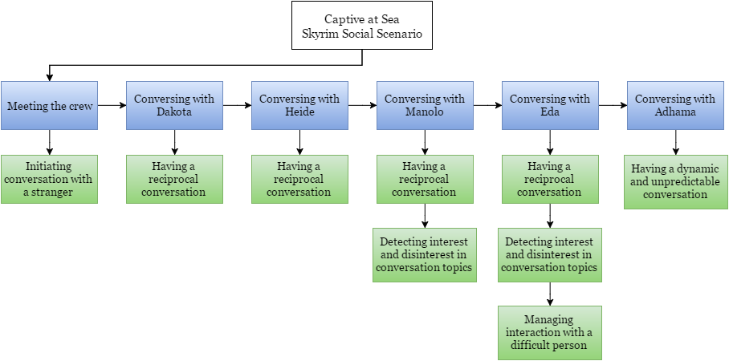
Figure 1: Scenario and social competencies addressed

Dialogue options are presented to the player when they approach a crew member for the first time. They can select only one of these dialogue options. Here, prompts are highlighted in blue, green or red, these outlines do not appear in the game and have been added for the purpose of explaining. Green highlighted options indicate good choices, blue for neutral choices and red for bad choices.

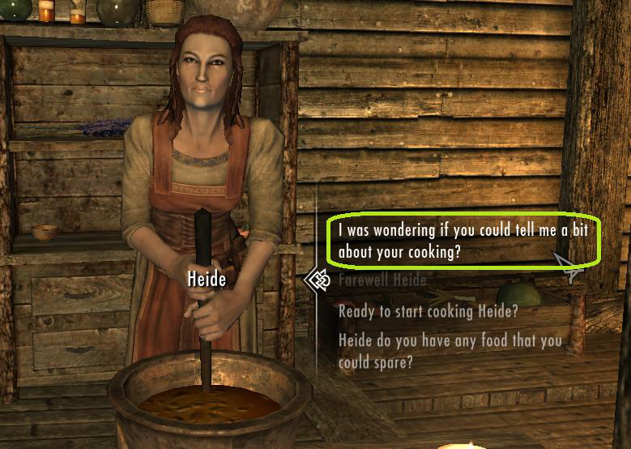
Figure 2: The player has the option to inquire about each character's interest
In the first phases of the game this selection is performed five times, allowing the player to observe the character’s reaction and potentially adjust their approach. Reciprocal conversation is tested in two dimensions within the mod. The first is that the player must actively seek opportunities to speak with characters about their interest, sparking conversation. The option to initiate reciprocal conversation can be seen in Figure 2, highlighted in green, surrounded by other dialogue options. They are encouraged to seek these opportunities this by their mentor embedded within the game, Fobahn. Providing the player commences a reciprocal conversation, they then must actively engage in the conversation. The character will ask them a question or for their opinion, they can respond to these prompts with a dialogue option that shows their interest in the conversation, or an option that indicates disinterest.
Whilst for Dakota and Heide, any type of discourse would result in a positive change in their disposition, for Manolo and Eda, the player will have to intermittently decide during discourse whether to encourage the character to continue speaking on a certain topic or whether they should change the topic. The correct decision can be identified based on the character’s verbal (tone of voice, choice of words) and non-verbal communication (facial expressions, gestures) whilst initially speaking about the topic. Later in the scenario Fobahn reflects on these types of attitudes with the player.
- Encounters Skyrim – Key game mechanics
Branching Dialogues: All conversation within the scenario is achieved through branching dialogues. This is the mechanism that makes discourse between the player and character change depending on the dialogue option chosen by the player. Conversation topics and lines are grouped and structured into branches to achieve this.

Character Disposition: In order to simulate the development or disintegration of relationships, our mod tracks a value representing the disposition of each character towards the player. Disposition can be increased by favorable choices made by the player in dialogue with the character, likewise disposition can decrease when unfavorable choices are made. The disposition of a character towards the player is observable through the way characters initially greet the player. For example, if the player has a negative disposition with Manolo, he might greet them by saying ‘I’m a little busy at the moment’, but if the player increases their disposition and speaks to him again he might greet the player by saying ‘It’s good to see you friend’.

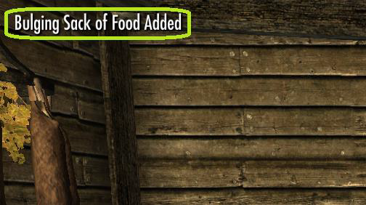
Figure 3: Example of in game rewarding, here the player acquired food supplies from Heide.

A character’s disposition towards the player also impacts how willing they are to help the player. During the scenario it is the player’s objective to acquire items of crew members that are necessary in order to escape. When a crewmember offers to help the player, their disposition will govern the quality or magnitude of this help. If disposition is low enough there are some characters who are entirely unwilling to help the player at all. Analysing the final disposition the player possesses with each character at the end of the scenario is also useful for evaluating how effectively they have interacted throughout the scenario.

Voices, Facial Expressions and Body Language: In Skyrim, characters' facial expression can be manipulated to depict neutrality, anger, sadness, happiness, fear, disgust or surprise to varying degrees.

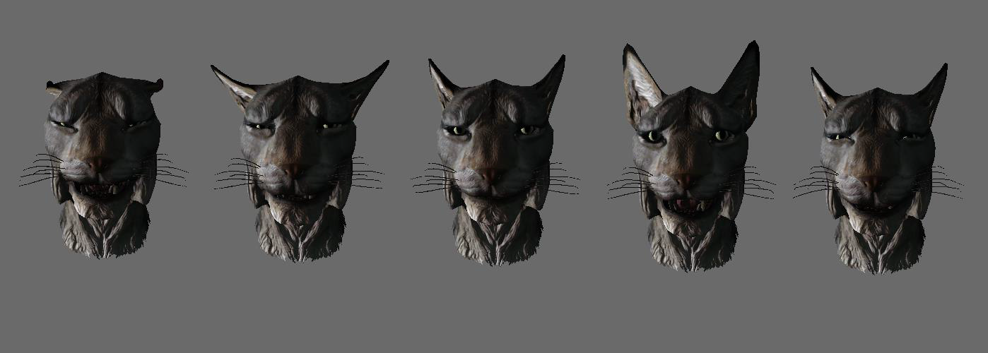
Figure 4: Characters' facial expression can be manipulated to depict neutrality, anger, sadness, happiness, fear, disgust or surprise to varying degrees

In order to simulate the communication of emotional responses, the mod manipulates characters with facial expression and gestures (figure 3). Additionally, whilst voices were being recorded for each of the characters, voice artists were instructed on the context of each line they delivered. This allowed voice artists to apply expressive intonations suited to the context of each line. These mechanisms allow characters to communicate through both verbal and non-verbal means to the player.

In-Game Mentor: Fobahn, the wizard locked inside of the cage with the player acts inexplicitly as their mentor. Fobahn guides the player through their escape plan, can give advice on how to effectively communicate and offer feedback on the player’s interactions with the crew. In the story, Fobahn explains that he is qualified to give the player feedback on the premise that he is secretly using magic extend his natural hearing to listen to the player as they converse with the crew.

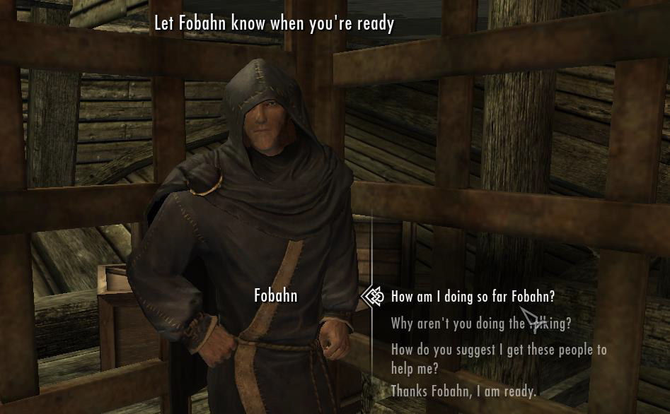 Figure 5: Fobahn, the in game mentor, offering the player advice and feedback

Fobahn was purposely modelled, scripted and casted (voice actor) to emanate the personality of an awkward teenager. This was in response to Goldberg and Cannon-Bowers [14] observation that if the appearance, communication and discourse of an in-game pedagogical agent aligns to its player base stimulate aspects such as motivation. Fobahn’s personality is non-judgmental, easy going and approachable.
Fobahn’s dialogue can alter depending on the actions performed by the player while conversing with other characters. In each segment of the game there is both undesired behaviour, that if performed Fobahn will comment on; and desired behaviour that Fobahn will congratulate the player on.
Personalisation: Aside from decisions made in dialogue, each player’s gameplay experience can be differing in two aspects, the mode in which they choose to play and through the appearance of the character the player controls.

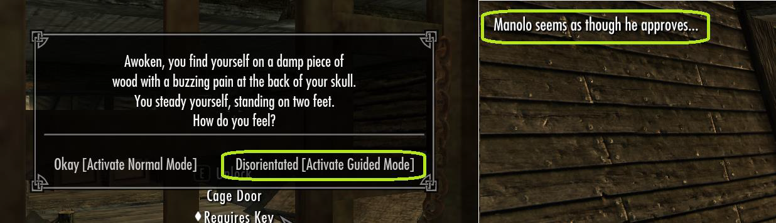
Figure 6: How 'Guided Mode' is activated (left) and type of prompts it enables (right).

There are two modes offered in the mod, guided mode and normal mode. In guided mode when the player selects a dialogue option that has changed the disposition of the character they are interaction with they are made aware through textual prompts in the top left hand corner. For example in image to the right of Figure 5, the player has chosen a dialogue option that has improved his disposition in Manolo, so a prompt explaining this appears in the left hand corner of the user interface. All prompts are written in the first person as though they are the thoughts of the player, this is done to maximize player immersion in the game. The player can also customise their character’s gender, race and appearance through a menu.

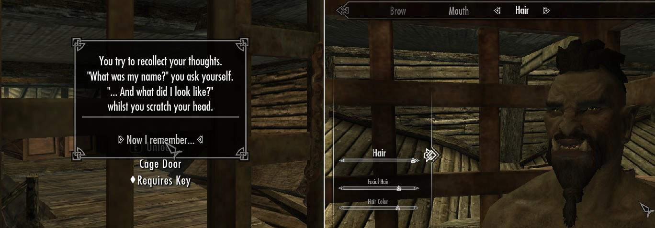
Figure 7: Customising at the beginning of the game (left) and customizing character (right).

This was done such that the player felt more connected to their character, and subsequently that the decisions they had to choose between were considered with greater weight because they would impact their character. Some examples can be viewed on the Encounters Skyrim videos [20].
- Discussions
This paper proposes an innovative twist to popular game. In this project we were able to identify the particularly critical game mechanics for a game for communicating concepts behind social interaction to the player. This included the implementation of an in game mentor that could encourage, correct, advise and guide the player, having characters either favor or disfavor the player based on past decisions they made and exploring how animated characters could express emotions both verbally and non-verbally.
Future work will involve giving the modification to a team of expert in Autism fro review. This will be followed by a user test to see if the gameplay is acceptable, meeting the expectations of people that regularly play commercial video games. The final test will involve a trial with autistic participants to evaluate if they like the game and if the game possesses the ability to improve understanding of social interaction. By performing trials with our game, we seek to collect quantifiable evidence on how effective our video game content is.
Two reviews conducted by Knight et al [21] and Ploog et al[22] assessed the state of assistive technology in 2013 concluded that there was a lack of empirical evidence to prove the efficacy of assistive technology in the intervention and treatment of Autism Spectrum Disorders. It was recommended that assistive technologies are used in conjunction with evidence based practices, not in substitution of. It is acknowledged that technology can play a beneficial role in encouraging and stimulating the acquisition and improvement of skills, but at this stage cannot be relied on as a sole source of treatment.
Whether popular video game can be modified to effectively evolve into a tool used to teach social competencies still remains to be proven. Our modification of Skyrim allowed us to illustrate the complexity involved in creating such a tool, conflicting with a seemingly unappeasable balance between covering a curriculum, making it clear enough, and ensuring the entertainment of the player.
- Acknowledgement
The authors would like to acknowledge Susan Bruck, David Cretney and Vicki Gibbs from ASPECT (Autism Spectrum Australia) for their feedback on this project.
- References
- Centers for Disease Control and Prevention (CDC). http://www.cdc.gov/ncbddd/autism/data.html
- Rao P & Beidel D & Murray M, 2008 ‘Social Skills Interventions for Children with Asperger’s Syndrome or High-Functioning Autism: A Review and Recommendations’, Journal of Autism and Developmental Disorders, Volume 38, Issue 2, pp 353-361
- Autism Speaks 2015c, Autism Apps, viewed 13 November 2013 <https://www.autismspeaks.org/autism-apps>
- Shane HC1, Laubscher EH, Schlosser RW, Flynn S, Sorce JF, Abramson J. Applying technology to visually support language and communication in individuals with autism spectrum disorders. J Autism Dev Disord. 2012 Jun;42(6):1228-35. doi: 10.1007/s10803-011-1304-z.
- Barber, A. (2013). Multilinguistic components of spelling: An overview. SIG 1 Perspectives on Language Learning and Education, 20(4), 124-128.
- Mazurek M, et al. ‘Video games from the perspective of adults with autism spectrum disorder’, 2015. Computers in Human Behavior Vol.51, pp. 122–130.
- Ferguson B R, Gillis J M & Sevlever M, ‘A Brief Group Intervention Using Video Games to Teach Sportsmanship Skills to Children with Autism Spectrum Disorders’, 2013. Child & Family Behavior Therapy 35:4, pp 293-306.
- Meindl J.N. & Cannella H.I., 2015. ‘Initiating and responding to joint attention bids in children with autism: A review of the literature’ Research in Developmental Disabilities, Volume 32, Issue 5, p.1441-1454.
- Khandaker M, 2015, Thinking About People: Designing Games for Social Simulation, viewed 20 November 2015, <http://mitu.nu/2015/03/22/thinking-about-people/>
- Khandaker M, ‘Designing Affective Video Games to Support the Social-Emotional Development of Teenagers with Autism Spectrum Disorders’, 2009. Annual Review of
- Goldberg B A & Cannon-Bowers J, ‘Feedback source modality effects on training outcomes in a serious game: Pedagogical agents make a difference’, 2015. Computers in Human Behavior Vol.52, pp. 1-11.
- TeachTown 2015, ‘Computer-Based Lessons’ , viewed November 19 2015, <http://web.teachtown.com/products/teachtown-basics-classroom/online-lessons>
- Secret Agent Society, http://www.sst-institute.net/
- MORSHIRNIA, A. V., and WALKER, A.C., 2007. Reciprocal innovation in modding communities as a means of increasing cultural diversity and historical accuracy within video games. IN: Situated Play – Proceedings of 2007 DiGRA conference, p. 362-368. Available at: http://www.digra.org/dl/db/07311.28264.pdf [Accessed: 28/2/12]
- Skyrim, http://www.elderscrolls.com/skyrim/
- S. Tang and M. Hanneghan, "Designing EducationalGames: A Pedagogical Approach," in Design and Implementation of Educational Games: Theoretical and Practical Perspectives, P. Zemliansky and D. Wilcox, Eds.,ed Hershey, PA: IGI Global, 2010, pp. 108-125
- ASPECT LaunchPad, leaving school and leading your own life.http://www.autismlaunchpad.org.au/
- J.Baker, Preparing for life : the complete guide for transitioning to adulthood for those with autism and Asperger's Syndrome, ISBN: 9781932565331
- ASPECT MEET, www.aspect.com.au
- Allan Pooley, Encounters Skyrim videos, Preview https://www.youtube.com/watch?v=-Kw9z6vY82s, Captive at sea ( 4 videos), https://youtu.be/lL8CsGqh-ic?list=PLjnj9yyST-am8uar5UqH9KLznHmQzfKMD
- Victoria Knight, Bethany R. McKissick , Alicia Saunders, A Review of Technology-Based Interventions to Teach Academic Skills to Students with Autism Spectrum Disorder, Journal of Autism and Developmental Disorders, November 2013, Volume 43, Issue 11, pp 2628-2648
- Ploog BO¹, Scharf A, Nelson D, Brooks PJ., Use of computer-assisted technologies (CAT) to enhance social, communicative, and language development in children with autism spectrum disorders. J Autism Dev Disord. 2013 Feb;43(2):301-22. doi: 10.1007/s10803-012-1571-3.

