Refugee Transit in Indonesia: The Critical Importance of Community

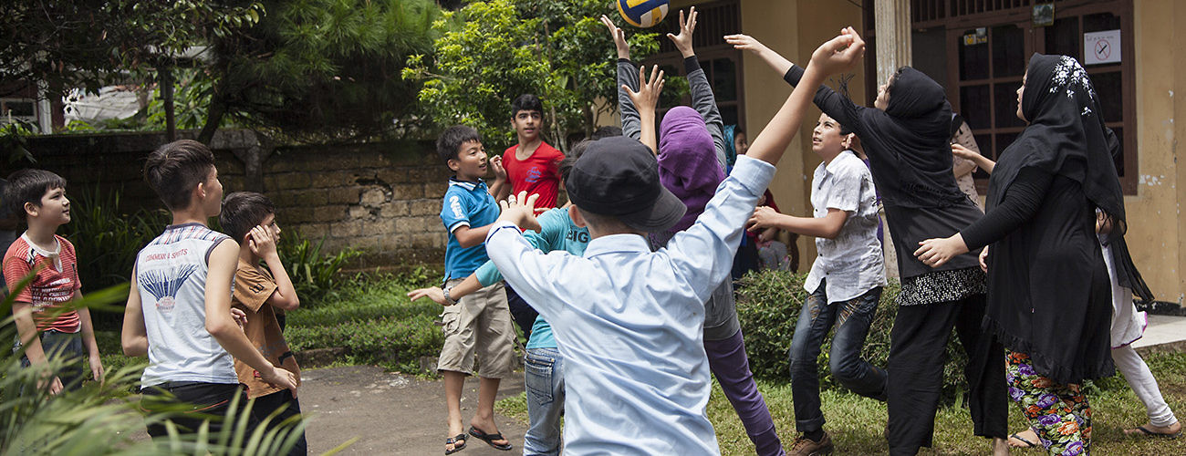

Refugee children play during a break at the Cisarua Refugee Learning Centre. Cisarua, Indonesia (Muzafar Ali).

Western nations are in retreat from their traditional willingness to take in refugees. The United States’ [recent halving](http://www.bbc.com/news/world-us-canada-38777437) of its annual intake comes as Europe has spent [billions of euros](http://www.publicfinanceinternational.org/news/2016/09/eu-spending-extra-border-controls-least-eu17bn) attempting to keep refugees from its jurisdiction, even briefly abandoning search and rescue operations in the Mediterranean. Australia, meanwhile, has used a system of “[offshore processing](https://www.nytimes.com/2016/12/09/opinion/sunday/australia-refugee-prisons-manus-island.html)” (indefinite incarceration on islands outside its jurisdiction and judicial and media oversight) to effectively prevent unauthorized arrivals by sea since 2013.

Opportunities for refuge are constricting globally, just as the need for them expands. The average time that a person will spend as a refugee [has extended](http://www.fmreview.org/sites/fmr/files/FMRdownloads/en/protracted/loescher-milner.pdf) from an average of nine years in 1990 to 26 years in 2016. Most of this waiting is done in countries with weak or no legal protections for refugees and [the least resources](http://www.unhcr.org/576408cd7.pdf) to support them. One such country is Indonesia; traditionally a transit country through which refugees pass en route to Australia, it is now hosting around 15,000 refugees who will likely remain there for many years. Refugees here, and the few international and local organizations working with them, must adjust to global events and policy shifts. Some of these responses are proving more nimble than others.

Refugees in Indonesia are not housed in United Nations refugee agency (UNHCR) camps, and most are safe from immigration detention if they strictly follow the rules of their stay. This includes registering with UNHCR, remaining within certain areas, not engaging in work, and not undertaking other business activity. During their stay they have no access to welfare, health, or other social services. During multiple visits to Indonesia over several years—most recently last month—I have observed three distinct refugee journeys emerge.

In the town of Cipayung—about 45 miles south of Jakarta near Mt Gede in West Java—is a population of predominantly Afghan and Pakistani Hazara refugees, with smaller numbers from Iran, Iraq and elsewhere. Most refugees here are classified by the UNHCR as single men—although many in fact have wives and children who are not with them in Indonesia—and only a handful of families and single women. Most refugees in Cipayung largely survive on some form of private financial support from families in Pakistan, Afghanistan, and among their respective diaspora. This support is at a bare minimum and consists of food and shelter only.

There are few structured activities in Cipayung—many play football once or twice a week or while away a few hours playing the game Carrom. Most commonly, days are passed by sleeping as much as possible. Boredom is rife and over time gives rise to anxiety and depression. These refugees tell of lives that are simultaneously precarious and dull. While Cipayung does not lack friendships, there is no discernible community here, and no safety net should anything go wrong. Many have been waiting for three years or more and have been advised by the UNHCR that they can expect to wait seven, eight, or even more years for a resolution of their cases. A lack of visibility and poor access to the UNHCR are among their chief frustrations.

A second group of refugees can be found in the laneways behind the UNHCR offices in Jakarta, sleeping on the street and imploring security guards for an audience with officials. Many of the people I have spoken to here were once like those in Cipayung, but have health problems, have run out of money, or have encountered some other kind of crisis. With no community to fall back on, no support network, and no access to any financial aid, their situation appears bleak.

The third type of refugee journey can be witnessed in Cisarua, further up Mount Gede, past Cipayung. Like the Cipayung refugees, these individuals too have little or no access to financial aid and must rely on family and diaspora support. However, members of this group have adjusted to their changed circumstances with remarkable success. They are mostly comprised of Hazara families from Afghanistan and Pakistan, with smaller numbers from Iraq, Syria, Iran, and Sudan. Refugees here have made the transition from being individual families to a community, largely driven by the need to provide education for their children.

The community was formed around a [refugee-run school](http://cisarualearning.com/#intro) that opened in August 2014 and now has 200 students and 17 volunteer staff. The school has provided the community a focal point and shared project in which all are heavily involved. Many other activities have grown from this, including men’s, women’s and mixed soccer teams, art exhibitions, a karate club, and at least two more independent schools. The community has a [strong social media presence](https://www.facebook.com/cisaruarefugeelearningcentre/) and manages its own public representation, focusing on a narrative of refugee capacity rather than need. The UNHCR have visited the school, as have journalists, NGOs, and researchers.

At a time when established ways of working with refugee displacement are proving inadequate, the situation in Indonesia provides some clues for rethinking global responses. While not a durable solution—regaining the rights associated with citizenship of a state remains imperative—refugees’ time in transit needn’t be spent solely in camps or detention centers.

The community development approach in Cisarua is yielding significant benefits in this respect—it is not only inoculating against the [precarious nature and mental health problems](https://bookshop.iseas.edu.sg/publication/2103) common to transitory life, but also developing skills and knowledge, such as English language abilities, organizational management, team work, and public communications. These will assist refugees in their futures pathways, whether this includes resettlement to a Western nation or return to their conflict-free countries of origin (at present this looks unlikely for refugees in Indonesia).

Of course, this multi-faceted, locally developed approach can’t simply be rolled out by international organizations, transplanting a model for a refugee-run school from Cisarua to Nairobi, Beirut, or Bangkok. The real value lies in the process behind the outcomes—refugees [building trust in one another](http://epress.lib.uts.edu.au/journals/index.php/mcs/article/view/4883/5490), confidence, participation in problem-solving and decision-making, and a general sense of starting each day with a purpose. After more than two decades working with refugees, this is certainly the most effective pre-departure preparation program I have encountered.

Community-based interventions are often seen as low-value, non-essential “extras” when dealing with issues of major global concern. The example in Cisarua, however, shows the value of allowing refugees themselves to have the greatest input into how their communities operate and create opportunities for more meaningful lives in the present and success in the future. As global policymakers contend with an unprecedented refugee problem in a time of diminishing political will, the Indonesian case study shows that the UN, international governments, and NGOs might do well to greatly increase support for community-driven initiatives.

*[Dr. Lucy Fiske](http://www.uts.edu.au/staff/lucy.fiske) is a Chancellor’s Postdoctoral Research Fellow at the University of Technology Sydney.*

[REFUGEES](https://theglobalobservatory.org/tag/refugees/)[SOUTH EAST ASIA](https://theglobalobservatory.org/tag/southeast-asia/)

[by Lucy Fiske](https://theglobalobservatory.org/by/lucy-fiske)