Dynamic modelling and simulation of a manual transmission based mild hybrid vehicle
  - Mohamed Awadallah, Peter Tawadros, Paul Walker, and Nong Zhang
ABSTRACT
This paper investigates the development of a mild hybrid powertrain system through the integration of a conventional manual transmission equipped powertrain and a secondary power source in the form of an electric motor driving the transmission output shaft. The primary goal of this paper is to study the performance of partial power-on gear shifts through the implementation of torque hole filling by the electric motor during gear changes. To achieve this goal, mathematical models of both conventional and mild hybrid powertrain are developed and used to compare the system dynamic performance of the two systems. This mathematical modelling is used to run different simulations for gear-shift control algorithm design during system development, allowing us to evaluate the achievable performance and its dependency on system properties. The impact of motor power on the degree of torque hole compensation is also investigated, keeping in mind the practical limits to motor specification. This investigation uses both the output torque, vehicle speed as well as vibration dose value to evaluate the quality of gearshifts at different motor sizes. Results demonstrate that the torque hole may be eliminated using a motor power of 50 kW. However, the minimum vibration dose value during gear change is achieved using a peak power of 16-20 kW.

Keywords: Dynamics; Manual transmission; Mild hybrid electric vehicle (MHEV); Torque hole; Powertrain; Gear-shifting control;
Authors
M. Awadallah, P. Tawadros, P. Walker and N. Zhang are with the School of Engineering and Information Technology, University of Technology Sydney, NSW 2007, Australia.
(E-mails: Mohamed.M.Awadallah@student.uts.edu.au / eng.m.zakaria@gmail.com, Peter.Tawadros@uts.edu.au, Paul.Walker@uts.edu.au, Nong.Zhang@uts.edu.au).

INTRODUCTION
The essential function of a modern powertrain is to deliver torque to the road-tyre interface while providing high efficiency, and excellent ride quality [1]. System design, and in particular, engine and transmission control design are the primary tools available to deliver these requirements. The control systems, including hydraulic clutch control, must provide ideal control of engine and transmission speed and torque, to achieve the best possible results during the shift period. The shift transients are the result of discontinuities in speed, torque, and inertia present during shifting. These discontinuities must be minimised to reduce the transient response of the powertrain [2]. A mild hybrid electric powertrain represents the greatest opportunity for improvement of driving comfort, shifting quality and improved driveability with low manufacturing costs. Such an architecture calls for a low-power electric motor mounted on the transmission output shaft, coupled to a controlled power source. This configuration allows for increased functionality of the powertrain along with a reduction in the torque hole during gear changes, improving driving performance.

Primary input signals to the motor controller are; clutch position, ICE load (calculated from speed and throttle angle), and selected gear. The function of the electric machine is to eliminate or reduce the torque hole during gear changes by providing a tractive force when the clutch is disengaged, and also, provide damping for torque oscillation, particularly during gear changes and take-off (anti-jerk). The electric motor may also act as a generator under certain driving situations [3].

Major trends in the hybrid automotive industry are aimed at improving gear shift quality and increasing hybridization or electrification of the powertrain. Improved shift quality without the use of hydrodynamic torque converters is achieved through the application of precise transient clutch control technologies. Vehicles in which hydrodynamic power couplings are not used are increasingly susceptible to driveline oscillations that are perceived by the driver as poor driving quality. These oscillations can be considered a source of noise, vibration, and harshness (NVH). In these cases, damping against NVH is sourced from torsional vibration absorbers and parasitic losses in clutches, transmission components and the differential. As a consequence of eliminating the torque converter from the powertrain system damping is reduced [4, 5]. However, with the use of manual transmission (MT) gear trains, a high-efficiency transmission is realised. In Hybrid Electric Vehicles (HEV) powertrains the electric machine (EM) output torque may be controlled to suppress powertrain transients rapidly. This control technique is commonly known as “anti-jerk”. Modelling and analysis for control of vehicle powertrains have been critical to the development of transmissions in recent years. Our research concerns the development of a detailed powertrain model of a front wheel drive mild hybrid electric vehicle.

This paper investigates the dynamics of a front wheel drive mild hybrid electric powertrain. A comprehensive analysis of the system with numerous degrees of freedom is proposed and the resulting sets of equations of motion are written in an indexed form that can easily be integrated into a vehicle model. Lumped stiffness-inertia torsional models of the powertrain will be developed for different powertrain states to investigate transient vibration. The major powertrain components - such as engine, flywheel, transmission, and differential - are lumped as inertia elements, interconnected with torsional stiffness and damping elements to represent a multi-degree of freedom model of the powertrain [6, 7]. The generalised Newton’s second law is used to derive the models. The aim of modelling the powertrain is to identify possible improvements when using the electric drive unit. The mild hybrid powertrain is compared with a traditional manual transmission driveline. The analysis is focused on the lower gears. The reason for this is that in lower gears, the torque transferred to the drive shaft is greater, as is the deflection in the shaft. This greater deflection means the shaft torsion is higher at lower gear ratios, yielding larger oscillations. Finally, this paper deals with the role of integrated powertrain control of both engine and motor in reducing torque-hole. High-quality shift control is critical to minimising torque hole and vibration of the powertrain.

SHIFT PROCESS ANALYSIS
Shift process analysis is essential for MT shift quality control. The process involves the disengagement and engagement of a single clutch connecting the transmission to the power source. The shift process may be divided into three phases. The first phase involves the disengagement of the clutch and is characterised by a rapid reduction in torque transmission to zero. The second phase is the gear selection phase and is characterised by a fully disengaged clutch, torque hole as well as minor torque oscillation from the synchronisation of the selected gear. The final phase is the inertia phase and is characterised by a significant torque oscillation as the clutch slips during re-engagement. When a constant speed ratio is achieved, the speed of the powertrain is proportional to the speed of the vehicle, and the clutch is fully engaged [8]. Various factors may influence the shift process, including the magnitude of transmitted torque before and after the gear change, and the speed of clutch disengagement and engagement. Fig. 1 shows an example of actual vehicle data for half-shaft torque (with torque fill during shifts) [9].

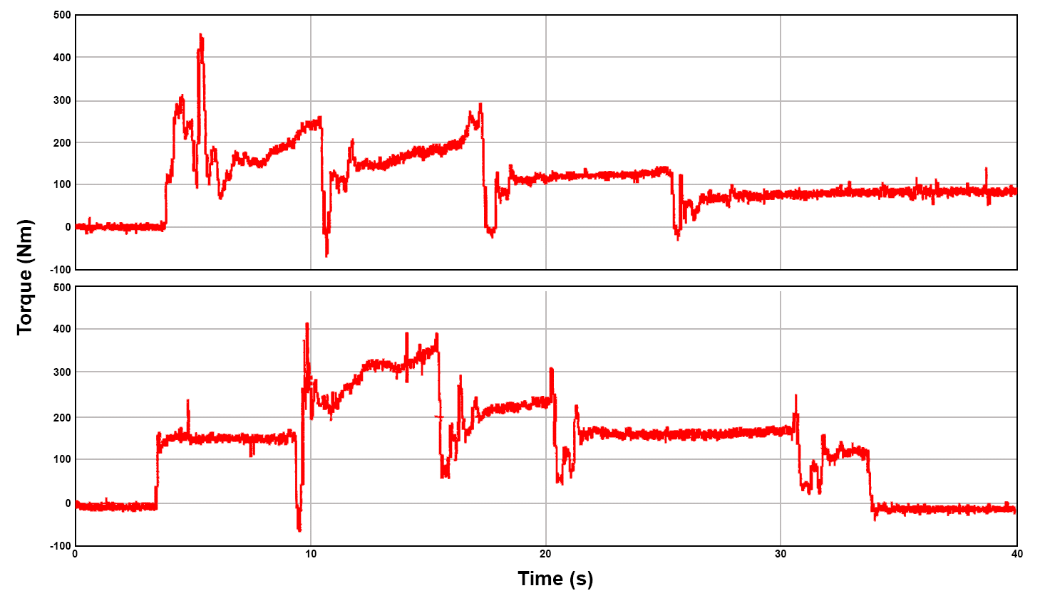
(a)
`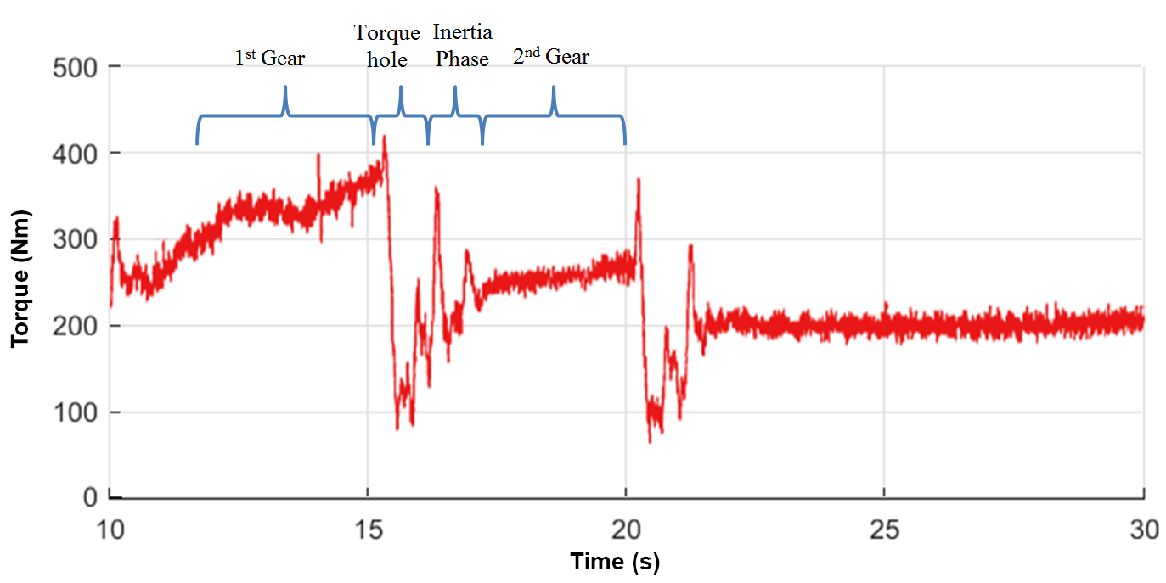
(b)
Fig. 1. a. Effect of torque-fill on halfshaft torque – torque-fill is shown below
b. Actual measured halfshaft torque with fill-in, showing the different phases of the gear change [10].

Proposed mild HEV powertrain system and its modelling
Simplified engine models are popular in modelling and control applications. These include empirical models, as well as more detailed dynamic studies which use an approximation of the torque variation from piston firing for transient powertrain studies based on engine harmonics. These reduce both the model complexity and computational demand, enabling rapid simulations. The model developed herein utilises a simple empirical engine element utilising a three-dimensional lookup table. This element is inserted into two powertrain models, both of which are presented in this section. This section presents the mathematical models of each configuration, using eight degrees of freedom for the mild HEV powertrain, compared to seven degrees of freedom for a conventional powertrain. Powertrain system torques are also presented for these models, including mean engine torque, a piecewise clutch model, vehicle resistance torque, and motor torque models. Free vibration analysis is undertaken to compare the two powertrain models and demonstrate the similarities in natural frequencies and mode shapes.

Mild hybrid powertrain configuration
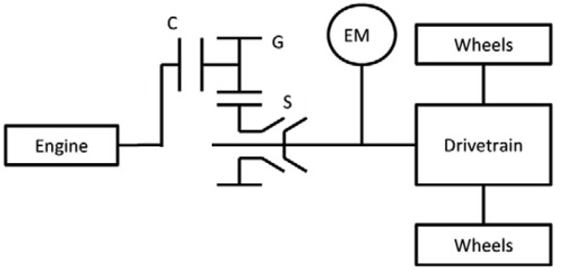
Fig. 2. Generalised powertrain layout with hybridization (only one gear/synchro pair shown).

Fig. 2 presents a basic mild hybrid powertrain. The powertrain is a post-transmission parallel hybrid type, utilising an electric machine (EM) permanently coupled to the transmission output shaft. This configuration allows the EM to drive the wheels directly. As the motor is downstream of the transmission, it, therefore, has a fixed constant speed ratio to the wheels, via the final drive. In our transmission model, gears, 1, 2, 3, 4, and 5 (G) are connected to the input and output shafts and are driven through the closed clutch (C). The synchronizer is denoted as S. In a traditional manual transmission it is necessary to release the clutch before synchronisation, isolating the synchroniser from engine inertia. The nature of the powertrain requires a single dry-plate clutch interfacing between the engine and transmission, shown in Fig. 3. The damping sourced from this coupling must be recognised in the system. This damping is related to the torsionally-mounted coil springs which connect the segments of the clutch disc, as well as the friction between the various segments as they move past each other [11]. A pressure plate consisting of a pre-tensioned (normally closed) diaphragm spring clamps the disc to the engine output, and the friction plate is independently splined to the transmission input shaft.
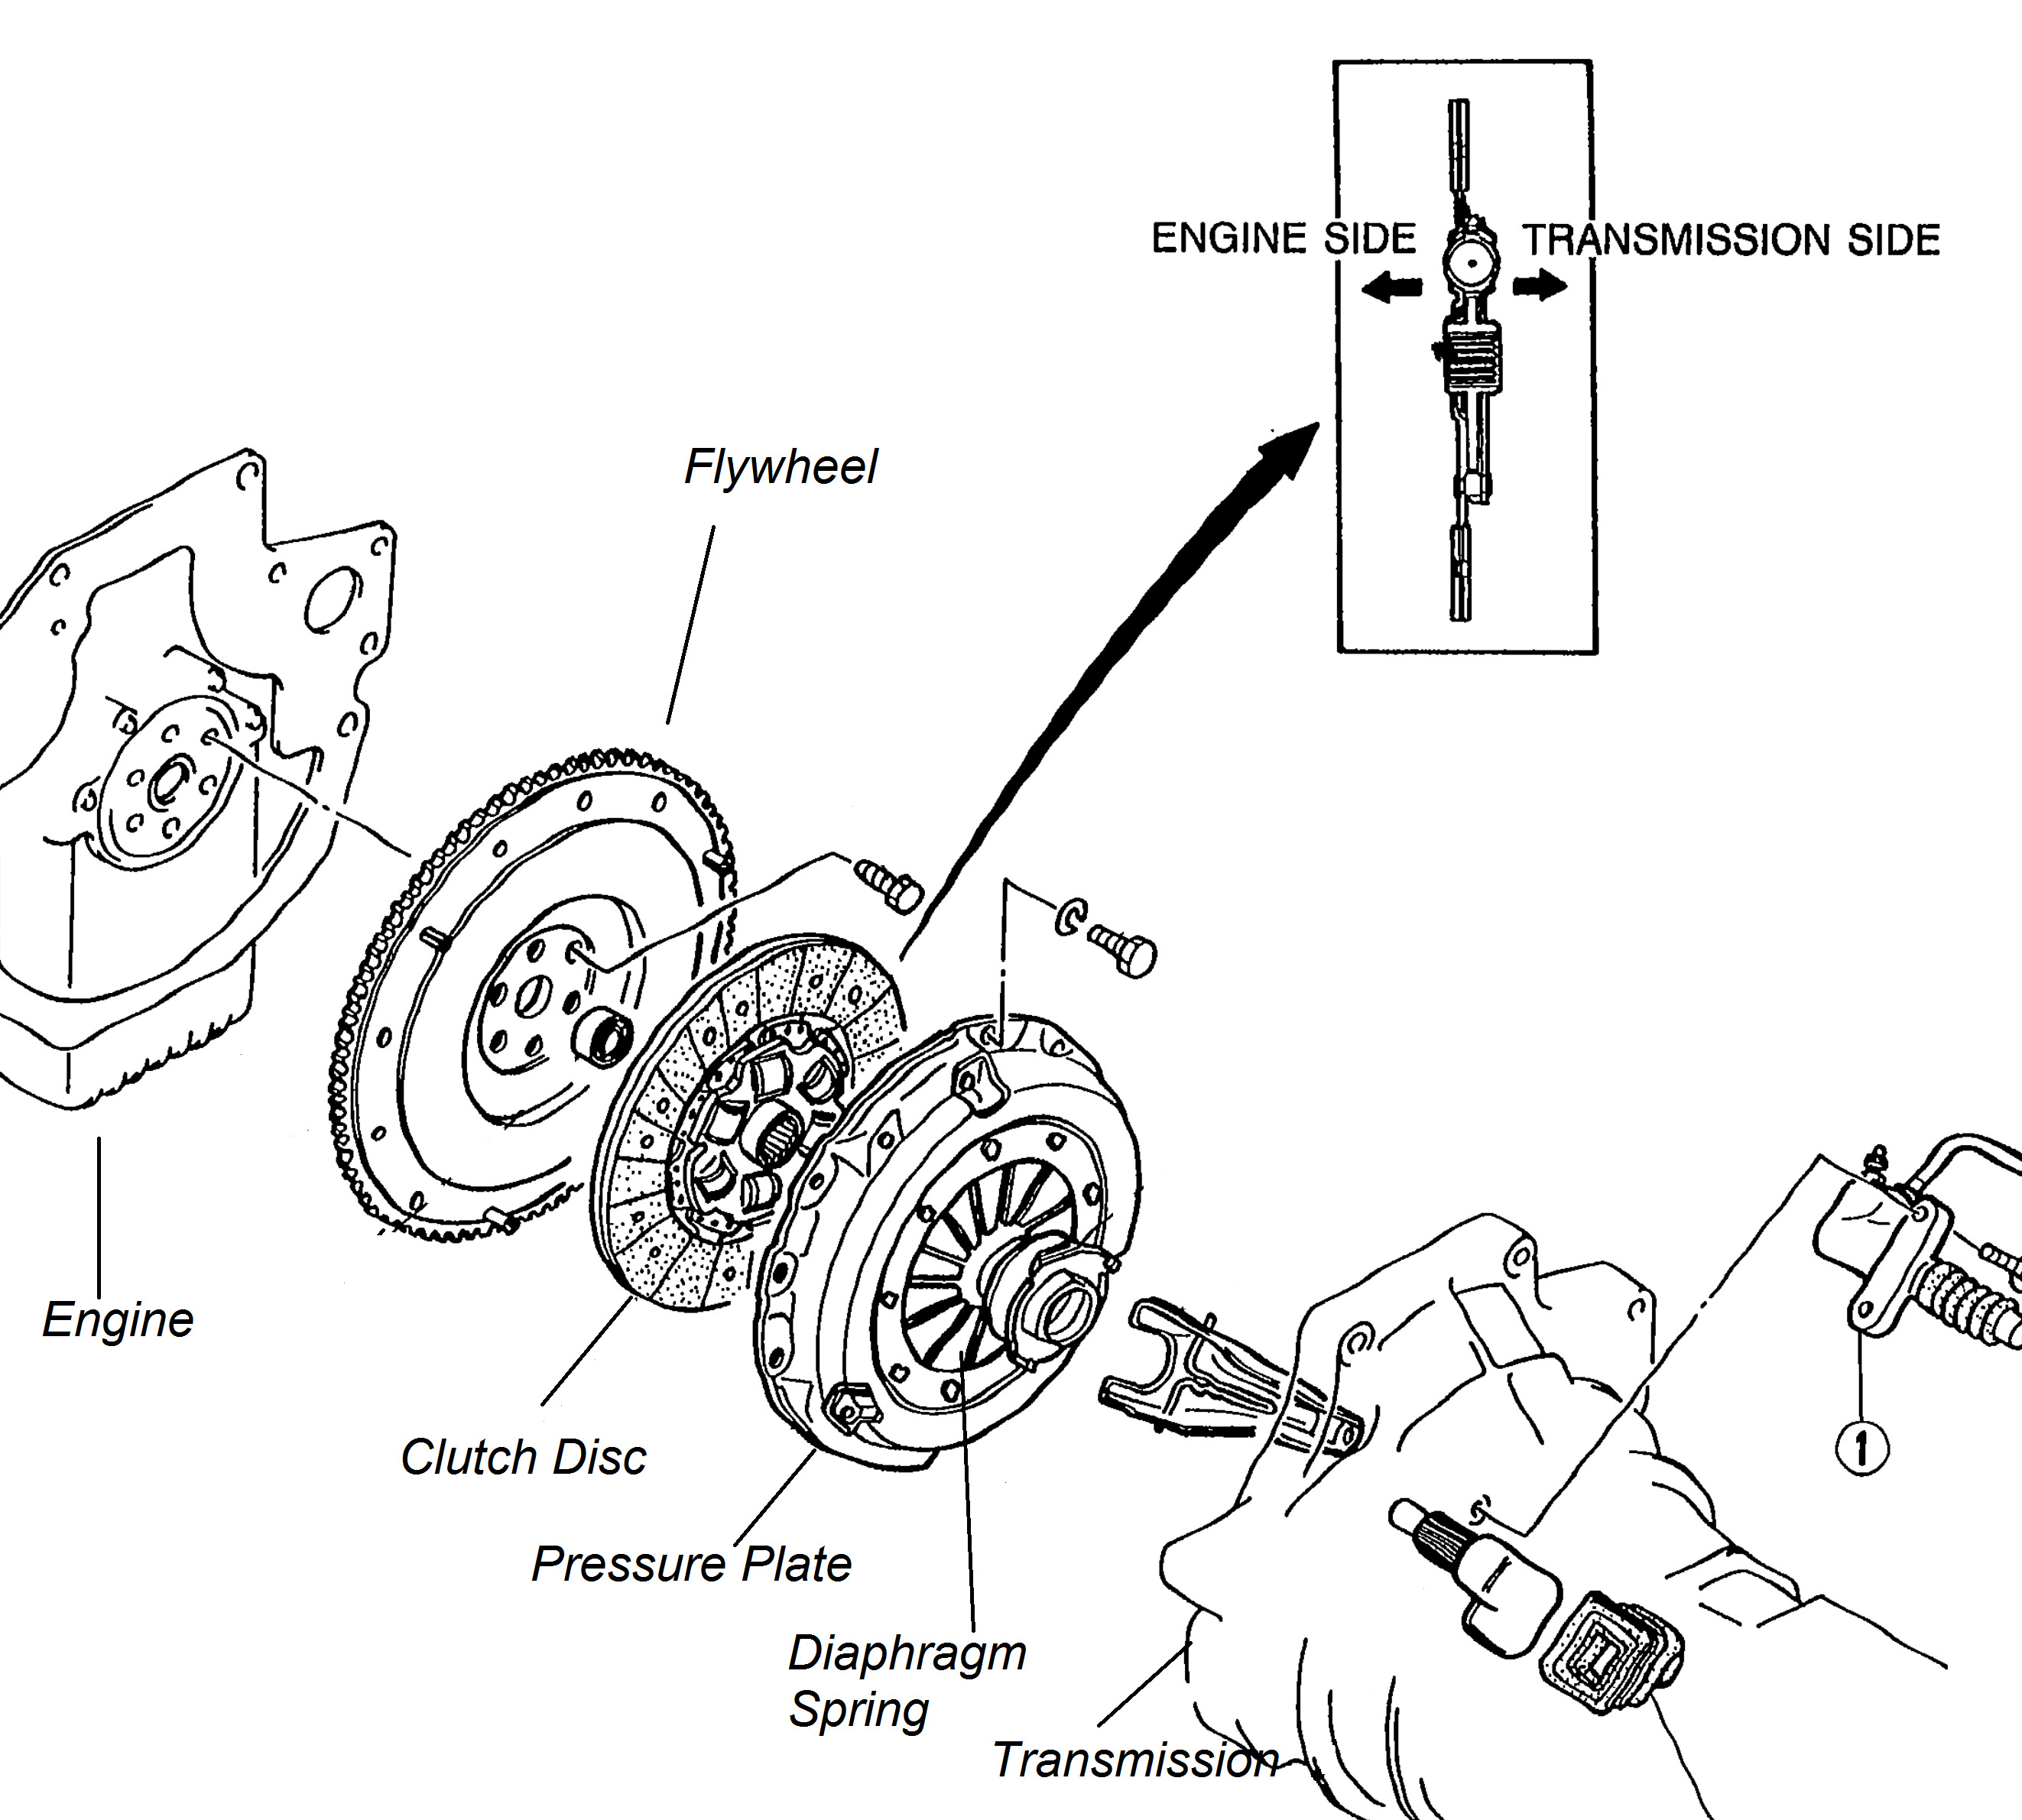
Fig. 3. Clutch assembly [12].

An extensive design study was previously conducted [13], suggesting that the most suitable EM for our low-cost HEV is a Brushless DC Motor (BLDC), with a rated continuous mechanical power output of 10 kW (30 kW peak). Because of our intended use profile involves short pulses of high power for torque-filling, the peak mechanical power figure is as significant in our consideration as the continuous output. BLDC drive is widely used for EV and HEV applications [14-16]. A 10 kW electric machine was found to satisfy most requirements for torque-fill in during gear change. It is also sufficiently powerful to be implemented for secondary functions to improve the powertrain efficiency. These secondary functions may include torque supplementation under high demand or low engine efficiency conditions [17] or energy recovery during braking events.

A detailed description of the motor selection process is given below. The obvious limitation of this vehicle configuration is that it is not possible to isolate the EM from the wheels, and therefore there are incidental losses while the motor is freewheeling. Speed synchronisation during gear shifting is accomplished using standard synchronizers that are popular in manual transmissions, having low cost and high reliability. It is recognised that due to the nature of the mild HEV system proposed, material savings may be found by removal of the synchronizers, instead using electronic throttle control to accomplish speed synchronisation. However, these savings assume that speed synchronisation may be achieved with a very high degree of accuracy, where the inclusion of synchronizers means that the accuracy of the speed synchronisation may be reduced, improving system response. Further, the savings do not translate into lower cost due to the current economies of scale. For these reasons, they are therefore not pursued.

Powertrains provide torque over a large range of operating speeds and deliver it to the road. Therefore, the driving torque, gear reduction and vehicle resistance torque must be considered to model the powertrain accurately. The powertrain is a simple post-transmission parallel hybrid configuration. It utilises a low-powered four-cylinder engine coupled to a five-speed manual transmission through a robotically actuated clutch. The electric motor is connected to the transmission output shaft, before the final drive.

Current literature includes some similar architectures to that proposed herein [10, 18, 19]. Of these, Baraszu [10] most closely resembles the architecture proposed herein. However, our proposed architecture is simpler still, by the omission of the motor clutch. Moreover, the primary focus of our research about achieving desired driveability characteristics at low manufacturing costs. Our project constraints are derived from the fundamental goal of bringing hybrid technology to developing nations. These regions typically do not have a high penetration of AT vehicles and even lower penetration of hybrid/low-emission/zero-emission vehicles, due to high cost-sensitivity. This focus compares well with the literature, which typically focuses on the technological aspect without significant reference to its social context. The focus of this particular article is about the technical and design decisions required to fulfil our fundamental goal; other impacts are part of the future research for this project.

As a complement to the discussion of torque hole control, this paper presents a brief treatment of shift quality and metrics using the Vibration Dose Value (VDV) approach, which provides a metric for occupant comfort. One of the project goal to fulfil our stated aim of bringing hybrid technology to developing nations is to show the occupant comfort of a vehicle equipped with our manual-transmission hybrid powertrain approaches the comfort of an identical vehicle with fully automatic ICE powertrain. We aim to accomplish this through effective motor sizing and control of the torque hole and engine clutch slip. The amount of motor torque applied and the length of time it is applied are optimised by minimising the VDV.

To make a complete study of system response, we must extend the study to consider the vibration of the powertrain, as well as control of clutch and motor. The powertrain model is divided into subsections; these are; the engine model, motor model, powertrain inertia model, and vehicle resistance torques model. These models are presented in this section.

Powertrain lumped model formulation
The application of lumped parameter methods for higher order powertrain models makes use of powertrain characteristics of shaft stiffness and rotating inertia, in conjunction with the physical layout to produce representative models for different powertrain configurations. The powertrain is modelled using torsional lumped parameters to capture the shift characteristics of the system. Inertia elements represent the major components of the powertrain, such as engine, flywheel, clutch drum, clutch plate, synchroniser with final drive gears, shafts, differential, electric motor, wheels and vehicle inertia. These are subjected to various loads such as rolling resistance and air drag. Torsional shaft stiffness is represented by spring elements connecting principal components, and losses are represented as damping elements. Fig. 4 shows the model layout of a motor mounted on a front wheel vehicle. Assumptions can be applied to reduce the complexity of the powertrain. The first is to lump inertia of idling gears in the transmission, and primary gear and synchroniser inertias, thus eliminating numerous transmission components. It is then assumed that there is no backlash in the gears, nor engaged synchronisers, eliminating high stiffness elements in the model. This assumption reduces computational demand. Finally, symmetry in the wheels and axle results in the ability to group these inertias together, as a single element. Additional losses in transmission and differential are modelled with grounded damping elements.
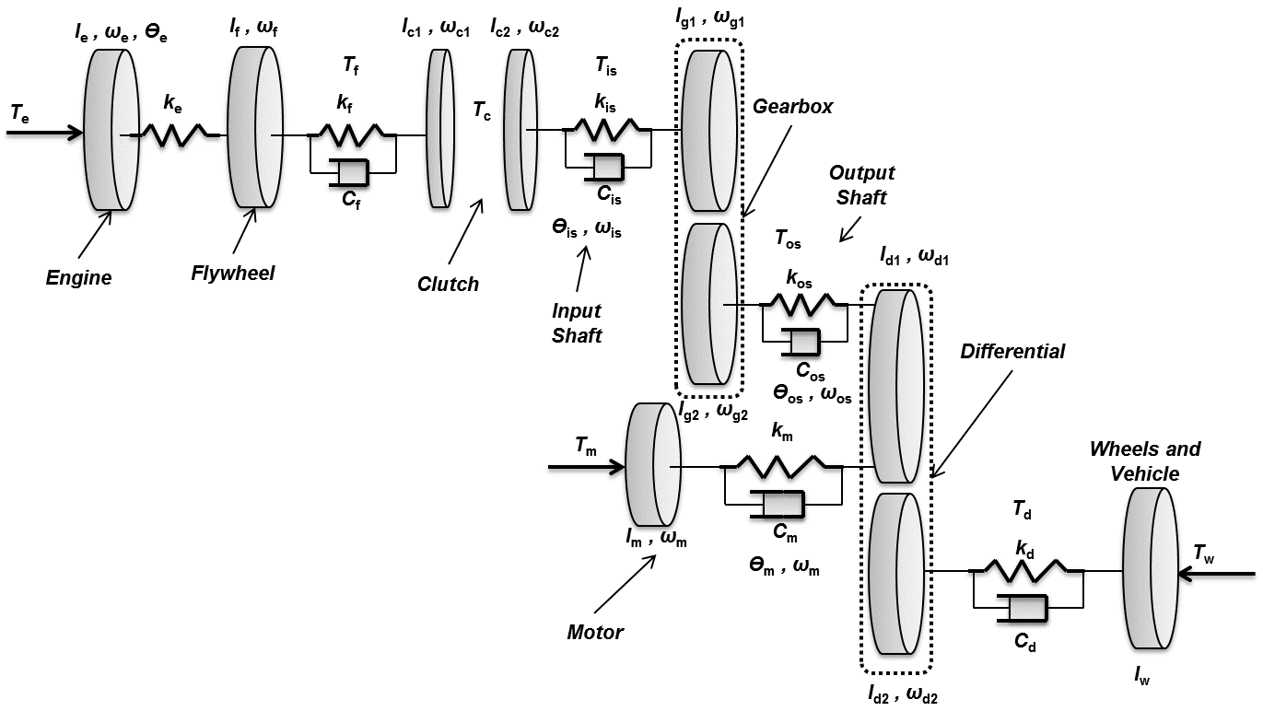
Fig. 4. Lumped parameter model for a mild HEV equipped powertrain.

The lumped parameter model is then constructed using the procedures defined by Rao [20] for torsional multi-body systems in equation (1). The equation of motion may be used for free vibration and forced vibration analysis. Idling gears are lumped as additional inertia on gears targeted for shifting. Backlash in gears is ignored as frequencies excited in lash are generally significantly higher than the main powertrain natural frequencies of 3 to 100 Hz and are unlikely to impact on synchroniser engagement [21]. The generalised equation of motion is:

 | $$I\ddot{θ}+C\dot{θ}+Kθ=T$$ | (1)

Where $I$ is the inertia matrix in kg-m², $C$ is the damping matrix in Nm-s/rad, $K$ is the stiffness matrix in Nm/rad, $T$ is the torque vector in Nm, and $θ$ is the rotational displacement in rad, $\dot{θ}$ is the angular velocity in rad/s and $\ddot{θ}$ is the angular acceleration in rad/s². Gear ratios are represented as γ for the transmission reduction pairs, and final drive pairs. Equations of motion for each element are:

 | $$I_{e}{\ddot{θ}}_{e}-K_{e}\left(θ_{F}-θ_{e}\right)=T_{e}$$ | (2)

 | $$I_{F}{\ddot{θ}}_{F}+K_{e}\left(θ_{F}-θ_{e}\right)-K_{F}\left(θ_{C1}-θ_{F}\right)-C_{F}\left({\dot{θ}}_{C1}-{\dot{θ}}_{F}\right)=0$$ | (3)

 | $$I_{C1}{\ddot{θ}}_{C1}+K_{F}\left(θ_{C1}-θ_{F}\right)+C_{F}\left({\dot{θ}}_{C1}-{\dot{θ}}_{F}\right)={-(T}_{C})$$ | (4)

 | $$I_{C2}{\ddot{θ}}_{C2}-K_{is}\left(θ_{g1}-θ_{c2}\right)-C_{is}\left({\dot{θ}}_{g1}-{\dot{θ}}_{c2}\right)=T_{C}$$ | (5)

 | $${\ddot{θ}}_{g1}({γ_{1}^{2}I}_{g2}+I_{g1})+K_{is}\left(θ_{g1}-θ_{c2}\right)+C_{is}\left({\dot{θ}}_{g1}-{\dot{θ}}_{C2}\right)-{γ_{1}K}_{os}\left({θ_{d1}-γ}_{1}θ_{g1}\right)-{γ_{1}C}_{os}\left({{\dot{θ}}_{d1}-γ}_{1}{\dot{θ}}_{g1}\right)=0$$ | (6)

 | $${{\ddot{θ}}_{d1}(γ_{2}^{2}I}_{d2}+I_{d1})+K_{os}\left(θ_{d1}-{γ_{1}θ}_{g1}\right)+C_{os}\left({\dot{θ}}_{d1}-{γ_{1}\dot{θ}}_{g1}\right)-{γ_{2}K}_{d}\left({θ_{W}-γ}_{2}θ_{d1}\right)-{γ_{2}C}_{d}\left({{\dot{θ}}_{W}-γ}_{2}{\dot{θ}}_{d1}\right)=0$$ | (7)

 | $${{\ddot{θ}}_{d1}(γ_{2}^{2}I}_{d2}+I_{d1})+K_{os}\left(θ_{d1}-{γ_{1}θ}_{g1}\right)+C_{os}\left({\dot{θ}}_{d1}-{γ_{1}\dot{θ}}_{g1}\right)+K_{m}\left(θ_{d1}-θ_{m}\right)+{C_{m}\left({\dot{θ}}_{d1}-{\dot{θ}}_{m}\right)-γ_{2}K}_{d}\left({θ_{W}-γ}_{2}θ_{d1}\right)-{γ_{2}C}_{d}\left({{\dot{θ}}_{W}-γ}_{2}{\dot{θ}}_{d1}\right)=0$$ | (8)

 | $$I_{W}{\ddot{θ}}_{W}+K_{d}\left(θ_{W}-γ_{2}θ_{d1}\right)+C_{d}\left({\dot{θ}}_{W}-γ_{2}{\dot{θ}}_{d1}\right)=T_{W}$$ | (9)

 | $$I_{m}{\ddot{θ}}_{m}+K_{m}\left(θ_{m}-θ_{d1}\right)-C_{d}\left({\dot{θ}}_{d1}-{\dot{θ}}_{m}\right)={-T}_{m}$$ | (10)

If the clutch is engaged, equations (4) and (5) are unified, and the inertias of the clutch members combine. Equation (11) is the resulting equation of motion. With the clutch engaged the total number of degrees of freedom of the system decreases. If the clutch is disengaged, then the system has eight degrees of freedoms, while if the clutch is engaged, there are only 7 degrees of freedom.

 | $${(I_{C2}+I}_{C1}{\ddot{)θ}}_{C}+K_{F}\left(θ_{C}-θ_{F}\right)+C_{F}\left({\dot{θ}}_{C}-{\dot{θ}}_{F}\right)-K_{is}\left(θ_{g1}-θ_{c}\right)-C_{is}\left({\dot{θ}}_{g1}-{\dot{θ}}_{c}\right)=0$$ | (11)

The flexibility of hybrid vehicles allows many choices of engine/electric machine configuration. This flexibility in configuration enables the study of the effect of different configurations on vehicle performance and transient vibration suppression. In the proposed configuration as presented in Fig. 4, the electric machine will be positioned on the transmission output shaft, using a constant gear ratio for power conversion. The powertrain configuration for hybrid vehicle powertrains is dependent on a range of design considerations which ultimately determine the layout, interconnection, and sizing of components. The model parameters of the powertrain (inertia, damping, and stiffness) are listed in the appendix, and are sourced from known data or estimated based on published literature. When looking at a mild hybrid powertrain equation (10) is introduced and equation (8) is used instead of equation (7) which is used when analysing a conventional powertrain.

Free vibration analysis
Damped free vibration analysis is used to determine the vehicle modes, damping ratios, and natural frequencies. This method requires the representation of the model in state-space form. The externally applied torques are assigned as a zero value for free vibration. The equations are then presented in matrix form, as:

 | $$I\ddot{θ}+C\dot{θ}+Kθ=0$$ | (12)

The system matrix is taken from equation (12) and used to perform damped free vibration analysis. The application of the eigenvalue problem can be used to determine natural frequencies and damping ratio. The system matrix is:

 | $$A=\left[\begin{matrix}0 & \overline{I} \\ I^{-1}C & I^{-1}K\end{matrix}\right]$$ | (13)

where A is the system matrix, and $\overline{I}$ is the identity matrix. The natural frequencies and damping ratios are presented in Table 1. With the clutch open there are effectively two rigid body modes as the two separate powertrain halves are effectively not coupled. Further, each of the open natural frequencies is associated with the two separate bodies, the higher frequency for the engine and clutch disc with high stiffness and relatively small inertia, and the lower frequency for the transmission and vehicle body. With the clutch closed, however, the damping ratios are essentially identical, and the natural frequencies are reasonably close, consistent with the change in effective inertia experienced by the locked drum and transmission inertias coupled via reduction gear pairs. The damped free vibration of the powertrain is completed using state-space methods. Matrices for I, C, K are developed and merged into the system matrix, and the eigenvalue problem is solved for the damped natural frequencies of the system. Real and imaginary components are utilised to identify the un-damped natural frequency and damping ratio.

Free vibration analysis is used here to compare powertrain models with and without a motor. Damped free vibration analysis is applied to both models, with natural frequencies and damping ratios presented for each. Modal shapes are then used to identify the relationship of natural frequency to the model. Damped free vibration results provide the essential characteristics of the powertrain. Damping ratio results demonstrate the lightly damped nature of the powertrain, where no damping ratio exceeds 10% (Table 2). Light damping provides more opportunities for excitation in the powertrain resulting from nonlinearities that can contribute to the initiation of high-frequency vibration in the propshaft. For the mild hybrid vehicle model with primary clutch closed free vibration analysis results in one rigid body mode of the powertrain and six natural frequencies with corresponding damping ratios. Solutions to the eigenvalue problem resulted in 7 paired solutions with real and imaginary components. For each solution, the real component of the eigenvalue was negative, indicating a mathematically stable system, and zeros have been omitted from matrices for clarity. The natural frequency of the rigid body mode (RBM) included a small imaginary component as a result of the use of grounded damping elements; this does not affect the stability of the system. In both powertrain models for the open clutch case, two RBM are present, while, for each of the closed clutch models only one RBM is present.

Table 1. Damped free vibration results of ICE powertrain and mild HEV in 1st gear.
 | ICE Model
Frequency number | Natural frequency  $ω_{n}$(Hz) | Damping ratio  ζ (%)
1 | 312.6261 | 1.901
2 | 134.9499 | 0.62
3 | 96.3400 | 8.41
4 | 10.1634 | 0.07
5 | 7.7347 | 1.71
6 | 0 | -

 | Mild HEV Model
Frequency number | Natural frequency  $ω_{n}$ (Hz) | Damping ratio  ζ (%)
1 | 312.6261 | 1.901
2 | 231.2795 | 0.03
3 | 134.9499 | 0.62
4 | 96.3400 | 8.41
5 | 10.1620 | 0.07
6 | 7.7347 | 1.71
7 | 0 | -

Table 2. Natural frequencies of each gear ratio
 | Original Drivetrain
Mode | 1st | 2nd | 3rd | 4th | 5th
1 | 312.62 | 328.15 | 347.12 | 369.53 | 390.57
2 | 134.94 | 134.95 | 134.96 | 134.96 | 134.97
3 | 96.34 | 90.87 | 84.76 | 78.25 | 72.71
4 | 10.16 | 10.19 | 10.23 | 10.28 | 10.32
5 | 7.73 | 7.53 | 7.25 | 6.86 | 6.43
6 | 0 | 0 | 0 | 0 | 0

 | Mild HEV
Mode | 1st | 2nd | 3rd | 4th | 5th
1 | 312.62 | 328.15 | 347.12 | 369.53 | 390.57
2 | 231.27 | 231.27 | 231.27 | 231.27 | 231.27
3 | 134.94 | 134.95 | 134.96 | 134.96 | 134.97
4 | 96.34 | 90.87 | 84.76 | 78.25 | 72.71
5 | 10.16 | 10.19 | 10.23 | 10.28 | 10.32
6 | 7.73 | 7.53 | 7.25 | 6.86 | 6.43
7 | 0 | 0 | 0 | 0 | 0

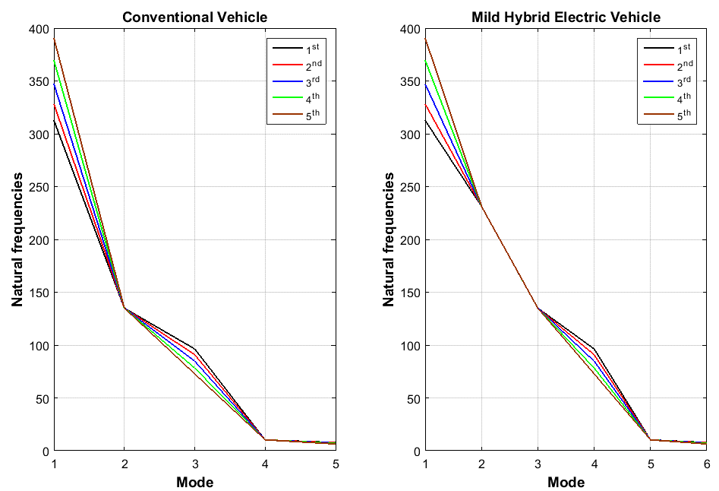
Fig. 5. Natural frequencies of each gear ratio

Compared with original drivetrain, the design system has one more degree of freedom, so there is one more state of natural frequency; the high-frequency response is higher than original drivetrain. For lower frequency response, there is no significant difference. Therefore, it can be concluded that inserting an electric motor with additional inertia does not have a significant effect on low-frequency response. Indeed, it can be observed in Fig. 5 that with the addition of the motor a single new frequency at 231 Hz is introduced to the system. It is otherwise unaffected.

Single dry clutch model
The preferred model describes the system in a piece-wise manner, with one equation describing the slipping phase and another describing the sticking phase of the clutch. The torque through the clutch while slipping is given by equation (14). The sticking of the clutch is sustained as long as the torque transmitted through clutch ($T_{c}$) remains below the maximally transmittable torque$T_{c}^{max}$ , which is given by equation (15) [11, 22, 23].

 | $$T_{c}={-F}_{n}μR_{a}sign(ω_{e}-ω_{c})$$ | (14)

 | $$T_{c}^{max}= F_{n}μ_{stick}R_{a}sign(T_{c})$$ | (15)

The active radius of clutch calculated given by equation (16), which is detailed in [24].

 | $$R_{a}= \frac{2}{3}\left(\frac{r_{o}^{3}-r_{i}^{3}}{r_{o}^{2}-r_{i}^{2}}\right)$$ | (16)

In equations (14), (15), (16): $μ$ is the dynamic friction coefficient of the clutch-facing material with opposing surfaces, $ω_{e}{, ω}_{c}$represent the rotational speed of the clutch disc and transmission input shaft respectively, $R_{a}$ is the active radius of the clutch plates. The clutch actuator produces the normal force $F_{n}$ as pressure load on the clutch and with this force the clutch torque $T_{c}$ that is transferred to the driveline is controlled. Simplifying assumptions are made regarding variation in dynamic friction according to clutch face pressure, interface temperature, and slip speed. The pressure is assumed uniform across the clutch face in this model, and, for simulation purposes the clutch is assumed to be non-varying in temperature. Generally speaking, the friction coefficient is expected to vary somewhat with both temperature and wear. Whilst these variables will have some impact on experimental work, for the purposes of this investigation it is sufficient to assume that friction is independent of these variables. The static friction coefficient $μ_{stick}$ is applied to the normal force across the clutch when the clutch is locked. $μ_{stick}$ must be larger than $μ$. Based on the available literature [25, 26], we have assumed $μ_{stick}$ is 0.3, and is 20% higher than $μ$ (that is, $μ_{stick}=1.2(μ)$). Furthermore, the term $sign(T_{c})$ is non-positive in the case of vehicle (engine) braking and positive in all other cases. $r_{o}$ is external diameter of clutch friction plate and $r_{i}$ is inner diameter of clutch friction plate. When modelling a dry clutch system, the stick-slip friction model is detailed in [25, 26].

Vehicle torque model
The vehicle resistance torque is defined as a combination of road grade, rolling resistance of the vehicle, and aerodynamic drag interactions with weight and gradeability factors as follows:

 | $$T_{v}=(f_{R}M_{v}g\cos{∅}+M_{v}g\sin{∅}+\frac{1}{2}C_{D}ρA_{v}V_{v}^{2})r_{w}$$ | (17)

Where $T_{v}$ is vehicle torque, $V_{v}$, m, $A_{v}$ are the speed, mass and frontal area of the vehicle, $r_{w}$ is the wheel radius, $f_{R}$ is the rolling resistance (friction) coefficient, $C_{D}$ and ρ are the drag coefficient and air density, $∅$ is the road grade and g is gravitational acceleration [27, 28].

Motor model
To simplify the system model, a DC equivalent motor model is used to represent the electric prime mover. This simplification reduces the three phase permanent magnet motor to a simple two degree of freedom model and allows direct control of input voltage without consideration of power electronics for these simulations. The complexity of simulating power electronics is eliminated, and the direct voltage control of the motor is now possible. The differential equation for the electric circuit is defined in equation (18).

 | $$V=IR+K_{e}\dot{θ}+L \frac{dI}{dt}$$ | (18)

Where I is the line current, L is the line inductance, $K_{e}$ is the back emf constant, R is the line resistance, and V is line voltage. The electromagnetic torque produced in the motor is defined as follows:

 | $$T_{em}= K_{t}\dot{θ}$$ | (19)

Where $K_{t}$ is the torque constant and $T_{em}$ is the electromagnetic torque. These two equations represent the electrical component of the model equations of motion, and should be considered in conjunction with the equations of motion presented [29].

Modelling the electric machine for vehicular powertrains is somewhat different to traditional engine modelling. Generally, electric machine models use only a maximum output torque with an integrated efficiency map and the supplied battery power to determine the driving load delivered to the wheels. For the electric machine, it is assumed that the demanded power from the controller is supplied to the motor ($P_{s}$), this is combined with motor speed and efficiency to determine the actual motor output torque. The motor output torque is calculated as follows for the motor.

 | $$T_{m}= η_{m}\frac{P_{s}}{\dot{θ}}$$ | (20)

Where $P_{s}$ is the supplied power, $T_{m}$ is the output torque of the motor, and $η_{m}$ is the motor efficiency. It is important to note here that the maximum torque available from the motor is limited by the rated power.

Engine model
The physical simulation models of engine and control were established within the Simscape environment. The engine model only plays a role as providing torque output and speed for a given throttle command, so the simple engine model “Generic Engine” in the SimDriveline package is chosen directly, as used in [30, 31].

Shift-control strategies for mild HEV
There are many considerations required for implementing the control strategy and its integration with gear shift control. These considerations include clutch position, gear state, engine speed, throttle position, and propshaft speed. A robotized clutch and gear actuator would be applied to the final system, allowing control of both target gear and shift time. This hardware simplifies the control problem immensely and improves the quality of the solution. However, for our proof of concept, a predictive model is established based on a known drive cycle. For simplicity, clutch and gear actuation may be controlled using driver-in-loop or open-loop electronic control. Either method is time- and cost-efficient, and provides valid results, that may be simply applied to a robotized system with little modification. Gear state and clutch engagement are electronically detected by a control unit, which drives the motor assembly integrated into the transmission output shaft. Our discussion of shift-control strategies below assumes a robotized gear and clutch actuator. There are three control regimes. The first is ICE-start, which is used when starting the vehicle from rest. The second and third are shift-up, and shift-down. During the ICE-start regime, the vehicle may be powered in three modes; by the engine alone, by the engine and motor, or by the motor alone. In the first (engine-only) mode, the first gear is engaged, and the clutch is open; thereby no torque is transferred to the wheels. When the clutch begins to engage, thanks to an axial load acting on its friction surface, a progressive torque transfer to the first gear set takes place through the input shaft. The system then passes control to the “shift-up” regime.

Under limited circumstances, the motor-only mode of ICE-start may be engaged. These circumstances include suitable high-SOC, idle start-stop has stopped the engine and, low torque request from the driver. In this case, second gear is engaged at zero speed, and the clutch is open so that it does not cause the engine to be driven by the motor. The motor supplies 100% of the requested torque until the shift schedule indicates a shift into second gear is required, or a low-SOC causes the engine to fire. At this point, the engine is fired, and the system switches to the “shift-up” control mode, having already preselected the required gear. In the case of a high torque request from the driver, the ICE-start regime may engage both engine and motor to propel the vehicle from rest. Because at high torque, the 1-2 torque hole will not be able to be completely filled by the motor, it may be minimised by operating the motor at peak torque until the completion of the 1-2 shift. This strategy ensures swift progress while maximising drivability. The shift-up regime is used whenever a higher gear is required than that currently selected. It is described in the flowchart presented in Fig. 7 Likewise, shift-down controls the system when a shorter gear is needed. The two regimes are very similar in operation, and both are called depending on a shift schedule that is illustrated in Fig. 6 [32]. Because the proof-of-concept will be tested according to specified drive cycles, robotized gear and clutch actuation is not strictly necessary for the development of the torque hole compensation function. Target torques and speeds may be programmed instead, and the control strategy is initiated using a clutch switch. This development programme also presents an interesting opportunity to study the performance of the system with and without automatic shifting, which may present further cost savings.

Manual transmission synchronizers are used to match speeds with the target gear and physically lock it to the shaft. The synchronizer consists of a dog-clutch and a cone. The dog-clutch is engaged after the cone and brings the gear up to the speed of the shaft. This hardware compensates for the normal dynamic limits of manual transmission [33], eliminating the need to accelerate each gear as it is engaged (“double de-clutching”). Synchronizers grant better performance in accelerating the vehicle and more comfortable driving in the absence of continuous torque transmission during gear shifts [34]. When synchronisers are combined with the electric torque-fill, the hardware will ideally result in no loss of tractive torque to the road, as well as reduced maintenance by reducing wear of the clutch friction lining through better synchronisation of the engine speed to the in-gear road speed.
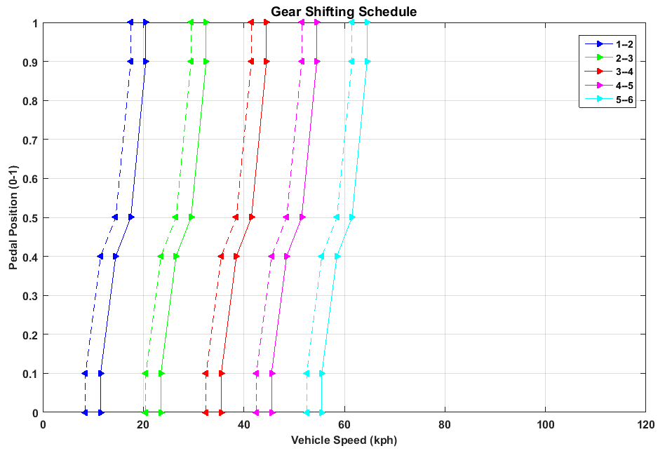
Fig. 6. Gear Shifting schedule.

The appendix contains some control block diagrams taken from our Simulink development work on shift control. The Stateflow chart, shown in Fig. 15 is a realisation of the conceptual framework discussed above. While very similar to the conceptual framework, the Stateflow chart has two notable differences. The shifting processes states have been grouped to form the “SelectionState” superstate, and the gear states have been grouped together to form the “GearState” superstate. This grouping helps organise the mode logic into a hierarchical structure that is simpler to visualise and debug. However, the inclusion of time delays in shift control must be considered to achieve best possible driveability (vibration) performance, as this allows torque disturbances caused by each event in the control algorithm to be absorbed by the powertrain, allowing the vehicle occupant more time to perceive the step in torque. This reduces the perceived aggressiveness of the shift event.
Fig. 7. Up-shift process

Simulation
Before building a prototype, model simulation is the most appropriate tool for evaluating and analysing the performance of vehicles, particularly hybrid electric vehicles. Moreover, model simulation is a major step for the validation and calibration of such systems and has therefore attracted interest from both industry and academics. The powertrain model discussed herein was built in the Matlab/Simulink environment as a mild HEV model. The Simscape simulation was performed using the ODE23t element from the ODE suite with a maximum time step of 10⁻¹ for the powertrain model; relative tolerance is set to 10⁻³. State flow event functions were used to determine lockup conditions and move between powertrain models. The results mainly focus on the electric drive mode part and comparison of the transient response of drivetrains. For initial data comparison with between models, a single cycle of the Rural Driving cycle (RDC) Fig. 8 was used. It was selected for its simplicity and utilises five up-shifts over its duration.
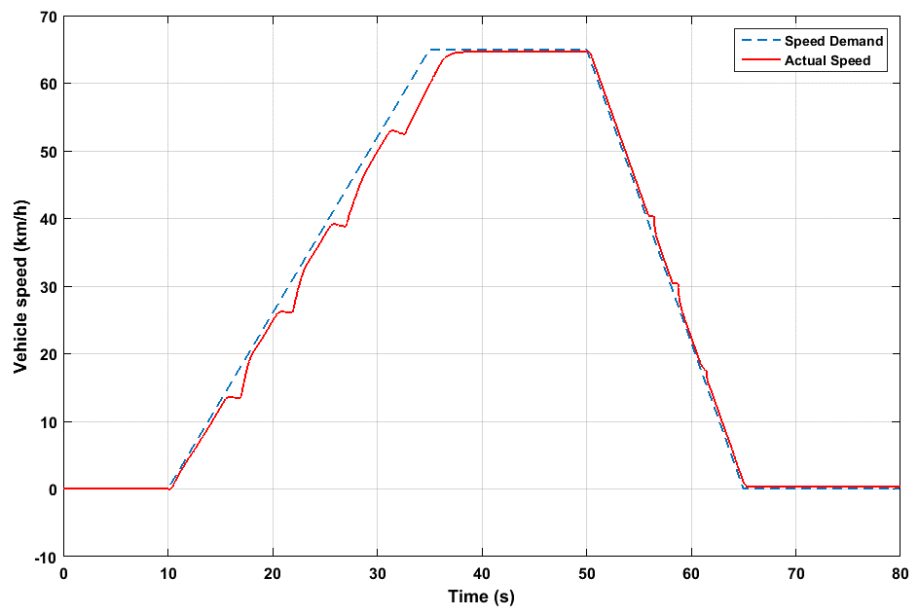
- Conventional vehicle Manual Transmission simulation on the RDC drive cycle.
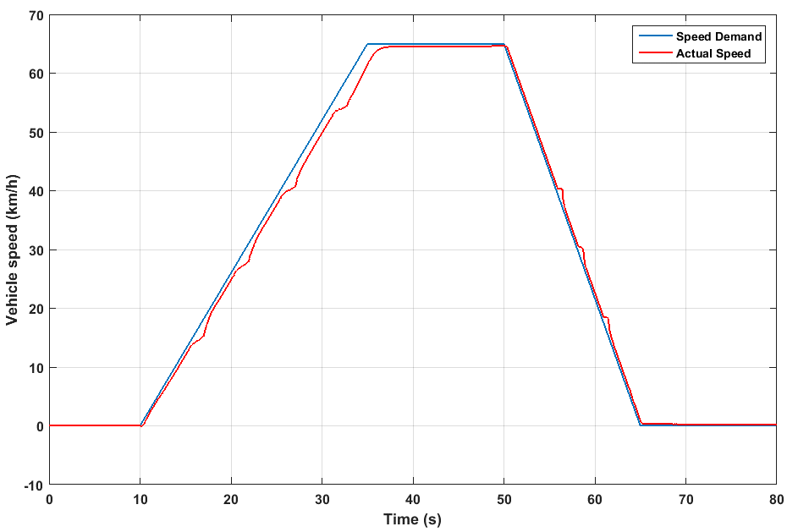
(b) Mild Hybrid vehicle simulation on the RDC drive cycle.
Fig. 8 (a)-(b). Rural Drive Cycle simulation for both conventional and mild hybrid vehicles.

The speed of the input shaft (i.e. engine speed) during the gear change event is related to the initial gear ratio and road speed in the first instance. When the clutch is disengaged, the engine speed becomes independent of the selected gear and road speed and is instead solely dependent on throttle angle. When the target gear is selected and the clutch is engaged, the engine speed is proportional to the new gear ratio and the road speed. The gear shift process results in a large hole in the output torque and a decrease in speed during both the clutch disengagement and gear selection processes during shifting. This torque hole can be reduced by bringing the electric motor into motive contact with the final drive throughout the control process, so long as the clutch hydraulic pressure is greater than zero. Simulations were conducted using both a conventional and a torque-fill drivetrain. These were modelled for comparison. The result shows the difference in magnitude of the torque hole between the different powertrains. The results mainly focus on the variation in shaft speed due to different gear ratios and compare the transient response.

Fig. 9 shows the velocity of the vehicle during an acceleration event 0-100 km/h under maximum throttle conditions. This simulation was conducted to gauge the performance improvement in this vehicle benchmark as compared to the conventional powertrain. During gear changes, the torque-fill control method was implemented. Other than during gear changes, the throttle was held fixed at 100% open. The results of this simulation show acceleration time is reduced by approximately 1.5 seconds using the torque-fill drivetrain, and the deceleration during each gear shift is reduced markedly.

Fig. 10 represents the output shaft torque of the conventional and mild HEV drivetrain when upshifting from 2nd to 5th gear, following the 0-100 km/h drive cycle shown in Fig. 9. For clarity, the data after the 4-5 gear change is truncated. In each upshift event, there are three discrete torque oscillation responses. Disengaging the clutch causes the first torque excitation. When the clutch is opened, the engine and flywheel inertia are decoupled from the transmission. This sudden change in inertia causes excitation of torque response. Synchronising gears causes a second, smaller excitation. When the previous gear is desynchronized, and the next gear is locked to the output shaft, this causes a variation in layshaft speed due to the energy absorbed by the synchroniser as well as windage and bearing losses. The third spike occurs when the clutch is re-engaged. Torque overshoot can occur due to different rotational speeds between the flywheel and clutch disc [35]. The torque excitations on the output shaft are clearly illustrated. The torque profiles of original drivetrain and the torque-fill drivetrain are compared. When the system is operating in torque fill-in mode, it is shown that the torque hole is reduced, as well as a marked reduction in the oscillatory peak, by approximately 175 Nm.

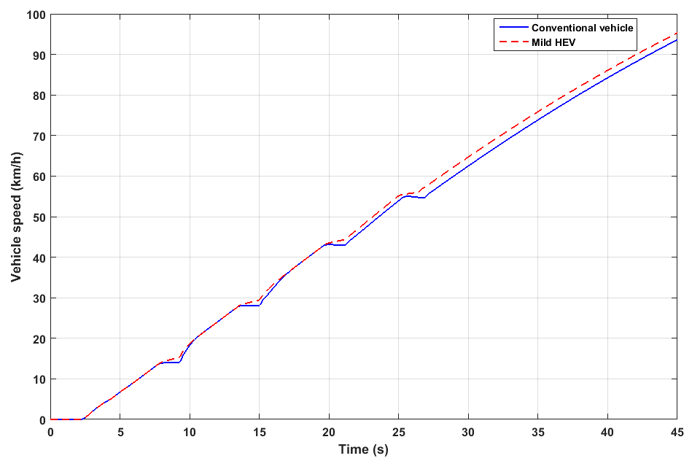
Fig. 9. 0-100 km/h acceleration in ICE and Mild HEV models.
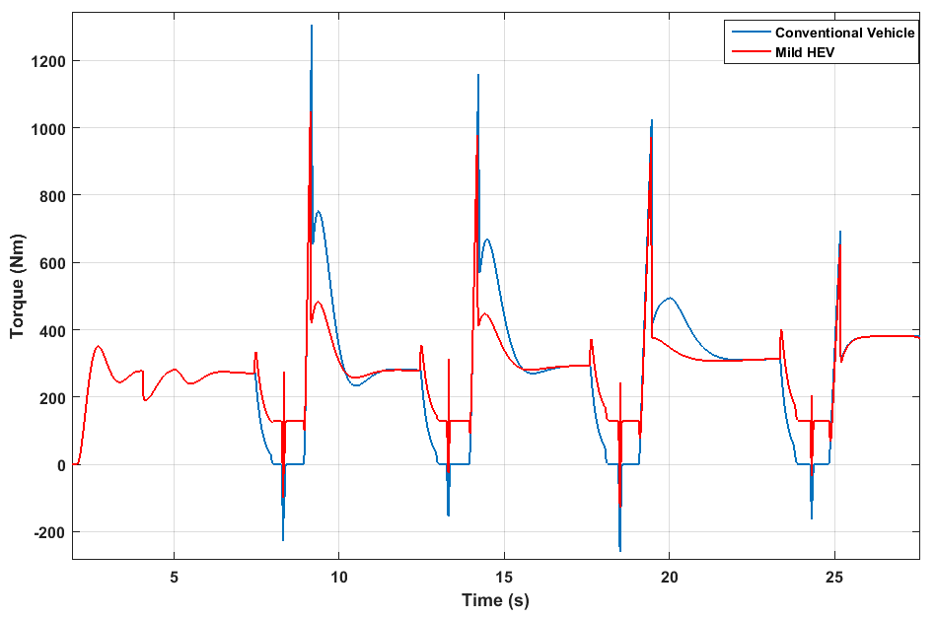
Fig. 10. Output shaft torque profile during 0-100km/h acceleration cycle.

Evaluating Motor Characteristics
The electric motor in our mild hybrid is designed to be mechanically connected directly to the propshaft. A mechanical input power of up to 10 kW is provided for the system. It is intended to provide acceleration assistance but no, or highly limited all-electric driving mode [36, 37]. The motor output is mainly used for accelerating and starting. The RDC was used to investigate the effect of the torque-fill system on gear changes. Its simplicity and the requirement to select all available gears to fulfil the speed profile made it ideal as a base for investigating transient torque characteristics shown above. However, it is not representative of the everyday stop-start driving and heavy congestion in many developing capital cities, which are the target market for our powertrain. Therefore, we could not use it to select appropriate motor characteristics. To select an appropriate electric motor, an analysis of the vehicle architecture under the New York City Dynamometer Drive Schedule (NYCDDS, or NYC Cycle) was conducted. The NYC cycle was selected as the most appropriate representation for the target market for our proposed vehicle architecture.

The analysis used a speed trigger to determine the number of gear shift events over the course of the cycle. In some sections of the NYC cycle, the speed profile fluctuates quickly. This rapid fluctuation resulted in the speed trigger identifying a number of shifts in quick succession. Where shifts that were not required to maintain the cycle profile were identified, or where the profile could be better maintained by holding a gear longer, superfluous shifts were deleted. For instance, a shift pattern of 3-2-3 in a period of fewer than ten seconds suggests that gear 3 could be held. Therefore, the superfluous 2-downshift and 3-upshift are deleted. Likewise, a shift pattern of 1-2-1-2-3 in rapid succession indicates that second gear may be held longer, eliminating the downshift and subsequent upshift.
For the total cycle length of 598 seconds, 42 gearshifts were required. Ignoring downshifts, the average power required at upshift was calculated to be 9.47 kW, with only five upshift events requiring over 10 kW (see Fig. 11 a). A similar plot can be produced for motor output torque using the target speed at each projected gear change. As the motor is placed after the first reduction ratio, it is independent of this variable, and the output torque is, therefore, a simple function of the target speed and required power. All but four gear change events are found to require less than 130 Nm output torque for torque fill-in (see Fig. 11 c). The motor speed and torque characteristics can then be determined by plotting these variables for each gear change event.
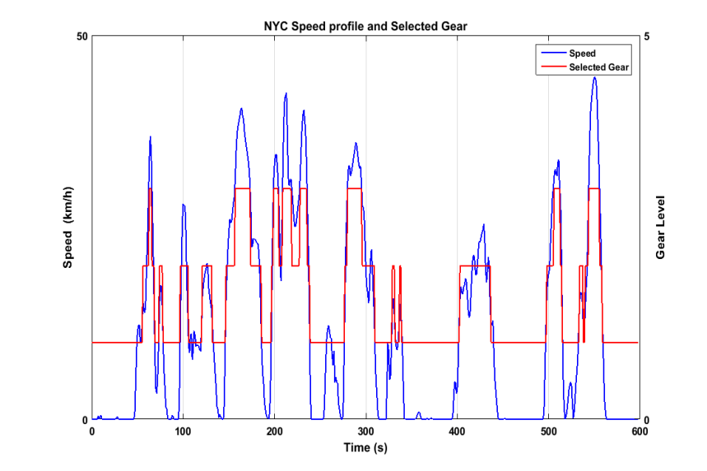
- NYC Cycle speed profile with selected gear superimposed.
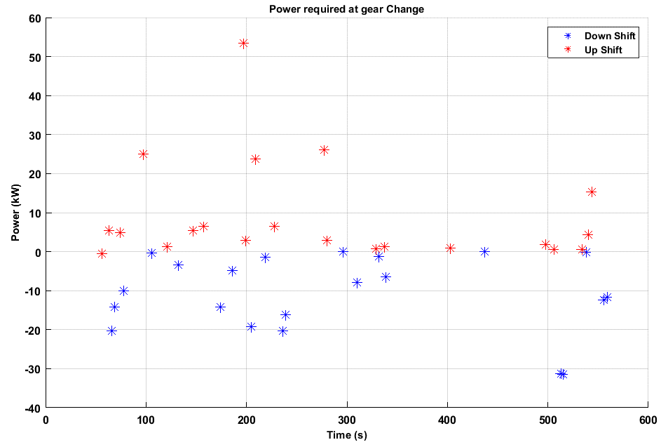
- Power required at gear change, NYC Cycle.
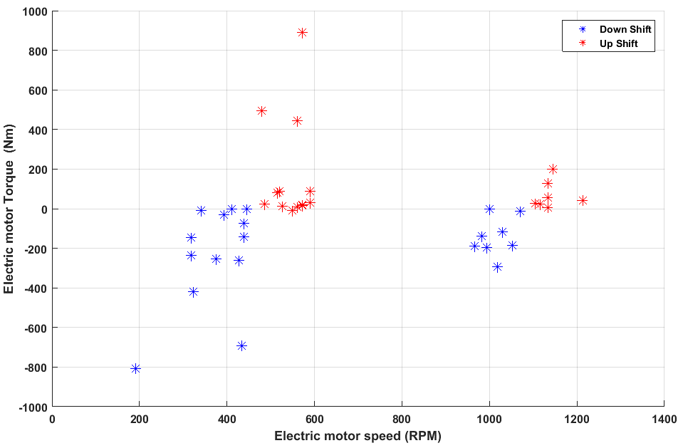
- Electric motor torque and speed required at gear change.
Fig. 11. (a)-(c). NYC cycle analysis.

Based on the NYC cycle analysis, a 10 kW / 30 kW pk. electric motor was found to satisfy requirements. The Motenergy ME0913 (12 kW / 30 kW pk. electrical input) motor was selected as a suitable off-the-shelf motor for initial testing. The manufacturer quotes a thermal efficiency of 85% at its full continuous power, which translates to 10.2 kW mechanical output. Although its peak torque is somewhat lower than ideal, it is the closest off-the-shelf solution to meet our hardware needs. Bench-testing yields characteristic curves, which are included in the Simulink programme. The complete testing and validation process is described in [13].

Other motor options were simulated to validate this selection, ranging from 8 kW (a sub-mild hybrid) to 20 kW electrical power in 4 kW increments. 25 kW and 50 kW simulations were also conducted to investigate the difference between a low-powered mild-hybrid, and a higher-powered electric motor as would be installed in a full-hybrid vehicle. The hypothetical motors were characterized by scaling the torque/speed characteristics of the ME0913 that was physically available for testing [38]. A partial throttle acceleration test was simulated using each hypothetical motor, consistent with a typical gradual acceleration to cruising speed and using time-based shift events. The output results were examined. Summary results are presented in Fig. 12. From the investigation of different motor characterizations, the hypothetical 20 kW motor had a noticeable effect in decreasing the oscillation excited by the gear synchronisation (the second and smallest oscillation observed in each gear shift event). However, the other two, larger oscillations showed an increasing trend in magnitude with decreasing motor size. Torque-fill effectiveness was similar for the hypothetical 16 kW and 20 kW motors. The ICE-only powertrain achieved a maximum vehicle velocity of 94 km/h at the end of the 30-second test. The hypothetical 20 kW and 16 kW motors achieved the same speed 36% faster. The ME0913 was approximately 6% slower than these on a 30-second acceleration test, and the hypothetical 8 kW motor was approximately 9% slower again. This difference indicates that the ME0913 is somewhat under-specified, which is consistent with our previous analysis. It also indicates that the hypothetical 20 kW motor offers no significant benefit compared to the 16 kW option.
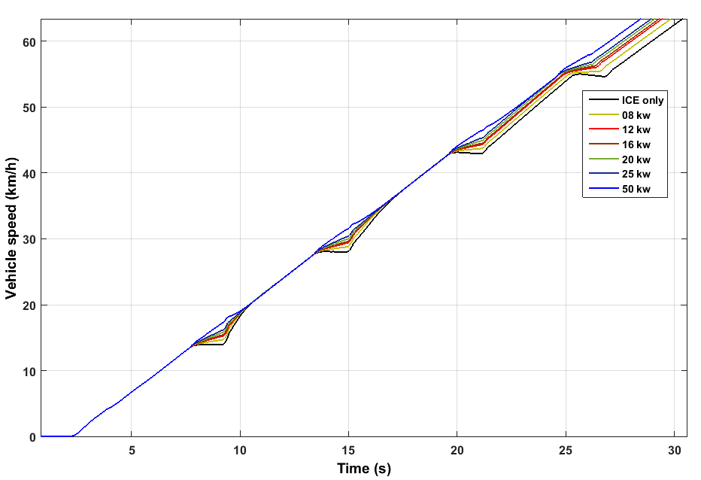
- Vehicle performance study: 0-60km/h.
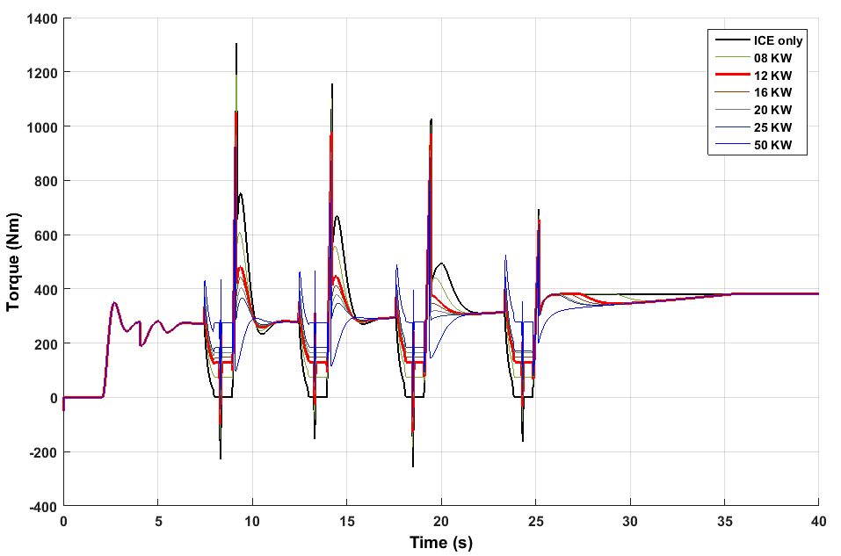
- Vehicle prop shaft torque during the study performed above.
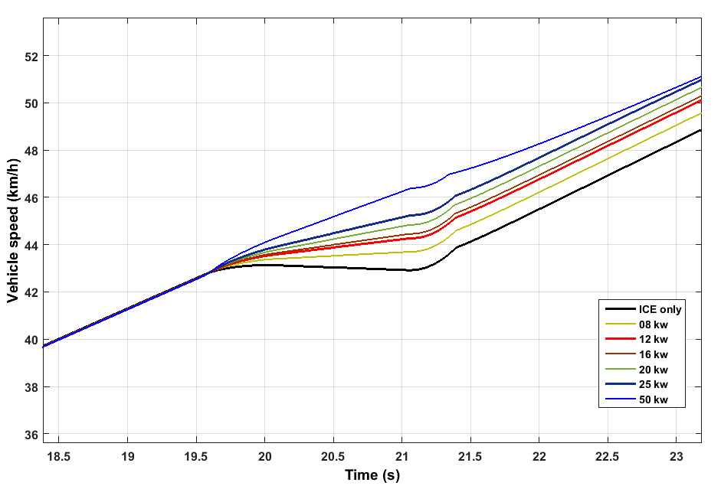
- Detail of the 3-4 shift, showing variation in vehicle speed.
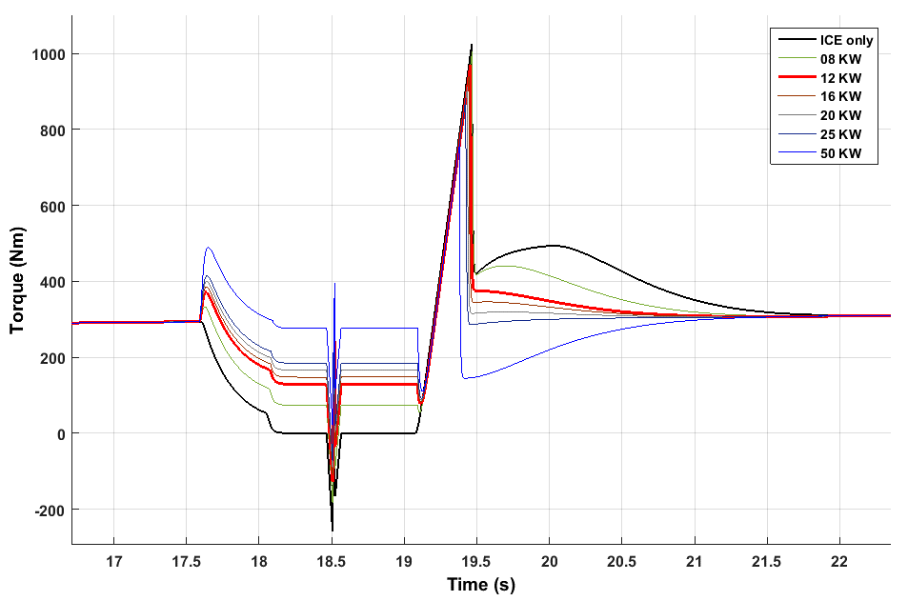
- Detail of the 3-4 shift, showing variation in prop shaft torque.
Fig. 12 (a)-(d). Mild Hybrid Manual Transmission performance study with different motor powers.

Shift quality
One of the most important performance characteristics of automobiles is shift quality. Disruption of driveline torque during gear ratio changes can result in noise, vibration, and harshness issues that can negatively impact the customer's perception of the vehicle's drivability and quality. Loud clunks and jerkiness do not translate into customer satisfaction.

Vibration Dose Value (VDV) has been used to quantify human reaction to vibration in many fields, including NVH in the automotive industry [39, 40]. Because VDV correlates well with human perception, it has become somewhat of an industry standard objective metric for transmission shift quality [41]. It is, in essence, an integration of the fourth power of a band-pass filtered acceleration signal over the shift event. When the technique is applied to longitudinal acceleration data collected during a transmission shift, the calculated VDV is representative of the driver’s physical perception of the harshness of the shift. The VDV is obtained from a suitably filtered vehicle acceleration signal, as shown equation (21). Because of the bandpass filtering applied to the acceleration signal, the figure obtained is independent of other acceleration events.

To calculate the full VDV to which the vehicle occupants are subjected, it is necessary to include calculations for acceleration in the three axes. However, because our focus is on the use of VDV as a shift-quality metric, it is not necessary to include vertical or lateral vibrations. VDV is calculated according to equation (21) below.

 | $$VDV= \sqrt[4]{\int_{t_{0}}^{t_{f}}{{\hat{a}}^{4}}}\left(t\right)dt (m/s^{7/4})$$ | (21)

In the equation (21), $\hat{a}(t)$is the vehicle longitudinal acceleration, filtered according to the Butterworth Band-pass filter with a 32 Hz cut-off. The range 0-32 Hz is used to calculate VDV values due to human sensitivity to this range of frequencies. $t_{0}$ is the time at the start of the gear shift and $t_{f}$ is the time at the end of shift. VDV was used to parameterize improvement in comfort. Following the method outlined in [42, 43], VDV was calculated for the ICE and mild hybrid cases presented in this study. Because VDV is time-dependent, it was used as a comparative tool, to analyse the VDV arising from the test scenario of a single gear change of three-second duration. The result from a single gear change can be used to inform a trend over a whole drive cycle. Table 3 shows how VDV varies with gear shift in both the ICE vehicle and the mild hybrid. As expected the shift quality improved approximately 16% when a torque-fill strategy was used, without any change in clutch actuation profile. Better transient control of the clutch and motor power ramping profile will yield further improvement in VDV, by minimising the torque excitation peaks shown in Fig. 10.

Table 3 VDV profile
 | VDV of mild HEV  (Motenergy ME0913 motor)  $$(m/s^{7/4})$$ | VDV of ICE vehicle  (no electric motor)  $$(m/s^{7/4})$$
1st to 2nd gear | 0.58 | 0.65
2nd to 3rd gear | 0.35 | 0.44
3rd to 4th gear | 0.26 | 0.34
4th to 5th gear | 0.25 | 0.30

Fig. 13 shows VDV calculated for each gear shift in our simple drive cycle (shown in Fig. 9). Our simple drive cycle features four sequential upshifts, from gear 1 to gear 5. For each upshift, VDV was calculated for no in-fill torque, as well as in-fill using 8, 12, 16, 20, 25, and 50 kW hypothetical motors. The control strategy was kept constant. The curves obtained represent interpolations of results obtained by testing the six mild HEV configurations. The minimum VDV was observed at a motor power of 15-20 kW. This result agrees well with our simple acceleration test, in which the 16 kW motor option presented the best results, and further agrees with our analyses presented previously.
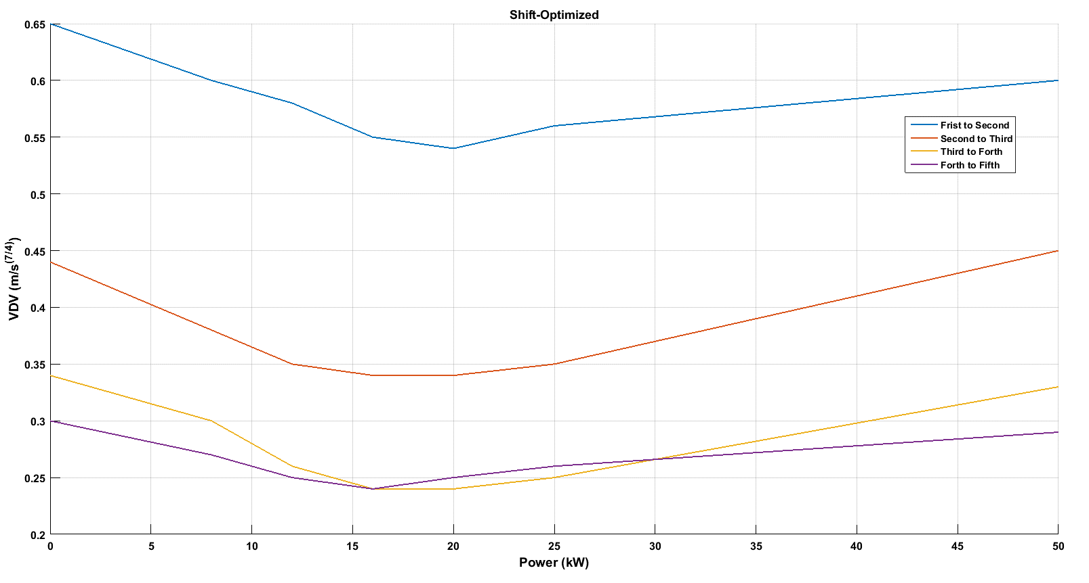
Fig. 13. Shift-optimized

CONCLUSION
This paper has introduced a mild hybrid powertrain for a manual transmission vehicle, integrating an electric machine to provide drivability and comfort by reducing torque holes during gear shifts. The adoption of an electric motor has required the development of vehicle shift-control strategies to improve the performance of powertrain system damping, by actively controlling the electric motor output during the transient vibration resulting from gear shifting. This paper has presented a strategy for up-shifting that employs the increased EM functionality to decrease the torque hole. The torque-fill drivetrain can be used equally successfully with automated manual, and traditional manual gearboxes, and the limited motor power and duty cycle limit the size and cost of other system components, such as batteries and converters. Due to the intermittent operation, it is also possible to safely operate the components beyond their rated continuous output and yield greater benefit.

Through investigation of power needs of the motor using the NYC driving cycle, it was established that only a limited number of shifts would require more than approximately 10 kW of power for the duration of the gear shift. This information was used to guide a study of the degree of torque hole compensation required. It was further established that a minimum power of less than 8 kW was necessary to prevent deceleration of the vehicle. These bounds were utilised for parametric investigation of alternative motor sizes and the impact on vehicle acceleration and vibration. These results demonstrated that while it is possible to compensate completely for any torque hole during shift changes, a minimum VDV is achieved with only partial torque compensation. This result leads to the conclusion that the analysis can consider the trade-off between additional cost requirements for the vehicle and driver comfort. This analysis is out of the scope of the current paper, but will be considered in future research.

The future extension of this research will be the implementation of these control strategies in experimental facilities available at the University of Technology, Sydney.

ACKNOWLEDGMENT
The financial support of this work by the Australian Research Council (DP150102751), Excellerate Australia (1-204) and the University of Technology Sydney, is gratefully acknowledged. We also wish to express our sincere gratitude to our research supervisor, Prof. Nong Zhang, and our thanks to the UTS – Green Energy Vehicle Innovations (GEVI) team.
Definitions/Abbreviations
ICE | Internal Combustion Engine
HEV | Hybrid Electric Vehicles
BLDC | Brushless DC Motors
AT | Automatic Transmission
MT | Manual Transmission
RDC | Rural Driving cycle
NYCDDS, NYC | the New York City Dynamometer Drive Schedule, New York Cycle
NVH | Noise, Vibration, and Harshness
EM | The electric machine
RBM | The rigid body mode
VDV | Vibration dose value
Model parameters
Name Symbol Units  Torque T Nm  Equivalent Inertia I Kg m²  Speed ω rad/s  Displacement ϴ rad  Torsional stiffness K Nm/rad  Friction Coefficient C Nms/rad | Component Symbol  Engine _{e}  Flywheel _{F}  Clutch drum _{C1}  Clutch hub _{C2}  Input Shaft _{is}  Gearbox _{g}  Output shaft _{os}  Differential _{d}  Motor _{m}  Vehicle with tyre _{W}
Appendix
- Parameters
Parameter Inertia (kg-m²)  $$I_{e}$$ 0.4  $$I_{F}$$ 0.2  $$I_{c1}$$ 0.0072  $$I_{c2}$$ 0.0125  $$I_{g1}$$ 0.0006  $$I_{g2}$$ 0.0013  $$I_{d1}$$ 0.16  $$I_{d2}$$ 1.6  $$I_{m}$$ 0.0045  $$I_{w}$$ 167.558 | Parameter Stiffness (Nm/rad)  $$K_{e}$$ 95000  $$K_{F}$$ 2000  $$K_{is}$$ 5600  $$K_{os}$$ 4700  $$K_{m}$$ 9500  $$K_{d}$$ 65000 | Parameter Damping (Nm/rad)  $$C_{F}$$ 2  $$C_{c}$$ 0.049  $$C_{is}$$ 0.0044  $$C_{os}$$ 0.1  $$C_{d}$$ 0.1  $$C_{m}$$ 0.0045

- Specifications
Table 4
Vehicle Global Specifications
Component | Parameter | SI Units
Vehicle | Mass as hybrid | 1200 kg
 | Frontal area | 3 m²
 | Drag coefficient | 0.4
 | Distance from CG to front axle | 1.4 m
 | Distance from CG to rear axle | 1.6 m
 | CG height | 0.5 m
 | Tire rolling radius | 0.312 m
Engine | Type | Spark-Ignition
 | Maximum power | 70 kW
 | Speed at maximum power | 5500 rpm
 | Maximum speed | 7000 rpm
 | Idling speed | 800 rpm
 | Cylinders | 4
Gear ratio | First | 3.581
 | Second | 2.022
 | Third | 1.4
 | Fourth | 1.03
 | Fifth | 0.94
 | Final drive ratio | 4.06
Motor  (MHEV only) | Voltage | 96 V
 | Maximum power output | 10 kW
 | Maximum torque | 54 Nm
Battery | Type | NiMH
 | Capacity | 1.2 kWh / 12.5 Ah
 | Discharge/Charge rate | 15C / 10C

- Models
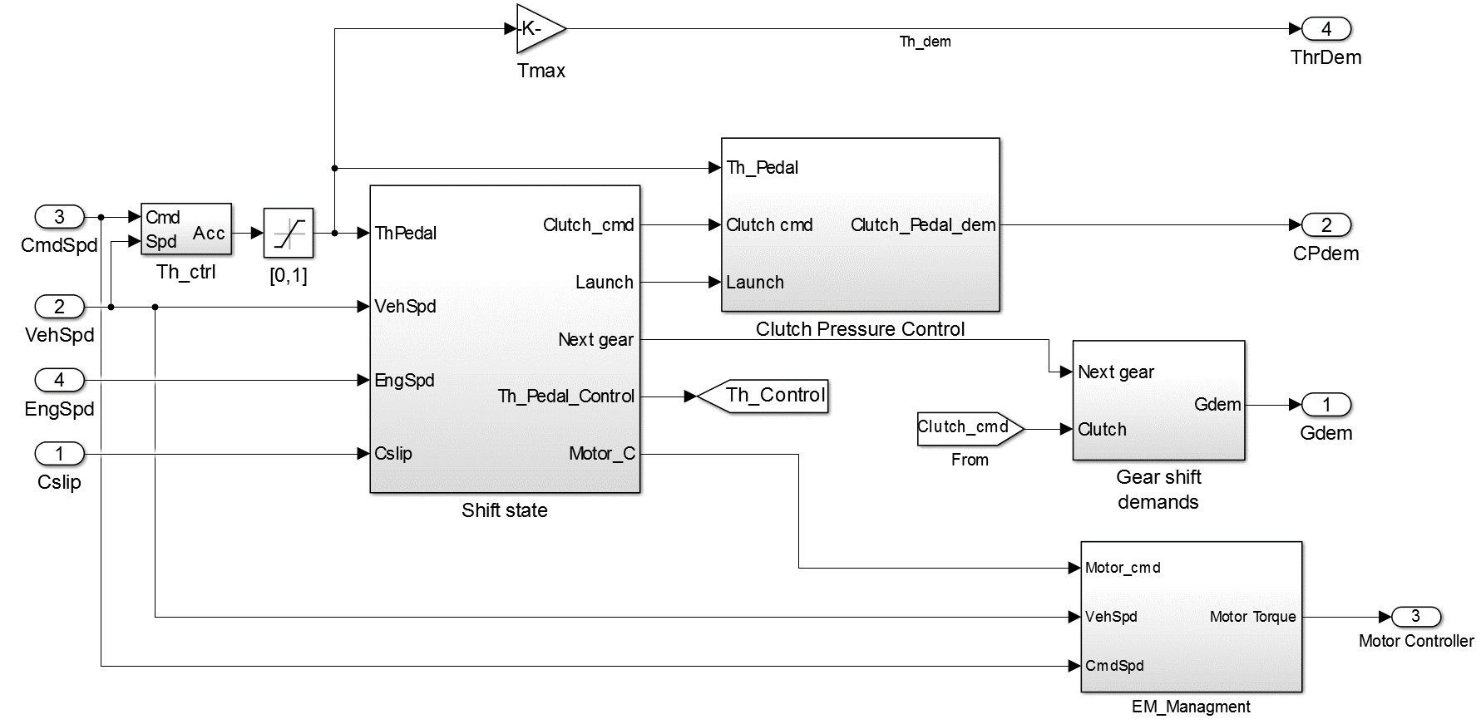
Fig. 14. Driver control unit

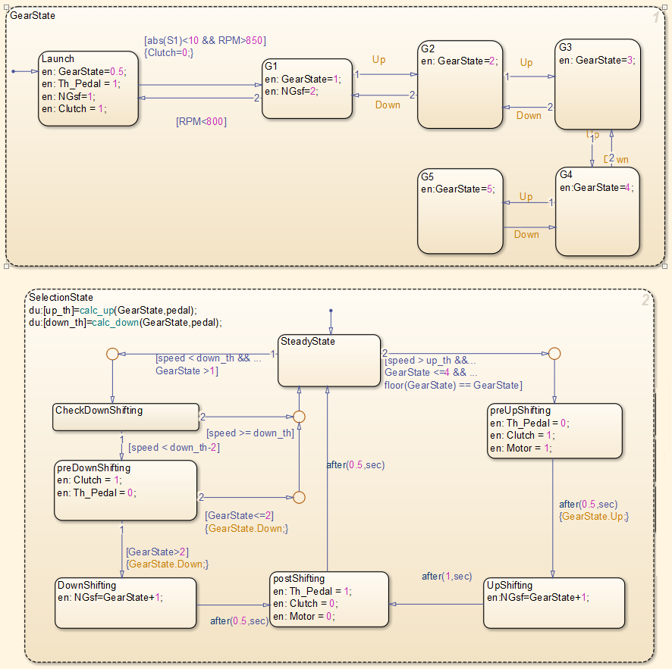
Fig. 15. Manual transmission logic modelled with Stateflow (shift state).
References
1. Kuo, K.-L., Simulation and Analysis of the Shift Process for an Automatic Transmission. World Academy of Science, Engineering and Technology, 2011. 52: p. 341-347.
2. Sun, Z. and K. Hebbale. Challenges and opportunities in automotive transmission control. in American Control Conference, 2005. Proceedings of the 2005. 2005. IEEE.
3. Wagner, G., Application of transmission systems for different driveline configurations in passenger cars. 2001, SAE Technical Paper.
4. Walker, P.D. and N. Zhang, Active damping of transient vibration in dual clutch transmission equipped powertrains: A comparison of conventional and hybrid electric vehicles. Mechanism and Machine Theory, 2014. 77: p. 1-12.
5. Zhou, X., et al., Numerical and experimental investigation of drag torque in a two-speed dual clutch transmission. Mechanism and Machine Theory, 2014. 79: p. 46-63.
6. Crowther, A. and N. Zhang, Torsional finite elements and nonlinear numerical modelling in vehicle powertrain dynamics. Journal of Sound and Vibration, 2005. 284(3): p. 825-849.
7. Crowther, A.R., et al., Impulsive response of an automatic transmission system with multiple clearances: Formulation, simulation and experiment. Journal of Sound and Vibration, 2007. 306(3): p. 444-466.
8. Galvagno, E., M. Velardocchia, and A. Vigliani, A model for a flywheel automatic assisted manual transmission. Mechanism and Machine Theory, 2009. 44(6): p. 1294-1305.
9. Baraszu, R.C. and S.R. Cikanek, Hybrid electric vehicle with motor torque fill in, in Ford Motor Company. 2003, Google Patents.
10. Baraszu, R. and S. Cikanek. Torque fill-in for an automated shift manual transmission in a parallel hybrid electric vehicle. in American Control Conference, 2002. Proceedings of the 2002. 2002. IEEE.
11. Serrarens, A., M. Dassen, and M. Steinbuch. Simulation and control of an automotive dry clutch. in American Control Conference, 2004. Proceedings of the 2004. 2004. IEEE.
12. Corporation, M.M., 1990 Mazda MX-5 Workshop Manual. 1989, HIROSHIMA, JAPAN.
13. Awadallah, M., et al., Selection and Characterisation of PMSM motor for mild HEV Applications, in Electric Vehicle Symposium & Exhibition 29 (EVS29). 2016: Montréal, Québec, Canada.
14. Zeraoulia, M., M.E.H. Benbouzid, and D. Diallo, Electric motor drive selection issues for HEV propulsion systems: A comparative study. Vehicular Technology, IEEE Transactions on, 2006. 55(6): p. 1756-1764.
15. Sharma, S. and V. Kumar, Optimized Motor Selection for Various Hybrid and Electric Vehicles. 2013, SAE Technical Paper.
16. Chang, L., Comparison of AC drives for electric vehicles-a report on experts' opinion survey. Aerospace and Electronic Systems Magazine, IEEE, 1994. 9(8): p. 7-11.
17. Wagner, U. and A. Wagner, Electrical shift gearbox (esg)-consistent development of the dual clutch transmission to a mild hybrid system. 2005, SAE Technical Paper.
18. Rahman, Z., K.L. Butler, and M. Ehsani, A comparison study between two parallel hybrid control concepts. Development, 2000. 1: p. 0978.
19. Aoki, K., et al., Development of integrated motor assist hybrid system: development of the'insight', a personal hybrid coupe. 2000, Honda R and D Co., Ltd.(US).
20. Rao, S.S., Mechanical Vibrations. 5th ed. 2011: Upper Saddle River, N.J. : Prentice Hall.
21. De la Cruz, M., S. Theodossiades, and H. Rahnejat, An investigation of manual transmission drive rattle. Proceedings of the Institution of Mechanical Engineers, Part K: Journal of Multi-body Dynamics, 2010. 224(2): p. 167-181.
22. Heijden, A.V.D., et al., Hybrid optimal control of dry clutch engagement. International Journal of Control, 2007. 80(11): p. 1717-1728.
23. BĂŢĂUŞ, M., et al., Automotive Clutch Models for Real Time Simulation. Proceedings of the Romanian Academy, Series A: Mathematics, Physics, Technical Sciences, Information Science, 2011.
24. Vasca, F., et al., Torque transmissibility assessment for automotive dry-clutch engagement. IEEE/ASME transactions on Mechatronics, 2011. 16(3): p. 564-573.
25. Mashadi, B. and M. Badrykoohi, Driveline oscillation control by using a dry clutch system. Applied Mathematical Modelling, 2015. 39(21): p. 6471-6490.
26. Rabeih, E. and D. Crolla, Intelligent control of clutch judder and shunt phenomena in vehicle drivelines. International journal of vehicle design, 1996. 17(3): p. 318-332.
27. Borhan, H.A., et al. Predictive energy management of a power-split hybrid electric vehicle. in American Control Conference, 2009. ACC'09. 2009. IEEE.
28. Hartani, K., Y. Miloud, and A. Miloudi, Improved direct torque control of permanent magnet synchronous electrical vehicle motor with proportional-integral resistance estimator. Journal of Electrical Engineering and Technology, 2010. 5(3): p. 451-461.
29. Sen, P.C., Principles of electric machines and power electronics. 2007: John Wiley & Sons.
30. Zhou, Z., et al. Modeling and simulation of hydro-mechanical continuously variable transmission system based on Simscape. in Advanced Mechatronic Systems (ICAMechS), 2015 International Conference on. 2015. IEEE.
31. Mahapatra, S., et al., Model-based design for hybrid electric vehicle systems. 2008, SAE Technical Paper.
32. Gong, J., et al., Study on shift schedule saving energy of automatic transmission of ground vehicles. Journal of Zhejiang University Science, 2004. 5(7): p. 878-883.
33. Lucente, G., M. Montanari, and C. Rossi, Modelling of an automated manual transmission system. Mechatronics, 2007. 17(2): p. 73-91.
34. Tseng, C.-Y. and C.-H. Yu, Advanced shifting control of synchronizer mechanisms for clutchless automatic manual transmission in an electric vehicle. Mechanism and Machine Theory, 2015. 84: p. 37-56.
35. Fredriksson, J. and B. Egardt. Nonlinear control applied to gearshifting in automated manual transmissions. in Decision and Control, 2000. Proceedings of the 39th IEEE Conference on. 2000. IEEE.
36. Chan, B.C., The state of the art of electric, hybrid, and fuel cell vehicles. Proceedings of the IEEE, 2007. 95(4): p. 704-718.
37. Hutchinson, T., S. Burgess, and G. Herrmann, Current hybrid-electric powertrain architectures: Applying empirical design data to life cycle assessment and whole-life cost analysis. Applied Energy, 2014. 119: p. 314-329.
38. Awadallah, M., P. Tawadros, and N. Zhang. Rapid Prototyping and Validation of Mars 0913 Brushless Motor to Develop Mild HEV. in The 7th TM Symposium China (TMC2015). 2015. Shanghai, China: SAE-China.
39. Govindswamy, K., T. Wellmann, and G. Eisele, Aspects of NVH Integration in Hybrid Vehicles. SAE Int. J. Passeng. Cars - Mech. Syst., 2009. 2(1): p. 1396-1405.
40. Wei, X., Modeling and control of a hybrid electric drivetrain for optimum fuel economy, performance and driveability. 2004, The Ohio State University.
41. Megli, T.W., M. Haghgooie, and D.S. Colvin, Shift Characteristics of a 4-Speed Automatic Transmission. 1999, SAE International.
42. Griffin, M.J., Methods for Measuring and Evaluating, in Handbook of human vibration. 2012, Academic press.
43. D'Anna, T., et al., Aspects of shift quality with emphasis on powertrain integration and vehicle sensitivity. 2005, SAE Technical Paper.

