**A *Nouveau Roman de la Route*: Marc Séguin’s *La foi du braconnier* and the Challenge of Rewriting**

***Abstract***

*Québécois novelist Marc Séguin’s* La foi du braconnier *(2009) is a road novel, an iconic American genre centred on the youthful quest for purpose and permissible rebellion against societal norms, reminiscent of Franco-American Jack Kerouac’s* On the Road. *Far from being just another imitator of this genre-defining novel, Séguin’s tale of a Québécois-Mohawk poacher who decides to drive a route that spells out FUCK YOU on the North American continent also draws on elements of the Nouveau Roman to posit a fraught relationship between the acts of writing and driving that are central to the road genre. The novel’s fragmented narration in particular suggests that the self-expression and personal freedom sought on the road are illusory goals.*

*Mais cette superposition de l’atlas et d’une biographie*

*ne va pas ici sans risque.—Jean Ricardou[1]*

When thinking of quintessential literary genres of the late twentieth century, arguably none is more typically “French” than the *Nouveau Roman*, which proved nothing short of revolutionary in terms of redefining literary narrative. The generic counterpart (or at least one of them) in the American sphere of influence at this time, the road novel, typified by Jack Kerouac’s *On the Road*, showcased rebelliousness and the escape from strictures, not so much in its form as through its characters and storylines.[2] Both genres are iconic, but they are also distinct, as distant from one another as France is from the sprawling expanses of the American heartland that are traversed by ribbons of asphalt.

To read Sal Paradise, one of *On the Road*’s protagonists, as the autobiographical embodiment of Kerouac’s outsider ethnicity as a French Canadian in America nonetheless justifies the place of the road novel in a French-speaking literary imaginary.[3] From the tales of the *coureurs des bois*, adventurers who took to the road (or more accurately the inland waterways that formed the fur trader’s highway), to twentieth- and twenty-first-century imitations of Kerouac’s own work, most famously Jacques Poulain’s *Volkswagen Blues*, the open expanses of the North American space and a means to travel have beckoned adventurers and authors alike to the escapist possibilities of the road.[4] Although written in French, French Canadian and Québécois road novels typically owe a great deal to their American counterparts given the impact of similar geography and commonalities in settlement patterns. Moreover, the crossover is indicative of the permeation of many things fashionably American into the larger cultural ethos of Quebec.

In Marc Séguin’s *La foi du braconnier*, a road novel that owes much to both *On the Road* and *Volkswagen Blues*, there is something distinctly – and generically – French about what is ostensibly an American (in the continental sense of the term) road novel.[5] Insofar as it breaks with the conventions of the typical road novel, which aims to chronicle a purposeful journey, often pushing westward across the continent, Séguin’s discontinuous narrative of seemingly erratic zigzagging recalls the breaks with novelistic convention initiated by the *Nouveau Roman*. As a *Nouveau Roman de la route*, perhaps one inspired as much by *On the Road* as by Michel Butor’s *Mobile*, it is a hybrid genre befitting a society that often, in a slightly abbreviated version of Marcel’s Rioux’s iconic formulation, sums itself up using the mathematically derived equation of américanité + francité = québécity.[6]

**Getting one’s bearings**

Séguin’s debut novel is the story of Marc S. Morris, a young man of mixed white and Mohawk heritage. Despite the linguistic legacy of the Mohawk nation’s former British alliances, Morris seems equally at home in his indigenous mother tongue as he is in French, but demonstrates a certain unease with the dominant language of the North American continent. His mixed parentage is a clear reference to the *métissage* that first took place centuries ago between European fur traders and the native peoples in North America, a fact that causes Morris to regard himself as “une conséquence de l’Amérique moderne”.[7] He, however, is more of an assembled character, harkening back to Deleuze and Guattari, than a métis or hybrid one.[8] His multiplicity of personas, each one of which makes for a fascinating story in its own right, combine to make him a particularly indecipherable character. He is a not-fully-trained chef (he completed only one year of culinary school) but is an accomplished cook with a talent for preparing game with technique-driven style. He is the single-handed thwarter of Al-Qaeda-inspired terrorist plots but shows little respect for the law, having been, as if playing to a blatantly racist stereotype, a smuggler of cigarettes. His illegal activities earned him millions of dollars, none of which he retains. He is a former Catholic seminarian who rubbed shoulders with the future Pope Benedict. He changes from being a womaniser who establishes fleeting connections with a number of women on the road to one half of a stable romantic partnership, one that eventuates in his becoming a father to a young girl. As the title implies, he is also a skilful hunter with a tendency to disregard the rules of when, what and where one is allowed to hunt.

Morris’ contempt for the rules of the parks services and game wardens speaks to an overall rebellious indifference to the norms of society. This trait is aptly illustrated when, in seeking to break off a relationship that was souring, an adolescent Morris scrawls two words onto the closest piece of paper to hand and nonchalantly and permanently walks away from a lover he describes briefly and dispassionately as “une fille très bien avec qui je couchais mais que je n’aurais jamais épousée”[9]:

Comme je ne savais pas quoi dire ni quoi répondre à ces affirmations, justes, je le sais maintenant, mes mains, ne sachant que faire elles non plus, ont sorti l’atlas et un stylo bleu de mon sac. Pendant qu’elle me regardait en silence, accusatrice, la bouche pincée, j’ai tranquillement tracé un gigantesque FUCK YOU qui partait de la Saskatchewan et dont le dernier U se terminait quelque part dans le Saint-Laurent près de Montmagny. Et je lui ai montré en me levant. Je suis parti et je ne l’ai jamais revue.[10]

This profanity on the page, the petulant expression of a young man, becomes the route for Morris’ journey, one that takes him from the geographic centre of the North American continent to a location not far from his Montreal home and that requires nearly a decade to complete. Yet, this itinerary also transcends the route of the road novel to become an act of inscription, Morris an author of a two-word manifesto addressed both within the story to society (and, obviously, his former girlfriend) and within the enunciation of the text to the reader, whose attempts at ready comprehension of the narrative and of his geographic inscription (simple thought it may seem) he continually confuses.

**Familiar Terrain**

Scholars of the road novel such as Ronald Primeau and Brian Ireland have done much to define this American genre.[11] Like any “type”, especially one that has been around for sixty years, there have been notable variations from its original form, a point made clear by Lars Erik Larson’s review of critical studies of road narratives, and particularly his attention to the twenty-first-century analyses that challenge the largely descriptive accounts of the road as a space to be navigated and through which young, white men come to find themselves.[12] These reimaginings notwithstanding, road novels remain identifiable as a genre thanks to a relatively common set of content-driven characteristics.

Evidently, road novels are stories of travel set on highways or roadways and that entail driving (or getting a ride) between two points. Although the “get in the car and drive” ethos is pervasive and suggests that road narratives are not guided by maps or set itineraries, travellers overwhelmingly tend to push westward in the footsteps of the pioneers along such well-travelled routes as the Oregon Trail and Route 66. It is for this reason that they have also traditionally been associated with the imagery and the mentalities of the American frontier. The vast plains that separate the relatively densely populated East Coast from the western mountain ranges and what lies beyond are often the settings for the travels. Although these settings are historically significant and road novels will frequently allude to protagonists crossing paths with historical figures, Kris Lackey notes a tendency for the characters to situate themselves as detached from historical forces, as though they were, in essence, just passing through.[13]

The usual protagonist of the road novel is one who conforms to a type. Feminist critics Deborah Paes de Barros and Alexandra Ganser note that the road genre is seen to be a masculine one and the open road, even when travelled by female protagonists, is more often than not a male space that is hostile toward women, who struggle to recreate it as a space of resistance and belonging through their mobility.[14] Similarly, the road is a young person’s space, at least insofar as the journey brings something meaningful to the traveller. What emerges, therefore, is frequently a young male protagonist who is not a settled man (in any sense of the word). Ireland argues that at the same time as the road genre transforms antiheroes into heroes these heroes also speak to an American zeitgeistthat unproblematically embraces the rebel: “In the road genre, geographical, cultural, and legal boundaries are crossed”.[15] Rowland Sherrill contends that the road protagonist is equally intent on blurring social boundaries, but attributes this more to a picaresque personality than to a genuinely rebellious nature.[16]

A quest of some kind is frequently a spur to the journey, although the search in question may be of an existential nature, borne of protest and a desire to redefine oneself, rather than being materially or interpersonally motivated. The matter of return to a settled existence, regardless of whether or not the quest has been successful, is frequently difficult for the travellers, so much so that the return leg of the journey is often narrated more succinctly, with fewer adventures and less overall interest, as if to foreshadow the problems that lie ahead at home.[17]

The road novel, as much of what precedes suggests, is recognised as an American genre. Tara Chittendon frames the road trip and its (fictionalised) narration as nothing short of “a literal and metaphorical quest for a sense of self, meaning, and the search for the American Dream”.[18] Ireland shares the view that road narratives are a distinctly American genre and problematically dismisses Australian and British tales of highway travel as lacking core elements, such as a westward trajectory across vast expanses of country or a genuine sense of a frontier.[19] Other scholars have tried (but not generally succeeded) in arguing for parallel national traditions of road narratives. Jenny Brasebin’s thesis on American, Québécois and German road narratives, for instance, construes the Québécois and German texts largely as imitators of Kerouac.[20] Pierre-Paul Ferland claims much the same of a spate of twenty-first-century Québécois road novels, calling them “kerouacienne” stories of rebellion, drugs and love.[21]

The *Nouveau Roman*, for its part, is decidedly harder to characterise than the road novel. Nearly every study published begins with some sort of disclaimer about the difficulty (or impossibility) of an accurate typology. Claude Murcia’s very lucid portrayal of the genre outlines the factors that make any such endeavour exceedingly difficult: the authors share no origins (although all are claimed as “French” writers); there is no commonality of subject matter; the styles vary considerably; and, in contrast to previous literary movements such as surrealism or dada, the authors did not necessarily see themselves as belonging to a group (although some in their midst, notably Jean Ricardou, sought to impose such a unity of identity).[22] Françoise Basqué even notes that Alain Robbe-Grillet’s own writings on the matter are contradictory.[23] As Celia Britton argues, though, the group’s identity has much to do with the fact that in addition to writing fiction, most of the *Nouveaux Romanciers* were also writing literary theory (much of it published in journalistic outlets) and many contributed to leftist political debates, albeit without venturing into the territory of *littérature engagée*.[24]

As for the texts themselves, perhaps the only shared trait among the *Nouveaux Romans* is a rejection of realism and narrative linearity, those hallmarks of the nineteenth-century French novel that were judged no longer capable of representing the complex realities of post-war France. Jean Ricardou’s theorising of this non-representational quality insists upon the ambiguity of the representational tendency, arguing that “d’une certaine manière, [elle rappelle] l’objet même, mais surtout, elle obéit à des nécessités impérieuses”.[25] In questioning the ability for literature to represent the world authors drew attention to the narrative act as a process that shaped reality instead of treating narrative as a means through which to access an extant actuality. Instead of representational forms, authors adopted all manner of formal innovations that spoke to “l’émergence d’un nouveau rapport au monde”.[26] These new techniques included *mise en abyme* (a tendency that led to many *Nouveau Roman* protagonists being writers), object orientation or *chosisme*, repetition, fragmentation – of both narrated time and character – and a lack of transitions between disparate elements. Such practises draw attention to the text as a deliberate product of authorial craft and demand much more from the reader, who must grapple with the narrative to make sense of the story.[27]

Although thematic or content-driven trends are not common in the *Nouveau Roman*, some of the formal manipulations and concerns give rise to recurring themes, much as the road novel features common motifs such as the American West. For instance, where traditional or conventional novels prioritise linear temporality through their narrative structures, several critics have noted the *Nouveau Roman*’s accentuation of space over time. This has led, in a curious overlap with a common feature of road novels, to a certain prominence for maps as well as for stories that feature much coming and going for the protagonists.[28] Murcia explains this phenomenon as follows: “Dans sa tentative d’appréhender l’espace afin de s’y situer, l’homme est amené à le parcourir, à y inscrire des trajets qui le jalonnent et l’apprivoisent”.[29] Travel and movement through space are therefore recurrent elements in works such as *Mise en scène* by Claude Ollier, *Le Voyeur* by Robbe-Grillet and Butor’s *Mobile*.[30] They are equally significant in Québécois *Nouveaux Romans*, such as Jacques Godbout’s *Le Couteau sur la table*, whose base premise is a train journey across Canada.[31]

The fractured and sometimes chaotic narrative structures that are commonly employed by the *Nouveaux Romanciers* also tend to mirror the protagonists’ (often futile) searches for meaning in their world. Thus, as readers attempt to follow the character in their quest to redefine their relationship to the world, readers are likely to find themselves confronted by formal or textual obstacles and impediments to ready comprehension of the story. Grappling with these complexities is nonetheless vital, for “ le livre n’est rien si le lecteur reste passif”.[32]

**Roads less travelled**

The voyage undertaken and narrated by Marc Morris draws on both the conventions of the road novel and the disparate commonalities of the *Nouveau Roman*. It is undoubtedly a narrative of roadway travel insofar as one of its narrative threads is a recounting of what happens as Morris steers his pick-up truck along the profane route that he has traced for himself. Readers are, more or less, given the means to follow along and plot his itinerary as he recounts towns he has passed through and junctions where he has turned to complete a letter.

Morris’ route takes him across the American plains, the Midwestern states and those in the east that border Quebec. The most westward locales of this journey, North Dakota for instance, are the fabled territories of the Wild West, which is in turn associated with the American frontier. So reminiscent of the icons of this mythologised American space is Morris, that he is quite literally portrayed as a gun-slinging outlaw, albeit one who prefers a hunting rifle to a duelling pistol. His First Nations heritage provides him with inherited ancestral understanding of the land that predates the designation of the northern 49th parallel as the international border. As such his travels also take him into the Canadian prairies, the Great Lakes region and much of Quebec, the very territories that constituted the Canadian version of the frontier or Wild West that was dominated by the figures of the *coureurs des bois* and the *voyageurs*, historical actors who engaged, much like Morris, in the profitable trade in hunted or trapped animal parts.

Where the stereotypical protagonist in a road novel is a young, adventurous man seeking a surer sense of his place in the world, Morris fits the bill. At the chronological start of his story – the paper-based breakup – he is but a teenager who has successfully freed himself from the only relationship in his life that can be construed as a commitment. His links to his home are tentative at best and his father is altogether absent. Morris has abandoned his Mohawk reservation – and thus the recognition that would flow to his descendants from being “Status Indians” – in favour of a relatively anonymous life in Montreal. Apart from a strong sense of tradition around hunting and food (both of which he manages to enjoy whilst on the road despite the occasional craving for his mother’s home cooking), he seems well suited to his rootless existence.

Where road novels are often narratives of questing or searching, the motivation for Morris’ journey remains elusive. Simon Harel’s concept of *braconnage* *identitaire*, which critics sometimes link to Séguin’s novel, would offer a rather politicised explanation for Morris’ travels.[33] *Braconnage*, as Harel defines it, is the covert and rebellious exploration and temporary occupation of territory that used to belong to the hunter but that has been taken from him, rendering him as an outlaw, a poacher. To adopt such a lens in viewing Morris’ travels would be to give them a doubled national significance, for both his Mohawk and French Canadian heritage speak to dispossession and occupation of the (Anglo) Other’s territory. His literal poaching activities only make such comparisons more obvious. Rejecting hypotheses that are more nationally than personally significant, Pierre-Paul Ferland attributes Morris’ wanderings to a nomadic phase where: “L’individu ‘sédentaire’ rompt avec son mode de vie stable et devient un ‘nomade’ qui explore le continent en quête de découvertes, d’épreuves ou de richesse qui vivra une transformation au contact de l’Autre et redeviendra de son plein gré sédentaire”.[34] Morris’ journey, though, begins almost by chance when his writing on a piece of paper is transformed into the markings of an itinerary of on a map. Political and deep personal motivations therefore ought to be seen as secondary, or at least adjuncts, to elements of chance. The root of the journey is not linked to travel, a quest or a political pursuit; its origins are an act of inscription.

Whilst the circumstances that led to him needing this map were the direct result of poaching and the literal crossing of borders to avoid detection for his crime, it is only later that this trip of expediency is incorporated into a larger journey. This apparent quest to complete the writing of the FUCK YOU is most frequently described in purely self-referential terms; it is a journey for its own sake. This is not to say that this road trip does not take on certain philosophical or existential implications – his statement of “je dois completer mon O. Et vice versa” being a perfect example – but the poacher’s search for deeper meaning along the road remains somewhat unrealised.[35] In part, this is because Morris finds fulfilment – both temporary in the case of his religious trajectory and longer lasting in his relationship with Emma and fatherhood – in the variety of pursuits that he embarks upon and identities that he assumes during the periods when he is not travelling. While the road does indeed call to him, he also searches for and ultimately finds meaning in the more rooted pursuits that call him back to Montreal and a fixed address. *La foi du braconnier* thus starts to diverge from traditional road narratives.

It is, however, the novel’s fragmented and self-conscious articulation as a written text, what Ferland dismisses as “structure narrative et prolepses inutilement complexes”, that align it just as much with the *Nouveau Roman* as with the road novel.[36] In a purely geographic sense, the drive is far from the expected route of an American road novel. Rather than pushing westward, Morris zigzags his way east and, much like the eastbound train journey in Godbout’s *Nouveau Roman*, there is a subversion of the cardinal premise. Furthermore, the starting point for the journey is not Morris’ home, but a random location on a map that just happens to coincide with some markings he had made upon it some time earlier.

In addition to the geographic sense of moving forward, of distancing oneself from a home base that is typically found in road novels but not in *La foi du braconnier*, Séguin’s narrator frequently employs the classic *Nouveau Roman* technique of analepsis to arrest the forward progression of the narrative. Where the novel begins with the curious phrase “Le lendemain matin, je n’étais pas mort,” it takes the narrator two further jumps back in time – one that follows in the next chapter to the previous day (the occasion of his failed suicide attempt), the one in the third chapter back to October 1991 – to begin the tale in earnest.[37] Even then, however, the narrator begins his story with a pluperfect that evokes a time even further back: “Je ne l’ai su que quatre jours plus tard dans un Holiday Inn de Winnipeg. Parc national du Mont-Riding au Manitoba. L’ours noir que j’avais tué pesait plus de 350 kilos.”[38] Still missing until some 20 pages further on is the chronological initiation of the story, the origins of the FUCK YOU on the map.

The initial series of analepses that opens the novel thereby creates a situation in which Morris, who describes himself as “un gars qui écrit FUCK YOU avec son pick-up sur la page d’un continent”, is “writing” – for twenty pages worth of narrated road trip – without his reader being able to comprehend that he is, in fact, writing at all.[39] The first indication that his seemingly erratic route constitutes anything other than pure chance, comes not even from his own narration, but from a third-person interlude that, reminiscent of *Mobile* and its collage of snippets from speeches, advertisements and local newspapers, is even typographically set apart from the rest of the text in italics, as though it has been clipped from a small-town paper’s *fait divers* column:

*À TIRE-D’AILE*

*Un pick-up Dakota bleu deux tons a traversé quatre fois la frontière, sans destination apparente. La trajectoire du véhicule, du parc du Mont-Riding jusqu’à Winnipeg, quatre jour plus tard, forme un ensemble de lignes visuellement reconnaissables et compréhesibles dans un alphabet occidental. La première lettre est un F et la seconde un U. 1790 kimomètres.[40]*

The entire premise of the story, the long and painstaking tracing/writing of his message is consequently framed as coincidence first, if not foremost, and is initially presented as detached from the main first-person narrative. This writing nonetheless provides a certain unity or coherence to the story, something that allows Morris to pithily describe his project. This coherence, the ability to represent one’s endeavours as a succinct and unified undertaking, ultimately proves false, for as is the case in almost all *Nouveaux Romans*, textual representation proves wanting or fails. As Robbe-Grillet argues about the attempt of writing as a way to find meaning, “L’écrivain, par definition, ne sait où il va et il écrit pour chercher à comprendre pourquoi il écrit”.[41] Yet, not even writing can represent the act of “writing” a seven-letter, two-word sentence.

**Illegible maps, confused directions**

For the reader, the revelations that there are, first, a pattern to the driving and, second, a deeper meaning to this pattern, call for a rereading of what preceded and a plotting out of the route. Where *Nouveaux Romans*, with their propensity for fragmentation and analepses often oblige the reader to recall seemingly insignificant elements and reconstruct the story from a convoluted narrative, Séguin forces his readers into an act of cartographic plotting, requiring them to imitate his protagonist and to write FUCK YOU on their own (possibly mental, possibly physical) maps as they string together the cities and towns Morris passes through. Hence, repetition – as is so typical in the *Nouveau Roman* – is not only embedded within the novel, in Morris’ retracing of his own handwriting as vehicular writing, but it is also produced by the readers themselves through their seeking to make sense of the narrative via their own cartographic inscription, which takes its direction from Morris’ narration of his travels.

If the original inscription of the FUCK YOU came in the form of a break-up note, it is likely that it would be recognisable as a handwritten message. Following the conventions of writing, this would mean that the letters, even making allowances for poor penmanship, would be readily recognisable. The block letters would be slightly separate from one another, the words separated from each other by a larger space and all of the letters roughly in line with each other, either on one or two lines. The letters would also be oriented the same way on the page so as to be legible without need for turning the page or angling one’s head. As Morris rewrites, repeats, this message with his pick-up, however, the writing – we must assume based on his narration thereof – becomes distorted and less recognisable. As Ferland demonstrates in his hypothetical plotting of the journey (figure 1), the written-as-driven, or at least the written/driven-as-narrated, is likely to differ significantly from the written-as-written. What begins quite clearly, in an interpersonal communication context to be “FUCK YOU”, is transformed by the narrative into something that approximates “FUCKY CO”.

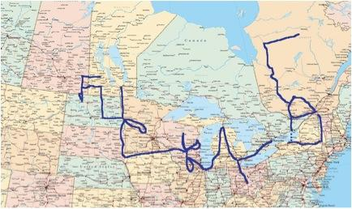*Figure 1: Hypothetical rendering of Morris’ route based on the narrative and extrapolations. Credit to Pierre-Paul Ferland, “Roadkill”*.

The distortion of the message that occurs as a result of its rewriting is an almost inevitable consequence of treating a map alternately as a blank piece of paper and then as a map. Letters that were originally written with the sole purpose of communicating meaning must then be traced over within the constraints imposed by the network of roads, highways, border crossings and bridges. To engage in a sense-making reading of the text reveals the extent of Morris’ authorial and map-making bravado. He is not, as he claims, driving his break-up note and writing FUCK YOU to the world. Rather, he is somebody who is approximating this project and producing a “text” that captures a certain rebelliousness in that it yields profanity (to a degree, the word *fuck* having many variations in English, but *fucky* not generally being one of them) but not truly being the unambiguous message of which he boasts. Morris’ narratorial credibility is consequently impugned.

The fragmentation of the driving-as-writing also contributes to a sense that Morris’ inscription upon the page of the continent is not as faithful as he portrays it and as a result here too he falls short in his grandiose statements of rebellious purpose. After having been able to plot the F and the U to a relatively reliable degree, the C disappears into a blur, the only information about it being that it was traced, along with the majority of the K in approximately three days. The only part of the K that is narrated is a section that runs from Chicago to Grand Rapids, Michigan, a stretch of highway that would see an inverted comma-like trace added to the inscription rounding the southern tip of Lake Michigan.

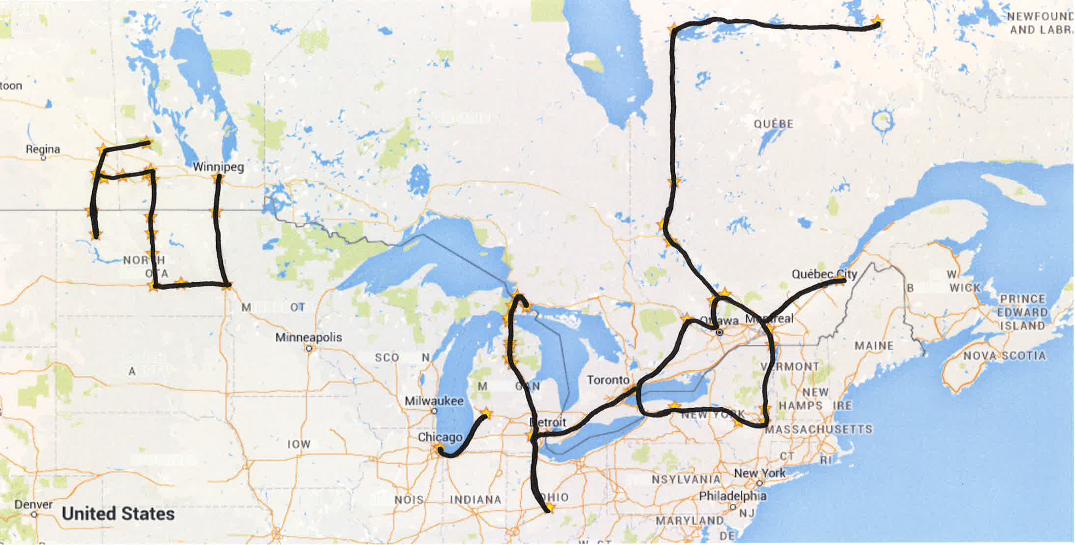*Figure 2: Morris’ journey as narrated, only “inscribing” itineraries noted.*

Where the driving that is done to trace the letters is typically narrated in some detail – chance encounters are related, the music Morris chooses to play on his truck’s stereo is identified, decision-making processes about routes are conveyed – Morris treats other forms of driving, notably the travel that disrupts and that reconnects him to his purposeful inscribing journey, very differently. When he decides to return to Montreal to enrol in the seminary after he has completed the K, the hundreds of kilometres of travel are almost entirely elided: “À la fin du K, dès mon retour de Grand Rapids, début Novembre 1991, et malgré la session déjà commencée, je m’étais inscrit au séminaire”.[42] The only textual evidence of his travel is the *retour*. Even more dramatically, three years later, Morris decides to begin “writing” again, and this decision comes without any indication of his having repositioned himself, this despite the tendency for outbound journeys in road narratives to be more painstakingly narrated than the returns home:[43] “J’ai repris la route du FUCK YOU. Je suis à la gauche du Y en haut, tout près de Sault-Saint-Marie, dans cette petite ville ontarienne où les habitants ont brûlé des drapeaux du Québec l’an dernier lors du référendum”.[44] Whilst the miles driven between Grand Rapids, Michigan and Montreal and Montreal and Northern Ontario would not perceptibly differ from one another, Morris suggests that the only travel worthy of narration is that which counts toward his project of inscription. Even then, however, not all of this travel makes the cut, as the absent tales of driving the C and the K confirm.

Narratively, such fragmentation, the elisions – or at least some of them – are needed. They make the inscription legible, the letters, distorted though some of them may be, distinct rather than a mess of squiggles. Thus, just as paper with writing upon it bears the traces of ink only where the pen has made contact with paper rather than exposing all of the pen’s motions (for instance to reposition itself to begin to write a new word or a new letter) only the travel that traces the FUCK YOU is recounted. Such breaks are necessary, for the picture would be far less clear, as the difference between figures 2 and 3 demonstrates, if every interrupting trip home, particularly in the latter part of the journey where such trips are more frequent and disrupt the tracing of individual letters, were recounted and thus “written”. The relatively legible FUCK YOU that functions as the impetus for Morris’ project would likely consist of the recognisable F and U, followed by a gap and an indecipherable tangle of lines.

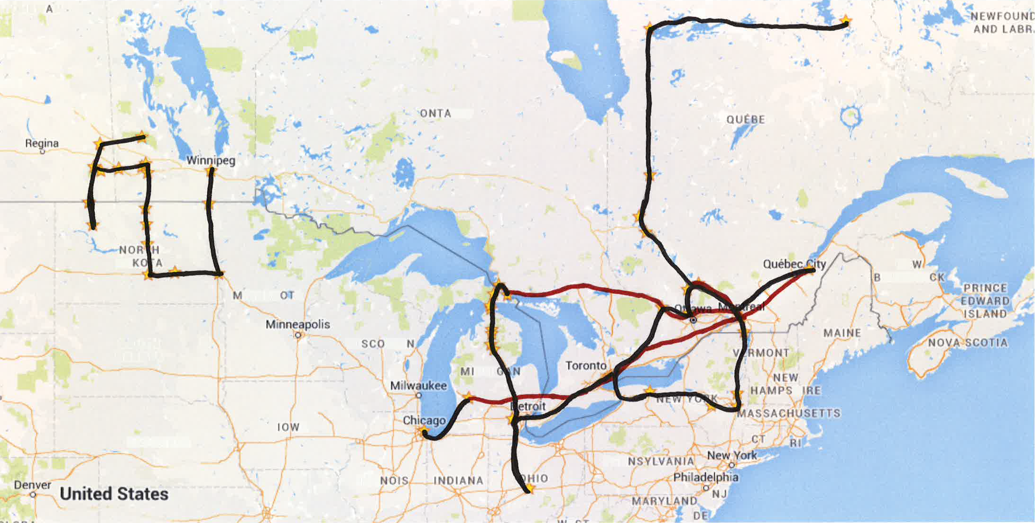

*Figure 3: Morris’ journey as narrated.*

As the narrative unfurls, a process necessary to following Morris on his journey, the inscription becomes less recognisable, less meaningful and is positioned as bearing ever less resemblance to what Morris claims he has written, both on the page of the road atlas and with his Dodge Dakota.

The significance of the reader’s being unable to reproduce the itinerary, either in the clear legibility of its mythologised form or the distorted variation of its narrated enactment, recalls Ricardou’s explanation of the role of reading for the *Nouveau Roman*: “En conséquence [de lire], loin de subir l’impérialisme des sens propres, lire c’est se rendre attentive à l’ordre clandestin du travail textuel”.[45] In this vein, the hidden work of Séguin’s text is multiple. At the level of the narrative, Morris’ claims to be writing FUCK YOU and the invitation to emulate his statement of protest reveal that his epic project is troubled by problems of inscription and that these problems prevent the reader from echoing his statement and in turn responding to the author by joining in the chorus of profanity. At the level of the work as a whole, Séguin’s text does not function as the “ultimate” road novel – something that the itinerary would suggest both in scope and specificity – but rather its inability to be retraced (as road protagonists traced the paths of pioneers and adventurers) accentuates its parodic relationship to the road novel as a genre. Indeed the premise of the road trip and its itinerary border on utter absurdism.

**Conclusion**

Marc Morris’ remarkable story of writing FUCK YOU on the North American continent, retracing a breakup note written some years earlier, is perhaps the ultimate act of youthful rebelliousness. This trait, along with the obvious subject matter and the protagonist’s resemblance to other road protagonists, both those created in other novels and those evoked in the historical narratives that inspired many of them, make *La foi du braconnier* a playful Québécois addition to the corpus of road novels.

The narration of this act of vehicular inscription nonetheless draws on the *Nouveau Roman*-inspired tradition of writing in a way that provokes readerly engagement, but not facilitate it. As Morris recounts his trip, using neither measures of time nor distance, but rather his progress in tracing letters to track his journey, he beckons his readers to follow his travels and to draw their own FUCK YOU. However, every embedded attempt to rewrite this message – Morris’ own driving, his recounting of his travels, the reader’s plotting of the route along a map based on the narration – produces an inscription that is ever less recognisable and thus less meaningful if its intent is to express dissatisfaction and wanting out: out of an early and unremarkable relationship, out of social constraints, out of life itself, and indeed out of some of the generic conventions of the road novel.

1. Jean Ricardou,  *Pour une théorie du nouveau roman* (Paris: Seuil, 1971), p. 41.
2. Jack Kerouac, *On the Road* (New York: Viking, 1957).
3. Karen E.H. Skinazi, “Through Roots and Routes: *On the Road*’s Portrayal of an Outsider’s Journey into the Meaning of America”, *Canadian Review of American Studies/Revue canadienne d’études américaines*, 39:1 (2009), pp. 85-103.
4. Jacques Poulain, *Volkswagen Blues* (Montreal: Leméac, 1988).
5. Marc Séguin, *La foi du braconnier* (Montreal: Lemác, 2009).
6. Michel Butor, *Mobile: étude pour une représentation des Etats-Unis* (Paris: Gallimard, 1962);Marcel Rioux, *Les Québécois* (Paris: Seuil, 1974).
7. Séguin, p. 15.
8. Gilles Deleuze & Félix Guattari, *Mille Plateaux* (Paris: Éditions de Minuit, 1980).
9. Séguin, p. 36.
10. Séguin, p. 36.
11. Ronald Primeau, *The Romance of the Road: The Literature of the American Highway* (Bowling Green, OH: Bowling Green State University Popular Press, 1996); Brian Ireland, “American Highways: Recurring Images and Themes of the Road Genre”, *The Journal of American Culture*, 26:4 (2003), pp. 474-484.
12. Lars Erik Larson, “Literary Criticism’s Road Scholars at the American Century’s Turn”, *Literature Compas*, 6:6 (2009), pp. 1071-1083.
13. Kris Lackey, *Road Frames: The American Highway Narrative*, (Omaha: University of Nebraska Press, 1999).
14. Deborah Paes de Barros, *Fast Cars and Bad Girls: Nomadic Subjects and Women’s Road Stories* (New York: Peter Lang, 2004); Alexandra Ganser, “On the Asphalt Frontier: American Women’s Road Narratives, Spatiality and Transgression”, *Journal of International Women’s Studies*, 7:4 (2006), pp. 153-167.
15. Ireland, p. 478.
16. Rowland A. Sherrill, *Road-Book America: Contemporary Culture and the New Picaresque* (Urbana, IL: University of Illinois Press, 2000).
17. Primeau, p. 127.
18. Tara Chittenden, “A Fold in the Road: Kerouac and the Temporal-Spatial Construction of Street Corner as Place in *On the Road*”, *Journeys* 15:2 (2014), pp86-103.
19. Ireland, pp. 483-484.
20. Jenny Brasebin, *Road novel, road movie: Approche chronotopique du récit de la route*, PhD Thesis: Comparative Literature, University of Montreal & Université Sorbonne Nouvelle (2013).
21. Pierre-Paul Ferland, “Roadkill”, *SalonDouble: Observatoire de la littérature contemporaine*; <http://salondouble.contemporain.info/lecture/roadkill> (20 November 2012). Viewed 5 March 2016.
22. Claude Murcia, *Nouveau Roman, nouveau cinéma* (Paris: Nathan, 1998).
23. Françoise Basqué, *Le Nouveau Roman* (Paris: Bordas, 1972), p. 5.
24. Celia Britton, *The Nouveau Roman: Fiction, theory and Politics* (New York: St Martin’s Press, 1992).
25. Ricardou, p. 18.
26. Murcia, p. 18.
27. Basqué, pp. 126, 91.
28. Nancy Pedri, “Cartographic Explorations of Self in Michael Ondaatje’s *Running in the Family* and Jacques Poulain’s *Volkswagen Blues*”, *International Journal of Canadian Studies/Revue international d’études canadiennes*, 38 (2008), pp. 41-60.
29. Murcia, p. 104.
30. Claude Ollier, *Mise en scène* (Paris: Éditions de Minuit, 1958); Alain Robbe-Grillet, *Le Voyeur* (Paris: Éditions de Minuit, 1955).
31. Jacques Godbout, *Le Couteau sur la table* (Paris: Seuil, 1958).
32. Basqué, p. 91.
33. Simon Harel, *Braconnages identitaires: Un Québec palimpseste* (Montreal: VLB, 2006); Ferland, “Roadkill”.
34. Pierre-Paul Ferland, “‘Les voyages forment la jeunesses’ : mythe américain et rite initatique dans le roman de la route québécois contemporain”, *Québec français* 164 (2012), pp. 38-41.
35. Séguin, p. 129.
36. Ferland, “Roadkill”.
37. Séguin, p. 7.
38. Séguin, p. 15.
39. Séguin, p. 141.
40. Séguin, p. 31.
41. Alain Robbe-Grillet, *Esprit* (1964), pp. 63-65.
42. Séguin, p. 49.
43. Primeau, p. 127.
44. Séguin, p. 65.
45. Ricardou, p. 51.